**PRSF NEW MUSIC BIENNIAL**

**HULL**

**29th JUNE to 2nd JULY 2017**

**ARTIST PACK**

**ARTIST**: Philip Veneables and David Hoyle

**ARTIST CONTACT (Mobile number):** TBC – PROMOTER TO CONFIRM

**VENUE**: Funktion

[Address](https://www.google.com/search?biw=2400&bih=1217&q=www+fruitspace+co+uk+address&stick=H4sIAAAAAAAAAOPgE-LWT9c3LDOyTMpKK9GSzU620s_JT04syczPgzOsElNSilKLiwFSWNTXLgAAAA&sa=X&ved=0ahUKEwiT5cTKt7jUAhUlKMAKHZ4BA-AQ6BMIowEwEA): Funktion, 54 Analby Road, Hull, HU3 2SB

[Phone](https://www.google.com/search?biw=2400&bih=1217&q=www+fruitspace+co+uk+phone&sa=X&ved=0ahUKEwiT5cTKt7jUAhUlKMAKHZ4BA-AQ6BMIpgEwEQ): 07578 935253

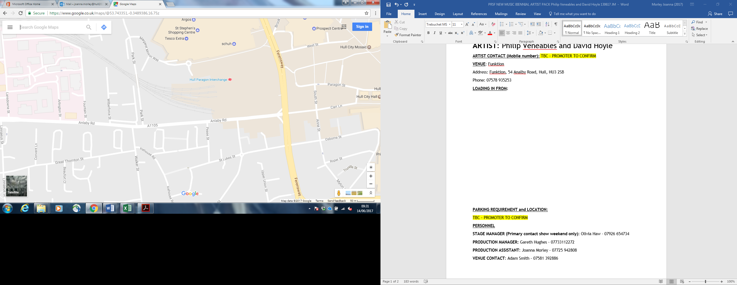**LOADING IN FROM:**

**PARKING REQUIREMENT and LOCATION:**

TBC – PROMOTER TO CONFIRM

**PERSONNEL**

**STAGE MANAGER (Primary contact show weekend only):** Olivia Haw - 07926 654734

**PRODUCTION MANAGER:** Gareth Hughes – 07733112272

**PRODUCTION ASSISTANT**: Joanna Morley – 07725 942808

**VENUE CONTACT**: Adam Smith – 07581 392886

**DATE AND TIME OF PERFORMANCE: Sunday 2nd July 17:30 (45mins)**

**PRODUCTION SCHEDULE:**

|  |  |  |  |
| --- | --- | --- | --- |
| **SUNDAY 2 JULY** |  |  |  |
| 09:00 - 22:00 (ACCESS) | AM | Piano in |  |
|  | AM | Piano tuned |  |
|  | 09:00 - 14:00 | LX and Sound in |  |
|  | 14:00 - 17:00 | Artists arrive and rehearsal |  |
|  | 17:00 | Doors |  |
|  | 17:30 | PERFORMANCE - Philip Venables and David Hoyles |  |
|  | 18:00 | Cleared |  |
|  | 18:00 - 22:00 | Tech out |  |
|  |  |  |  |
| **MONDAY 3 JULY** |  |  |  |
| 08:00 - 12:00 (ACCESS) | 08:00 - 12:00 | Staging out |  |
|  | AM | Piano out |  |

**TECHNICAL**

**Sound**

**FOH Control**

1 Allen & Heath Qu-Pac Ultra Compact Digital Mixer

1 iPAD & Router

**Speaker System**

2 L Acoustic 115XT

2 Powerdrive 44BE Speaker Stand

2 L Acoustics - SB18

2 L Acoustics LA8

**Balcony Fills**

2 L Acoustic 108P

2 Powerdrive 44BE Speaker Stand

**Monitor System**

**Microphones**

1 Shure ULXP Beta58 Handheld Radio System - CH38

**Other Equipment**

1 63A 3-Phase Mains Distro #3

**Staff**

1 Engineer – FOH

**AV**

**Material**

1 Laptop

1 Christie LHD 700 HD Projector

1 Christie LNS-W33 Lens for LHD 700 1.3-1.8:1

1 10' x 5.9' Fastfold Screen (Widescreen)

**Staff**

1 Engineer – AV

**Lighting**

**Material**

1 Avolites Tiger Touch Pro Console

1 Paradim Patch Rack Dimmer

8 Equinox Maxi Par Tri RGB LED

8 650W Fresnel

4 3.5m Wind Up Manfrotto Stand

4 Aluminium Leg - 4ft / 1257mm

4 13A To 16A Adapter

1 Socapex To 6x 16A Adapter

**Staff**

1 Engineer - Lighting

**RIDER:**

TBC

**BACKLINE**:?

|  |  |  |
| --- | --- | --- |
| **BACKLINE** | Upright Piano | Teagues Pianos |

**ACCREDITATION**

David & Alice Porter (Directors)

Steve & Sam Shaw (Directors)

Peter & Lorraine Boardman (Directors)

Wes Zepherin (Director)

Kirsty & Gary Halliday (Marketing)

Ben Pugh (Production)