**From stage to screen**

BBC Arts and Channel 4’s Random Acts discuss routes into being commissioned for broadcast.

BBC Arts, and a panel comprised of the UK’s leading arts broadcasters share their insights into connecting with arts organisations and how digital changes are impacting their decisions.

**Nikki Bedi – Chair**

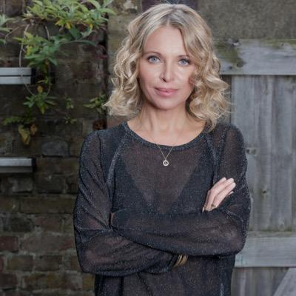

Nikki is a televison and radio broadcaster with a passion for making arts and culture accessible. She currently wakes up the capital presenting the Early Breakfast Show Monday to Friday on BBC Radio London. Nikki curates, writes and presents The Arts Hour on the BBC World Service, is a regular interviewer and presenter on BBC Radio 4’s Loose Ends, can often be seen on BBC1's Sunday Morning Live interviewing famous names and celebrities about their faith and also on BBC1's current affairs show Inside Out reporting on everything from eye transplants to cinema restorations. Nikki also presents The Heart Of... TV series on BBC World News, an arts and culture programme looking at fresh new talent from across the world's great cities and has presented BBC Radio 4's Womans Hour.

**Lamia Dabboussy - Panellist**

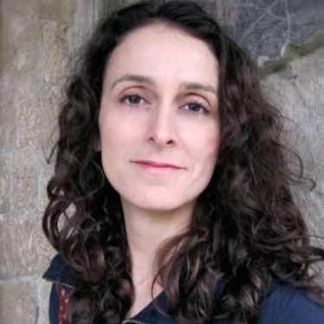

BBC Arts- Lamia Dabboussy is the Editor for BBC Arts.  This year the BBC Director General, Tony Hall said the BBC will create a new Artists First BBC commissioning fund that will prioritise artists and arts organisations who want to create new works for broadcast and online. It will have £4m of funding in the first year, with BBC Arts overseeing the project.

**Jeremy Routledge- Panellist**

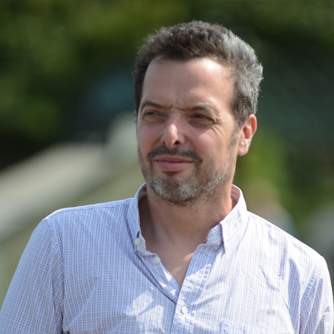

Channel 4 Random Acts - Jeremy Routledge is co-founder of Calling The Shots based in the South West. The film production company also provide educational workshops around filmmaking. Jeremy started off his career helping to run the Bristol 1980s music club the EEC Punk Rock Mountain. He then made pop promos, worked as a freelance editor and then documentary director for the BBC, Maverick TV and ITV West.

**Peter Groom - Panellist**

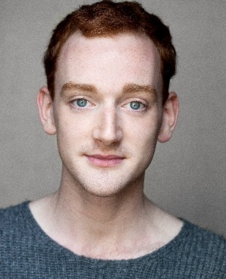

Peter Groom is a Newcastle based actor, dancer and choreographer working mainly with dance and theatre. He directed the short film Herd as part of Random Acts, the Channel 4 short film strand focussed on the arts. Peter is also an Associate Dance Artist of DanceCity.

**Rocio Cano - Panellist**

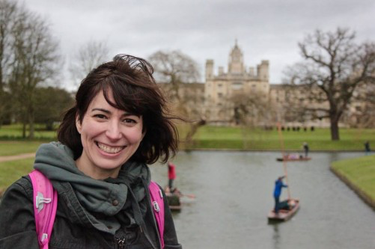

Rocio Cano is a TV Producer who has worked mainly on arts and entertainment series, and who is currently running ART 50, a funding scheme for Sky Arts commissioning 50 arts projects on the subject of being British.