- Arts & Culture

  - Introduction
Arts & Culture is one of the key themes of Hull 2017, made up of three aims and their accompanying objectives:
- Aim 1: To produce a high-quality, exemplary programme of arts, culture and heritage, helping to position the UK City of Culture as a quadrennial national event
  - Objective 1: Deliver a 365-day programme that is ‘of the city’ yet outward looking, and which includes 60 commissions.
  - Objective 2: Improve understanding and appreciation of Hull’s heritage.

- Aim 2: To develop (new and existing) audiences for Hull and East Riding’s cultural offer locally, regionally, nationally and internationally
  - Objective 3: Increase total audiences for Hull’s arts, culture and heritage offer.
  - Objective 4: Increase engagement and participation in arts and heritage amongst Hull residents.
  - Objective 5: Increase the diversity of audiences for Hull’s arts and heritage offer.
- Aim 3: To develop the capacity and capabilities of the cultural sector
  - Objective 6: Develop the city’s cultural infrastructure through capacity building and collaborative work undertaken by/with Hull 2017 and its partners.
Flood will be evaluated, referencing these aims and objectives, as well as identifying additional outcome areas not covered in the above, but linked to the project-specific aims and objectives (see Chapter 1).
  - Contribution to Overall Hull 2017 Programme
Flood: From The Sea (Part 1) was released on 27 February 2017.
Flood: Abundance (Part 2) was a live theatre performance at Victoria Dock which ran for 5 days between from 11 April and 15 April 2017. The performance started at 8pm each night and the event was ticketed.
Flood: To The Sea (Part 3) was broadcast on BBC2 at 10pm on 22 August (except Scotland), and repeated for viewers in Scotland at 12.40am on 23 August. It was also available on BBC iPlayer for 30 days after the broadcast date.
Flood: A New World (Part 4), the live theatre performance at Victoria Dock, started on 26 September and ran for 4 days until 29 September 2017. The performance began each day at 9pm. The event was ticketed.
Audiences could catch up on Parts 2, 3 and 4 in one evening as part of omnibus performances held on 4 – 8 October 2017. Each performance began at 7pm and finished at 10.30pm with a 40 minute interval. The event was ticketed.
Each section was created as a standalone piece, but audiences were invited to follow the entire series with each part enriching and linking to every other.
  - Quality of Flood
To assess the quality of Flood several questions were incorporated into the evaluation of the event. This included recognition of Arts Council England’s (ACE) Creative Case for Diversity and its Quality Metrics.
    - Creative Case for Diversity
ACE’s mission is ‘great art and culture for everyone’. They state that this can only be achieved through funding work that promotes and embeds diversity.
To assess how ‘Flood’ promoted and embedded diversity, equal opportunities data was collected across the Core Project Team and Commissioned Artists.
In reflecting on the equal opportunities data collected on the CPT and artists, four were female and six were male. The youngest age group represented was 20-24 years and the oldest age group was 45-49 years.
Amongst Artists the age profile was more concentrated – the youngest age group represented was 25-29 years and the oldest age group was 35-39 years.
In both the CPT and amongst Artists there were no disabled artists / creatives, and little in the way of ethnic diversity, with all CPT members selecting ‘White British’ and all but one of the artistic team selecting this ethnicity.
Despite this the CPT stated that they had made a conscious effort to ensure diversity within the community cast and the professional performers.
This seems to have been successfully achieved, based on feedback from the Peer Assessors who felt that diversity was represented by the cast and within the story itself.
‘The fact that the father speaks to the woman in Arabic made reference to ethnic diversity and the son's question about where they should say she was from hints at persecution.’
(Peer Assessor, in reference to Part 1)

‘It was good there was a racially diverse cast (although these characters were 'other' rather than representing local people in the story). There was a good mix of ages and a story that touched upon the lives of people in different classes of society and explored a same sex relationship without making an 'issue' of it. There was a good gender balance.’
(Peer Assessor, in reference to Part 2)

Disability was also represented and explored as an issue within the performances.
‘The woman's deaf blindness and how the father dealt with it represents an encounter with disability.’
(Peer Assessor, in reference to Part 1)

The production team ensured that the site had level access with a wheelchair viewing platform, whilst blue-badge parking was available nearby. Spaces were offered on a first-come, first-served basis and were available to book in advance. Furthermore, captioned and audio described performances took place on certain nights.
Indeed, there was a feeling amongst Peer Assessors that the live performances had been largely accessible to people of all ages and backgrounds.
‘It felt like access needs of audience members were well supported by the team.’
(Peer Assessor, in reference to Part 2)

Despite the availability of some seating, some audience members with enduring health problems said they struggled to cope with the physical demands of standing outside in the cold for a prolonged length of time.
‘The pain in my back from standing in the cold for so long. I really, really struggled with that…my husband was with me and I was trying to lean against him because we didn't get a place near the railing either so it was really difficult when we saw Flood 2. I was in a lot of pain by the time it finished.’
(Audience Focus Group Respondent, in reference to Part 2)

    - Quality Metrics
Following the guidelines for ACE Quality Metrics, the Flood evaluation asked the Quality Metrics of three respondent groups:
- The CPT (pre- and post-event);
- Peer Assessors (pre- and post-event);
- Audiences (post-event); and
- Delivery Partners (post-event).

The average score out of 10 for each respondent group is presented in Table 1.
Overall, all post-event Quality Metrics scored an average of 8.3 out of 10, suggesting that most respondent groups felt it was a high-quality production. The CPT rated it 9.3, Peer Assessors 7.1, and audiences 8.8. All post-event Quality Metrics scored a minimum of 6.3 out of 10 with most frequent scores between 9 and 10 out of 10 across the CPT, Peer Assessors, and audiences.
Concept - it was an interesting idea; and Local Impact – it is important that it’s happening here (in Hull) were the two highest scoring Quality Metrics on average across the CPT, Peer Assessors, and audiences (scoring 8.9 out of 10 on average across all three groups).
Peer Assessors felt the weakest Quality Metrics were Excellence - It was one of the best examples of its type, due in part to the complex narrative, and Distinctiveness - It was different from things I’ve experienced before, because they had seen elements of the production elsewhere.
The individual episodes assessed by Peers ranked Part Four: New World the highest in terms of Quality Metrics, with an average of 8.5 out of 10. Part 3: To The Sea ranked lowest with 5.9 out of 10.
Audiences gave particularly high scores for Distinctiveness (9.1), Local Impact (9.1) and the Concept (9.0), with the average score being 8.8 out of 10. Indeed, only Captivation received an average score below 8.5, driven by the low rating of Part Three: To The Sea, the Performance Live broadcast on BBC2.
Amongst the CPT, the pre-event scores reflect the high expectations for the project, whilst the post-event scores show that they felt these ambitions had largely been achieved. The only metric which changed by more than 1 mark was distinctiveness, because Flood was seen as a continuation of some of the previous work that Slung Low had delivered.
“I think the endeavour to do a political piece of discourse out of the spectacular was I think the thing that was the real strength… There are plenty of interesting political plays about the state of the nation and immigration and: who's nation is it? There's plenty of great spectacle, but I think combining the two was the things I was really excited about.”
(CPT Member)

“It was also a very bold and visionary piece of work, and then, beautifully executed as well. Really, once, it did not break down, it wasn't clumsy, it was beautifully, beautifully executed.”
(CPT Member)

“What was really one of the many ground-breaking things about the thing was that, it's the first project I've ever seen that was on television, live, and online.”
(CPT Member)

Some CPT members felt that the pacing of the live performances (Part Two and Part Four in particular) was a slight weakness of the production.
“It was hard work, at times, watching that show, you know, it went at their pace, not yours. It had a very, very key aesthetic, a very certain way of speaking, and some people can't get on like that.”
(CPT Member)

Peer Assessors were, perhaps naturally, the most critical. However, all the Quality Metrics were given a rating of at least 6.3 out of 10. The concept for Flood was given the highest rating overall, largely because the scale and multi-platform nature of the project was so ambitious.
“It is a very complex idea to use a mixed media approach to tell the story - especially with the episodes over such a long period of time. To have live elements and to intersperse these with the televisual elements, I’ve never seen anything like it, it really is very clever and interesting.”
(Peer Assessor)
Peers recognised that Slung Low had taken plenty of risks with Flood – both in terms of the physical production of each part, and the range of issues it sought to explore. This ambition was admired, but they felt this approach was ultimately to the detriment of the project.
“It was thought provoking with many agendas covered: climate change, refugee crises, fear of 'the others', family feuds, same sex love. But there were too many issues and that made it rather overblown.”
(Peer Assessor)

Although the issues weren’t presented in a particularly new or innovative way, the storyline was absorbing, and the outdoor setting helped to hold the audience’s attention.
“I enjoy being in outdoor settings where I am free to move when I want to and view things from different stand points specially as I have a tendency to fall asleep when I am sitting down in a theatre. This experience was certainly refreshing! The setting in the dock in particular was evocative and this held my attention.”
(Peer Assessor)

There were some misgivings about the script, which some felt was convoluted. They praised the writer’s ambition to include a wide range of issues, but there was a feeling that this had prevented them being explored in any great depth.
“I can see how the writer wanted to flesh out the characters by introducing dramatic stories about relationships, sexuality, immigration, diversity, murder, torture, religion, political intrigue and more but it did feel a bit like a soap opera at times. Maybe this was intentional and part of an exploration into using different genres – especially as TV was part of the experience. But I found myself feeling less engaged with that aspect of the show and at times it felt like the writer was throwing in yet another ‘issue’ that never quite got properly explored.”
(Peer Assessor)

Distinctiveness received the lowest average ratings from Peer Assessors, partly because they had seen elements of the production elsewhere. However, the significance of producing this type of show in Hull was recognised.
“As a production it has links to outdoor theatre presentations I’ve seen at Derry-Londonderry, Edinburgh and in Greek and Roman theatre settings in Europe – but it is certainly very different for Hull!”
(Peer Assessor)

Flood was rated highly by Artists for most aspects of the production, namely the sound quality, sets, visual aspects and quality of filming for Part One: From The Sea. The lighting across all episodes and the quality of Part Three were given the lowest average ratings.
How would you rate the following aspects of Flood's Production out of 5? | Avg rating (n=2)
The sound quality across all four parts of Flood | 5
The sets used across all four parts of Flood | 4.5
The other visual aspects across all four parts of Flood (e.g. projections and props) | 4.5
The quality of filming for the online video | 4.5
Positioning of audiences to view live performances | 4
The lighting across all four parts of Flood | 3.5
The quality of the live BBC Broadcast | 3.5

In terms of audience reflections on the quality of all the live performances, Focus Group respondents described it different, unusual, perplexing and thought-provoking. Many spoke of their amazement at some of the special effects and the technical complexity of the production. In this respect it had challenged their understanding of theatre.
“I think for me it was technically ground-breaking because I haven't seen quite a lot of the effects that they used ever before, when they were beaming video onto water. And the fact that it all went off and I didn’t notice anything go wrong, it might have done, but I didn’t see it, that was astonishing. It was complicated.”
(Focus Group Respondent: Flood Audience)

“Before that I've never seen anything outside at all. When I think about that I'm quite shocked because basically my whole life has been around going to theatre and participating and never ever seen anything outside.”
(Focus Group Respondent: Flood Audience)

Focus Group respondents identified a range of issues that Flood had dealt with through the narrative, namely:
- Environmental issues / climate change;
- Human behaviour / self-preservation;
- Fundamentals of political systems / society;
- Migration and the treatment of refugees;
- Love and loss;
- Tolerance.

Flood was interpreted by many Focus Group respondents as an exploration of intrinsic human behaviour; it had challenged them to think about their own morals and how they would react in situations of extreme adversity.
“It was more about the behaviours of people for me, it was more about if you were put in this situation, what would your behaviours be and thinking about that and about the refugee and all of that. That was what hooked me in I guess, it was less about the story but more about the underlying messages.”
(Focus Group Respondent: Flood Audience)

“I've been teaching psychology for years and it fitted with loads of the different theories about what happens when people are in a crisis situation.”
(Focus Group Respondent: Flood Audience)

“There's a part in Part 2 where the security guard talks about we'll feed ourselves and we'll send whatever food into the wilderness, and she goes, well we've run out. And he goes well it's them or us and that is a real real point that if anyone was ever in that situation there is a fine line where is it self preservation or ... how many other people can you look after before you stop being able to look after anybody. And that was a really tipping point for a lot of us was like, oh my god, what would you do in that situation?”
(Focus Group Respondent: Flood Audience)

Issues around migration was also identified as a key theme by focus group respondents. This had forced them to re-evaluate their understanding of, and attitudes towards, the issues of immigration and the treatment of refugees.
“What is it? 6 million migrants and refugees last year. By 2030s it's going to be about 700 million. Where are they going to go?”
(Focus Group Respondent: Flood Audience)

“It wasn't just about a flood. It was about what's happening now in the world with migrants. Floods of people.”
(Focus Group Respondent: Flood Audience)

“Blame the refugee. Blame the migrants.”
(Focus Group Respondent: Flood Audience)

“Yeah, you do think about the perilous journeys that refugees make to go and flee their conflicts and stuff.”
(Focus Group Respondent: Flood Audience)

It also made audiences consider how society is structured, and the fundamental principles of government and democracy.
“How different groups emerge and leaders emerge and conflicts and support and cults and all sorts of different things. So I thought it was incredibly thought provoking.”
(Focus Group Respondent: Flood Audience)

The main criticism of the narrative was that it attempted to address too many issues at once, which made it confusing and difficult to follow. This lack of focus, along with the structure of the performance, explains why some said it had failed to challenge their opinions on the issues presented.
“I didn't think it was sufficiently well written to challenge, the ideas were there but I don't think the actual plot and the way the whole thing was structured and put across, you almost felt like it was a tick box exercise.”
(Focus Group Respondent: Flood Audience)

Table 1: ACE Quality Metric – Average Scores Across Respondent Groups (Aggregate Score Across 4 Parts)
ACE Quality Metrics | CPT  In-Delivery (n=4) | Peers  Pre-Event  (n=3) | CPT  Post-Event  (n=3) | Peers  Post-Event  (n=3) | Delivery Partners Post (n=2) | Audiences  Post-Event  (n=446)
Presentation: It will be / is well produced and presented | 9.5 | 8.3 | 9.5 | 7.6 | 9.0 | 8.8
Distinctiveness: It will be / is different from things I’ve experienced before | 10.0 | 7.3 | 7.0 | 6.3 | 8.0 | 9.1
Challenge: It will be / is thought-provoking | 10.0 | 9.0 | 9.5 | 7.0 | 7.0 | 8.5
Captivation: It will be / is absorbing and will hold my attention | 10.0 | 8.3 | 9.0 | 6.6 | 7.0 | 8.3
Enthusiasm: I will / would come to something like this again | 10.0 | 8.3 | 10.0 | 7.2 | 8.5 | 8.8
Local impact: It is / is important that it's happening here (in Hull) | 10.0 | 9.3 | 9.5 | 8.0 | 8.5 | 9.1
Concept: It will be / is an interesting idea | 10.0 | 8.7 | 9.5 | 8.2 | 9.5 | 9.0
Relevance: It will have/has something to say about the world in which we live | 10.0 | 9.0 | 9.5 | 7.6 | 8.5 | 8.6
Rigour: It will be / is well thought through and put together | 10.0 | 7.7 | 9.5 | 7.3 | 8.0 | 8.6
Originality: It will be / is ground-breaking | 9.5 | 7.3 | 10.0 | 6.7 | 8.0 | N/A
Risk: The artists are really challenging/challenged themselves with this work | 10.0 | 8.3 | 9.5 | 6.9 | 8.0 | N/A
Excellence: It will be / is one of the best examples of its type | 10.0 | 7.0 | 9.5 | 6.3 | 8.0 | N/A

Table 2: ACE Quality Metrics Average Audience Scores by Episode
ACE Quality Metrics | Post-Event Abundance P2  (n=187) | Post-Event Flood To The Sea P3  (n=65) | Post-Event New World P4  (n=124) | Post-Event P2 & P4 combined  (n=70)
Presentation: It was well produced and presented | 8.9 | 7.3 | 9.3 | 9.2
Distinctiveness: It was different from things I’ve experienced before | 9.3 | 8.1 | 9.2 | 9.2
Challenge: It was thought-provoking | 8.6 | 7.3 | 8.7 | 8.7
Captivation: It was absorbing and held my attention | 8.5 | 6.6 | 8.8 | 8.7
Enthusiasm: I would come to something like this again | 9.0 | 6.9 | 9.2 | 9.1
Local impact: It is important that it happened here (in Hull) | 9.4 | 8.2 | 9.1 | 9.1
Concept: It was an interesting idea | 9.1 | 8.2 | 9.3 | 9.0
Relevance: It had something to say about the world in which we live | 8.9 | 8.0 | 8.5 | 8.7
Rigour: It was well thought through and put together | 8.8 | 7.1 | 8.9 | 8.8

    - Part One: From The Sea
Part One: From The Sea was given universal praise by audience members in the Focus Groups who were engaged by its succinctness and its simple, engaging storyline, which acted as an effective ‘hook’ for audiences. They also enjoyed the dark, mysterious tone, and the claustrophobic setting of the ship’s cabin.
“We just felt it really got our attention and drew us in the whole kind of mystery of it, lots of questions it posed and it sort of hinted at supernatural science fiction-y kind of thing. It was short and sharp, to the point, it didn't kind of drift about.”
(Focus Group Respondent: Flood Audience)
Creative professionals and Peer Assessors were also impressed by its high production values and how it created a sense of intrigue.
“I thought that was a great piece of work and it was really well made, I think it set the story in a really intriguing way and left a lot of questions to be answered.”
(Artist)

    - Part Two: Abundance
As shown in Table xx, Part Two received high ratings from audiences in most areas. Distinctiveness, concept, local impact and presentation were all rated 93% or higher.
However, it was given mixed feedback by audience members in the Focus Groups. Those who liked Part Two: Abundance said it had been the most emotional and thought-provoking episode of Flood.
“It pulled it all together and you were just left there thinking this could be us and this is what we're doing to other people on our planet and I don't know. I was just completely immersed in the second one and really emotional and it just made me think for days afterwards”
(Focus Group Respondent: Flood Audience)

The following elements were also singled out for praise:
- The “absorbing” plotline;
- The immersive theatre experience;
- The script, which contained words and phrases that resonated with audience members;
- The projections on the water;
- The spectacular visual experience.

“I think it's a completely different experience. It's not as personal as when you go to the theatre, like it was a very different personal experience than that. I think it's sort of halfway towards film really.”
(Focus Group Respondent: Flood Audience)

Some felt the narrative was convoluted and the language was florid, which made it difficult to understand the issues that were being presented to the audience.
“There were bits of part two where I thought, if we’d cut bit of it out, like there was the guy with his wife and they split up, and if they’d cut that out, you’d knock half an hour off, it would have been a tighter, less distraction. It might have benefited from that.”
(Focus Group Respondent: Flood Audience)

Audience members also recalled a number of things which made it difficult for them to fully engage with the performance:
- Feeling cold;
- The distance from the stage made it difficult to see what was going on;
- Poor projection made it difficult to hear performers;
- Lack of spotlighting on speakers, which made the dialogue hard to follow;
- Use of headphones made some people feel slightly disconnected from the performance (although others enjoyed this aspect of the experience).

“The negatives were feeling cold, and aching backs in seats, as we've said. The distance from the action. So, feeling distant because you were looking at it in the distance and also not being able to see because of the distance.”
(Focus Group Respondent: Flood Audience)

“Headphones, we've got them as positive but also as a negative because of the way it was staged, the necessity of wearing the headphones which also sometimes made you feel a little bit disconnected. It was a bit disconnected.”
(Focus Group Respondent: Flood Audience)

    - Part Three: To The Sea
Part Three: To The Sea, the Performance Live broadcast on BBC2, received significantly lower scores from audience members across all the Quality Metrics. The highest score was for concept (8.2) and the lowest was captivation (6.6).
This was also reflected in the Focus Groups with audience members. Despite the same location at Victoria Dock, there was a feeling that it lost the immersive theatre experience that had been so integral to forging the emotional connections that audiences had made with the performances in Parts Two and Four.
“I have to be honest. I switched it off. It just didn't engage me at all in the way that the live play had done. I felt that it kind of ... It was dealing with some really complex issues about morality and ethics and politics in the world, their migration, and in the play, I felt captivated by completely drawn in and moved and really emotional and really challenged as well like my own values. I just didn't get any of that sense in the TV thing.”
(Focus Group Respondent: Flood Audience)

There was agreement that it didn’t work as a standalone piece; viewers would have been confused if they hadn’t seen Parts 1 and 2, and those who had seen the previous parts and missed Part Three: To The Sea would have been able to pick up the storyline immediately in Part Four: New World.
Some of the disappointment with Part Three appears to have been driven by the high standards set by the previous two episodes, particularly Part One; From the Sea, which was thought to be better suited to the small screen. On a practical level it was pointed out that the camera was too narrow, which prevented viewers from seeing the full scope of the production.
On a positive note, Part Three: To The Sea could be enjoyed in the warmth of people’s homes and its availability on BBC iPlayer made it widely accessible. However there was a sense of disappointment and frustration that the opportunity to reach such a large audience had been squandered.
“Anybody else watching it on the TV from any other part of the country would've thought, what's all the fuss about?”
(Focus Group Respondent: Flood Audience)

Part Three also received notably lower ratings for captivation (4.3), risk (4.7) and excellence (3.7) amongst Peers Assessors, which brought the average score down for these three metrics. There was a feeling that showing this part on TV made it far less immersive and engaging than Parts One and Two, whilst the writing and acting styles were less suited to this medium.
“The experience of watching Episode 3 on a TV screen was very disengaging, I felt. The style of acting that the actors were driven to use because they were in a dock was quite a broad style of acting – and not conducive to TV close ups. And the writing, for me, was not strong enough to make the characters engaging and so I didn’t feel an emotional connection to what was going on the screen. If I hadn’t seen the other two parts, if I hadn’t been invested in carrying on with the journey I think I would have switched off within about a minute.”
(Peer Assessor)

    - Part Four: New World
Part Four: New World was also given mixed feedback by audience members in the Focus Groups. Some felt it had been more successful in presenting the main issues because the storyline was easier to follow, and there was a sense that it was the most visually spectacular episodes.
“There seemed to be a lot more coherent message with four.”
(Focus Group Respondent: Flood Audience)

“I think for me it was technically ground-breaking because I haven't seen quite a lot of the effects that they used ever before, when they were beaming video onto water. And the fact that it all went off and I didn’t notice anything go wrong, it might have done, but I didn’t see it, that was astonishing.”
(Focus Group Respondent: Flood Audience)

Peer Assessors praised the production and presentation of Flood in general, but the production values for Part Four: New World in particular were considered to be high.
“Part Four: New World’s production values were excellent and it was streets ahead of all the other parts. Given the scope of the timeline involved, it is understandable that the cast, crew and technical team - in fact everyone involved in every aspect of Flood will have learned on the job for the other parts - and they were clearly able to take that knowledge and experience into Part Four: New World”.
(Peer Assessor)

The main criticisms were the level of violence, the florid language, and the ambiguity of the ending.
“I found the language and dialogue so florid it was kind of difficult to take it all in, and I was really struggling to kind of get to the heart of what Part Four: New World was about really. I kind of had enough of the poetic-ness of it. I just really wanted to know a little bit more directly what was going on.”
(Focus Group Respondent: Flood Audience)

“I expect an answer after 4 episodes.”
(Focus Group Respondent: Flood Audience)

Audience members also recognised that the team had addressed a number of the issues which affected the audience experience in Part Two, namely, the introduction of spotlighting and changing the location of the stage.

    - Digital Platform
Despite limited usage amongst audience Focus Group members, the Flood microsite was given positive feedback for its interesting content. Those who’d used it said it had provided a useful interpretation of the narrative and retained their interest in between episodes and, which was important given the long periods of time between each episode.
“I found them really interesting. For me they certainly built up the excitement. Looking forward to seeing the last part kind of tide you over between parts. Yeah I really enjoyed looking through them.
(Focus Group Respondent: Flood Audience)

“It was nice to sort of see what other people were feeling about it.”
(Focus Group Respondent: Flood Audience)

Artists felt that offering digital content alongside the performance elements worked well. The website provided interesting content for members of the public, provided effective refreshers on the narrative, and gave a real insight into how theatre is produced. The podcast for Part Two: Abundance was well-received and seemed to be effective in getting people up to speed with the storyline.
“It got people up to speed on the story we were telling but also gave them information about the world behind it which I think a lot of the, like the big behind the scenes film that we've done.”
(Artist)

However, there was some criticism of the site itself, which was difficult to navigate and old-fashioned. The new website (www.floodsurvivalpack.com) was considered an improvement, with better access and navigation.
“It was just one big long scrolling website that frankly, I don't think looked great. I think it looks a little old fashioned.”
(Artist)

In terms of content, Artists felt the weakest element of the digital content was the semi-fictionalised film blogs because the team didn’t have the time or budget to be able to promote it effectively.
“I think the ones that we made worked pretty well, but I think early on, no one was watching them which was slightly disheartening but then also just in terms of that type of storytelling, I think we were very ambitious in trying to make a semi-fictionalised version that really relied on having a lot of time and probably money spent in the market in of it.”
(Artist)

Both Delivery Partners felt that the project had been extremely successful in delivering effective digital content, which had enabled Slung Low to reach new audiences. The digital content itself was praised for being “moving and challenging”.

    - Flood as Four Episodes
One of the objectives of the production was to create four episodes which could be enjoyed as a series or as standalone productions; an idea reportedly pushed by the project’s commissioners: the BBC, The Space and Hull2017. Amongst CPT members there was a feeling that this had been achieved fairly successfully, although it was recognised that the storyline in Part Three had been difficult to pick up without a recap (which was used as a device in Part Four).
Overall the team agreed that the whole was far greater than the sum of its parts, but in general audiences were able to get something from each individual episode.
“I think we always knew that each piece was going to tie into the next one. It would be like just me and you sitting down now and watching an episode of the series five of the Sopranos and not watching any of the others.”
(CPT Member)

“I thought people who came to see part two really enjoyed part two as standalone. I don't think they felt like they missed anything. At the end, when we did part four, we had the recap.”
(CPT Member)

Audience members in the Focus Groups tended to agree that the storyline was too closely intertwined across the four episodes for any of them to be truly standalone. However, there was agreement that each episode was visually engaging in its own right.
“I don't think any of them would have made sense on their own really.”
(Focus Group Respondent: Flood Audience)

“You didn't have to have a continuation but the continuation was still interesting.”
(Focus Group Respondent: Flood Audience)

  - Ticket Analysis for Flood
Flood Parts Two, Four and the Omnibus performance were paid ticketed events, with a total of 5,462 tickets provided to the general public, partners, etc.:
- 3,897 tickets were sold. The tickets were released at different stages throughout the year.
- 1,947 were sold for Part Two, 1,232 were sold for Part Four and 718 were sold for the Omnibus performance of Parts Two and Four.
- 1,565 were locked to distribute amongst Hull residents (via community groups), partners and staff.
For options those that went on general sale it is possible to do an analysis of Bookers based on the Box Office Report.
On the night of the event, those holding tickets that were part of the general sale as well as those comp tickets which were put aside were scanned in at the ticket gates.
There were no reported technical difficulties with the ticket scanners, so the final box office report includes everyone that attended, apart from perhaps a very small handful. An estimated 20-30 tickets were not scanned.
The following analysis (see Table 12) is therefore based on the tickets that were scanned.
**Table below needs reviewing – not sure where the data has come from**
Table 12: Tickets Issued and Used – ‘Flood’
Excludes Guests and VIPs | Total Number
Total tickets sold | 5121
Total tickets scanned | 3110
Total estimated audience, including tickets not scanned | 3565
% of tickets used (based on total audience) | 69.6%
% of tickets not used (based on total audience) | 30.4%
Bookers who used every ticket | 71%
Bookers who did not use every ticket | 12%
Bookers who did not use any ticket | 17%

CPT Members discussed why ticket sales declined throughout the year. Some speculated that audiences were experiencing cultural exhaustion towards the end of the year, whilst others suggested that there should have been more investment in developing new audiences rather than relying on those who had attended Part Two.
“Looking at sales, the majority of people who came to part four, had seen part two. Actually, it was about new audiences, and maybe we were exhausted too…when we announced part two, that was one of the first projects that was announced at the beginning of the year. Oh my God. Everybody had the energy and enthusiasm, I've got to get to this. It was a large-scale and outdoor event.”
(CPT Member)
    - Audience Retention
It should be noted that this total audience figure does not account for the fact that a proportion of the audience for Flood attended more than one of the performances. Therefore, the total audience is not referring to unique visitors.
The CATI post-event audience survey provides an indication of what proportion of audiences had previously watched or attended an episode of Flood.
Of the post-Part Two audience survey respondents, 97% had seen Part One online.
Of the post-Part Three survey respondents:
- 74% had seen Part One online;
- 54% had seen Part Two.

Of the post-Part Four survey respondents:
- 93% had seen Part One online (and a further 2% had seen it in the airstream caravan which toured the city);
- 83% had seen Part Two;
- 50% had seen Part Three on BBC and 43% had seen it on BBC iPlayer.

Of the post-Omnibus survey respondents:
- 86% had seen Part One;
- 29% had seen Part Three on BBC and 14% had seen it on iPlayer (note this was also shown at the omnibus performance).

This data suggests that the majority of audience members had engaged with one, if not all, of the previous Flood episodes prior to attending or watching Flood.
Audience retention was considered a major success of the project by the CPT, particularly as it demonstrated the traction of the narrative. A number of individual CPT members said they could tell, even anecdotally, that audience members who attended Part Four had also attended Part Two.
“Definitely when we performed Part Four in the autumn before we did the full omnibus, those were audiences who had mostly seen the show before, and you could tell because when we did the thing with the headphone system, when the lady was giving them out, they’d know whether to give them the full system or a bit of an abridged one. So it seemed like audiences did follow and join us which was nice.”
(CPT Member)

  - Demographics of Audiences
In comparing the demographic breakdown of audiences for Flood with those of Hull Truck and overall Hull 2017 audiences, there are some key differences (see Tables 14 to 19):
- Flood attracted a similar proportion of Hull residents to Hull Truck’s audience (around 41%), lower than the proportion who attended Hull 2017 activities more generally.
- A higher proportion of employed people attended Flood compared to Hull Truck and Hull 2017 overall, and a lower proportion were retired.
- Audiences were slightly younger for Flood. The proportion of 25-29 year olds was higher than Hull Truck and Hull 2017 overall, whilst the proportion of over 65s was lower.
- Like Hull Truck productions and other Hull 2017 events, Flood attracted significantly more women than men. Indeed, the proportion of women was highest for Flood.
- Audiences tended to be largely White British and just over one in ten said they had some form of disability or LTC. This is largely in line with the makeup of Hull Truck and wider Hull 2017 audiences.
Table 14: Area of Residence
 | Flood P2  (n=440) | Hull Truck  (n=XXX) | Hull 2017 overall  (14,716)
Hull | 41% | 42% | 52%
East Riding | 38% | 35% | 27%
Other | 21% | 24% | 20%
Overseas | N/A | 0% | 1%
Table 15: Gender
 | Flood  (n=440) | Hull Truck  (n=XXX) | Hull 2017 Overall  (14,716)
Male | 31% | 35% | 33%
Female | 68% | 65% | 65%
Transgender | 0% | 0% | 1%
Other | 0% | 0% | 1%
Prefer not to say | 2% | 0% | 0%

Table 16: Employment Status
 | Flood  (n=440) | Hull Truck  (n=XXX) | Overall  (14,716)
Employed / working full or part time | 59% | 49% | 51%
Self-employed | 9% | 8% | 8%
Unemployed | 0% | 1% | 2%
On a government scheme | 0% | 0% | 0%
Looking after family / home | 3% | 2% | 3%
Unable to work | 3% | 1% | 1%
Retired | 23% | 36% | 31%
Student | 1% | 3% | 3%
Prefer not to say | 2% | 0% | 0%

Table 17: Ethnicity
 | Flood  (n=440) | Hull Truck  (n=XXX) | Overall  (n=14,716)
White British | 94% | 94% | 94%
White Other | 2% | 3% | 3%
Mixed/Multiple Ethnic | 0% | 1% | 1%
Asian/Asian British | 0% | 1% | 1%
Black/Black British | 0% | 0% | 1%
Other ethnic background | 0% | 2% | 2%
Prefer not to say | 3% | 0% | 0%

Table 18: Age
 | Flood  (n=440) | Hull Truck  (n=XXX) | Overall  (n=14,716)
16-17 years | 0% | 1% | 1%
18-19 years | 0% | 0% | 3%
20-24 years | 2% | 2% | 4%
25-29 years | 7% | 3% | 2%
30-34 years | 5% | 4% | 6%
35-44 years | 14% | 11% | 15%
45-54 years | 23% | 23% | 22%
55-64 years | 32% | 31% | 27%
65-74 years | 13% | 22% | 18%
75+ years | 1% | 3% | 3%
Prefer not to say | 2% | 0% | 0%

Table 19: Disability
Q:Are your day-to-day activities limited because of a health problem or disability which has lasted, or is expected to last, at least 12 months? | Flood  (n=440) | Hull Truck  (n=XXX) | Overall  (n=14,716)
Yes – limited a little | 8% | 9% | 8%
Yes – limited a lot | 4% | 2% | 3%
No | 87% | 89% | 89%
Prefer not to say | 2% | 0% | 0%

  - Mapping of Audiences
    - Flood
As Flood was a ticketed event, there is postcode data linked to all those who booked a ticket. This is the most comprehensive post code data set linked to the event, so has been used to map the audiences that came to Flood.
Hull City Council’s Business Intelligence Team have undertaken a post code analysis of this data set on behalf of Hull 2017, which shows (see Tables 20 to 24 and Maps 1 to 3) the following from those that could be successfully matched to a post code:
- 8 in 10 were from a HU post code area, with very much smaller, but significant proportions relative to the whole, from YO and DN post code areas;
- The remaining post code areas covered were broad reaching across the rest of England, and included households in Scotland;
- The top ten post code districts in descending order were HU5, HU17, HU10, HU9, HU16, HU15, HU13, HU7, HU4, and HU8;
- HU9, the Victoria Dock postcode district, accounted for 6% of all audiences (the joint third highest);
- 40% of post codes were in the Kingston Upon Hull local authority and much of the remainder from East Riding of Yorkshire local authority (38%); and
- The wards most commonly represented were Avenue, Dale, Hessle, Willerby and Kirk Ella, Drypool, Cottingham North and Bricknell.

Table 20: Flood - Postcode Area
Postcode Area | Postcode Name | Count | Percentage
HU | Hull | 1160 | 80%
YO | York | 74 | 5%
DN | Doncaster | 46 | 3%
LS | Leeds | 21 | 1%
S | Sheffield | 20 | 1%

Table 21: Flood - Postcode District
Postcode District | Count | Percentage | Postcode District | Count | Percentage
HU5 | 274 | 19% | HU9 | 82 | 6%
HU17 | 91 | 6% | HU16 | 80 | 6%
HU10 | 82 | 6% | HU15 | 76 | 5%

Table 22: Flood – Hull & East Riding Postcode Sector
Postcode Sector | Count | Percentage | Postcode Sector | Count | Percentage
HU5 3 | 164 | 11% | HU16 5 | 45 | 3%
HU9 1 | 49 | 3% | HU10 7 | 43 | 3%
HU5 4 | 47 | 3% | HU14 3 | 43 | 3%
HU15 1 | 45 | 3%

Table 23: Flood - Local Authority
Local Authority Area | Count | Percentage
Hull | 624 | 43%
East Riding | 582 | 40%
Hull and ER Sub Total | 1206 | 83%
Other Local Authorities | 245 | 17%

Table 24: Flood - Hull & East Riding Wards
Ward | Local Authority | Count | Percentage
Avenue | Hull | 187 | 16%
Dale | ER | 65 | 5%
Hessle | ER | 63 | 5%
Willerby and Kirk Ella | ER | 60 | 5%
Drypool | Hull | 57 | 5%

Map 1: Postcode Mapping – Flood from Hull

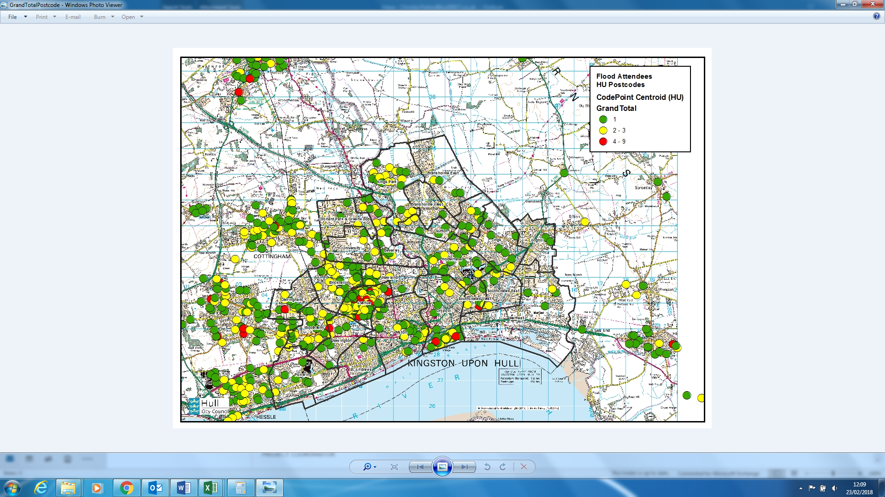
Map 2: Post Code Mapping – Flood from Hull (LSOA)

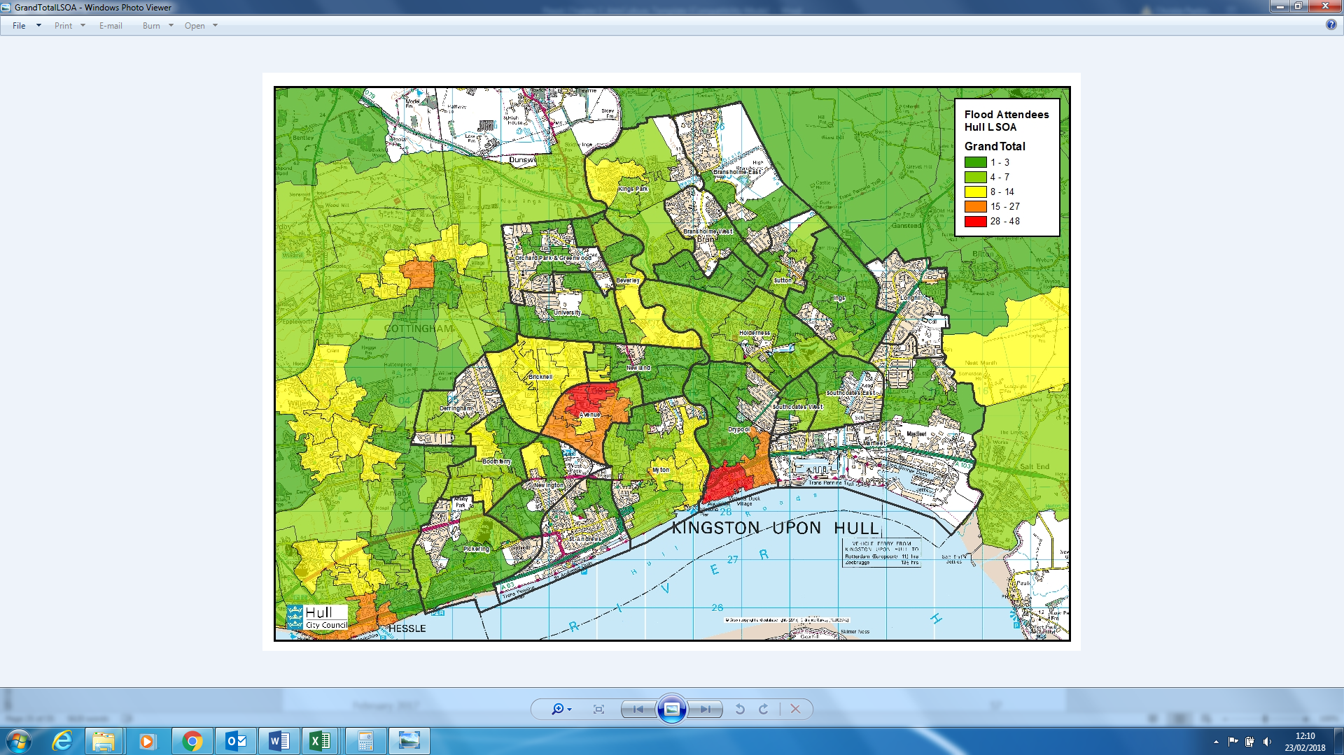
Map 3: Postcode Mapping – Flood from Yorkshire & Humber

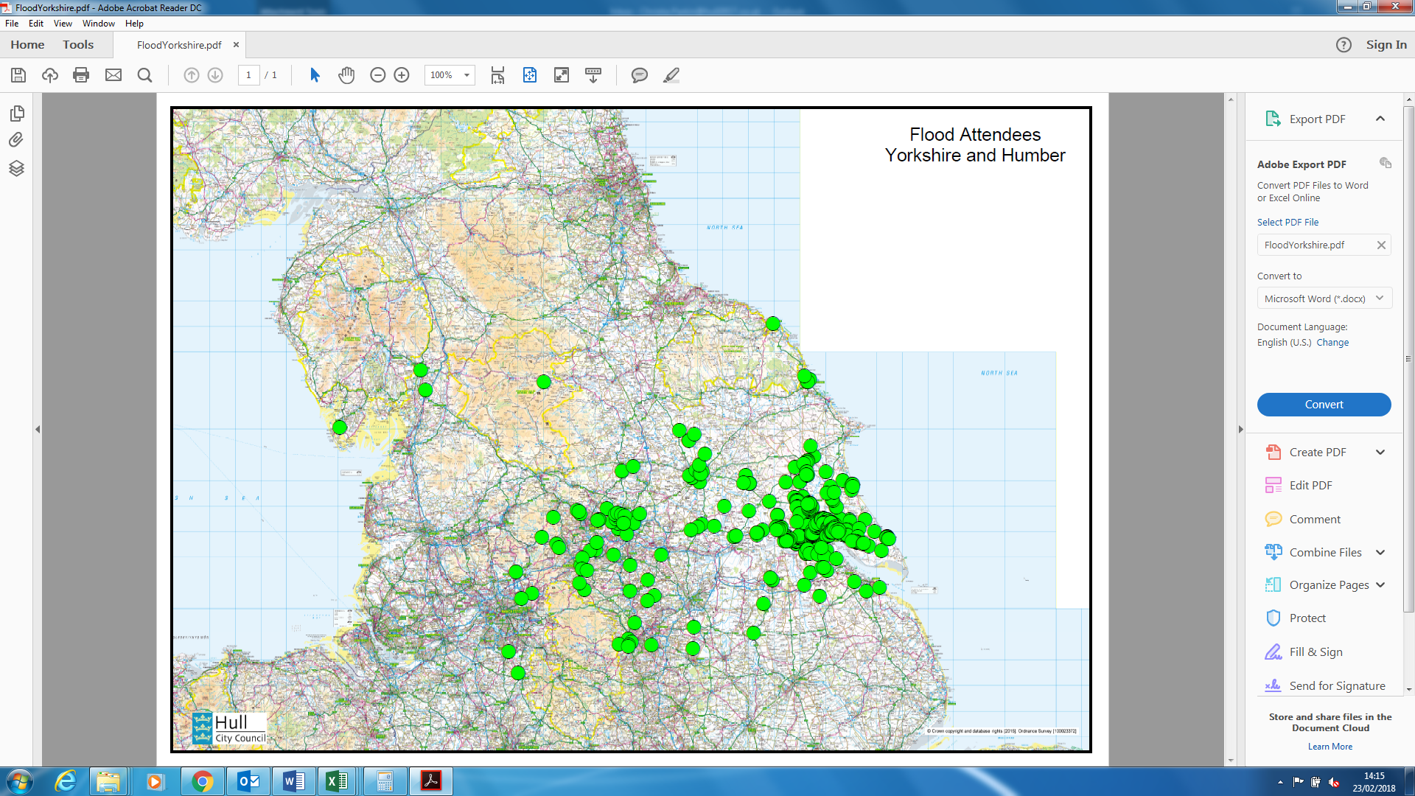
    - Indices of Deprivation
The Indices of Deprivation are prepared using the Lower Super Output Area (LSOA) geography which has the dual benefits of consistent size throughout England, and being stable over time so that changes in deprivation levels can be measured.
There are 32,844 LSOAs in England (166 in Kingston upon Hull). Deprivation scores are calculated for each LSOA and they are then ranked from 1 (most deprived) to 32,844 (least deprived). The rankings are often reported as deciles of deprivation from 0-10% (most deprived), 10-20%, 20-30%, etc. and 90-100% (least deprived).
It should be noted that:
- The Indices of Deprivation measure relative deprivation, not absolute.
- Not all residents of deprived areas are deprived, and not all deprived people live in deprived areas.
Utilising the post code data for Flood and Hull Truck, attendees have been broken down by deprivation deciles (see Tables 30-32).
Table 30: Deprivation Decile – ‘Flood’
 | Hull Attendees  (n=440) | All Hull Residents | Difference: Hull Attendees vs. All Hull Residents
10% Most Deprived | 12% | 45% | -33%
10%-20% Deprived | xx | xx | xx
20%-30% Deprived | 10% | 8% | +2%
30%-40% Deprived | 17% | 8% | +9%
40%-50% Deprived | 17% | 12% | +5%
50%-60% Deprived | 18% | 11% | +7%
60%-70% Deprived | 12% | 10% | +2%
70%-80% Deprived | 9% | 6% | +3%
80%-90% Deprived | 4% | 5% | -1%
90%-100% Deprived | 1% | 3% | -2%

Table 31: Deprivation Decile – Hull Truck
 | Hull Attendees  (n=1,858) | All Hull Residents | Difference: Hull Attendees vs. All Hull Residents
10% Most Deprived | 14% | 45% | -31%
10%-20% Deprived | 9% | 8% | +1%
20%-30% Deprived | 13% | 12% | +1%
30%-40% Deprived | 16% | 11% | +5%
40%-50% Deprived | 22% | 10% | +12%
50%-60% Deprived | 12% | 6% | +6%
60%-70% Deprived | 8% | 5% | +3%
70%-80% Deprived | 5% | 3% | +2%
80%-90% Deprived | 2% | 1% | +1%
90%-100% Deprived | 0% | 0% | 0%
This data shows that of the two events, Flood has been the least successful in attracting residents from the most deprived areas of the city:
- It attracted 2% fewer residents from the 10% most deprived LSOAs than Hull Truck
- The most highly overrepresented decile was the 30%-40% deprived, whereas for Hull Truck this was the 40%-50% deprived decile.
Despite this success in diversifying audiences, relative to the population of Kingston Upon Hull, residents from the 10% most deprived deciles are still under-represented by 33%. This indicates that more must be done to programme for these audiences and / or identify the barriers to engagement that they are experiencing.
  - Group Composition
    - Post-Event Surveys
Within the post-event audience surveys for Flood and Hull Truck, audiences were asked about their group size and the ages of people within their group (see Tables 35 & 36). This data shows that, on average Flood attracted mainly adults and couples.
Table 35: Group Size
Size of Group | Flood  (n=440)
Mean Group Size | 2.2
Mode Group Size | 2.0
Table 36: Group Size – Adults and Children
Size of Group | Flood  (n=440)
Children | 0.1
Adults | 2.5
Mean Group Size | 2.0

    - Intentions to Attend More Events & Activities
Intentions to attend or participate in other events and activities programmed for Hull UK City of Culture 2017 were tested across audiences.
Responses show that Flood audiences were more likely than Hull Truck and wider Hull 2017 audiences to say they would attend further arts and cultural activities in the city.
Table 37: Future Intentions to Attend UK City of Culture 2017
 | Flood  (n=440) | Hull Truck  (n=XXX) | Total  (14,716)
Yes | 97% | 90% | 87%
No | 1% | 3% | 6%
Don’t Know | 2% | 7% | 8%
When comparing by different demographics:
- Those from outside Hull were 8% less likely to be planning to attend or participate in other Hull 2017 activities or events, suggesting that travel and/or accommodation is a potential barrier to engagement for these visitors.
- Younger audience members were 6% more likely to be planning to attend or participate in other Hull 2017 activities or events, compared to over 65s, suggesting that age is another slight barrier to engagement.

  - Cultural Sector Development
Across many respondent groups, Flood was reported to have positively impacted on professionals within the cultural sector - both CPT members and Artists gained new skills; developed existing skills further; and built new partnerships.
    - Skills Development
Across all respondent groups, the major impact on individuals was learning how to deliver site-specific, outdoor theatre and understanding the logistics of production. This resulted in many creative professionals learning a range of new skills and techniques.
“We had to practically learn how to drive telehandlers, how to drive boats, how to sail, you do a whole range of things, all of which can be umbrella'd as practical production skills.”
(CPT Member)

Additionally, all CPT and Artist survey respondents said they had learned or developed skills in the following areas:
- Artistic / Creative skills (e.g. art forms, artistic techniques);
- Production & Technical Skills.
This advancement had come about through the opportunity to deliver a site-specific, outdoor theatre production which, for many, was a new experience.
Both artists and some CPT Members also said they had learned or developed skills in community engagement and health and safety.
Some CPT Members and Artists also talked about developing skills in project management, project development, and audience development.
During the in-depth interviews Artists talked about a number of practical skills they’d learnt, such as:
- How to make a podcast;
- How to drive a speedboat, and;
- Understanding technicalities of working on water.
CPT members also talked about specific skills they’d developed whilst working on the project, such as learning how to make outdoor theatre performances accessible for audiences.
“I've never worked outdoors before… We had to take into consideration things like transport and parking and how actual audiences would walk to the event, and leave the event. It was much more event management than anything I've done previously. I think that was a learning thing for me.”
(CPT Member)

“We did a lot access permission. I think that was a learning thing for all of us… providing captions for the audio described performances and for that specific show.”
(CPT Member)

Part Three provided a steep learning curve for Slung Low, who had never produced a television show before. Specifically, it showed them how difficult it was to manage expectations and demands within a creative partnership.
“We never worked in telly...we didn't know how to make a piece of television, what we learned was how to collaborate with television people, which was an unbelievably sharp learning curve.”
(CPT Member)

“A week before it was filmed, there were people literally shouting at me, "We want to be able to deliver what you're being contracted to deliver. This will be the end of you if you don't agree with what I just asked you to agree to," and me standing in the room often on my own going, "Okay. I'm not going to agree to what you want me to agree to. Then, this will be the end of me. Okay. "What's extraordinary is I thought, "Wow, this is really massive. This could be the end." Obviously we then war gamed and prepped for that, and then when it worked, those people just ran to me and went, "Do you know what, mate? You were right. I was wrong. Never mind. Okay, see you." I was like, "What?" I thought there would be a point when I get crowned king of everything. Actually these people are used to just working at that level of drama and bullshit.”
(CPT Member)

    - Confidence & Ambition
CPT Members reported that Flood has made a significant impact on Slung Low as an organization in terms of changing their ambitions as a theatre company and giving them confidence in their capabilities.
“It would be really hard to go back to what we were doing after Flood. The sense of scale, the sense of ambition is huge. We've learnt so much production-wise.”
(CPT Member)

Both Artists said that seeing their work being performed on this scale had made them feel proud and given them confidence in their work and abilities as an artist.
“My confidence in what we could do video-wise and in terms of what I wanted for us to try and do with stuff in the show certainly grew as well.”
(Artist)

“I'm just proud to have been involved in it and all of the people that came together to make it.”
(Artist)

“Because I was a Digital Producer but really a film specialist as well so I was able to contribute to the actual show. And content went both online but also in the show as well, which was quite rewarding.”
(Artist)

    - Collaboration & Partnership Development
‘Flood’ provided many opportunities for those working on the project to collaborate with other individuals and organisations. All CPT Members and Artists said they had built new relationships and developed pre-existing relationships, which had meant an increase and diversification in their professional networks.
“The partnerships that I made with the creative heads of department in Slung Low were really useful in terms of the work that we produced here but also beneficial to me just as a creative seeing how these people that are the top of their craft work.”
(Artist)

Many of the creative professionals involved said they had established positive working relationships with other individuals on the project which may lead to future collaborations.
As an organisation, Slung Low said they’d forged valuable new relationships with a number of other creative organisations such as Hull2017, The Space, and the BBC, and individuals such as the Digital Producer and members of the Hull2017 team.
The project also provided an opportunity for them to strengthen their relationship with the Arts Council, who provided funding to Hull 2017. There was some suggestion that the increased funding they awarded to Slung Low midway through 2017 was in part influenced by their involvement in Flood.
“The Arts Council is the most important funder to us generally and the reason we are able to exist in the way that we do, so that has always has been and continues to be our most important relationship, so the fact that during Flood we were awarded the uplift and so many of the Arts Council came and supported and appreciated Flood, that was brilliant.”
(CPT Member)

Despite a frustrating experience working with the BBC, the opportunity to work with organisations of this stature gave them confidence in their own ability to deliver theatre projects in future.
“They're all very clever people with important jobs and they all said absolutely it wouldn't work, and it did… holding onto that confidence will be really key to it so that when we're working on ... when we're talking on partners just as powerful and as challenging as a BBC in the future, we can remember that confidence that it gave us.”
(CPT Member)

They also developed their relationship with The Space, who pushed them to be more ambitious and, specifically, to employ a Digital Producer to manage a supplementary digital platform. This has opened up the possibility of future collaborations.
“Certainly it would be interesting to work with the Space and build that digital stream within our work, definitely.”
(CPT Member)

Delivery Partners were particularly impressed with the attitude and willingness of the CPT to learn from partner organisations.
“The team at Slung Low and Hull 2017 worked so hard to maximise audience engagement with the project and to learn and adapt to new skills around social media.”
(Delivery Partner)

Both Delivery Partners said they were proud of their involvement and were keen to support something like Flood again. One said they would like to share the project as a case study across the arts sector.

    - Additional Outcomes
In addition to the above, a good number of artists talked of the positive impact working on ‘Flood’ had on them professionally, namely:
- Successfully reaching more diverse audience with their work;
- Enjoyment in working with a wider creative team;
- Improving their professional profile, and;
- Building confidence in their professional future.
Equally, Delivery Partners all reported that they would be more confident working on a similar project in future, mainly because they now had the necessary skills and experience of working on a project of this scale.

  - SWOT Analysis – Arts & Culture
To summarise the key learnings from the above evaluation of Arts & Culture outcomes, the key strengths, weaknesses, opportunities and threats have been identified and placed within a SWOT Analysis (see overleaf).
Table 39: SWOT Analysis – Arts & Culture
STRENGTHS OF FLOOD | WEAKNESSES OF FLOOD
- General agreement that it was a high-quality production.  - Everyone generally agreed that it was important that it had happened here in Hull, and that it was an interesting idea.  - Production quality was highly rated by both audiences and Peers.  - Almost all audience members had never seen anything like Flood before, and many said they would come to something like this again.  - A range of issues were presented through the story – including disability, LGBT, climate change and democracy.  - Many audience members said it had forced them to consider their personal attitudes towards the issues presented.  - Positive feedback on the content of the Flood website; users were kept engaged in between episodes.  - Audience retention was high, in part driven by the Flood website which kept audiences engaged in between episodes.  - Agreement that each episode could be enjoyed in its own right.  - Intention to attend other events and activities was very high for Flood audiences.  - Flood was reported to have positively impacted on professionals within the cultural sector - both CPT members and Artists gained new skills; developed existing skills further; and built new partnerships. | - Lack of diversity within the CPT and amongst Artists, although the cast were much more diverse.  - Some felt the writer had attempted to introduced too many themes and storylines, making it difficult to follow.  - All of the Quality Metrics for Part Three: To The Sea received lower average ratings than the other episodes. Enthusiasm – I would come to something like this again, and Captivation – It was absorbing and held my attention, were rated particularly poorly in comparison.  - Some technical / production issues affected the audience’s enjoyment of Flood, such as the distance from the stage, poor projection, lack of spotlighting and the use of headphones.  - Lack of promotion meant that website usage was low, despite praise for its content.  - Agreement that the four episodes did not truly work as standalone pieces because the narrative was too closely intertwined.  - Ticket sales declined throughout the year, possibly as audiences experience cultural exhaustion. Nevertheless, there was a feeling that a more targeted marketing strategy might have prevented this decline.  - Like many other events during 2017, Flood failed to engage Hull residents from the 10% most deprived areas of the city.
OPPORTUNITIES IDENTIFIED BY FLOOD | THREATS IDENTIFIED BY FLOOD
- Highlighted an appetite amongst audiences for outdoor theatre.
- Success of the website demonstrates how a digital presence can be used to maintain interest in longitudinal projects.
- Audiences reported being inspired to try other events and activities, which presents an opportunity to build loyalty amongst Hull 2017 audiences for the future.

