**CREATIVE COMMUNITIES PROGRAMME**  
**END OF PROJECT REPORT**

**GENERAL INFORMATION**

|  |  |
| --- | --- |
| **PROJECT NAME:** | Song for Hull |
| **PROJECT LEAD:** | Martin Gore / Lucy Vere |
| **REPORT DATE:** | 12/12/17 |

**INTRODUCTION**

Everyone who receives a grant from the Creative Communities Programme must complete this End of Project Report. Please read it straight away – you will need to collect the information throughout the lifetime of your project.

Please refer to your Agreement, and any changes you agreed with us, when you complete this Report.

This End of Project Report tells us:

* What has happened during your project as a whole;
* Your final income and expenditure figures;
* What you have learned from the project, how you have adapted to these learnings, and what you plan to do with this learning in future.

We will send you a separate online survey about your experience of the Creative Communities Programme as a grant recipient. We will process the information you give us to understand:

* The outcomes and impacts of our grant and support on your organisation;
* The effectiveness of our services and grants administration; and
* What key things the city needs to be aware of in future, when supporting community level arts and culture projects.

We also use this information to report to our funders.

Please email this activity report to: creativecommunities@hull2017.co.uk

1. **PROJECT REPORT**

Please provide a brief update (3 or 4) sentences on each of the following areas to let us know how your project went, what you’ve learnt and how well we supported you.

**EVENT PLANNING AND PROJECT MANAGEMENT**

* The night event was relatively simple to manage and we employed an events manager from HPSS to ensure that things went smoothly
* The overall project management could be challenging with so many stakeholders and people providing services – meeting their needs could be difficult and time consuming
* Managing relationships with the 7 schools was also challenging – to find the right person!
* Marketing and ticket sales – we felt well support in the latter stages of the project from the COC team (thanks Michael) but earlier on felt a little bit lost.

**MARKETING AND COMMUNCIATIONS, PARTICIPATION AND LEARNING**

* I think we assumed in the city of culture year that we would sell out but on reflection we had a very specific demographic that would be interested in our event.
* Ticket prices overall were probably too high for general sales and for families of NHS staff and the School Children to attend in the numbers we needed.
* Competitions worked well as well as anything connected to the children writing the song for Hull with Luke (NB).
* The schools participation was the triumph of the project, the poems, the song recording, the song learning with Helen Garnett, online learning resources all allowed schools to create amazing choirs with very little effort. They love it!

**RISK MANAGEMENT**

The budget set was not in line initially with what we actually has to spend. Without finding sponsorship to bridge the gap in sales we would not have broken even.

Marketing and getting the word out there was not managed effectively until the end but was still not enough to impact significantly on ticket sales.

**BUDGET**

In this section we ask for a final summary of the income and expenditure of your activity to date.

Pleasecomplete the Budget Template provided. The template includes instructions on how to complete it.

**Please use the space below for any comments and supporting information.**

Please see attached

**Specific Requirements - VAT**

If you are registered for VAT, your expenditure figures should not include VAT that you can claim back. If you are not registered for VAT, your figures should include VAT. You may need to get advice from your own accountant or the relevant tax office. For information about VAT and other taxes, contact HM Revenue and Customs (HMRC) through their website at [www.hmrc.gov.uk](http://www.hmrc.gov.uk)

**B. MONITORING & EVALUATION REPORT**

1. **Event Delivery**

**How did you do on reaching the targets laid out for project activity?**

|  |  |  |  |
| --- | --- | --- | --- |
|  | **ORIGINAL TARGET\*** | **REVISED TARGET\*** | **TOTAL\*** |
| **PROJECT VENUE/LOCATION** | | |  |
| HU1 – HU9 | 8 schools | 7 schools | 7 schools |
| Not HU1 – HU9 |  |  |  |
| **ACTIVITY** | | | **ACTIVITY** |  |
| Number of performances | 1 | 1 | 1 |
| Number of exhibition days | 2 | 2 | 2 |
| Number of commissions* |  |  |  |
| Number of sessions for education, training or taking part* | 18 | 17 | 17 |
| Number of accessible activities | 18 | 17 | 17 |

**\*Original target: target(s) listed within your contract  
*Revised target: new suggested targets now that your project planning and delivery is underway  
*Total: final figures for the project as a whole  
*Commissions: a commission is defined as the hiring or payment to an artist / artistic company to create an art work or performance. A commission can be wholly or partly funded by you / your organisation.  
*Sessions for education, training or taking part: includes guided sessions, learning sessions, skills development workshops, formal training of volunteers, practical workshops, all other community/public facing workshops.**

If your project incorporated heritage, please briefly say how you developed, presented and / or told people about heritage or historical content, e.g. using heritage buildings or sites, collecting oral history (stories and memories), displaying historical artworks or collections, working with museums or archives, sharing or presenting historical stories or events.

1. **Project Delivery Team**

**Who was involved in delivering your project? Please include yourself, employees and any freelancers that you contracted for this project.**

|  |  |  |  |  |
| --- | --- | --- | --- | --- |
|  | **TOTAL NO. INDIVIDUALS** | **TOTAL NO. OF DAYS WORKED** | **TOTAL NO. OF HU1-HU9 RESIDENTS** | **TOTAL NO. OF DAYS WORKED BY HU1-HU9 RESIDENTS** |
| **CATEGORY OR ROLE** | | | | |
| Project Manager(s) | 2 | 100 | 0 | 0 |
| Artists | 41 | 40 | Don’t Know | Don’t Know |
| Production/exhibition staff |  |  |  |  |
| Other staff |  |  |  |  |
| Volunteers | 17 | 2 | Don’t know | Don’t know |

**Using the equal opportunities form provided in the Toolkit, please complete the Total column within the tables below for all people involved in the Delivery Team for your project. We recommend that you ask all members of the project Delivery Team to complete this form at the start of the project, and include it as part of the contracting process for any new staff or freelancers going forward.**

|  |  |  |  |  |
| --- | --- | --- | --- | --- |
|  | **TOTAL** |  |  | **TOTAL** |
| **AGE GROUPS – DELIVERY TEAM** | |  | **DISABILITY/LONG TERM ILLNESS – DELIVERY TEAM** | |
| 16-17 years |  |  | Yes | 1 |
| 18-19 years |  |  | No | 5 |
| 20-24 years |  |  | Prefer not to say |  |
| 25-29 years | 1 |  | **CONDITIONS – DELIVERY TEAM** | |
| 30-34 years | 1 |  | Learning disability |  |
| 35-39 years | 1 |  | Long-term illness/condition |  |
| 40-44 years | 2 |  | Sensory impairment | 1 |
| 45-49 years | 1 |  | Mental Health condition |  |
| 50-54 years | 1 |  | Physical impairment |  |
| 55-59 years | 1 |  | Cognitive impairment |  |
| 60-64 years |  |  | Other |  |
| 65-69 years |  |  |  |  |
| 70-74 years |  |  |  |  |
| 75+ years |  |  |  |  |
| Prefer not to say |  |  |  |  |

|  |  |  |  |  |  |  |
| --- | --- | --- | --- | --- | --- | --- |
|  | | **TOTAL** |  |  | | **TOTAL** |
| **GENDER - DELIVERY TEAM** | | |  | **ETHNICITY – DELIVERY TEAM** | | |
| Male | 3 | |  | Welsh/English/Scottish/Northern Irish/British | 8 | |
| Female | 5 | |  | Irish |  | |
| Transgender |  | |  | Gypsy or Irish Traveller |  | |
| Other |  | |  | Any other White background |  | |
| Prefer not to say |  | |  | White and Black Caribbean |  | |
|  |  | |  | White and Black African |  | |
|  |  | |  | White and Asian |  | |
|  |  | |  | Any other Mixed/multiple ethnic background |  | |
|  |  | |  | Indian |  | |
|  |  | |  | Pakistani |  | |
|  |  | |  | Bangladeshi |  | |
|  | | |  | Chinese |  | |
|  |  | |  | Any other Asian background |  | |
|  |  | |  | African |  | |
|  |  | |  | Caribbean |  | |
|  |  | |  | Any other Black/African/Caribbean background |  | |
|  |  | |  | Arab |  | |
|  |  | |  | Any other ethnic group |  | |
|  |  | |  | Prefer not to say |  | |

**Thinking about your project as a whole, what would you say have been the main successes and challenges for you and your project delivery team (approximately 500 words):**

Schools feedback:

“The chance to learn and sing together with a professional artist. The ability to then take that learning and learn and sing in your own time using the resources from the Song for Hull Online rehearsal areas.”

“Clear high profile goals to work towards. Feeling part of the City of Culture at a personal level”

The event was truly spectacular! Children loved it, audience loved it, hospital choir loved it. Lived up to the goal of giving the kids and experience they would never forget.

Challenges

Getting in touch with schools and getting timely responses! They are busy and can be hard to keep in touch and get them to do the things we need to keep the project going.

Scheduling to match hospital schedules, school children and the artists! It’s like herding cats!

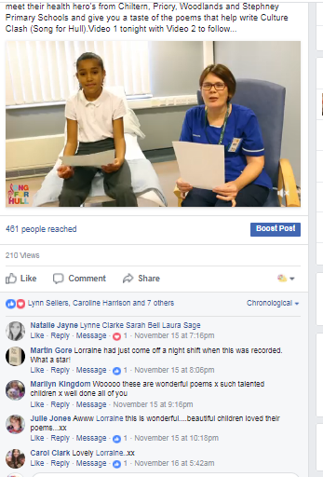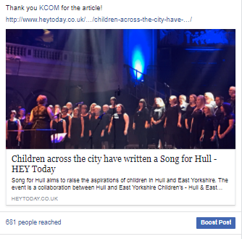

**This can include formal and informal feedback given to you by staff and / or your own observations. You can use notes or minutes from project team meetings; informal conversations; emails; etc. to inform this.**

1. **Audiences & Participants**

**How many people, in total, attended or participated in the project as a whole?**

|  |  |  |
| --- | --- | --- |
| **TYPE OF ENGAGEMENT** | **TOTAL** | **% FROM HU1-HU9** |
| Number of audience members* | 900 | Don’t know |
| Number of participants* | 300 | Don’t know |
| **TOTAL BENEFICIARIES** |  |  |

**\*The % can be taken from the results of your audience and participant surveys or box office reports  
*‘Audience members’ includes people going to an exhibition or performance, and people getting access to work that is printed, recorded, broadcast or on the internet.**  
**\*‘Participants’ means those doing the activity.**

**Please complete the Total column within the tables below. You should collect this information using the Audience Survey (which will be designed with support from the Hull 2017 team) and / or via the Participant Equal Opportunities Form provided in the Toolkit.**

**We didn’t complete the survey on the night due to operational problems with the project team members outside project commitments. We are getting more specific demographics from the schools but having trouble getting a reponse. We will send these later.**

|  |  |  |  |  |
| --- | --- | --- | --- | --- |
|  | **TOTAL** |  |  | **TOTAL** |
| **AGE GROUPS – AUD. & PART.** | |  | **DISABILITY/LONG TERM ILLNESS – AUD. & PART.** | |
| 0-2 years |  |  | Yes |  |
| 3-5 years |  |  | No |  |
| 6-10 years |  |  | Prefer not to say |  |
| 11-15 years |  |  | **CONDITIONS – AUD. & PART.** | |
| 16-17 years |  |  | Learning disability |  |
| 18-19 years |  |  | Long-term illness/condition |  |
| 20-24 years |  |  | Sensory impairment |  |
| 25-29 years |  |  | Mental Health condition |  |
| 30-34 years |  |  | Physical impairment |  |
| 35-39 years |  |  | Cognitive impairment |  |
| 40-44 years |  |  | Other |  |
| 45-49 years |  |  |  |  |
| 50-54 years |  |  |  |  |
| 55-59 years |  |  |  |  |
| 60-64 years |  |  |  |  |
| 65-69 years |  |  |  |  |
| 70-74 years |  |  |  |  |
| 75+ years |  |  |  |  |
| Prefer not to say |  |  |  |  |

|  |  |  |  |  |  |  |
| --- | --- | --- | --- | --- | --- | --- |
|  | | **TOTAL** |  |  | | **TOTAL** |
| **GENDER - AUDIENCES** | | |  | **ETHNICITY – AUDIENCES** | | |
| Male |  | |  | Welsh/English/Scottish/Northern Irish/British |  | |
| Female |  | |  | Irish |  | |
| Transgender |  | |  | Gypsy or Irish Traveller |  | |
| Other |  | |  | Any other White background |  | |
| Prefer not to say |  | |  | White and Black Caribbean |  | |
|  |  | |  | White and Black African |  | |
|  |  | |  | White and Asian |  | |
|  |  | |  | Any other Mixed/multiple ethnic background |  | |
|  |  | |  | Indian |  | |
|  |  | |  | Pakistani |  | |
|  |  | |  | Bangladeshi |  | |
|  | | |  | Chinese |  | |
|  |  | |  | Any other Asian background |  | |
|  |  | |  | African |  | |
|  |  | |  | Caribbean |  | |
|  |  | |  | Any other Black/African/Caribbean background |  | |
|  |  | |  | Arab |  | |
|  |  | |  | Any other ethnic group |  | |
|  |  | |  | Prefer not to say |  | |

**Thinking about your project as a whole, what would you say have been the main successes and challenges for your audience members / participants:**

**This can include formal and informal feedback given to you by staff and / or your own observations. You can use comments books; informal conversations; emails; etc. to inform this. It must also include any findings from your Audience/Participant Survey (A Question Bank is provided for the Audience/Participant Survey, from which you will build your own project questionnaire with support from Hull 2017 staff).**

The audience on the night was fantastic and mainly made up of local schools kids families, hospital staff and choir memebers families.

We didn’t unfortunately prepare a survey to be completed on the night due to the pressures on the project team (Day job vs Song for Hull).

Facebook feedback was brilliant as was Twitter which we used as our main vehicles for feedback.

We were not able to provide merchandise or the CD of song for Hull which I think the would of liked.

The whole experience was amazing and the Hull City Hall was on it’s feet most of the time. The end finale (please see pictures) was just outstanding.

1. **Online Engagement**

**How did your project impact upon your online presence? – no web page**

|  |  |  |
| --- | --- | --- |
|  | **TOTAL PAGE VIEWS** | **UNIQUE PAGE VEIWS** |
| Website views relating to project |  |  |

|  |  |  |  |  |
| --- | --- | --- | --- | --- |
|  | **LIKES/FOLLOWERS AT START** | **LIKES/FOLLOWERS AT END** | **IMPRESSIONS ON POSTS RELATING TO THE PROJECT** | **ENGAGEMENTS WITH POSTS RELATING TO THE PROJECT** |
| Facebook | **0** | **243** | **18,000** | **SEE GRAPH BELOW** |
| Twitter | **0** | **113** | **?** | **?** |
| Instagram | **n/A** |  |  |  |
| Other |  |  |  |  |

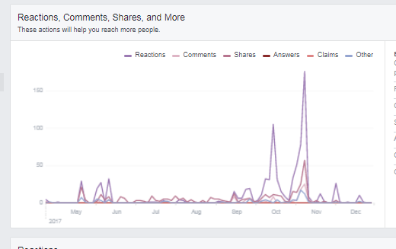

**DEFINITIONS**

**In the boxes below, please share a selection of audience comments or quotes from social media made about your project. Please provide different examples to those in your Project Update Report:**

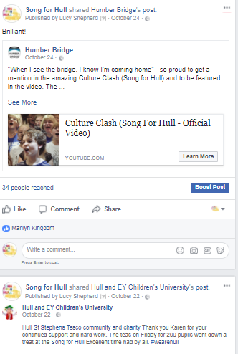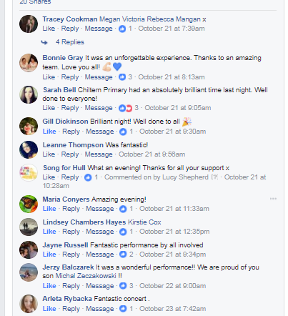

1. **Partners**

**How many partners were involved with the project?**

|  |  |  |
| --- | --- | --- |
|  | **TOTAL BASED IN**  **HU1 – HU9** | **TOTAL BASED OUTSIDE**  **HU1 – HU9** |
| **PARTNER TYPE** | | |
| Artistic partner (e.g. theatre, art gallery, music venue) | 1 | 0 |
| Heritage partner (e.g. museum, archive) | 0 | 0 |
| Funder (e.g. Arts Council England, business, private trust) | 4 | 1 |
| Public Sector partner (e.g. libraries, GPs) | 1 | 0 |
| Voluntary sector partner (e.g. community group, charity) | 1 | 0 |
| Education (e.g. school, college, university) | 7 | 0 |
| Other | 2 | 2 |
| **PARTNERSHIP STAGE** | | | **PARTNERSHIP STAGE** |
| Number of new partnerships established via this project | 9 | 3 |
| Number of existing partners involved in this project | 1 | 1 |

**Thinking about your project as a whole, what would you say have been the main successes and challenges for your partners:**  
**This can include formal and informal feedback given to you by staff and / or your own observations. You can use notes or minutes from partner meetings; informal conversations; emails; etc. to inform this.**

Hull Children’s university have been able to give 7 schools the opportunity to involved in a project that will give the kids and teachers (free of charge) an amazing collective experience.

Great exposure for HPSS and All For One Choirs to new projects and opportunities.

Swift – Great partnership and community support reputation. Chance to support schools their employees kids go to.

Hospital improving connections with the community and showing it’s a great place to work and been treated in. Workforce of the future!

Schools loved the approach and would love to do it again!

**Challenges:**

Getting them to work alongside the public sector and their needs for process and structure. Artistic vs bureaucracy!!

Understanding the different priorities and timelines. Some partners have not got used to the pace of work and the notice needed to get everyone in the right place at the right time!