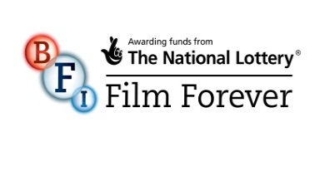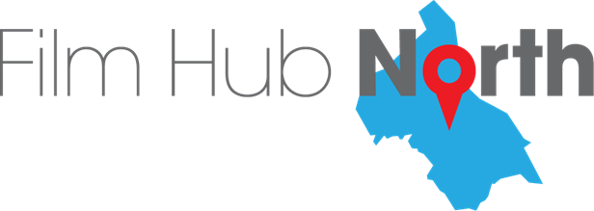

**Transformative Film Culture for Hull 2017:**

**Strategic Partners**

**REPORTING Template**

|  |
| --- |
| **Please note: Your FINAL REPORT should be made up of the following items:** |
| 1. **This completed NARRATIVE REPORT Template**   **Please use the EVALUATION tab on the KPI BUDGET Spreadsheet you received with your Project Plan as a guide to inform this NARRATIVE REPORT.** |
| 1. **Updated BUDGET sheets**   **Please update the BUDGET sheets on the PROJECT REPORT TABLE to provide your actual income and expenditure for the project set against your original proposed figures.** |
| 1. **An updated KPI and PROJECT REPORT TABLE**   **Please complete the PROJECT REPORT TABLE and feed screening activity information into the KPI tab. Please ensure to provide explanations for any variance (either way) to your projected figures.** |
| 1. **Copies of any marketing or other materials created for your project. Please ensure you include (where possible) images, press cuttings, and any other relevant materials.** |

|  |  |
| --- | --- |
| **Organisation:** | Hull 2017 |
| **Project Title:** | Women of the World Festival 2017 |

|  |
| --- |
| 1. **Please provide a summary of the delivery of your project, highlighting in particular any critical successes, and any significant issues, you encountered.** |
| WOW was a festival of talks, debates, music, film, comedy and activism that celebrates women and girls and took a frank look at what stops them from achieving their potential. Based on the premise that an equal world is a better world for all of us, WOW was a celebration not only of women and girls but of equality in all its forms. Since WOW was founded in 2010 at Southbank Centre, London, it has become a rapidly expanding global movement with festivals taking place on five continents from Pakistan to Finland, and New York to Sydney.  Within the Hull festival, we programmed 8 features and shorts screening including 6 titles. The event closed with a special screening of Viceroy’s House which was followed by a Q&A with Director, Gurinder Chadha and Amanda Nevill CBE, CEO of the British Film Institute (BFI). |
| 1. **Did the project meet your aims, objectives and intended outcomes (please see the Evaluation tab on your project’s KPI & Budget spreadsheet for guidance)? Please demonstrate how these were achieved. If they were not achieved then please outline why you think this is the case.** |
| The project met the KPIs in terms of number screenings and exceeded planned activity in terms of number of titles delivered. The audience demographics came from a sample of only 31 respondents, and thus it is difficult to say whether these accurately reflect audiences as a whole. Attendance at individual showings varied across the programme with some being extremely well attended (Viceroy’s House and Funny Girls Shorts) and others appealing to a smaller audience (Matkay Pay Thappa). Conflicts within the festival programme, with a lot of activities taking place at the same time across a number of venues may have also contributed to some of the lower attendance figures. |
| 1. **Please outline how your marketing strategy helped you achieve your Audience target figures. If you did not reach these figures, please explain why you think this is, and what you might do differently if dealing with a similar situation in the future.** |
| The festival as a whole used both marketing and PR activities to raise the profile of the festival and to market individual screenings. A print programme for the festival was produced and the screenings highlighted most significantly within this were well attended. Conflicts within the festival programme, with a lot of activities taking place at the same time across a number of venues may have also contributed to some of the lower attendance figures. |
| 1. **Please describe how the project addressed issues of access, and how it engaged with diverse audiences and differing perspectives in the programme and activities.** |
| The venues used were assessed for their physical accessibility and other parts of the Women of the World Festival programme included BSL interpretation and captioning. The programme of the festival and the film programme sought to bring together diverse and international experiences throughout to provoke discussion and debate. |
| 1. **Please provide an outline of your work with partners on this project. What went well? What didn’t? Did you engage with all the partners you intended to? If not, why not?** |
| Within the Women of the World Festival project we engaged with a ‘Circle of Friends’ made up of representatives from local women’s and community organisations. This created a buy in to the festival from these organisations, many of whom acted as panellists and promoted the festival and its screenings to their members and service users. |
| 1. **Please provide an overview of the press and media coverage that your project achieved.** |
| <http://www.broadwayworld.com/westend/article/Details-of-First-Ever-WOW--WOMEN-OF-THE-WORLD-HULL-Announced-for-UK-City-of-Culture-20170210>  <http://www.whatsonstage.com/london-theatre/news/southbank-centre-launches-women-of-the-world-festival_43070.html>  <http://www.hulldailymail.co.uk/top-10-made-in-hull-city-of-culture-events-still-to-see/story-30180938-detail/story.html>  <http://www.radiotimes.com/news/2017-02-28/made-in-hull-theres-more-to-the-uks-city-of-culture-than-philip-larkin>  <http://www.itv.com/news/calendar/2017-02-08/royal-visit-for-uk-city-of-culture/>  <http://www.thedebrief.co.uk/things-to-do/books/gemma-cairney-book-open-a-toolkit-for-how-magic-and-messy-life-can-be-20170466968> |
| 1. **Please outline any further legacy from your project, and any potential for its future sustainability. How will your project’s outcomes contribute to future growth for a cinematic audience in Hull?** |
| Conversations are still currently ongoing about the legacy of the Women of the World Festival project and the potential for this to run again in future years. |
| 1. **Please provide any other conclusions or recommendations you may have about any aspect of your project.** |
|  |
| 1. **In what way(s) did your project benefit from its association with the wider Transformative Film Culture for Hull 2017 project? Were there any negative implications to being associated with the wider project? In what way did your project contribute to the cultural objectives of the wider project? If you have any further comments on this relationship, please also add these here.** |
| The association with the wider Transformative Film Culture for Hull 2017 project enabled us to think about  programming works that fitted within the theme of this specific festival, but also that are able to contribute  to the ongoing audience development for film in the city. The film programme within the festival was able to create an opportunity to screen titles with a focus on women and girls. |

**Please email all elements of your report to** [megan@filmhubnorth.org.uk](mailto:megan@filmhubnorth.org.uk)

**OR post to Megan Liotta**

**Film Hub North**

**c/o Showroom Workstation**

**15 Paternoster Row**

**Sheffield**

**S1 2BX**

**Thank you.**