**Freedom Chorus**

**Roots of the City at Hull City Hall**

24 June 2017

**PRS New Music Biennial Composer Residencies**

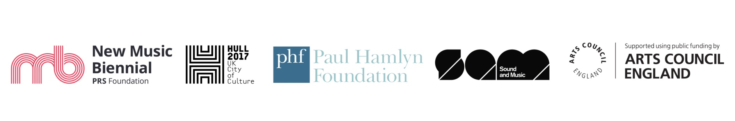

**Wyke College**

**Roots of the City at Hull City Hall**

24 June 2017

**PRS New Music Biennial Composer Residencies**



**Open Doors**

**Roots of the City at Hull City Hall**

24 June 2017

**PRS New Music Biennial Composer Residencies**



**Thoresby**

**Roots of the City at Hull City Hall**

24 June 2017

**PRS New Music Biennial Composer Residencies**



**Buckingham**

**Roots of the City at Hull City Hall**

24 June 2017

**PRS New Music Biennial Composer Residencies**



**Trinity Academy**

**Roots of the City at Hull City Hall**

24 June 2017

**PRS New Music Biennial Composer Residencies**



**Mersey Primary**

**Roots of the City at Hull City Hall**

24 June 2017

**PRS New Music Biennial Composer Residencies**



**Hull2017 Volunteers – Sam Lee**

**Roots of the City at Hull City Hall**

24 June 2017

**PRS New Music Biennial Composer Residencies**



**Pickering and Ferens Homes**

**Roots of the City at Hull City Hall**

24 June 2017

**PRS New Music Biennial Composer Residencies**

