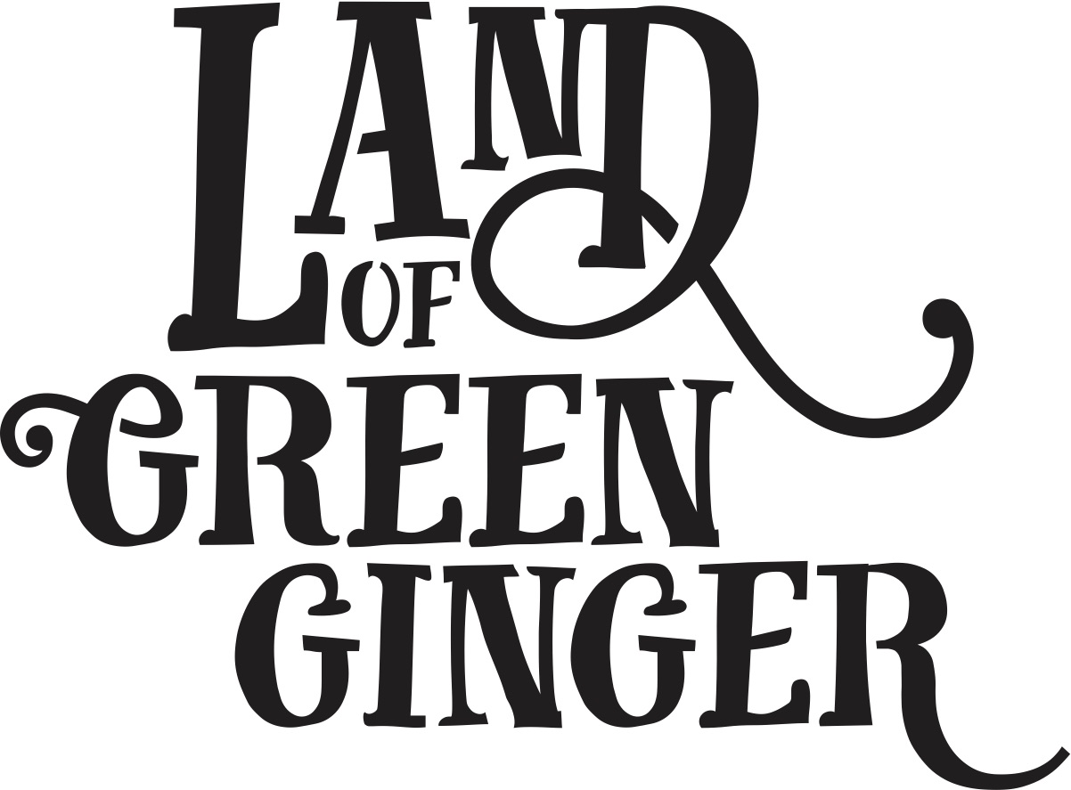

**Call for Illustrator**

**Summary**

Throughout the year Hull 2017’s ground-breaking community engagement project, Land of Green Ginger, invited Hull’s residents to immerse themselves in a magical citywide story, inspired by and celebrating the spirit of Hull.

Land of Green Ginger was presented as a series of Acts of Wanton Wonder delivered by artists in neighbourhoods outside of the city centre. The Acts were united under one story line, which was presented online for the public to delve into.

In 2018, the Land of Green Ginger story will culminate in a seventh and final Act of Wanton Wonder – a beautiful book that will be delivered to every household in Hull.

The Land of Green Ginger book will tell the stories of the project, the narrative as it took place, and the stories of the local people it touched. It will be the record of City of Culture as lived by the residents of the city and as informed by their imagination and creativity.

We are seeking a talented freelance illustrator to help us to tell the Land of Green Ginger story.

**Brief**

**Job Title:** Illustrator

**Reporting to:** Executive Producer

**Fee:** Up to £350 per illustration depending on experience

**Contract type:** Freelance

**Contract length:** 15 January – mid-February. The illustrator will be appointed, and need to start work in the week of 15 January. Final illustrations would need to be delivered by the week of 12 February.

We are looking to engage an experienced and talented illustrator to provide illustrations throughout the Land of Green Ginger book.

The book will be up to 60 pages long, and we would be looking for up to/a minimum of 20 illustrations included throughout. These could be a range of double page and full-page spreads as well as half page and smaller complimentary illustrations.

The illustrator needs to be able to work to a tight timescale of up to 5 weeks for initial concept design, storyboarding, draft sketches/illustration and final illustration delivery.

**Key responsibilities**

To work closely with the producing team and other creative partners to create up to 20 illustrations that visually represent elements of the Land of Green Ginger story. The visuals may be created digitally, hand drawn or a combination of mixed media.

**Required Skills and Experience**

* Strong illustration skills
* The ability to interpret written content and create visuals from that content.
* A knowledge of, and skill in, a variety if illustration techniques.

**Personal characteristics**

* A self - starter, with the motivation, commitment, enthusiasm and drive to define clear goals.
* An independent thinker with the flexibility to adapt.
* Ability to work under pressure and to tight deadlines.
* The ability to treat information as confidential (successful candidates will be required to sign a non - disclosure agreement).

**Timescales**

Monday 8 January 2018: Deadline for applications.

W/C 8 January 2018: Potential meetings/interviews.

W/C 15 January 2018: Illustrator appointed.

W/C 15 January 2018: Full brief and draft manuscript delivered to illustrator.

W/C 29 January 2018: Initial sketches submitted and feedback received.

W/C 12 February 2018: Final illustrations complete and submitted.

**How to Apply**

To apply, please email the following to maddie.maughan@hull2017.co.uk by 5pm on Monday 8 January 2018.

* A current CV including biography
* A covering letter (no more than 2 sides of A4), outlining your suitability for this role and relevant experience
* 5 examples of y our work
* Your expectations of hourly and daily rates

Interviews may be held in the week commencing 8 January 2018. Owing to the high volume of applications we expect to receive, we will not be able to respond to every applicant. If you have not heard from us by 19 January 2015, then unfortunately your application has not been successful on this occasion.