Venue Event Manager Handbook

Future Forum – 7th December 2017

Section 1 – Overview

1.0 Event Overview

1.1 Contacts and Festival Team

1.2 Communication

1.3 Risk Assessments

1.4 Timetable of Events

1.5 Accident and Near-Miss Reporting and Investigation (PRINT)

Section 2 – Venues

2.0 Venue Details

Panellist Overview and Contacts

Section 3 – Public and Volunteers

3.0 Volunteers

3.1 Fire Safety

Section 4 – Schedules

4.0 Production Schedules

**Section 1 – Overview**

*Substance is a festival of place. A bespoke celebration and exploration of the The North - the people and stories, music, arts and culture, urbanism and architecture. Substance aims to own the conversation about where, what and how the cultural Northern Powerhouse exists. How we might define it; should we try and define it. How it has changed our cities and landscape. How it has regenerated our cities and changed national and international perceptions of them. The impact it has on everything from the economy to civic pride. How it has changed, how we might change it.*

*Substance Future Forum invites creative industries, businesses, organisations, artists, digital pioneers, social commentators, policy makers and change makers of the future to a day of active debate and discussion on the culture, creativity and future of the north.*

*Through panel discussions, keynote speeches, installations and debate; Substance aims to deliver a day that sets out how the rich creativity and culture of the north can lay the foundations for future generations, using the regenerated areas of Hull UK City of Culture as a backdrop.*

The Venue Event Managers are the Hull 2017 representative as the primary point of contact for the Core Festival Team and Venue staff, working closely with artists and co-ordinating with any suppliers.

**Venue Event Manager Responsibilities:**

* Artist, production and venue coordination and liaison to ensure that each conference is successfully delivered
* Being aware of and carrying out preventative measures as detailed in the event risk assessment. Report Incidents following the Hull 2017 accident reporting procedure. Liaise with and report to festival core team in the event of any serious incidents or issues arising
* Liaise with venue staff to ensure the festival is successfully delivered according to the venue’s standard working procedures and policies
* In emergencies, follow the venue emergency procedures and co-ordinate safe evacuation with venue staff
* Any other reasonable duties required in order to meet the purpose of this role

**1.1 Contacts and Festival Team**

**Carys Tavener** Production Manager

Mobile no.: 07851077582  
Office: 01482 318860   
Email: [carys.tavener@hull2017.co.uk](mailto:carys.tavener@hull2017.co.uk)

The festival team is made up of core members from Hull 2017 working in partnership with venues in and around Humber Street:

**Hull UK City of Culture Festival Team Core Members:**

Sam Hunt Executive Producer  
Martin Atkinson Producer **07721754934**  
Carys Tavener Junior Production Manager **07851077582**Andrew Carruthers Operations Manager **07962112218**  
Sarah Moor Marketing  
Ben McKnight Media & PR

**Venue Staff:**Joe Hubbard Fruit 07875971439  
Tom Watson Wykeland (1 @ The Dock) 01482 320968  
Dileepa Ranawake C4Di Theatre 07446698735  
Jane Owen Hull Minster 01482 224460  
Louis Jones Humber Street Gallery 07585443895

**Other Staff:**2x First Aiders North East Medical Services Roaming, on-call  
Claire Drury Artist Liaison 07740408504  
Siana-Mae Heppell-Secker Artist Liaison 07552458936

**Venue Event Managers**

|  |  |  |  |
| --- | --- | --- | --- |
| **Venue** | **Event Manager** | **Time** | **Contact** |
| Fruit | Danielle Harris | All Day | **07594212377** |
| 1 @ The Dock | Oliver Cooper | All Day | **07450941066** |
| C4Di | Joanna Morley | All Day | **07725942808** |
| Hull Minster | Danielle Harris | 12:30 – 1:30 (Lunch) | - |
| Danielle Harris | 1:30 – 2:20 (Guardian) | - |

**Festival Team Roles and Accreditation:**

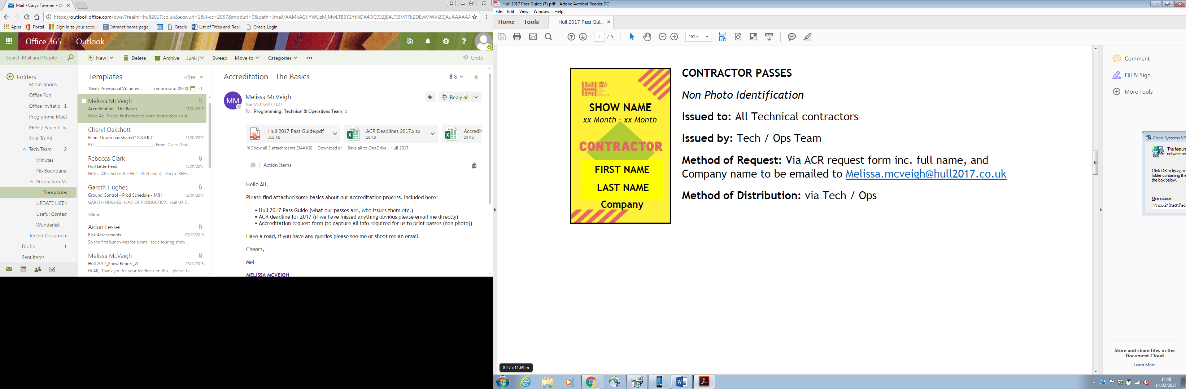 Technical Crew  
Set-up the production and event space  
Ensure the smooth running of the production, including operating

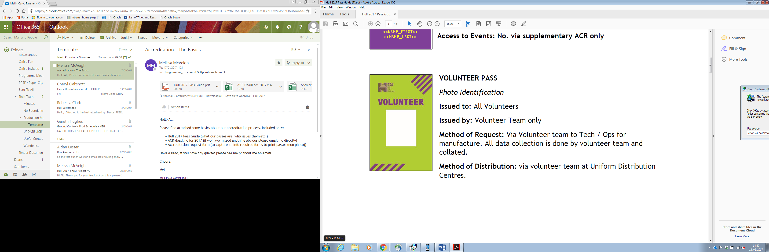 Volunteers  
Greet and welcome members of the public  
Assist with public way-finding  
Assist with ticketing, ushering, and Front of House

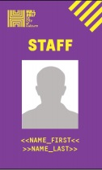Core Team  
Keep an overview of entire festival operation  
Answer questions and respond to incidents

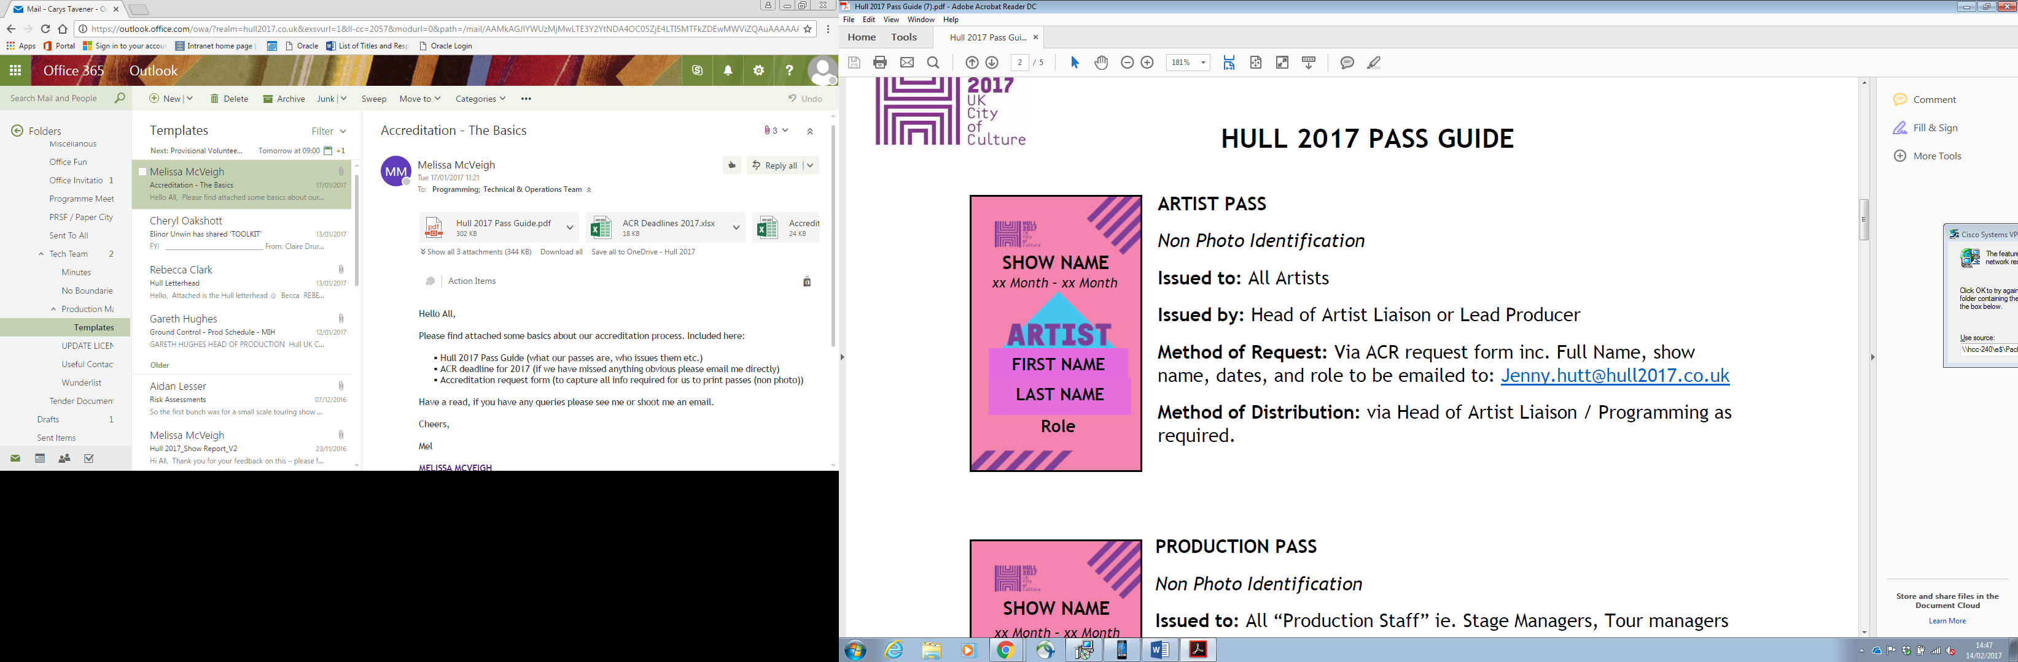 Panellist

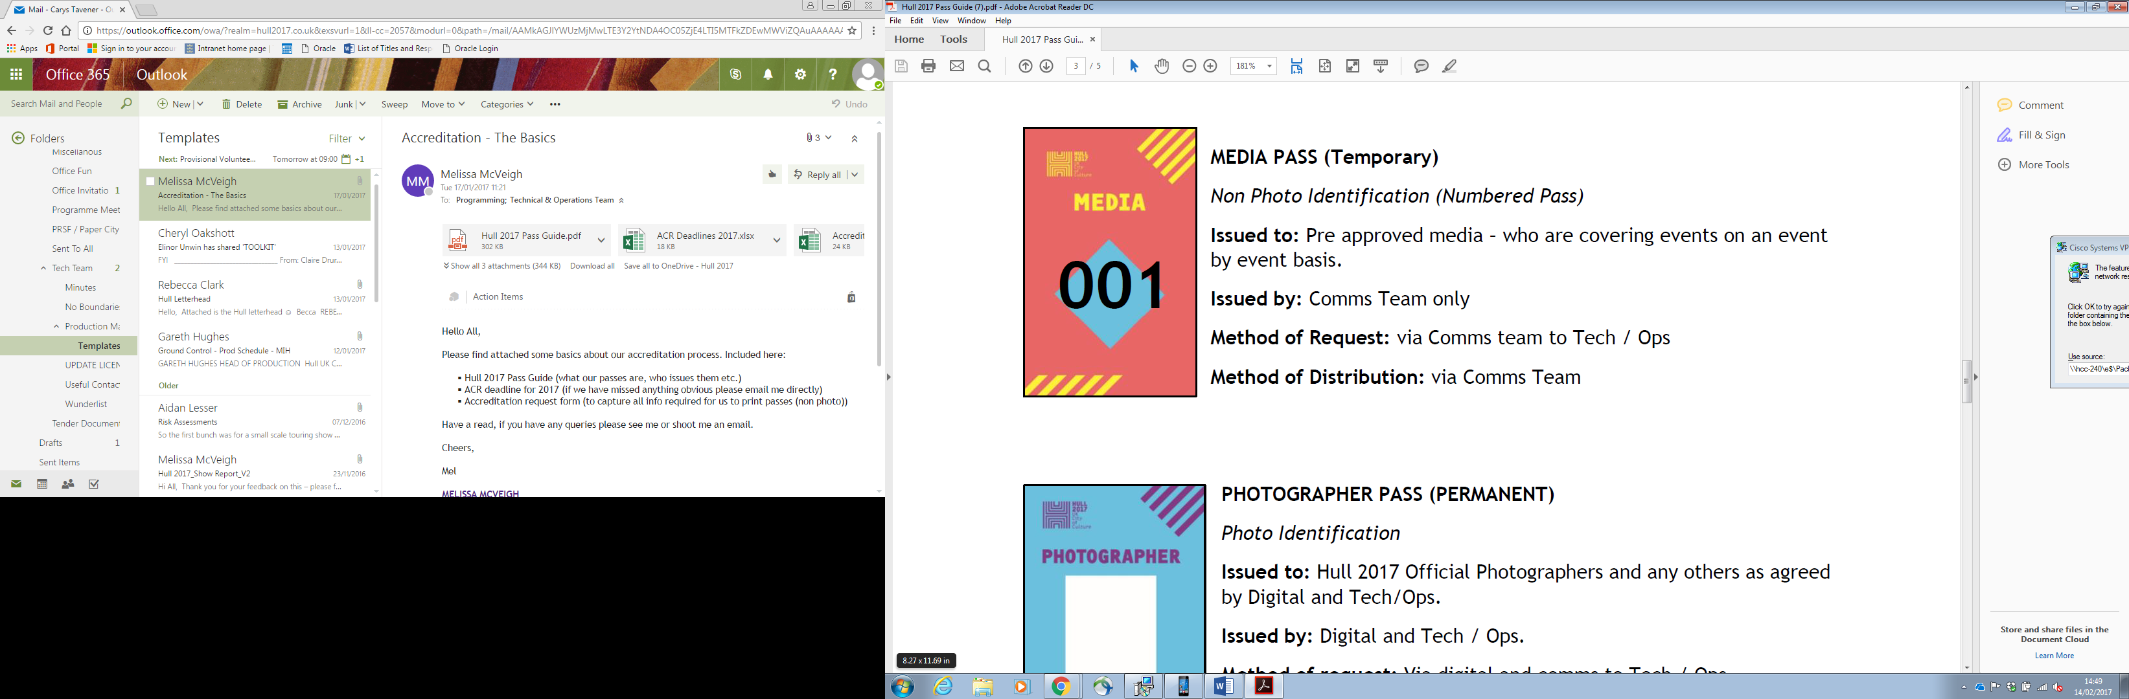 *Media*

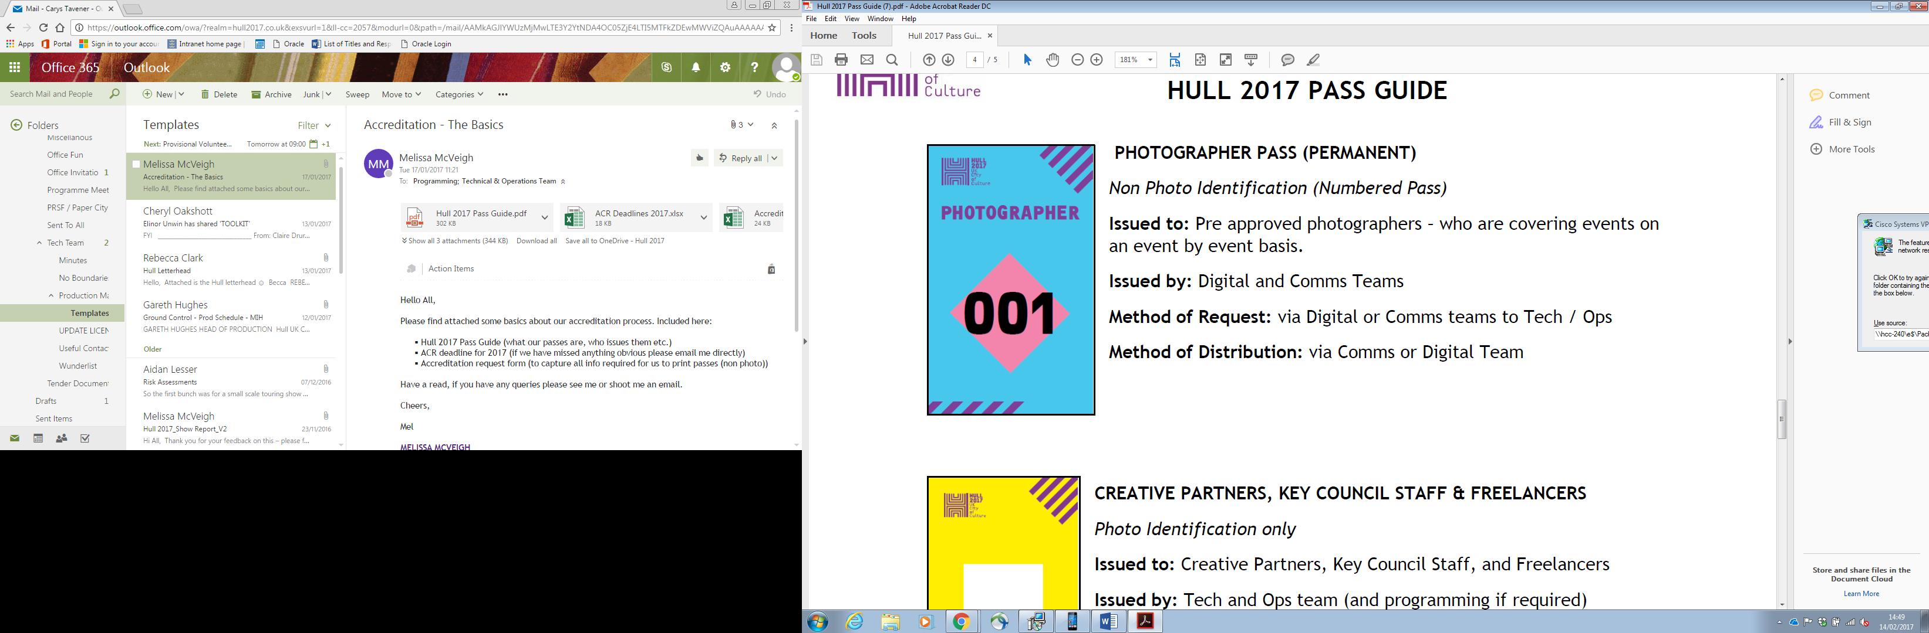 *Photographer*

**1.2 Communication**

The following staff will collect a radio from Pacific Exchange and communicate on channel 1 throughout the day:

Carys Tavener

Andrew Carruthers

Joanna Morley

Danielle Harris

Olly Cooper

First Aid x2

Martin Atkinson

A What’sApp group will be created for the duration of the day’s events for all staff to communicate.

Festival core team will always be contactable by direct mobile.

**1.3 Risk Assessment  
*See Attached***

**1.4 Timetable of Events**

|  |  |  |
| --- | --- | --- |
| Welcome, register and breakfast | **09:00 – 10:00** | Humber Street Gallery |
| Welcome and Introduction | **10:00 – 10:20** | Fruit |
| **Title** | **Time** | **Venue** |
| How Arts Can Save the NHS | 10:30 – 11:15 | 1 @ The Dock |
| Tell The World | 10:45 -11:30 | C4Di Theatre |
| You’re Only Here For The Culture | 11:00 – 11:45 | Fruit |
| How To Avoid An Identity Crisis | 11:30 – 12:15 | 1 @ The Dock |
| Lunch | 12:30 – 1:30 | Hull Minster: Nave |
| Guardian Live in Conversation | 1:30 – 2:20 | Hull Minster: Nave |
| Show Me The Money! | 2:45 – 3:30 | C4Di Theatre |
| From Stage To Screen | 3:00 – 3:45 | Fruit |
| HullOS v2042gm – your City evolved. Connected, Accelerated and Accepted | 3:15 – 4:00 | 1 @ The Dock |
| What Is The Role of A Capital City? | 3:45 – 4:30 | C4Di Theatre |
| It’s A Little Bit Leave It | 4:00 – 4:45 | Fruit |
| Art Can Change The World | 4:14 – 5:00 | 1 @ The Dock |
| We Made Ourselves Over | 4:45 – 5:30 | C4Di Theatre |
| Northern Souls | 5:00 – 5:45 | Fruit |
| A Journey Through the Land of Green Ginger | 6:00 – 6:30 | Fruit |
| Social Event | 8:00 | Fruit |

**1.5 Accident and Near-Miss Reporting and Investigation**

**Venue Event Managers are to ensure any completed report forms are given to Carys Tavener**

An Accident and Near-miss Reporting Form, a Safeguarding Incident Reporting Form and Volunteer Concern Reporting Form will be available at all times in the venue.

Show Reporting

The Venue Event Manager is to confirm capacity of each conference and email it to Carys Tavener.

Accident or Near-Miss Reporting: (*an event that results in injury or ill health OR an event not causing harm but with the potential to cause injury or ill health)*

Any person involved in or witness of an accident or near-miss is to complete an Accident/Near Miss Reporting Form, and give it to the Venue Event Manager.

Safeguarding Incident Reporting (*disclosures or suspicions of abuse)*

Any person involved in or witness of a safeguarding incident is to complete a Safeguarding Incident Reporting Form and give it to the Venue Event Manger.

Volunteer Concern Reporting

Any person involved in or witness to a volunteer incident is to raise their concern with either the Team Leader Volunteer (a volunteer) or the Venue Event Mangaer, who are to give the person the option to complete a Volunteer Concern Reporting Form. If so, the Venue Event Manager passes it directly to Carys Tavener.

**Section 2 Venues**

**2.0 Venue Details**

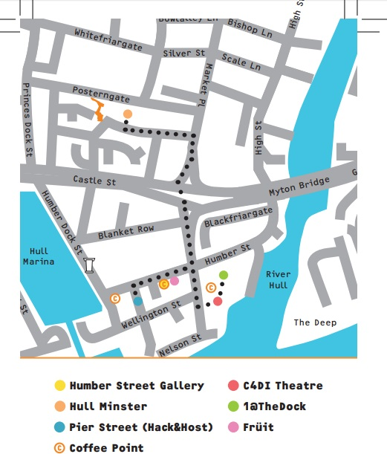

**FRUIT**

|  |  |
| --- | --- |
| 62-63 Humber St, Hull HU1 1TU | |
| Capacity | **150 Seated** |
| Layout | Audience seating in rows  6 Panelist chairs on stage with 2x black cube coffee tables (1 per 3 chairs) TV Screen either side of stage behind panelists  Please Ensure all panelists have water provision |
| Wi-Fi (for staff use only) | Username: ZyXel86031E Password: 58AF815F55C3 |
| Tech | 12x Mic headsets  6x Beltpacks  2x Handheld Mics  For 15 minute change-overs between panelists, prepare headsets on waiting panelists and then swap beltpacks. |

**Overview and Contacts**

**You’re Only Here For The Culture**

|  |  |  |  |
| --- | --- | --- | --- |
| **Chair** | **John Harris** | Organisation |  |
|  | |  |  |
| Panellist | **Martin Green** | Organisation | **Hull 2017** |
|  | |  |  |
| Panellist | **Paula Murray** | Organisation | **Croydon Council (bidding for Borough of Culture)** |
| **O7436039215** | |  |  |
| Panellist | **Shona McArthy** | Organisation | **Edinburgh Festival Fringe** |
|  | |  |  |
| Panellist | **Chris Baldwin** | Organisation | **Galway 2020 European Capital of Culture** |
|  | |  |  |
| Panellist | **Pete Massey** | Organisation | **Arts Council** |
|  | |  |  |

**From Stage To Screen**

|  |  |  |  |
| --- | --- | --- | --- |
| **Chair** | **Nikki Bedi** | Organisation | **BBC** |
|  | |  |  |
| Panellist | **Rocio Cano** | Organisation | **Sky Arts Producer** |
|  | |  |  |
| Panellist | **Jeremy Routledge** | Organisation | **Calling the Shots: Channel 4 Random Acts** |
|  | |  |  |
| Panellist | **Lamia Dabboussy** | Organisation | **BBC Arts Editor** |
|  | |  |  |
| Panellist | **Peter Groom** | Organisation | **Director of Herd and Commissioned Random Acts Artist** |
| **O7702157163** | |  |  |

**It’s A Little Bit Leave It**

|  |  |  |  |
| --- | --- | --- | --- |
| **Chair** | **Joe Hakim** | Organisation | **Warren: Spoken Word Artist** |
| **07949055681** | |  |  |
| Panellist | **Andrew Gooch** |  | **Writer, actor and poet from East Hull** |
| **Please contact Joe Hakim** | |  |  |
| Panellist | **Jodie Langford** |  | **Spoken Word Artist based in Hull** |
| **Please contact Joe Hakim** | |  |  |
| Panellist | **Frank Mathers** |  | **Supporting Hull’s Music Scene** |
| **Please contact Joe Hakim** | |  |  |
| Panellist | **Jack Foster** |  | **From North Hull Estate** |
| **Please contact Joe Hakim** | |  |  |
| Panellist | **Emily Morrison** | Organisation | **British Council** |
|  | |  |  |
| Panellist | **Emma Hardy** |  | **MP** |
| **07963 195277** | |  |  |

**Northern Souls**

|  |  |  |  |
| --- | --- | --- | --- |
| **Chair** | **Ra Page** | Organisation | **Comma Press** |
|  | |  |  |
| Panellist | **Saba Ahmad** | Organisation | **And Other Stories** |
|  | |  |  |
| Panellist | **Jacob Ross** | Organisation | **Peepal Tree** |
|  | |  |  |
| Panellist | **Jamie McGarry** | Organisation | **Valley Press** |
|  | |  |  |

**A Journey through the Land of Green Ginger**

|  |  |  |  |
| --- | --- | --- | --- |
| **Chair** | **Katy Fuller** | Organisation | **Hull 2017** |
| **07771764656** | |  |  |

**1 @ THE DOCK**

|  |  |
| --- | --- |
| Building 1, @ The Dock, Fruit Market, HU1 1UU | |
| *Alarm Code* | *160517 (almost certainly won’t need to use)* |
| Capacity | **130 Seated** |
| Layout | Audience seating in rows  6 Panelist chairs raised on a temporary stage with 2x black cube coffee tables (1 per 3 chairs) TV screen off stage either side pointing to opposite banks of seating Bins provided by Hull 2017.  Please Ensure all panelists have water provision |
| Wi-Fi (for staff use only) | Name: TNCAPE08931 (-5G) Password: 39F6ECAE03 |
| Tech | 12x Mic headsets  6x Beltpacks  2x Handheld Mics  For 15 minute change-overs between panelists, prepare headsets on waiting panelists and swap beltpacks. |

**Overview and Contacts**

**How Art Can Save the NHS**

|  |  |  |  |
| --- | --- | --- | --- |
| **Chair** | **Nikki Bedi** | Organisation | **BBC** |
|  | |  |  |
| Panellist | **Bob Fulcher** | Organisation | **West Yorkshire Playhouse** |
|  |  |  |  |
| Panellist | **Nicky Taylor** | Organisation | **Theatre and Dementia Research Associate at West Yorkshire Playhouse** |
| **07888723429** | |  |  |
| Panellist | **Victoria Amedume** | Organisation | **Upswing** |
| **07939027444** | |  |  |
| Panellist | **Alex Mitchell** | Organisation | **Silent Uproar** |
| **07855801234** | |  |  |
| Panellist | **Dr Dan Roper: CCG** | Organisation | **Hull Clinical Commissioning Group** |
| **07760270467** | |  |  |
| Panellist | **Sarah Emmott** | Organisation | **Art With Heart** |
| **07763643281** | |  |  |

**How To Avoid An Identity Crisis**

|  |  |  |  |
| --- | --- | --- | --- |
| **Chair** | **Amy Garcia** | Organisation |  |
|  | |  |  |
| Panellist | **Dr Jo Byrne** | Organisation | **Culture, Place and Policy Institute, University of Hull** |
| **07540232309** | |  |  |
| Panellist | **Anthony Yates** | Organisation | **Visit Hull and East Yorkshire** |
| **O7855507018** | |  |  |
| Panellist | **Professor David Atkinson** | Organisation | **University of Hull, Professor of Cultural and Historical Geography** |
| **07775 650595** | |  |  |
| Panellist | **Lottie Gross** | Organisation | **Editor of Love Exploring** |
| **O7542116737** | |  |  |
| Panellist | **Emma Elizabeth Davidson** | Organisation | **Writer** |
|  | |  |  |
| Panellist | **Julie Corbett** | Organisation | **Hull 2017 Volunteer** |
|  | |  |  |

**HullOS v2042gm – your City evolved. Connected, Accelerated and Accepted**

|  |  |  |  |
| --- | --- | --- | --- |
| **Chair** | **David Keel & Sarah Louise** | Organisation |  |
|  | |  |  |
| Panellist |  | Organisation | **C4Di** |
|  | |  |  |
| Panellist |  | Organisation | **C4Di** |
|  | |  |  |
| Panellist |  | Organisation | **C4Di** |
|  | |  |  |
| Panellist |  | Organisation | **C4Di** |
|  | |  |  |

**Art Can Change The World**

|  |  |  |  |
| --- | --- | --- | --- |
| **Chair** | **Nikki Bedi** | Organisation | **BBC** |
| **07708510727** | |  |  |
| Panellist | **Aisha Zia** | Organisation | **Theatre 503 & Common Wealth Theatre** |
| **O7877316600** | |  |  |
| Panellist | **Leone Higgins** | Organisation | **Eggs Collective** |
| **079791 246053** | |  |  |
| Panellist | **Gillian Nicole** | Organisation | **Director of Digital and Online Content at The Artists Information Company** |
| **07936 599323** | |  |  |
| Panellist |  | Organisation | **Hack & Host** |
|  | |  |  |

**C4Di Theatre**

|  |  |
| --- | --- |
| 31-38 Queen St, Hull HU1 1UU | |
| Capacity | **40 Seated 10 Standing** |
| Layout | Audience seating in rows  6 Panelist chairs with 2x black cube coffee tables (1 per 3 chairs)  Please Ensure all panelists have water provision  Image result for c4Di theatre |
| Wi-Fi | Please see venue staff |
| Tech | Projection screen lowered  No Microphones. Please see venue staff for any assistance |

**Overview and Contacts**

**Tell The World**

|  |  |  |  |
| --- | --- | --- | --- |
| **Chair** | **Susannah Simons** | Organisation | **Director of Arts and Outreach for Canvas** |
| **07736481163** | |  |  |
| Panellist | **David Collins** | Organisation | **Opera North** |
| **07970 463173** | |  |  |
| Panellist | **Daniel Elms** | Organisation | **New Sound Collective** |
| **07731587989** | |  |  |
| Panellist | **Katherine Jewkes** | Organisation | **MIF and The Space** |
|  | |  |  |
| Panellist | **Nina Rogers** | Organisation | **Yorkshire Sculpture Park** |
|  | |  |  |

**Show Me The Money!**

|  |  |  |  |
| --- | --- | --- | --- |
| **Chair** | **Susannah Simons** | Organisation | **Director of Arts and Outreach for Canvas** |
| **07736481163** | |  |  |
| Panellist | **Dominic Gibbons** | Organisation | **Wykeland Group** |
| **07730 488153** | |  |  |
| Panellist | **Francesca Heygi** | Organisation | **Hull 2017** |
|  | |  |  |
| Panellist | **Pat Connor** | Organisation | **Head of BBC Development & Events** |
| **07710 304053** | |  |  |
| Panellist | **Kevin Moore** | Organisation | **Humber Bridge** |
| **078500 99467** | |  |  |

**What is The Role of a Capital City?**

|  |  |  |  |
| --- | --- | --- | --- |
| **Chair** | **Anna Wood** | Organisation | **The Quietus** |
|  | |  |  |
| Panellist | **Vanessa Reed** | Organisation | **PRS Foundation** |
|  | |  |  |
| Panellist | **Chiedu Oraka** | Organisation | **Hull based Grime artist** |
| **O7729409125** | |  |  |
| Panellist | **Mal Campbell** | Organisation | **The Trades Club in Hebden** |
| **07716 532019** | |  |  |
| Panellist | **Katherine Cantwell** | Organisation | **Heavenly Recordings** |
| **07583 434259** | |  |  |

**We Made Ourselves Over**

|  |  |  |  |
| --- | --- | --- | --- |
| **Panellist** | Nick Tandavanitj | Organisation | **Blast Theory** |
|  | |  |  |
| **Panellist** | Rich Wilson | Organisation | **One Hull of a City** |
| **O7539032304** | |  |  |

**Hull Minster**

|  |  |
| --- | --- |
| Market Place, HU1 1RR | |
| Capacity | **Nave: 210** |
| Layout | Nave:    Please Ensure panelists have water provision |
| Wi-Fi |  |
| Tech | 6x Mic headsets  6x Beltpacks  2x Handheld Mics |

**Overview and Contacts**

**Guardian Live in Conversation**

|  |  |  |  |
| --- | --- | --- | --- |
| **Panellist** | John Harris | **Organisation** |  |
|  | |  |  |
| **Panellist** | Stuart Arnold | **Organisation** | The Yorkshire Party |
|  | |  |  |

**Section 4 – Public and Volunteers**

**4.0 Volunteers**

Hull 2017 Volunteers will be briefed and deployed throughout the day at Humber Street Gallery by Andrew Carruthers, who will respond to varying requirements throughout the day.

Please radio to Andrew if you need more volunteer assistance in your venue.

|  |  |  |  |
| --- | --- | --- | --- |
| Time | Total No. of volunteers | Positions: Venues | Positions: Wayfinding |
| 09:00 – 13:00 | 20 | 2x Fruit  2x C4Di  2x 1 @ The Dock | 2x Wayfinding between C4Di and 1 @ The Dock entrances  2x Corner of Humber Street  2x Outside Fruit on Humber Street  6x Roaming |
| 11:30 – 15:30 | 10 | 4x Hull Minster | All wayfinding to and from Hull Minster:  2x A63 Crossing  2x Corner of Market Place  2x North Church Side |
| 14:00 – 18:00 | 20 | 2x Fruit  2x C4Di  2x 1 @ The Dock | 2x Wayfinding between C4Di and 1 @ The Dock entrances  2x Corner of Humber Street  2x Outside Fruit on Humber Street  6x Roaming |
| 18:00 – 22:00 | 10 | Fruit | Assisting get-outs, tidying, closing venues. |

**4.1 Fire Safety**

**Show-stop procedure for Venue Event Manager in the event of an emergency evacuation**

**Show-stop is required if the alarm sounds or venue staff order.**

Ensure houselights are turned on and stop any discussion. Stand as fully visible to the audience as possible and make a clear and audible announcement instructing the audience to evacuate the building quickly and calmly.

*“Ladies and Gentlemen, due to circumstances beyond our control we are unable to continue. Please leave at once by the nearest available exit and assemble:*   
Fruit – Humber Street  
1 @ The Dock – Queen Street Car Park  
C4Di Theatre – Car Park Adjacent to Nibble  
Hull Minster -   
*Do not stop to collect any personal belongings. Thank you.”*

Leave the venue through the nearest available exit. Contact venue staff and inform them of the emergency. The venue staff will ensure that the suitable emergency services are summoned.

Once in the Assembly Area:

Make yourself known to emergency services.  
When it is safe to do so, contact Carys Tavener to inform of the evacuation.   
You will be informed by the emergency services when (or if) clear to return and address the public to inform them.

# EVACUATION PLAN FOR FRUIT

**If you discover a fire, raise the alarm immediately. Manually operated call points (break glass boxes) are located on behind the bar, box-office and stage left, adjacent to the firedoors.**

**\*\* When the alarm has been raised, leave the venue by the fire doors to the right of the box-office and await the duty manager at the exterior of the building.\*\***

It is imperative that the building is evacuated calmly and quickly. DO NOT PANIC MEMBERS OF THE PUBLIC, this could cause people to be crushed and fire exits to be blocked.

Management, security and all other staff must repeatedly tell members of the public, artists and any other people unfamiliar with the building that it is not a false alarm and to leave through the nearest fire escape. Remember, people in the venue could be intoxicated and may not treat the alarm seriously.

It is the responsibility of the duty manager to call the emergency services.

DO NOT re-enter the building under any circumstances unless authorised to do so by the emergency services.

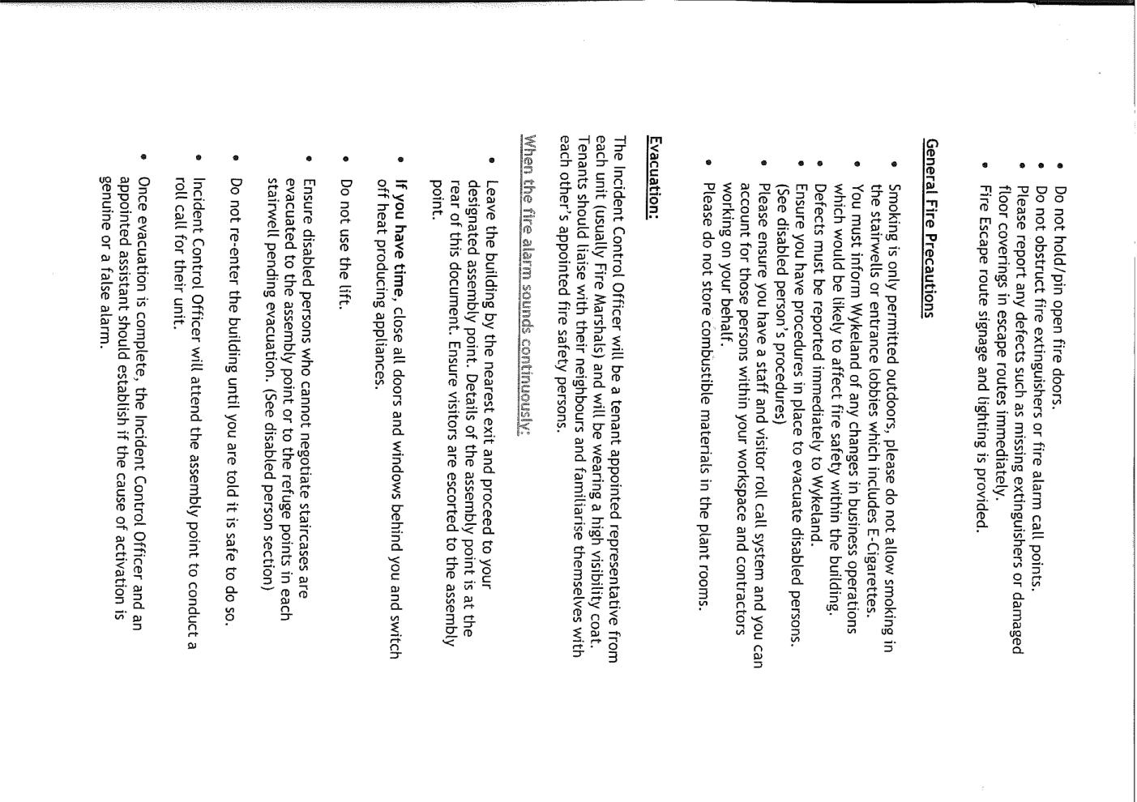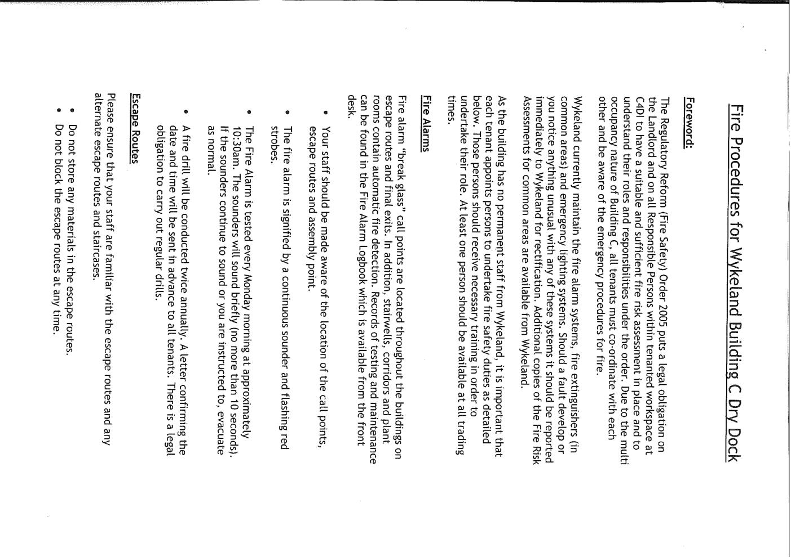**Evacuation Plan for 1 @ The Dock**



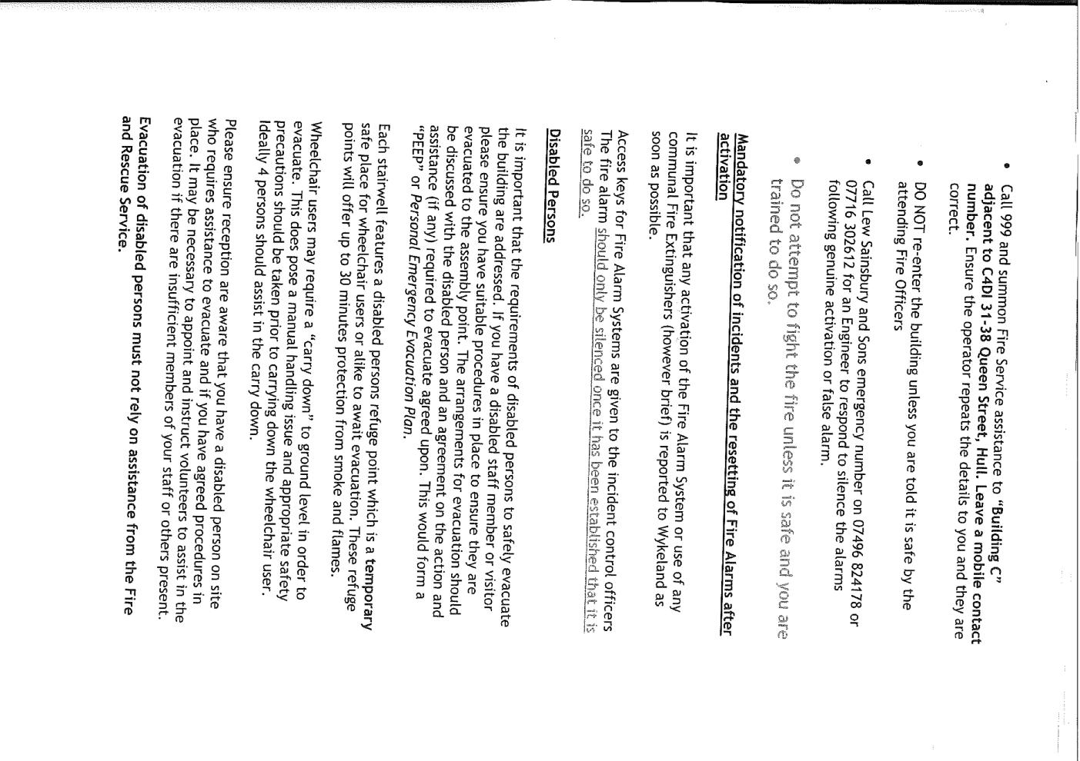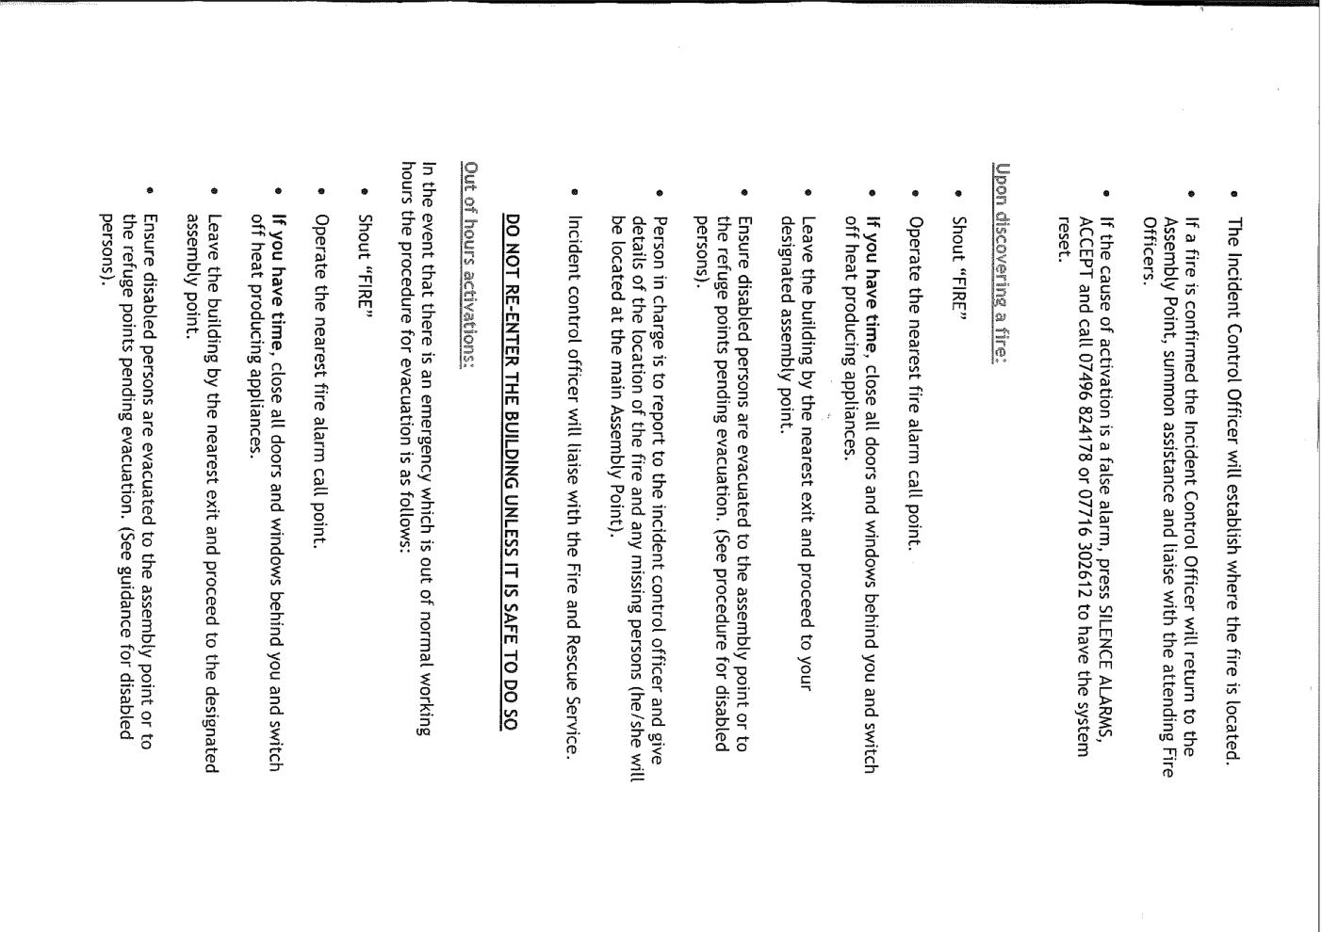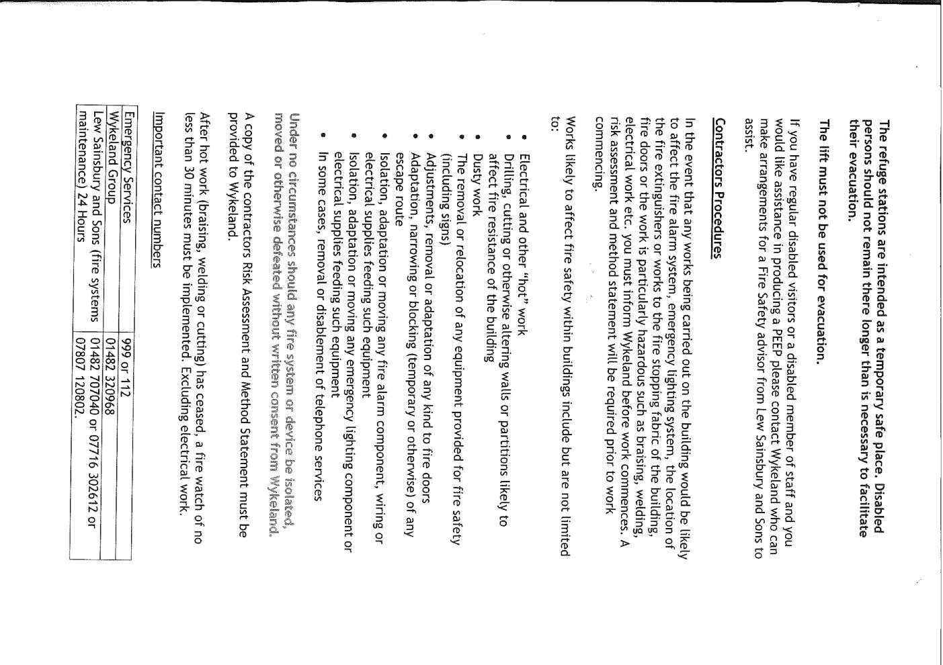**Section 5 – Schedules**

**5.0 Fruit Production Schedule**

**5.0 1 @ The Dock Production Schedule**

**5.0 C4Di Theatre Production Schedule**

**5.0 Hull Minster Production Schedule**

|  |  |
| --- | --- |
|  | **Hull Minster** |
|  |  |
| 07:00 |  |
|  |  |
| 08:00 |  |
| 08:30 |  |
| 09:00 | Get-in and set-up |
| 09:15 |
| 09:30 |
| 10:00 | Joanna deliver panellist chairs |
| 10:20 | Set-up |
| 10:30 |
| 10:45 |
| 11:00 |
| 11:15 |
| 11:30 |
| 11:45 |
| 12:00 |
| 12:15 |  |
| 12:30 | LUNCH |
| 13:00 |
| 13:30 | Guardian Live in Conversation |
| 14:00 |
| 14:20 |
| 14:30 – 16:00 | Get-Out: PANELLIST CHAIRS COLLECTED BY? |
|  |