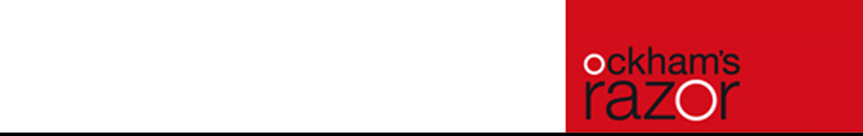
Tipping Point

Indoor Technical

Specifications

Spring 2017

Thank you for having us at your venue – we’re looking forward to meeting you!

The following information is a description of the production requirements for an indoor performance of Ockham’s Razor’s new Show Tipping Point

Note: As with all devised work the show is constantly changing and improving. Whilst we have tried to ensure the accuracy of all information, please check first.

Additional useful information can be found here:
www.ockhamsrazor.co.uk
www.turtlekeyarts.org.uk

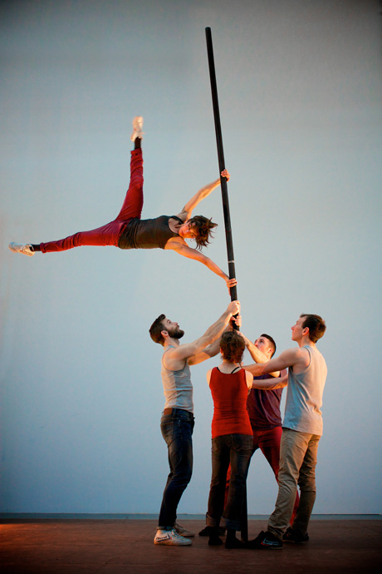

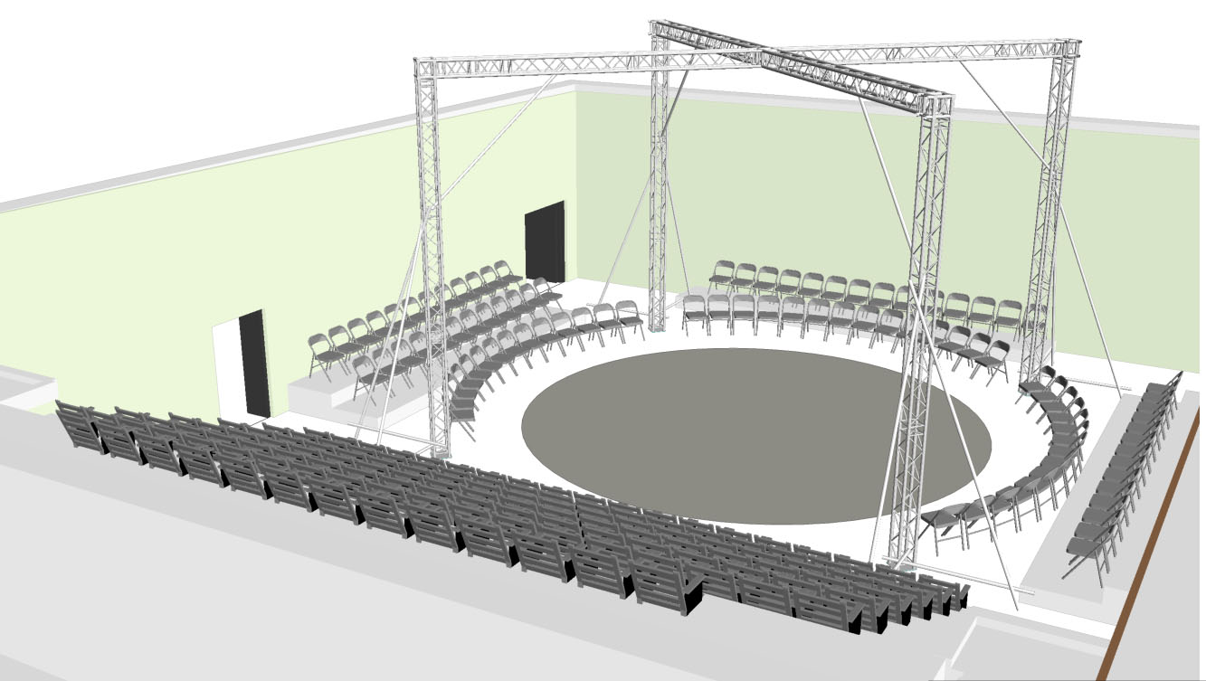

main contacts
Ockham’s Razor are produced by:
Turtle Key Arts. Lyric Hammersmith, Lyric Square King Street London W6 0QL
Tel: 020 8964 5060| www.turtlekeyarts.org.uk
Alison King | Producer | +44 (0)7970 426 763 | ali@turtlekeyarts.org.uk
Sophie Postlethwaite | Technical Stage Manager | +44 (0)7980 660 613 | soafyp@gmail.com
Phil Supple | Lighting designer/3D plans | +44 (0)7976 251 935 | phil@lightrefreshment.co.uk
Alex Harvey | Co-artistic director/head of rigging | +44 (0)7792 486 890 | alexockham@gmail.com
Shaun Dawson | Sound Engineer | 0208 964 5060 | shaun@turtlekeyarts.org.uk

staffing and schedule
- We require the venue to prepare a clear space, remove seats if applicable, clear drapes and cyc prior to our arrival.
- We require a minimum of 3 multi-skilled/all-rounder technicians for get in and get out, with good sound and Lx knowledge.
- At least 1 technician should be a fly-person in counterweight flying houses.
- Please advise us if your venue has particular staffing requirements that we may not have taken into account. For instance; additional staffing required for tallescope / access equipment use.
- We may choose to stagger the lunchtime breaks of the lighting and stage departments if this serves the process better. We will aim to advise this at the beginning of the fit-up.
- We require a minimum of 2 days to get in, opening the evening of the second day.
- Get out takes between 2.5-3.5 hours
- Exact schedule will be tailored and discussed to allow for venue specific details.
- Show running time: 60 mins, no interval.

stage department

stage
- Minimum stage 10 metre square x 7m high clear space.(this can be discussed)
- The truss is built in a cross configuration and the X equating to an 8m circle within the truss legs.
- Our truss stands at a height of 6m 50cm and this is non-negotiable for performance.
- All performance takes place within and around our truss area. The audience are seated in ‘the round’ within the stage/ truss area, creating close up and intimate viewing. The seating will be created using existing venue seats i.e. bleacher seating/steel deck to raise up rows and rows of chairs on the ground. The ground row of circular seating placed 1.20 min from the edge of the performance circle.
- Venue to provide the decking and seating following an agreed drawn plan by the company
- Grid height for lighting minimum 8m. (can be discussed)
- Grid height for rigging minimum 7m/ ideally 7.50m to raise truss.
- Clear view for performance needed to 6m high.
- We require no masking and borders. In fact we would like to remove all masking to leave a bare, clear look.
- A matt black dance floor suitable for barefoot dance. We do tour with our own dance floor if required - Min 10mSQ
- Please advise if your stage is not level or does not conform with BS6399, Part 1. A concentrated load of 500Kg/ m²

set
- We tour a ground supported, free standing truss structure. All aerial performance and rigging takes place on this structure.
- The total weight of the truss is approximately 500Kg. Including 5 performers with all set and rigging this increases to approx. 1400Kg dynamic load incl performer and equipment weight. (performer weight is 340KG/equipment weight 200Kg)
- The structure is pulled up using 2 or 4x 10m chain hoists which we own.
- Ideally we will arrive with the truss in 2m or 4m sections. Please advise if this is not possible to get to stage.

rigging
All performance rigging happens from our truss and has been worked out prior to arriving. We require the following to lift and secure the truss.
- We will need ideally 4 suitable points (ideally 500Kg WLL) from which to rig chain hoists. Rigging points need to be approx. 8m apart, exact positions to be discussed and drawn onto the plan.
- To stabilise the truss we use scaffolding outriggers on each leg x 2. Or we can use scaffolding to fix our truss to existing points in the building. It is essential that we stabilise (it is not possible to use ratchet straps for this)
- If there are no suitable overhead points there are options to lift the truss from the ground, but this requires the hire of suitable lifts. Please let us know this at the earliest opportunity.

stage management
- 2 x dressing room required for performers:
Alex Harvey, Telma Pinto, Steve Ryan, Emily Nichols, Nich Galzin.
- It should be clean, private and have access to WC, basins and shower. It must be lockable, have well-lit mirrors and a wardrobe rack. It should be separate from public access and be close to the stage.
- 1 smaller dressing room / office for technical and production if possible.
- A suitable area to warm-up and rehearse prior to the show is appreciated.
- No stage blues and tidy stage required please (see lack of masking above!)
- Please advise if in house laundry facilities are not available and free of charge
- Brooms, mops and crew to sweep and mop the stage before each performance is important for us please.

lighting
A generic lighting plan is available.

A venue specific plan will be produced in conjunction with your staff

generally we require:
- ETC Ion or EOS lighting desk – please let us know if you have one in-house.

we require:
- Sufficient TRS cable to reach all positions
- Full lighting blackout, except emergency lighting
- Control of house lights at the control position
- Control position with visual to the whole stage, shared desk with sound

sound

As the show is in the round ideally we would want the main PA to be rigged centre stage above the truss (6.5 m) covering the four seating areas. These would be rigged on the venue bars or can be rigged directly onto the truss using scaff bars (4 X 1.5metres, 2 X 4metres) and 12 X Doherty clamps to create 2 goal posts. EM81 or equivalent speakers with clamps. 2 or 4 subs positioned on the ground outside the performance space. Possible use of additional monitors positioned on the floor or floor stands to fill any “dead” areas of seating.

we tour:
- Laptop for Qlab playback

we require:
- Full PA system with speakers ideally rigged centrally above the performance space and floor based subs.
- Mini Jack connection to PA in a suitable control position with visual to whole stage
- Headset communication between lighting, sound and backstage

general

transport and parking
- All set, truss, lighting and sound are toured in 2 x 3.5T Vans. We require 2 x spaces to park the vans 4/5M long and 2.5m wide parking space. With 3m of clearance height.
- We require parking for a maximum of 4 vehicles. Vans (as above), and 1 x car for performer transport.

licensing / special / other

- Tipping Point is a performance set in the round the audience are seated all around- 360’. The show has five performers, Maximum audience number is determined by the seating plan
- As a circus based aerial show several portions are in the air. All are comprehensively rehearsed and performed by trained professionals.
- Please advise of any curfews, mandatory inspections by licensing or safety departments
- Company have full insurance and all rigging is undertaken and checked by qualified technical staff.
- Site visit by technical manager/LD or head of rigging will be undertaken if necessary where all aspects of the rigging can be discussed.
- All music has been composed for this show and is not covered by PRS / PPL requirements

