MADE IN HULL
DAILY SCHEDULING & MANAGEMENT PLAN – Artists.

Event Build 19th – 28th December 2016 (No works on 24th /25th or 26th December)
Tech Rehearsals and programming (Inc Artists) - 29th December 2016
Rehearsals (including artists and NH/AL sign off) – 30th December 2016
Dress Rehearsal: 30th December – 11pm.

Event Live 1st – 7th January 2017*

Event De-rig 8th – 10th January 2017

*The event will be live from 1st – 7th January 2017, 16:00 – 21:00 daily with the exception of
1st January, when the event will be open 16:00 – 22:00.

Event Information:

Description: See the city like you’ve never seen it before. Join us on a spectacular trail where the streets speak and buildings tell stories inspired by 70 years of Hull’s heritage. From river to rooftop, in shop windows and streets, this is the story of Hull and its people. Who we are. What we’ve lived through. Where we’re going next.

From Queen Victoria Square to the area overlooking the Deep, ‘an eclectic group of extraordinary artists’ premier work inspired by the city and its people. Take the free trail for an hour, spend the whole evening, or come back for more. Be part of the story.

Locations and Artists:

Queen Victoria Square: Zsolt Balogh presents ‘We are Hull’
Whitefriargate: Chris Hees, Helga Gift, Sodium, Invisible Flock & Preston Likely present the series the ‘Character of Hull’
Zebedee’s Yard: Invisible Flock presents ‘105db’
Scale Lane Staith: MakeAMPLIFY presents ‘(in) Dignity of Labour’
High Street Underpass: Jesse Kanda presents ‘Embers’
The Deep: imitating the dog presents ‘Arrivals and Departures’
Silver Street: Quentin Budworth presents ‘Hullywood Icons’
Humber Street: Urban Projections presents ‘Vantage Point’

Creative core team:
Creative Director Sean McAllister.
Writer Rupert Creed
Production Designer Ala Lloyd
Lighting Designer Durham Marenghi
Sound Designer Dan Jones
Producer Niccy Hallifax

Ticket Sales: Free event. Tickets Fruit (120 PAX, 30 Comps)
Configuration: Trail across the city 8 sites.

Audience Profile: Family event,
All ages and genders are welcome to the trail at all times.
Fruit: 18+ audience only.

Risk Assessment: Low.

Duty Staff:

Event Manager Day to Day: Kate Doyle
Event Manager Deputy: Charlotte Denton
Technical Manager: Kevin Peacock

Site Controller: Jim Gee.

Emergency Liaison Team : Kate Doyle, Niccy Hallifax, Chris Clay, Kevin Peacock, ,
Amy Newhouse, Event Control, Ben McKnight

General Event Contacts:

City of Culture 2017 Management Team
Lead Creative Producer Niccy Hallifax 07971 819 860 ;
Technical & Operations Director Chris Clay 07771 788 221
Assistant Producer Lindsey Hammond 07917 805 883
Technical & Operations Coordinator Melissa McVeigh 07557 398 447
Director of Communications- Ben McKnight 07716 778 850
Head of Volunteering – Harriet Johnson ; 07879 470560

Ground Control Management Team

Event Manager Kate Doyle 07780 002 977
Event Co-ordinator Charlotte Denton 07780 681 961
Tech. Production Manager Kevin Peacock 07836 336 759
Tech. Production Assistant Dominic Morris 07722 065 572
Event Safety Advisor Amy Newhouse 07894 116 455

From the 30th Jan:
Area Manager : Queen Victoria Sq. Nick Robinson 07711 006 168
Area Manager: Whitefriargate &Zebedee’s Yard, Jon Green 07595 344 630
Area Manager: The Underpass: Chris Carr 07707 351 816
Area Manager: The Deep: Elliott Morris 07521 554248
Area Manager: Scale Lane Staith: Sarah Howlett 07766 545044

Easy Catering: Nikki Blowers 07855 775531 or office 01482 770360
Welfare Centre: Unison Building. Adrian: 01482 318 673
Trinity House: Owners of Zebedee yard / Whitefriar gate shops.: 0770 209 1192
Customer Service Point: The stage on the Dock (the Deep)

Hotels: Artists staying
Where possible we have tried to keep you in the same Hotels.

Zsolt + Team – Ibis
Helga – Home
Chris Hees – Home
Andy Roe – (Home on the 1st)
Invisible Flock – Eazy Rooms
Imitating the Dog – Ibis
Jesse – Ibis
Urban Pojections – Your booking.
Quentin – Home
Sodium -

Hotel Information:
Ibis Hotel Hull
Osbourne Street
Ferensway
Hull
HU1 2NL
http://www.accorhotels.com/gb/hotel-3479-ibis-hull-city-centre/index.shtml
https://www.google.co.uk/maps/place/Osborne+St,+Hull+HU1+2NL/@53.7423859,-0.3438892,17z/data=!3m1!4b1!4m5!3m4!1s0x4878be25db8138ed:0x54ad2d616f85011c!8m2!3d53.7423859!4d-0.3417005

Eazy Rooms
Unit F11, The Bloc,
Springfield Way, Anlaby, HU10 6RJ
Tel: 01482 770360
Email: nikki@eazy-rooms.co.uk

Catering and welfare area:
Unison building, Town Hall Chambers, Alfred Gelder St, Hull HU1 2AG

(There will be a wristband system for lunch and dinner please see the first 2 for show days.)
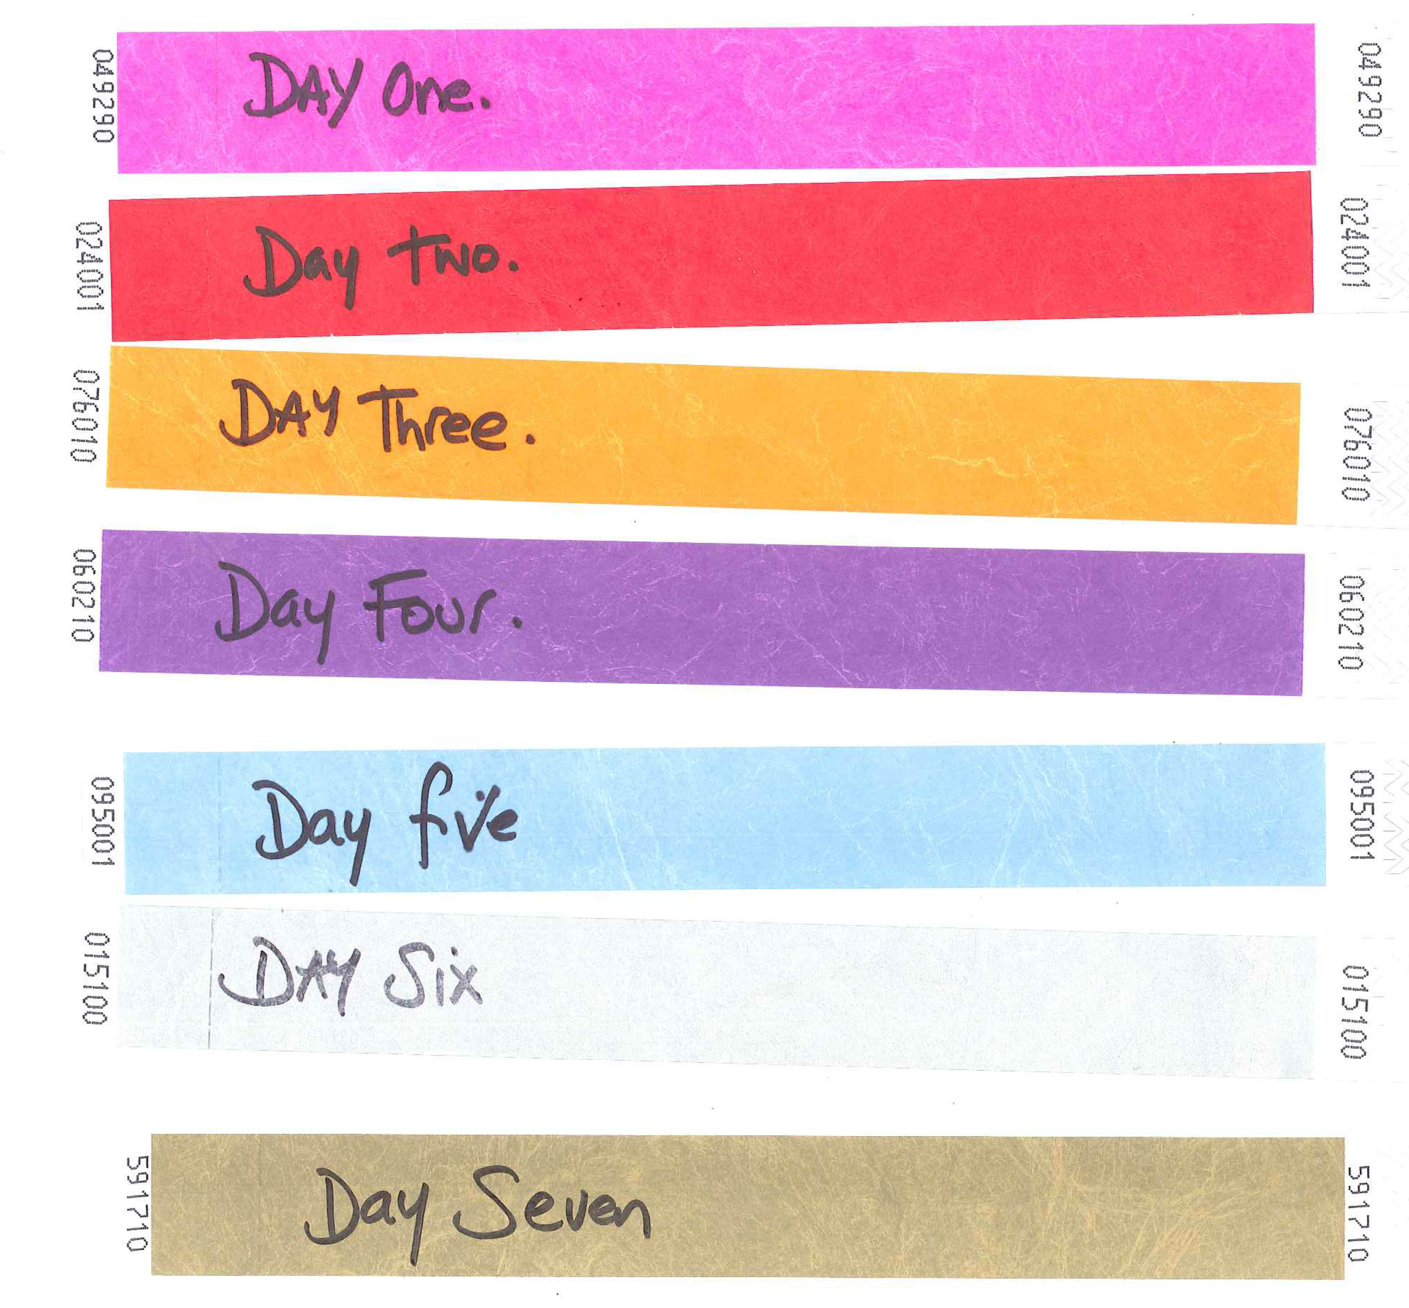

Timings: Lunch and Dinner.
(please note that on the show days because of call times we are only providing Dinner.)
Crew / Artists Meal times:
27th - 29th Dec | Lunch: 1pm - 3pm. | Dinner: 7pm - 9pm
30th Dec | Lunch: 1pm - 3pm. | Dinner: 10pm - 11pm
Show days: Crew and Volunteering (1st - 7th)
Volunteering Dinner session |  | Dinner 3pm - 3.45pm
Crew and artists (show) |  | Dinner: 9pm - 11pm

Daily Schedule: In a glance.

Weds 21st Dec | 8am – 6pm | Whitefriar Gate | Production - Internal clean all shop interiors  Andy Roe: Unit 4/5 in to build his window
Thurs 22nd Dec | Midday – 6pm | Whitefriar Gate | Production - Install Projection film to windows in shop units 9, 16 & 17
Fri 23rd Dec | Midday – 10pm | Whitefriar Gate | Production/Creative & Video – Projection test to window cubes in unit 8  Invisible Flock in
Sat 24th Dec | XMAS EVE | Holidays
Sun 25th Dec | XMAS DAY | Holidays
Mon 26th Dec | BOXING DAY |  | Midus in: cables for Bluman
Tues 27th Dec | 8am – 11am | The Deep | Steelworkers build PA towers
 | 9am - Midday | The Deep | Lighting deliver and install
 | 10am – 2pm | Queen Victoria Square | Video install projectors and control
 | 10am – 2pm | The Deep | Video install projectors and control
 | Midday – 4pm | The Underpass | Video install projectors and control
 | Midday – 4pm | Scale Lane Staith | Video install projectors and control
 | Midday – 6pm | Queen Victoria Square | Lighting deliver and install rooftop fixtures and control
 | Midday – 7pm | The Underpass | Lighting deliver and install fixtures and control
 | Midday – 8pm | The Underpass | Production install screens
 | 1pm – 4pm | Queen Victoria Square | Audio install PA
 | 2:30pm – 6pm | Whitefriar Gate | Video install projection into shop units including drape.

Tues 27th Dec | 4pm – 8pm | ALL SITES | Video carry out system checks and tests
 | 5pm – 7pm | Queen Victoria Square | Lighting deliver and install fixtures and control to Monument area
Weds 28th Dec | 8am – 1pm | Zebedees Yard | Lighting deliver and install fixtures and control
 | 8am – 6pm | The Underpass | Audio install PA
 | 8am – 6pm | The Deep | Audio install PA
 | 8am – 6pm | Whitefriar Gate | Audio install PA: croft from invisible flock, set up.
 | 8am – 6pm | Zebedees Yard | Audio install PA
 | 8am – 6pm | Scale Lane Staith | Audio install PA
 | Midday – 6pm | Whitefriar Gate | Audio install window speakers into shop units 16,17 & 20
 | 2pm – 7pm | The Underpass | Lighting deliver and install fixtures and control
 | 4pm – 4am | ALL SITES | Video – initial line up all projectors
 | 4pm – 10pm | The Underpass | Lighting – programme intelligent fixtures
 | 5:30pm – 7pm | Whitefriar Gate | Lighting deliver and install fixtures and control in shop units
Thurs 29th Dec |  |  | ALL ARTISTES ON SITE (for Tech run through and to start line up.)
 | 10am – Midday  2pm | ALL SITES | All Departments - System checks and fine tuning . Audio IF PM and engineer in to programme.  ARTISTS MEETING WITH NH : Danish building: 12 noon.
 | Midday – 4pm | Zebedees Yard | Audio – Sound check
 | 9am – 12 noon. | QVS | Print to go up on towers, Hording Print to go up.
 | Artists on site: in areas from 4pm unless indicated by Technical.
 | 4pm – 7pm | Whitefriar Gate | Audio & Video – System checks
 | 4pm - Midnight | Queen Victoria Square | Lighting – programme intelligent fixtures
 | 4pm - Midnight | Queen Victoria Square | Audio & Video – System checks
 | 4pm - Midnight | Whitefriar Gate | Audio & Video – System checks
 | 4pm - Midnight | The Deep | Audio & Video – System checks
 | 4pm - Midnight | The Underpass | Audio & Video – System checks
 | 4pm - Midnight | Scale Lane Staith | Audio & Video – System checks

Fri 30th Dec | Midday – 4pm | ALL SITES | Production & Event Management – Noise level checks for Hull CC approval
 | 5am – 5pm  2pm | All sites  Danish Building | Interpretation and Print. Starting at Humber street and the Deep moving to QVS.  Artists meeting with NH: Danish 3 ,
 | Midday – 9pm | Zebedees Yard | Lighting – programme intelligent fixtures
 | Midday – 10pm | Queen Victoria Square | Audio & Video – System checks
 | Midday – 10pm | The Underpass | Audio & Video – System checks
 | Midday – 10pm | Scale Lane Staith | Audio & Video – System checks
 | Midday – 10pm | The Deep | Audio & Video – System checks
 | 9pm – 10pm | Zebedees Yard | Audio – Sound check
 | 9pm – 11pm | The Deep | Lighting – programme intelligent fixtures
 | 11pm – Midnight | ALL SITES | DRESS REHEARSALS
Sat 31st Dec |  | Contingency | Production / Technical.
 | 11am |  | NH and AL to place up student work on hording and varnish.
 | 1.30p-3.30pm |  | ELT Meeting- Artist sand core team not required.
Sun 1st Jan | 2pm | ALL SITES | Technical and Production crews – Show Standby
 | 12 noon. | Danish 3: Danish building | Artist standby and meeting with NH/ BM
Mon 2nd Jan | 12 noon | Artists meeting | NH/CC/KD/KP/DM
 | 3pm | ALL SITES | Technical and Production crews – Show Standby

Schedule: each area 2 days:
NH/AL sign off means look and feel of areas.

Date | QVS | Whitefriar gate | Scale lane | Underpass | The Deep | Zebedee yard | Silver street | Humber street
29th Dec | 4pm - 12am Full Tech  LX programming (4 - 10pm) | 4pm - 7pm Tech,  5pm - 8pm Dressing  NH/AL - sign off (7pm) | Audio /VT -Tech  (4pm - 12) | Audio /VT -Tech  (4pm - 12) | Audio /VT -Tech  (4pm - 12) | Audio /VT -Tech  (4pm - 12) | active  NH/AL - sign off (5pm) | Dress space  NH/AL - sign off (8pm)
30th Dec | Sound propergation test all sites (12 noon - 3pm)
30th Dec (artists on site) | Rehearsal: 4- 10pm  NH/AL - sign off (3pm) | Active | Rehearsal: 4- 10pm  NH/AL - sign off (2pm) | Rehearsal: 7pm- 10pm  NH/AL - sign off (6pm) | Lx programming: 9- 11pm  NH/AL - sign off (7pm) | LX programing 4pm - 9pm  NH/AL - sign off (1pm) | active | Rehearsal (4pm - 8pm)
30th Dec (artists on site) | Dress rehearsal (audio low) 11pm - 00:00

Site Map:
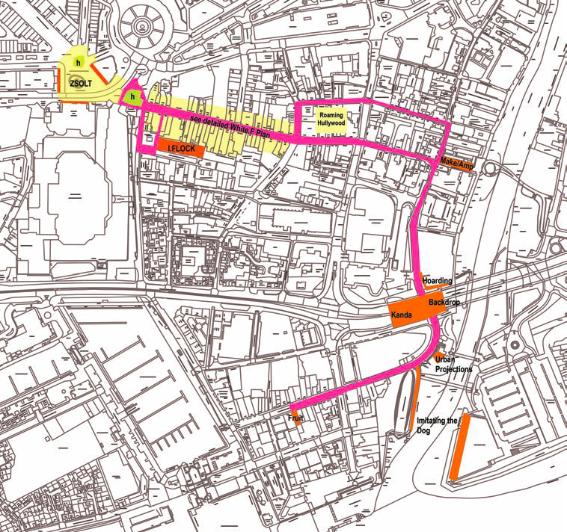

Running schedule as it stands until the 30th December

date | fixed time | QVS | Whitefriar | Zedadee's | Scale Lane | Underpass | The deep | Humber St | Silver St
1st Jan. | 15:00:00
 | 15:15:00
 | 15:30:00
 | 15:45:00 | STANDBY | STANDBY | STANDBY | STANDBY | STANDBY | STANDBY
 | 16:00:00 |  |  | STANDBY |  | STANDBY |  | STANDBY | STANDBY
 | 16:05:00 |  | STANDBY |  |  |  |  |  | STANDBY
 | 16:10:00 |  | ACTIVATE |  |  |  |  |  | STANDBY
 | 16:15:00 |  | ACTIVATE |  |  |  |  |  | STANDBY
 | 16:20:00 |  | ACTIVATE |  |  |  |  |  | STANDBY
 | 16:25:00 |  | ACTIVATE |  |  |  |  |  | STANDBY
 | 16:30:00 |  | ACTIVATE |  |  |  |  |  | STANDBY
 | 16:35:00 |  | ACTIVATE |  |  |  |  |  | STANDBY
 | 16:40:00 |  | ACTIVATE |  |  |  |  |  | STANDBY
 | 16:45:00 |  | ACTIVATE |  |  |  |  |  | STANDBY
 | 16:50:00 |  | ACTIVATE |  |  |  |  |  | STANDBY
 | 16:55:00 |  | ACTIVATE
 | 17:00:00 |  | ACTIVATE
 | 17:05:00 |  | ACTIVATE
 | 17:10:00 |  | ACTIVATE
 | 17:15:00 |  | ACTIVATE
 | 17:20:00 |  | ACTIVATE
 | 17:25:00
 | 17:30:00 |  | ACTIVATE
 | 17:35:00 |  | ACTIVATE
 | 17:40:00 |  | ACTIVATE
 | 17:45:00 |  | ACTIVATE
 | 17:50:00 |  | ACTIVATE
 | 17:55:00 |  | ACTIVATE
 | 18:00:00 |  | ACTIVATE
 | 18:05:00 |  | ACTIVATE
 | 18:10:00 |  | ACTIVATE
 | 18:15:00
 | 18:20:00 |  | ACTIVATE
 | 18:25:00 |  | ACTIVATE
 | 18:30:00 |  | ACTIVATE
 | 18:35:00 |  | ACTIVATE
 | 18:40:00
 | 18:45:00 |  | ACTIVATE
 | 18:50:00 |  | ACTIVATE
 | 18:55:00 |  | ACTIVATE |  |  |  | Holding 2x slides
 | 19:00:00 |  | ACTIVATE |  |  |  | Holding 2x slides
 | 19:05:00 |  | ACTIVATE |  |  |  | Holding 2x slides
 | 19:10:00 |  | ACTIVATE |  |  |  | Holding 2x slides
 | 19:15:00 |  | ACTIVATE
 | 19:20:00 |  | ACTIVATE
 | 19:25:00 |  | ACTIVATE
 | 19:30:00 |  | ACTIVATE |  |  |  | Holding 2x slides
 | 19:35:00 |  | ACTIVATE |  |  |  | Holding 2x slides
 | 19:40:00 |  | ACTIVATE |  |  |  | Holding 2x slides
 | 19:45:00 |  | ACTIVATE |  |  |  | Holding 2x slides
 | 19:50:00 |  | ACTIVATE |  |  |  | Holding 2x slides
 | 19:55:00 |  | ACTIVATE |  |  |  | Holding 2x slides
 | 20:00:00 |  | ACTIVATE |  |  |  | Holding 2x slides
 | 20:05:00 |  | ACTIVATE |  |  |  | Holding 2x slides
 | 20:10:00 |  | ACTIVATE |  |  |  | Holding 2x slides
 | 20:15:00 |  | ACTIVATE |  |  |  | Holding 2x slides
 | 20:20:00 |  | ACTIVATE
 | 20:25:00 |  | ACTIVATE
 | 20:30:00 |  | ACTIVATE
 | 20:35:00 |  | ACTIVATE
 | 20:40:00 |  | ACTIVATE
 | 20:45:00
 | 20:50:00 |  | ACTIVATE
 | 20:55:00 |  | ACTIVATE
 | 21:00:00 |  | ACTIVATE
 | 21:05:00 |  | ACTIVATE
 | 21:10:00
 | 21:15:00 |  | ACTIVATE
 | 21:20:00 |  | ACTIVATE
 | 21:25:00 |  | ACTIVATE
 | 21:30:00 |  | ACTIVATE
 | 21:35:00 |  | ACTIVATE
 | 21:40:00 |  | ACTIVATE
 | 21:45:00 |  | ACTIVATE
 | 21:50:00 |  | ACTIVATE
 | 21:55:00 |  | ACTIVATE
 | 22:00:00 |  | ACTIVATE
 | 21:55:00 |  | ACTIVATE
 | 22:00:00

