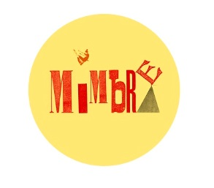Mimbre create nuanced, breathtaking and highly-skilled **acrobatic theatre**. We use circus and dance innovatively as a physical language to illuminate human connections and promote a positive image of women.

Since 2008 Mimbre has developed a participation programme that connects the professional acrobatic world with young people. Making arts and cultural activities accessible to young people in Hackney is our passion and now after seven years Mimbre is known as one of the UK’s leading acrobatic companies providing young people the opportunity to work with professional and highly skilled acrobats and dancers.

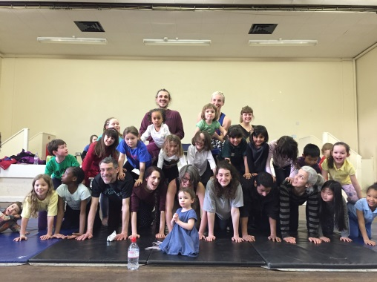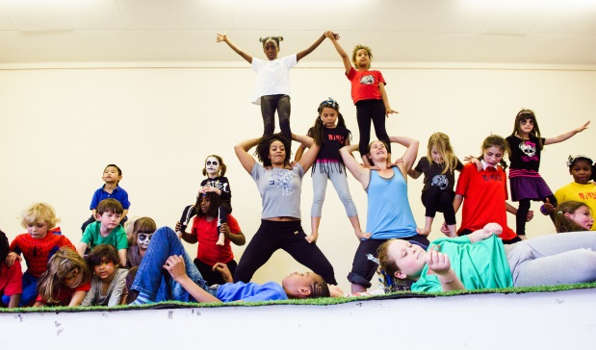

**Acrobatics, acrobalance, and dance can:**

* Help **increase confidence**
* Be adapted to **all ages and skill levels**
* Contribute to **health and wellbeing**
* Battle obesity
* Promote **team work**
* Be taught and adapted to **all curriculums**
* Can help teach **numeracy, literacy, and other academic topics**
* Be fun and **non-competitive**

All our workshops are tailored to specific needs and can include

* Hour long taster sessions
* Fun days
* Intergenerational sessions
* Circus skills sessions
* Intensive half-term or holiday performance projects (3-5 days)
* Intensive workshops with performance alongside our professional company
* Weekly classes over a term or after school clubs

This year Mimbre is working on two new professional shows (a special Shakespeare production ‘Wondrous Strange’ and a super hero themed piece ‘If I could I would’). Both themes can be easily integrated into workshop options. ‘If I could I would’ can be performed alongside young people or on its own.

**Mimbre Acrobats workshop proposals**

Each workshop has capacity for 16 children

|  |  |  |  |  |
| --- | --- | --- | --- | --- |
| **Fun day (Full Day)** |  |  |  |  |
| 2 Teachers |  |  | £ 300.00 |  |
| Teacher assistant |  |  | £ 75.00 |  |
| Space hire |  |  | £ - |  |
| Materials for class |  |  | £ 30.00 |  |
| Fruit, water etc |  |  | £ 10.00 |  |
| Marketing (design, print) |  |  | £ 200.00 |  |
| Mimbre project management fee & Overheads |  |  | £ 226.50 |  |
| ***Total*** |  |  |  | ***£841.50*** |
|  |  |  |  |  |
| **Intensive Week (5 consecutive full days with performance on last day)** | | | |  |
| 2 Teachers |  |  | £ 1,300.00 |  |
| Teaching Assistant |  |  | £ 375.00 |  |
| Space hire |  |  | £ - |  |
| Fruits, water etc for workshops |  |  | £ 50.00 |  |
| Props and material for performance |  |  | £ 80.00 |  |
| Technical support for performance |  |  | £ 150.00 |  |
| Snacks and food for performance |  |  | £ 50.00 |  |
| Marketing (design, print) |  |  | £ 200.00 |  |
| Mimbre project management fee & Overheads |  |  | £ 440.50 |  |
| ***Total*** |  |  |  | ***£2,645.50*** |

|  |  |  |  |  |
| --- | --- | --- | --- | --- |
| **Weekly class for 10 weeks (2 hour class with 1 open class)** | | |  |  |
| 2 Teachers planning Fees |  |  | £ 200.00 |  |
| 2 Teachers |  |  | £ 1,400.00 |  |
| Teaching Assistant |  |  | £ 250.00 |  |
| Fruits, water etc for workshops |  |  | £ 50.00 |  |
| Space hire |  |  | £ - |  |
| Snacks and food for open class |  |  | £ 30.00 |  |
| Marketing (design, print) |  |  | £ 200.00 |  |
| Mimbre project management fee inc. evaluation & reports |  |  | £ 800.00 |  |
| Overheads (10%) |  |  | £ 293.00 |  |
| ***Total*** |  |  |  | ***£3,223.00*** |

** Please note**

|  |  |  |  |  |  |
| --- | --- | --- | --- | --- | --- |
| For the **Intensive Week**; Mimbre's professional company can also perform **'If I could I would'**, incorporating the workshop participants in the show for an additional £600. | | | | | |
| Both the **Intensive Week & Fun Day** budgets assume that the partner organisation are in charge of recruiting, outreach, contacting participants and any evaluation/reports. | | | | | |
| The budget line for marketing print and design can be removed in all options if this is done in-house by the partner organisation. | | | | | |
| **Contact** |  |  |  |  |  |
| For more information please do not hesitate to contact our education program manager, Jana on **education@mimbre.co.uk or 0207 6131 068.** | | | | | |
| These are our standard offers, we are happy to tailor our programs to suit your needs.  Find out more on our website: [www.mimbre.co.uk](http://www.mimbre.co.uk) | | | | |  |