Dan Fox lives in New York, USA. Educated at the Ruskin School of Fine Art, Oxford University, since 1999 he has worked as an editor and staff writer for frieze magazine - currently as co-editor, having first joined as the magazine's intern in London, then worked in assistant, associate and senior editor roles. He has written extensively for frieze, and his essays and criticism has appeared in numerous artist books, exhibition catalogues and in publications as diverse as *Bulletins of The ServingLibrary*, *Dot Dot Dot*, *The Guardian*, *Financial Times, Los Angeles Times*and*Triple Canopy*. His book *Pretentiousness: Why It Matters* was published by Fitzcarraldo Editions in 2016, and chosen by the *New York Times* as one its 100 Notable Books of 2016. He has lectured internationally on art and culture, and been guest lecturer at a range of institutions, most recently including the Ruskin School, Oxford University, and CCS Bard, Annandale-on-Hudson.  
  
He is a musician and codirector of the music label [Junior Aspirin Records](http://www.junioraspirin.com/). With the bands The God in Hackney, Skill 7 Stamina 12, and Big Legs he has performed internationally, including the Centre Pompidou, Paris; the Hammer Museum, Los Angeles; ICA, London; CAC, Vilnius. Junior Aspirin Records' tour of China in 2012 will be the subject of a documentary film by Marcus Werner Hed. His music has been released on a number of records from Junior Aspirin, and can be heard on the compilations 'Crystal Flowers' (Kompakt, 2012) and '41'36"' (Kompakt, 2017). With musician Steve Mackey, he programmed the Frieze Music concert series in London from 2003–2007.  
  
Beyond Dan's work as a critic, he has collaborated as a musician and writer with various artists including Marc Camille Chaimowicz, Nathaniel Mellors, Michael Portnoy, Dexter Sinister and C Spencer Yeh. With Marcus Werner Hed, he is currently making a documentary film about the work of the performance art group COUM Transmissions.

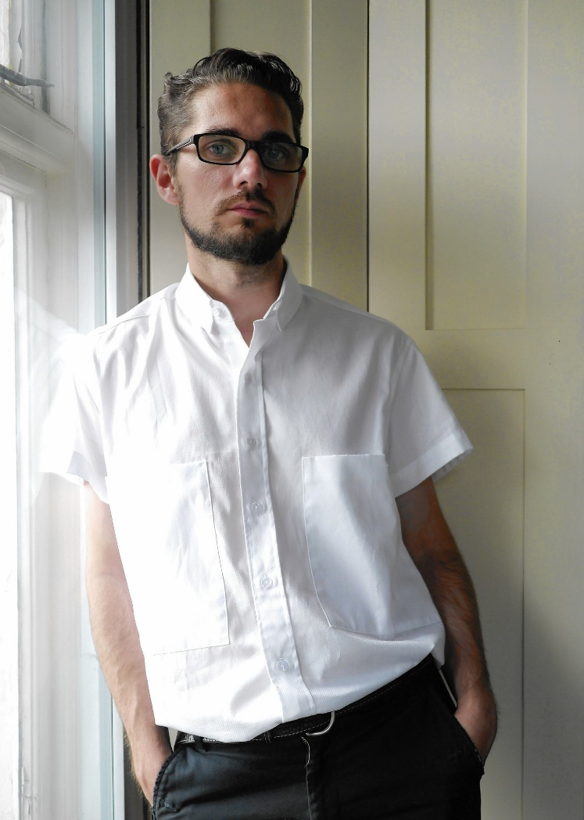

(Left) Photo: Tom Gidley

(Below) No credit

