Appendix 18:
Delivery Partner Consultation

  - Introduction
Delivery Partners were involved in a number of ways, in terms of project development and delivery. This included:
- Researching and sourcing archive content;
- Advising on areas of specialist knowledge linked to historical content;
- Providing access to required communities for commissioned artists; and
- Providing creative content for installation soundtracks.
    - Delivery Partners
In order to gain feedback from Delivery Partners, consultation was undertaken after delivery of the live ‘Made in Hull’ event. In total, 6 responses were received from:
- The Warren
- Freedom Chorus
- Holy Trinity Church
- Yorkshire Film Archive
- Nova Studios
- WISE (Wilberforce Institute of Slavery and Emancipation).
The data collection methodology employed was a quantitative and qualitative questionnaire. Delivery Partners were approached to complete this as a telephone interview, but given time pressures some requested to complete it as an online survey. The template for the interview is provided in Appendix 19.
The focus of this research was to undertake two types of evaluation:
- Process Evaluation: motivations; involvement in the development and delivery of the project; key learnings, successes and challenges; and the effectiveness of the partnership with Hull 2017 and the broader team.
- Outcomes Evaluation: response to the event (if attended); response to how the event helped them think about using the arts in their own area of work; skills and knowledge development; confidence working on similar events in future; collaboration and partnership development; and perception changes towards Hull among stakeholders.

  - Profile of Delivery Partners
Delivery partners were asked to define their organisation, or their role in ‘Made in Hull’:
- 3 of 6 selected Heritage Partners
- 1 of 6 selected Voluntary Sector / Charity Partner
- 2 of 6 selected ‘Other’.
Those who selected other, specified their organisation type. Based on these responses, they were in fact an Artistic / Creative Partner and a second Voluntary Sector / Charity Partner.
However, it should be noted at this point that some respondents did not identify themselves as ‘delivery partners’ either because their input had been limited, they had been brought on board late in the process, or both.
This should be taken into consideration when interpreting the feedback summarised below. It also suggests there is an opportunity to improve how supplier contracts and relationships are managed by Hull 2017, which is explored later.
  - Process Evaluation
In order to inform the planning, development and delivery of future projects, a series of questions were asked linked to the process of ‘Made in Hull’. These concentrated primarily on:
- Motivations: What attracts delivery partners to get involved in projects such as ‘Made in Hull’?
- Project Development and Delivery: What variety of ways were delivery partners involved in the development and delivery of ‘Made in Hull’?
- Learnings: What were the key learnings taken from working on ‘Made in Hull’?
- Partner Performance: How did they feel Hull 2017 performed as a partner throughout the course of their involvement and how could this be improved?
    - What Was It About ‘Made in Hull?
Hull’s ‘UK City of Culture’ status appears to have been a significant factor for some partners in their decision to work on ‘Made in Hull’:
- 3 out of 6 said it had ‘completely’ influenced their decision
- 3 out of 6 said it had been far less of an influence
  - 1 gave a score of 5 out of 10
  - 1 gave a score of 3 out of 10
  - 1 gave a score of 0 out of 10.
This led to an average score of 6.3 out of 10 in regard to the influence of UK City of Culture status as a motivation to be involved.
Partners were also asked to share their other key motivations for working on the project, with the opportunity to provide up to three key motivations. Although principally each individual / organisation was asked by a member of the team at Hull 2017 to be involved, there were a variety of other motivations for getting involved, such as:
- To be part of the celebrations;
- To offer their skills and knowledge;
- To provide content, whether historical or artistic;
- A commitment to Hull or the arts and culture;
- The opportunity to work with artists and creatives involved;
- To raise their profile or the profile of their service users; and
- To help deliver against their own remit / strategic objectives.
    - Project Development and Delivery
Partners were asked to describe their own, or their organisation’s involvement in the development or delivery of ‘Made in Hull.’ There were a variety of levels of involvement, with some being involved across the project as a whole, and others working with artists on a specific installation.
Those working across the project as a whole were all heritage partners and described their involvement as researching and supplying archive content. One of the two partners went into a greater level of detail and spoke of how the content required was informed by group discussion with the artists. The archive content sourced included film, maps, books and images.
Those who worked with specific artists did so in a variety of ways:
- Connecting artists to the individuals and communities they were interested in exploring;
- Performing vocal elements that were integrated into the soundtrack for individual installations;
- Advising artists and Creative Core Team members on areas of specialist knowledge to ensure that the history being explored was accurately represented, as well as signposting them to relevant content.
    - Partner Performance
The partnership with Hull 2017 was difficult to evaluate as some partners had dealt directly with the artist. Those that said they had dealt directly with the Hull 2017 team were generally referring to the Creative Core Team who had been commissioned to deliver ‘Made in Hull’.
Whilst partners were generally satisfied with how the project was managed, the most challenging aspect of working on the project was the limited time they were given. 3 out of 6 partners cited this.
A lack of communication was raised by 2 out of 6 partners, and a lack of information about the event itself was also raised as an issue.
‘Not really knowing what was going on and not treading on people's toes. Adjusting to the time demands.’
‘Changes in project management, lack of significant funding, an unclear idea of requirements from some artists, and changing timescales made delivery quite difficult.’
One partner felt they had been unable to capitalise on footfall during event delivery because they were not given enough prior information about what the event would entail.
Figure x (overleaf) shows that most partners were satisfied with the explanation of the concept, aims and objectives of ‘Made in Hull’, although one mentioned that the strong focus on heritage had not been made clear at the start.
It would also appear that they were satisfied with communication post-event, however 3 partners said this was not applicable, which suggests they have not received any contact since the event (nor, perhaps, would they expect to be contacted). One felt it would be beneficial to have some kind of mechanism for reflection on the process of collaborative working.
Figure x (overleaf) again suggests that some partners were less than fully satisfied with the level of communication from the team at Hull 2017 before and during the event itself.
  - Reaction to Event
Partners were asked if they had attended ‘Made in Hull’. 5 out of 6 stated that they had.
The partner that had not attended was unable to do so because all staff had previous engagements, were on holiday or travelling over the period.
All partners, however, stated that seeing the final artworks and event was the most exciting part of being involved in the project across all partners. In addition, audience reaction and the process of working with the artists were highlights of being involved.
‘We Are Hull came together so well from what was quite an abstract idea and different use of archive footage was quite exciting, as well as hearing reports of how it was so widely enjoyed by audiences.’
‘Seeing how technologists and academics and artists can come together to create something which was so meaningful and respectful.’
Figure X: Hull 2017’s Partnership Performance
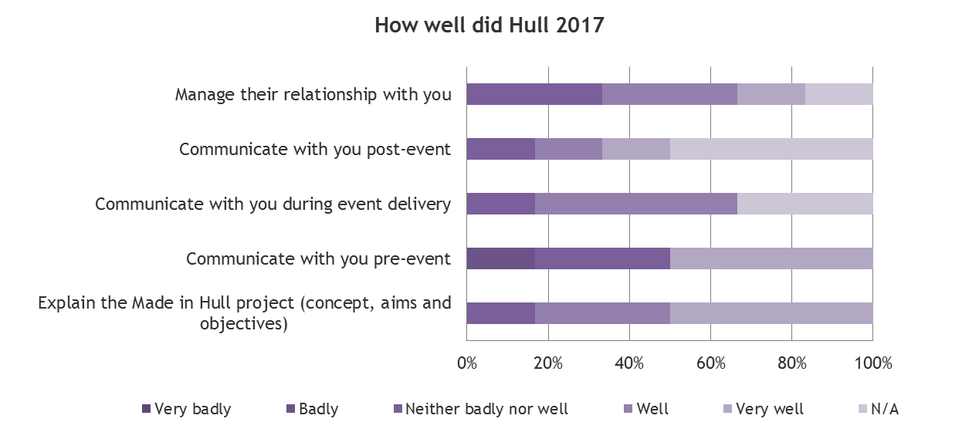

Figure X: Effectiveness of Project Partnerships

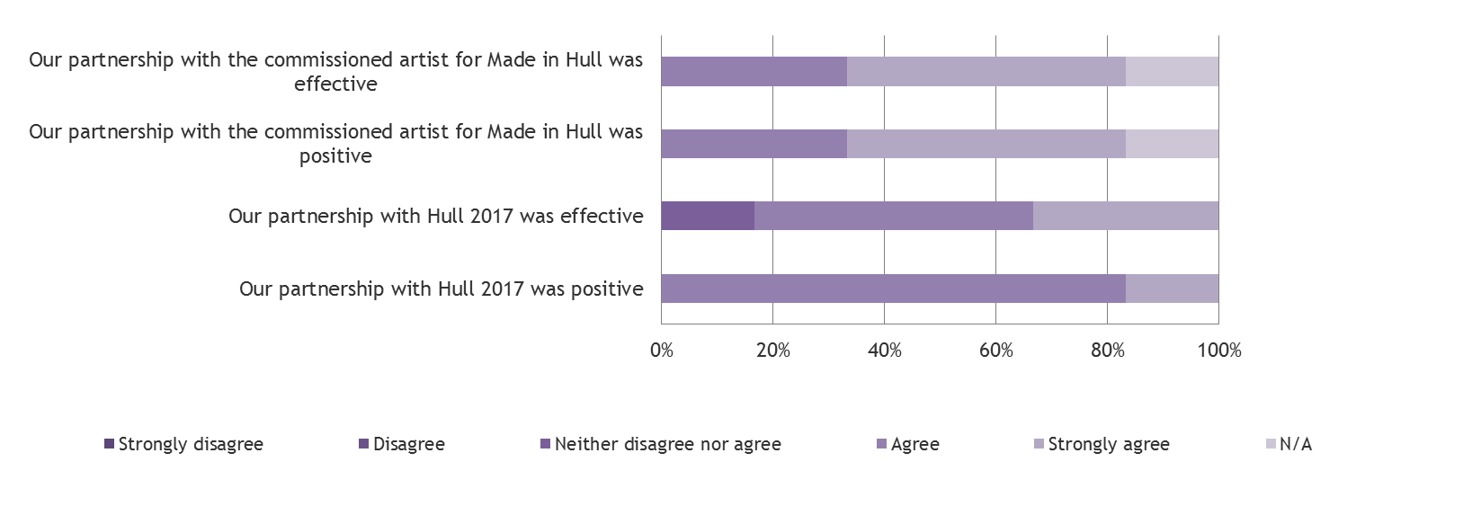

    - Installations Visited
Of the five partners who did attend:
- All five saw We are Hull at Queen Victoria Square; Arrivals and Departures at The Deep; (in) Dignity of Labour at Scale Lane; and the installations on Whitefriargate.
- Four had seen to 105+ dB at Zebedee’s Yard.
- Three had seen Embers at High Street Underpass and Hullywood Icons at Silver Street / Queen Street.
- Two had seen Vantage Point at Humber Street.
Figure X: Installations Visited by Delivery Partners
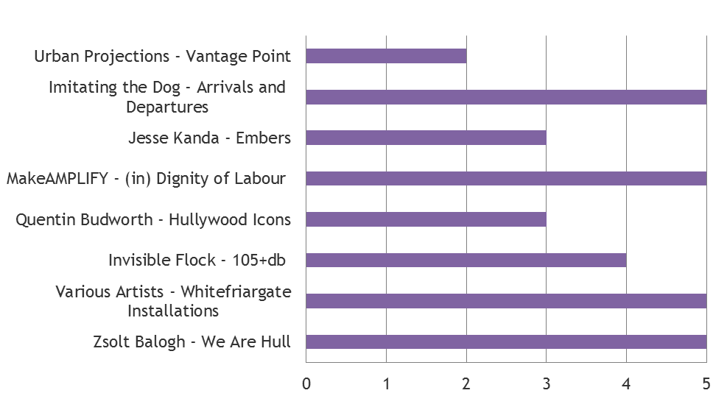
    - Recommendation and Values
All 5 partners said they would be extremely likely to recommend the event to friends and family (rating it 10 out of 10).
When asked to state how much they disagreed or agreed with a variety of value statements about the event, more than half of the value statements received an average score of more than 4 out of 5 (where 4 = Agree and 5 = Strongly Agree).
Two statements received a rating of ‘Strongly agree’ from all five partners:
- ‘Made in Hull gave everyone the chance to share and celebrate together’
- ‘Made in Hull was an enjoyable experience’.
The other statements receiving high ratings were:
- ‘Made in Hull made me feel more connected with the stories of Hull and its people’
- ‘Made in Hull’ placed the community at the centre’
- ‘Made in Hull gave me the opportunity to interact with other people who I wouldn’t normally have interacted with
- ‘Made in Hull made me think more positively about people from other generations’.
There was a lower level of agreement to the statements:
- ‘Made in Hull inspired me to talk to people from other generations about the stories presented’
- ‘Made in Hull showed me that there is more to Hull than I expected’ - some partners gave this a lower score because they already knew that the city has a lot to offer.
- ‘Made in Hull makes me think that getting involved in a project as a volunteer looks like fun’ – partners stated they simply would not have time to volunteer.
The above findings are illustrated in Figure X overleaf.
    - Staff and Volunteers
Respondents generally felt welcomed by volunteers and staff, with respondents almost exclusively selecting ‘Agree’ or ‘Strongly Agree’ with the statements:
- I felt welcomed by staff; and
- I felt welcomed by volunteers.
    - Event as a Way to Present History and Heritage
All 5 partners gave the event 5 stars (‘Outstanding’) for how it presented history and heritage to audiences and all selected ‘Strongly Agree’ to the statements that presenting history and heritage through art based approaches made it both easier to understand and more interesting for the audience.
In general respondents said they had not learnt much about Hull’s history or heritage from attending the event, but it should be acknowledged that at least half of them had supplied or sourced the material on which the installations were based.
Those who had learnt a significant amount about the history and heritage of the event were from the voluntary /charity sector (7 out of 10, where 10 is ‘A lot’), and a heritage partner with a particular specialist knowledge in one area of the history explored through ‘Made in Hull’ (10 out of 10).
Figure X: Value Statement Ratings
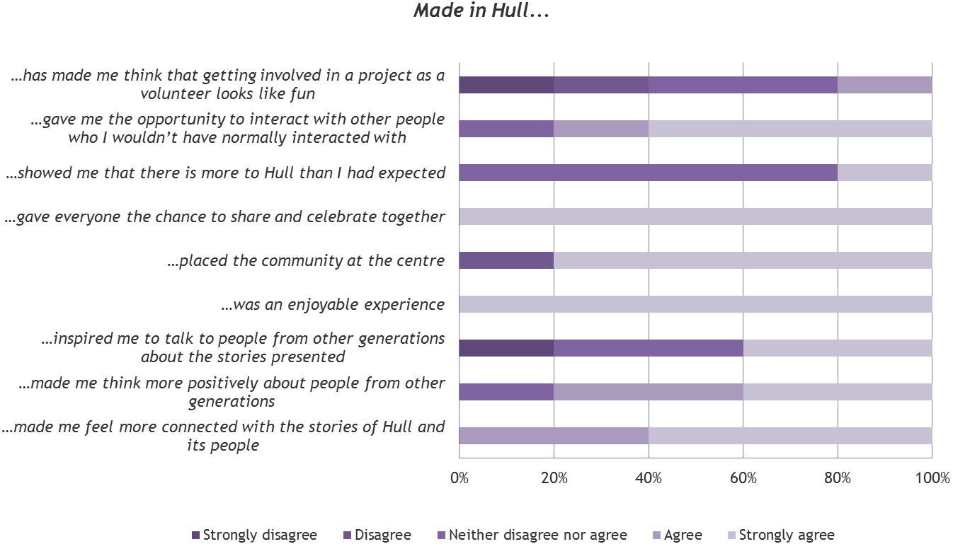
  - Outcomes
The key areas of focus, dependent on the type of partner they were, included:
- Presentation and Interpretation of Heritage and History: the success of the project in making partners reassess how the arts can contribute to the interpretation of history heritage.
- Representation of communities: the success of the project in making partners reassess how the arts can contribute to the presentation and sharing of community stories.
- Skills and knowledge development: new and existing skills, knowledge and learning, in regard to professional skills and the heritage and history of Hull, as a result of working on ‘Made in Hull’.
- Collaboration and partnerships: new and existing collaborations and partnerships built or developed as a result of working on ‘Made in Hull’.
- Perceptions of Hull: shifts in the perceptions of Hull amongst CCT member, as a result of working on ‘Made in Hull’.
    - Presentation and Interpretation of History and Heritage
Only those stating that they were heritage partners were asked to comment on this aspect of the event, drawing on their professional experience and expertise.
Two of three heritage partners said that the project had made them think about new ways in which the arts can contribute to the interpretation of heritage.
One said they had been sceptical about how the City of Culture team would be able to cover more traditional history and heritage through the arts (as opposed to cultural history) but the project had demonstrated that it could be done effectively. The other person said they would explore new ways of presenting archive footage in public spaces.
All three heritage partners felt that historically inspired arts events, such as ‘Made in Hull’, differed in their impact to other more traditional forms of presenting and interpreting history and heritage (e.g. museums and exhibitions). In the main it was seen to have a wider appeal and immediate engagement with the archive content, which might take longer to “get into” should you be reading and researching yourself.
‘These types of events can be more inclusive for audiences who shy away from academic settings or have certain expectations about archive footage or an archive presentations. Made in Hull demonstrated the local pride and how archive footage resonates with local audiences’
‘Utterly different. Main thing is immediacy. You get immediate, positive and critical engagement. It transcends all ages and cultures. Really did enable audiences to see work. I feel really lucky, as other [people in my field] don’t get the opportunity to see their work presented in this way.’
    - Representation of Communities
Only the one partner stating they were a voluntary sector / community Partner were asked to comment on this aspect of the event, drawing on their professional experience and expertise.
When asked if the project had made them think about new ways in which the arts can contribute to the presentation and sharing of community stories or issues, the partner responded that it had. They felt that the art work had been amazingly successful at translating the work the artists had undertaken with the community in question, into a large scale high-quality piece of art. It was described as ‘amazing’.
It was also felt, by this partner, that using art in this way can have a different impact that other ways of presenting and sharing community stories and issues.
‘Its interactive, more attractive, open to anyone, easy to absorb, feel good, great atmosphere. Its engaging.’
    - Skills and Knowledge
Professional Skills and Knowledge
2 partners said they had gained or developed skills or knowledge from working on the project. Both stated they gained or increased skills and knowledge of museums, libraries and archives; and project management.
Other skills and knowledge areas selected were:
- Project development
- Creative / Artistic skills
- Audience development
- Marketing and / or social media
- Production and / or technical
- Community engagement
- Health and safety
- Other skills: negotiation, finance, licensing, understating of artists.
In providing reasons for these answers, partners said:
‘Trained as a journalist so I feel this was a re-purposing and widening of my research skills, for example I learnt a lot about archives and licensing.’

‘Developed how we work in many aspects. Community engagement was a big one because we engaged with so many different communities with this work. In general, we really learnt how best to work with the artistic community.’
Confidence
All the respondents said they would be confident in working on a similar project in future (8 out of 10 or higher) mainly because they now had the necessary skills and experience of working on a project of this scale.
    - Collaboration & Partnerships
2 out of 6 partners stated that working on ‘Made in Hull’ had enabled them to build new relationships with other individuals and / or organisations that they had not come across before.
All partners stated that working on ‘Made in Hull’ had enabled them to develop existing relationships with other individuals and / or organisations (i.e. a deepening of partnerships that pre-date Made in Hull).
Those who worked directly with an individual artist / artist collective, were very keen to do so again. There also seemed to be an appetite amongst creatives that utilised archive footage to repeat this in future projects.
Two of the partners who were linked up by the project also talked of how they were already working together on a more ongoing basis.
    - Perceptions of Hull
2 out of 6 partners stated that they would speak more positively about Hull to someone else, as a result of working on ‘Made in Hull’, with the remainder stating that they would not change the way they describe the city.
This stating that they would speak more positively talked predominantly about the atmosphere that the event had created and how people had taken to the event, as well as how the city had been showcased.
Where there was no change in the way people would speak about it, this was because respondents would already speak positively about the city.

