**Crediting and Press Guidelines for New Music Biennial** **2017**

# Crediting New Music Biennial’s funders and partners

You **must** use the correct funder lock-up on:

* **Your website**
* **Concert programmes/ brochures**
* **Flyers/ Posters**
* **Any other printed material**

1. ***For the New Music Biennial Festival weekends***

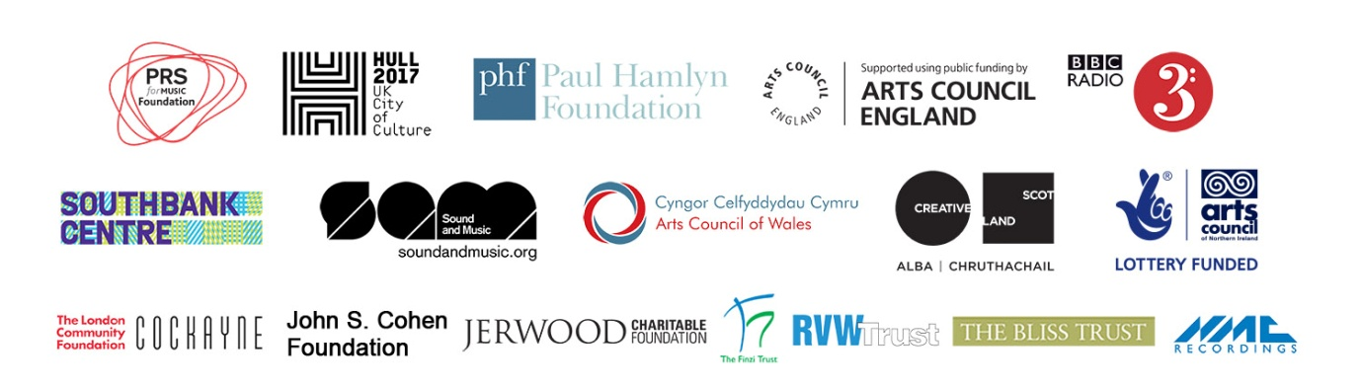

You can download this from our website [here](http://www.prsformusicfoundation.com/partnerships/flagship-programmes/new-music-biennial/logo-and-crediting/).

1. ***For the New Music Biennial Composer residencies and minute of listening only:***

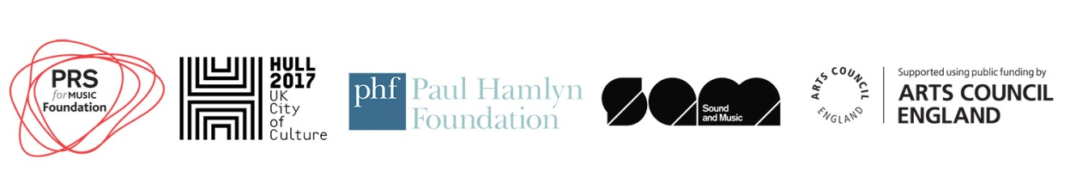

You can download this from our website [here](http://www.prsformusicfoundation.com/partnerships/flagship-programmes/new-music-biennial/logo-and-crediting/).

And include a link to [www.newmusicbiennial.co.uk](http://www.newmusicbiennial.co.uk)

**NB. Logos subject to change and updated.**

Please hyperlink the lock-up image to our funders and patrons page on our website: <http://www.prsformusicfoundation.com/partnerships/flagship-programmes/new-music-biennial/new-music-biennial-2017/new-music-biennial-2017-funders-and-patrons/>

**If you have limited space and cannot include the logo-lock-up**, you must credit the funders and partners in text as follows:

***If you are taking part in the New Music Biennial weekends only:***

PRS for Music Foundation’s New Music Biennial is generously supported by Hull UK City of Culture, Paul Hamlyn Foundation, Arts Council England, BBC Radio 3, Southbank Centre, Arts Council of Wales, Creative Scotland, Arts Council of Northern Ireland, Cockayne, The John S Cohen Foundation, the Jerwood Charitable Foundation, The Finzi Trust, RVW Trust, The Bliss Trust and NMC Recordings. [www.newmusicbiennial.co.uk](http://www.newmusicbiennial.co.uk)

***If crediting the residencies only:***

PRS for Music Foundation’s New Music Biennial residency programme is generously supported by Hull UK City of Culture, Paul Hamlyn Foundation and Arts Council England. [www.newmusicbiennial.co.uk](http://www.newmusicbiennial.co.uk)

***If crediting the Minute of Listening only:***

PRS for Music Foundation’s New Music Biennial Minute of Listening is delivered in partnership with Sound and Music and is generously supported by Paul Hamlyn Foundation and Arts Council England. [www.newmusicbiennial.co.uk](http://www.newmusicbiennial.co.uk)

Crediting New Music Biennial in text/ copy

In addition to the New Music Biennial logo lock-up and hyperlink to <http://www.newmusicbiennial.co.uk> please use the text below to help promote New Music Biennial in you the main text/copy of the following:

* **Websites**
* **Facebook, Youtube (or similar) descriptions**
* **Concert programmes / brochures**
* **Flyers/ posters**
* **Any other printed materials**

***For the New Music Biennial weekends:***

PRS for Music Foundation’s **New Music Biennial** is an exciting and free new music festival which forms part of Hull 2017 UK City of Culture, presenting 20 pieces of new music across two festival weekends in Hull (30th June – 2nd July 2017) and at London’s Southbank Centre (7th – 9th July 2017). The New Music Biennial will be broadcast on BBC Radio 3.

## 

***For the residencies:***

**New Music Biennial Composer Residencies** will take place between September 2016 and March 2018 so that local communities in Hull can spend time and create music with some of the New Music Biennial’s brilliant music creators**.** These local groups and composers will come together and be part of the New Music Biennial Festival in Hull, July 2017, where they will perform a large-scale culmination piece. The Composer Residencies will continue beyond July 2017 with local student music leaders mentored by New Music Biennial composers.

**If you are unable to fit crediting on any materials/communications then please contact:** [**liam@prsformusicfoundation.com**](mailto:liam@prsformusicfoundation.com) **to ask for permission on crediting.**

***For Minute of Listening:***

**New Music Biennial Minute of Listening** is a special edition of Sound and Music’s simple digital learning tool which provides primary-aged children with the opportunity to experience 60 seconds of creative listening each day of the school year. Featuring minute-long tracks from New Music Biennial composers and sounds from Hull, the New Music Biennial Minute of Listening will run in schools between October 2017 and March 2018.

## Your website

Please create a New Music Biennial page on your website to:

* display the New Music Biennial logo lock-up and crediting in text/copy
* post news and updates about your commission/residency
* list your commission premiere, other performances, or residency
* promote the festival weekend in Hull (30th June - 2nd July 2017)
* promote the festival weekend at London’s Southbank Centre (7th – 9th July 2017)
* promote the BBC Radio 3 broadcasts and share them via BBC iPlayer.
* promote the NMC Recordings digital releases

## 

## Your Social Media channels

Please connect with:

* **Twitter @prsfoundation** and use the hashtag **#NMB17**
* **Facebook.com/PRSforMusicFoundation**
* **Youtube.com/PRSFmusic**

In order to effectively share and promote news about New Music Biennial composers, commissions and performances we ask all 20 commissioning organisations, along with their composers and performance groups, and partners and supporters to connect to each other’s social media channels. You can find out about all 20 New Music Biennial commissioning organisations and composers on our [website](http://www.prsformusicfoundation.com/Partnerships/Flagship-Programmes/New-Music-Biennial/Logo-and-Crediting) and at [www.newmusicbiennial.co.uk](http://www.newmusicbiennial.co.uk).

**Please link to and share New Music Biennial content from all the partners and stakeholders to ensure maximum exposure for the programme, and in all social media messaging always use #NMB17.**

# 

# Crediting New Music Biennial in Press Releases and speeches

In the ‘Notes to Editors’ section of your press releases about New Music Biennial premieres, performances and other news please use:

**When making speeches please use the following as a guide**:

**About New Music Biennial:**

PRS for Music Foundation’s New Music Biennial and residency programme is generously supported by Hull UK City of Culture, Paul Hamlyn Foundation, Arts Council England, BBC Radio 3, Southbank Centre, Arts Council of Wales, Creative Scotland, Arts Council of Northern Ireland, Cockayne, The John S Cohen Foundation, the Jerwood Charitable Foundation, The Finzi Trust, RVW Trust, The Bliss Trust and NMC Recordings. [www.newmusicbiennial.co.uk](http://www.newmusicbiennial.co.uk)

The New Music Biennial Minute of Listening programme is delivered in partnership with Sound and Music and is generously supported by PRS Foundation, Paul Hamlyn Foundation and Arts Council England.

“[Name of commission] *is part of PRS Foundation’s* ***New Music Biennial****, an exciting free festival of new music by some of the UK’s leading composers. It takes place across two cities in 2017 in Hull and London’s Southbank Centre and audiences across the UK, and broadcast on BBC Radio 3.*

[Mention BBC Radio 3 broadcast date if known/relevant]

**Thanking supporters and partners in speeches:**

***Supporters to thank for the New Music Biennial weekends only:***

*PRS Foundation, Hull UK City of Culture, Paul Hamlyn Foundation, Arts Council England, BBC Radio 3, Southbank Centre and all the many partners and supporters who’ve made New Music Biennial possible. You can find out more at prsformusicfoundation.com”*

***For the residencies:***

*We’d like to take this opportunity to thank PRS Foundation, Hull UK City of Culture and Paul Hamlyn Foundation and Arts Council England for making the residencies possible. You can find out more at prsformusicfoundation.com”*

***For the Minute of Listening:***

*We’d like to take this opportunity to thank PRS Foundation, Sound and Music, Paul Hamlyn Foundation, Hull City of Culture and Arts Council England. You can find out more at prsformusicfoundation.com”*

**Please note crediting information is subject to change.**