TURNER // RETURN 16 November 6-10pm
A night returning us to times when we valued time. Time to talk, chat, unwind, listen watch and enjoy. Enter the Ferens via our RETURN // ENTER sign and enjoy an evening of contemplation and conversation.
RETURN. TIME & TIME AGAIN. We're here all night
1 | RETURN // PRINT  Lead : Hack & Host | Outside to the right of the Ferens entrance  Seating for 10 | Meet Me at the Blue Box  The Blue Box is a place to meet and exchange conversation. For the last couple of months, it has been making its way around Hull, with the help of our friends from Hack & Host, asking people what they think of contemporary art.  Located at the main entrance of the Ferens Art Gallery, you’re invited to pay the Blue Box a visit and find out what the story is so far. Feel free to add your own thoughts, or simply have a sit down with a cuppa and read the paper whilst you’re there. Remember: Whatever you think about art, you’re right.  6-9pm  <<INSERT>>
2 | RETURN // ART  Lead: Curators George & Sacha | Studio  150 capacity | Between Competition and Care  Artes Mundi, BALTIC Artists’ Award, Turner Prize, John Moores Painting Prize, Paul Hamlyn Foundation Awards for Artists and the Max Mara Prize for Woman… the list of contemporary art prizes goes on.  There has been an explosion of such prizes in recent years which raises the question:  Is competition the best environment for artists to make work and for the public to encounter new work?  And as a result, how do we care for art, audiences, and artwork in the context of competition?  As part of Turner//Return, the Ferens Art Gallery is pleased to present ‘Between Competition and Care’, a panel discussion on the nature of art prizes with Sarah Munro, Director of BALTIC, and Ben Borthwick, Artistic Director of Plymouth Art Centre. Hosted by Turner Prize 2017 curators Sacha Craddock and George Vasey.  6.30-7.30pm  The Studio  Free, booking tickets advisable as spaces are limited  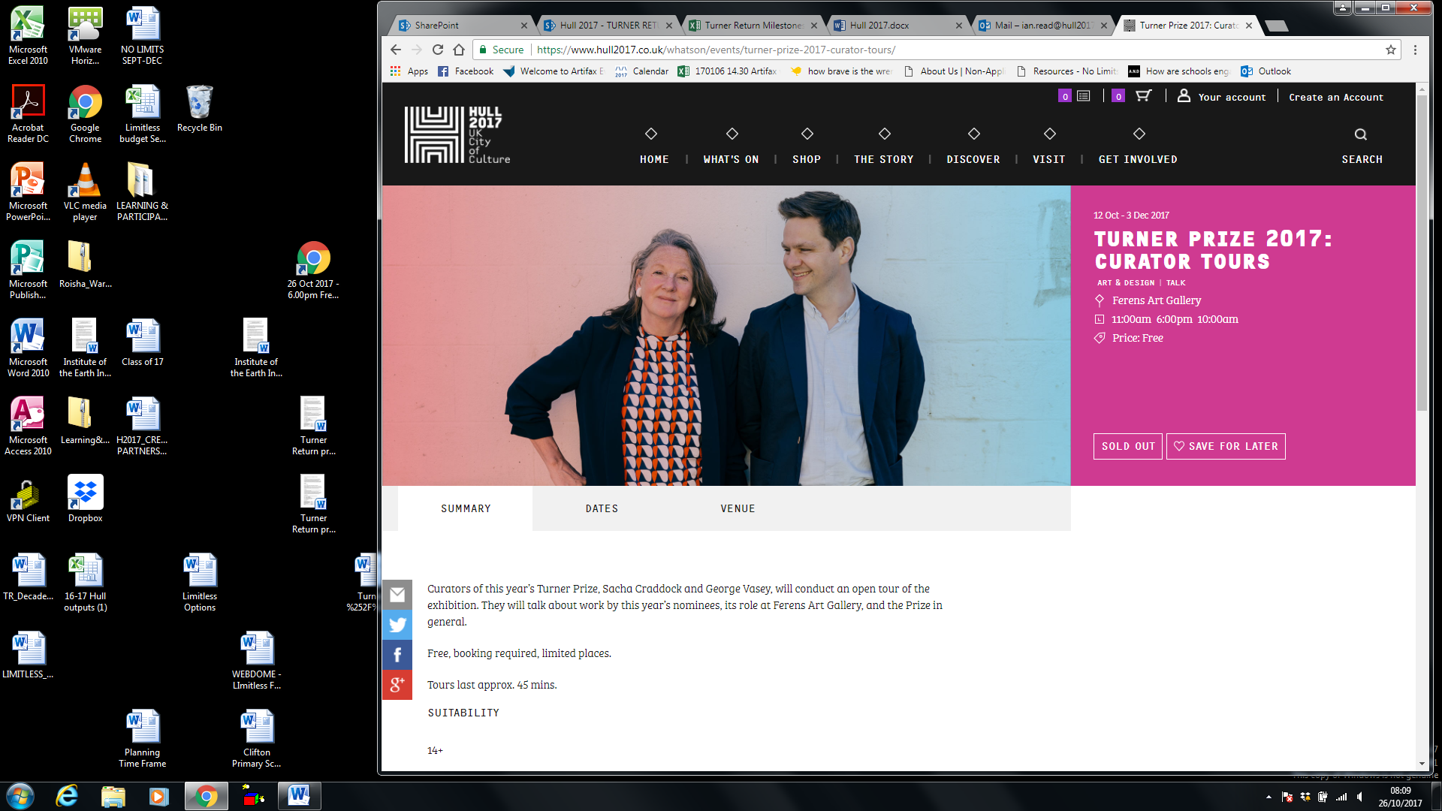  Art Film Screenings  Between Competition and Care will be followed by the screening of emerging artists’ films.  8-10pm  The Studio
3 | RETURN // FEESTING  Lead: Future Ferens & Anna Bean | Gallery 2  Dutch 17th  Seating for 20 | FEEST  The table has been set, the food has been made… all we need now are the guests. In the sumptuous surroundings of the Dutch 17th Century Gallery we are inviting visitors to join our ‘feest’ - taking in as much art as possible in one sitting.  Artists Anna Bean and Future Ferens ask you to join them to talk about art, life, your day at work - whatever it is, they are there to listen and respond, and there’s plenty to eat. Tuck in. Bon Appetit! (could you say this in Dutch? Smakelijk!)  Will this seating be on rotation? So you can join a different sitting in the time period from 6-10pm? Do we know how many sittings there will be?  6-10pm  Dutch 17th Gallery  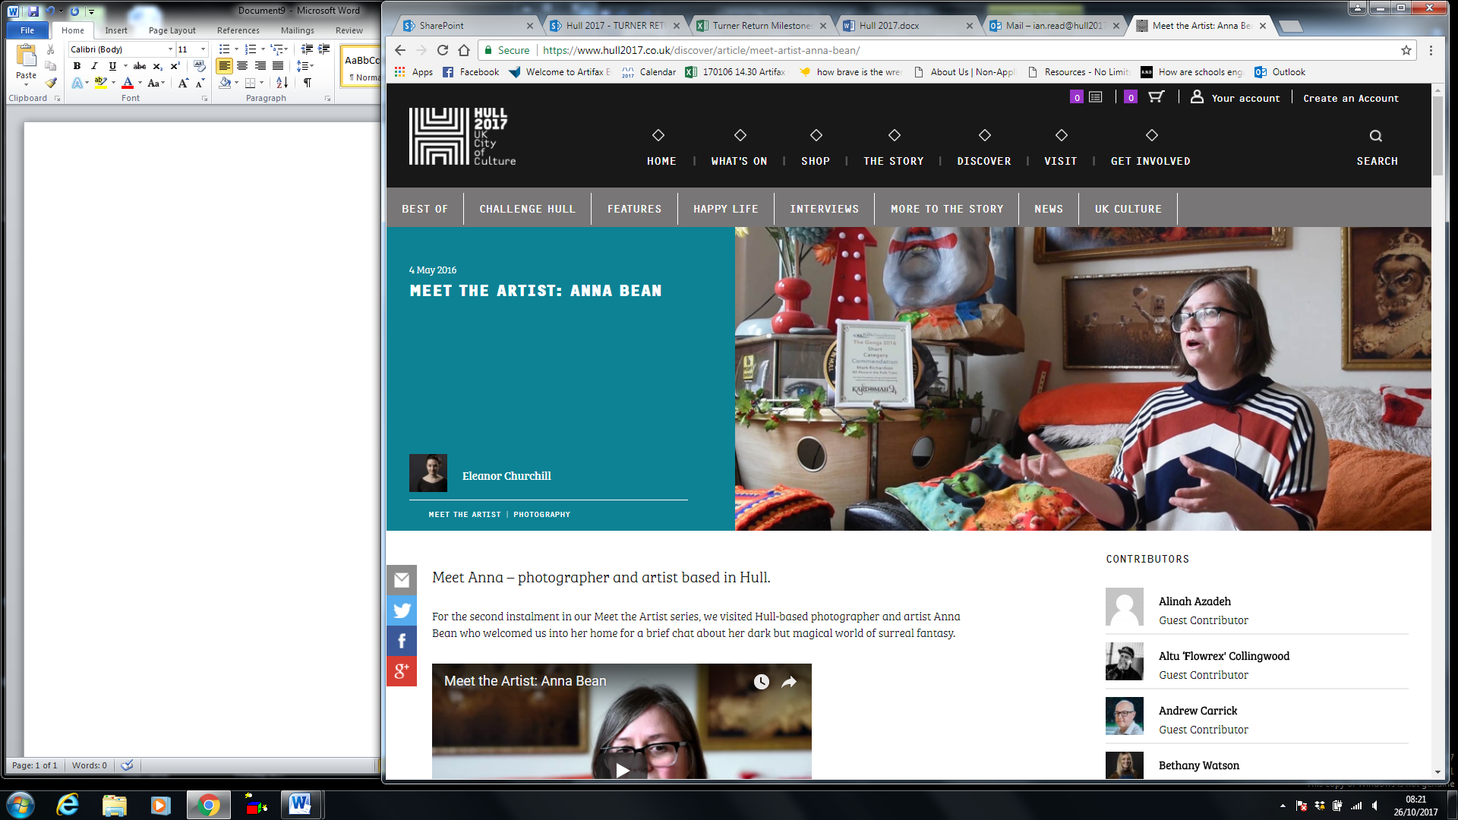  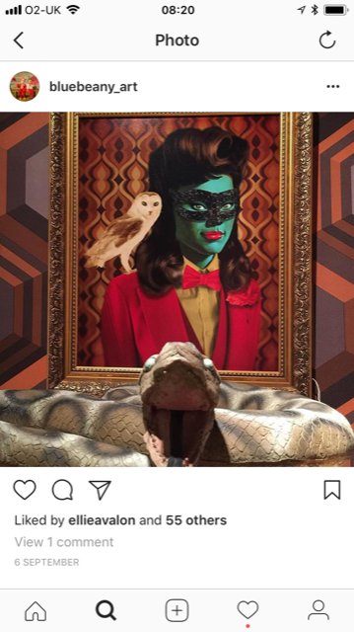
4 | RETURN // FINE CUT  Lead: Greasy Fingers | Gallery 3  European 18th  10 capacity | GREASY FINGERS  Let your hair down in RETURN // FINE CUT with local lads Greasy Fingers, who are bringing their barber chair and scissor skills to the gallery for one night only. Sit down, relax and get a quick trim in style, a hair’s breadth away from some of the finest European art.  6-9.30pm  European 18th  (When there is anything happening with the Turner// Return or Return// Fine cut – need to decide whether or not this is in upper or lower case. Look for these references throughout. I have highlighted in red where I have picked up.)
5 | RETURN // DEBATE  Lead: FandangoeKid | Café / shop  30 capacity | TABOO EMOTIONS  Annie Nicholson is Fandangoekid. She is renowned for her work that deals with tackling taboo subjects in a more open and inclusive way.  Her work is a heartfelt and honest ode to survival.  Join Annie at the Ferens café, where she’ll be showcasing a specially made mural. She will be joined by photographer and filmmaker Tara Darby to lead a drop-in workshop where you’re encouraged to contribute to piece of art to make your voice heard. (not sure if this is 100% accurate? I’ve embellished slightly)  Be brave, join the discussion and let your words be seen.  6-10pm  Café & Shop (the Café will be serving refreshments)  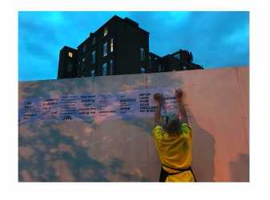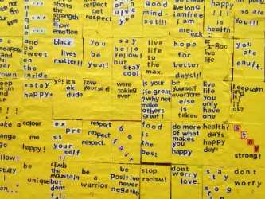
7 | RETURN // PERFORMANCE  Lead: LO:CUS | Court Galleries 5 & 8  50 capacity | Bits of Things  Taking inspiration from the Turner Prize 2017 exhibition, Jo Ashbridge and Tamar Draper perform a piece of dance exploring place and identity, memory, communication, vulnerability and contrast – themes all depicted in the work of the Turner Prize 2017 nominees.  First performance 6.15pm  Gallery 5 & 8
8 | RETURN // EXCHANGE  Lead: Kate Genever | Galleries 5, 6, 7, 8 &9  30 per tour | LIVE TOURS  Want to know more about the exhibitions at the Ferens Art Gallery? (Are they just doing exhibition tours of TP work – or the full gallery? In the next para it makes me think it’s just TP2017)  This is your chance to glean insider knowledge from a group of young professionals as they lead tours throughout the exhibition space. Having taken part in the EXCHANGE programme, they’re sure to have some hints and tips to demonstrate there is more to contemporary art than originally meets the eye. Join them at programmed times to experience Turner Prize 2017.  From The Central Courtyard, first one leaves at 6.10pm
9 | RETURN // DECADENCE  Lead: Eli Chambers | Thomas Ferens gallery  50 capacity | THE GIFT  Tonight, decadence is a virtue.  Gorge yourself on the decadent surroundings of art purchased by Thomas Ferens and gifted to the city. Indulge in the electronic sounds of Polo and Kev Le Kat curated by Eli Chambers.  And get waited on hand and foot, sipping on the delights that the glitzy Prosecco Bar has to offer.  The Prosecco Bar will be open from 7pm-10pm  Thomas Ferens Gallery (upstairs)  POLO // 9.30-10pm  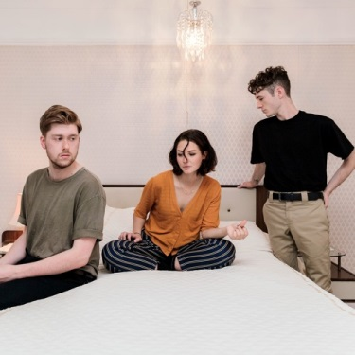  Kev Le Kat  8.30-9pm  B Band  7.30-8pm

