**Green Ginger Unleashed (working title) - by Macnas**

**a new outdoor night-time spectacle for Hull UK City of Culture 2017**

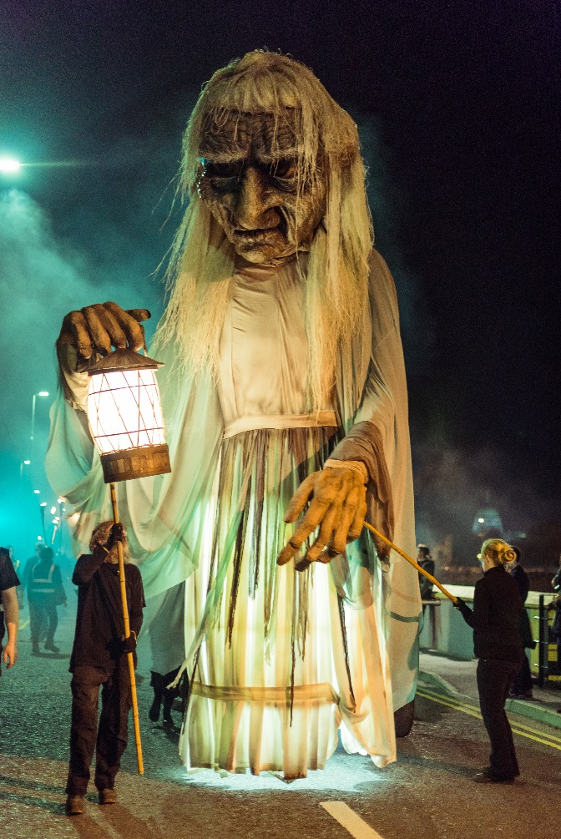

**Would you like to take part in something fantastic?**

**Show** ‘Green Ginger Unleashed’ is a brand new large-scale outdoor parade for audiences of up to 35,000 people, specially created for Hull 2017 by an internationally touring team of artists. It will be free to the public, performed in the city centre and bring the Land of Green Ginger story to life. It features fire, pyrotechnics, large-scale puppetry and promenading action taking place in and around the audience. This is a secret project and we would ask you to be part of keeping this secret to help bring a magical surprise to the people of Hull. If you’re interested in taking part in this exciting performance read on!

**Taking Part** This is an opportunity for up to 130 local participants to take part in a major outdoor spectacle. You will work with a team of expert practitioners, who will give you on-site training and workshops and rehearsals in outdoor performance. There are several types of roles including but not limited to performing, puppeteering, stage managing and stewarding.

**To find out more,** come join us for an informal discussion and workshop about outdoor performance.

**Date:** 16 September 2017

**Time**: TBC

**Location**: Holy Apostles Church, Thornton Estate, 59 Walker Street, Hull, HU3 2HD