Show me the money!
Culture and business: the benefits of investment in culture.
Hull 2017 raised more corporate money for its year as city of culture than the London Olympics did for the Cultural Olympiad. The benefits of working with a range of businesses and organisations whose investment in City of Culture go far beyond the obvious. The discussion focuses on the crucial nature of this investment and highlights the benefits to place, people and the local economy when business and culture find the correct synergy.
Susannah Simons - Chair
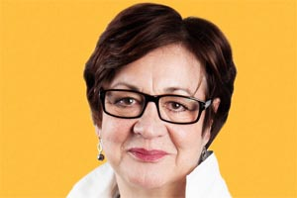
Susannah Simons is Director Arts and Outreach for Canvas, the Arts Council England funded project designed to grow the audience for arts based online video particularly among the 18-30 year old demographic, whilst simultaneously developing the skills base of the sector with a mixture of online tutorials, workshops ,one-to-one surgeries and advice on digital strategy.
She was previously the Head of Policy and Outreach for BBC Radio and Music and was the Project Director of the BBC's engagement with the Cultural Olympiad between 2008 and 2013 , in which role she was also responsible the pilot phase of The Space.
She began her career as a broadcaster with BBC Radio 4 presenting the PM programme , World at One and Today before joining Channel 4 as presenter of Business Daily. She was one of the original presenters at Classic FM before swapping sides to become the Director of Communications of the GWR group and then returned to the BBC in a management role.
She is a Trustee of The Orchestra of the Age of Enlightenment , One Dance UK and the PRS Foundation for Music.
Dominic Gibbons- Panellist
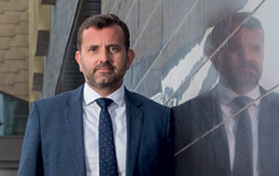
Managing Director of Wykeland Group
Dominic has been the Group Managing Director of Hull based Property Development and Investment Company, Wykeland Group, since 2009.
As well as having a property portfolio which stretches from Grimsby to Glasgow Wykeland have a current £300M commercial property development programme within the Yorkshire and Humber region and being based in Hull have been at the leading edge in supporting the cultural regeneration of the City.
As a Major sponsor of 2017 they have delivered the Amphitheatre at @thedock and in partnership with Beals and Hull City Council have developed the Humber Street Gallery in the Fruit Market for the 2017 Culture Company. Wykeland continue to be a main sponsor of the annual Freedom Festival and have in the past supported the likes of Ferens Art Gallery, Kingston Art Group, Gallery 1 monthly meet ups, and the Toad (Larkin) and Moths (Amy Johnson) public art programmes in the City. Cultural and Social regeneration is at the heart of Wykeland’s physical regeneration strategy.
Dominic is also a Member of Council at the University of Hull and its Finance Committee, a Member of the CBI Yorkshire and Humber Regional Council, a Member of Hull City Council City Leadership Board, a Trustee of Holy Trinity Church Developments, a Director of C4Di Limited and Chairs the Estates and Capital Works Committee at Hymers College.
Francesca Hegyi - Panellist
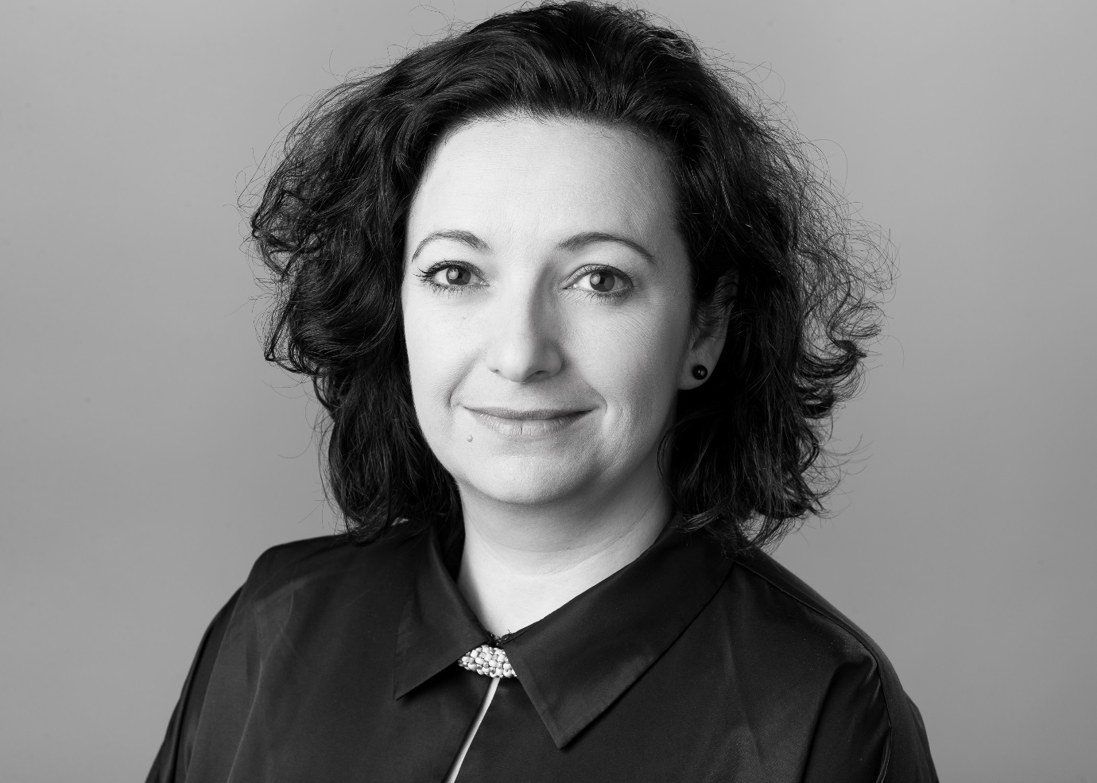
Executive Director Hull 2017
Fran Hegyi has worked in culture and the arts for the last 20 years.
She began her career in museums and galleries in London and Scotland. From there she took up the position of Head of Regions and International at MLA, the national council for museums, libraries and archives in the UK, and worked on the development of national and regional policy for the sector. In 2005 Fran joined the London Organising Committee for the Olympic and Paralympic Games, where she led fundraising and commercial partnerships for the Cultural Olympiad and London 2012 Festival, the £126m UK-wide programme. Following the 2012 Games, Fran became an affiliate at King’s College London’s Cultural Institute, leading the first Cultural Enquiry into Culture and Major events, exploring how to maximise the benefits that culture can bring to major events.
Fran joined Hull 2017 in February 2015 as Executive Director and Director of Partnerships & Development. Her role is to manage the UK City of Culture company and secure the funding and partnerships to deliver 365 days of transformative culture.
She holds degrees from the University of Edinburgh, Imperial College London and Warwick Business School.
Pat Connor - Panellist
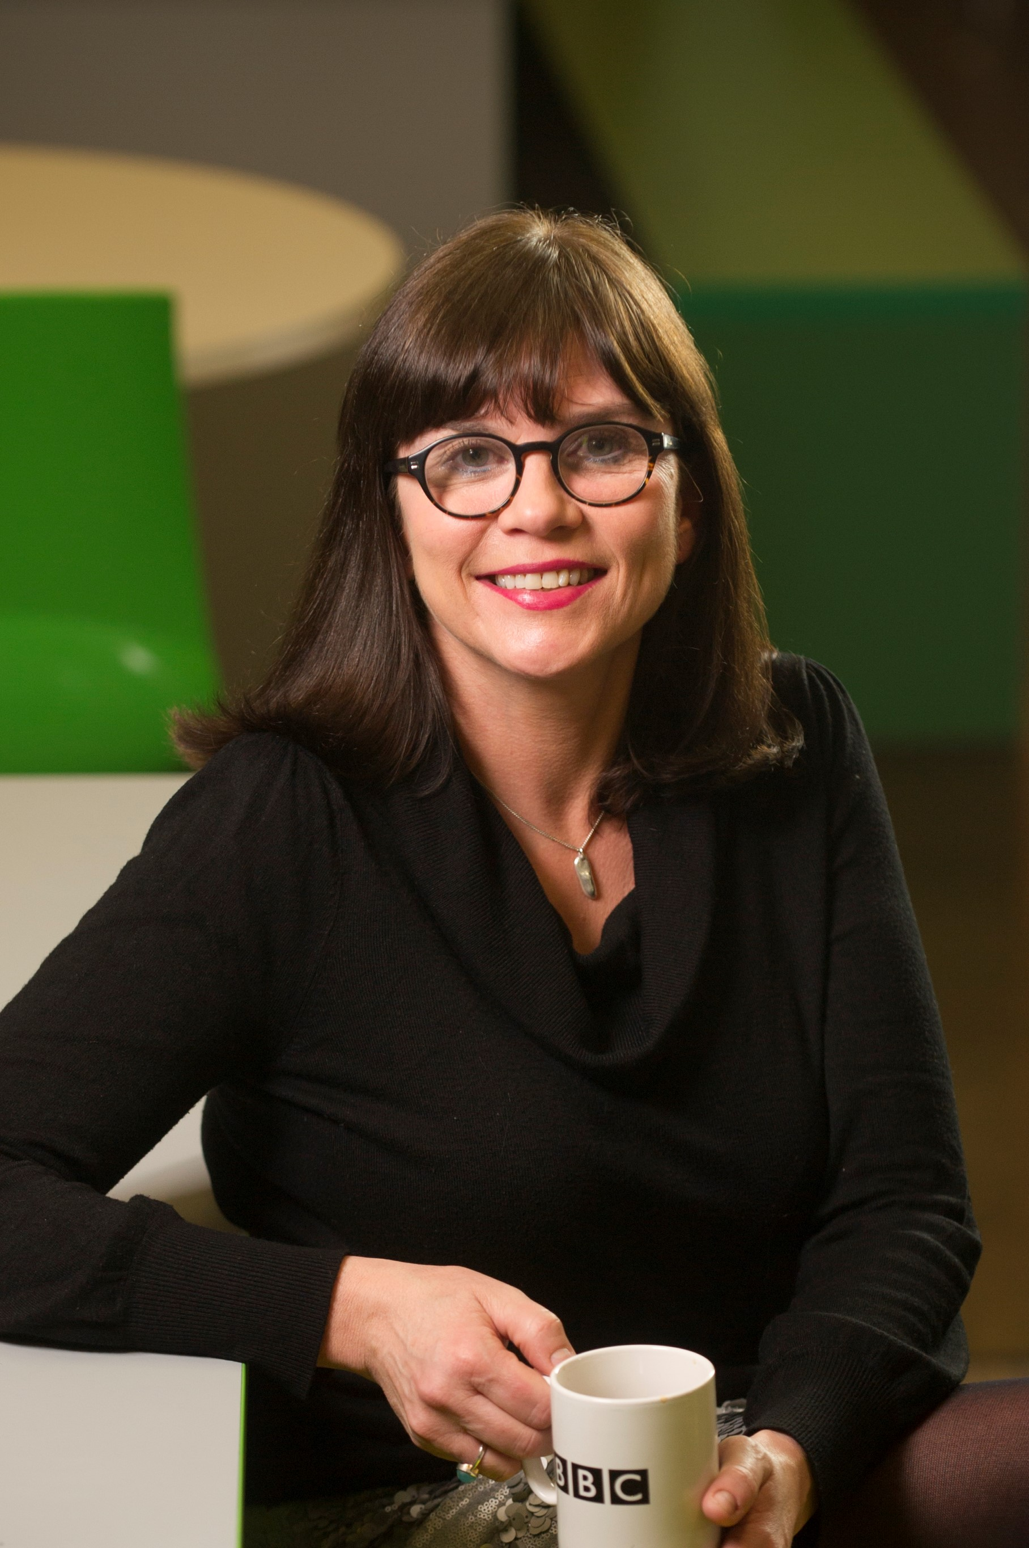
Head of BBC Development & Events, UK & Director, BBC South West
Pat Connor became Director, BBC South West in December last year alongside her role as the BBC’s Head of Development and Events across the UK.
As Director of BBC South West Pat sits on the newly created BBC Nations and Regions Board and she oversees the BBC’s audience, external stakeholders and staff engagement in the region, representing the BBC in both the South West and the West. She also provides overall leadership for BBC Bristol. She chairs the BBC Bristol Partnership which she signed, along with the key partners, for the third time in February last year, reinforcing the BBC’s commitment to Bristol.
In her role as Head of Development and Events Pat oversees the BBC’s strategy to improve connection with regional audiences through facilitating content production and live events across the UK. Her live event projects have ranged from the 6Music Festival in Bristol to the Great North Passion in South Shields and the BBC Philharmonic Presents Tour across the North of England. Pat also oversees major projects for the BBC such as Shakespeare 400 in 2016, The Manchester International Festival and the BBC’s partnership with Hull, UK City of Culture 2017.
Previously Pat worked as series producer of the Culture Show on BBC Two and as Head of Development for BBC Arts. She began her career as a music journalist and presenter at BBC Radio Bristol before joining BBC Radio Four to make dramas and poetry programmes. She later became Head of specialist and mainstream music programmes at Radio 1, developing an expertise in live events across the BBC.
Dr Kevin Moore - Panellist
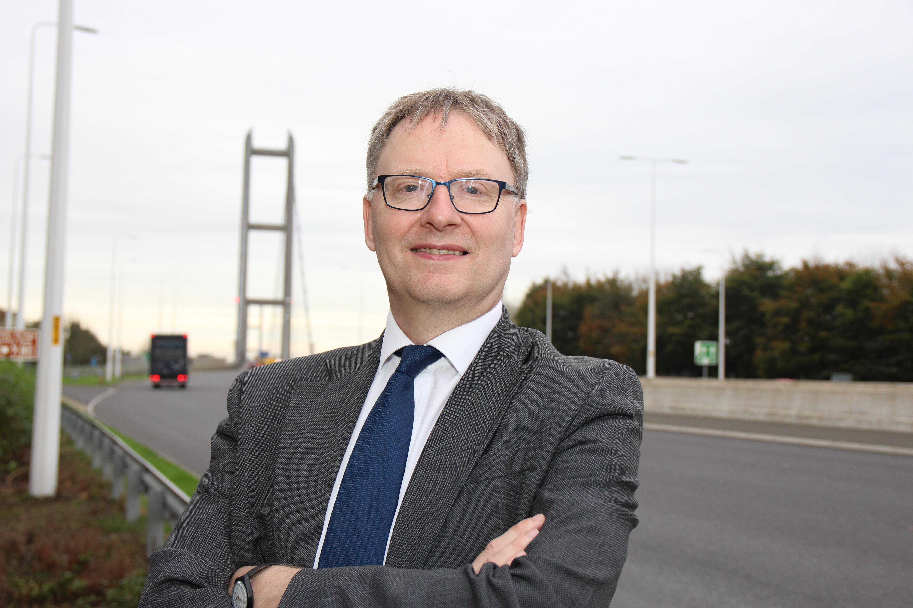
Chief Executive at Humber Bridge
From February 2017 Kevin Moore has been Chief Executive of the Humber Bridge Board. He is responsible for operating and developing the Humber Bridge, an important piece of national infrastructure, and developing it into a major museum/visitor attraction.
Kevin was previously the founding Director of the National Football Museum. He is an experienced museum professional of international stature. He is regularly invited to give papers at academic and museum conferences around the world, and has published a number of books and papers about museums, football and sport, including Museums and Popular Culture, Sport, History and Heritage, and the Routledge Handbook of Football Studies.
As Director of the National Football Museum, Kevin led the team which created the world’s leading football museum, the most visited national sports museum in the world, with the world’s greatest collection of football’s history and culture.
Kevin is a Visiting Fellow at the University of Central Lancashire, De Montfort University and Manchester Metropolitan University. He is a member of the Arts Council England Designation Scheme Panel and of the Advisory Board of the University of Cambridge Doctoral Training Programme.

