**We made ourselves over**

16:45 – 17:30 at C4DI Theatre

**Nick Tandavanitj**

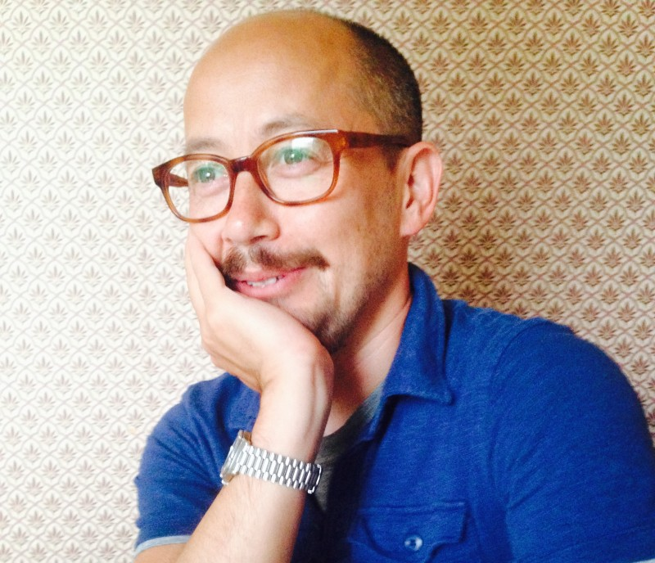 Blast Theory and Arts & Humanities Research Council Research Fellow at the Uni of Notts

**Rich Wilson**

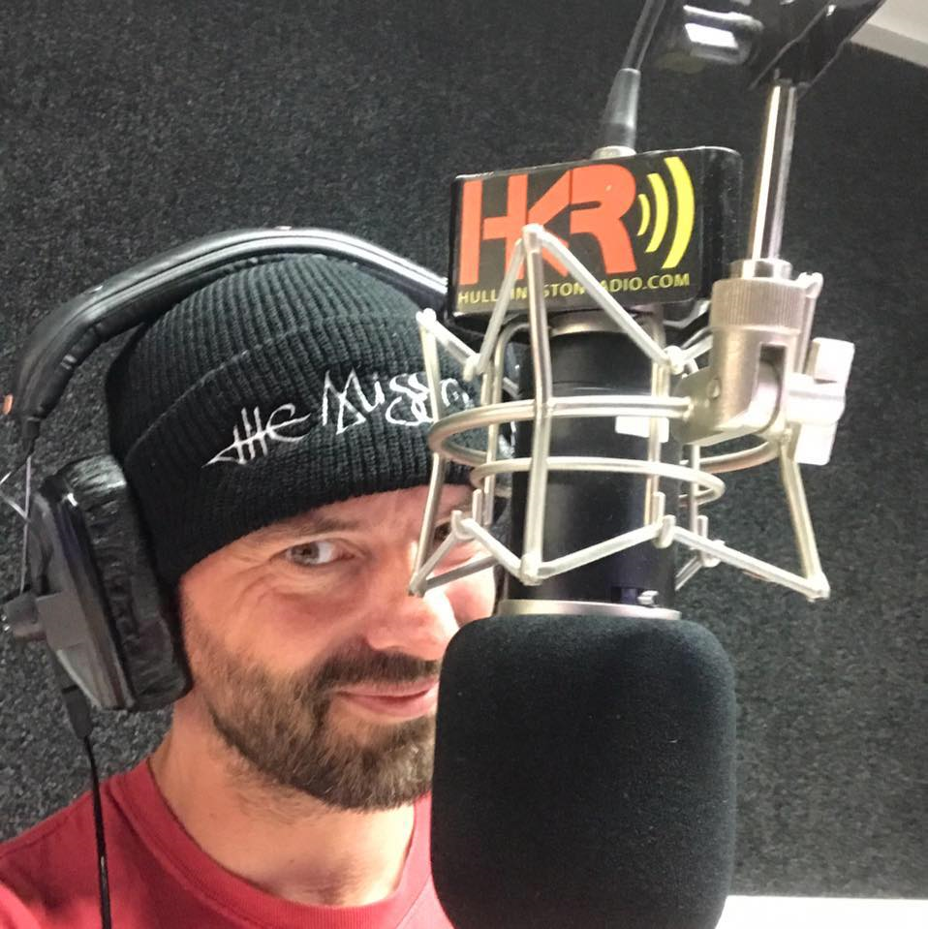 One Hull of a City