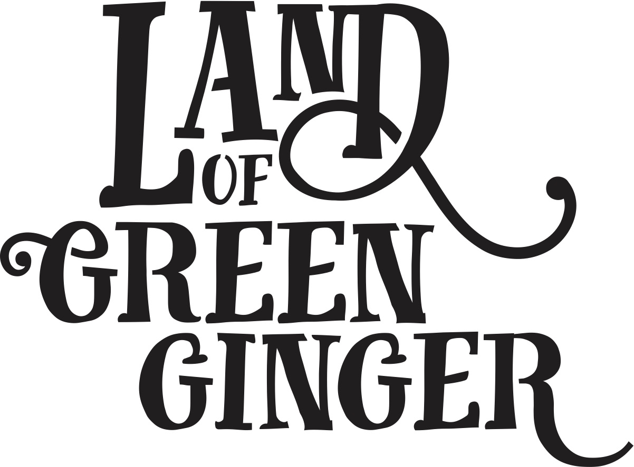

**Book**

**Project Plan**

**Summary**

Throughout the year Hull 2017’s ground-breaking community engagement project, Land of Green Ginger, invited Hull’s residents to immerse themselves in a magical citywide story, inspired by and celebrating the spirit of Hull.

In 2018, the Land of Green Ginger story will culminate in a seventh Act of Wanton Wonder – a beautiful book that will be delivered to every household in Hull.

The Land of Green Ginger book will tell the stories of the project, the narrative as it took place and the stories of the local people it touched. It will be the record of City of Culture as lived by the residents of the city and as informed by their imagination and creativity.

This project plan outlines the possible formats, timescales and budget for delivery of the Land of Green Ginger book.

**Quantities**

x118,500 for postage to reach every home in Hull

**\*Suggest an additional 5,000 for potential schools workshops**

**Style Options**

260x210mm *(the same size as “hello hull” magazine)*

60 pages

300gsm outer cover

120gsm inners

Option 1

Full colour throughout. Special finish on cover. PUR bound - £55-60k.

Option 2

Black and white inside. Saddle stitched finish - £45-50k

**Postage Costs**

For either option, delivery to 118,500 households - £40-50k.

**Timescales**

For delivery in middle of March to tie in with the programme announcement on 15 March we’d be looking at the following booking and print timescales.

**Option 1**

Printing booked by 31 January.

Sent to print W/C 12 February.

Delivered on Thursday 15 March.

**Option 2**

Printing booked by 31 January.

Sent to print W/C 19 February (difference of 4 working days).

Delivered on Thursday 15 March.

For delivery nearer the end of March we’d be looking at the following booking and print timescales.

**Option 1**

Printing booked by Monday 12 February.

Sent to print W/C 26 February.

Delivery in W/C 26 March*.

**Option 2**

Printing booked by Monday 12 February.

Sent to print 5 March (difference of 4 working days).

Delivery in W/C 26 March*.

*This is half term week. Schools workshops wold potentially be possible in the week before or the week after.

**Budget**

**Option 1**

|  |  |
| --- | --- |
| Writer/Illustrator | £15,000 |
| Design | £10,000 |
| Print | £60,000 |
| Postage | £50,000 |
| **Total** | **£135,000** |

**Option 2**

|  |  |
| --- | --- |
| Writer/Illustrator | £15,000 |
| Design | £10,000 |
| Print | £50,000 |
| Postage | £50,000 |
| **Total** | **£125,000** |