**Songs of Flight, 20 April 2018**

Songs of Flight brings together people of all ages and from all walks of life in the creation and performance of a new 45 minute work for massed chorus and City of Hull Youth Symphony Orchestra.  Inspired by the incredible true stories of bird migration, Hull residents have written lyrics and melodies, arranged by composer James Redwood into a new composition looking at why birds migrate, how they navigate and the perils that they face on their long and arduous journeys.

Woven into Sounds of Flight are 4 musical sections created by the community groups working alongside professional composers and musicians:  Hull Freedom Chorus and Hull2017 Volunteers with composer and song-writer Hannah Peel; Open Doors (a group supporting refugees, asylum seekers and migrant workers) with percussionist extraordinaire Gary Hammond; residents of Pickering and Ferens Homes with local folk hero Sam Pirt; and Students from Wyke College with Ben Newton, Mambo Jambo and local Turkish musicians.

This mammoth new commission is presented as part of the PRS Foundation’s New Music Biennial Composer Residency programme with Hull Music Service, supported by Hull City Council, and celebrates music making and the creative talent of our city.

PRS Foundation’s New Music Biennial residency programme is generously supported by Hull UK City of Culture, Paul Hamlyn Foundation and Arts Council England. [www.newmusicbiennial.co.uk](http://www.newmusicbiennial.co.uk/)

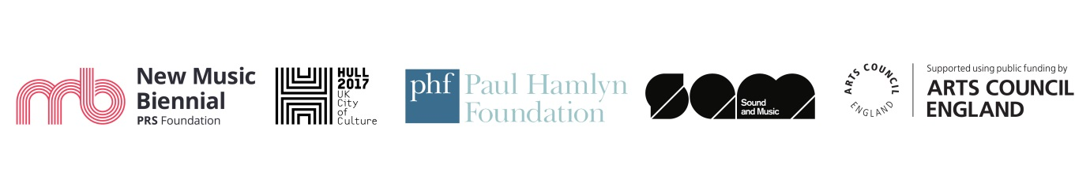

NOTE

If it’s necessary to separate the logo lock up from the brochure copy about the event, please could the logo lock up be preceded by the following line of text:

“*PRS Foundation’s New Music Biennial residency programme is generously supported by*:”



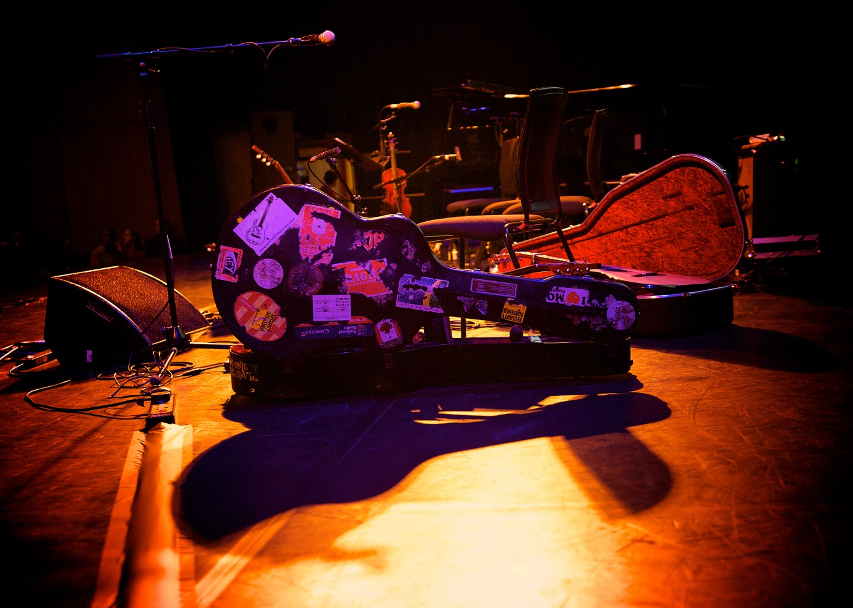

Photograph by Elliott Franks

**Short version:**

**Songs of Flight, 20 April 2018**

A new 45 minute work for massed chorus and City of Hull Youth Symphony Orchestra, inspired by the theme of bird migration. Created as part of the PRS Foundation’s New Music Biennial composer residency programme with composer James Redwood, featuring contributions from local groups working with: composer and song-writer Hannah Peel; percussionist Gary Hammond; local folk hero Sam Pirt; Ben Newton, and Mambo Jambo.

This mammoth new commission is presented as part of the PRS Foundation’s New Music Biennial Composer Residency programme with Hull Music Service, supported by Hull City Council.

PRS Foundation’s New Music Biennial residency programme is generously supported by Hull UK City of Culture, Paul Hamlyn Foundation and Arts Council England. [www.newmusicbiennial.co.uk](http://www.newmusicbiennial.co.uk/)