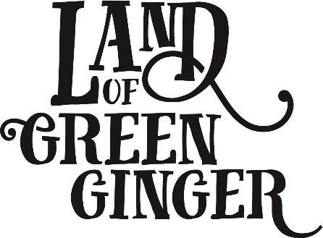

**PARENTAL/GUARDIAN CONSENT FORM**

Please complete this form, sign overleaf and return it to your group leader at the next rehearsal. A signed consent form is a condition of participation in all our activities for those under the age of 18.

I am willing for:

Name: _________________________________________________________________

Address: _________________________________________________________________

Mobile tel: _________________________________________________________________

Email: _________________________________________________________________

Date of Birth: _________________________________________________________________

Name of School: _________________________________________________________________

(PLEASE USE BLOCK CAPITALS)

To participate in rehearsals and performances on behalf of Hull 2017 and confirm that he/she is willing to participate as fully as possible.

Furthermore (please tick the following)

I permit ___________________ if necessary to travel on transport designated as official for the purpose of a Hull 2017 performance (e.g. minibus/coach).

I permit ____________________ if necessary to travel in either private vehicles or any other transport that has been designated as official for the purpose of a Hull 2017 performance.

_______________________ has the following medical condition/mental health/allergies and/or requires the following medication (Give details):

_______________________________________________________________________________

In case of emergency, leaders will do everything possible to contact parents so that appropriate medical decisions for their child. Please provide your details below.

**Parent/Guardian One: Parent/Guardian Two:**

Name: ­­­­­­­­­­­­­­­­­­­_____________________________ Name: _____________________________

Contact No: _________________________ Contact No: _________________________

Email:______________________________ Email: ______________________________

Please see overleaf →

By giving my details below and being filmed, interviewed or photographed, I understand that I may be included in Hull 2017 documentation, publicity, promotion and publications. Should you **not** wish your child to be photographed please tick

**Terms and conditions of Membership of Land of Green Ginger Unleashed Young Ensemble**

If a member leaves the building without permission or does not gain entry, Hull 2017 cannot be held responsible for the member’s safety.

Parents / guardians are reminded that members are not under the care of Hull 2017 outside designated hours of activity.

It is the responsibility of parent / guardian to inform Hull 2017 if there is a change in the members medical or other conditions.

For the duration of any programme/project Hull 2017 is running, all members must adhere to the organisation’s Drugs and Alcohol Policy which means zero tolerance in relation to anyone using/taking drugs or alcohol. A drug is any substance, other than food, that changes the way the body thinks, acts or feels.

At all times, members must adhere to an acceptable level of behaviour during all activities.

Hull 2017 is not responsible for members who do not shown up for designated activities and also once activity is finished it is the responsibility of parent/guardian to arrange how members get home.

Would you be happy for your child to be contacted to take part in research about your experience with Land of Green Ginger Unleashed?

Yes  No

Signature: _______________________ Date: _____________________

**Parent / Guardian**

Signature: _______________________ Date: _____________________

**Young Ensemble Member**