Hull station manager 'delighted' to host Gypsy Moth model
Posted at
11:54
10 Feb 17
The Manger at Hull Paragon Station, David Hatfield says they're thrilled to have worked with HMP Hull and delighted to have the model on display at the railway station.
He hopes it will become a talking point for visitors coming to Hull by train for City of Culture.
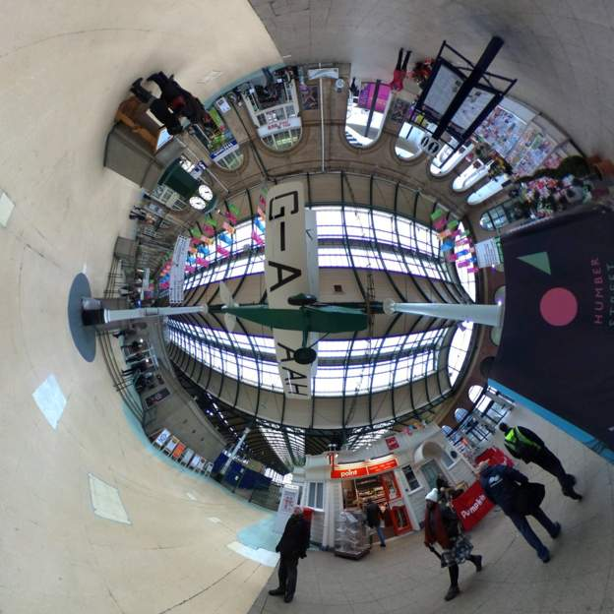
BBC
Yesterday evening the model of Amy Johnson's Gypsy Moth was installed at Hull Paragon Station after being built by inmates at HMP Hull.

