Re-Rooted: a celebration of the ROOT Festival and Hull Time Based Arts in 2017

"16 July 1985 at The Posterngate Gallery...HTBA was formally constituted. The organisation's founding principles were to bring together experimental and avant-garde areas of work, to establish funding and resources and to make work available to a wider audience. Co-operation, anti-sexism and anti-rascism were central"

– Rob Gawthrop, Out of Time: Hull Time Based Arts 1984-1998, p. 150

Focus: Reflecting on the best practice and impact of artists work placed in the public domain during the glory days of Time Based Arts and 10 years of the ROOT Festival and the impact of independent arts practice on Hull.

Re-Rooted will look not only at the period of HTBA between 1984- 2002 but also where its founding aspirations for experimentation, publicness and cooperation can be identified in the years preceding.

It’s establishment and it’s legacy for artists working internationally since it dissolved.

The symposium will gather together speakers both within and outside Hull to reflect upon contemporary local and global conditions in relation to the founding principles of HTBA.:

-Bring together experimental and avant-garde areas of work
-Establish funding and resources
-Make work available to a wider audience
-Cooperation
-Ant-sexism
-Anti-racism
-Quest for independence or claim for freedom outside market
-Network and topologies
-Interdisciplinary
-New technologies

since. conditions specific to Hull that

in Hull that preceded it of collective improvisation tied to a late modernist ideal of an avant-garde.

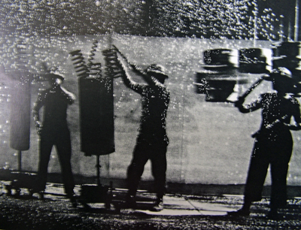

The Bow Gamelan Ensemble (Anne Bean, Richard Wilson and Paul Burwell) performed at the Ferens Gallery in 1984 where the smoke detectors were set off and the fire brigade arrived, adding their sirens to the fire alarms of the gallery to the sound-scape.

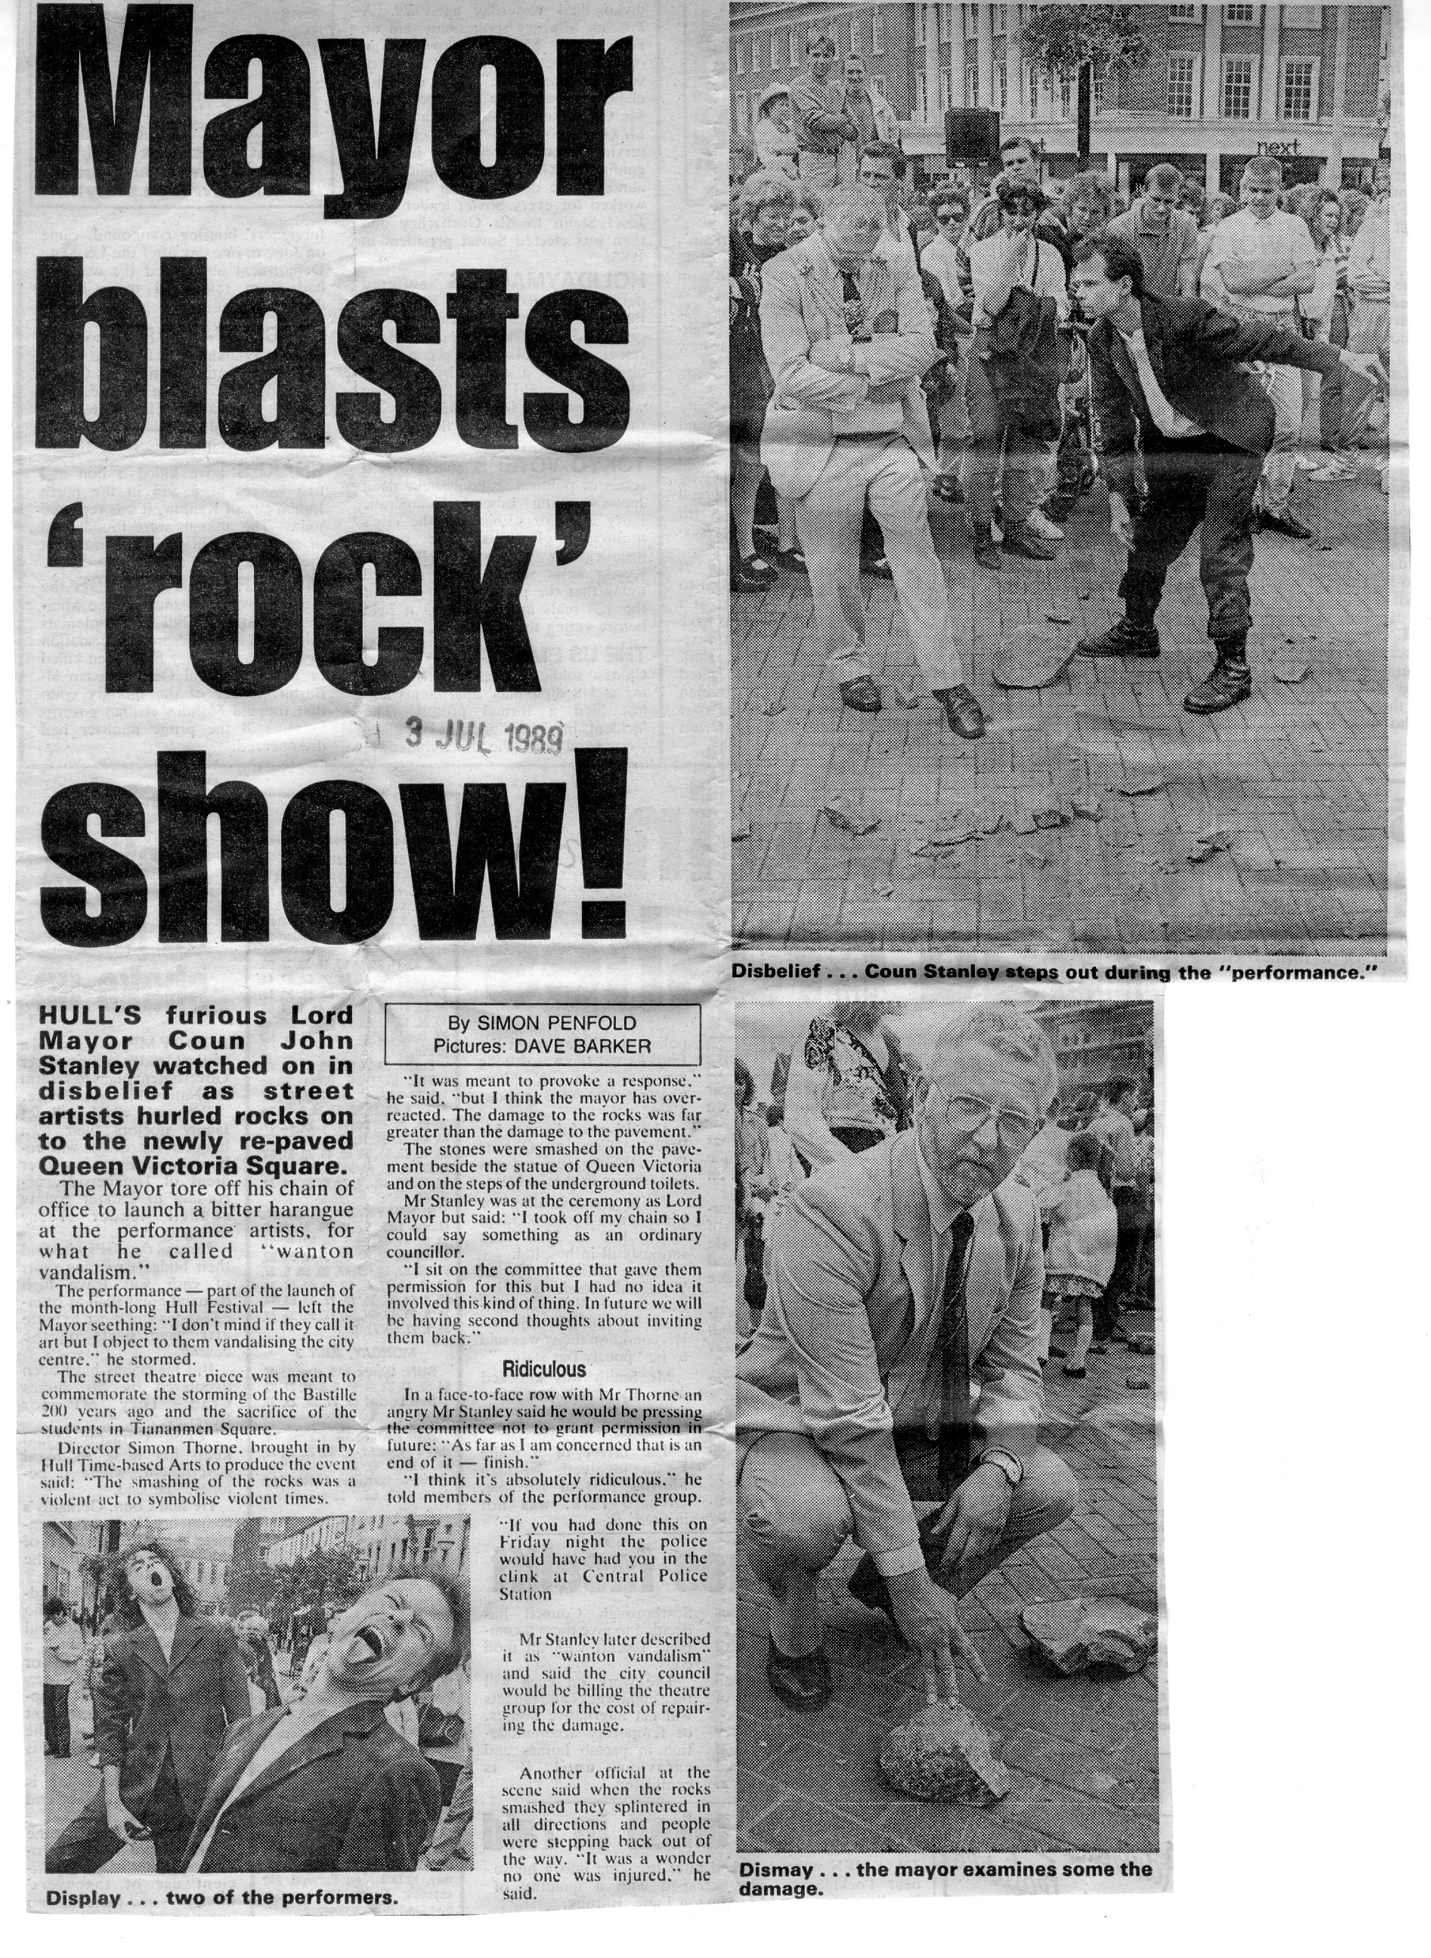

HTBA collective actions such as Throwing Stones in the Town Square, which took place outside Ferens Gallery, Hull (Man Act, Simon Thorne and Philip McKenzie, 1989), referred to earlier anti-establishment, co-produced art movements such as the Situationists and Fluxus. The both destructive and celebratory action, in the centre of Victorian civic public space was undertaken without formal consent and heavily criticised by the local council and press.

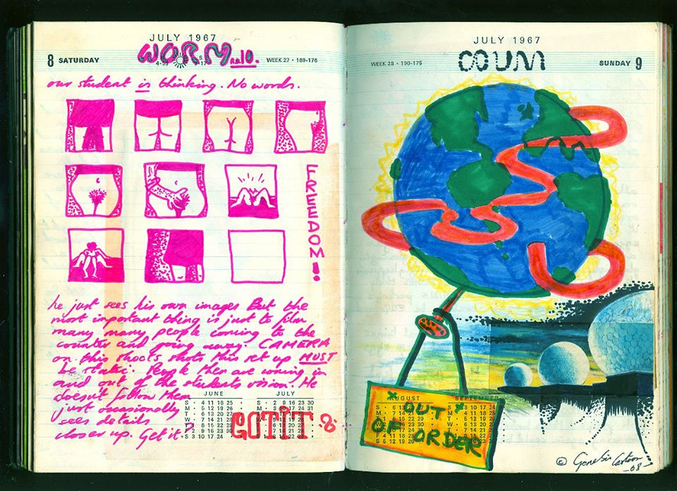

COUM Transmissions performance at the Gondola Club on Little Queen Street in Hull, was raided by the police after a riot broke out. The club closed down permanently soon after the performance, and COUM were blamed across the city for its closure, resulting in them being unofficially banned from playing in Hull again

Work with Rob Gawthrop and Anne Bean to create a contemporary iteration of the boathouse?

COUMs and HTBA – idea of avant-garde influenced by Dada and Situationism. Find other contemporary artists also working in this lineage?

First big COUMs gig, supporting Hawkwind in Hull in 1971

How: Time based media, involving artwork that unfolds over time performance, critical intervention and media projects engaging local people and in collaboration with significant international contemporary artists.

Commissioned site-specific work and performances.

A film programme of works commissioned by HTBA and aeries of short films made by Video in Common exploring the history of HTBA.

Where: The festival event will be across the city implementing peripatetic, interstical and significant sites. An exhibition is feasible, funding and gallery space permitting.

What: A two day creative event (party) with a new program of performances, film events and site specific interventions by artists originally part of ROOT/HTBA and contemporary artists both influenced and now emulating values of experimentation and risk.

A network of activities in cultural institutions, civic space and living environments will include: art and media installations, performances, film program, social events and creative information exchange.

New Commissions, informal symposia and publication investigating how current practice has been informed through radical and practical interventions of embodied and performative improvisation pioneered in Hull.

A short informal round-table will discuss and document themes and practice and how this is relevant today.

The event will be revelatory, radical and entertaining, ROOT set in a contemporary setting and within a new agenda of talent development and retention.

Creative projects to be jointly commissioned and presented by Hull UK City of Culture and the curators.

Key artistic contributors under consideration include

- Heather Ackroyd, Dan Harvey
- Julie Bacon
- Rachel Baker
- Anne Bean (Bow Gamelan Ensemble)
- Heath Bunting
- Paul Burwell
- COUM transmissions
- Philip Courtney
- Fran Cottell
- Gillian Dyson
- Dave Ellis
- Mark Fell
- Rob Gawthrop
- Geoff Hobbs
- Roddy Hunter
- Esther Johnson
- Alastair MacClennan
- Jo Millet
- Hayley Newman- HK
- Richard Parry=HK
- Dave Priestman
- Karen Rann
- Gnod- HK
- Trebor Scholz
- Richard Sides-HK
- Mike Stubbs
- Reto Pulfer- HK

Partners in UK:
FACT

Curatorial Research team:
Jo Millet, Rob Gawthrop, Mike Stubbs, Gillian Dyson, Helen Kaplinsky, Noami Pearce, Andy Abbot Yvonne Carmichael.

