**What is the role of a capital city**

15:45 – 17:30 at C4DI Theatre

**Anna Wood -**

Reviews Editor, The Quietus

**Paddy Clarke -**

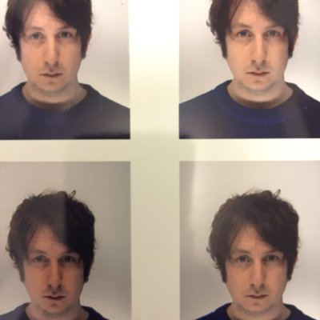 Staff Writer at The Quietus, the rock music and pop culture website

**Katherine Cantwell -** 07583 434259

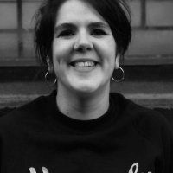 Online content manager at Heavenly Recordings.

**Vanessa Reed -** O7766268706

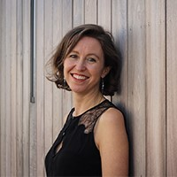 Leads the overall strategic direction of the PRS Foundation.

**Cheidu Oraka -** O7729409125

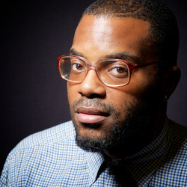 UK rapper residing out of the city of Hull (HU6).

**Mal Campbel**l - 07716 532019

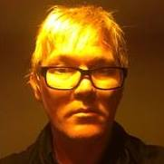 Promoter of the Trades Club in Hebden Bridge.