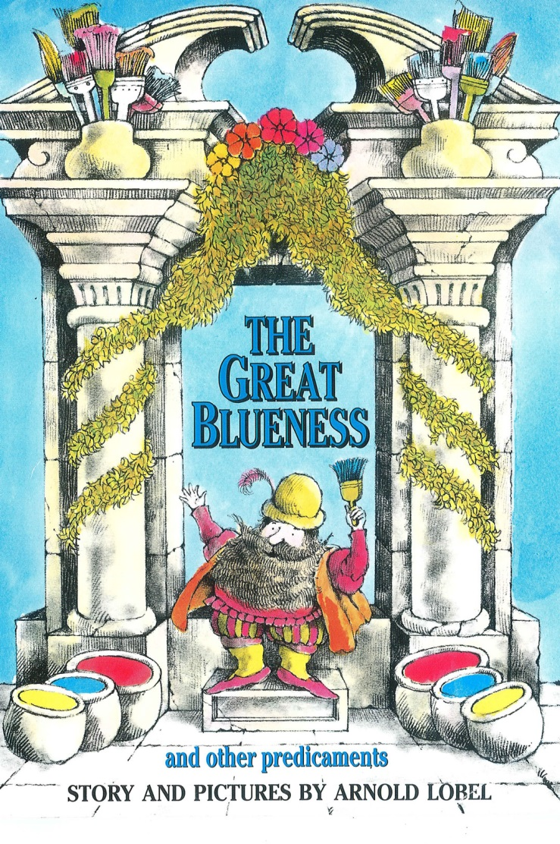

This beautiful and fantastic story celebrates difference.

The world would be a boring place if it were all the same colour.

We have the freedom to be individuals, expressing ourselves in different ways. This project gives Hull and the rest of the UK the opportunity to celebrate our differences.

A wizard lives in the time of The Great Greyness and he is not happy with the world. One day, while experimenting with potions he discovers a colour, which he names blue.  With the help of his neighbours the wizard colours the world blue, starting on his and their journey to create a multi-coloured and beautifully diverse world.

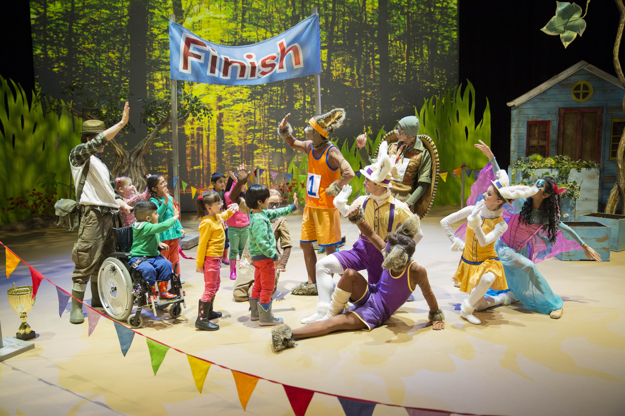

Northern Ballet and the BBC (CBeebies) are collaborating to create a colourful new interactive children’s ballet based on the book *The Great Blueness and Other Predicaments* by Arnold Lobel.

This will premiere and be performed in Hull in August 2017 during the Hull 2017 “Freedom” section of the festival and then broadcast on CBeebies with associated digital web and short form content.

The ballet will be choreographed and directed by Daniel de Andrade, accompanied by a commissioned score from Gary Yershon with costume and set designs by Mark Bailey.

Northern Ballet is a powerhouse of inventive dance. Bold and confident in approach, it engages, involves and moves audiences. It reaches a diverse range of people through passionate story-telling, a mastery of classical dance technique and an absolute commitment its leading role as an international ambassador for world-class dance.

Over the past four years Northern Ballet have produced ballets specifically for children of pre-school age – Ugly Duckling; Three Little Pigs; The Elves and the Shoemaker and Tortoise and the Hare. Each of these has been filmed and broadcast on CBeebies creating dance events for the Channel, with the Ugly Duckling winning the Children’s BAFTA for Best Pre-School Live Action Programme.

CBeebies is the multi platform brand used by the BBC for content aimed at encouraging "learning through play in a consistently safe environment for children aged 6 or under" and providing "high quality, mostly UK-produced content". CBeebies is the most-watched children's channel in the UK.

Developing the choreography with local children, filming the scenic backdrops in local communities, creating a fantastic multi-coloured final scene in East Park with children, families, schools and groups from all around Hull – *The Great Blueness* gives amazing opportunities for community involvement. Hull itself will be part of every backdrop with streets collaborating to paint houses, city fountains with coloured water and city buildings changing colour through the fully controllable city LED lighting installation.

Digitally this project aims to colour the whole of the UK, celebrating diversity everywhere as audiences help the Wizard. Resources will be created and disseminated through websites and social media with easy ways for parents, carers and early years workers to play and interact with colour in activities and learning for all.

There will be legacy for Hull in the work local communities create together, encouraging young children to engage in the arts while bringing together those who may never have met or had the chance to perform before. As well as reaching out to the UK, this project truly can influence the whole city

Let’s paint Hull Red and Yellow and Blue!

