2018

Hull 2017 UK City of Culture Back To Ours Festivals 1 - 4 Report



**Hull UK City of Culture**

**Back to Ours – Festival 1, 2, 3 and 4**

**ACKNOWLEDGEMENTS**

This report was prepared for Hull UK City of Culture 2017 in March 2018.

Our thanks are given to:

* Elinor Unwin at Hull 2017;
* Members of the public who participated in the research;
* Hull 2017 Staff and Volunteers who gave their valuable time to support IbyD staff at various venues during names collection.

**Authors:**

Kate Marshall, Gillian Roberts, Steve Wisher, Tom Wisher

Main point of contact: [kate.marshall@ibyd.com](mailto:kate.marshall@ibyd.com)

Draft Report – March 2018

IBD Logo Envelopes

**Head Office**

Information by Design Ltd

Newlands House

Newlands Science Park

Kingston-upon-Hull

HU6 7TQ

Telephone: 01482 467467

Fax: 01482 467468

Email: [info@ibyd.com](mailto:info@ibyd.com)

Web: [www.ibyd.com](http://www.ibyd.com)



Contents

executive Summary 4

1 BACKGROUND AND METHODOLOGy 7

Background 7

Methodology (Festival 3 and 4) 7

Quota (Festival 3 and 4) 9

Weighting (Festival 3 and 4) 9

Sample Size 9

2 SURVEY FINDINGS 10

Demographics 10

IMD Analysis 12

Children in the Party 13

Shows and Venues Attended 14

Motivation to attend ‘Back to Ours’ 17

Previous ‘Back to Ours’ festivals attended 20

Visitor Experience 21

Providing Feedback 32

Arts and Culture 35

Marketing and Visitor Engagement with Hull 2017 41

Proximity to venues 44

Visitors to Hull 46

Overnight Visitors 49

Visitor Satisfaction (non-Hull residents) 49

Visitor Spend 50

3 CONCLUSIONS 52

Appendix A – Profile of Respondents – WEIGHTED DATA 54

APPENDIX B – Audience Maps 56

Appendix C – Base Sizes for Subgroups 64

APPENDIX D – Ace Quality Metrics 65

# executive Summary

This report contains the findings from the survey with visitors to the various ‘Back to Ours’ events in Hull during Festival 1, 2, 3 and 4. For Festival 3 and 4, the research was commissioned by Hull UK City of Culture 2017 and conducted by Information by Design (IbyD). Names and contact numbers were collected from visitors across the city in early November 2017 and February 2018 and visitors were subsequently contacted via an online or CATI survey in the following two weeks.

Key findings from the research include:

* 40% had attended a venue in East Hull, with 22% attending the Freedom Centre and 21% Archbishop Sentamu Academy. 48% had attended a venue in North Hull, with 17% attending Winifred Holtby Academy, 26% North Point Shopping Centre and 8% Kingswood Academy. 31% had attended a venue in West Hull, with 12% attending Hymers College, 13% Sirius Academy West and 9% William Gemmell.
* When asked what was the main reason for attending the ‘Back to Ours’ festival, 27% had attended because was part of Hull 2017, 26% because it was something to do with the kids, 20% because they had a specific interest in one of the artists or actors involved and 19% because they had a general interest in this type of event.
* 29% had attended a previous ‘Back to Ours’ Festival at the time they were interviewed, with 19% having attended the festival in February, 14% in May and 9% in October.
* 82% of respondents were very likely to recommend ‘Back to Ours’ to friends or family, giving a score of 9 or 10 out of 10. Less than 1% of respondents were very unlikely to recommend ‘Back to Ours’ (a score of 0 or 1). The mean score for recommendation was 9.38.
* 98% of respondents agreed that ‘Back to Ours was an enjoyable experience’ and 93% agreed that ‘Back to Ours gave everyone the chance to share and celebrate together’.
* 88% of respondents strongly agreed (a score of 9 or 10) that ‘I would come to something like this again and 82% strongly agreed that ‘it is important that it’s happening here (in the community)’.
* 80% rated the ‘Back to Ours’ venues as better than city centre venues for affordability and 74 rated them better for parking. 46% rated the ‘Back to Ours’ venues as better than city centre for atmosphere and 43% rated them better for accessibility. Only 26% rated the ‘Back to Ours’ venues as better than city centre venues for facilities, while 24% rated them as worse.
* The majority of respondents agreed that they had felt welcomed at ‘Back to Ours’ with 97% agreeing that they had felt welcomed by volunteers and 96% that they had felt welcomed by staff.
* 96% had given feedback by providing contact details to take part in an online or telephone questionnaire, 39% by using the usherette tray, 22% using emoji masks, 21% by a ‘chat with gran’ and 3% by attending a focus group.
* Of those who gave feedback using this method, 93% liked ‘chat with gran’, liked using emoji masks, 88% liked attending a focus group, 87% liked using the usherette tray and 81% liked providing contact details and taking part in an online or telephone questionnaire as method of giving feedback.
* Of those who did not give feedback using this method, 63% would like using the usherette tray, 55% would like having a ‘chat with gran’, 45% would like providing contact details to then take part in an online or telephone questionnaire, 43% would like using emoji masks and 31% would like attending a focus group as a method of giving feedback.
* 93% had attended a museum, gallery or other historic attraction, 92% had attended a creative, artistic, dance, theatrical or music event or performance in the last 12 months and 57% had taken part in a creative, artistic, dance, theatrical or music activity or spent time doing a craft in the last 12 months.
* 88% had attended a museum or historical attraction in the last 12 months. Over 70% had attended a music event, an outdoor event, a film, festival or the theatre. 98% of respondents had attended at least one of the activities asked about and 27% had taken part in at least one of the activities asked about
* 38% had found out about ‘Back to Ours’ from the Hull 2017 website. 31% had found out from family friends and colleagues and 27% from Hull 2017 social media.
* 87% had attended or were planning to attend or take part in other events and activities programmes for Hull 2017.
* Of the respondents who had attended these venues, 70% or more lived within 5 miles of Sirius Academy West, William Gemmell and Kingswood Academy. Over 60% lived within 5 miles of Hymers College, Archbishop Sentamu Academy and North Point Shopping Centre. Over 50% lived within 5 miles of Winifred Holtby Academy and the Freedom Centre. 70% of respondents lived within 5 miles of at least one of the venues they attended.
* Of the respondents who had attended these venues, 20% or more had visited the area around the Freedom Centre, North Point Shopping Centre, Archbishop Sentamu Academy, Winifred Holtby Academy and William Gemmell before. Over 10% had visited the area around Hymers College, Kingswood Academy and Sirius Academy West before.
* 79% of respondents from outside of Hull were in Hull ‘mainly’ to attend ‘Back to Ours’ when they attended the ‘Back to Ours’ show.
* A third of respondents who were visitors to Hull when they attended ‘Back to Ours’ had taken part in another arts or cultural activity during their visit to Hull, with 8% having taken part in one activity, 9% two or three activities and 16% four or more activities.
* Attending ‘Back to Ours’ was the main reason for their visit to Hull for 70% of respondents who were visitors to Hull. 13% stated that the main reason for their visit to Hull was because Hull is UK City of Culture.
* 96% of respondents who were visitors to Hull had been to Hull before coming to Back to Ours. Of these, 6% visit Hull twice a year or less, 10% visit Hull three to six times per year and 84% visit Hull more frequently than six times a year.
* Of the respondents who were visitors to Hull and had been to Hull before coming to Back to Ours, just over a third (34%) thought that the frequency of their visits to Hull over the course of the year would increase based on their experience during their visit when they attended ‘Back to Ours’ and nearly two-thirds thought that the frequency of their visits would stay the same.
* Of these respondents who were visitors to Hull, 88% were in Hull just for the day and 12% were staying overnight when they attended ‘Back to Ours’. Of the 12% who were staying in Hull overnight, 33% were staying in the area for 1 night, 35% for 2 nights and 33% were staying for 3 or more nights. 65% were staying with friends and family, 30% were staying in a hotel and 5% were camping. The mean spend on accommodation was £71.
* Hull was rated highly on overall value for money, visitor welcome and places to eat and drink with 91% of respondents satisfied with overall value for money, 88% satisfied with the general visitor welcome and 80% satisfied with places to eat and drink (a score of 4 or 5 out of 5).
* Respondents estimated that they spent a mean of £35.05 on themselves and others with them in Hull when they attended ‘Back to Ours’. 47% of this spend was on food and drink, 14% was on travel and transport and 13% was on shopping.

**Information by Design**

**March 2018**

# 1 BACKGROUND AND METHODOLOGy

## Background

* 1. This report contains the findings from the surveys undertaken with visitors to the various ‘Back to Ours’ events in Hull during Festivals 1, 2, 3 and 4. For Festival 1 and 2, the research was undertaken internally by Hull 2017. For Festivals 3 and 4, the research was commissioned by Hull UK City of Culture 2017 and conducted by Information by Design (IbyD). Names and contact numbers were collected from visitors across the city in early November 2017 and February 2018 and visitors were subsequently contacted via an online or CATI survey in the two weeks following the Festivals.
  2. The overall aim of the research was to provide information to support the evaluation of the process and impact of ‘Back to Ours’. Key objectives were to:
* Assess the reach of the ‘Back to Ours’ festivals to local and/or possibly less culturally engaged audiences;
* Measure audience awareness, motivation and reaction to the events;
* Understand the economic, social and cultural impact of the ‘Back to Ours’ festivals;
* Inform future planning of events.

## Methodology (Festival 3 and 4)

* 1. Names collection took place at 18 of the 24 events for festival 3 and 19 of the 28 events for festival 4. The following details were collected from visitors prior to, and in some cases after, each event:
* Name
* Age
* Gender
* Postcode
* Phone number
* Email address
  1. A total of 1,381 names were collected, 745 for festival 3 and 636 for festival 4. The breakdown by event is as follows:

|  |  |  |  |
| --- | --- | --- | --- |
| **Festival** | **Event** | **Estimated Audience** | **Names collected** |
| 3 | Pillow Fight | 50 | 13 |
| Pillow Fight | 50 | 10 |
| Skin | 150 | 47 |
| Pillow Fight | 50 | 12 |
| Pillow Fight | 50 | 10 |
| Skin | 150 | 34 |
| Skin | 150 | 49 |
| Drip - 7.30pm 2nd Nov | 75 | 20 |
| Drip - 7.30pm 1st Nov | 75 | 12 |
| Secret Gig | 140 | 55 |
| Badly Drawn Boy | 350 | 148 |
| Drip - 7.30pm 3rd Nov | 75 | 17 |
| Black Grape | 350 | 157 |
| Picture House: Monsters Inc. - 10.30am 4th Nov | 150 | 19 |
| Bedtime Stories - 11am 4th Nov | 200 | 42 |
| Bedtime Stories - 2pm 4th Nov | 200 | 48 |
| Picture House: Beauty & The Beast - 3pm 4th Nov | 150 | 18 |
| Picture House: Rocky Horror Show - 8pm 4th Nov | 150 | 34 |
| Festival 3 Total | 2565 | 745 |
| 4 | Carl Barat & The Jackals | 414 | 115 |
| Reverend & The Makers | 414 | 85 |
| The Giant's Loo Roll - 11am 13th Feb | 195 | 36 |
| The Giant's Loo Roll - 2pm 13th Feb | 195 | 39 |
| The Giant's Loo Roll - 2pm 14th Feb | 110 | 41 |
| The Giant's Loo Roll - 11am 15th Feb | 175 | 35 |
| Hotel Paradiso - 8pm 16th Feb | 175 | 27 |
| Hotel Paradiso - 4pm 17th Feb | 175 | 29 |
| Hotel Paradiso - 4pm 18th Feb | 175 | 24 |
| Picture House: Chicken Run - 11am 15th Feb | 30 | 13 |
| Picture House: Chicken Run - 11am 17th Feb | 38 | 16 |
| Picture House: Wallace & Gromit - 2pm 15th Feb | 30 | 25 |
| Picture House: Wallace & Gromit - 2pm 17th Feb | 38 | 18 |
| Secret Gig - 7.30pm 15th Feb | 129 | 58 |
| The Amazing Bubbleman - 7.30pm 16th Feb | 121 | 19 |
| The Amazing Bubbleman - 2pm 18th Feb | 180 | 29 |
| Gary & Jeddybears Picnic - 2pm 17th Feb | 28 | 10 |
| Gary & Jeddybears Picnic - 11am 18th Feb | 35 | 7 |
| Gary & Jeddybears Picnic - 2pm 18th Feb | 35 | 10 |
| Festival 4 Total | 2,692 | 636 |
|  | Total | **5,257** | **1,381** |

* 1. A total of 562 audience members participated in the research via CATI or online following the Festivals, 280 for Festival 3 and 282 for Festival 4.

## Quota (Festival 3 and 4)

* 1. Data analysis of the names collected was undertaken immediately after Festival 3 and 4. The quota for each festival was set to ensure that it matched the profile of the audience (from the contact details collected) in terms of age, gender, area of residence (East, North, West Hull, East Riding, outside Hull and East Riding) and the event attended.

## Weighting (Festival 3 and 4)

* 1. The data from the 562 post-event interviews was weighted on age to match the audience profile for the festival from ‘Back to Ours’. Appendix A provides a profile of respondents to the survey.

## Sample Size

* 1. In total, 735 questionnaires were completed with ‘Back to Ours’ audience members, 77 from Festival 1, 96 from Festival 2, 280 from Festival 3 and 282 from Festival 4. It should be noted that respondents were able to choose not to answer questions, and so the base size for some of the questions is smaller than the total achieved sample size. There were some differences between the questionnaires completed with audience members for the four festivals, so the base size for some of the questions do not include respondents from all four festivals.

# 2 SURVEY FINDINGS

* 1. This section presents the results from analysis of the questions asked to the audience at ‘Back to Ours’ Festival 1, 2, 3 and 4.

## Demographics

* 1. Nearly two-thirds (64%) of respondents were from Hull. 32% from the East Riding, 4% from the UK but outside of Hull and the East Riding and 0.1% were from outside of the UK. The map below shows the audience – each pin on the map represents a postcode and may therefore represent more than one person. Maps showing the postcode of audience members for each of the shows is contained in Appendix B.

Overall audience

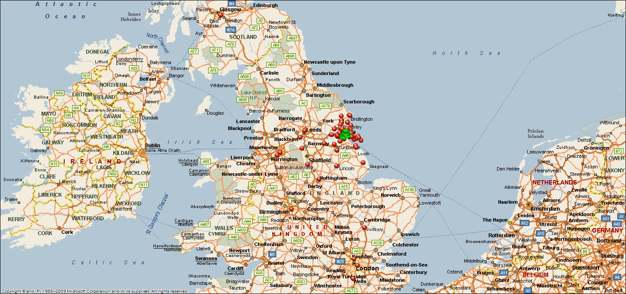

Hull Audience

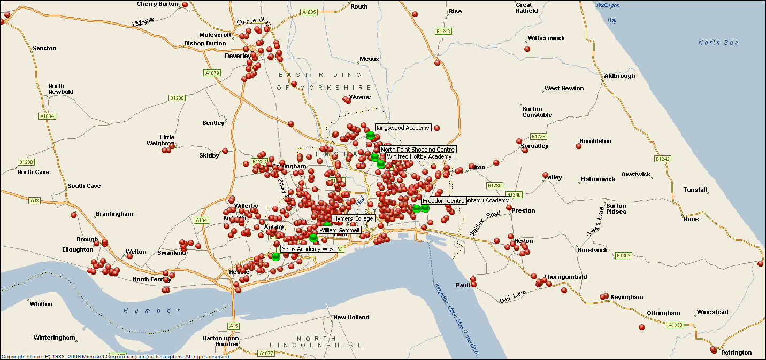

* 1. The following figures do not include respondents who answered ‘prefer not to say’.
  2. 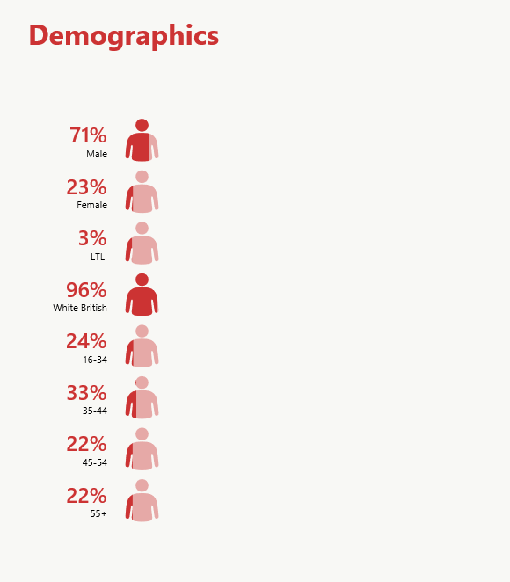Seventy-one percent (71%) of respondents were female and 28% were male, and 1 respondent was transgender.
  3. Just over two-thirds (67%) were employed either full or part-time and 9% were self-employed, with 11% retired.
  4. Twenty-four percent (24%) of respondents were aged between 16 and 34, 33% were aged between 35 and 44, 22% were aged between 45 and 54 and 22% were aged 55 and over.
  5. Ninety-six (96%) of respondents were White British, 3% from other white ethnic groups and 1% were from other ethnic groups.
  6. Three percent (3%) of respondents were ‘limited a lot’ and 5% ‘limited a little’ in their day-to-day activities because of a health problem or disability.
  7. In comparison to the population of Hull and East Riding, the BTO audience had a higher proportion from those aged 30-64 and a lower proportion from both younger and older age groups, and a higher proportion of women.

|  |  |  |  |  |
| --- | --- | --- | --- | --- |
| Age |  | |  | |
|  | Hull | | East Riding | |
| BTO Audience | Population | BTO Audience | Population |
| 16-17 years | 1% | 3% | 2% | 3% |
| 18-19 years | 1% | 3% | 1% | 3% |
| 20-24 years | 4% | 11% | 3% | 6% |
| 25-29 years | 5% | 11% | 5% | 5% |
| 30-34 years | 12% | 9% | 11% | 6% |
| 35-44 years | 35% | 15% | 30% | 13% |
| 45-54 years | 22% | 16% | 23% | 18% |
| 55-64 years | 15% | 13% | 15% | 17% |
| 65-75 years | 4% | 10% | 10% | 17% |
| 75+ years | 2% | 8% | 0% | 13% |

|  |  |  |  |  |  |  |
| --- | --- | --- | --- | --- | --- | --- |
| Gender |  | | |  | | |
|  | Hull | | | | East Riding | |
|  | | BTO  Audience | Population | | BTO Audience | Population |
| Male | | 29% | 50% | | 25% | 49% |
| Female | | 71% | 50% | | 74% | 51% |
| Transgender | | 0% |  | | 0% |  |
| Gender non-conforming | | 0% |  | | 0% |  |
| Other | | 0 |  | | 0 |  |

## IMD Analysis

* 1. In relation to IMD, 58% of the audience were from the 5 most deprived deciles of the UK. The chart below shows the profile of the total audience by National IMD (England). However, it should be noted that residents of Hull are generally within the most deprived deciles of England (see analysis in 2.9 below).

**Base: 699**

**Festivals 1-4**

* 1. The table below shows the ‘Back to Ours’ audience in comparison to the population of the three areas of Hull, East Riding and the Rest of England. As an example, 45% of the population of Hull are in the 1st most deprived decile, and only 23% of the audience were from that decile. In comparison, 6% of the population of the East Riding are from the 1st most deprived quintile – but none of the audience were from that IMD decile. Whilst 45% of the Hull population are from the 1st most deprived decile, only 23% of the audience are from this. Those from the 2nd most deprived quintile (deciles 3 and 4) are over-represented (31% compared to 23% of the population). Those from the least deprived (more affluent) areas are also over-represented, with 15% from the top 3 deciles in Hull (7/8/9) compared to 9% of the population.

|  |  |  |  |  |  |  |  |  |
| --- | --- | --- | --- | --- | --- | --- | --- | --- |
| National IMD (England) | | | | | | | | |
|  | Hull | | East Riding | | Rest of England | | Overall | |
|  | BTO Audience | Population | BTO Audience | Population | BTO Audience | Population | BTO Audience | Population |
| 1 - most deprived | 23% | 45% | 0% | 6% | 0% | 10% | 15% | 10% |
| 2 | 9% | 8% | 2% | 2% | 0% | 10% | 6% | 10% |
| 3 | 15% | 12% | 4% | 7% | 13% | 10% | 12% | 10% |
| 4 | 16% | 11% | 2% | 8% | 8% | 10% | 11% | 10% |
| 5 | 16% | 9% | 9% | 8% | 16% | 10% | 14% | 10% |
| 6 | 6% | 6% | 10% | 11% | 13% | 10% | 7% | 10% |
| 7 | 8% | 5% | 13% | 15% | 17% | 10% | 10% | 10% |
| 8 | 6% | 3% | 11% | 12% | 13% | 10% | 8% | 10% |
| 9 | 1% | 1% | 15% | 11% | 8% | 10% | 6% | 10% |
| 10 - Least deprived | 0% | 0% | 33% | 21% | 12% | 9% | 11% | 9% |

## Children in the Party

* 1. Respondents were asked the composition of the group they attended ‘Back to Ours’ with. 44% overall had attended an event with children in their party. This was slightly lower for the audience members from outside of Hull and East Riding.

|  |  |  |  |
| --- | --- | --- | --- |
| Presence of children in party | | | |
|  | Hull | East Riding | Rest of UK |
| Children in party | 43% | 45% | 39% |
| No children in party | 57% | 55% | 61% |

* 1. As might be expected the presence of children in the party was different for different events at the Festivals. These are shown in the table below.

|  |  |  |  |
| --- | --- | --- | --- |
| Presence of children in party | | | |
|  |  | Children in Party | No children in party |
| Festival 2 | Tipping Point | 38% | 62% |
| The Boy Who Bit Picasso | 100% | 0% |
| The Funny Thing About | 100% | 0% |
| Picture House: The Lion King | 92% | 8% |
| Picture House: Sing-A-Long Grease | 75% | 25% |
| LFE & Black Delta Movement | 0% | 100% |
| Audio Subsubscene | 50% | 50% |
| The King Blues | 50% | 50% |
| Yvette | 6% | 94% |
| Word on the Street | 17% | 83% |
| Festival 3 | Once Upon a Pillow Fight | 95% | 5% |
| Drip | 48% | 52% |
| SKIN | 14% | 86% |
| Bedtime Stories | 83% | 17% |
| Secret gig: Barbara Nice | 4% | 96% |
| Picture House: Beauty & The Beast | 75% | 25% |
| Picture House: Rocky Horror Picture Show | 15% | 85% |
| Picture House: Monsters Inc. | 80% | 20% |
| Badly Drawn Boy | 12% | 88% |
| Black Grape | 16% | 84% |
| Festival 4 | Carl Barat | 8% | 92% |
| Hotel Paradiso | 66% | 34% |
| Jeddybears & Gary's Picnic | 92% | 8% |
| Picture House: Chicken Run | 100% | 0% |
| Picture House: Wallace & Gromit - Curse of the Were Rabbit | 90% | 10% |
| Reverend & The Makers | 13% | 87% |
| Secret Gig | 11% | 89% |
| The Amazing Bubble Man | 96% | 4% |
| The Giants Loo Roll | 96% | 4% |

* 1. The mean number in the group was 3.68, made up of 0.93 children and 2.75 adults.

**Base: 651**

**Festivals 2-4**

## Shows and Venues Attended

* 1. The table below gives the number of respondents who were included in the research who attended each show.

|  |  |  |  |  |
| --- | --- | --- | --- | --- |
| Festival | | Show | Count | % |
| Festival 1 | The Story of Mr. B | | 16 | 4% |
| Picture House: Willy Wonka | | 5 | 1% |
| Picture House: Matilda | | 2 | 1% |
| Picture House: Fantastic Mr. Fox | | 2 | 1% |
| The Pigeon Detectives | | 10 | 3% |
| Meet Fred | | 14 | 4% |
| Joan (& Hekima) | | 19 | 5% |
| The Red Shed | | 20 | 5% |
| Secret Gig: Ceri Dupree & Special Guests | | 9 | 2% |
| Festival 2 | Tipping Point | | 46 | 12% |
| The Boy Who Bit Picasso | | 17 | 5% |
| The Funny Thing About | | 9 | 2% |
| Picture House: The Lion King | | 14 | 4% |
| Picture House: Sing-A-Long Grease | | 14 | 4% |
| LFE & Black Delta Movement | | 4 | 1% |
| Audio Subsubscene | | 3 | 1% |
| The King Blues | | 3 | 1% |
| Yvette | | 18 | 5% |
| Word on the Street | | 13 | 3% |
| Festival 3 | Once Upon a Pillow Fight | | 24 | 6% |
| Drip | | 38 | 10% |
| SKIN | | 60 | 16% |
| Bedtime Stories | | 45 | 12% |
| Secret gig: Barbara Nice | | 25 | 7% |
| Picture House: Beauty & The Beast | | 14 | 4% |
| Picture House: Rocky Horror Picture Show | | 16 | 4% |
| Picture House: Monsters Inc. | | 14 | 4% |
| Badly Drawn Boy | | 71 | 19% |
| Black Grape | | 62 | 17% |
| Festival 4 | Carl Barat | | 66 | 9% |
| Hotel Paradiso | | 57 | 8% |
| Jeddybears & Gary's Picnic | | 26 | 4% |
| Picture House: Chicken Run | | 14 | 2% |
| Picture House: Wallace & Gromit - Curse of the Were Rabbit | | 25 | 3% |
| Reverend & The Makers | | 49 | 7% |
| Secret Gig | | 27 | 4% |
| The Amazing Bubble Man | | 44 | 6% |
| The Giants Loo Roll | | 87 | 12% |

* 1. Forty percent (40%) of respondents had attended a venue in East Hull, with 22% attending the Freedom Centre and 21% Archbishop Sentamu Academy. 48% had attended a venue in North Hull, with 17% attending Winifred Holtby Academy, 26% North Point Shopping Centre and 8% Kingswood Academy. 31% had attended a venue in West Hull, with 12% attending Hymers College, 13% Sirius Academy West and 9% William Gemmell.

**Base: 735**

**Festivals 1-4**

* 1. There were significant differences in the proportion of respondents who had attended a show at Sirius Academy West by gender and IMD. Women and respondents from the least deprived areas of Hull were more likely to have attended a show at Sirius Academy West.

**See Appendix C for Base Size**

**Significant differences by gender and Hull IMD**

* 1. There were significant differences in the proportion of respondents who had attended a show at North Point Shopping Centre by age and gender. Men and younger respondents were more likely to have attended a show at North Point Shopping Centre.

**See Appendix C for Base Size**

**Significant differences by age and gender**

* 1. There were significant differences in the proportion of respondents who had attended a show at Winifred Holtby Academy by age and gender. Women and respondents aged 55 and over were more likely to have attended a show at Winifred Holtby Academy.

**See Appendix C for Base Size**

**Significant differences by age and gender**

* 1. There were other significant differences in venues attended by gender, age and area. Women were more likely to have attended a show at Kingswood Academy, with 5% of men and 10% of women having attended a show at this venue. Older respondents were more likely to have attended a show at William Gemmel, with 8% of 16-34, 6% of 35-54 and 19% of 55 and over having attended a show at this venue. Respondents aged 35 to 54 were more likely to have attended a show at the Freedom Centre, with 16% of 16-34, 27% 35-54 and 19% 55 and over having attended a show at this venue. Respondents from East Riding were more likely to have attended a show at Hymers College, with 9% from Hull, 17% from East Riding and 13% from the rest of the UK having attended a show at this venue. Respondents from Hull were more likely to have attended a show at Archbishop Sentamu Academy, with 24% from Hull, 17% from East Riding and 12% from the rest of the UK having attended a show at this venue.

## Motivation to attend ‘Back to Ours’

* 1. Respondents were asked the main reasons for attending the ‘Back to Ours’ festival and the show they saw. Over a quarter had attended ‘Back to Ours’ because was part of Hull 2017 (27%) and because it was something to do with the kids (26%). 20% had attended because they had a specific interest in one of the artists or actors involved and 19% because they had a general interest in this type of event.

**Base: 735**

**Festivals 1-4**

* 1. There were significant differences in the main reasons for attending ‘Back to Ours’ by gender. Men were more likely to have attended ‘Back to Ours’ because they had a specific interest in an actor or artists involved and because they had a specific interest in the show. Women were more likely to have attended ‘Back to Ours’ because it was something to do with the kids, because it’s part of Hull UK City of Culture 2017, because it is something to do with friends and family, because it is affordable or good value and because they have attended one or more of the previous ‘Back to Ours’ festivals.

**See Appendix C for Base Size**

**\* = Significant differences by gender**

* 1. There were significant differences in the main reasons for attending ‘Back to Ours’ by age. Younger respondents were more likely to have attended ‘Back to Ours’ because they had a specific interest in an actor or artists involved. Older respondents were more likely to have attended ‘Back to Ours’ because it’s part of Hull UK City of Culture, because they were trying something new or different, because it is a unique experience not to be missed and because they were getting involved in what’s happening.

**See Appendix C for Base Size**

**\* = Significant differences by age**

* 1. There were significant differences in the main reasons for attending ‘Back to Ours’ by area. Respondents from Hull and the East Riding were more likely to have attended ‘Back to Ours’ because it is a unique experience not to be missed, with 17% from Hull, 15% from East Riding and 0% from the rest of the UK having attended for this reason. Respondents from outside of Hull and the East Riding were more likely to have attended ‘Back to Ours’ because they had a specific interest in an actor or artists involved, with 19% from Hull, 22% from East Riding and 42% from the rest of the UK having attended for this reason.
  2. There was a significant difference in the main reason for attending ‘Back to Ours’ by Hull IMD. Respondents from the second most deprived area of Hull were more likely to have attended ‘Back to Ours’ because they had attended one or more of the previous ‘Back to Ours’ festivals, with 2% of those in the most deprived areas in Hull, 11% of those in the second most deprived areas of Hull, and 6% of those in the least deprived areas of Hull having attended for this reason.

## Previous ‘Back to Ours’ festivals attended

* 1. Twenty-nine percent (29%) had attended a previous ‘Back to Ours’ Festival at the time they were interviewed, with 19% having attended the festival in February, 14% in May and 9% in October. Please note that this question is a multiple response so there is overlap in the data.

**Base: 658**

**Festivals 2-4**

* 1. There were significant differences in the proportion of respondents who had attended at least one previous ‘Back to Ours’ festival by gender, area and IMD. Women, respondents from Hull and respondents from the second most deprived areas of Hull were more likely to have attended at least one previous ‘Back to Ours’ festival.

**See Appendix C for Base Size**

**Significant differences by gender, area and IMD**

## Visitor Experience

* 1. The majority of respondents were very likely to recommend ‘Back to Ours’ to friends or family, with 82% giving a score of 9 or 10 out of 10. Less than 1% of respondents were very unlikely to recommend ‘Back to Ours’ (a score of 0 or 1). The mean score for recommendation was 9.38.

**Base: 735**

**Festivals 1-4**

* 1. There were significant differences in the proportion of respondents who were very likely to recommend ‘Back to Ours’ to friends or family (a score of 9 or 10 out of 10) by gender. Women were more likely to be ‘very likely’ to recommend ‘Back to Ours’ to friends or family (a score of 9 or 10 out of 10).

**See Appendix C for Base Size**

**Significant differences by gender**

* 1. Ninety-eight percent (98%) of respondents agreed that ‘Back to Ours was an enjoyable experience’ and 93% agreed that ‘Back to Ours gave everyone the chance to share and celebrate together’.

**Base: 735**

**Festivals 1-4**

* 1. There were significant differences in agreement with the statement ‘Back to Ours made me feel more connected to the local community here’ by age. Younger respondents were more likely to agree that ‘Back to Ours made me feel more connected to the local community here’.

**See Appendix C for Base Size**

**Significant differences by age**

* 1. There were significant differences in agreement with the statement ‘Back to Ours made me feel more connected with Hull and its’ people’ by age. Younger respondents were more likely to agree that ‘Back to Ours made me feel more connected with Hull and its’ people’.

**See Appendix C for Base Size**

**Significant differences by age**

* 1. There were significant differences in agreement with the statement ‘Back to Ours showed me that there is more to Hull than I expected’ by gender, age, area and IMD. Women, younger respondents and respondents from outside of Hull and the East Riding and were more likely to agree with the statement and respondents from the least deprived areas of Hull were less likely to agree with the statement.

**See Appendix C for Base Size**

**Significant differences by gender, age, area and IMD**

* 1. There were significant differences in agreement with the statement ‘Back to Ours has made me think that getting involved as volunteer looks like fun’ by gender and age. Men and respondents aged 35-54 were less likely to agree that ‘Back to Ours has made me think that getting involved as volunteer looks like fun’.

**See Appendix C for Base Size**

**Significant differences by gender and age**

* 1. Respondents were asked about different aspects of the Festival using the Arts Council for England Quality Metrics[1] (see Appendix D). Eight-eight percent (88%) of respondents strongly agreed (a score of 9 or 10) that ‘I would come to something like this again and 82% strongly agreed that ‘it is important that it’s happening here (in the community)’. 70% or more strongly agreed (a score of 9 or 10) with the statements ‘it was an interesting idea’, ‘it was well produced and presented’, ‘it was well thought through and put together’ and ‘it was absorbing and held my attention’.

**Base: 658**

**Festivals 2-4 (‘It has something to say about the world’ and ‘it was well thought through and put together’ only asked at Festival 3 and 4, base: 562)**

* 1. Agreement with the statements about Back to Ours can also be presented as a mean score. The table below shows the mean score for each statement.

|  |  |
| --- | --- |
| How much would you disagree or agree with the following statements about the Back to Ours show(s) you have seen? - Mean |  |
|  | Mean |
| It was an interesting idea (Concept) | 9.23 |
| It was well produced and presented (Presentation) | 9.14 |
| It was different from things I’ve experienced before (Distinctiveness) | 8.41 |
| It was thought-provoking (Challenge) | 7.48 |
| It was absorbing and held my attention (Captivation | 9.01 |
| I would come to something like this again (Enthusiasm) | 9.51 |
| It is important that it's happening here (in the community) (Local impact) | 9.37 |
| It has something to say about the world in which we live (Relevance) | 7.51 |
| It was well thought through and put together (Rigour) | 9.03 |

* 1. There were significant differences in agreement with the statements about ‘Back to Ours’ by gender. Women were more likely to strongly agree (a score of 9 or 10) with all eight of the nine statements. Women were also more likely to strongly agree with the statement ‘I would come to something like this again’ than men, but the difference is not statistically significant.

**See Appendix C for Base Size**

**\* = Significant differences by gender**

* 1. There were also significant differences in agreement with the statements about ‘Back to Ours’ by age. Respondents age 35-54 were more likely to strongly agree with the statements ‘it was thought-provoking’ and ‘it has something to say about the world in which we live’. 61% of those aged 16-34, 65% of 35-54 and 52% of those aged 55 and over strongly agreed (a score of 9 or 10) with the statement ‘it was thought-provoking. 56% of 16-34, 65% of 35-54 and 53% of 55 and over strongly agreed (a score of 9 or 10) with the statement ‘it has something to say about the world in which we live’.
  2. Eighty percent (80%) rated the ‘Back to Ours’ venues as better than city centre venues for affordability and 74% rated them better for parking. 46% rated the ‘Back to Ours’ venues as better than city centre for atmosphere and 43% rated them better for accessibility. Only 26% rated the ‘Back to Ours’ venues as better than city centre venues for facilities, while 24% rated them as worse.

**Base: 658**

**Festivals 2-4**

* 1. There was a significant difference in the proportion of respondents who rated the venues for ‘Back to Ours’ as better than Hull’s City Centre venues for arts and cultural activity on accessibility by gender, with women more likely than men to rate them highly.

**See Appendix C for Base Size**

**Significant differences by gender**

* 1. There was a significant difference in the proportion of respondents who rated the venues for ‘Back to Ours’ as better than Hull’s City Centre venues for arts and cultural activity on the parking by area. Respondents from East Riding were more likely to rate the venues for ‘Back to Ours’ as better than Hull’s City Centre venues for arts and cultural activity on parking.

**See Appendix C for Base Size**

**Significant differences by area**

* 1. There was a significant difference in the proportion of respondents who rated the venues for ‘Back to Ours’ as better than Hull’s City Centre venues for arts and cultural activity on the affordability by area. Respondents from East Riding were more likely to rate the venues for ‘Back to Ours’ as better than Hull’s City Centre venues for arts and cultural activity on affordability.

**See Appendix C for Base Size**

**Significant differences by area**

* 1. There were significant differences in the proportion of respondents who rated the venues for ‘Back to Ours’ as better than Hull’s City Centre venues for arts and cultural activity on the atmosphere by gender and area. Women and respondents from outside of Hull and the East Riding were more likely to rate the venues for ‘Back to Ours’ as better than Hull’s City Centre venues for arts and cultural activity on the atmosphere.

**See Appendix C for Base Size**

**Significant differences by gender and area**

* 1. The majority of respondents agreed that they had felt welcomed at ‘Back to Ours’ with 97% agreeing that they had felt welcomed by volunteers and 96% agreeing that they had felt welcomed by staff.

**Base: 735**

**Festivals 1-4**

* 1. There was a significant difference in the proportion of respondents who agreed that they had felt welcomed by staff by IMD. Respondents from the least deprived areas of Hull were less likely to agree that they had felt welcomed by staff.

**See Appendix C for Base Size**

**Significant differences by Hull IMD**

* 1. There were significant differences in the proportion of respondent who agreed that they had felt welcomed by Hull 2017 volunteers by gender and area. Women and respondents from outside of Hull and East Riding were less likely to agree that they had felt welcomed by Hull 2017 volunteers.

**See Appendix C for Base Size**

**Significant differences by gender and area**

## Providing Feedback

* 1. The majority of respondents (96%) stated that they had given feedback by providing contact details to take part in an online or telephone questionnaire. Despite having provided contact details and completing the Back to Ours audiences survey, 3% of respondents stated that they had not provided feedback in this way and 1% of respondents did not know. 39% of respondents had given feedback using the usherette tray, 22% using emoji masks, 21% by a ‘chat with gran’ and 3% by attending a focus group.

**Base: 282**

**Festival 4**

* 1. There was a significant difference in the proportion of respondents who had given feedback using emoji masks by gender. Women were more likely to have given feedback in this way.

**See Appendix C for Base Size**

**Significant differences by gender**

* 1. There were significant differences in the proportion of respondents who had given feedback using the usherette tray by gender and age. Men and respondents aged 16 to 34 were less likely to have given feedback in this way.

**See Appendix C for Base Size**

**Significant differences by gender and age**

* 1. Ninety-three percent (93%) of respondent who gave feedback by having a ‘chat with gran’ liked this method of giving feedback. 89% of respondents who gave feedback this way liked like giving feedback using emoji masks, 88% liked giving feedback by attending a focus group, 87% liked giving feedback using the usherette tray and 81% liked giving feedback by providing contact details and taking part in an online or telephone questionnaire.

**Base: 9 - 269**

**Festival 4**

**Caution: small sample size for attended a focus group (9)**

* 1. Sixty-three percent (63%) of respondents who had not given feedback by using the usherette tray would like to use this method to giving feedback. 55% of respondents who had not given feedback using this method would like to give feedback by having a ‘chat with gran’, 45% would like to give feedback by providing contact details to then take part in an online or telephone questionnaire, 43% would like to give feedback by using emoji masks and 31% would like to give feedback by attending a focus group.

**Base: 8 - 261**

**Festival 4**

**Caution: small sample size for provided contact details to then take part in an online or telephone questionnaire (8)**

* 1. There was a significant difference in the proportion of respondents who had not given feedback using emoji masks and would like to give feedback in this way by gender. Women who had not given feedback using emoji masks were more likely to have liked to give feedback in this way.

**See Appendix C for Base Size**

**Significant differences by gender**

## Arts and Culture

* 1. The majority of respondents (93%) had attended a museum, gallery or other historic attraction and 92% had attended a creative, artistic, dance, theatrical or music event or performance in the last 12 months. 57% had taken part in a creative, artistic, dance, theatrical or music activity or spent time doing a craft in the last 12 months.

**Base: 685**

**Festivals 2-4**

* 1. There were significant differences in the proportion of respondents who had taken part in a creative, artistic, dance, theatrical or music activity or spent time doing a craft in the last 12 months by gender. Women were more likely to have taken part in a creative, artistic, dance, theatrical or music activity or spent time doing a craft once or more in the last 12 months.

**See Appendix C for Base Size**

**Significant differences by gender**

* 1. There was a significant difference in the proportion of respondents who had attended a museum, gallery or other historic attraction in the last 12 months by gender and age. Men and younger respondents aged 16 to 34 were less likely to have attended a museum, gallery or other historic attraction in the last 12 months.

**See Appendix C for Base Size**

**Significant differences by gender and age**

* 1. Eighty-eight percent (88%) of respondents had attended a museum or historical attraction in the last 12 months. Over 70% had attended a music event, an outdoor event, a film, festival or the theatre. 98% of respondents had attended at least one of the activities asked about and 27% had taken part in at least one of the activities asked about.

**Base: 735**

**Festivals 1-4**

* 1. There were significant differences in the activities attended by gender. Men were more likely to have attended music events, while women were more likely to have attended theatre, ballet and dance and circus events.

**See Appendix C for Base Size**

**\* = Significant differences by gender**

* 1. There were significant differences in the activities attended by age. Respondents aged 55 and over were more likely to have attended theatre, heritage and local history events, ballet and dance and opera. Respondents aged 35 to 54 were more likely to have attended outdoor events.

**See Appendix C for Base Size**

**\* = Significant differences by age**

* 1. There were significant differences in the activities attended by IMD. Respondents from the most deprived areas of Hull were less likely to have attended museum and historical attractions, films, festivals, heritage and local history events, comedy, ballet and dance and literature, spoken word and poetry events.

**See Appendix C for Base Size**

**\* = Significant differences by age**

* 1. There were also significant differences in the type of activities in the last 12 months by area. Respondents from East Riding were more likely to have attended comedy, with 51% from Hull, 61% from East Riding and 53% from the rest of the UK had attended a comedy event in the last 12 months. Respondents from Hull were less likely to have attended theatre, with 70% from Hull, 78% from East Riding and 82% from the rest of the UK had attended a theatre in the last 12 months.
  2. There were significant differences in the proportion of respondents who had taken part in ballet and dance in the last 12 months by age and gender. Men and respondents aged 34 to 54 were less likely to have taken part in ballet and dance in the last 12 months.

**See Appendix C for Base Size**

**Significant differences by gender and age**

* 1. There was a significant difference in the proportion of respondents who had taken part in museum and historical attractions in the last 12 months by IMD. Respondents from the most deprived areas of Hull were more likely to have taken part in museum and historical attractions in the last 12 months.

**See Appendix C for Base Size**

**Significant differences by Hull IMD**

## Marketing and Visitor Engagement with Hull 2017

* 1. The highest proportion, nearly two-fifths of respondents (38%), had found out about ‘Back to Ours’ from the Hull 2017 website. 31% had found out from family/friends/colleagues and 27% from Hull 2017 social media.

**Base: 735**

**Festivals 1-4**

* 1. The proportion who found out from the website has declined in each wave since BTO 2. In BTO 1 52% found out from the Hull 2017 website, and this was 67% in BTO 2, 43% in BTO 3, and 21% in BTO4.

* 1. There were significant differences in the proportion of respondents who had found out about ‘Back to Ours’ from the Hull 2017 website by gender and age. Men and respondents aged 16 to 34 were less likely to have found out about ‘Back to Ours’ from the Hull 2017 website.

**See Appendix C for Base Size**

**Significant differences by gender and age**

* 1. There were significant differences in the proportion of respondents who had found out about ‘Back to Ours’ from Hull 2017 social media by gender, age and IMD. Men, respondents aged 55 and over and respondents from the most deprived areas of Hull were less likely to have found out about ‘Back to Ours’ from Hull 2017 social media.

**See Appendix C for Base Size**

**Significant differences by gender, age and Hull IMD**

* 1. There were significant differences in the proportion of respondents who had found out about ‘Back to Ours’ from advertising and printed promotional material by gender, age and area. Women, respondents aged 55 and over and respondents from Hull were more likely to have found out about ‘Back to Ours’ from advertising and printed promotional material.

**See Appendix C for Base Size**

**Significant differences by gender, age and area**

* 1. There was a significant difference in the proportion of respondents who had found out about ‘Back to Ours’ from being told in person by friends, family or colleagues by gender. Men were more likely to have found out about ‘Back to Ours’ from being told in person by friends/family/colleagues, with 39% of men and 28% of women having found out in this way.
  2. There was a significant difference in the proportion of respondents who had found out about ‘Back to Ours’ from being told by a Hull 2017 volunteer by age. Older respondents were more likely to have found out about ‘Back to Ours’ from being told by a Hull 2017 volunteer, with 10% of 16-34, 10% of 35-54 and 19% of 55 and over having found out in this way.
  3. Eighty-seven percent (87%) of respondents had attended or were planning to attend or take part in other events and activities programmes for Hull 2017.

**Base: 640**

**Festivals 2-4**

* 1. There was a significant difference in the proportion of respondents who had been to or taken part in, or were planning to attend or take part in, other activities programmed for Hull 2017 by area. Respondents from outside of Hull were less likely had been to or taken part in, or to be planning to attend or take part in, other activities programmed for Hull 2017.

**See Appendix C for Base Size**

**Significant differences by area**

## Proximity to venues

* 1. Of the respondents who had attended these venues, 70% or more lived within 5 miles of Sirius Academy West, William Gemmell and Kingswood Academy. Over 60% lived within 5 miles of Hymers College, Archbishop Sentamu Academy and North Point Shopping Centre. Over 50% lived within 5 miles of Winifred Holtby Academy and the Freedom Centre. 70% of respondents lived within 5 miles of at least one of the venues they attended.

.

**Base: 47-176**

**Festivals 2-4 (only asked for venue attended)**

* 1. There were significant differences in the proportion of respondents who lived within 5 miles of at least one of the venues they attended by IMD. Respondents from the most deprived areas of Hull were more likely to live within 5 miles of at least one of the venues they attended.

**See Appendix C for Base Size**

**Significant differences by Hull IMD and area**

* 1. Of the respondents who had attended these venues, 20% or more had visited the area around the Freedom Centre, North Point Shopping Centre, Archbishop Sentamu Academy, Winifred Holtby Academy and William Gemmell before. Over 10% had visited the area around Hymers College, Kingswood Academy and Sirius Academy West before.

**Base: 47-176**

**Festivals 2-4 (only asked for venue attended)**

* 1. There was a significant difference in the proportion of respondents who had visited the area around at least one of the venues they attended prior to attending ‘Back to Ours’ by area. Respondents from the East Riding were more likely to have visited the area around at least one of the venues they attended prior to attending the ‘Back to Ours’ event.

**See Appendix C for Base Size**

**Significant differences by area**

## Visitors to Hull

* 1. Nearly four-fifths (79%) of respondents from outside of Hull were in Hull ‘mainly’ to attend ‘Back to Ours’ when they attended the ‘Back to Ours’ show. 14% were in Hull ‘partly’ and 7% ‘not at all’ to attend the ‘Back to Ours’ show.

**Base: 154**

**Festivals 2-4 (only asked to respondent from outside Hull)**

* 1. A third (33%) of respondents who were visitors to Hull when they attended ‘Back to Ours’ had taken part in another arts or cultural activity during their visit to Hull, with 8% having taken part in one activity, 9% two or three and 16% four or more activities.

**Base: 154**

**Festivals 2-4 (only asked to respondent from outside Hull)**

* 1. Attending ‘Back to Ours’ was the main reason for their visit to Hull for 70% of respondents who were visitors to Hull. 13% stated that the main reason for their visit to Hull was because Hull is UK City of Culture.

**Base: 186**

**Festivals 1-4 (only asked to respondent from outside Hull)**

* 1. The majority of respondents who were visitors to Hull (96%) had been to Hull before coming to Back to Ours. Of these, 6% visit Hull twice a year or less, 10% three to six times per year and 84% more frequently than six times a year.

**Base: 146**

**Festivals 2-4 (only asked to respondent from outside Hull who had been to Hull before coming to Back to Ours)**

* 1. Of the respondents who were visitors to Hull and had been to Hull before coming to Back to Ours, just over a third (34%) thought that the frequency of their visits to Hull over the course of the year would increase, based on their experience during their visit when they attended ‘Back to Ours’ and nearly two-thirds thought that the frequency would stay the same.

**Base: 145**

**Festivals 2-4 (only asked to respondent from outside Hull who had been to Hull before coming to Back to Ours)**

* 1. Only 4 respondents who were visitors to Hull had not been to Hull before coming to Back to Ours. Three of these agreed with the statement ‘based on my experience of Hull during the time I attended Back to Ours, I will visit Hull again in future’.

## Overnight Visitors

* 1. Of the respondents who were visitors to Hull, 88% were in Hull just for the day and 12% were staying overnight when they attended ‘Back to Ours’. Of the 12% who were staying in Hull overnight, 33% were staying in the area for 1 night, 35% for 2 nights and 33% were staying for 3 or more nights. 65% were staying with friends and family, 30% were staying in a hotel and 5% were camping. The mean spend on accommodation was £71.

## Visitor Satisfaction (non-Hull residents)

* 1. Respondents from outside of Hull were asked to rate how satisfied they were with various aspects of Hull as a visitor. Hull was rated highly on overall value for money, visitor welcome and places to eat and drink with 91% of respondents satisfied with overall value for money, 88% satisfied with the general visitor welcome and 80% satisfied with places to eat and drink (a score of 4 or 5 out of 5). 63% of respondents were satisfied with city centre signposting although 23% of respondents answered ‘not-applicable’. A high proportion of respondents answered ‘not-applicable’ when asked to rate public transport and accommodation. Of the respondents who thought these were applicable to them 94% were satisfied with the quality of accommodation and 85% were satisfied with public transport – see chart below and analysis in the following paragraph.

**Base: 152**

**Festivals 2-4 (only asked to respondent from outside Hull)**

* 1. This paragraph considers the results on satisfaction with various aspects of Hull again, but with respondents who indicated ‘not applicable’ excluded from the analysis. Respondents from outside of Hull rated Hull highly on all aspects of their visit. 97% were satisfied with overall value for money (a score of 4 or 5), 94% with the general visitor welcome, 94% with the quality of accommodation, 90% with places to eat and drink, 85% with public transport and 81% with city centre signposting.

**Base: 30-142**

**Festivals 2-4 (only asked to respondent from outside Hull, excluding ‘N/A’)**

## Visitor Spend

* 1. Respondents were asked to estimate how much they had spent on themselves and on others with them during their visit to Hull to attend ‘Back to Ours’. Respondents estimated that they spent a mean of £35.05 on themselves and others with them in Hull when they attended ‘Back to Ours’. 47% of this spend was on food and drink, 14% was on travel and transport and 13% was on shopping.

**Base: 609**

**Festivals 2-4**

* 1. There was a significant difference in respondents estimated spend on themselves and on others with them during their visit to Hull to attend ‘Back to Ours’. Men had a higher mean estimated spend than women.

**See Appendix C for Base Size**

**Significant differences by gender**

* 1. Within the estimated spend data, there are significant differences in estimated mean spend on different categories of spend by gender, age, area and IMD. Men had a higher mean estimated spend on food and drink. Respondents aged 16 to 34 had a higher mean estimated spend on ‘spending money’ for children. Respondents from outside of Hull and East Riding had a higher mean estimated spend on travel and transport. Respondents from the least deprived areas of Hull had a lower mean estimated spend on shopping and travel and transport.

|  |  |  |  |  |  |  |  |
| --- | --- | --- | --- | --- | --- | --- | --- |
| Estimated spend in Hull during visit for ‘Back to Ours’ (mean) | | | | | | | |
|  | Hull 2017 merchandise | Food and drink | Shopping | Travel and transport (including parking) | Other 'attractions' | ‘Spending money' for children | Other |
| Male | 4.23 | 23.51 | 9.74 | 5.39 | 6.21 | 3.05 | 0.00 |
| Female | 2.46 | 13.60 | 2.57 | 4.57 | 2.28 | 2.28 | 0.17 |
| 16-34 | 5.04 | 20.39 | 8.05 | 6.97 | 2.02 | 5.52 | 0.00 |
| 35-54 | 1.50 | 15.86 | 3.28 | 4.24 | 3.33 | 1.88 | 0.22 |
| 55+ | 4.45 | 14.64 | 4.74 | 4.01 | 5.69 | 0.77 | 0.01 |
| Hull | 3.02 | 16.25 | 3.10 | 3.76 | 3.03 | 2.43 | 0.19 |
| East Riding | 2.54 | 16.63 | 7.02 | 4.64 | 3.86 | 2.95 | 0.00 |
| Rest of UK | 5.55 | 21.57 | 10.66 | 19.29 | 6.38 | 1.02 | 0.00 |
| Most deprived | 2.37 | 17.40 | 5.73 | 5.33 | 1.69 | 5.28 | 0.49 |
| 2nd Most deprived | 4.12 | 16.03 | 4.76 | 4.18 | 4.08 | 2.12 | 0.01 |
| Least deprived | 2.46 | 16.23 | 0.75 | 2.65 | 2.79 | 1.64 | 0.23 |

# CONCLUSIONS

* 1. The Back to Ours festivals appeared to have been successful in engaging those with families, as the audience is predominantly female and a significant majority with children, as this was the target group for many of the shows. It also attracted a local audience, with around two-thirds from Hull with one-third from the East Riding, and only a very small proportion from outside the area. In relation to IMD, there is an over-representation of those from the more affluent areas of Hull and the East Riding, compared to the population, particularly for those from the most deprived decile in Hull, which comprises 45% of the population. This is emphasised by the mapping of attendees to the different venues, which suggests that the audience did not necessarily attend venues close to their home. The intention of ‘Back to Ours’ was to reach audiences who are generally under-represented in cultural activity. This suggests that still more needs to be done to attract those who are less culturally engaged, to attract them to attend cultural events, even in their own area.
  2. There is some suggestion that the audience were active in culture and the arts, with the majority having attended different arts and cultural activities and around two-thirds having taken part. However, those who were from the most deprived areas were less likely to have participated, suggesting that the Back to Ours events give them the opportunity to do so in a non-threatening and for some familiar environment. In addition, two-fifths overall, had found out about the BTO events from the Hull 2017 website, but this proportion declined from BTO2 and nearly 9 out of 10 were planning to take part in other Hull 2017 events and activities. Again this suggests that those who were attending may have already been culturally engaged.
  3. In terms of the audience experience, the majority were likely to recommend Back to Ours – but women were more likely to recommend than men and younger people more likely to agree that the event had made them feel more connected to the community. There were also high levels of agreement with the Arts Council quality metrics, with the mean scores for concept, presentation, captivation, enthusiasm, local impact, and rigour all over 9.00. There were lower scores for challenge (It was thought-provoking), and relevance (It has something to say about the world in which we live) – but this may be expected for this type of event. Again there were differences by gender with men less likely to agree with the statements. This may be due to the ‘family-friendly’ nature of the majority of the events. This suggests that the events are meeting the audience needs, but that more work may need to be done to improve the relevance to men.
  4. The audience were also asked about their satisfaction with a number of aspects of their visit, and the audience clearly rated them highly on aspects such as parking and affordability, however, there were some issues with atmosphere, accessibility and facilities, with a small minority thinking they were worse than city centre venues. As such, careful selection of venues for future festivals of this kind would be helpful, taking into account the demographic of the audience which does not necessarily attend their ‘most local’ venue. This may also support making events more appropriate for men, who may not feel comfortable in a predominantly female and school-based environment.
  5. One interesting aspect is that of those who attended, only small proportions (20%) had visited the areas around the venues previously, which is again emphasised by the mapping of the audience at each venue. This suggests that those who did attend were visiting new areas of Hull.
  6. Interestingly, those who were visitors to Hull were there mainly for the BTO event – although a third had taken part in another arts or cultural activity during their visit. A large proportion were visiting because Hull was the UK City of Culture and the vast majority had been to Hull before coming to BTO. However, they had clearly been encouraged by their visit, and one-third of visitors thought that their visits to Hull would increase. Although a very small number, of the four respondents who were visiting for the first time, three said that they would visit in the future. Satisfaction levels with different aspects of their visit were high.
  7. Although spend was small in comparison to some of the other events forming part of the City of Culture year, visitors had spent a mean of £35.05, primarily on food and drink. Spend was not asked on the survey conducted with Festival 1 audience members, but was asked in Festivals 2-4. Using the actual mean spend per party for each festival separately, the total spend from the audience for Festivals 2-4 only was £78,045. Estimated spend increased between Festivals 2, 3 and 4, and so in order to estimate a mean spend per party for Festival 1, a calculation of the increased spend was undertaken, which estimated the difference in spend between festivals 2, 3 and 4 and applied the difference to Festival 1. Using this estimate, the total spend from visitors to festivals 1-4 was £91,105 as shown in the table below.

|  |  |  |  |
| --- | --- | --- | --- |
| **Festival** | **Estimated Audience** | **Mean spend per party member** | **Estimated** |
| **spend** |
| 1 | 2,060 | *6.34 | *13,060 |
| 2 | 2,196 | 7.30 | 16,025 |
| 3 | 1,821 | 9.21 | 16,776 |
| 4 | 3,459 | 13.08 | 45,245 |
| Total |  |  | 91,105 |

* estimated as not asked on festival 1 audience survey

**Information by Design**

**March 2018**

# Appendix A – Profile of Respondents – WEIGHTED DATA

|  |  |  |
| --- | --- | --- |
| Employment Status | Count | Column N % |
|  | Count | % |
| Employed / working full or part time | 437 | 66% |
| Self-employed | 55 | 8% |
| Unemployed | 15 | 2% |
| On a government scheme for employment training | 0 | 0% |
| Looking after family / home | 32 | 5% |
| Unable to work | 12 | 2% |
| Retired | 71 | 11% |
| Student | 26 | 4% |
| Prefer not to say | 9 | 1% |
| Total | 658 | 100% |

|  |  |  |
| --- | --- | --- |
| Gender | Count | Column N % |
|  | Count | % |
| Male | 207 | 28% |
| Female | 523 | 71% |
| Transgender | 1 | 0% |
| Gender non-conforming | 0 | 0% |
| Other | 0 | 0% |
| Prefer not to say | 4 | 1% |
| Total | 735 | 100% |

|  |  |  |
| --- | --- | --- |
| Ethnic group | Count | Column N % |
|  | Count | % |
| White British | 693 | 96% |
| White Other | 23 | 3% |
| Mixed/multiple ethnic groups | 6 | 1% |
| Asian/Asian British | 2 | 0% |
| Black/ Black British: | 0 | 0% |
| Other ethnic background | 1 | 0% |
| Total | 725 | 100% |

|  |  |  |
| --- | --- | --- |
| Age Group | Count | Column N % |
|  | Count | % |
| 16-17 years | 10 | 1% |
| 18-19 years | 6 | 1% |
| 20-24 years | 27 | 4% |
| 25-29 years | 38 | 5% |
| 30-34 years | 89 | 12% |
| 35-44 years | 236 | 32% |
| 45-54 years | 158 | 22% |
| 55-64 years | 105 | 14% |
| 65-75 years | 42 | 6% |
| 75+ years | 8 | 1% |
| Prefer not to say | 16 | 2% |
| Total | 735 | 100% |

|  |  |  |
| --- | --- | --- |
| Day-to-day activities limited because of a health problem or disability  Count  Column N % | | |
|  | Count | % |
| No | 24 | 3% |
| Yes, limited a lot | 36 | 5% |
| Yes, limited a little | 666 | 91% |
| Prefer not to say | 10 | 1% |
| Total | 735 | 100% |

# APPENDIX B – Audience Maps

Sirius Academy West Audience Map

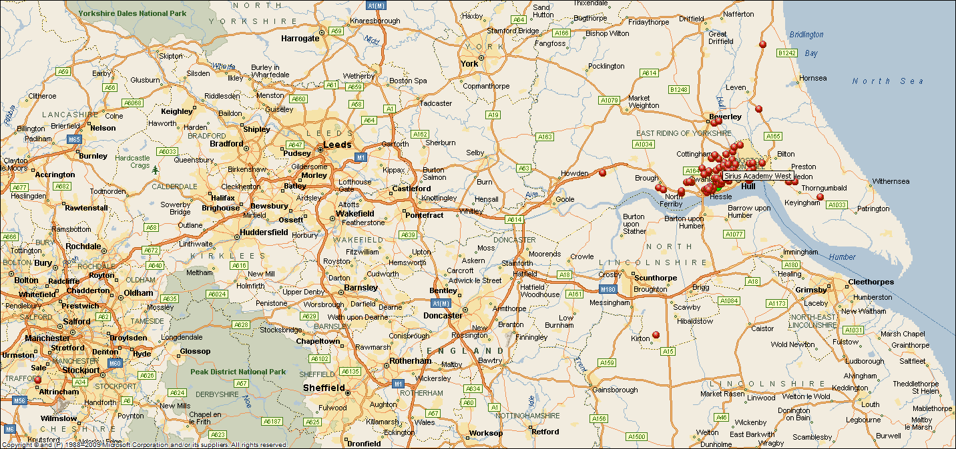

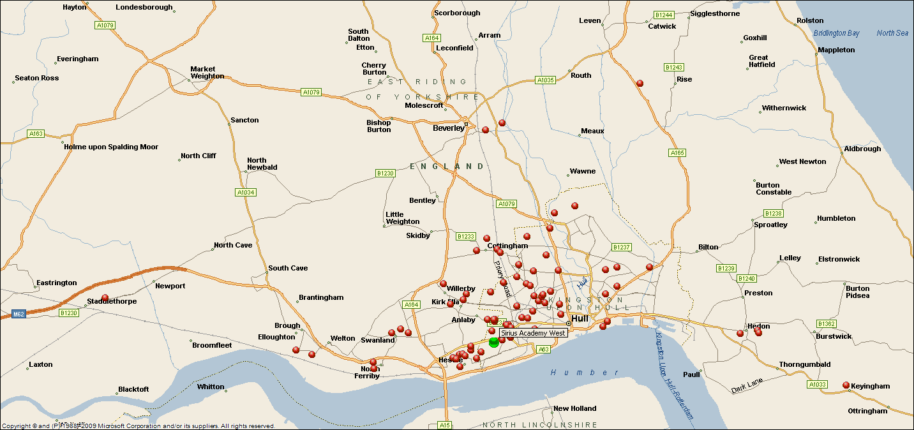

Hymers College Audience Map

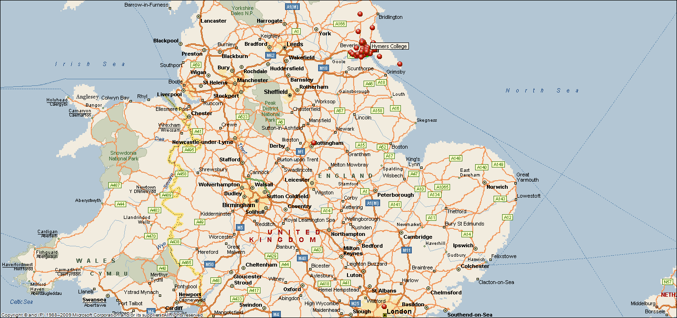

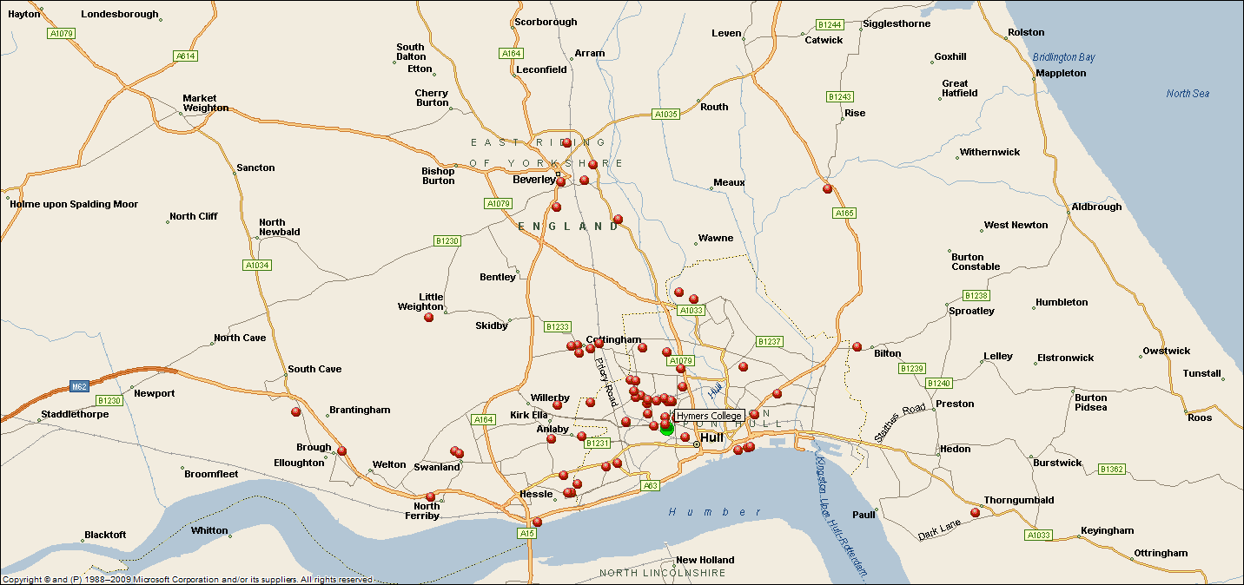

William Gemmell Audience Map

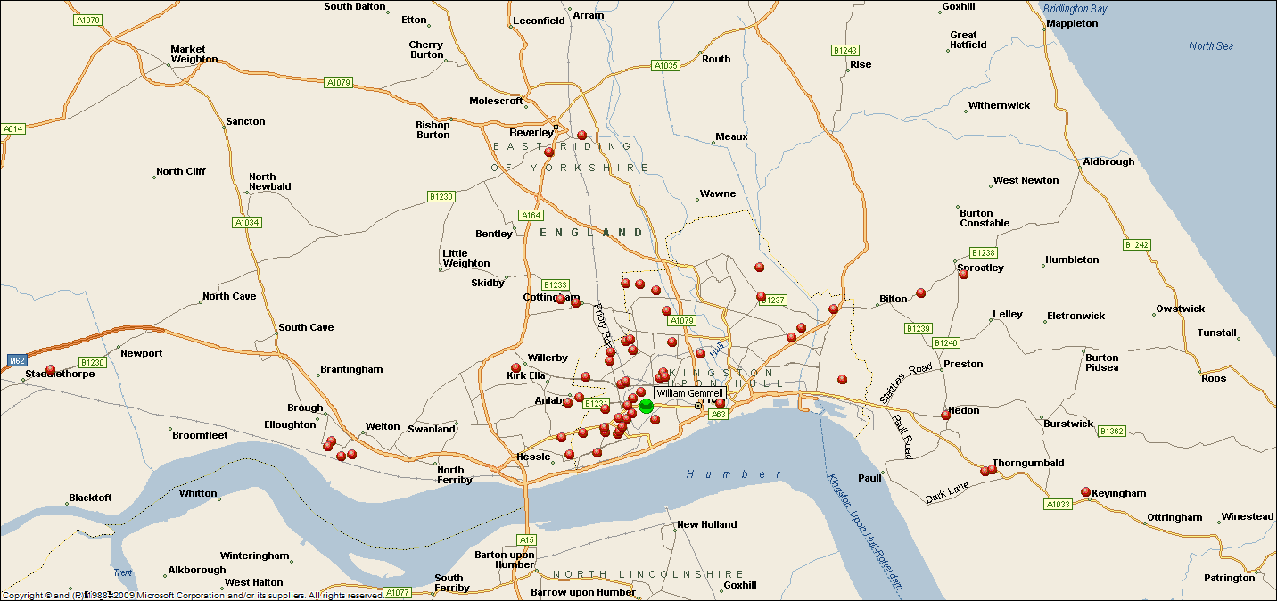

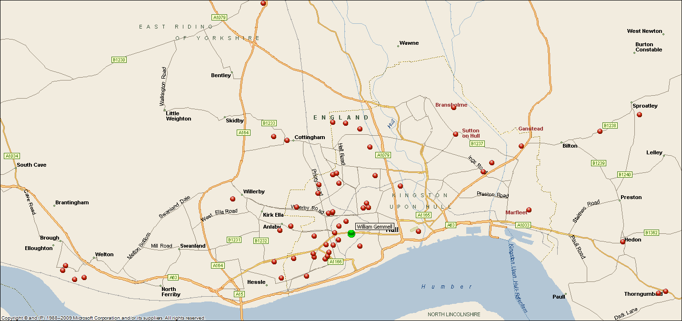

Kingswood Academy Audience Map

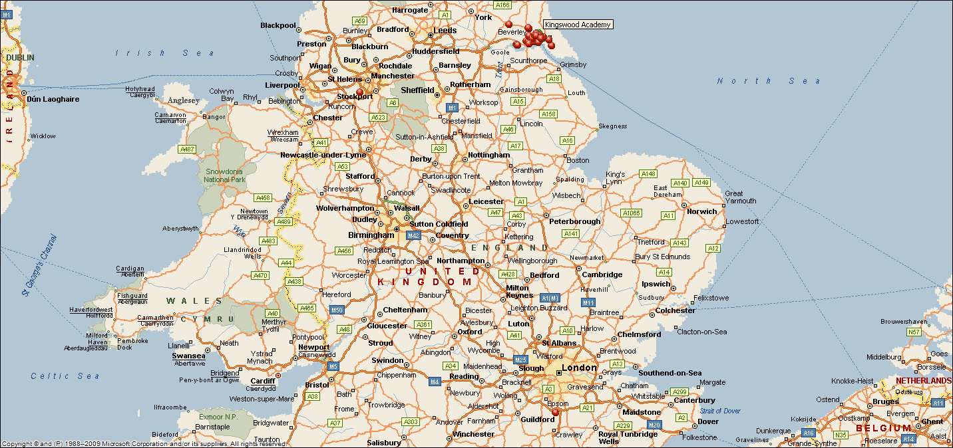

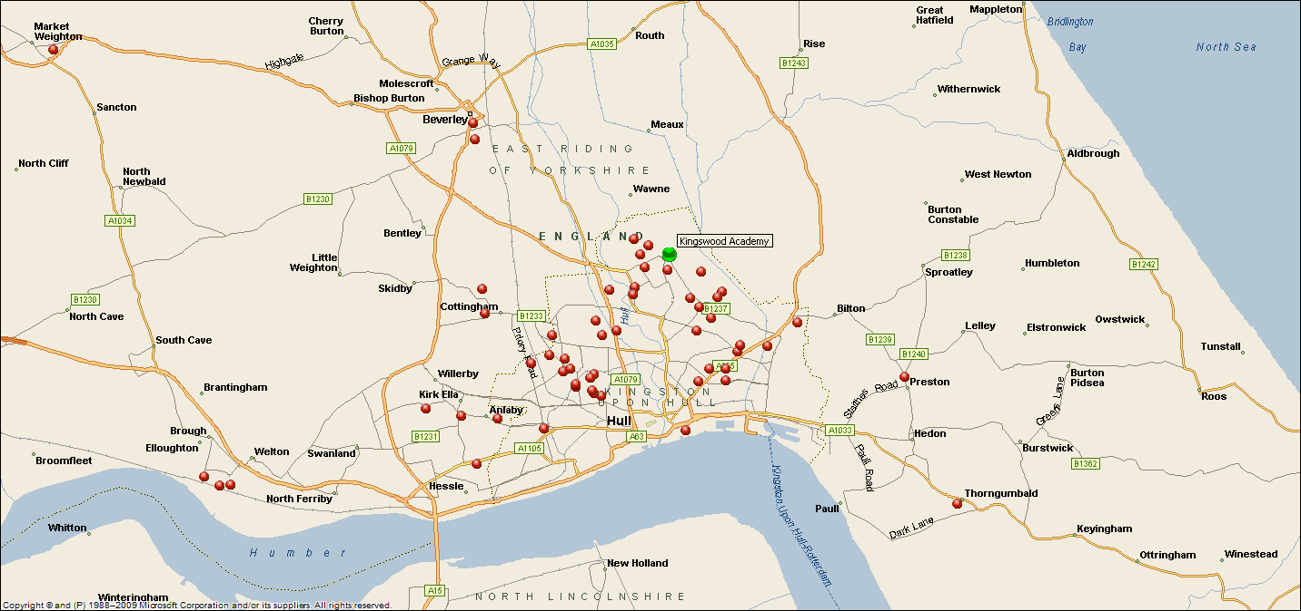

North Point Shopping Centre Audience Map

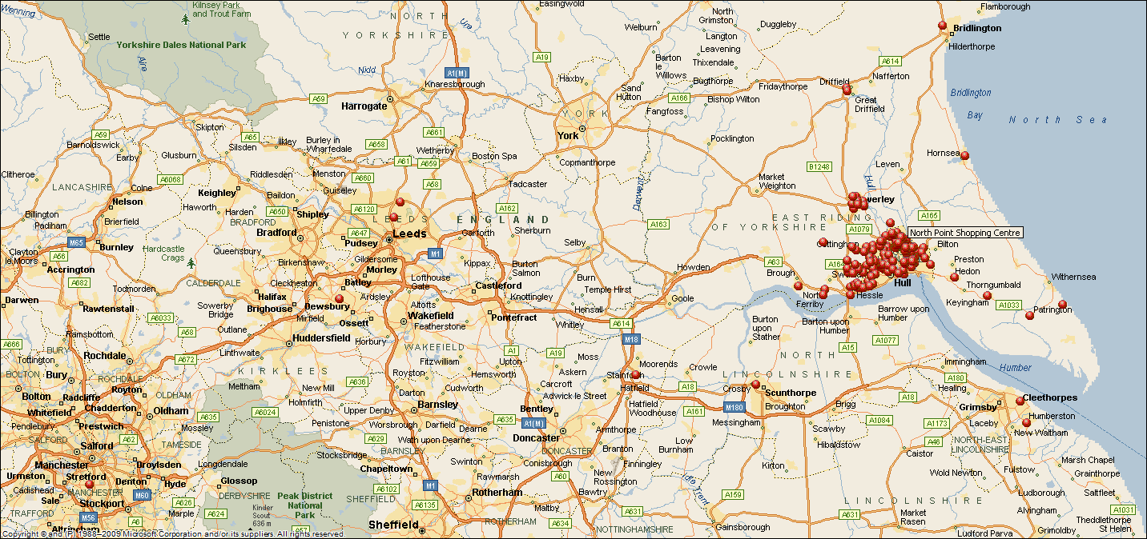

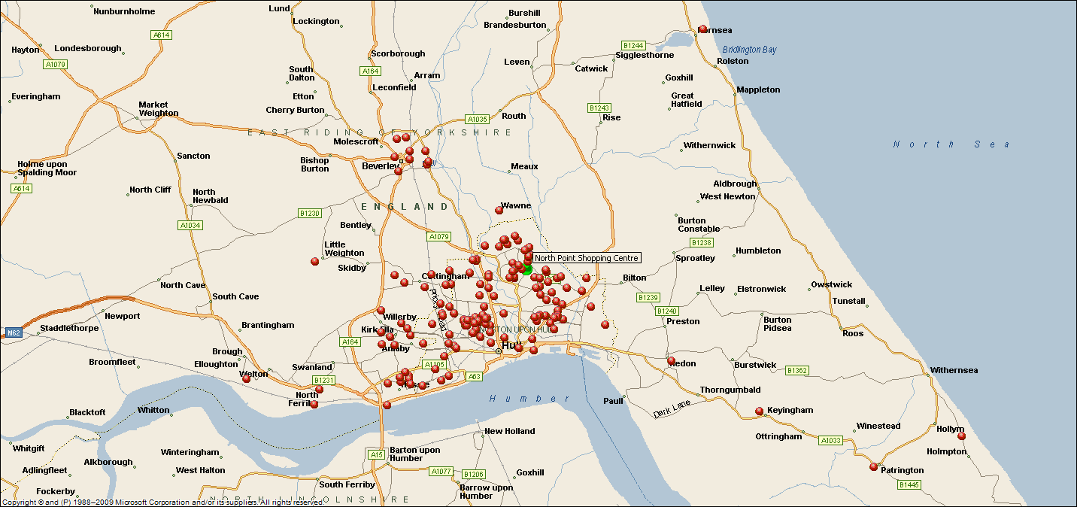

Winifred Holtby Academy Audience Map

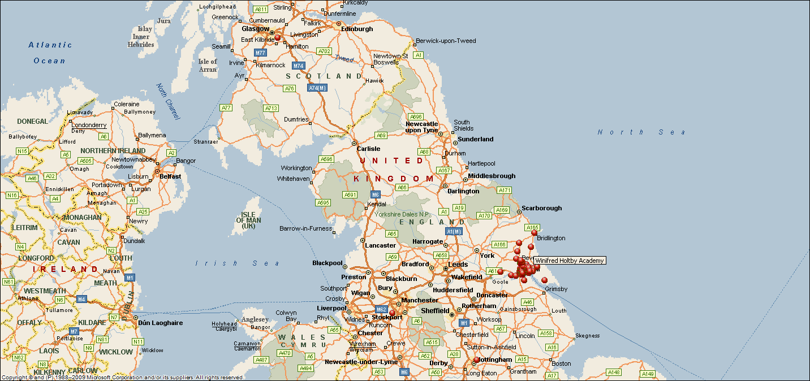

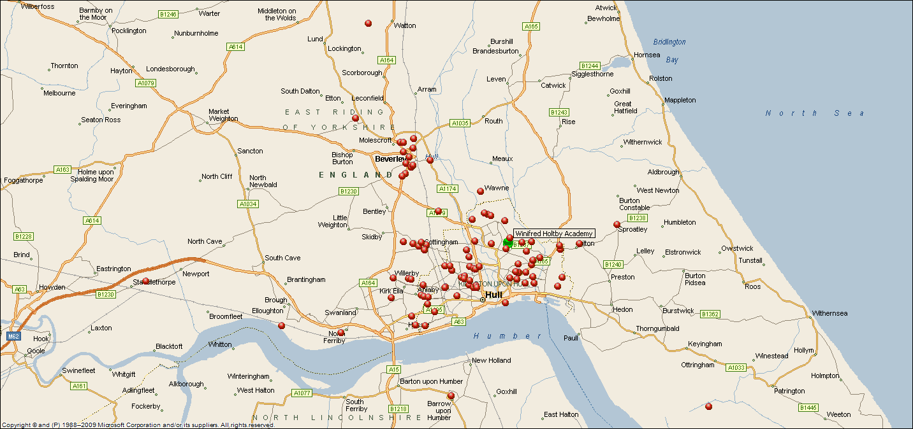

Freedom Centre Audience Map

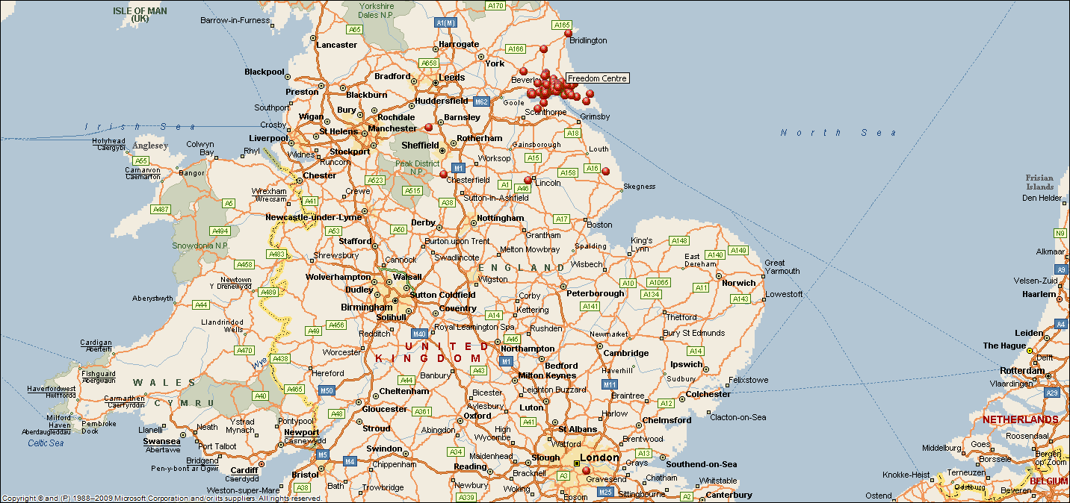

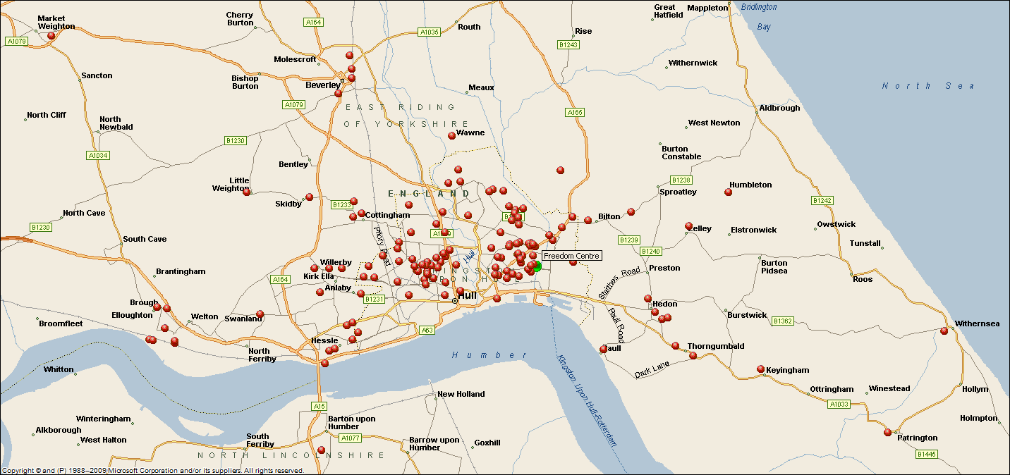

Archbishop Sentamu Academy Audience Map

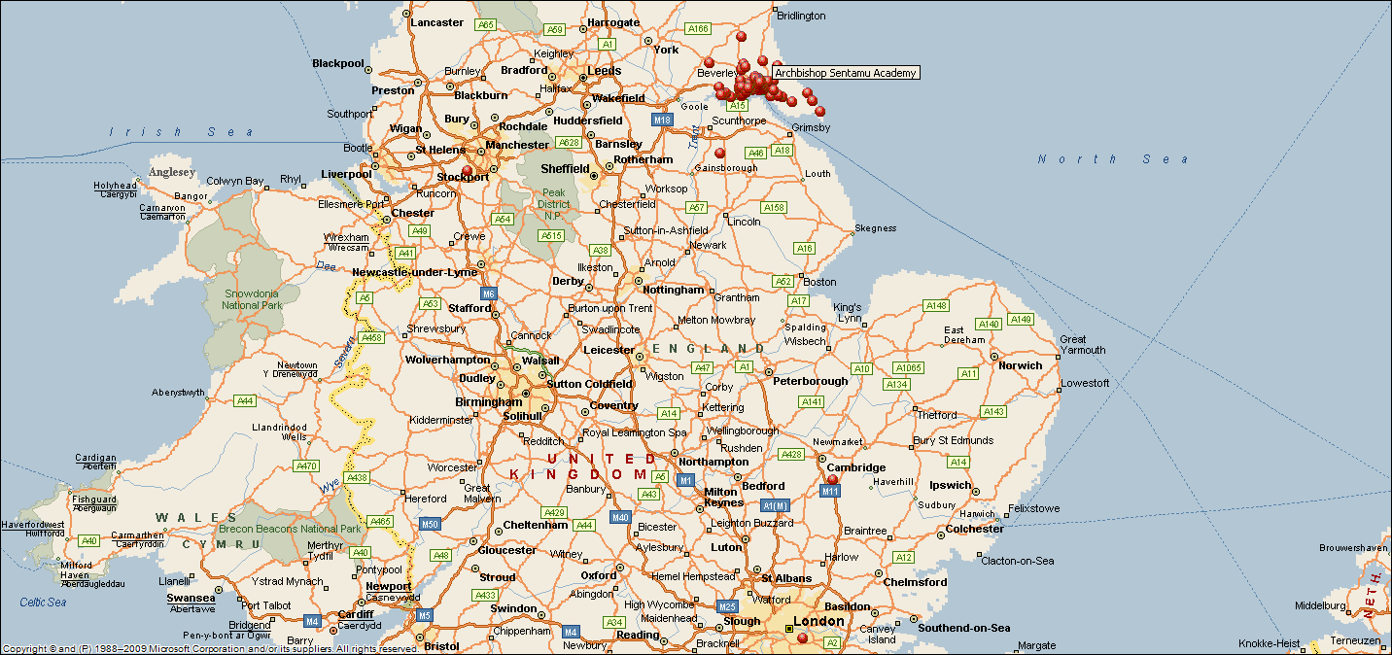

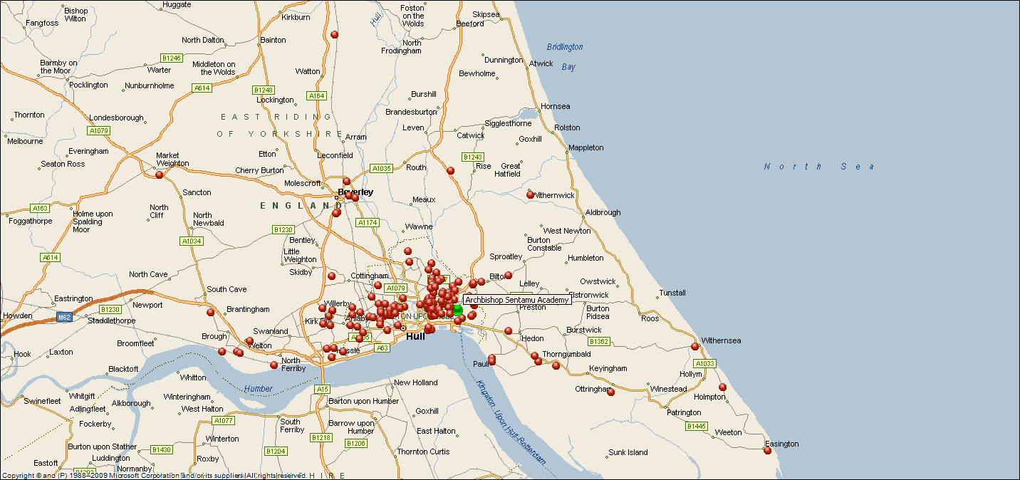

# Appendix C – Base Sizes for Subgroups

|  |  |
| --- | --- |
| Gender | Sample Size |
| Male | 207 |
| Female | 523 |

|  |  |
| --- | --- |
| Age | Sample Size |
| 16-34 | 169 |
| 35-54 | 394 |
| 55+ | 155 |

|  |  |
| --- | --- |
| Area | Sample Size |
| Hull | 461 |
| East Riding | 228 |
| Rest of UK | 32 |

|  |  |
| --- | --- |
| Hull IMD | Sample Size |
| Most deprived | 73 |
| 2nd Most deprived | 168 |
| Least deprived | 212 |

# APPENDIX D – Ace Quality Metrics

The Arts Council for England Quality Metrics are as follows:

* **Concept**: it was an interesting idea
* **Presentation**: it was well produced and presented
* **Distinctiveness**: it was different from things I’ve experienced before
* **Challenge**: it was thought-provoking
* **Captivation**: it was absorbing and held my attention
* **Enthusiasm**: I would come to something like this again
* **Local impact**: it is important that it's happening here
* **Relevance:** it has something to say about the world in which we live
* **Rigour:** it was well thought through and put together

1. Arts Council for England. Quality Metrics. [<http://www.artscouncil.org.uk/quality-metrics/quality-metrics>]