You’re only here for the Culture
What’s the point of a city of Culture?
What are the measures of success for a city of culture? How does this manifest and what is the promise in relation to the reality? Are they brilliant examples of culture as a change agent or an apology in disproportionate levels of arts funding? The panel will be comprised of representatives from cities of culture and also those instrumental to their success.
John Harris - Chair
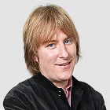
John Harris is an journalist and author who regularly writes for the Guardian about a range of subjects built around politics popular culture and music.
Pete Massey- Panellist
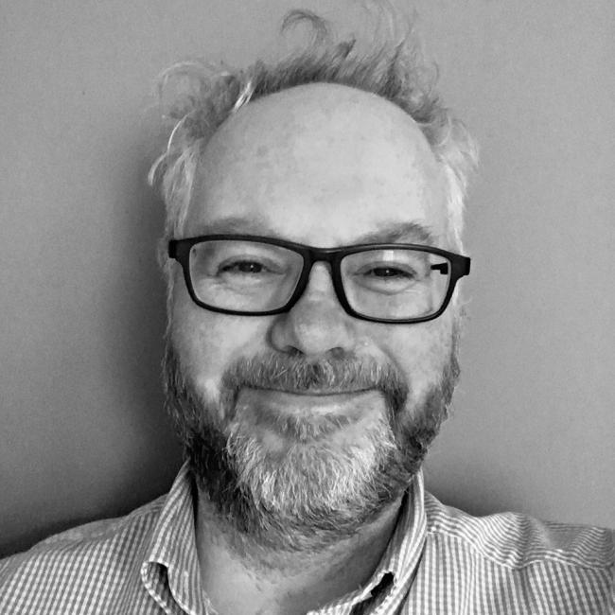
Arts Council England (Director North)

Chris Baldwin- Panellist
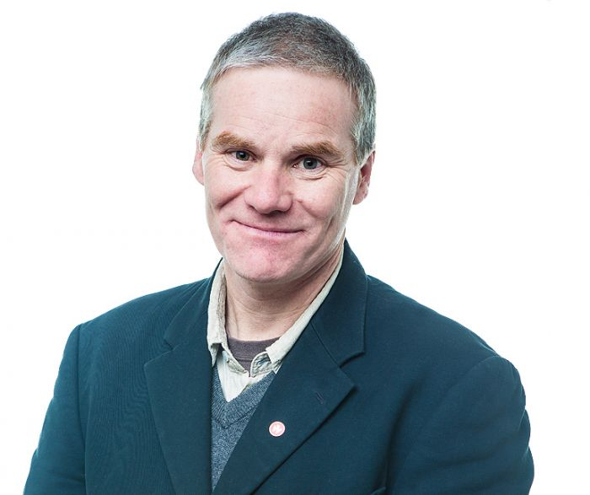
Chris Baldwin is a performance director, curator and writer. He is presently Creative Director of Galway, European Capital of Culture 2020 (Ireland). Previously he was Curator of Interdisciplinary Performance for Wroclaw, European Capital of Culture 2016 in Poland. Chris has become known widely for Teatro de Creacion (TdC) - an approach to making large scale performance designed for a place, about that place - itʼs history and relationship to local people and usually made in deep collaboration with the people of that place. He has directed widely in Spain, UK, Poland, Bulgaria and Germany and elsewhere. During 2011 and 2012 he wrote and directed two major pieces of work as part of the London Olympic Gamescelebrations; "The Way the Winds Blow” in Rutland and “Raise the Sky" for the Olympic Torch Celebrations. His play, Cosima, won "Best Theatre Text" at the FETEN international theatre festival, Gijon, Spain, and his play "Bright Angel" (written in collaboration with Bernd Kessler) has been performed in various British and German theatres. He has published various plays and books about theatre and the teaching of history in post authoritarian countries. He has been Visiting Professor at Rose Bruford College of Theatre and Performance in London and is also a Permaculture designer.
Paula Murray- Panellist
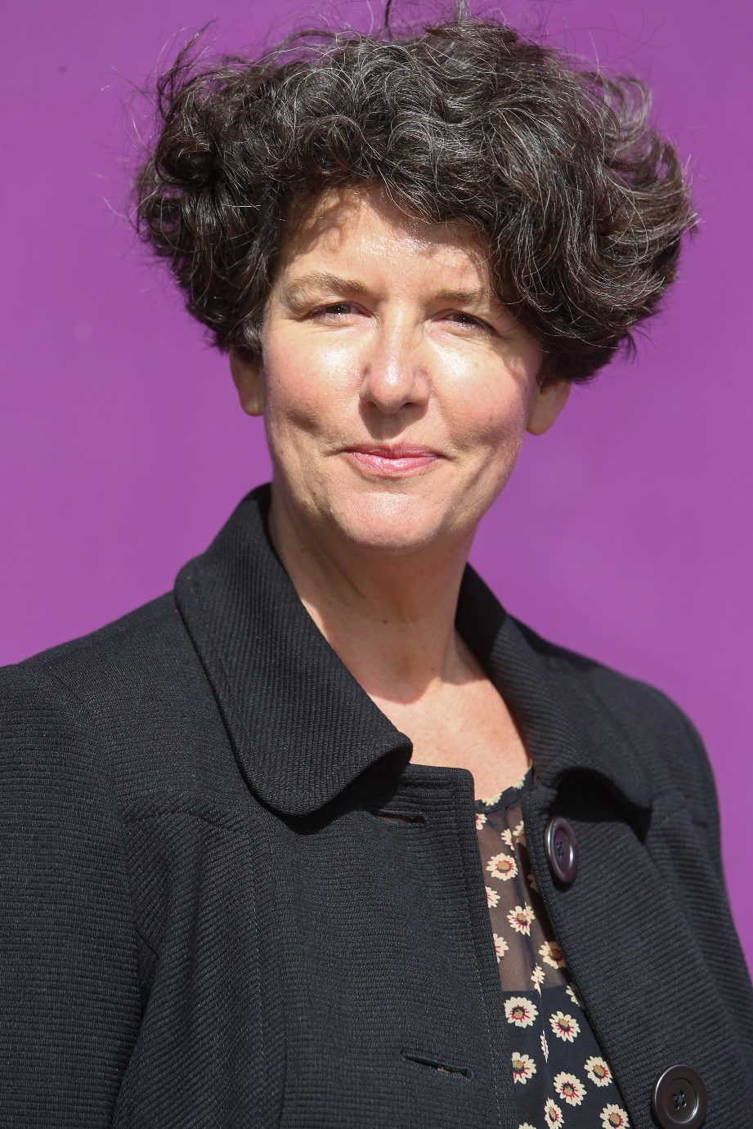
Paula is currently Creative Director at Croydon Council, and is responsible for the shaping of a cultural programme for the Borough as part of the significant regeneration there. This includes working on the £30m refurbishment of the Fairfield Halls and leading the Boroughs bid to be the London Borough of Culture.

Before joining Croydon Council, Paula was at Brighton & Hove City Council, where she worked for 18 years, latterly as Assistant Chief Executive, developing the city’s cultural and tourism offer.

Shona McCarthy - Panellist
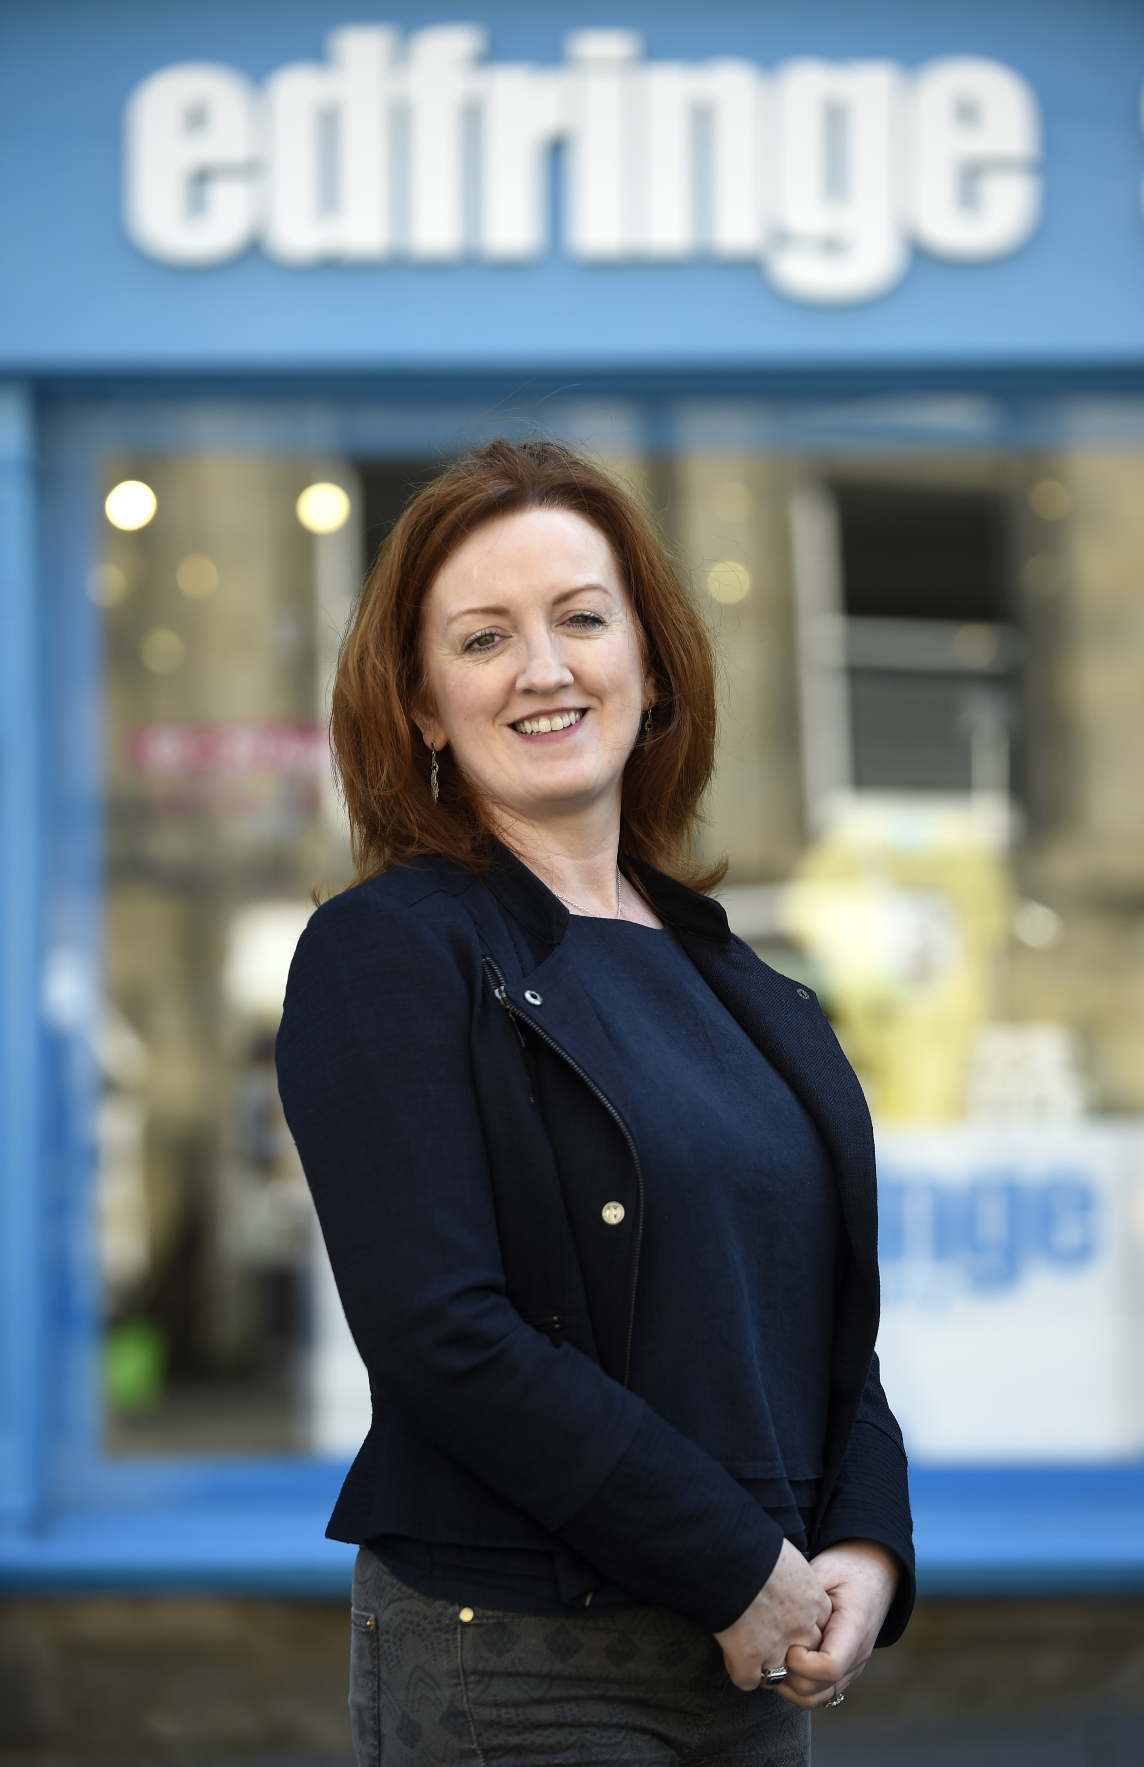
Shona McCarthy is the Chief Executive of the Edinburgh Festival Fringe Society - the charity that underpins the Edinburgh Festival Fringe, the largest arts festival in the world. Originally from County Down, Shona has dedicated her career to championing and developing arts and culture.
From 2011 to 2014 she was Chief Executive of the Culture Company, leading on Derry-Londonderry’s transformational year as UK City of Culture, creating and delivering a world-class, citywide cultural programme for 2013. Prior to that she was Director of the British Council Northern Ireland leading a team of 40 to oversee international programmes of work across schools, arts and Higher Education, to build positive international cultural relations. She was the CEO of Imagine Belfast, heading up Belfast’s bid to be European Capital of Culture and was Head of Exhibition at the Northern Ireland Film Council.
Shona spent many years as Chief Executive of Cinemagic Film Festival for young people and the Foyle Film Festival. In 2007 she was the recipient of a NESTA cultural leadership award which enabled her to live and work in India with Seagull Foundation for the Arts in Calcutta, and in 2014 she received an Eisenhower Fellowship. As well as her Fringe commitments, Shona is also Chair of Oh Yeah Music Centre in Belfast, and Walk the Plank, a Salford-based Creative agency specialising in spectacular outdoor arts and pyrotechnics.
Martin Green - Panellist
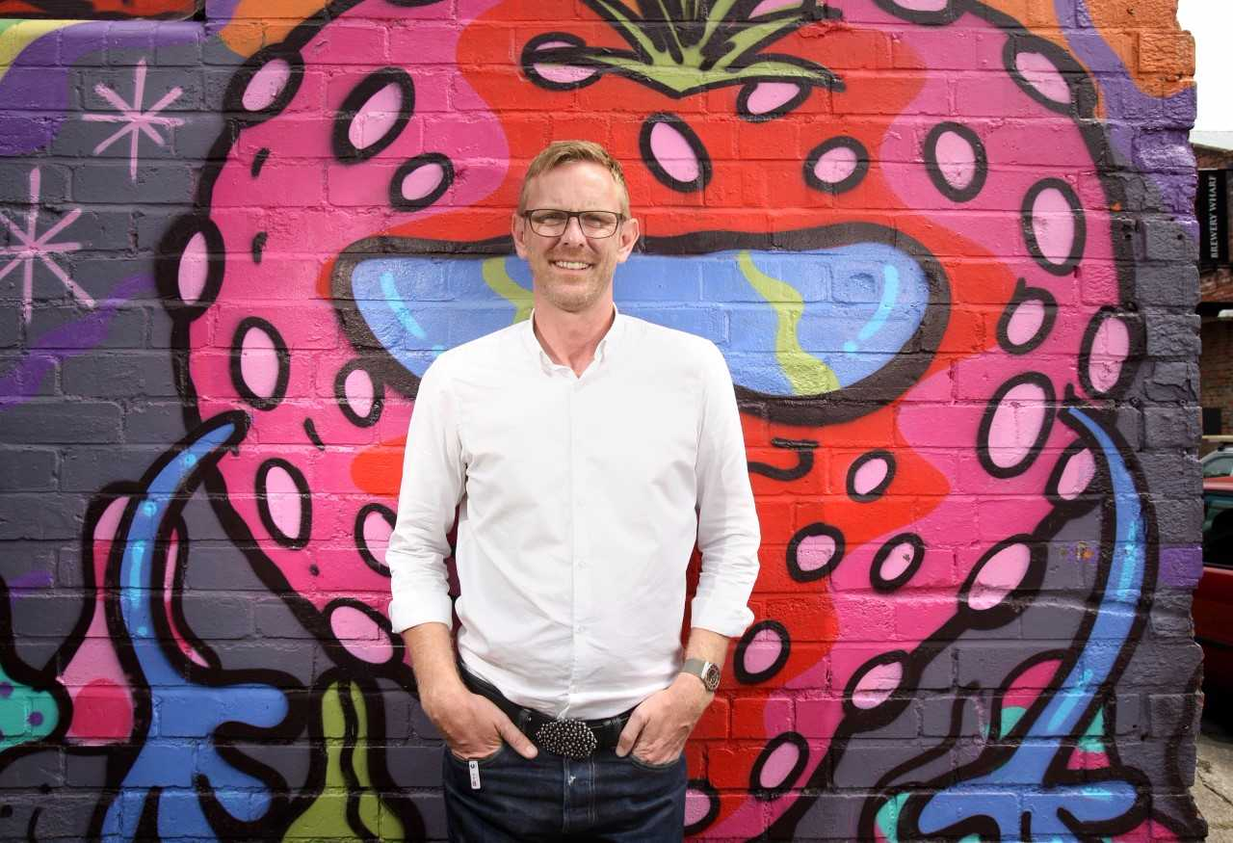
Martin Green, Chief Executive & Director, Hull: UK City of Culture 2017
Martin Green has earned an international reputation for delivering world class, large-scale events. As Head of Events for then Mayor of London Ken Livingstone, he produced more than 60 events each, including the City’s New Year’s Eve celebrations.
In 2007 as Director of events for AEG Live he was part of the team that opened the O2 venue – formerly the Millennium Dome – in London. In 2008 Martin was appointed Head of Ceremonies for the London 2012 Olympic and Paralympic Games, where he oversaw the delivery of the Welcome and Medal ceremonies, Torch relays and Opening and Closing Ceremonies of the Games.
He recruited Danny Boyle and other artistic directors and hand-picked the artists, production and back-of-house teams that showcased the best of British culture on a global stage. Martin masterminded the opening ceremony of the 2014 Tour de France Grand Départ. As Executive Producer, he worked alongside Welcome to Yorkshire to create an occasion that promoted the beauty and character of Yorkshire to audiences around the world. His latest post as Director of Hull UK City of Culture 2017 sees him leading the delivery of a curated 365 day programme of transformative Culture as a major regeneration programme for Hull and the UK’s cultural quadrennial.
Martin is an inaugural member of the Circle of Cultural Fellows at King’s College London and sits on the Board of the The Space, a digital commissioning and development agency, founded by the BBC and Arts Council England. Martin is an advisor to the ceremonies team at the Tokyo 2020 Olympic and Paralympic Games, to Birmingham’s bid for the 2022 Commonwealth games and the Executive Producer of Edinburgh’s Hogmanay celebrations 2017.

