LGBT 50

£245k Budget

Pride parade weekend (also involving Duckie) – 22-23 July 2017

Duckie special event weekend – 29-30 July 2017

Mass Dance with YD – 29th July

Sierra Leone LGBT photography exhibition throughout week between

Victoria Square for second weekend?

Giant glitterball?

City Hall for Duckie show (1800 people?) Ticketed

Ticketing income is not part of budget income

Budget:

£230k x 10-15% for internal staff costs and expenses

£30k for pride parade (to work with Duckie too)

There is a contractually agreed amount to be spent on mass dance project – to clarify with Henrietta/Katy

Balance available for Duckie and other events

Budget for Sierra Leone exhibit – to clarify?

Estimated:

£23k - £35k – Hull CoC costs

£30k for pride parade

(c £60k = £170k remaining)

up to £100k for mass dance

up to £70k or more for Duckie

Allow an amount for Sierra Leone?

Questions:

New project name? Tainted Love?

Strictly Come Dancing conversations?

What is gay about the mass dance?

Should the parade just reflect history or also include creative responses to the future?

Heritage England project around decriminalisation? Sierra Leone project only Hull connection. Dates of Heritage England exhibition?

Tone and nature of second weekend? Communal – low key versus spectacular?

Spirit of event? The civic ownership of public space and focussing on LGBT visibility in public space is powerful in and of itself.

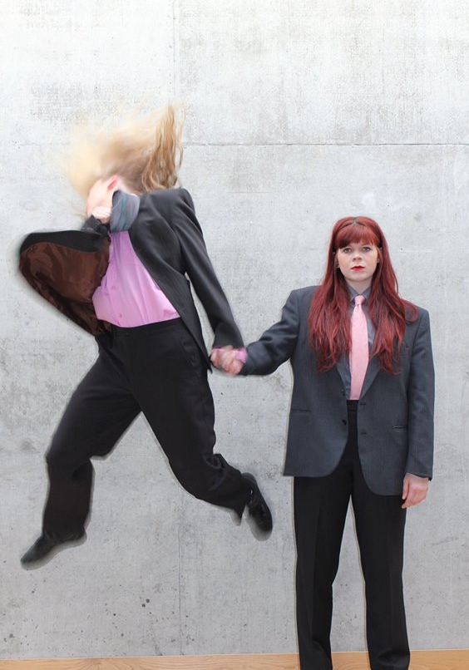

Duckie + Hull 2017 presents

**50**

Duckie would like to produce a free public programme to celebrate the 50th anniversary of the decriminalisation of homosexuality with the following 4 ingredients:

A parade

A dance

A party

A concert

…all on Saturday 29 July 2017, 3pm - 11pm at Hull City Hall

plus a panel talk a couple of days before on Thursday.

**THE PARADE**

The parade will be artistically directed by Robin Whitmore.  Robin has been Duckie’s lead designer for 20 years - designing and directing all of the acclaimed Gay Shame events.  The working title of the event is 50 Queers in 50 Years.  In collaboration with the community and with other artists, Robin will create mini moving tableaux vivants that depict iconic scenes from UK LGBT culture.  These visual tableaux scenes will be portrayed by between one and 4 people in a group.  Each will look a bit like a 3D painted cartoon that moves.  The main materials will be cardboard, canvas, wood and paint.   It will handmade, expressive and with much attention to detail. It will be big, bold and visually iconic.  It will be the opposite of a corporate gay pride parade.   it will seek to be a nationwide celebration.  Much of Robin’s work for Gay Shame looked like this aesthetic - see videos below for reference.

Visually it will highlight seminal moments in British LGBT history since 1967 including:   The Wolfenden Report, secret gay clubs, Gay Liberation Front, cottaging, gay bashing, The Naked Civil Servant, radical lesbian separatism, clones, gay disco, cruising, lesbian folk singers, GRID, AIDS, Princess Diana, bookish lesbians, the first THT meeting, Act-Up, Chris Smith, Section 28, Outrage!,  Freddie Mercury, lesbians absailing Sue Lawley on the news, Manchester gay village, Soho muscle marys, lesbians kissing on Brookside, combination therapy, lezzas in the military, Angela Eagle, Warren Cup,  same sex weddings, corporate takeover of gay identity, lesbian mums and gay dads, gender non-conformers, trans activism and the queerest of the queer.  It will celebrate the past 50 years of progress and propose a hopeful and ambitious future for LGBT and queer folk.

The parade will travel inside and outside the Hull City Hall on a dynamic circular loop.  Outside we will build a catwalk/runway in the street.  Readers Wifes will design the soundtrack for the parade, it will crib a lot from the style and attitude and presentation of vogue balls.  There will be two MCs who will rap and commentate in a Jackie 60’s stylee - David Hoyle and Ether L9.

Duckie will rent a live-work space in Hull for 4 months (April, May, June, July).  Robin will live in the space and use the space for public drop in workshops four days per week.  We will engage the services off a professional props maker to work three months on the project.

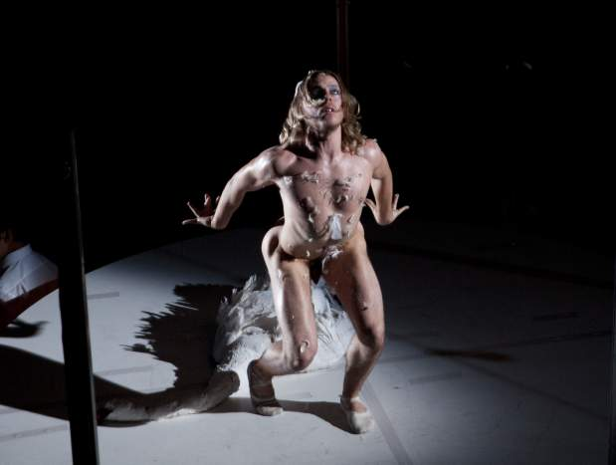

**THE DANCE**

The dance will be choreographed by Gary Clarke.  It will be intergenerational - with younger and older dancers - and will mix professional dancers with people from the community.  Readers Wifes will design the soundtrack for the dance.  It will be 15 minutes long and happen twice - indoor and outdoors.

**THE PARTY**

The parade and the dance happen out of the party.  The party runs from 3pm until 11pm in Hull City Hall, with the parade at 4pm & 6pm and the dance at 5pm & 7pm.  The atmosphere of the party changes from a tea dance to a gay disco.  In the daytime/afternoon it will be styled like The Posh Club - a posh piss elegant atmosphere with fancy tea and 50 posh cakes on vintage crockery served by ‘Trolly Dollys’ - hostesses of all genders with hostess trollies.  The 50 cakes will be themed based on 50 years of LGBT icons - from Grace Jones to John Inman.  The trolly dollies will also be part of the big dance, from serving to performing.  After the parade and the dance, at 9pm there will be a set by Marc Almond with support from David McAlmont.  It will be very torch singer. The whole event will be free.

**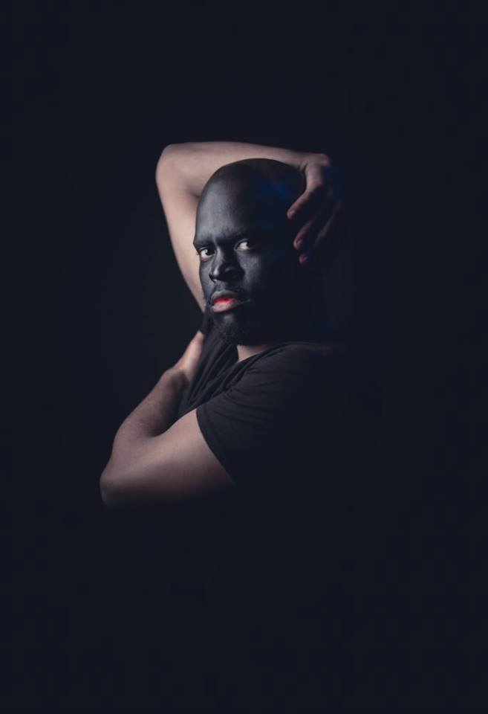**

**THE AUDIENCE**

The audience is a mix of all of the LGBT people from the local area plus queer people from elsewhere plus all of our friends and allies and anyone who fancies it.  It will be very straight friendly, be outward looking and the queers will welcome all old and new friends as guests into the party.  It will not be an exclusively LGBT event.  It will be very outward looking and über inclusive.  Traditionally queers put on the best parties, and Hull is going to get it this time, big time.

For participants (dancers and paraders) we will aim to make a relationship with Hull LGBT Social Network and One Humber (older folks) and The Shout Group (16 - 25 yr old LGBT people) and Hull & East Riding LGBT Forum.  We will have a central producer who will recruit.  We will make much use of social media and a have a prominent presence on the commercial gay scene.

**THE TALK**

All of the above elements happen on the same big day Saturday 29 July 2017, at Hull City Hall.  In addition there will be a talk event on the Thursday night looking at the future possibilities of LGBT culture which host a panel with queer historian Matt Holbrook, trans activists Dark Matter, artist David Hoyle, actor Bette Bourne and filmmaker Campbell X.

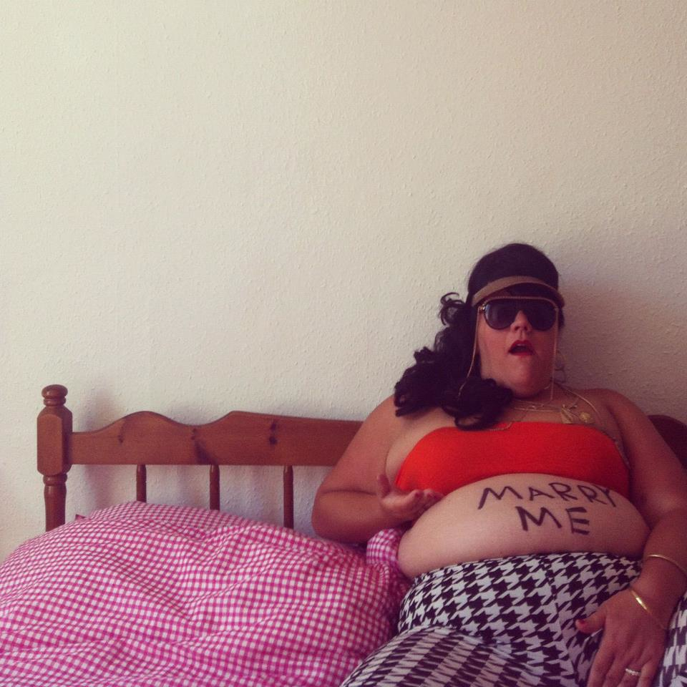 [DUCKIE](http://www.duckie.co.uk/events/twenty-first-century-music-hall)

TWENTY FIRST CENTURY MUSIC HALL

Friday 14 October.  Show 8pm.  Doors 7.30pm.  Dancing till 1am.

Tickets are just £5, Admission All Classes.  18+

In preparation for Hull 2017 City of Culture, the Duckie crew travel up north to Hull to present an evening of up-to-the-minute show business, illegitimate entertainment and vanguard variety.

Mistress of melody Miss Amy Lamé introduces a hit parade of short sharp shows and in-between the acts plays pure pop, rock’n’roll and northern soul.

Starring the Duckie All-Stars: [Ursula Martinez](http://www.ursulamartinez.com/), [Lucy McCormick](https://twitter.com/lucy_muck), [Lasana Shabazz](https://twitter.com/lasana_shabazz" \t "_blank),[PanicLab](http://paniclab.co.uk/), [Debs Gatenby](https://debsgatenby.co.uk/) and [The Non-Applicables](http://www.n-adc.co.uk/)

It's not that complicated:

Come and watch shows, chat to your mates and schlep to the beat.

[This is the Facebook Event Page](https://www.facebook.com/events/191882734564289/).

Presented in association with [Hull 2017](https://www.hull2017.co.uk/).

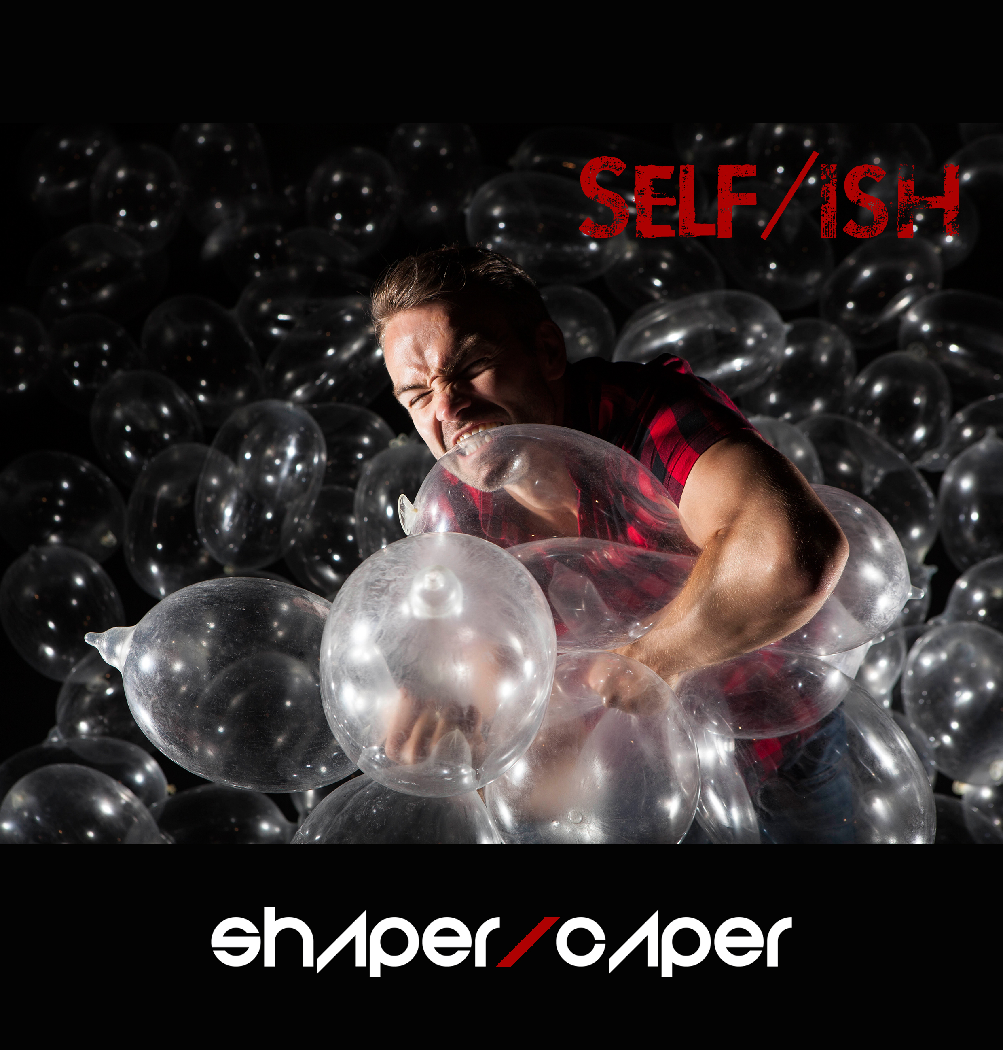

SELF/ISH - THOMAS SMALL

Artist in Residence at BBC Radio 2

I was given your contact details from Jonty Claypole at BBC Arts as I’m the Artist in Residence at BBC Radio 2 and I’m developing a new show exploring LGBT themes.  I believe Owen Hopkin from The Space has mentioned my ideas to your team too.   Jonty mentioned the Coming Out season and the work BBC Arts are doing with Hull City of Culture so I wanted to get in touch to see if there was anyway that I can get involved in what you are doing for this season.

In addition to being the Artist in Residence at BBC Radio 2, I’m also a Clore fellow and a multi award winning choreographer.  I’m developing a touring production called ‘Self/ish’ which is supported by a digital experience for people aged 14 years upwards exploring LGBT themes.

Self/ish is a story told through live and digital experiences that explores what the process of coming out is like in the 21st century for young people. The narrative journey follows a young man called Ishmael as he comes out and makes sense of his sexuality.  The live experience is a touring production that will visit theatres across the UK supported by a version of the show that will tour schools and rural venues with associated workshops.   
  
Audiences experience the interactive digital story through a custom website that weaves together dance, animation, video design, film, sound and games giving a multi-layered view of Ishmael’s world as he pieces together the puzzle of understanding, and accepting, who he is.  This website gives a wider, extended view of Ishmael’s world where audiences can find out more about the characters and the real life challenges young LGBT people still face.  
  
Self/ish examines how the UK’s legislative landscape has changed over the past 50 years and whether or not societal attitudes have shifted at the same time.  Ish's story is drawn from verbatim transcriptions of interviews with LGBT young people around the world through partnerships with the It Gets Better project and the Trevor project based in LA.   This work stems from a recent government study which revealed that since the repeal of section 28 fifteen years ago, 75% of primary teachers and 44% of secondary teaches are still unsure if they can discuss LGBT issues if a pupil asks them a question.  Coupled with the fact that Stonewall discovered that 96% of young LGBT people are bullied at school and called homophobic language such as ‘poof’, ‘lezzie’ or ‘tranny’, there is an urgent need for education and awareness around this matter.

I’m working with five world class dancers on this project as well as CATS award winning video artist Simon Wainwright and Imitating the Dog, acclaimed set designer Claire Halleran, Trad Awards Composer of the Year Jim Sutherland and University of Abertay for the gaming sections.

We also hope to create a film version of the show which could be included as part of the Coming Out season if that were at all possible.  If possible, we would love to work with LGBT people in Hull to work with us on the production.

We have created some marketing imagery for the work which i’ve included below.

Here is a sample of one of the pieces of work i’ve created during my time at the BBC.  ‘Shakespeare Shuffle’ was created for the BBC Shakespeare Festival and featured dancers from youth companies, community dancers, Scottish Ballet and professional dancers dancing in iconic landmarks across the UK.  The film features platinum selling band The Overtones and bespoke voiceovers from Radio 2 presenters including Jonathan Ross, Chris Evans and Sara Cox amongst others - <http://www.bbc.co.uk/programmes/p03rgkq2>

