**NIKI BEDI’s schedule for the day:**

Arrive at Fruit Humber Street at 9am

**10am – 10:20am: Welcoming remarks with John Harris at Fruit.**

Niki leaves at 10:10am half way to go to 1@thedock for How Arts can Save the NHS. See session agenda and bios. John finishes the welcoming notes. See skeleton script for welcome.

**10:30 – 11:15: 1@thedock for How Arts can Save the NHS**

An all-party enquiry this summer showed how a thriving arts and culture scene has a huge impact on the health and well being of any town or city, leading to a fall in hospital admissions. Can arts relieve the pressure on the NHS?

**12:30pm: Head to Hull Minster for lunch**

**1:30pm: Introduce key note from John Harris About The Future of the North: Hull Minster. Very brief introduction.**

**3pm: Chair From stage to screen. See attached bios. Agenda to follow from BBC Academy.**

**Fruit Humber Street**

BBC Arts and Channel 4’s Random Acts discuss routes into being commissioned for broadcast.

BBC Arts, and a panel comprised of the UK’s leading arts broadcasters share their insights into connecting with arts organisations and how digital changes are impacting their decisions.

**4:15pm – 5pm: Art can change the World**

All female panel on how the arts are driving political, social and economic change.

See below agenda and bios attached.

**6pm: Fruit**

**Introduce Katy Fuller as a key note. Brief introduction**

A Journey through the Land of Green Ginger: Hull 2017’s year-round project, Land of Green Ginger, asked the whole city to suspend disbelief and exercise its imagination through a series of “Acts of Wanton Wonder”. This ambitious programme of work infiltrated the neighbourhoods of the city with the collaborating cohort of artists weaving a new urban legend for an audience of over 100,000. What started as a secret resulted in spectacle. Join the mastermind behind this ambitious, city-wide artistic intervention Hull 2017 Executive Producer Katy Fuller as she takes us on a journey through The Land of Green.

**6:30pm: Very brief closing remarks: 15 minutes max. Fruit** with John Harris. We can work these up on the day. It will be mainly thank you for coming and stick around for the party.

# **10am: John Harris and Nikki Bedi introduce the day: FRUIT**

# **Hello and Welcome:**

# Welcome to Substance Future Forum: a creative enquiry into the culture, creativity and future of the North.

# John: I’m from the North.

# Nikki: I’m not from the North.

# Introduce yourselves.

# NIKKI.

# We will be chairing some of the discussions and introducing others today.

# You should have in your bags, in your hands or round your neck a schedule of the day - if you haven’t picked one up you can grab one after this just next door at the registration table for Humber Street Gallery. You’ll need to show this to get into each session so please don’t lose them. If you do head with your ticket for the event back to Humber Street Gallery.

# As you might notice today does not happen in one place.

# The map and street signs should be able to guide you to each of your sessions.

# Most of it sits on Humber Street, where you are now. Lunch, however, will take place across the main road at Hull Minster (point right).

# As you will also notice the sessions do not happen at the same time – some rooms are also bigger than others with C4DI Theatre being the smallest, seating just 50 – whilst the other spaces hold pretty much all of you.

# People are here for different reasons and some sessions will appeal to some much more than others. This is an active day. You will be going from place to place. It’s so active I am going to get ready now to chair the first session. So I will leave in the capable hands of John.

# JOHN.

# If you have any queries throughout the day do ask one of the very friendly volunteers who are so illuminous you can’t miss them. They will either answer your question, or find someone who might be able to.

# Your Substance Future Forum Hub will be next door at Humber Street Gallery where staff will be throughout the day if you need further information about anything.

# We also have coffee points situated along Humber Street. One at Nibble, another at Thieving Harry’s and another at Humber Street Gallery. If you show your Substance pass you will receive a cup of coffee or tea.

# You’ll also see a campaign shop on the map presented by Hack & Host that you can visit throughout the day and view their manifesto.

# Sessions are presented from a whole range of partners such as Guardian Live, BBC Academy, British Council, Hack & Host, Arts Council England – who have all come up some meaty and excellent discussions. The panellists come from the north, the entire country and overseas. This is a conversation about the culture, creativity and the future of the north – you do not have to be northern to have an opinion.

# The sessions are 45 minutes long. This is not a long time. If you want to know more about someone, something or feel like the person you saw speaking could be your new best buddy - use the coffee points to have a discussion further about the session. If you find a group of you wanting to talk further – take it to the gallery or Thieving Harry’s. The day is yours to use as you wish.

# If there’s only three of you in a session because you are the only three that bought tickets to hear more about that session. Don’t worry. Do sit at the front and make it a conversation. This might happen at some points in the day, it might not. The main thing is the right people are in the room.

# By the end of the day we will know who the next UK City of Culture is as it is announced directly after this, the Future Forum. At 8pm we will come back here, Fruit, to party in true northern fashion, delighting in Hull Pi and a few free drinks, whilst The Resident’s Association providing absolutely banging tunes.

# Along your way today, don’t miss Marshmallow Laserfeast: *A Collosal Wave*. Roll VT. **SHOW MLF A COLLOSAL WAVE TRAILER: 1 MINUTE.**

# Also, don’t miss *Where do we Go from here?* By Jason Bruges Studiowhich should also be marked on your maps in the form of orange little robots. ROLL VT. **SHOW JASON BRUGES WHERE DO WE GO FROM HERE TRAILER. 54 SECONDS**

# **If you are still here Saturday then make sure you get yourself to City Hall for Substance Live: The Future of the North. With this killer line up of the most exciting and inventive musicians the north have to offer: ROLL VT. SHOW TRAILER FOR SUBSTANCE LIVE: 1 MINUTE 9 SECONDS.**

# **JOHN HARRIS: PRESENT A SHORT 2 MINUTE PRECUROSOR ABOUT WHAT HE WILL TALK ABOUT AT 1:30PM.**

# Now please head off to your first sessions – if I don’t see you at lunch I’ll see you before then. Then again, you don’t have to head off to the first session – if you wanted to just have a chat with someone you haven’t seen for a long time. Go and do that – this is your day – make as much of it as possible.

**How Can Arts Save the NHS?**

An all-party enquiry this summer showed how a thriving arts and culture scene has a huge impact on the health and well being of any town or city, leading to a fall in hospital admissions. Can arts relieve the pressure on the NHS?

**Nikki Bedi – Chair**

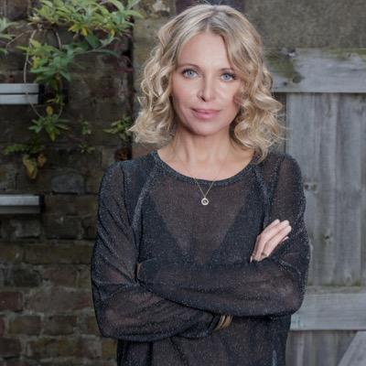

Nikki is a televison and radio broadcaster with a passion for making arts and culture accessible. She currently wakes up the capital presenting the Early Breakfast Show Monday to Friday on BBC Radio London. Nikki curates, writes and presents The Arts Hour on the BBC World Service, is a regular interviewer and presenter on BBC Radio 4’s Loose Ends, can often be seen on BBC1's Sunday Morning Live interviewing famous names and celebrities about their faith and also on BBC1's current affairs show Inside Out reporting on everything from eye transplants to cinema restorations. Nikki also presents The Heart Of... TV series on BBC World News, an arts and culture programme looking at fresh new talent from across the world's great cities and has presented BBC Radio 4's Womans Hour.

**Nicky Taylor - Panellist**

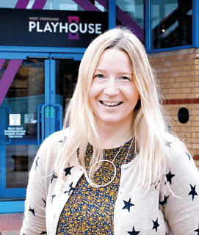

**Theatre & Dementia Research Associate**

PhD student at Leeds Beckett University, Theatre & Dementia Research Associate at West Yorkshire Playhouse, Churchill fellow – Nicky Taylor has pioneered the way in dementia friendly performance at West Yorkshire Playhouse, the largest regional repertory theatre in the UK outside London and Stratford. Nicky’s research has taken her all over the world and as well as receiving many awards and accolades for her work in making theatre and performance more accessible in new and innovative ways Nicky has more recently secured funding to develop the first Festival of theatre and dementia.

**Vicki Amedume - Panellist**

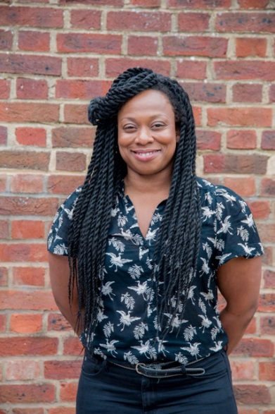

**Artistic Director Upswing**

Vicki has over 18 years of experience of working in circus arts following her initial training as a research scientist. She founded Upswing, a contemporary circus company, in 2006 after years performing and devising with circus companies in the UK, France and the US. Upswing is now a charity and an Arts Council England NPO developing a variety of performances, programmes and participatory experiences that use the playfulness and wonder of circus to bring people together and enable them to discover new potential in themselves and in others. Their work is presented in range of contexts from theatres and festivals to libraries, care homes and other public spaces, taking shows beyond theatres to meet people in the places they live, work and play. As a freelance practitioner she has previously been an associate director of Greenwich + Docklands International Festival producing large-scale spectacular outdoor work in Greenwich and East London, a circus and aerial consultant on a range companies including The RSC, The National Theatre of Scotland, New Vic Theatre and The Royal Exchange.

**Dr Dan Roper - Panellist**

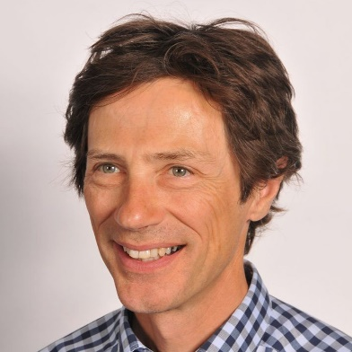

**Chair of Hull Clinical Commissioning Group**

Dr Dan Roper is the Chair of Hull CCG, one of the major sponsors of the City of Culture, an association that recognises the strong links between art, culture and health.

He was a GP in Hull for 30 years and was born and grew up in Hull. He was involved in the training of health care professionals for 25 years with an emphasis on cultural influences and what the impact of those influences might be on behaviour affecting peoples health and how they seek and access health and social care.

**Alex Mitchell - Panellist**

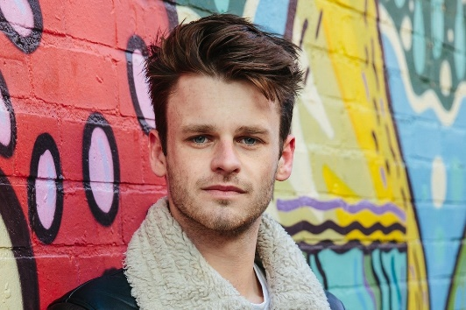

**Artistic Director Silent Uproar**

Alex founded Silent Uproar in late 2012. As well as being Artistic Director of the company, he is also the company's theatre director. Alex has worked and been trained by practioners and companies throughout the UK. Originally from down south Alex went to Hull University and thought to root himself in the north.

Alex directed the smash hit, critically acclaimed A Super Happy Story (About Feeling Super Sad), an energetic, touching musical about depression. Written by Olivier award winning Jon Britten, winning a fringe first and Best Musical award at the Edinburgh Festival, the performance was described by the Guardian as **"A mix of wit and low-key emotion that suddenly grips your heart"**

**Sarah Emmott - Panellist**

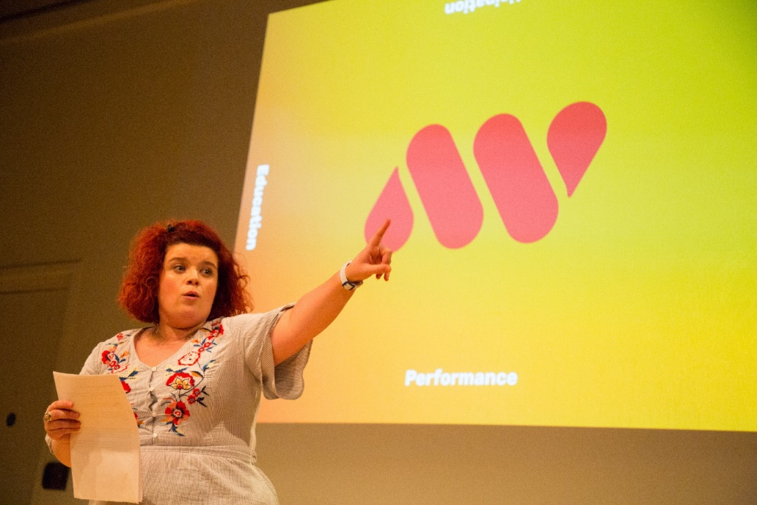

**Creative Director: Art with Heart**

Sarah is a theatre-maker, writer, performer, producer, facilitator and Co-Creative Director of Art with Heart. Salford based award winning Art with Heart are Associate Artists at The Lowry Theatre who deliver Performance, Participation and Education projects both locally and nationally.

Our latest theatre production is Declaration; an autobiographical, riotous celebration of Sarah’s experience with ADHD, mental health and diagnosis which toured in Summer 2017 with 5* reviews. Alongside Declaration tours our curated wellbeing room ‘SPACE’ which was visited by 78% of our audiences. On tour 47% of our audience were age 14-35 and 20% identified as neurodiverse, deaf or disabled. For 44% it was their first visit to the venue and for 13% was their first theatre experience. We are looking to re-tour Declaration in Autumn 2018.

We make work for the here and now which responds to the world we live in and questions what it means to be part of society and provide platforms for under-represented voices; working to open conversations, provoke debate and challenge perceptions. “The work of Art with Heart is a must see. The positive change they are making is incredible” - The Reviews Hub

**Can arts save the NHS?**

**1@thedock: 10:30am. Please register at Humber Street Gallery.**

**45 minutes**

**Chair: Nikki Bedi**

**Panellists:**

**Nicky Taylor:** PhD student at Leeds Beckett University, Theatre & Dementia Research Associate at West Yorkshire Playhouse

**Bob Fulcher:** Curator of a new Festival of Theatre and Dementia at West Yorkshire Playhouse, whilst also living with dementia.

**Sarah Emmott:** Creative Director of Art with Heart, an autobiographical, riotous celebration of Sarah’s experience with ADHD, mental health and diagnosis which toured in Summer 2017 with 5* reviews.

**Vicki Amedume:** Artistic Director and Founder of Upswing, a contemporary circus company, who have presented their work in Hull and also toured to care homes leading circus workshops with older members of the community.

**Dr Dan Roper:** Chair of Hull Clinical Commissioning Group

**Alex Mitchell:** Director of Silent Uproar, Hull based director, who recently made the critically acclaimed A Super Happy Story (About Feeling Super Sad)

Conversation with **Nicky Taylor and Bob Fulcher** for those in the call. Please read.

* Bob is someone **living with dementia**, NOT suffering with dementia – Bob and Nicky will explain this at the beginning of what they talk about.
* Nicky works collaboratively with Bob to make and present work, Nicky as someone not with dementia, Bob as someone living with dementia.
* Most important rationale of the festival that Bob is curating is that society values people living with dementia.
* There’s a lot of stories out there told by people who don’t live with dementia, this festival aims to give a clearer picture of what living dementia is like. A first person perspective.

About Bob:

* 8 years ago Bob was diagnosed with dementia, and was self admittedly, more shy and retiring before being diagnosed. Didn’t talk to people anywhere near as much – and lived a much more lonely life.
* In order to avoid things like depression, which often have a connection with dementia, Bob needs to keep himself active – this manifests in working with West Yorkshire Playhouse, participating in classes, sessions, and more.
* Bob would never imagined he would be calling himself a curator of a festival.
* Bob noted Laughter and Hope – two incredibly important things to living a life with dementia.

Nicky and Bob to write something for Hull 2017 website, that we can offer out to media partners. Also present images and slides.

**Agenda for Discussion:**

On the panel are a wide range of individuals. Some addressing mental health conditions, others finding a solution to improve quality of life for those living with a wide range of conditions that could lead to social isolation and a lower quality of life. We also have a medical expert and Chair of the Clinical Commissioning Group in Dr Dan Roper.

**Suggested Questions:**

* Dan, could you give us a very brief explanation of what the Clinical Commissioning Group is, what it does? And the role they have played in working with Hull 2017? After this I’d love each of the panel to give us a quick 2 minutes on how their work has addressed issues of health and well being.
* Bob, as someone living with dementia can you tell us about your experience from being diagnosed as having dementia to becoming a curator of a theatre festival. Nicky, could you also tell us a little bit about your work and how this festival came about?
* A lot of what has been outlined has addressed certain stigmas attached to living with conditions such as depression and dementia. Is it the point of view that once you get these stigmas out of the way and shift culture around these, in a meaningful and open way, a better quality of life can be approached? **Nicky, Alex, Sarah, Dan.**
* **Vicki**, your work addresses a slightly more physical element of someone’s wellbeing – what has been the impact of the sessions you have carried out in care homes?
* **Nicky and Bob**: Bob you are someone living dementia who is also curating a festival with Nicky at West Yorkshire Playhouse as someone who is living with the condition they are addressing how do you feel this will impact the presentation and curation of the festival?
* **Dan:** You have had years of experience treating patients in a very conventional sense and also looking at how the medical profession can improve its practise in order to treat individuals in a more effective way. Are the arts crucial to treatment and improving training techniques and methods of those giving the treatment.
* The effect of the arts might have effects on people’s lives can be quite difficult to quantify – if it’s true that the arts do improve a standard of living, that might lead to improvements of wellbeing and health and potentially reduce the costs of other treatments. How do we make this case in age of austerity and budget cuts?
* From each of you, what do arts and culture do for someone’s health and wellbeing that might be missing in other areas of life.
* Questions from the audience if time allows. If not encourage everyone to go to individual coffee points throughout the day and discuss these elements further.

**From Stage to Screen: 3pm at Fruit, Humber Street**

***Sky Arts, BBC Arts and Channel 4’s Random Acts discuss routes into being commissioned for broadcast.***

Sky Arts, BBC Arts, and a panel comprised of the UK’s leading arts broadcasters share their insights into connecting with arts organisations and how digital changes are impacting their decisions.

Panellists include **Lamia Dabboussy**, Editor for BBC Arts, **Jeremy Routledge** from Channel 4 film Random Acts, **Peter Groom,**who directed the short film Herd as part of Random Acts and **Rocio Cano**,a TV producer who has worked mainly on arts and entertainment series for Sky Arts.

**Lamia Dabboussy** is the Editor for BBC Arts. This year the BBC Director General, Tony Hall said the BBC will create a new Artists First BBC commissioning fund that will prioritise artists and arts organisations who want to create new works for broadcast and online. It will have £4m of funding in the first year, with BBC Arts overseeing the project.

**Jeremy Routledge** is development director at production company Calling The Shots in Bristol. and Executive Producer of Random Acts South West. Calling the Shots specialise in developing creative talent.

**Peter Groom** is a Newcastle based actor, dancer and choreographer working mainly with dance and theatre. He directed the short film Herd as part of Random Acts, the Channel 4 short film strand and **Rocio Cano** is a TV producer who has worked mainly on arts and entertainment series, most recently both Portrait and Landscape Artist of the Year for Sky Arts.

BIOS:

**From stage to screen**

BBC Arts and Channel 4’s Random Acts discuss routes into being commissioned for broadcast.

BBC Arts, and a panel comprised of the UK’s leading arts broadcasters share their insights into connecting with arts organisations and how digital changes are impacting their decisions.

**Nikki Bedi – Chair**

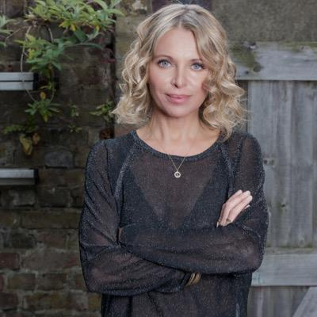

Nikki is a televison and radio broadcaster with a passion for making arts and culture accessible. She currently wakes up the capital presenting the Early Breakfast Show Monday to Friday on BBC Radio London. Nikki curates, writes and presents The Arts Hour on the BBC World Service, is a regular interviewer and presenter on BBC Radio 4’s Loose Ends, can often be seen on BBC1's Sunday Morning Live interviewing famous names and celebrities about their faith and also on BBC1's current affairs show Inside Out reporting on everything from eye transplants to cinema restorations. Nikki also presents The Heart Of... TV series on BBC World News, an arts and culture programme looking at fresh new talent from across the world's great cities and has presented BBC Radio 4's Womans Hour.

**Lamia Dabboussy - Panellist**

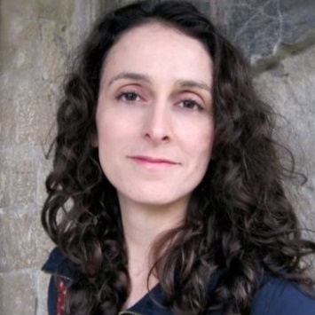

BBC Arts

Lamia Dabboussy is the Editor for BBC Arts.  This year the BBC Director General, Tony Hall said the BBC will create a new Artists First BBC commissioning fund that will prioritise artists and arts organisations who want to create new works for broadcast and online. It will have £4m of funding in the first year, with BBC Arts overseeing the project.

**Jeremy Routledge- Panellist**

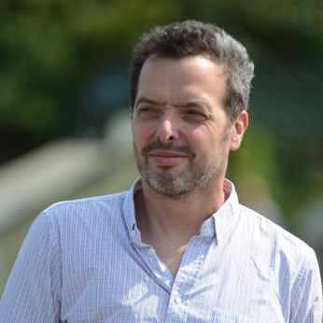

Channel 4 Random Acts

Jeremy Routledge is co-founder of Calling The Shots based in the South West. The film production company also provide educational workshops around filmmaking. Jeremy started off his career helping to run the Bristol 1980s music club the EEC Punk Rock Mountain. He then made pop promos, worked as a freelance editor and then documentary director for the BBC, Maverick TV and ITV West.

**Peter Groom - Panellist**

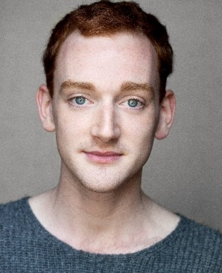

Peter Groom is a Newcastle based actor, dancer and choreographer working mainly with dance and theatre. He directed the short film Herd as part of Random Acts, the Channel 4 short film strand focussed on the arts. Peter is also an Associate Dance Artist of DanceCity.

**Rocio Cano - Panellist**

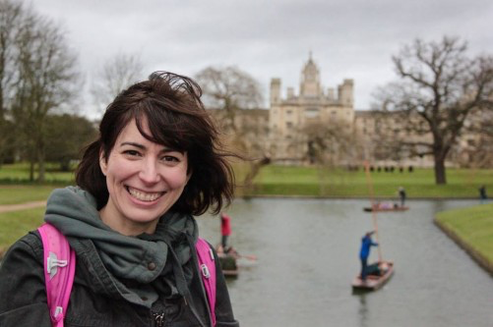

Rocio Cano is a TV Producer who has worked mainly on arts and entertainment series, and who is currently running ART 50, a funding scheme for Sky Arts commissioning 50 arts projects on the subject of being British.

AGENDA FOR FROM STAGE TO SCREEN: BBC ACADEMY SUPPLYING

**ART CAN CHANGE THE WORLD:** **1 @ THE DOCK, 4.15PM – 5PM**

**How the arts are driving political, social and economic change.**

**Art can change the world**

*How the arts are driving political, social and economic change AND How do artists talk about politics, place and gender?*

**Nikki Bedi - Chair**

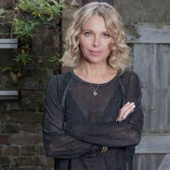

Nikki is a televison and radio broadcaster with a passion for making arts and culture accessible.  
  
She currently wakes up the capital presenting the **Early Breakfast Show** Monday to Friday on BBC Radio London. Nikki curates, writes and presents **The Arts Hour** on the BBC World Service, is a regular interviewer and presenter on BBC Radio 4’s **Loose Ends***,* can often be seen on BBC1's **Sunday Morning Live** interviewing famous names and celebrities about their faith and also on BBC1's current affairs show **Inside Out** reporting on everything from eye transplants to cinema restorations.  
Nikki also presents**The Heart Of***...* TV series on BBC World News, an arts and culture programme looking at fresh new talent from across the world's great cities and has presented BBC Radio 4's **Woman's Hour.**

**Kate West, Hack and Host – Session Lead**

Hack & Host is a collective of artists who have a mutual interest in raising the quality of contemporary art in Hull. Hack & Host will showcase contemporary art through interactive, participatory work, interventions, live art performances, and artist talks. We are a social space where conversation is generated around the theme of contemporary art from the viewpoints of the maker and the participant. We hope to challenge views and perceptions through progressive and experimental works.

**Aisha Zia - Panellist**

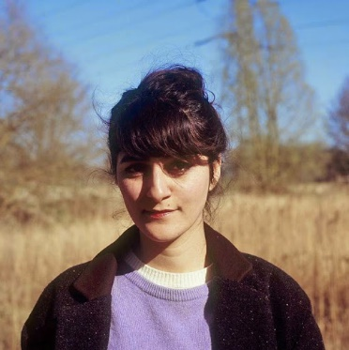

Aisha is a British writer for both theatre and film. She won Highly Commended from Amnesty International at the Edinburgh Fringe in 2013 for her play with Common Wealth Our Glass House, and The Scotsman Fringe First in 2014 for No Guts, No Heart, No Glory.

No Guts was selected for the Women of the World Festival a the Southbank Centre, and Live from TVC with the Battersea Arts Centre screened on BBC4 in 2015.

Aisha is currently resident playwright at Theatre 503, is under commission from Curve Theatre in Leicester and Contact Theatre in Manchester. She is former Resident Artist at Somerset House Studios in London and Foundation Jan Michalski in Switzerland where she began working on her new personal project, with a grant from Arts Council England.

**Léonie Higgins - Panellist**

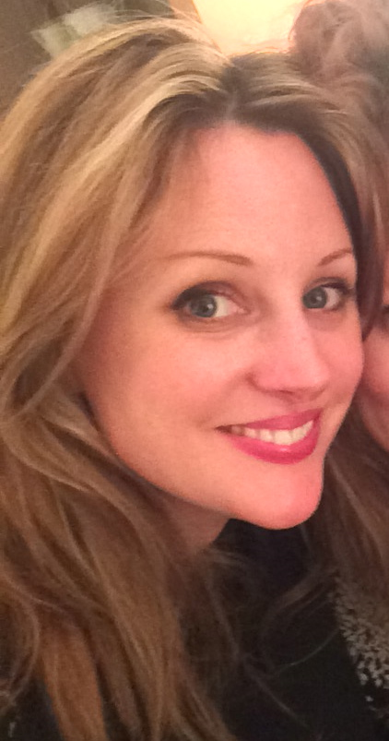

Léonie Higgins is one third of Eggs Collective - a Manchester-based performance company who write, produce and perform their work.

Eggs Collective are a trio making sharp, fun, culturally-observational performance that falls somewhere in the cracks between theatre and cabaret. They explore feminism and connection through the way they see the world and what they find funny. They have toured two full-length stage shows, and have performed in ballrooms, in cinemas, in toilet cubicles, on bars, on traffic islands and on stages for events and organisations including Contact, Duckie, The Royal Shakespeare Company, Southbank Centre, TED, Latitude Festival, HOME, Forest Fringe, Heart of Glass and Islington Mill.

This year they adapted their show Get A Round for BBC2's Performance Live series, supported by Battersea Arts Centre and Arts Council England. The show was broadcast on BBC2 in August 2017.

Léonie is also a writer, performer and musician. She has written and performed two solo theatre shows, and has performed her music at venues and festivals across the country.

**Gillian Nicol - Panellist**

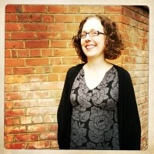

**Director of Digital and Online Content, a-n The Artists Information Company**  
Gillian has a key role in instigating and leading artistic and business developments at a-n. She is experienced in developing and delivering content via UK-wide networks of contributors across different publishing formats and social media. Her background in art practice and artist-led activity informs her commitment to ensuring artists’ voices are heard, rights are recognised and infrastructures to support developing practice are valued. She is based in Newcastle upon Tyne.

***ART CAN CHANGE THE WORLD AGENDA***

Artists often comment on the social and political landscapes but this becomes more apparent in times of austerity. Our political uncertainty in recent years has been spoken about a lot in the media - print and social, there has been reports issued and academic insight but what happens when artists use their skills to talk about it too. Can this have an effect? Can gender come into play within this conversation and will it change our sense of place?

**POLITICS**

Introductions - all four panelists describe how they talk about politics in their work.

Sub questions to intros;

1/ Do you feel that when there is a lot of political change that it makes for rich artistic content.

2/ Is there more of an urge to collaborate during political movements when artists bond over beliefs.

3/ Are you ever worried you alienate audiences making a strong political stance?

**GENDER**

With an all female line up and all panel members representing organisations with female directors it's important we talk about gender.

1/ does anyone feel this is not an important topic / is your gender considered or not in the the work you make, represent or talk about?

2/ if you are to comment on social, political and economic topics are you heard? Do you ever feel tokenistic? Or seen as a raving feminist?

3/ Do some women reach a stage in the arts where they feel pushed out, with little stability in terms of maternity pay and leave for freelancers plus unsociable long hours - is this the reason for a gender pay gap in the arts?

4/ the widely used hashtag #MeToo and the thousands of signatures by artists on the not-surprised letter is eye opening about abuse of power in the arts, are any of the panel members victims of this?

**PLACE**

1/ how much does where you live influence the work you make or represent?

2/ does the work we show to audiences change with the place in which we show it?

3/ all 4 organisations talk about elements of open dialog and interaction, how does this change from place to place? What can the we learn from this?

**Things to add:**

**Outdating of work**

Do you worry work can become out of date all too soon by addressing political issues too directly?

**Artificial deadlines:**

Deadlines applied to making work don’t allow the time in order to present things that are ready. Have most artforms given themselves standardised deadlines to create work, that don’t allow for anywhere near as much interrogation before the work has to be ready. Or pieces of art are performed half ready – not full pieces.

**TV/Radio:**

Roles in TV and radio are even harder to break down. Everyone has a very set job/role – with women being under represented. How do we break those barriers down? Eggs Collective have just had the experience of setting up their own TV Production Company, presenting Get A Round on Saturday night, prime time, TV. Question possibly more aimed at Leonie.

Media Available:

Video: Common Wealth (Aisha Zia): Our Glass House: A Site-Specific Theatre Production