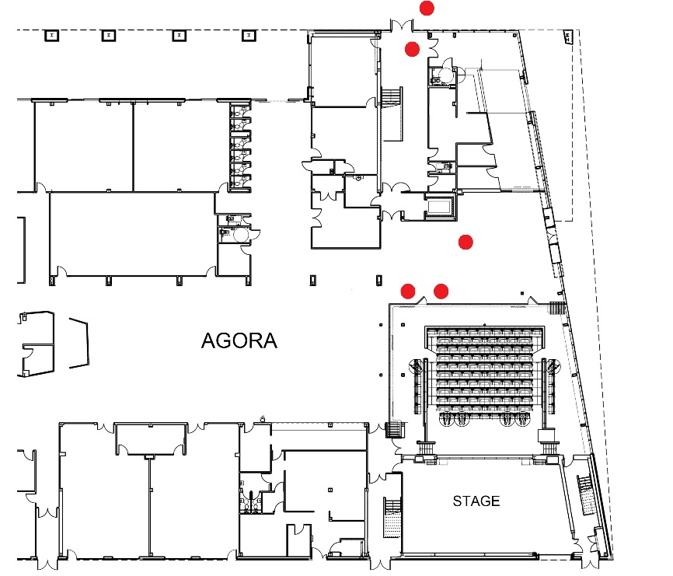**Archbishop Sentamu**: James Campbell & Yvette

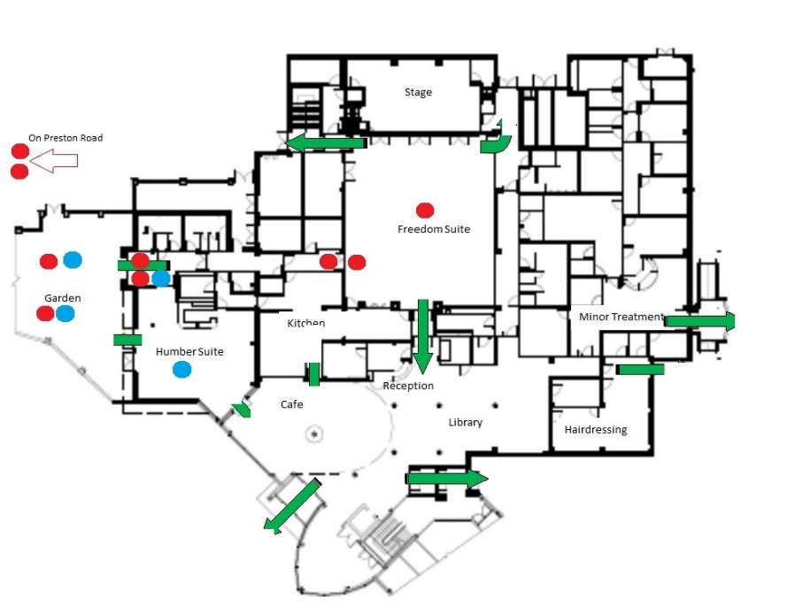**Freedom Centre**: Word on the Street, Band, Picture House & Picasso

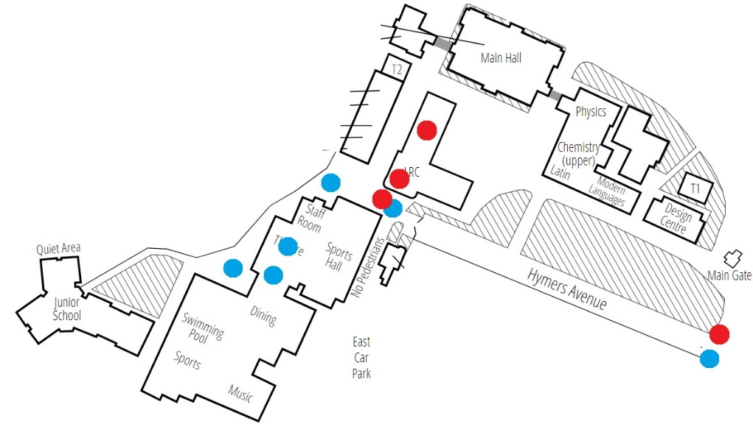**Hymers College:** Picture House, Yvette & Picasso

KINGSWOOD

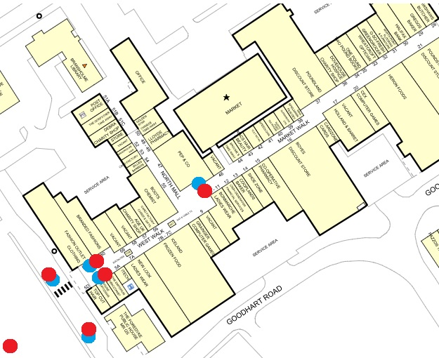**North Point**: Word on the Street & Band

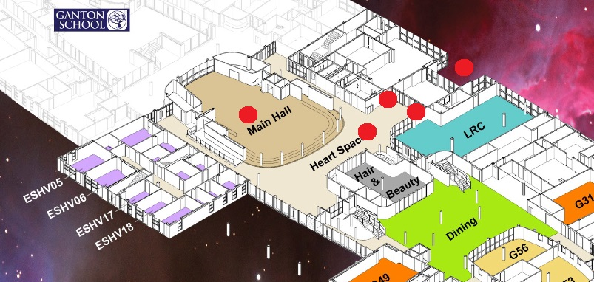**Sirius Academy:** James Campbell, Band, Tipping Point

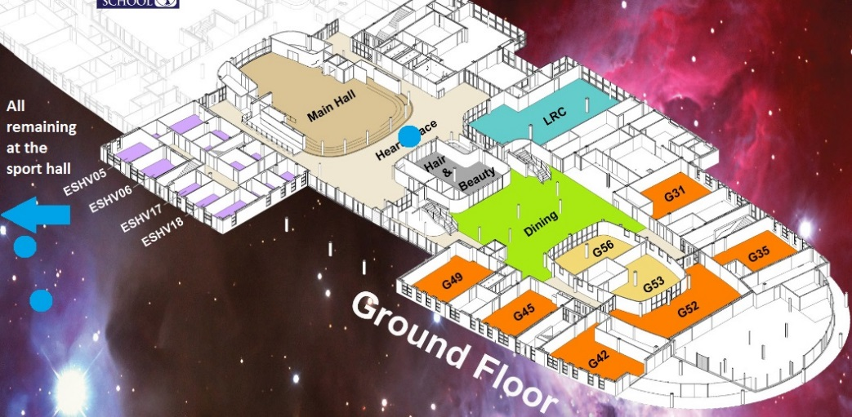

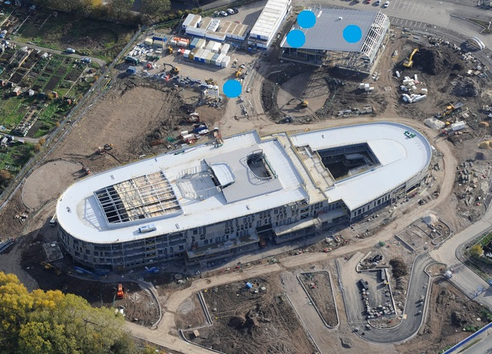

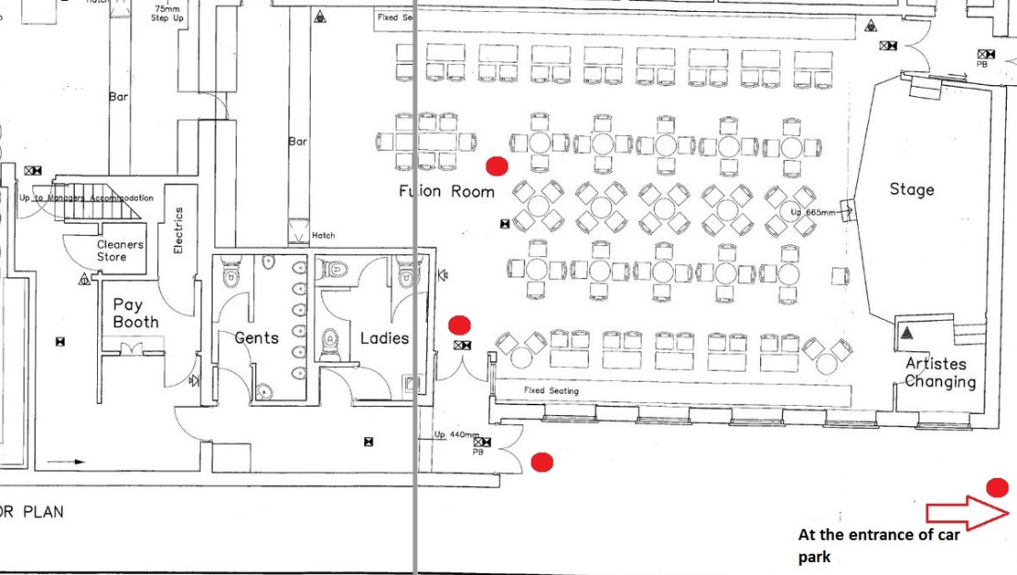**The William Gemmel**l: Word on the Street

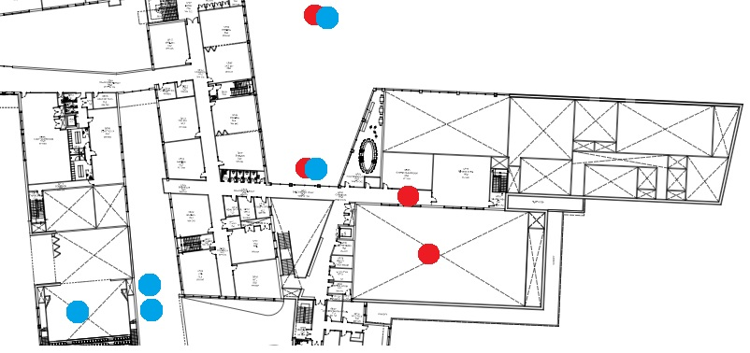**Winifred Holtby Academy:** Tipping Point, James Campbell & Picture House