TATE LOGO

HULL 2017 LOGO

HULL CITY COUNCILLOGO

TURNER // RETURN

Copy about the event

RETURN // ART

Schedule of talks

Schedule of film screenings

With thanks to…

List of artists

List of artists

List of artists

List of artists

List of artists

TURNER

//

RETURN

BACK COVER

(A6)

4

INSIDE COVERS

(Double A6)

2 3

FRONT COVER

(A6)

1

4 on the back

1 on the back

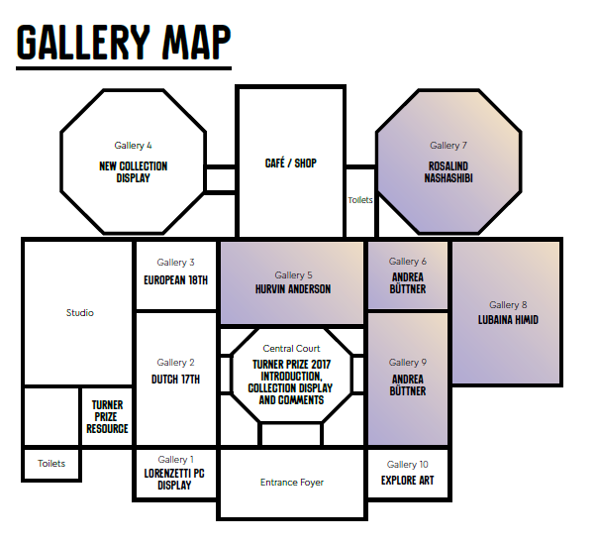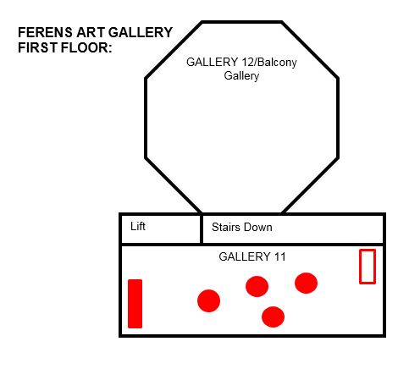

FULLY FOLDED OUT

(A4)

7) RETURN // EXCHANGE

8) RETURN // DECADENCE

Music listings:

Your guide to Turner // Return

1) RETURN // PRINT

2) RETURN // ART

3) RETURN // FEESTING

4) RETURN // FINE CUT

5) RETURN // DEBATE

6) RETURN // PERFORMANCE

6

8

7

5

1/4 on the back

2/3 on the back