No. | Image | Description | Maker | Material
1 | 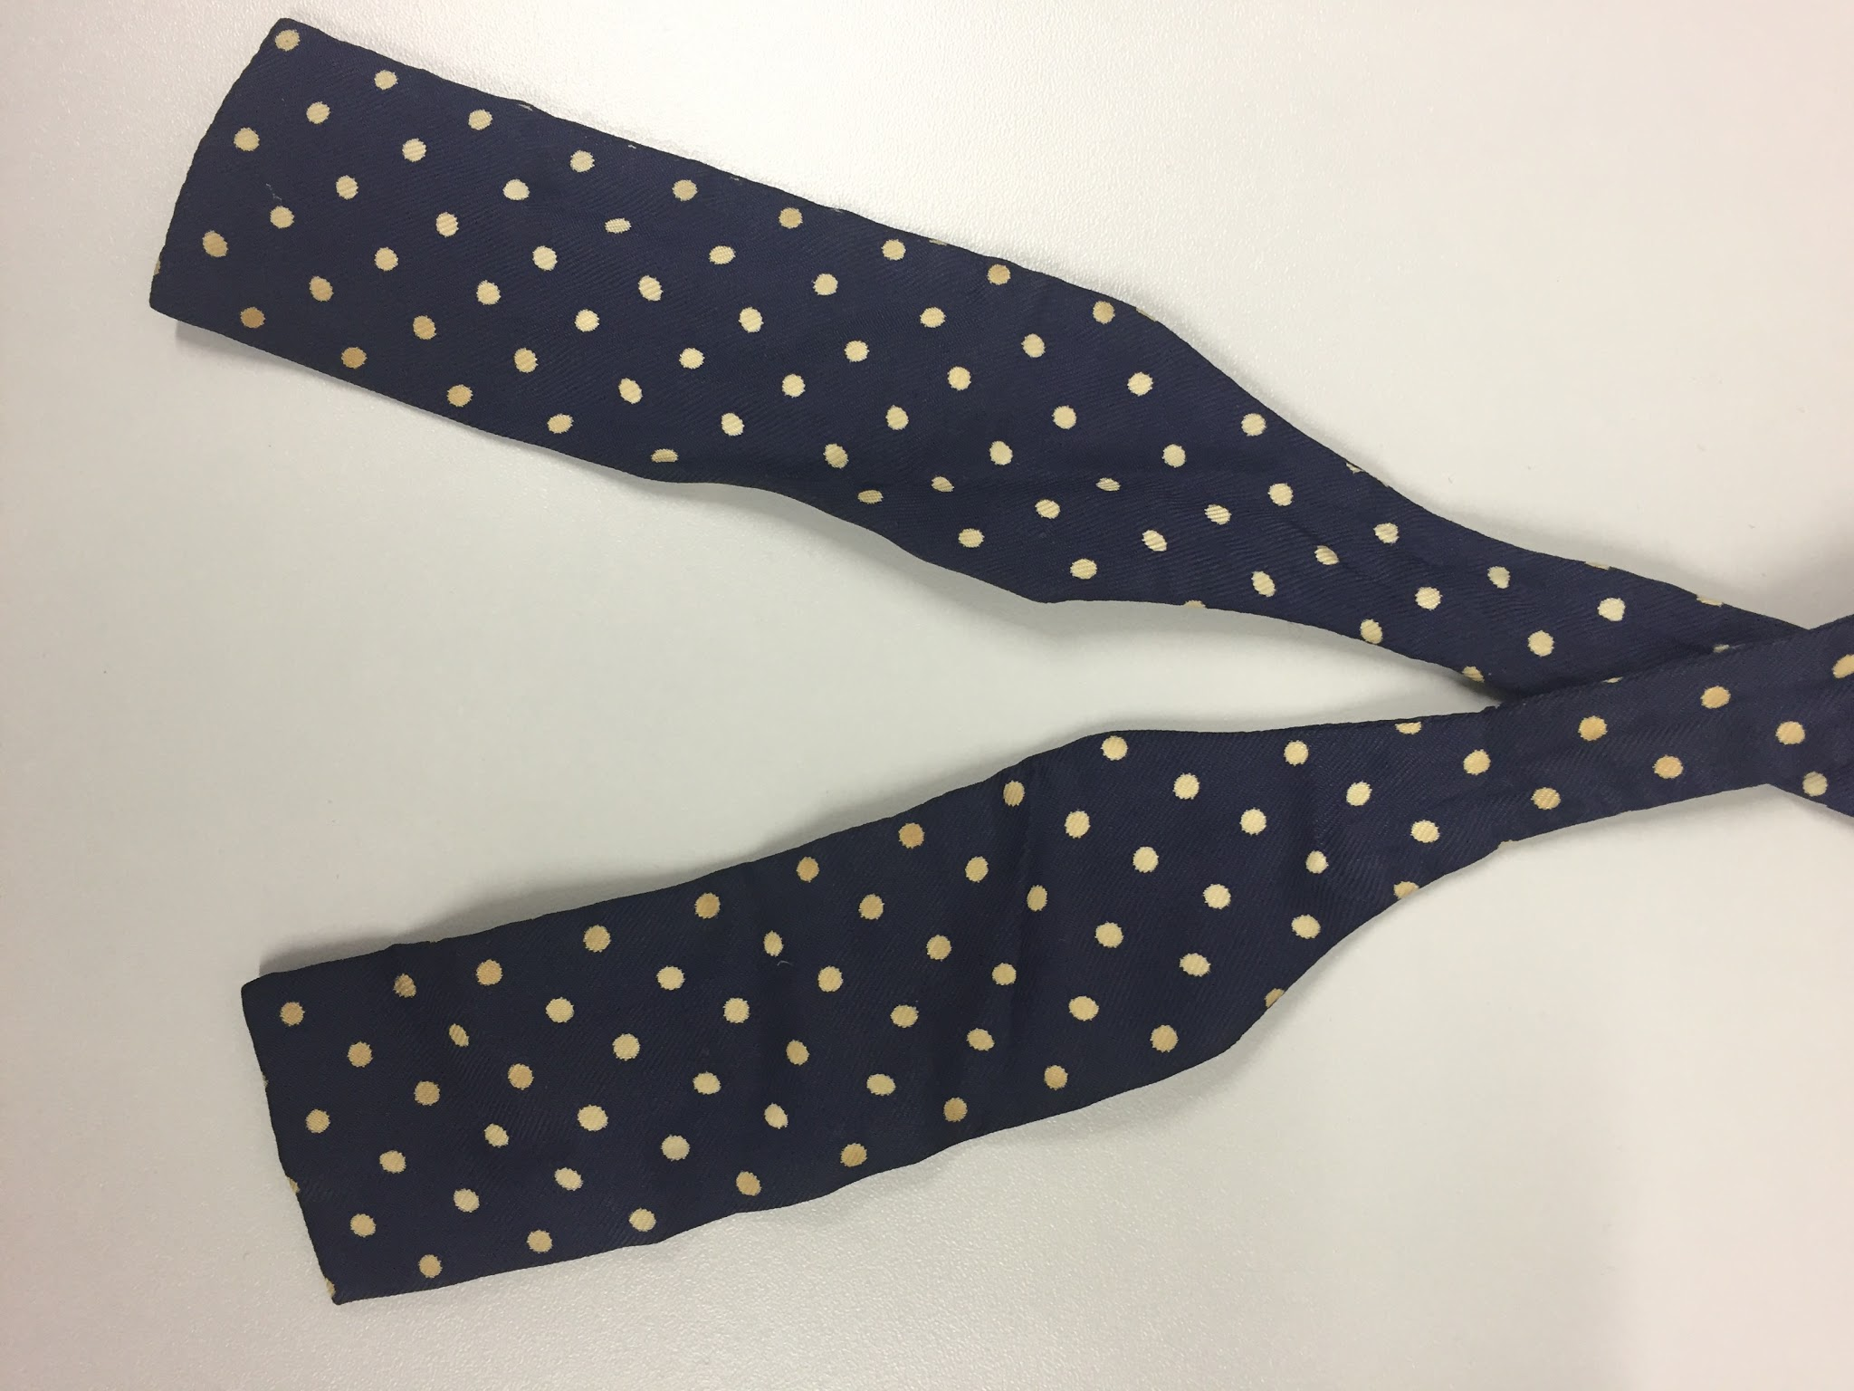 | Square bow, navy, large white dots | None | Silk
2 | 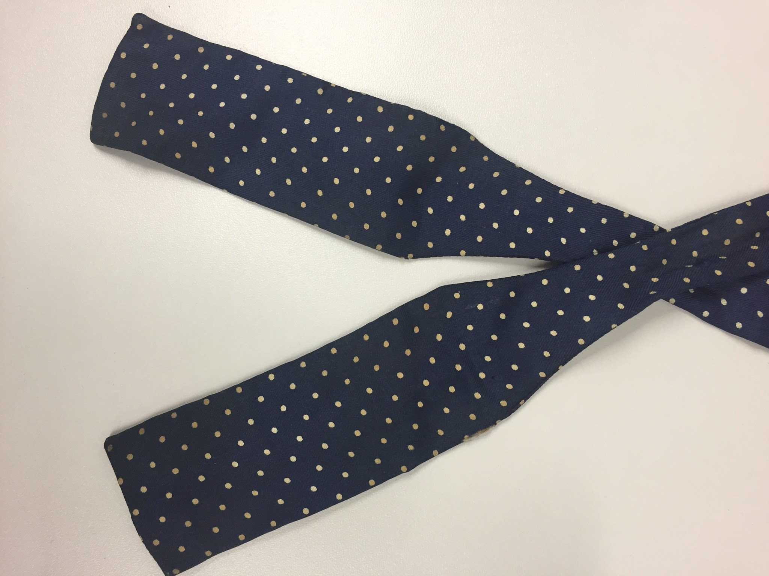 | Square bow, navy, small white dots | None | Silk
3 | 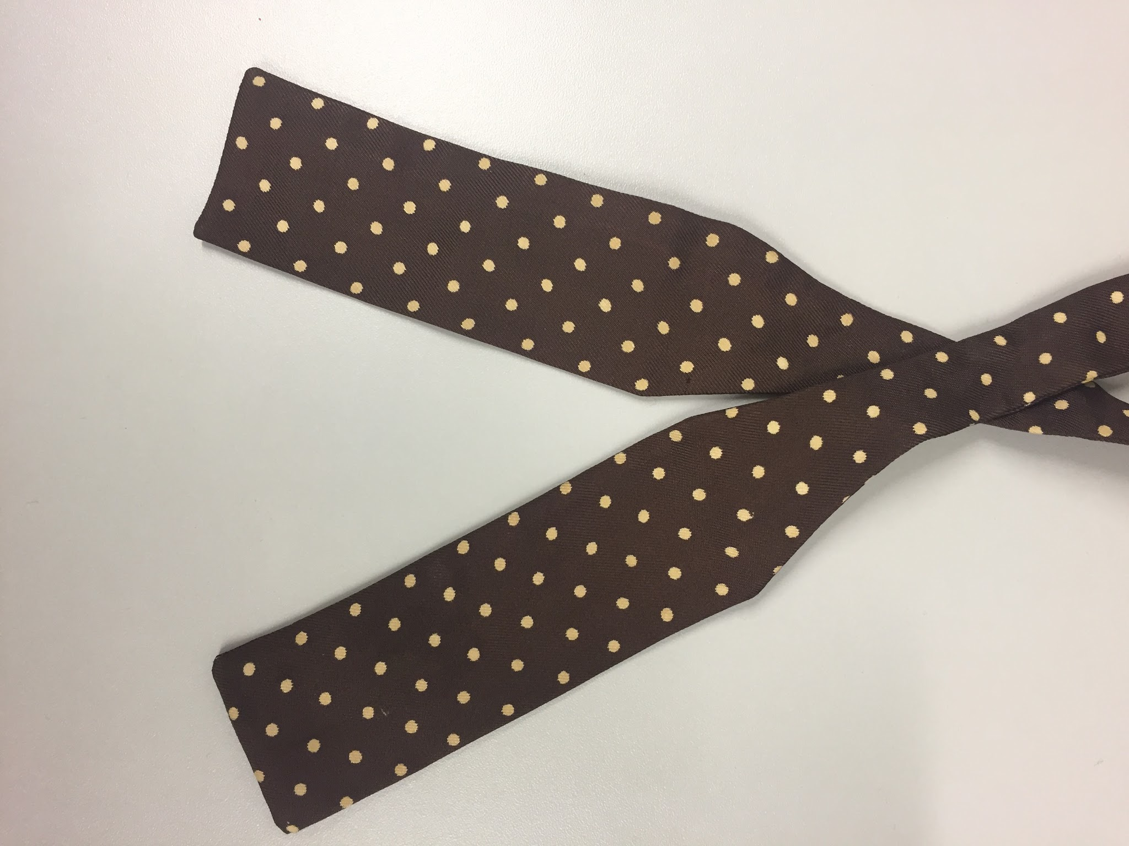 | Square bow, brown, large white dots | Austen Reed | Silk
4 | 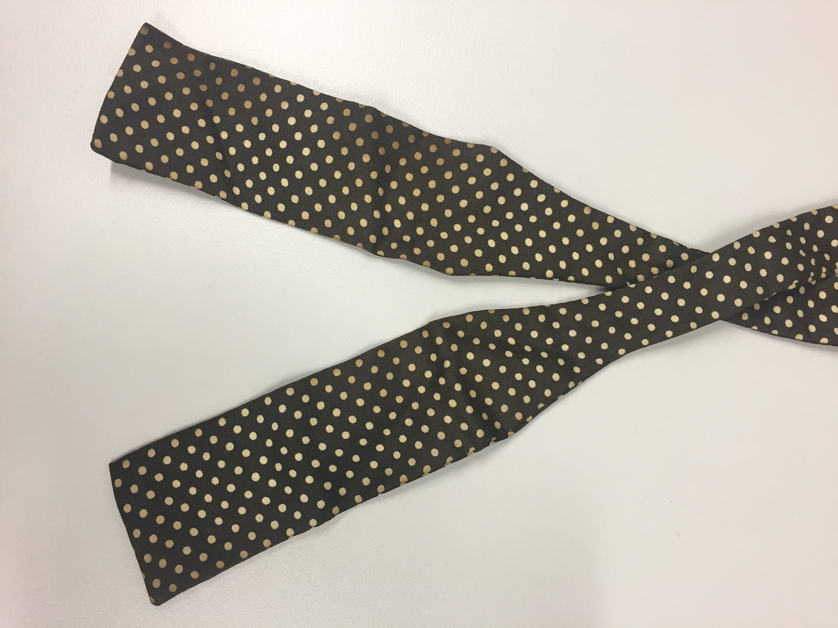 | Square bow, brown, small white dots | Austen Reed | Silk
5 | 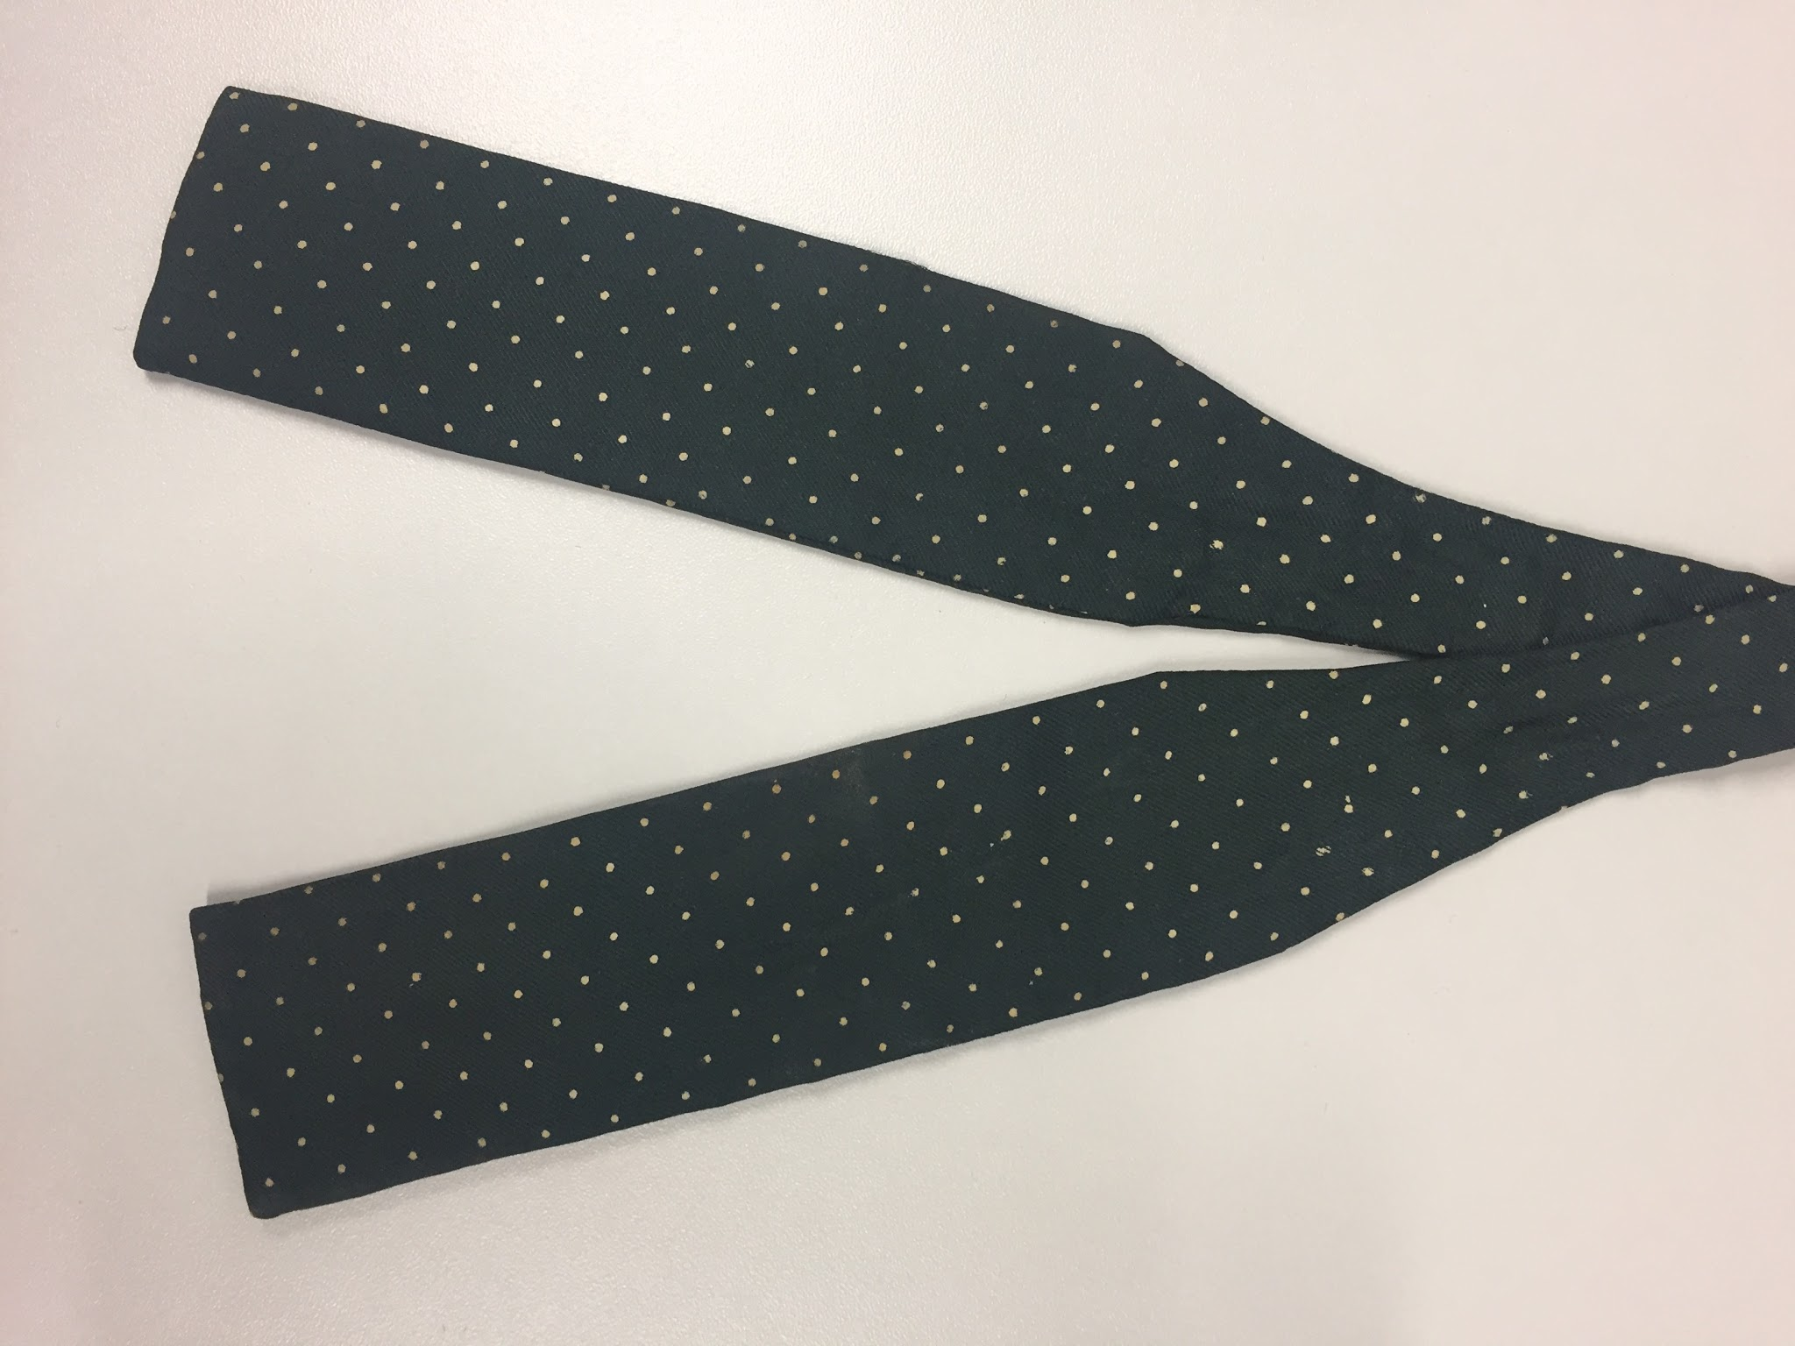 | Square bow, dark green, small white dots | Hope Brothers | Silk
6 | 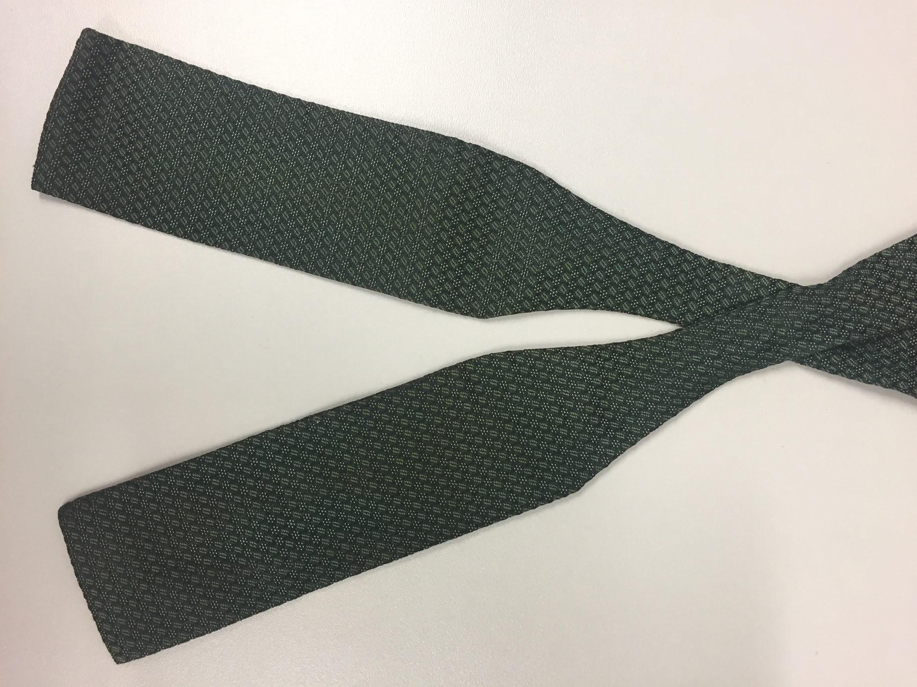 | Square bow, dark green, woven | Austen Reed | Silk
7 | 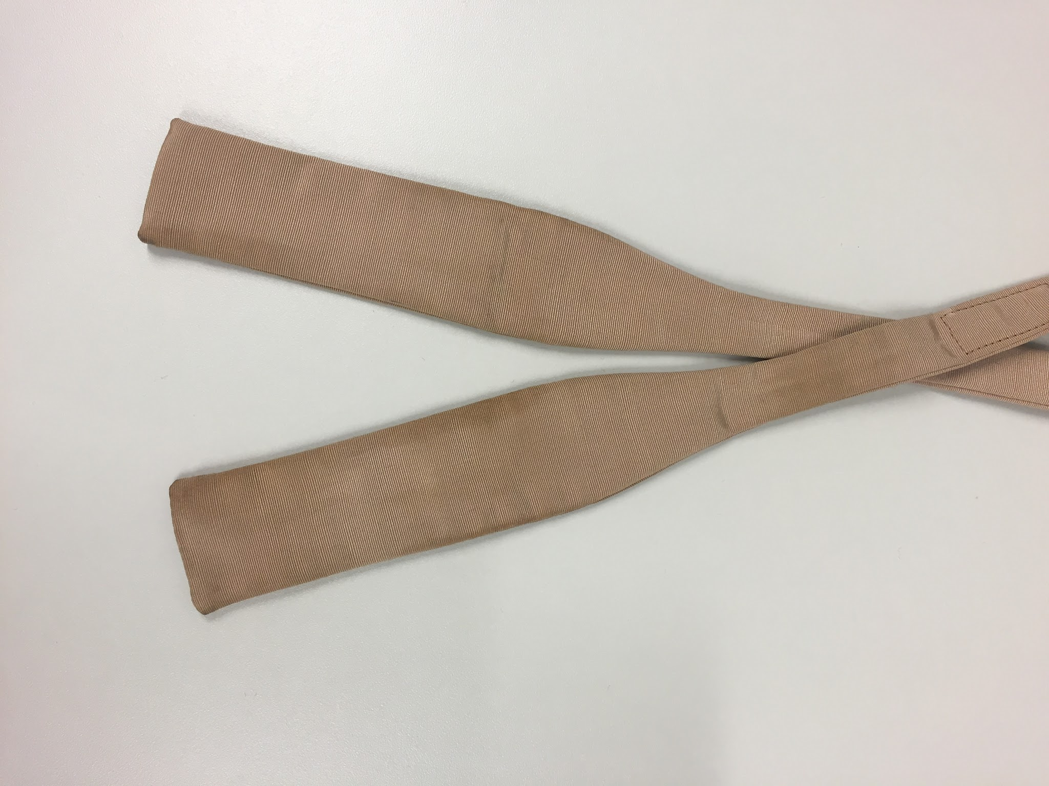 | Square bow, peach/stone | Austen Reed | Silk
8 | 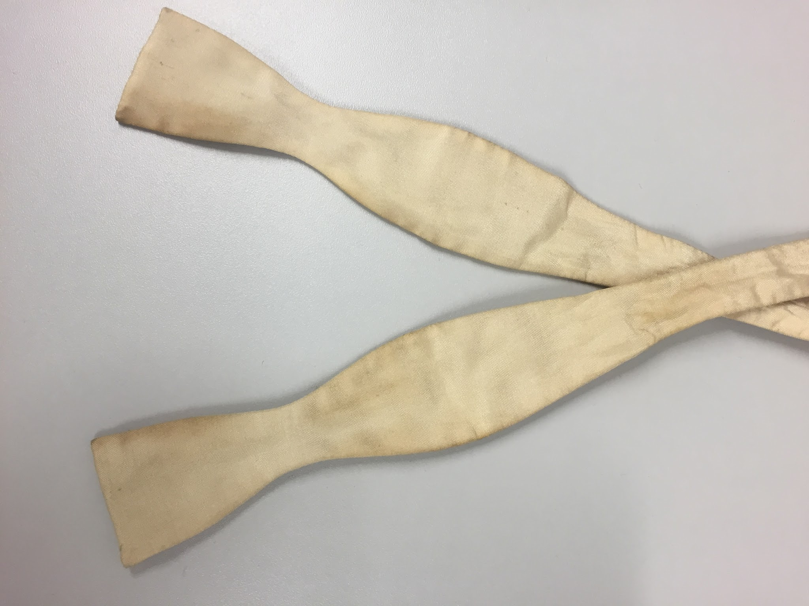 | Butterfly bow, white, evening/formal | Austen Reed | Silk
9 | 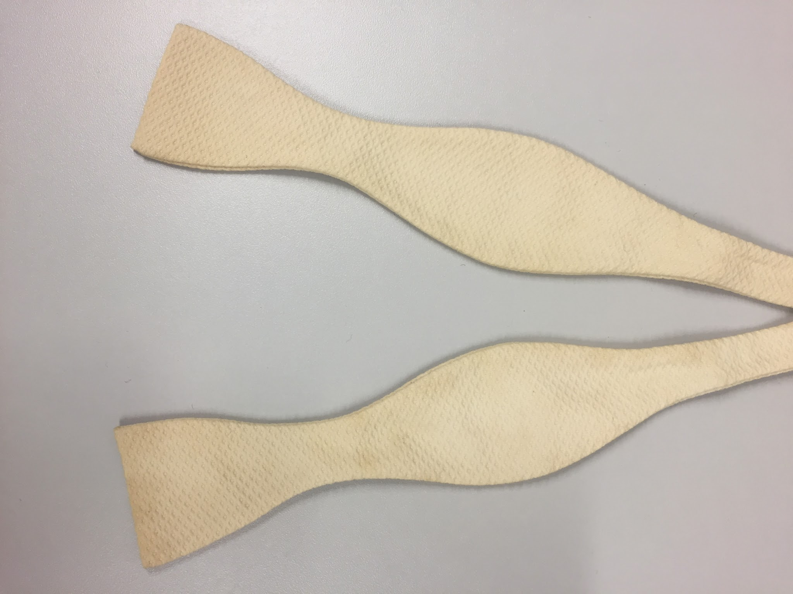 | Butterfly bow, white, evening/formal, textured | No maker | Silk
10 | 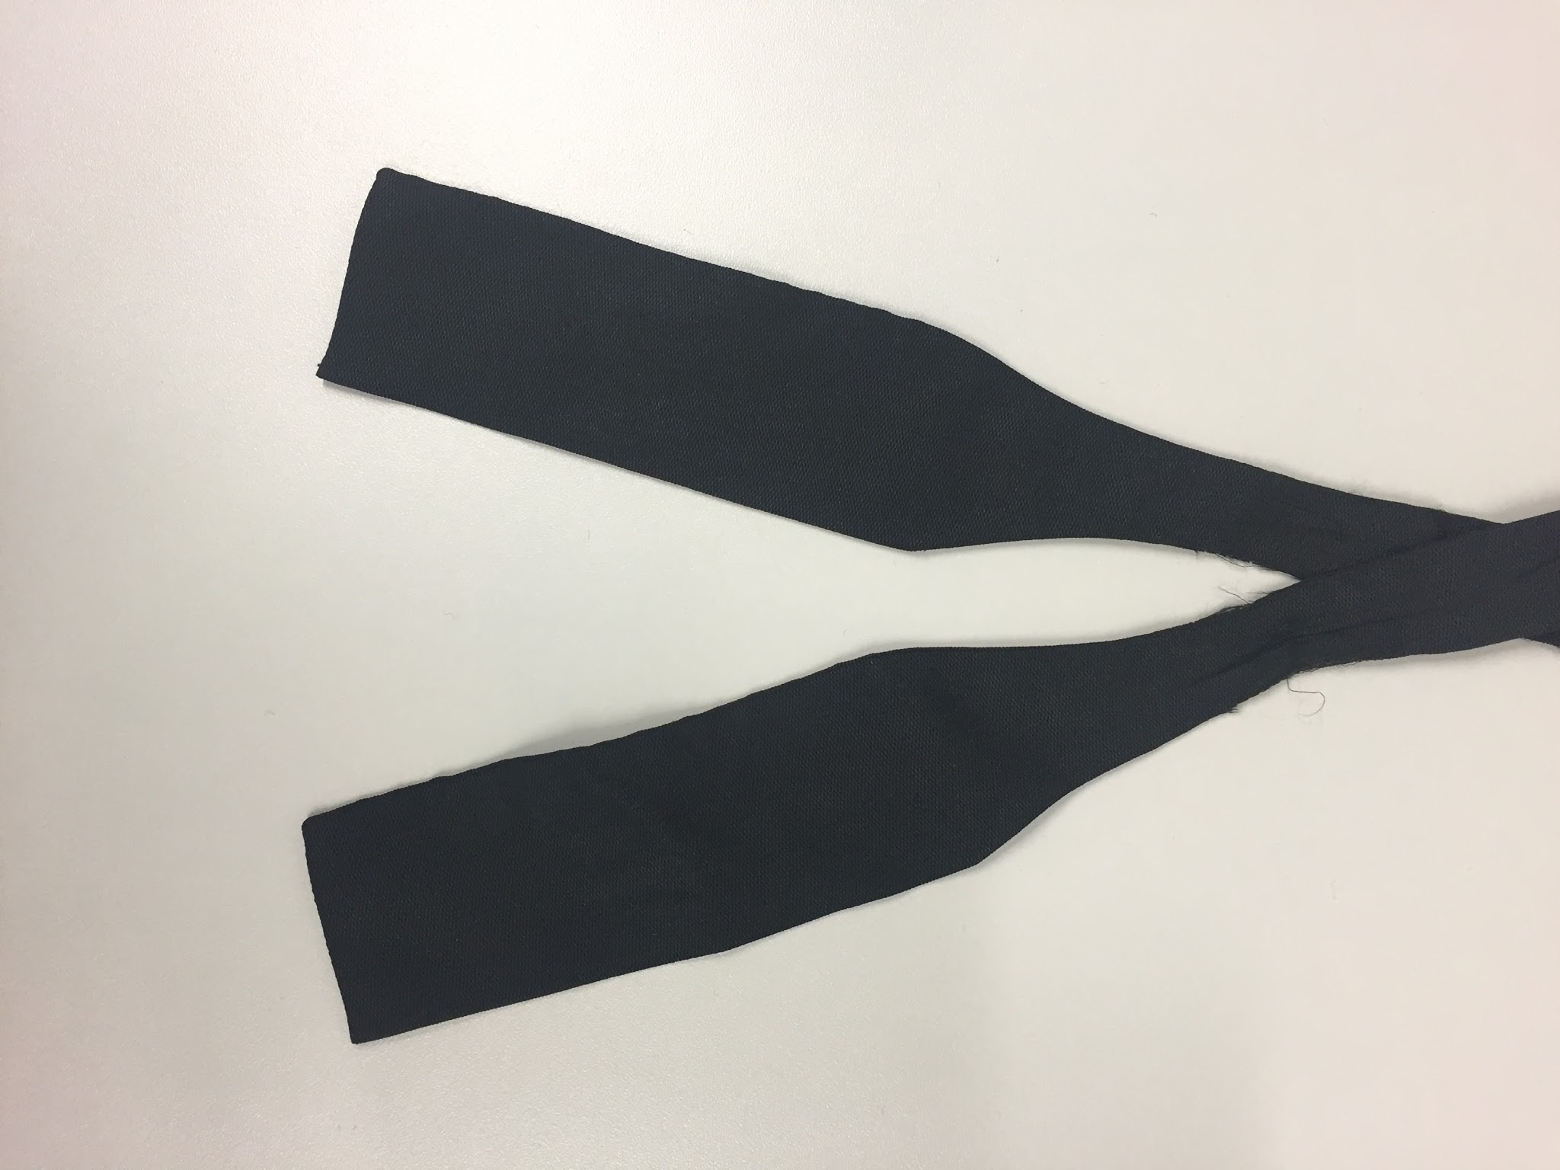 | Square bow, black, evening/formal | No maker | Silk
11 | 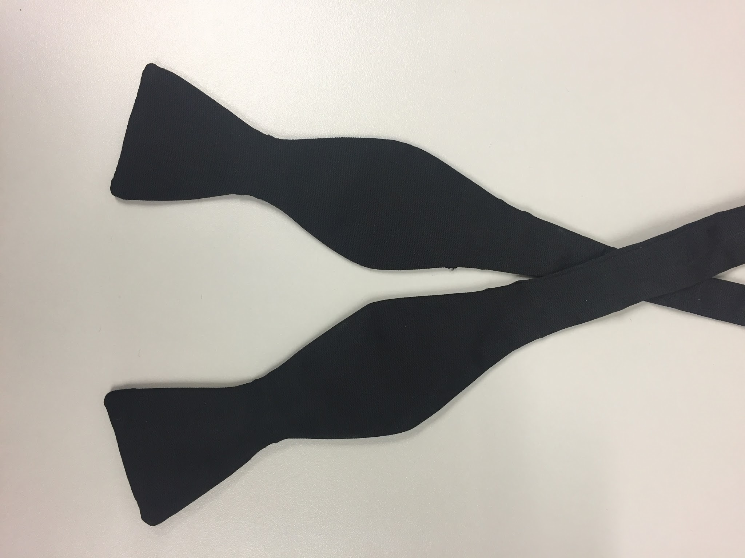 | Butterfly bow, black, evening/formal | No maker | Silk
12 | 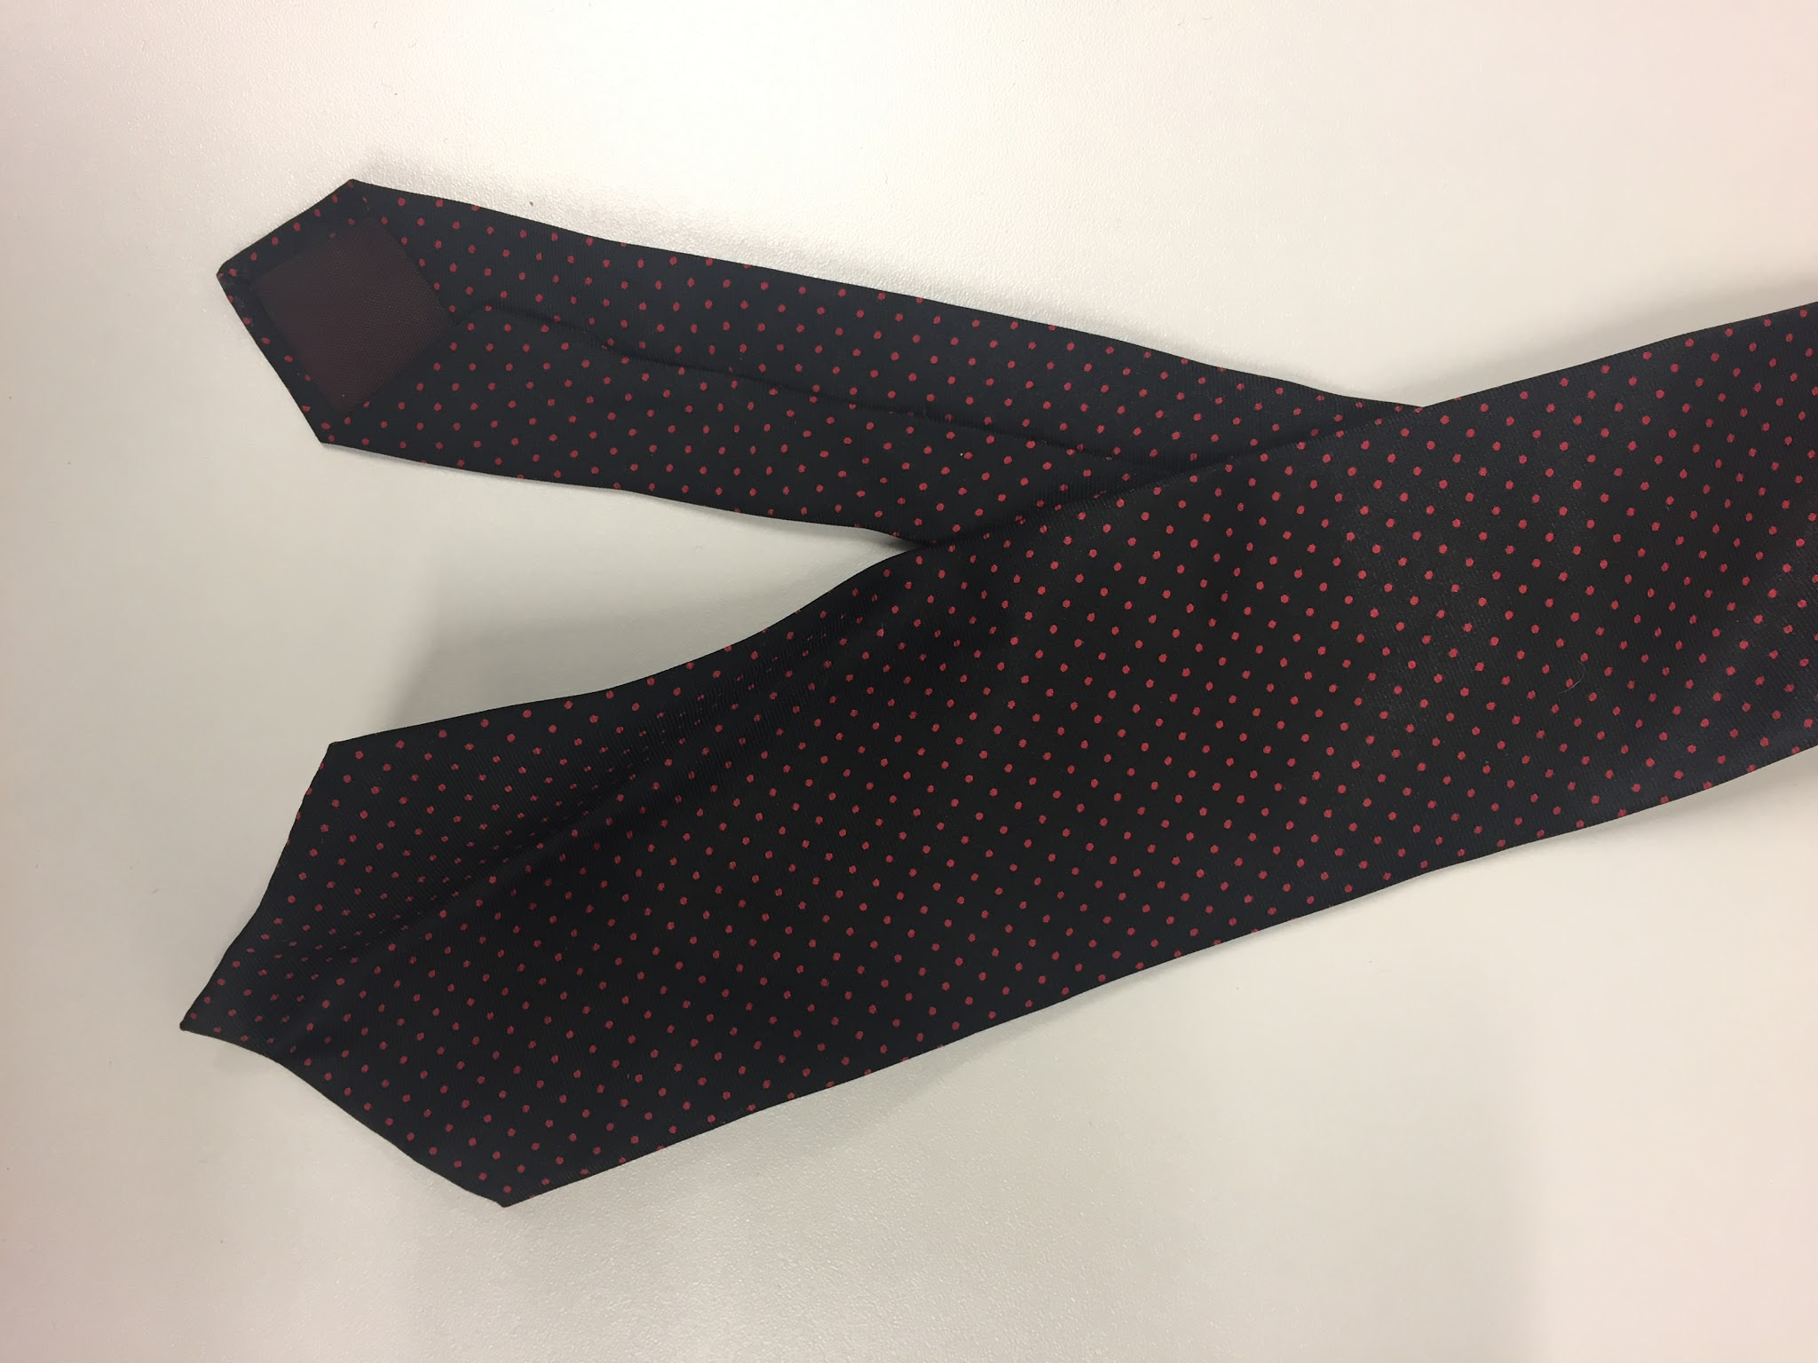 | Necktie, black with red dots | Simpson of Piccadilly | Silk
13 | 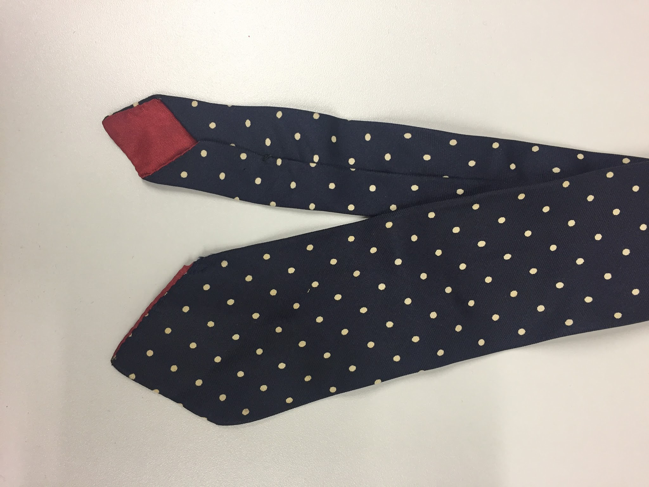 | Necktie, navy with white dots | Shepard & Woodward, John Comfort | Silk
14 | 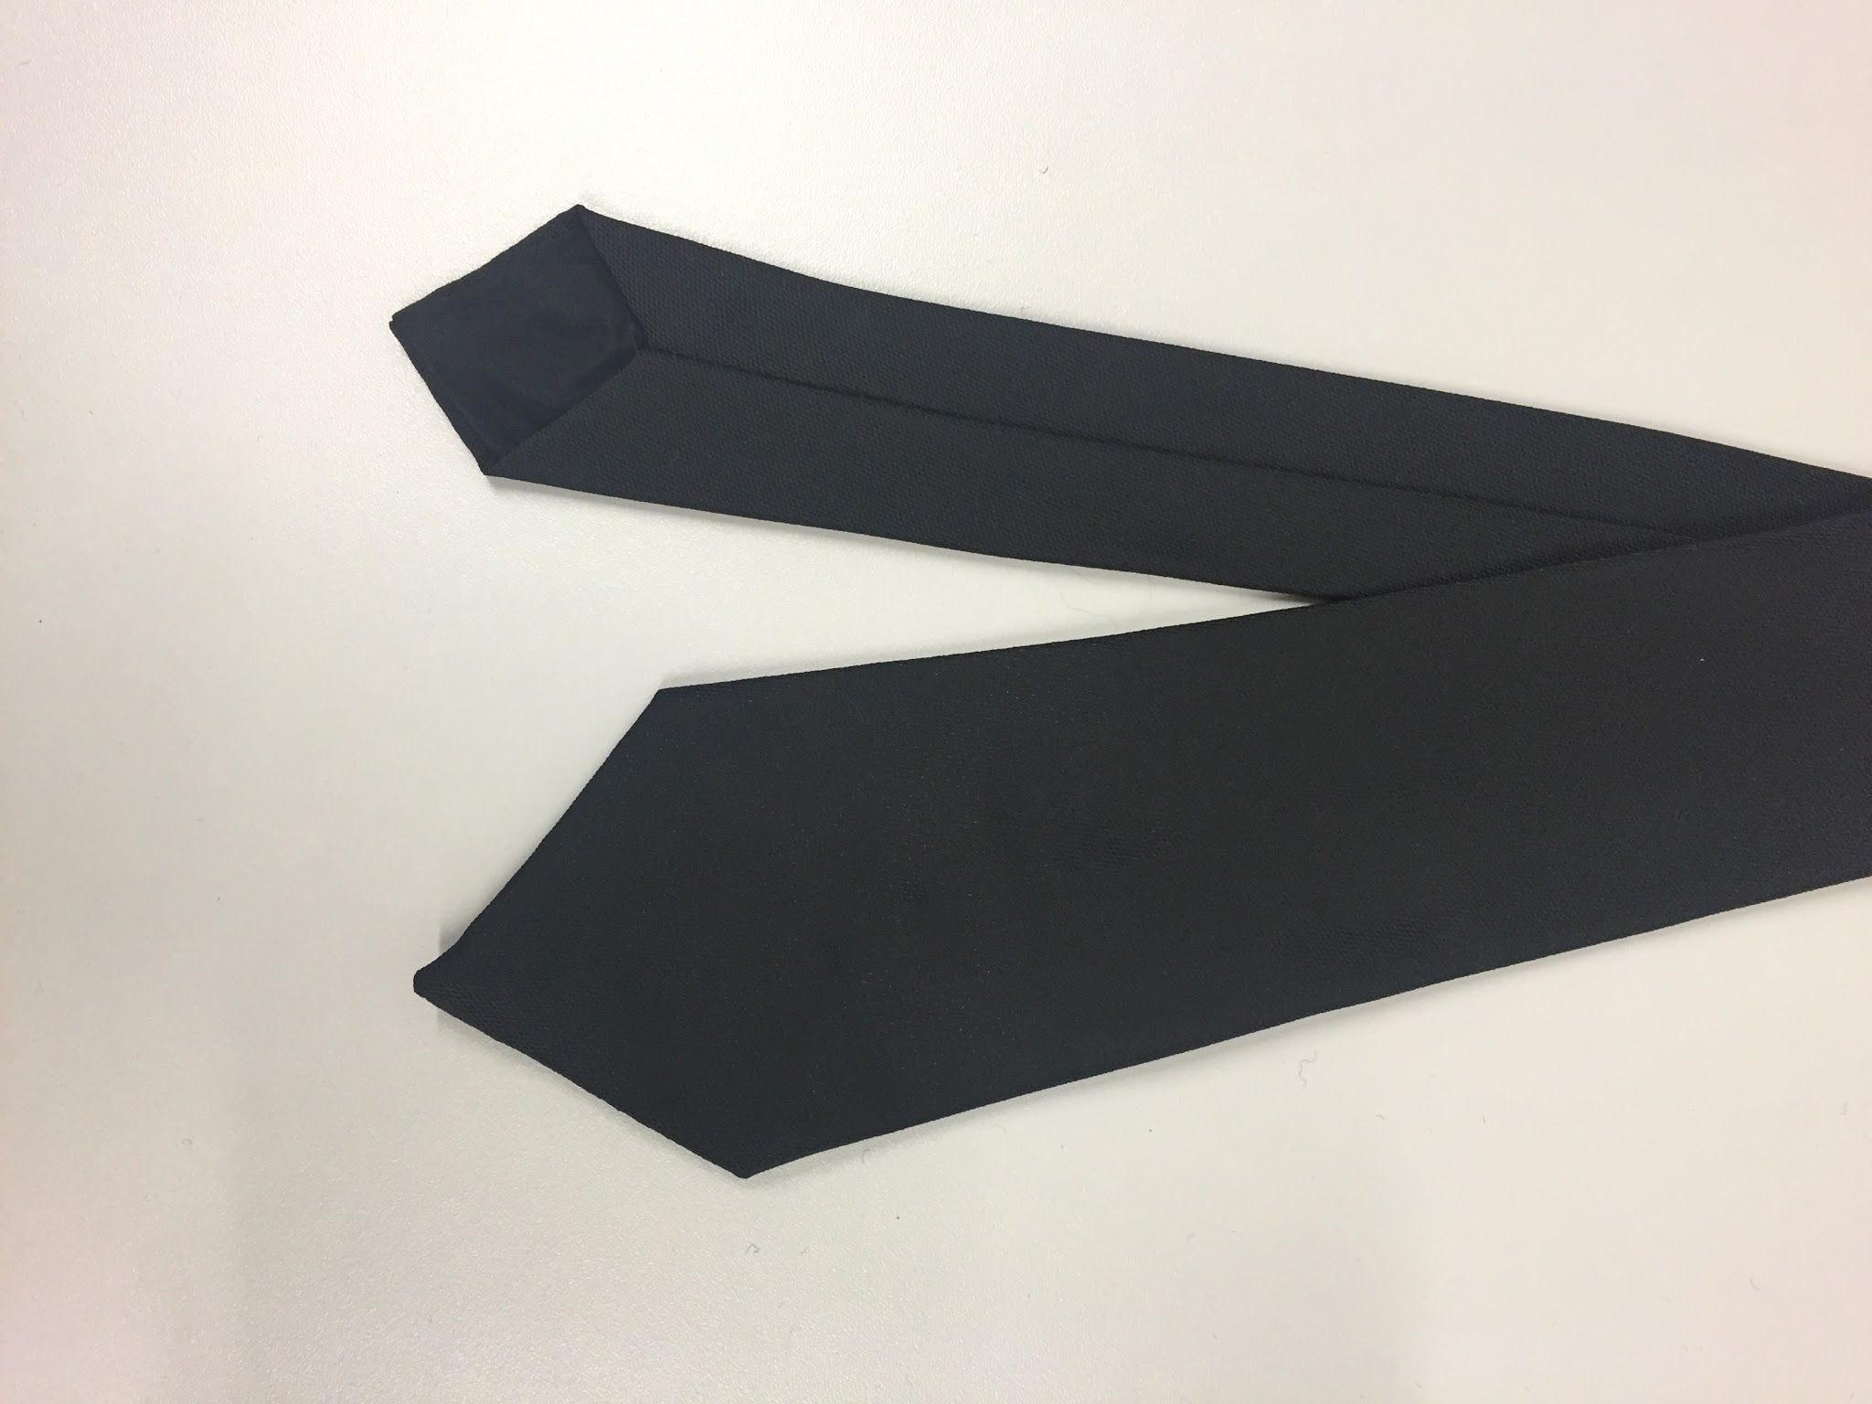 | Necktie, black plain | Welch Margetson | Polyester
15 | 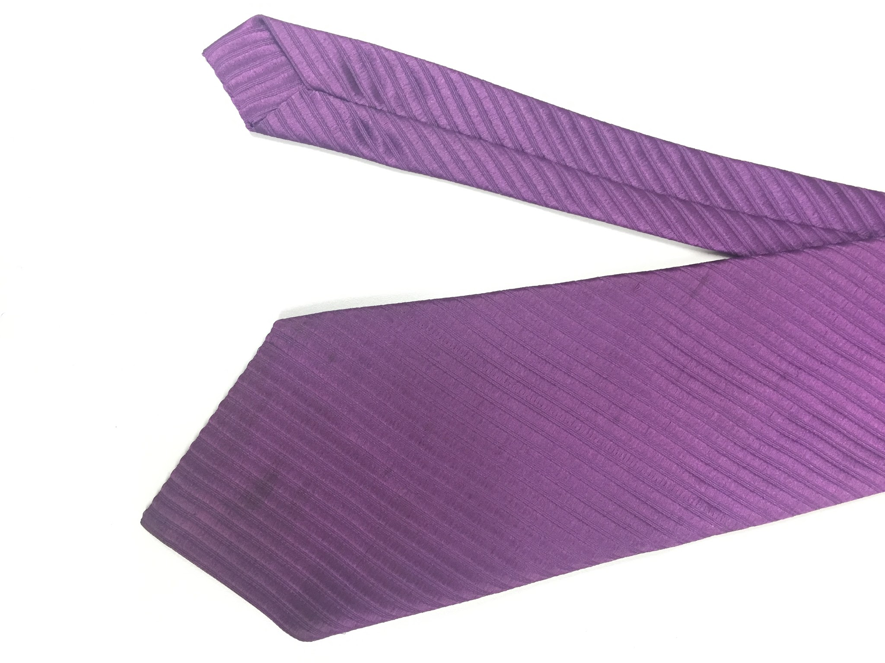 | Necktie, purple, diagonal texture | Boots Fashion | Polyester
16 | 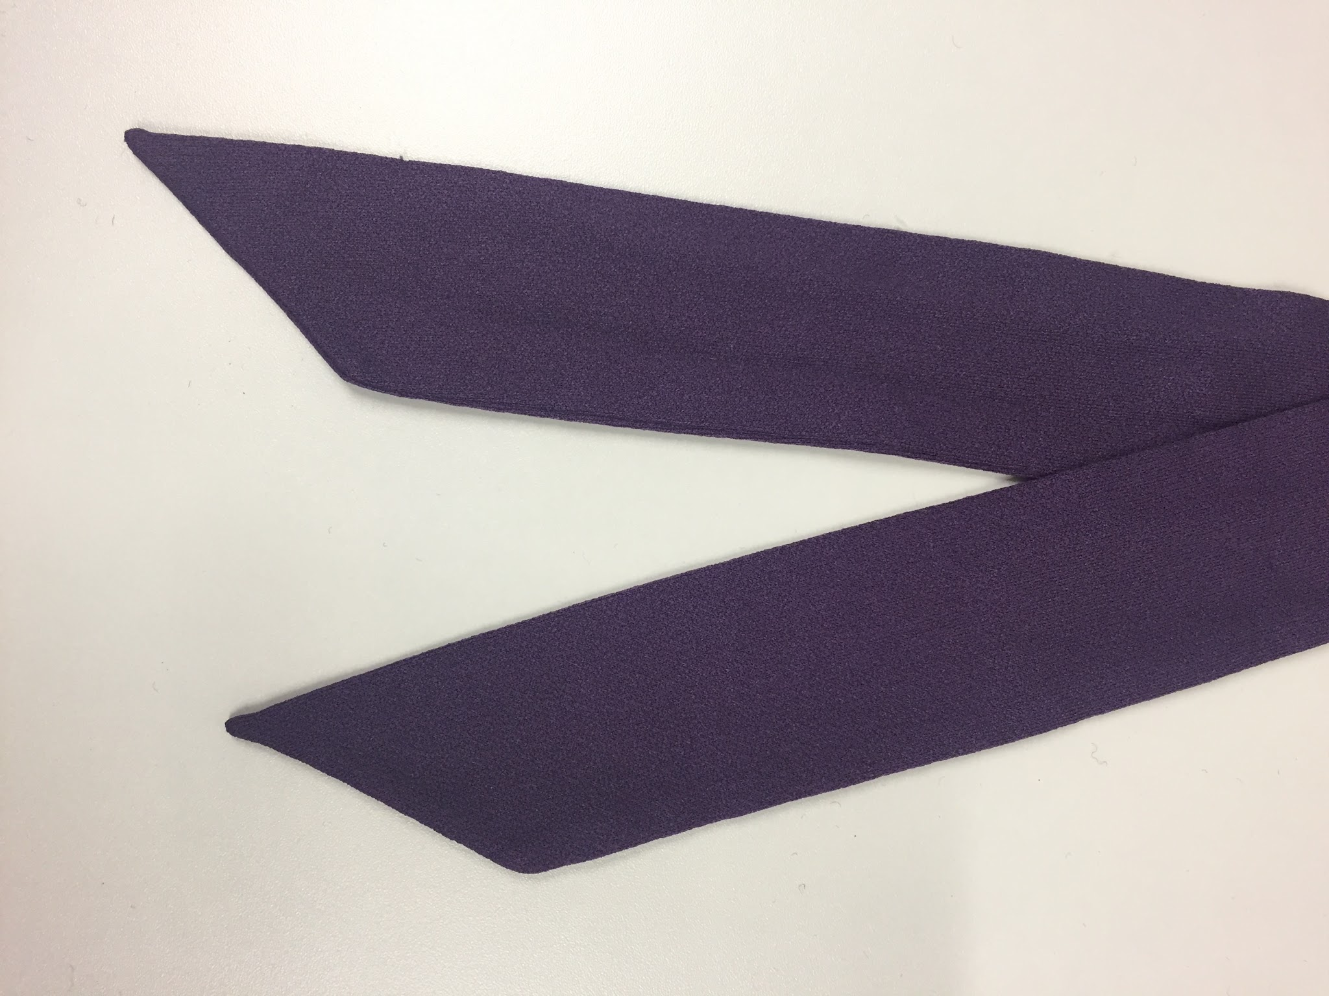 | Necktie, dark purple asymmetrical, unlined | No maker | Polyester
17 | 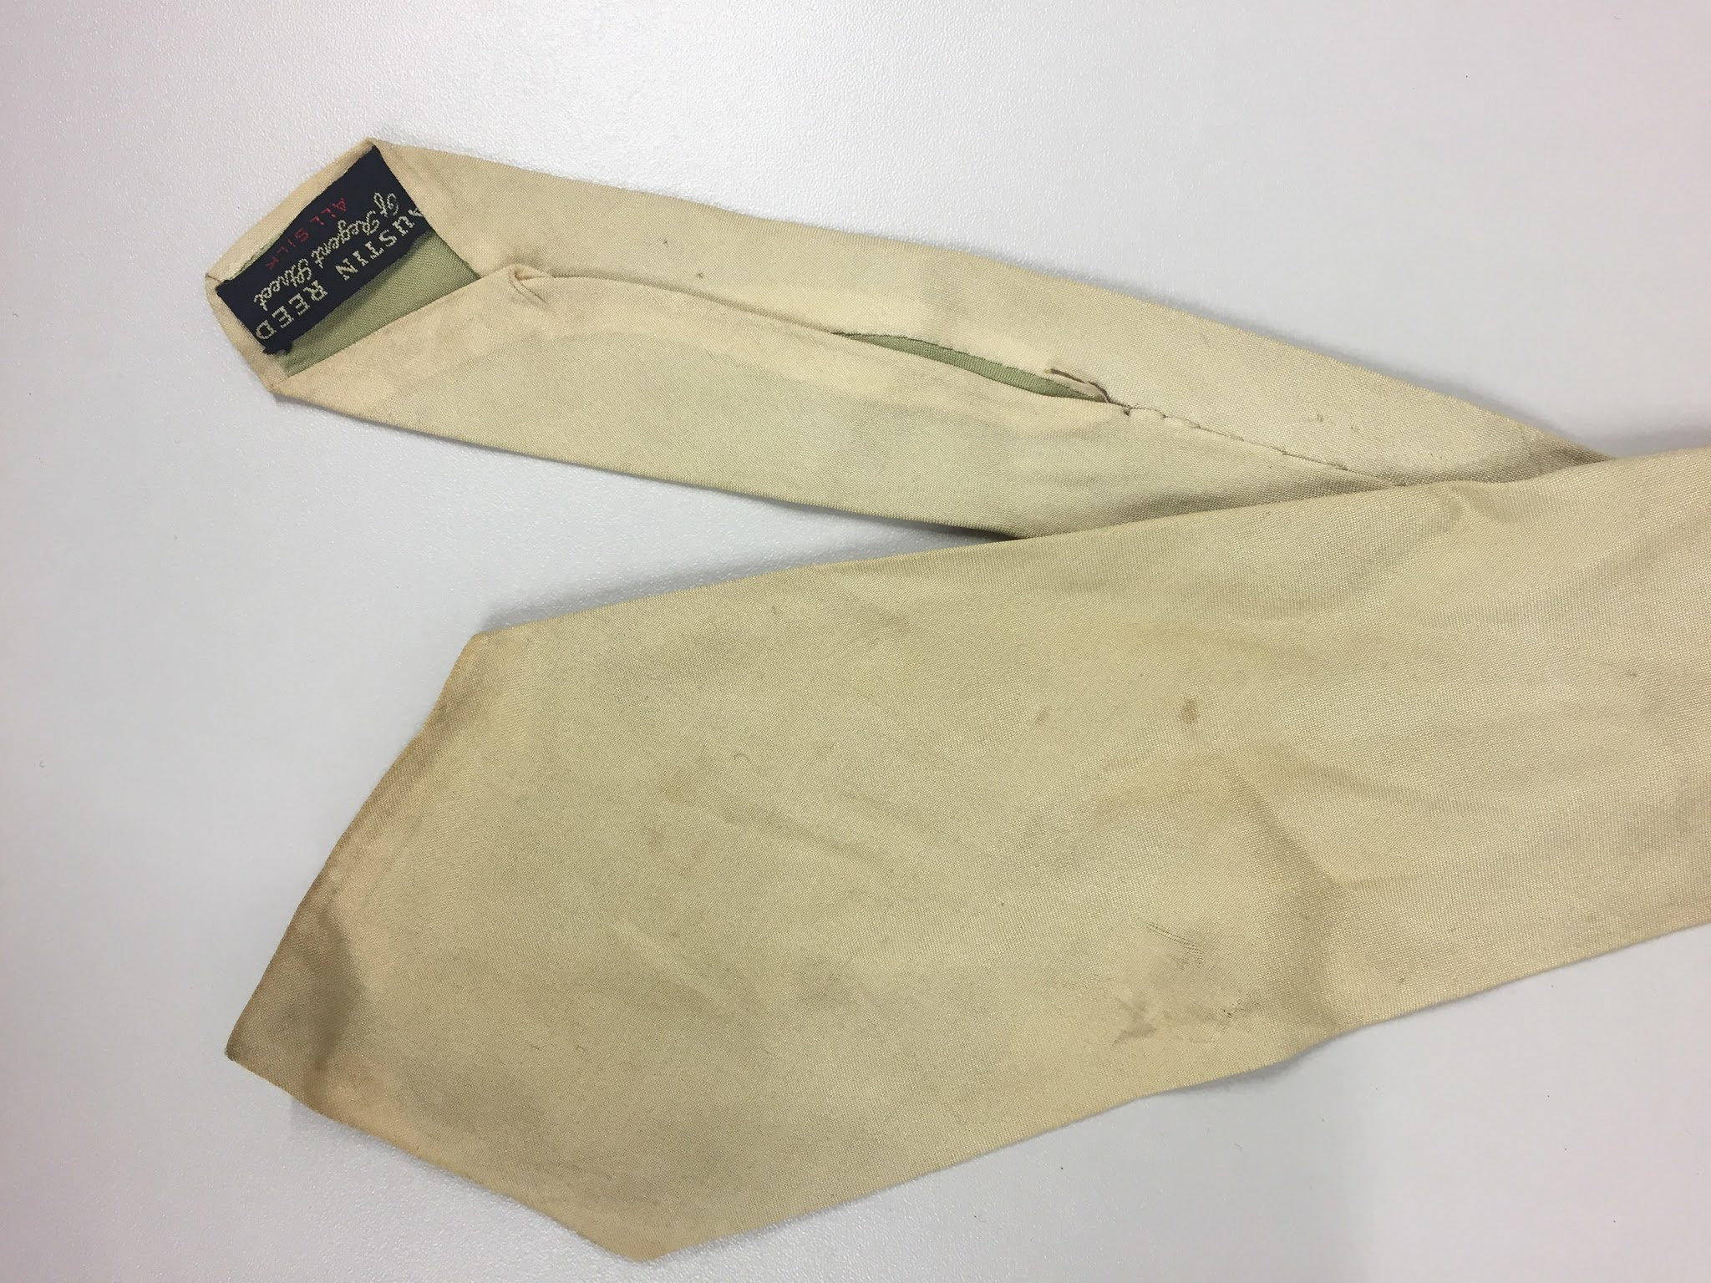 | Necktie, cream with green lining | Austen Reed | Silk
18 | 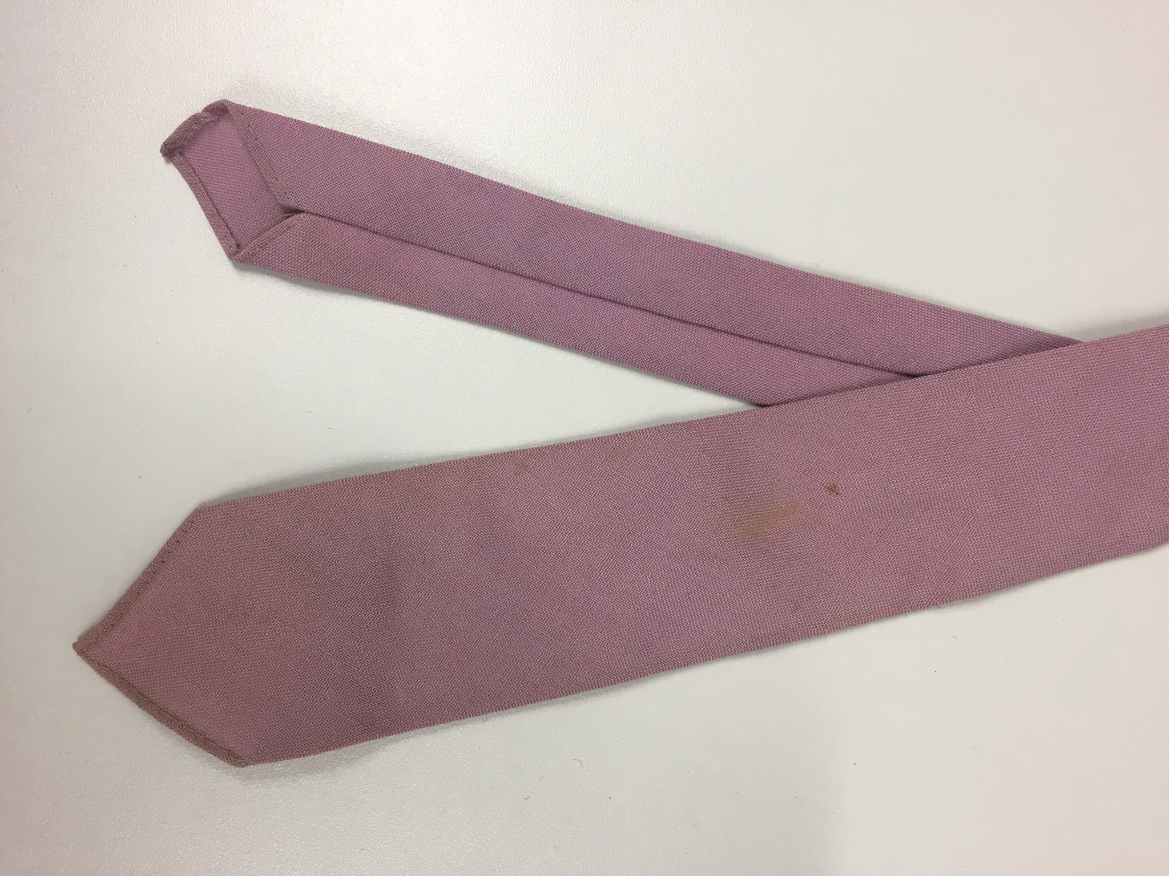 | Necktie, pink, plain | Giovanni | Wool
19 | 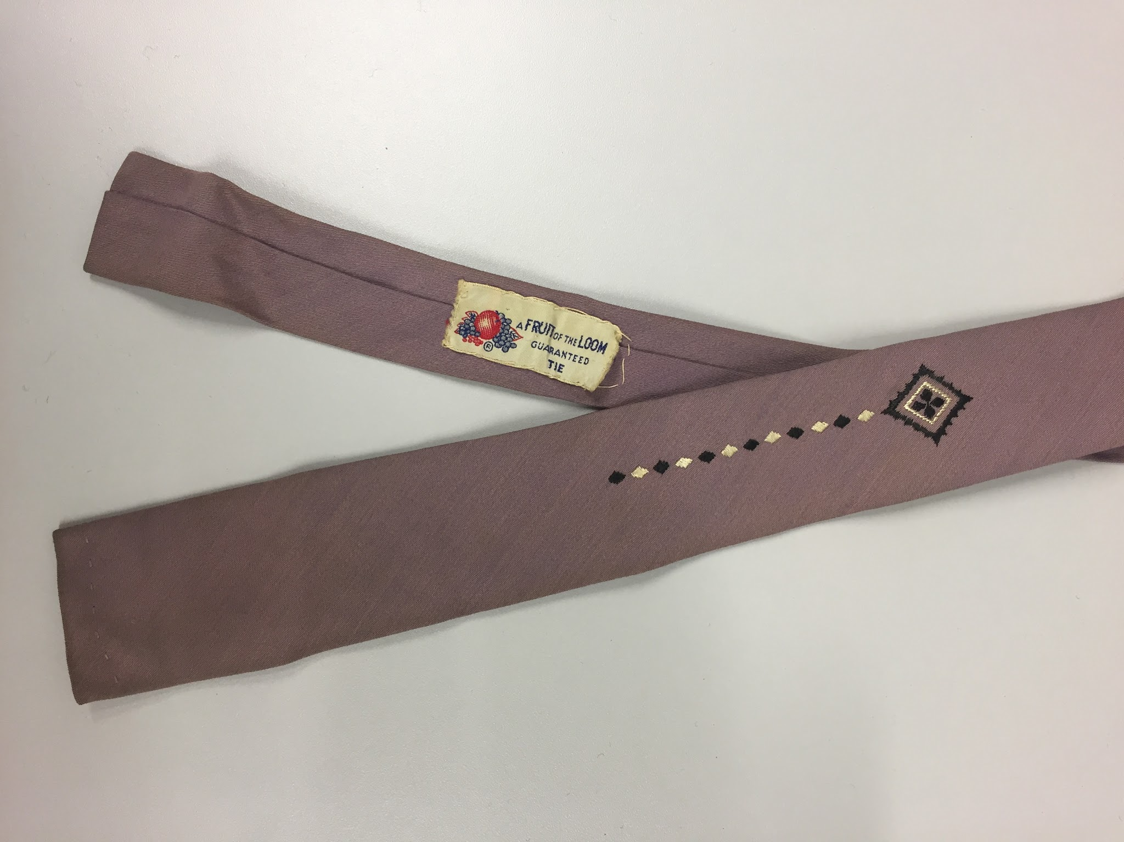 | Necktie, pink/lilac, diamond pattern, square | Fruit of the Loom | Polyestyer
20 | 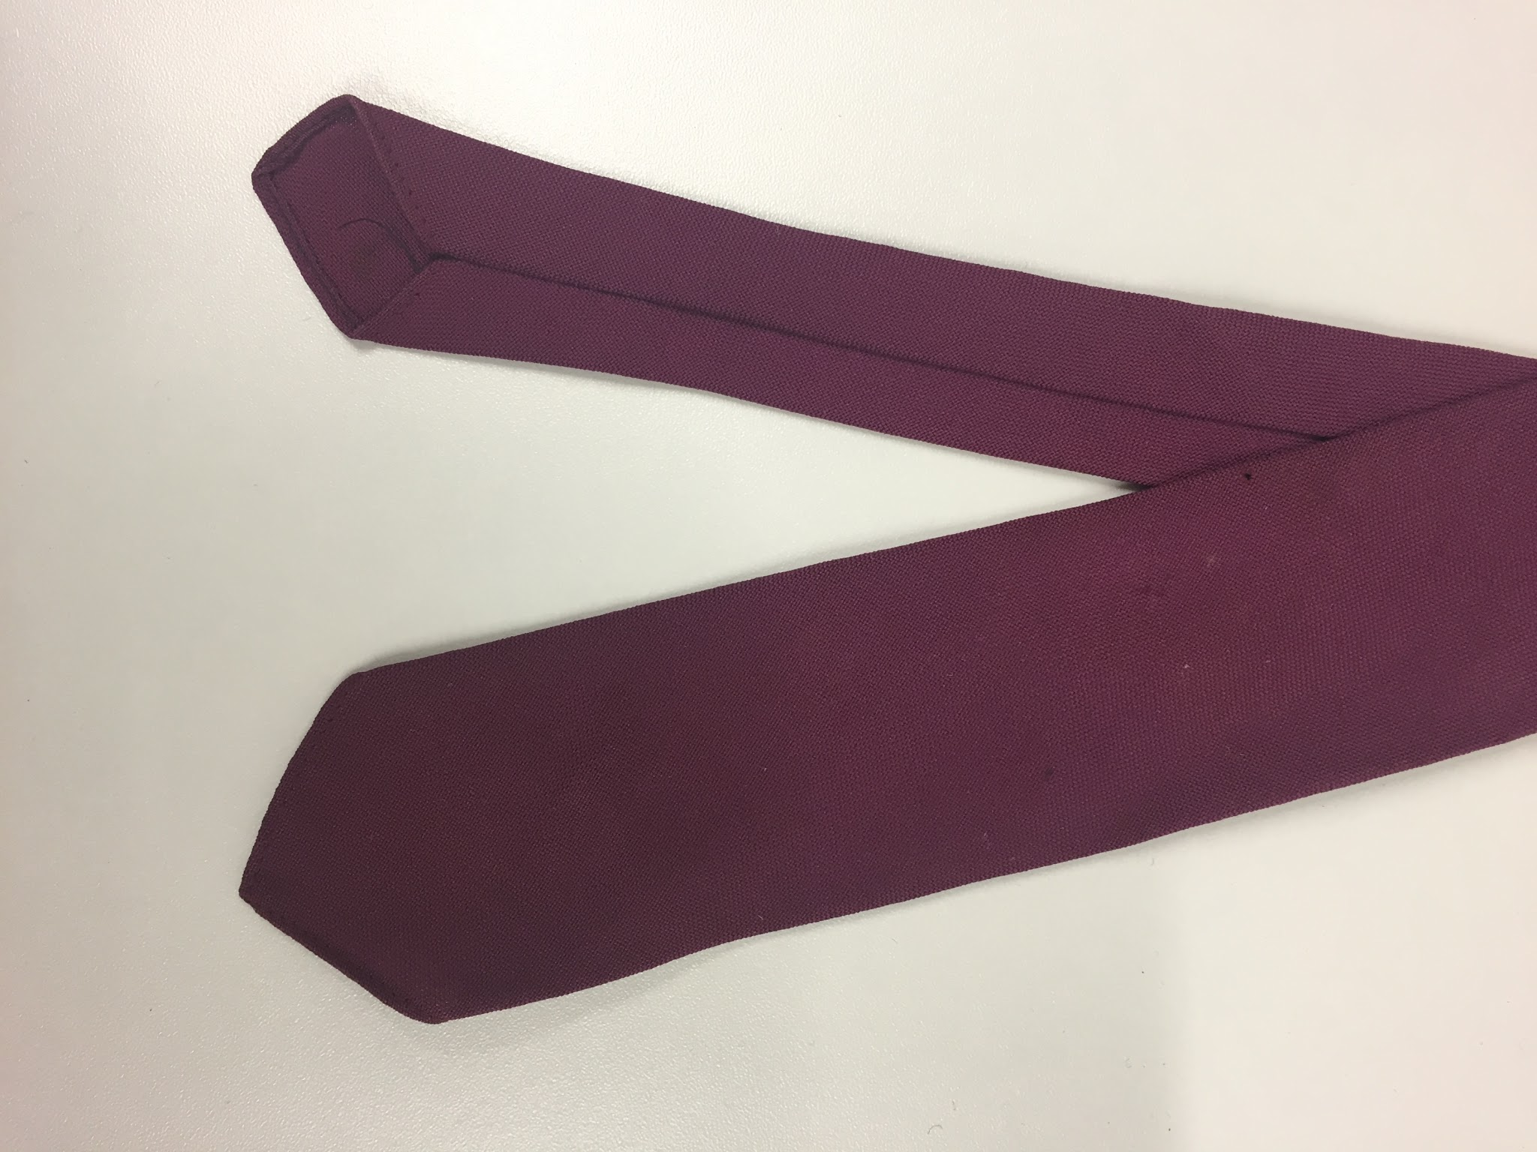 | Necktie, purple/fuchsia, plain | Giovanni | Wool
21 | 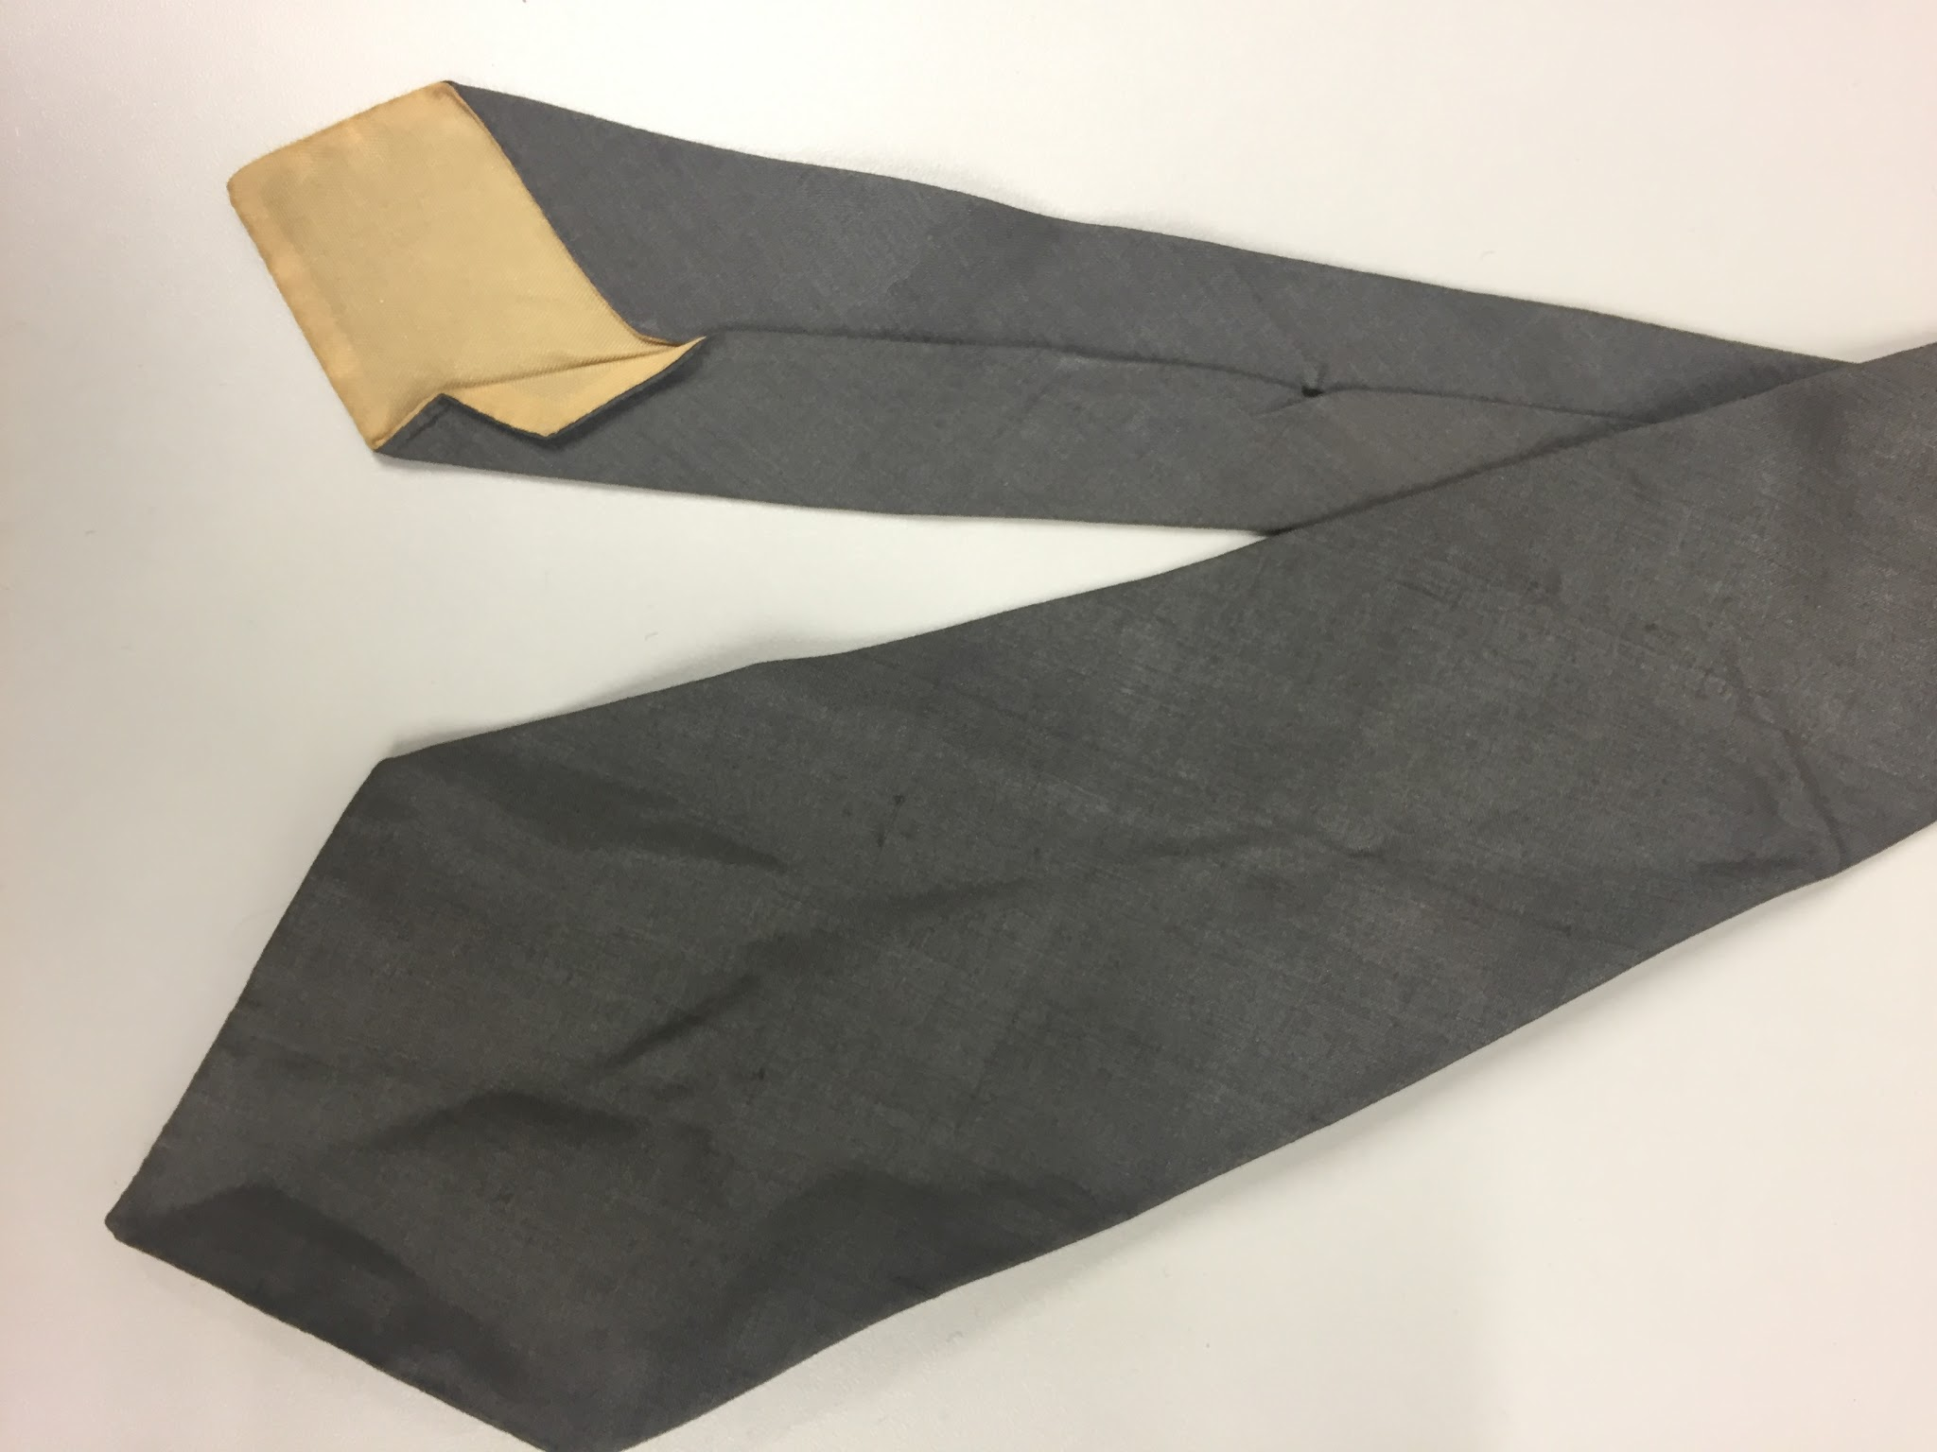 | Necktie, mid grey, plain | Shantung | Silk
22 | 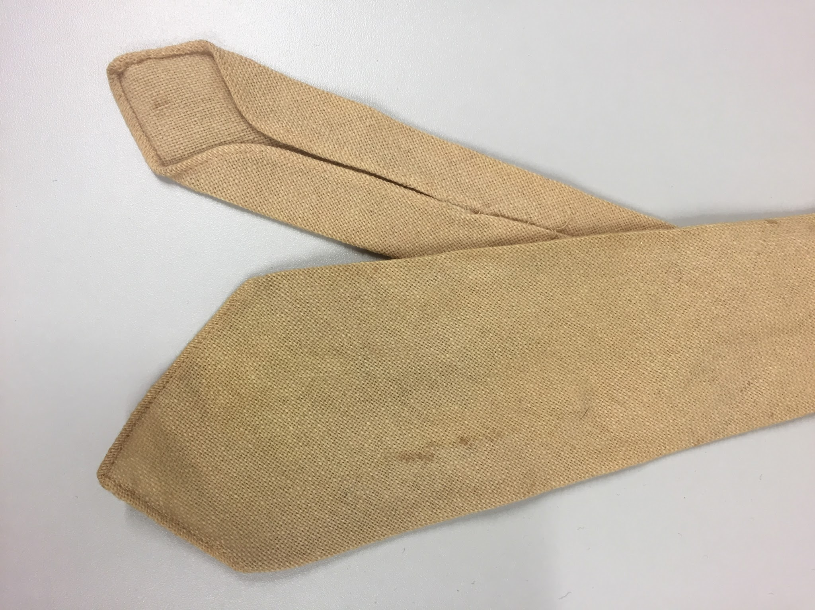 | Necktie, woven, cream/stone | No maker | Wool
23 | 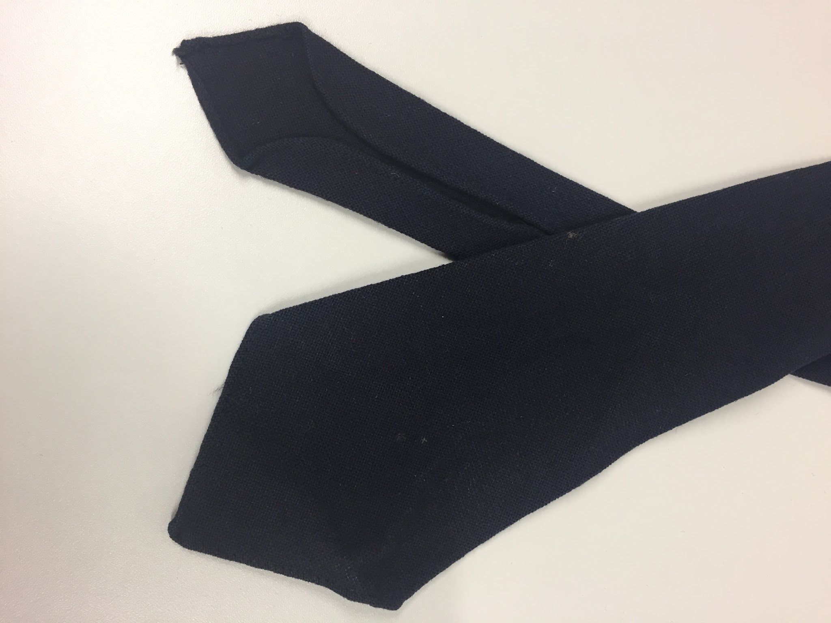 | Necktie, woven, navy | No maker | Wool
24 | 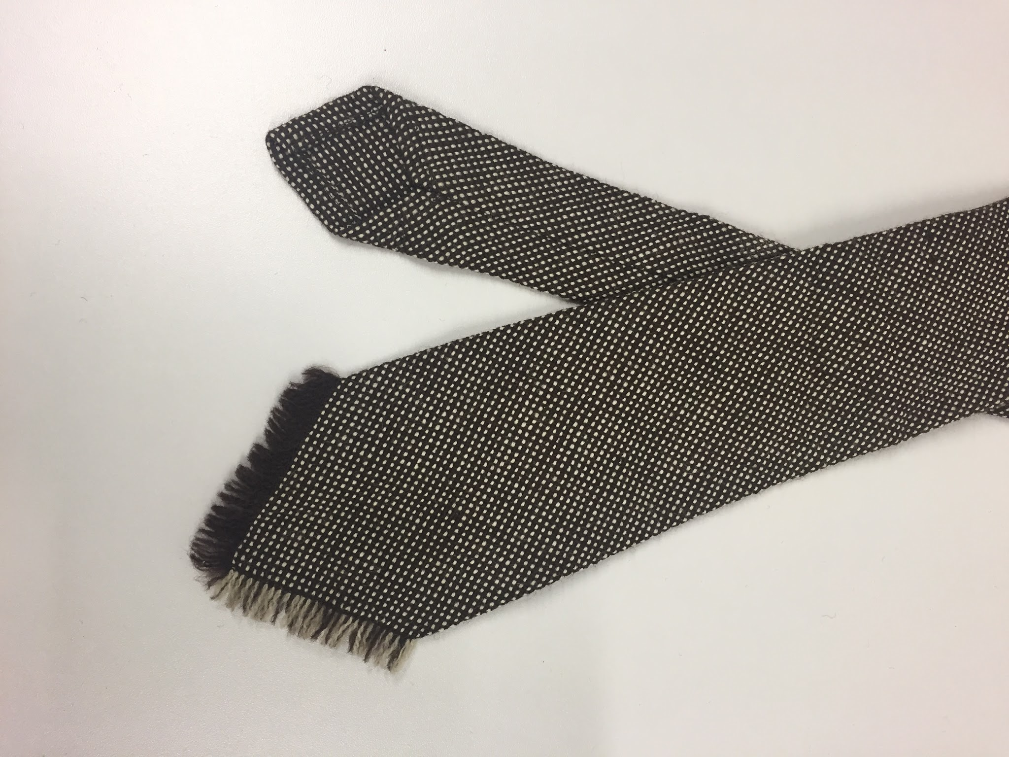 | Necktie, woven, black & white | Vardoc of Oxford | Pure new wool
25 | 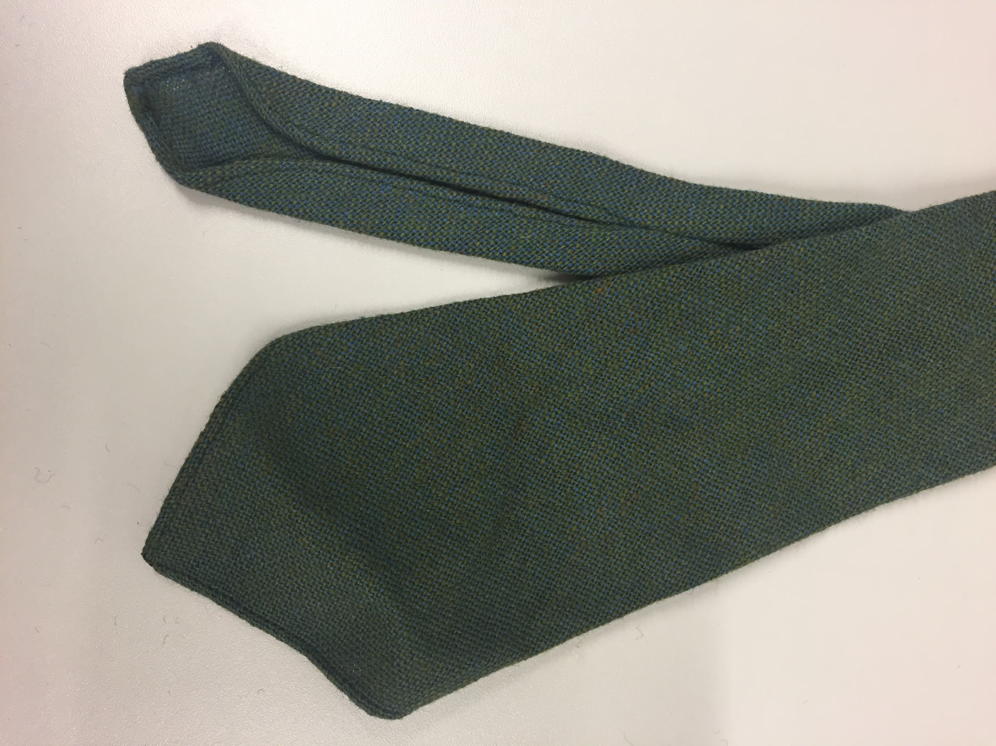 | Necktie, woven, green marl | No maker, made in Orkney | Pure wool
26 | 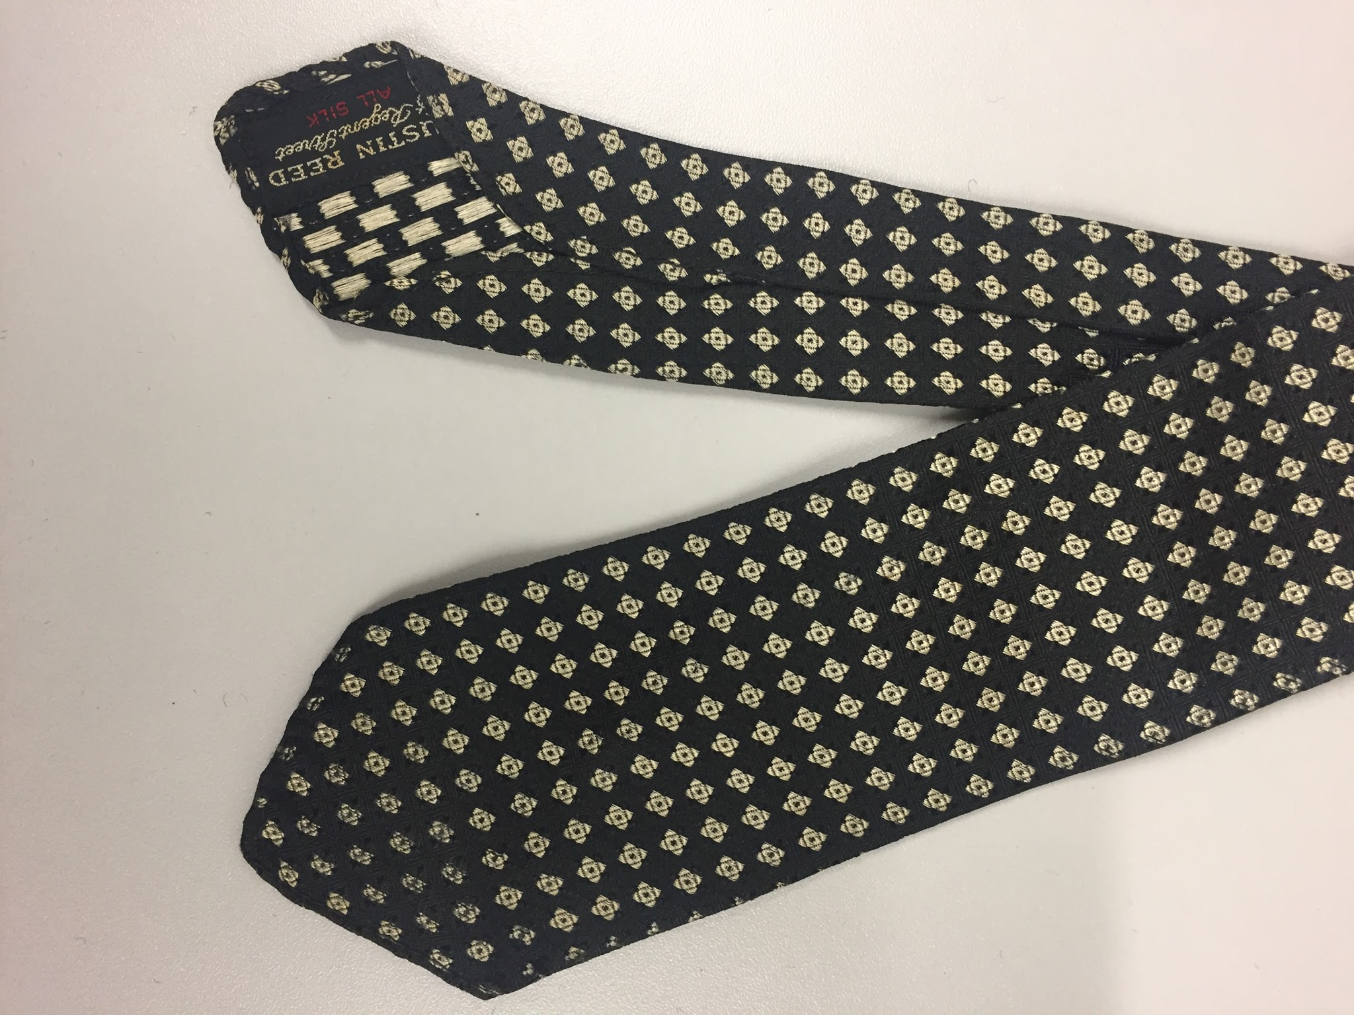 | Necktie, woven, black & white diamond pattern | Austen Reed | Silk
27 | 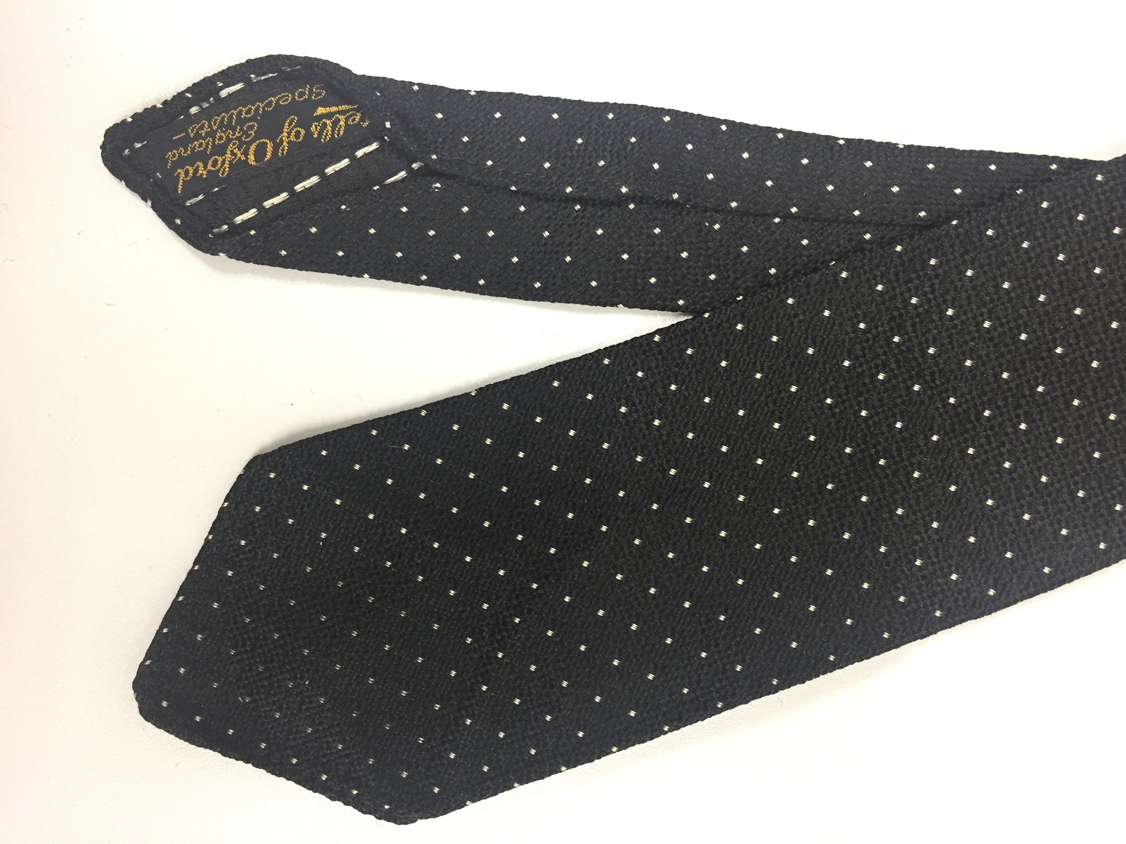 | Necktie, woven, black with white dots | Castells of Oxford | Silk
28 | 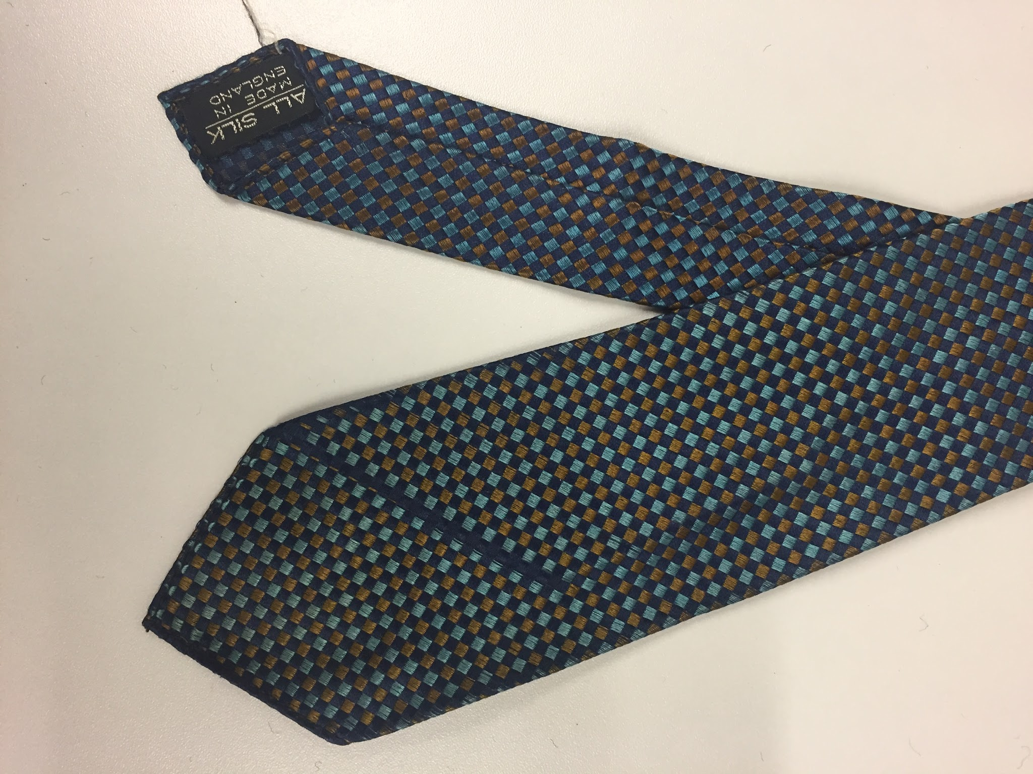 | Necktie, woven, navy/teal/bronze diamond pattern | Tilleys of Hull | Silk
29 | 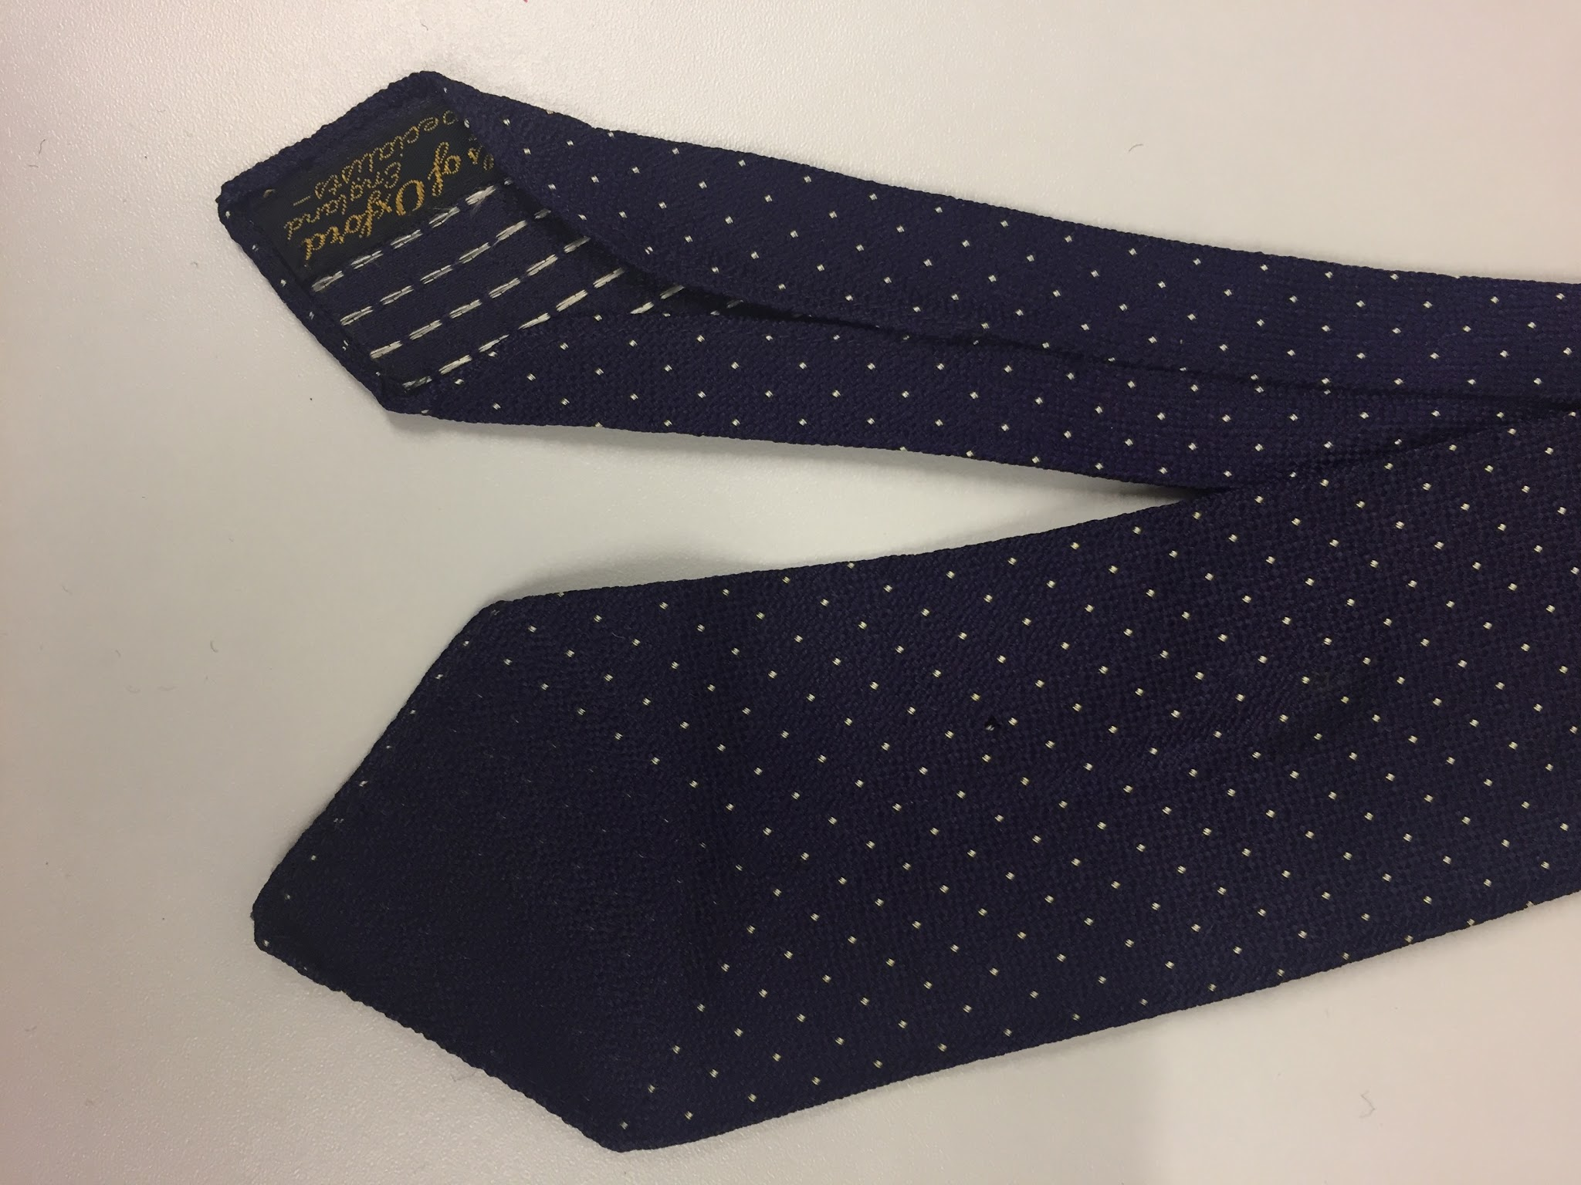 | Necktie, woven, navy with white dots | Castells of Oxford | Silk
30 | 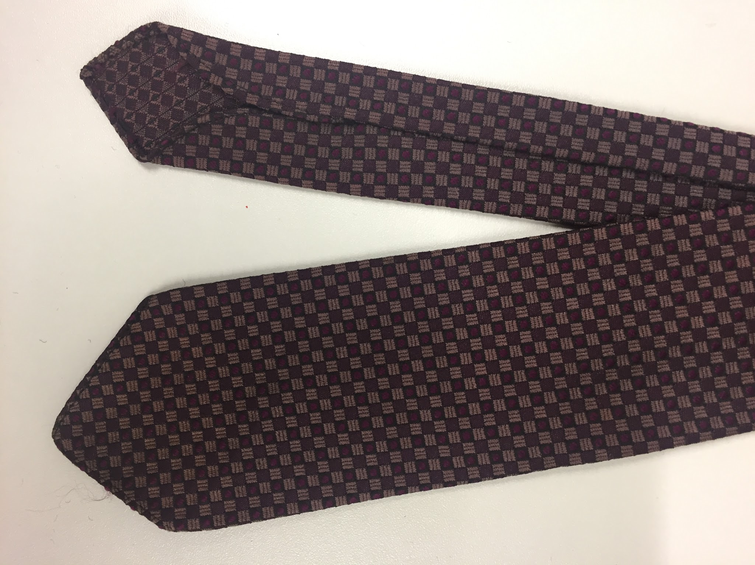 | Necktie, woven, purple/mauve square pattern | Austen Reed | Polyester
31 | 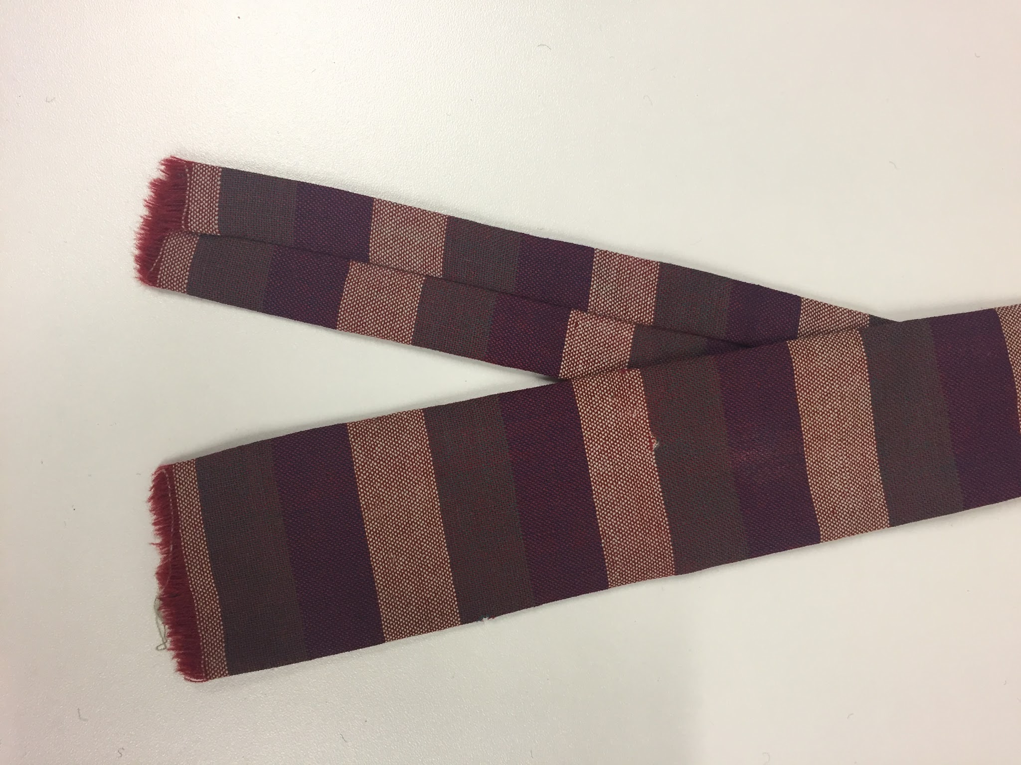 | Necktie, woven, square, pink/purple/brown horizontal stripe | Ascot | Wool
32 | 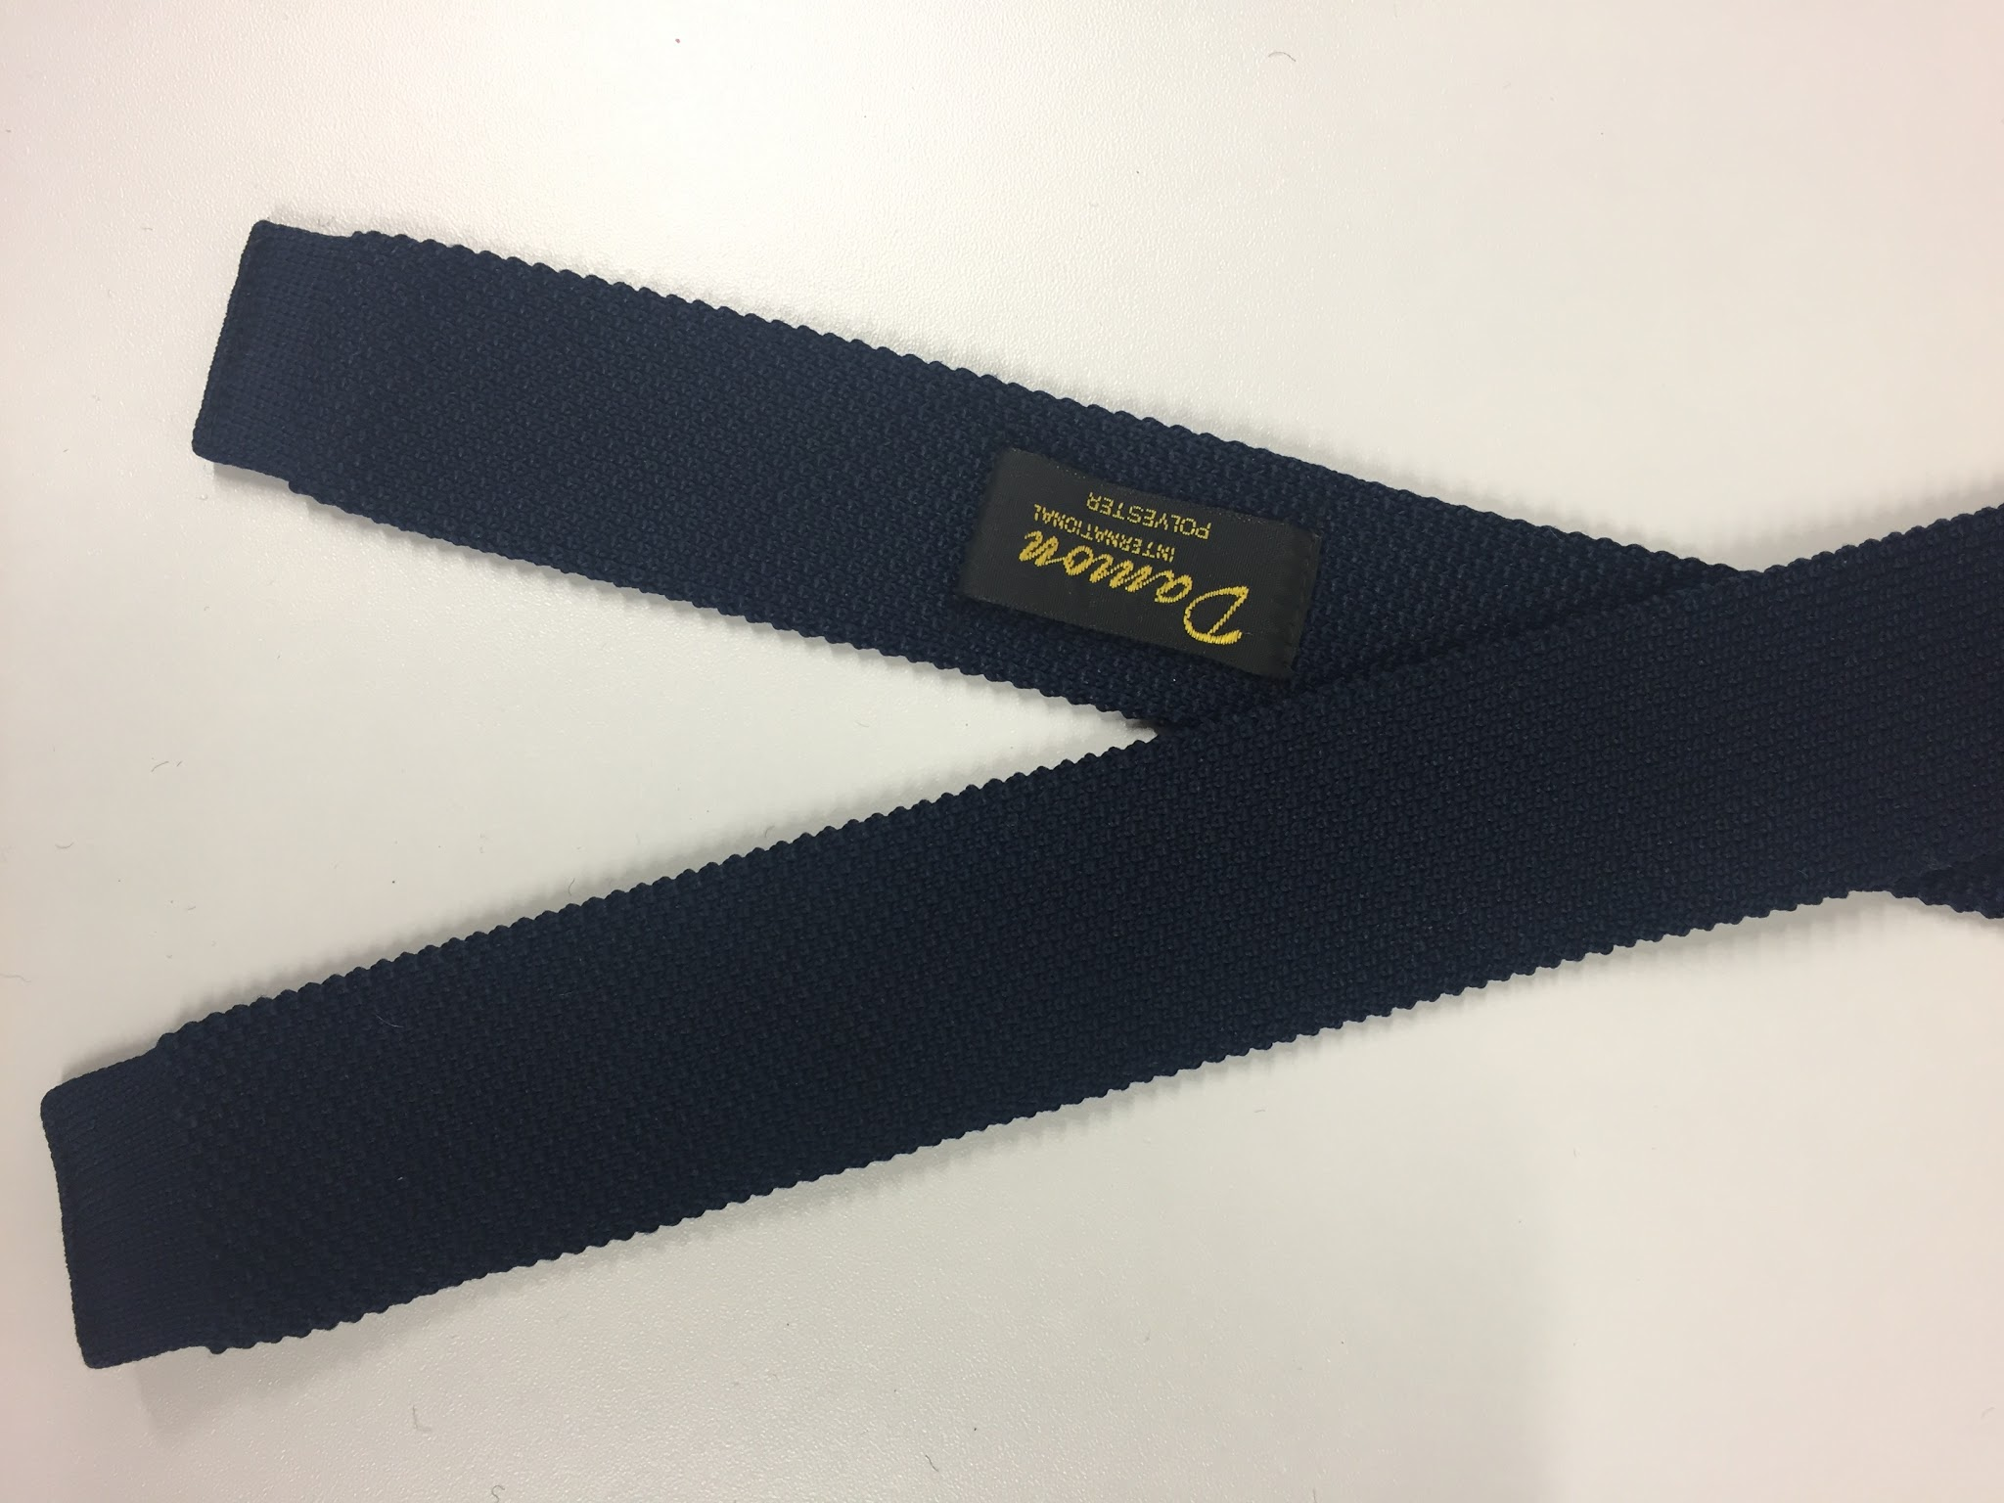 | Necktie, knitted, square, navy | Damon | Polyester
33 | 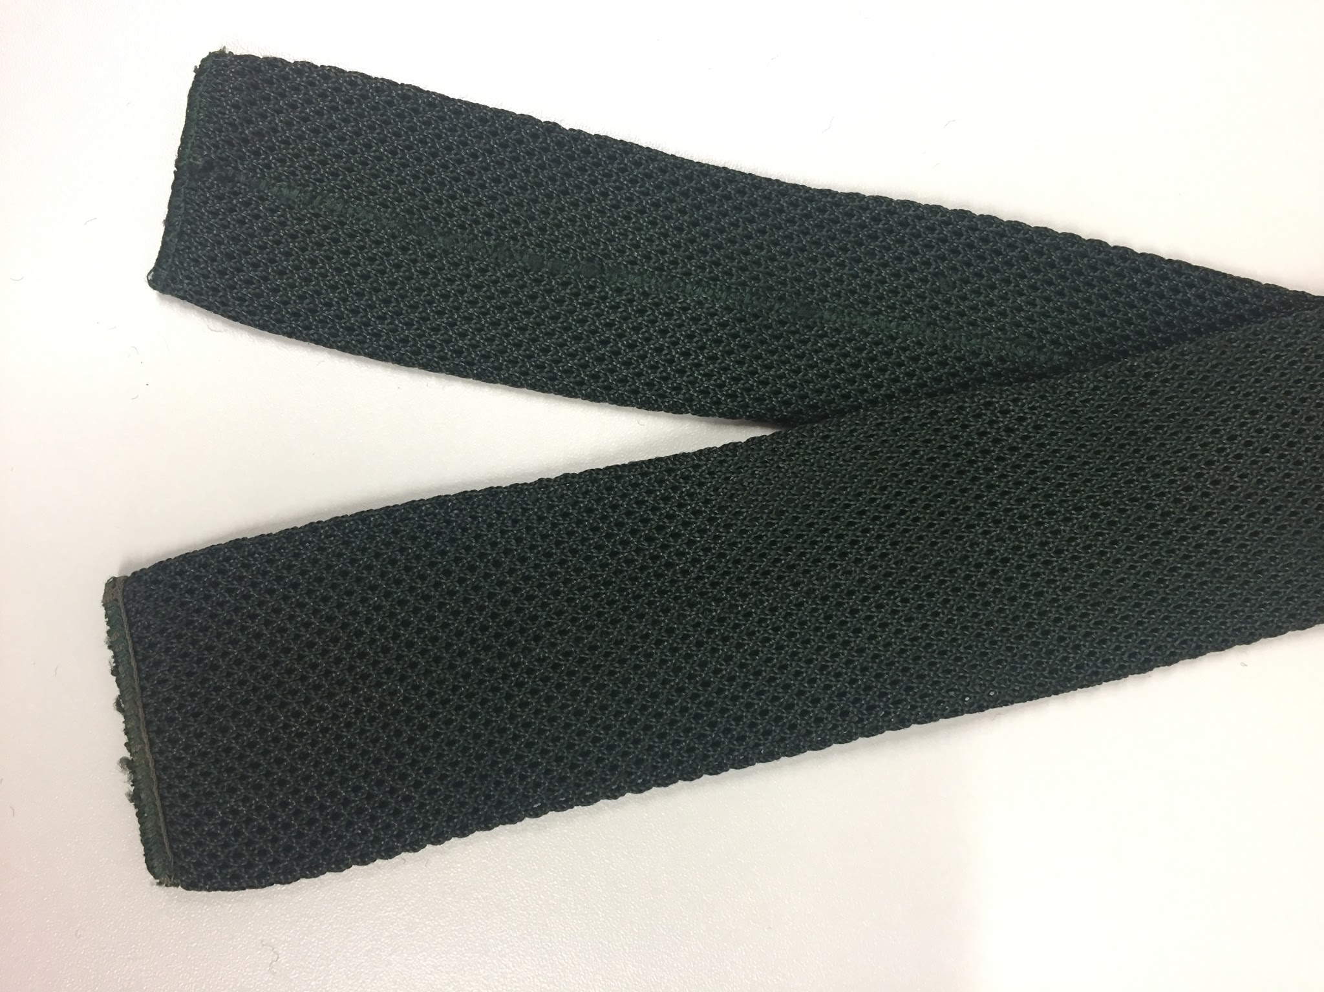 | Necktie, knitted, square, dark green | No Maker | Polyester
34 | 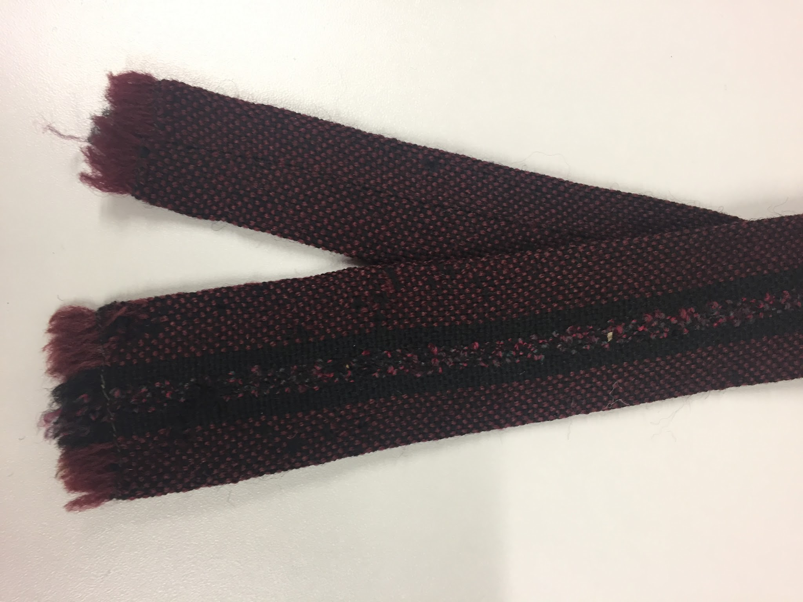 | Necktie, woven, square, maroon with vertical double black stripe | Cornucopia of Loughborough | Wool
35 | 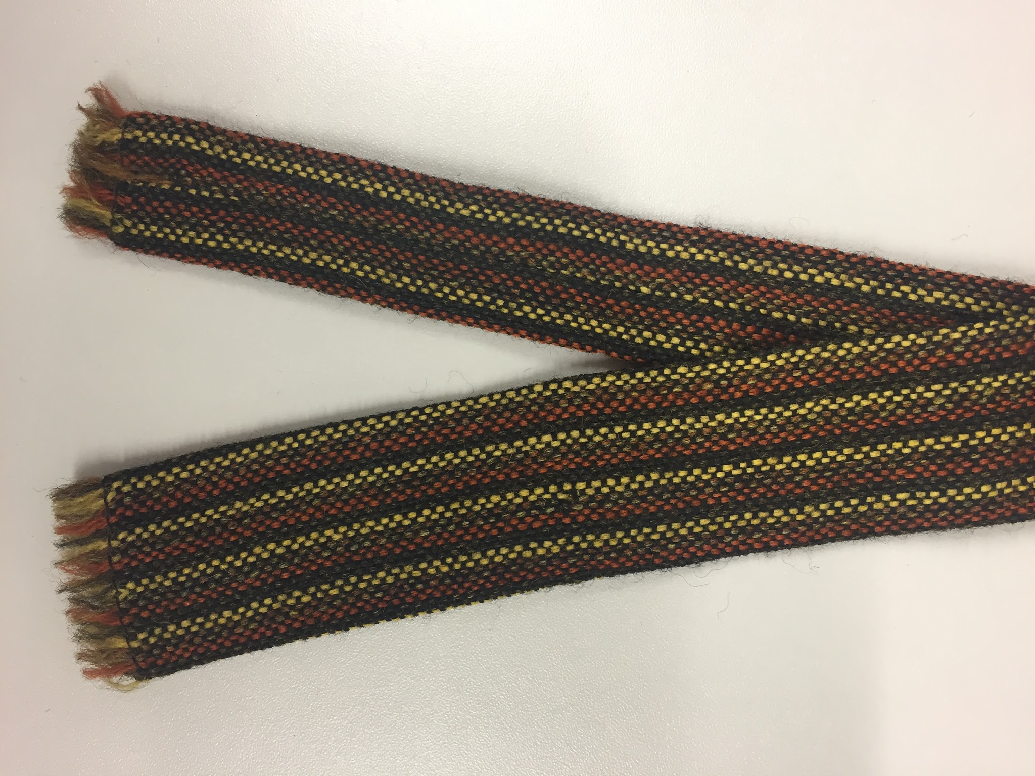 | Necktie, woven, square/yellow/brown vertical stripes | Cornucopia of Loughborough | Wool
36 | 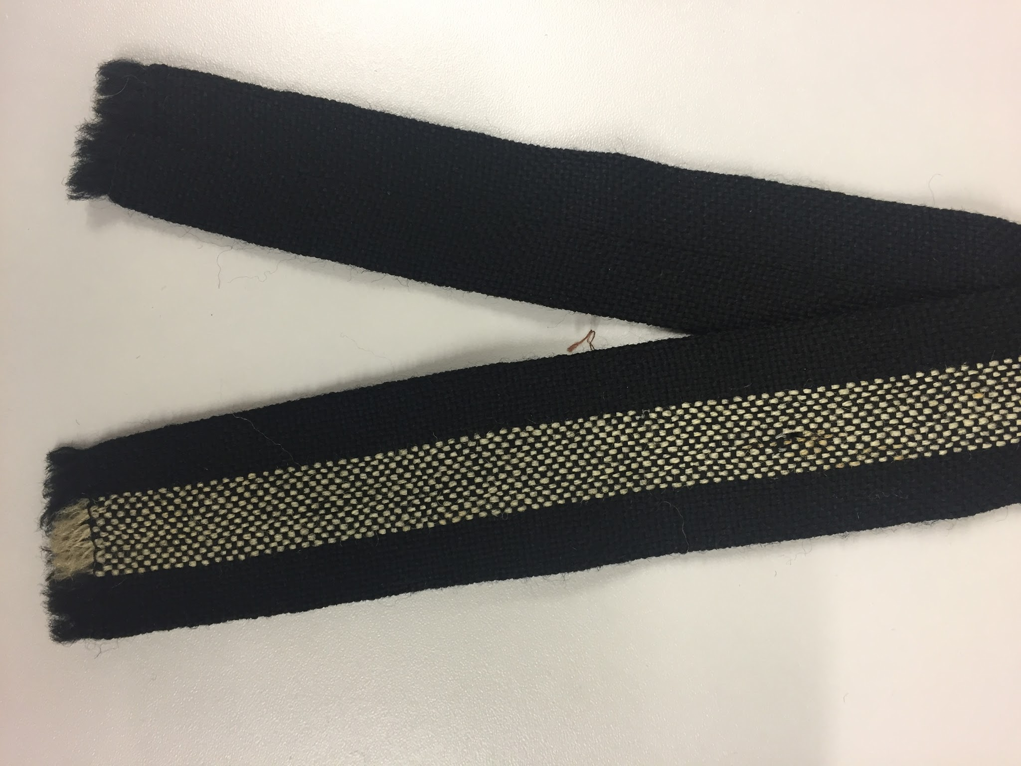 | Necktie, woven, square, black with white vertical stripe | Vardoc of Oxford | New wool
37 | 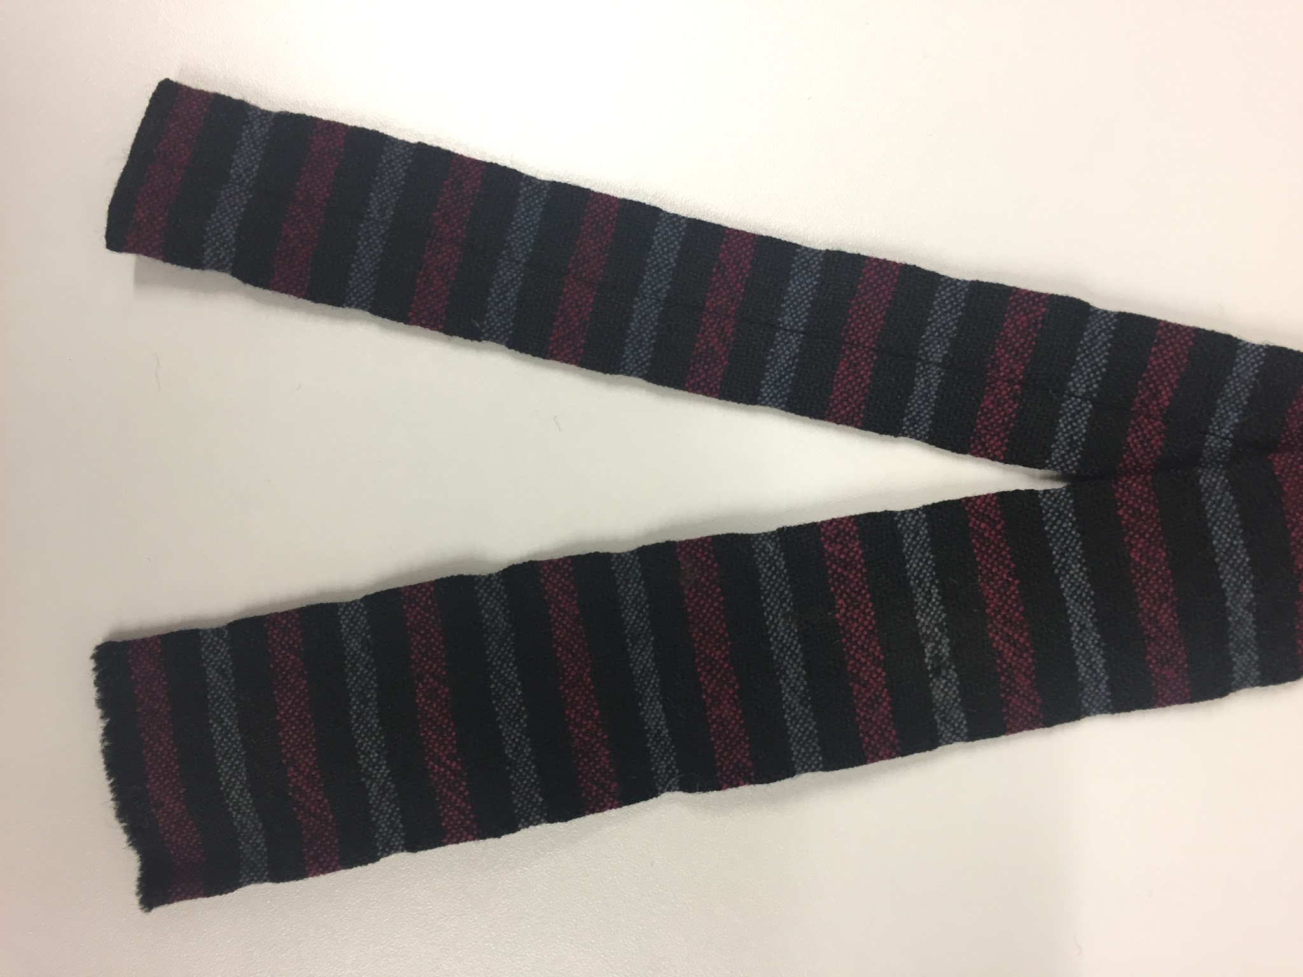 | Necktie, woven, square, grey/black/dark pink horizontal stripe | Peasey Beck of Westmorland | Wool
38 | 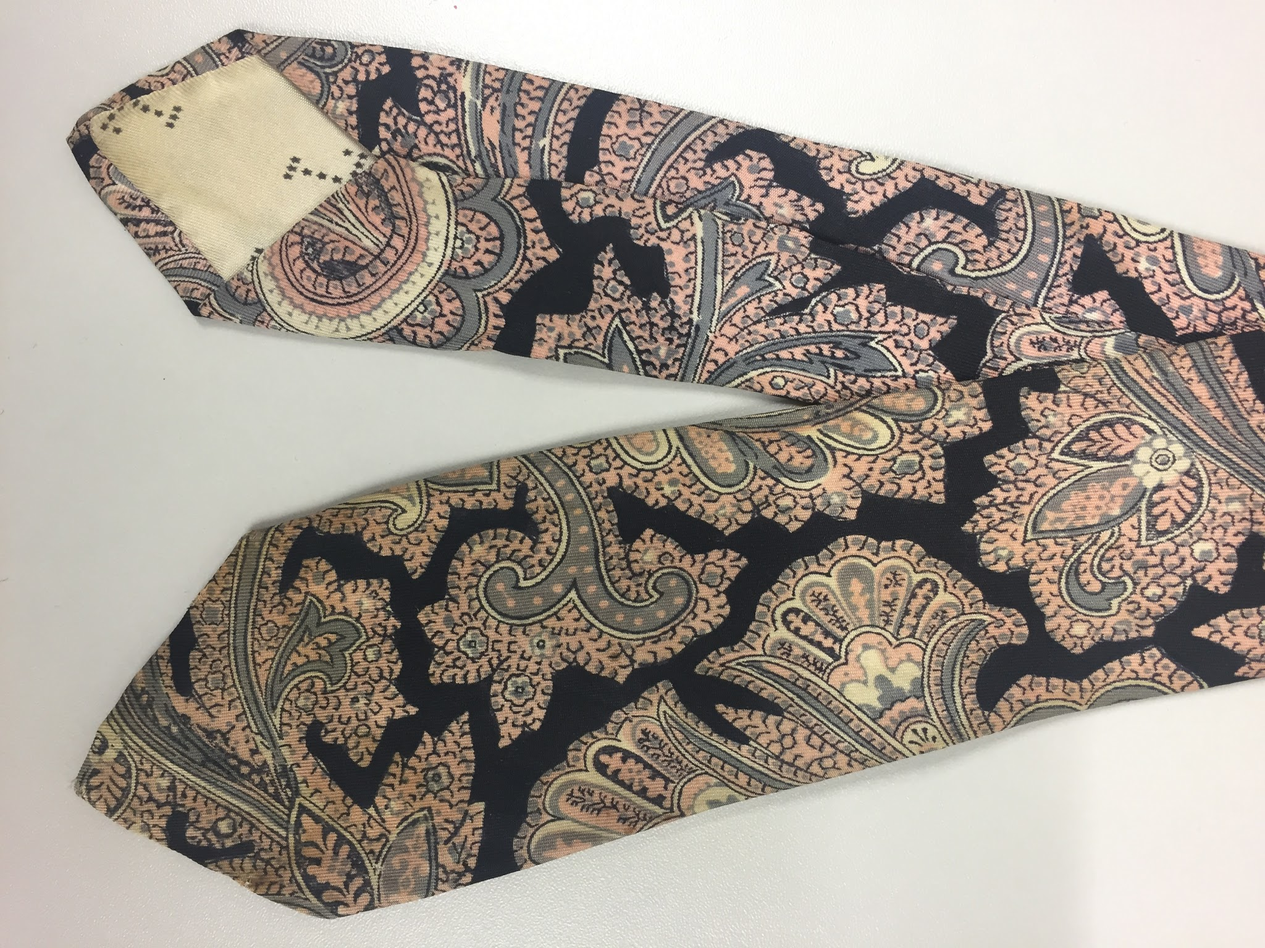 | Necktie, black/pink/teal/white paisley | Liberty of London | Silk
39 | 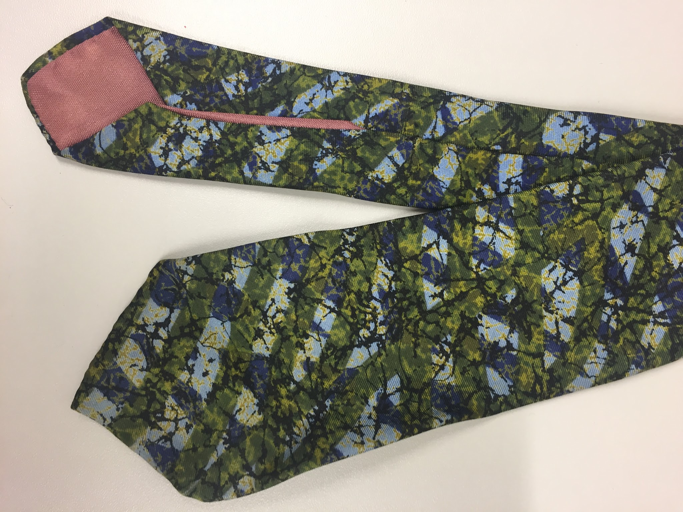 | Necktie, green/light blue/navy/gold/black abstract stripe pattern | Michelsons | Silk
40 | 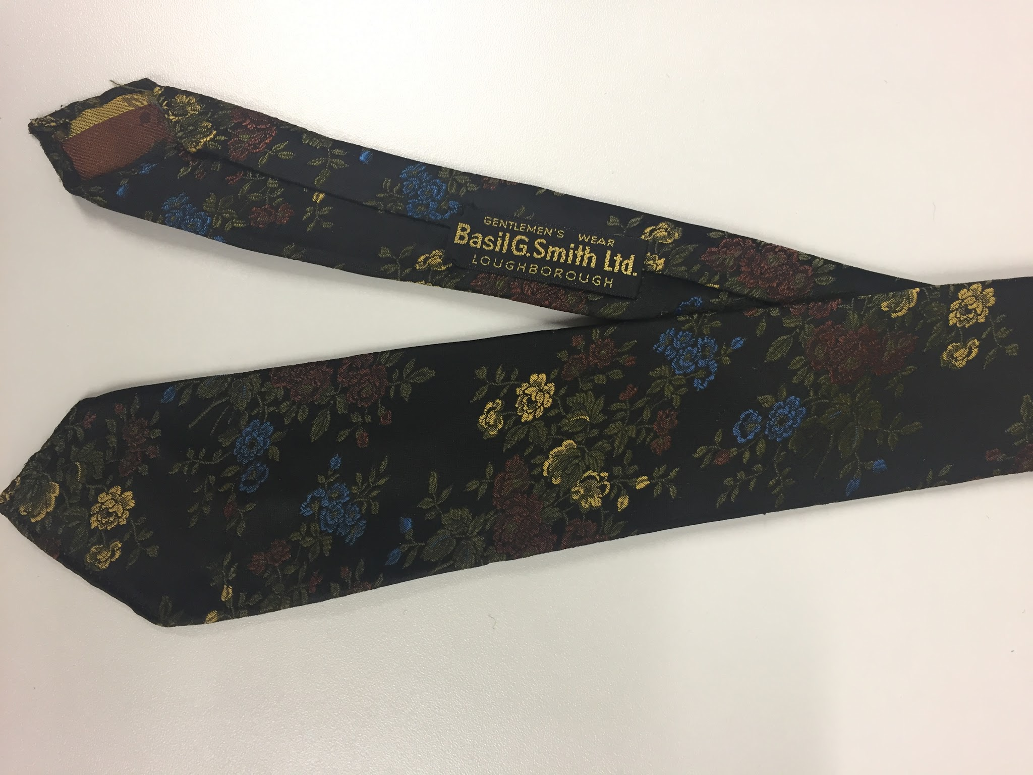 | Necktie, black with olive/gold/bronze/blue floral pattern | Basil G. Smith | Terylene
41 | 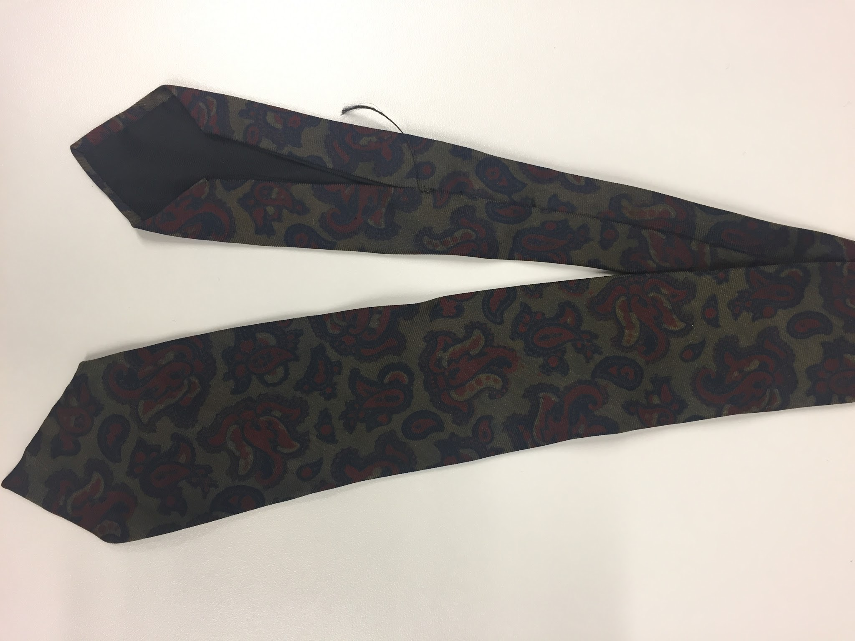 | Necktie, olive/maroon/navy paisley | Liberty of London | Silk
 | From Hull History centre:
42 | 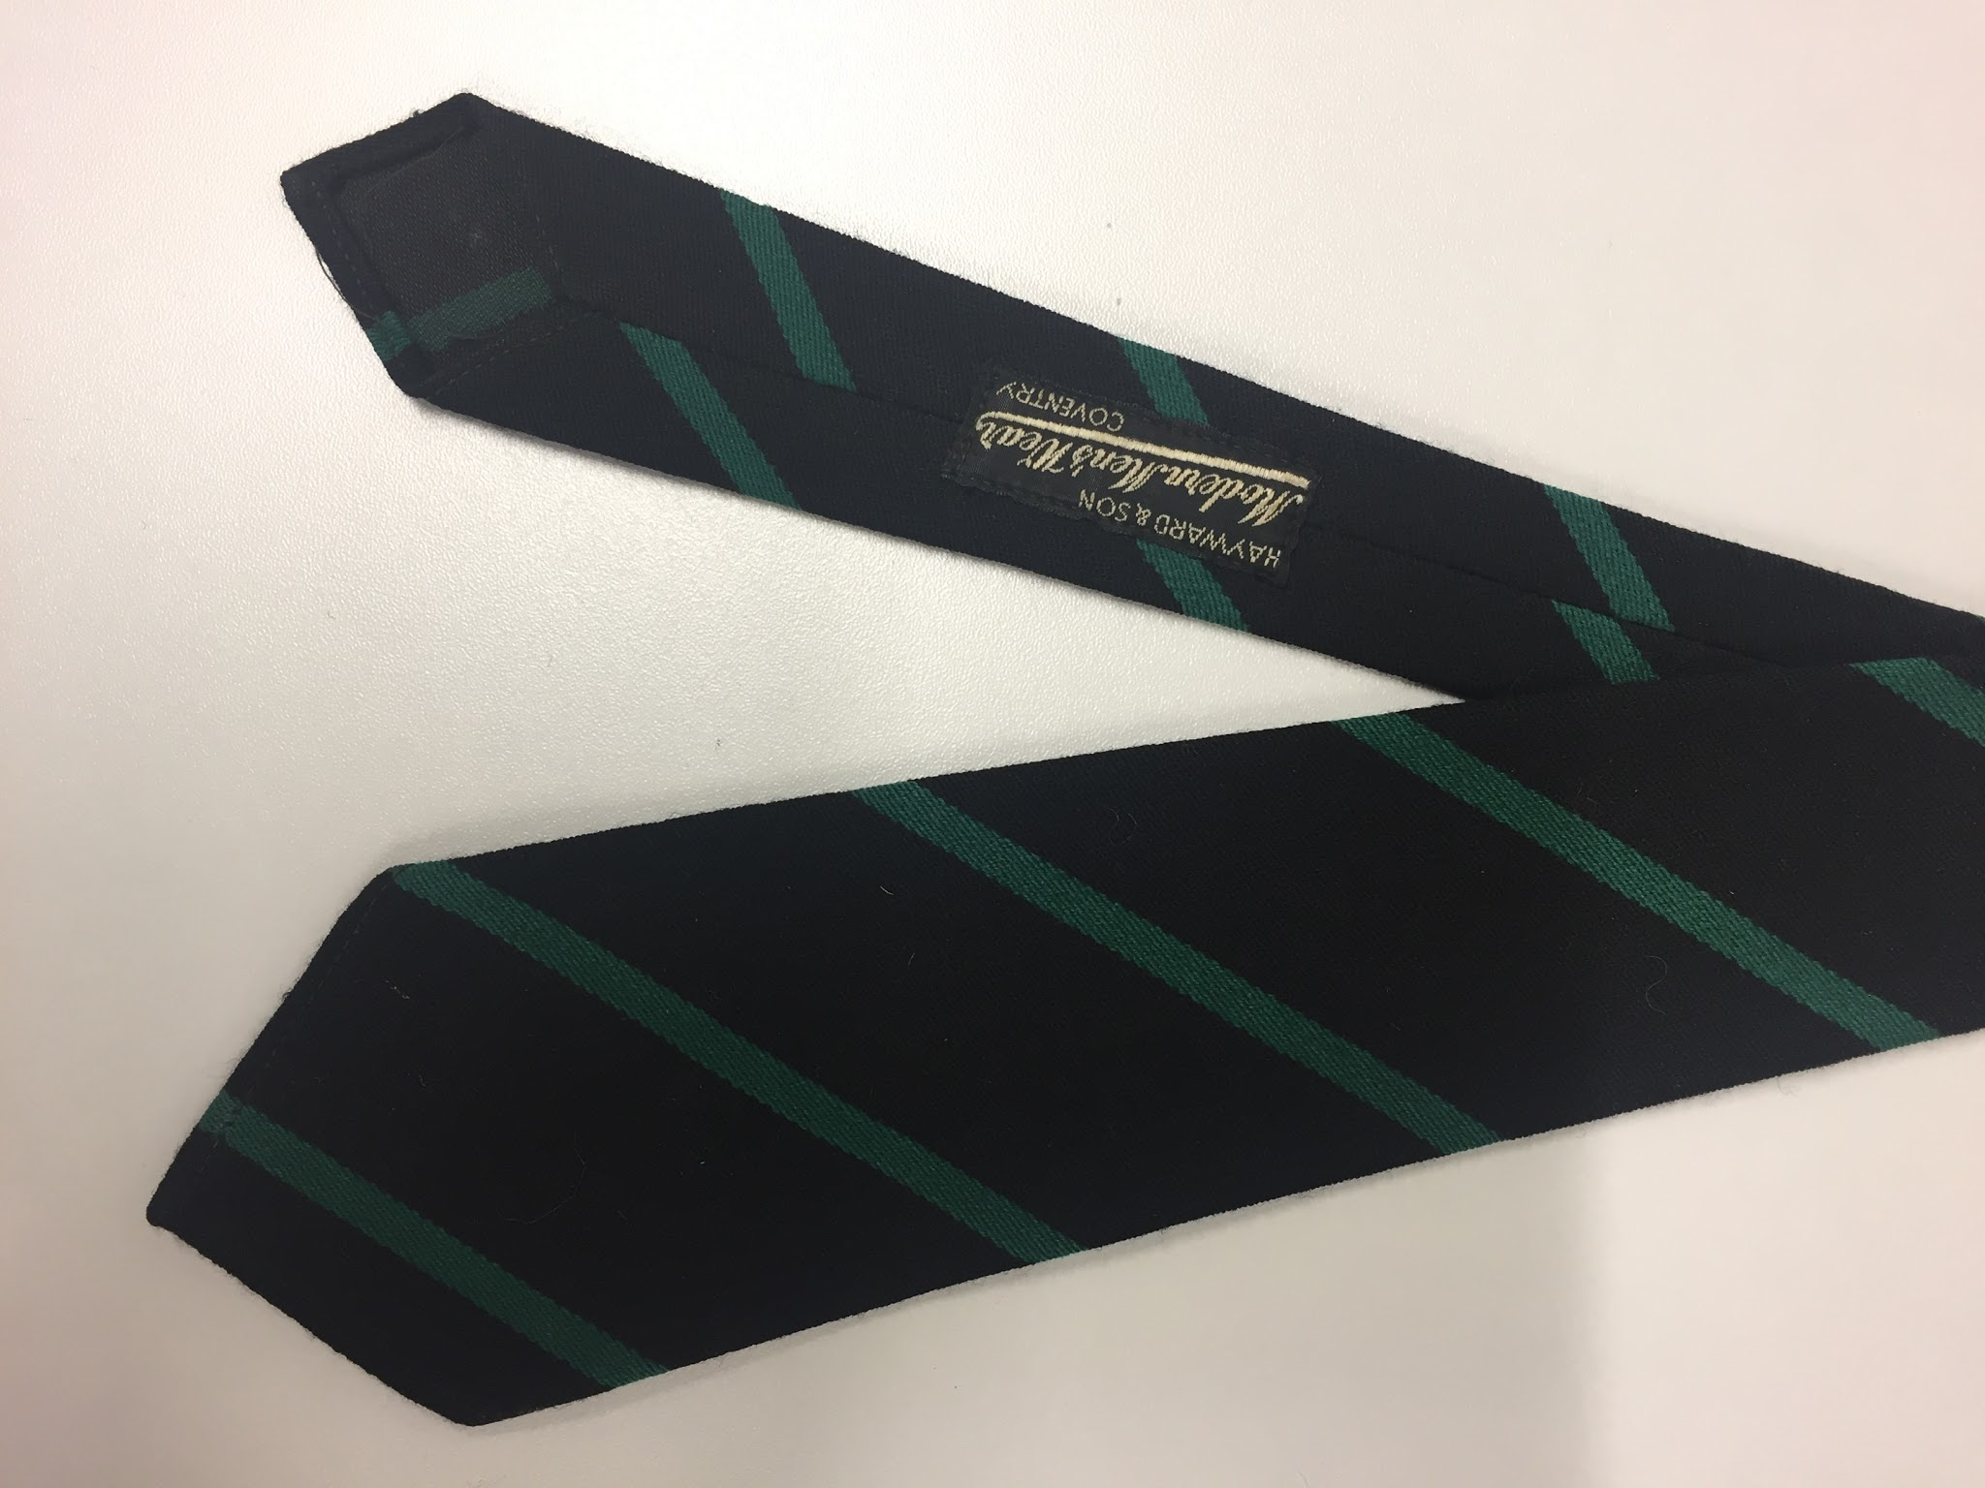 | Necktie, small, black with green diagonal stripe, marked with name. Potentially a school/club tie | Hayward & Son, Coventry | Polyester
43 | 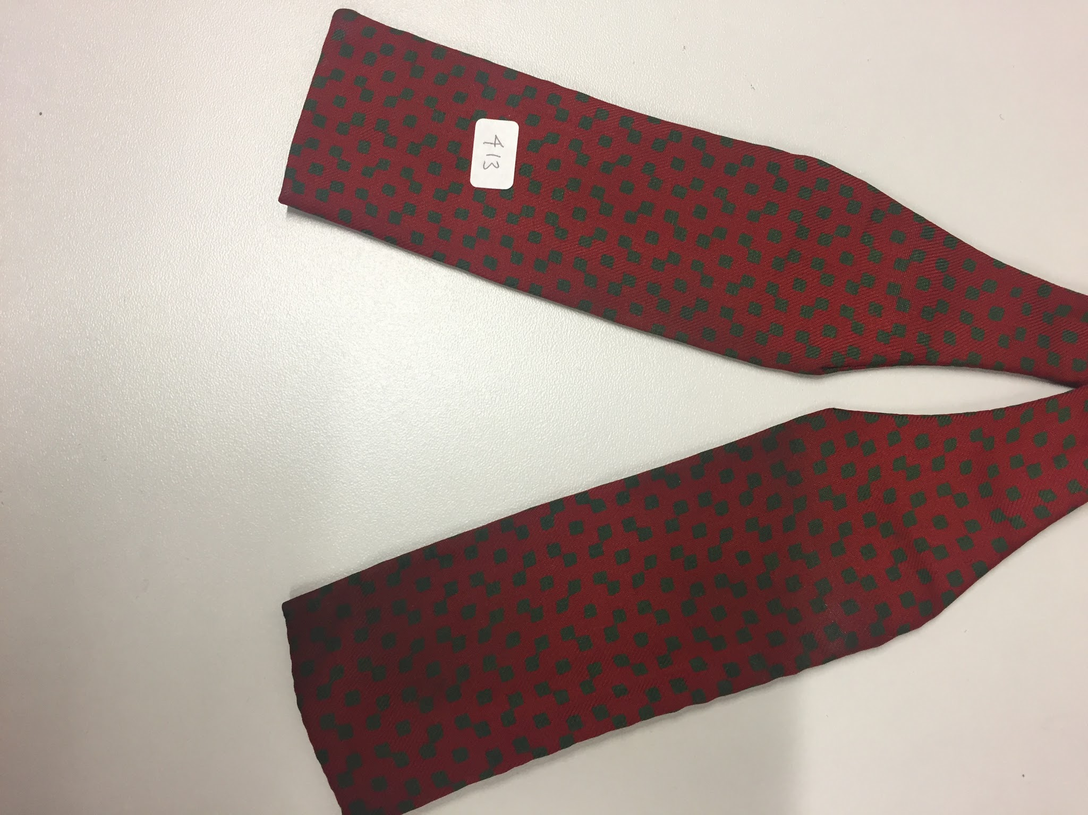 | Bowtie, square, red with small green squares | Foster & Co. | Silk
44 |  | Bowtie, butterfly, black, evening/formal | Akco | Terylene
45 | 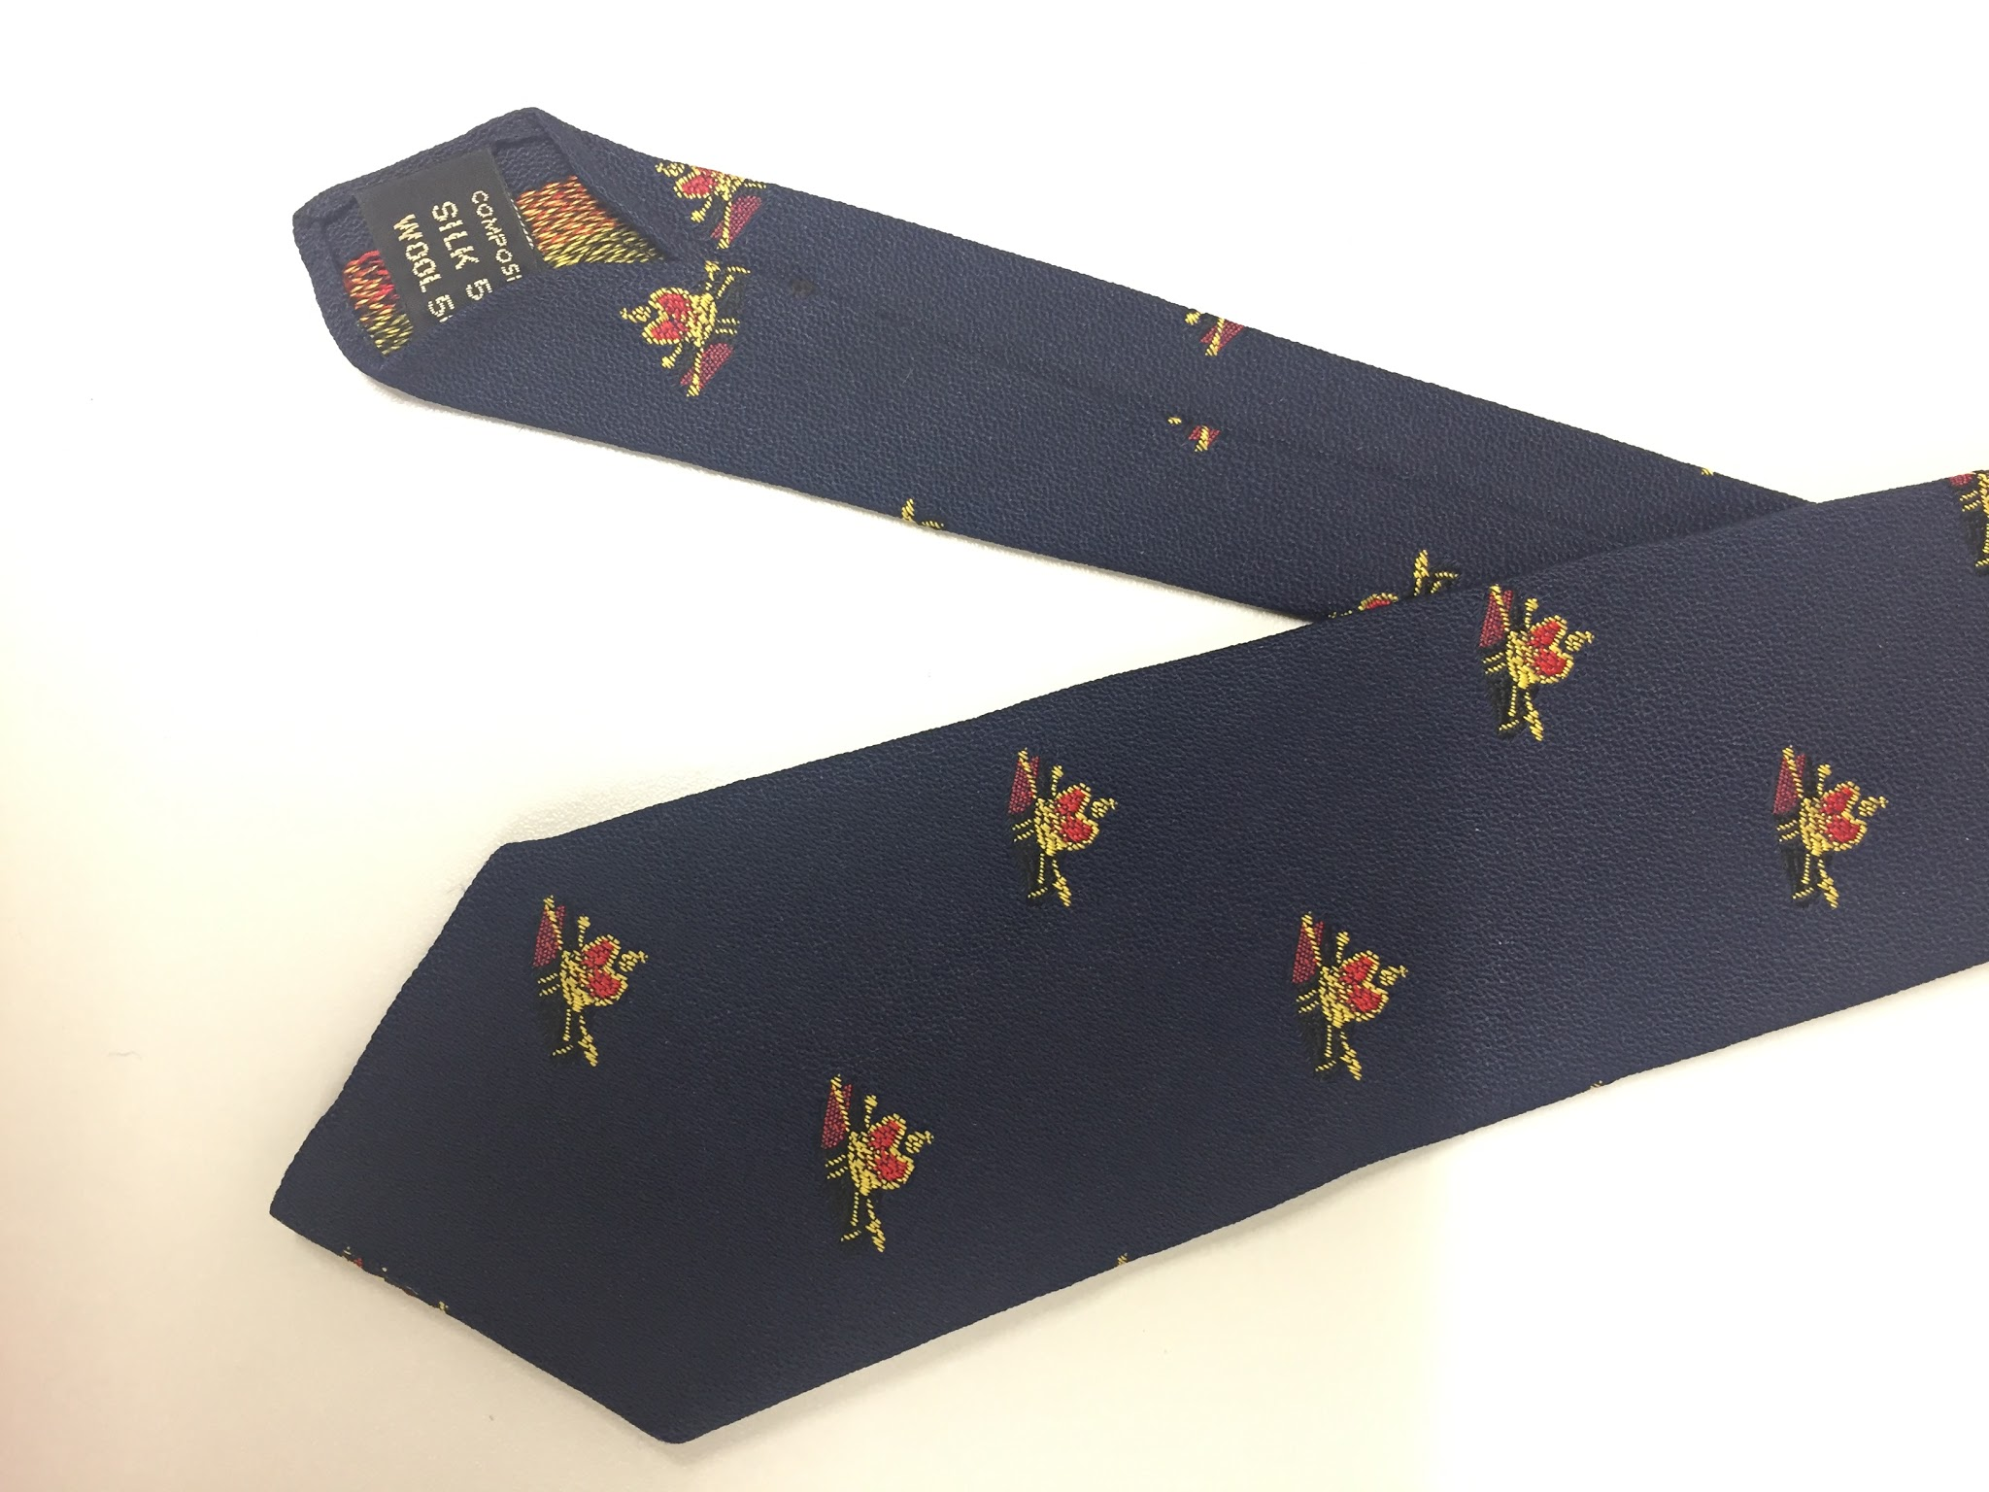 | Necktie, navy with crown and book motiff | Atkinsons (Ireland) | Silk/wool mix
46 | 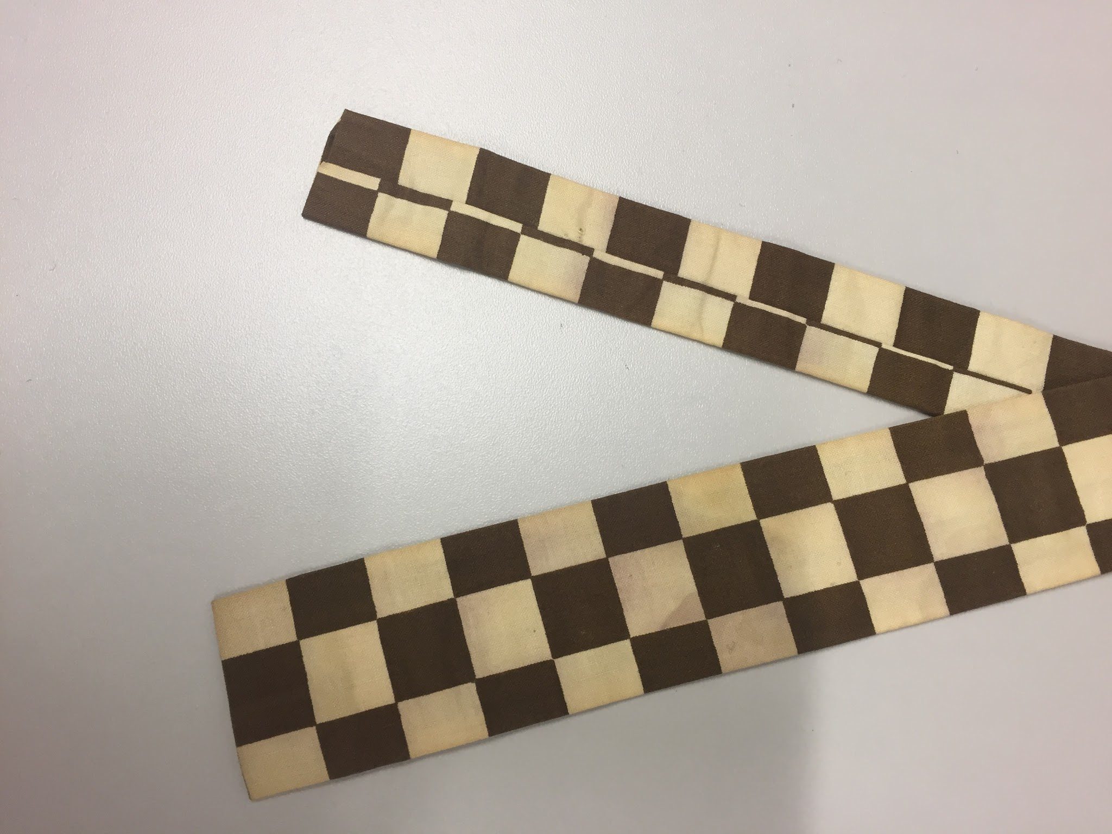 | Necktie, square, brown/beige chequerboard | No maker | Silk
47 | 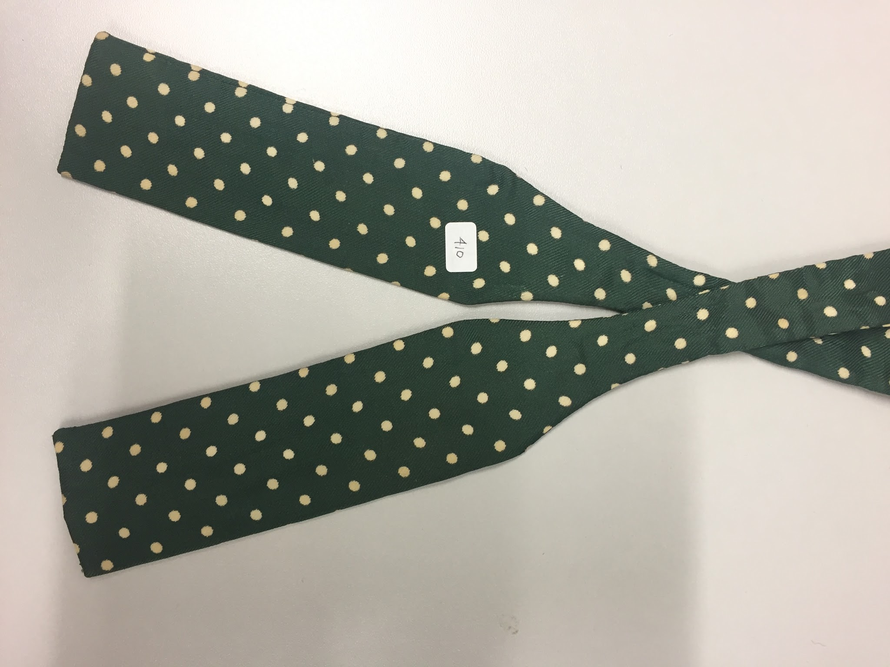 | Bowtie, square, green with white dots | No maker | Silk
48 | 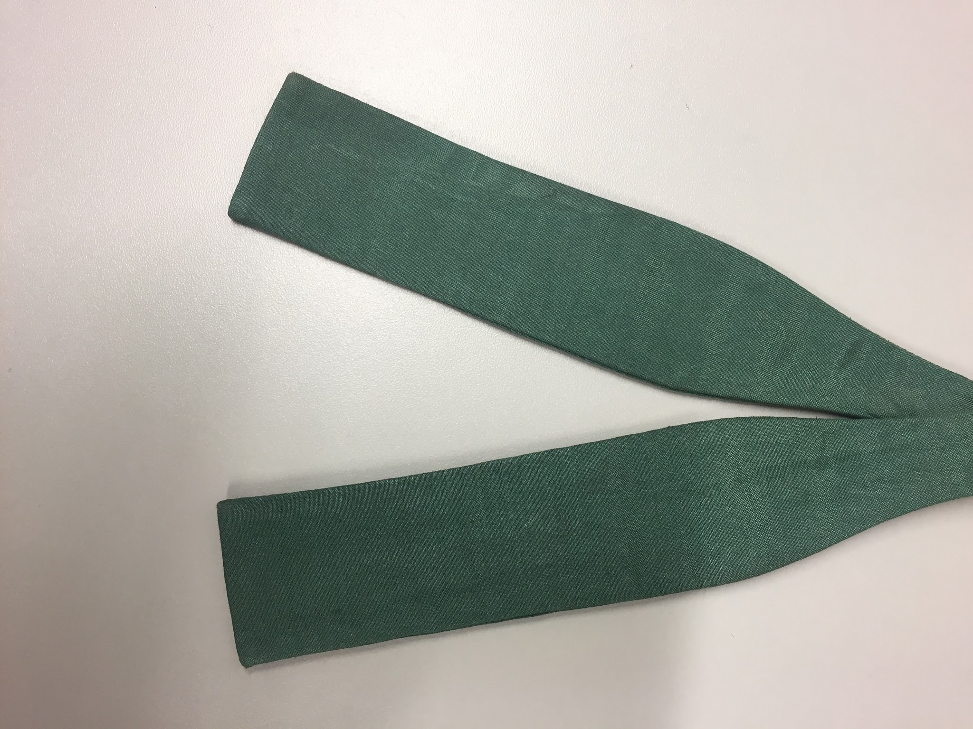 | Bowtie, square, midgreen, plain | Austen Reed | Silk
49 | 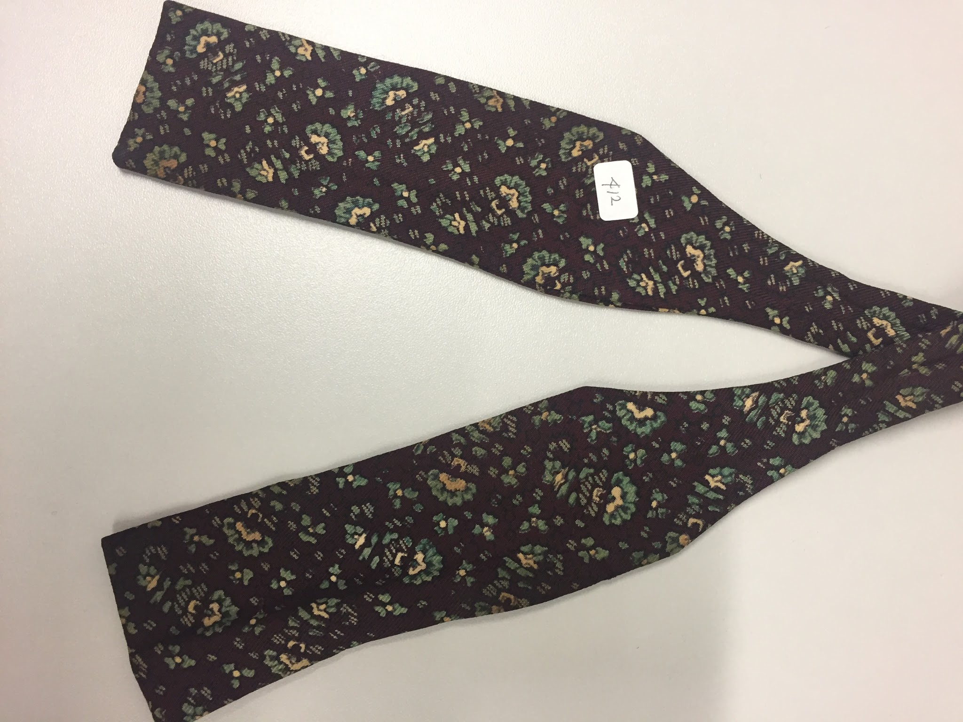 | Bowtie, square, maroon with green/cream floral pattern | No maker | Silk
50 | 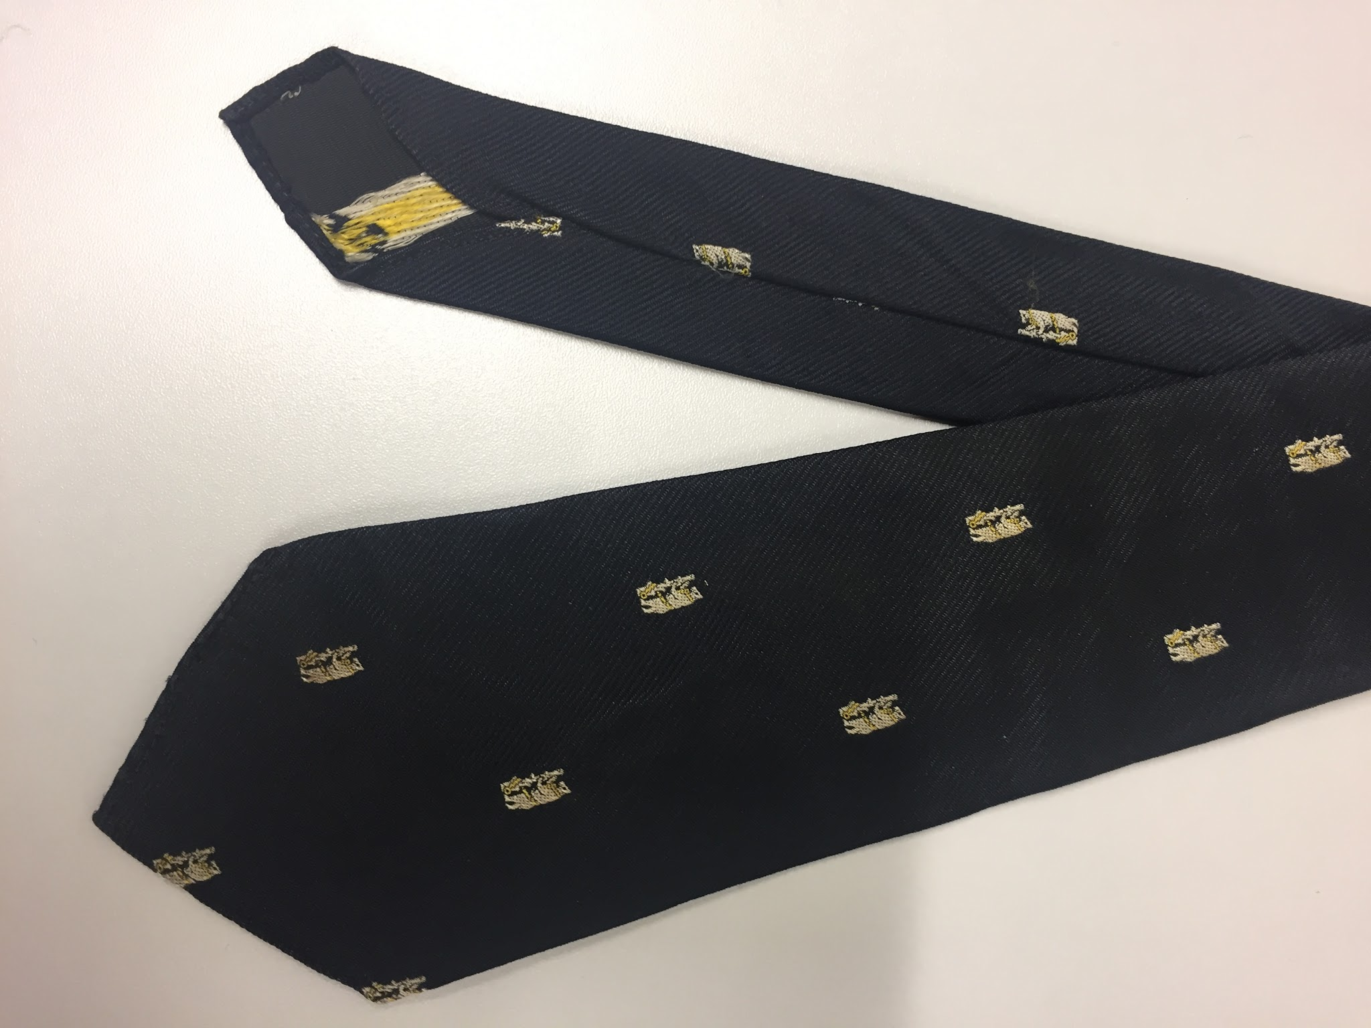 | Necktie, black with white bear motiff | Warwickshire | Terylene
51 | 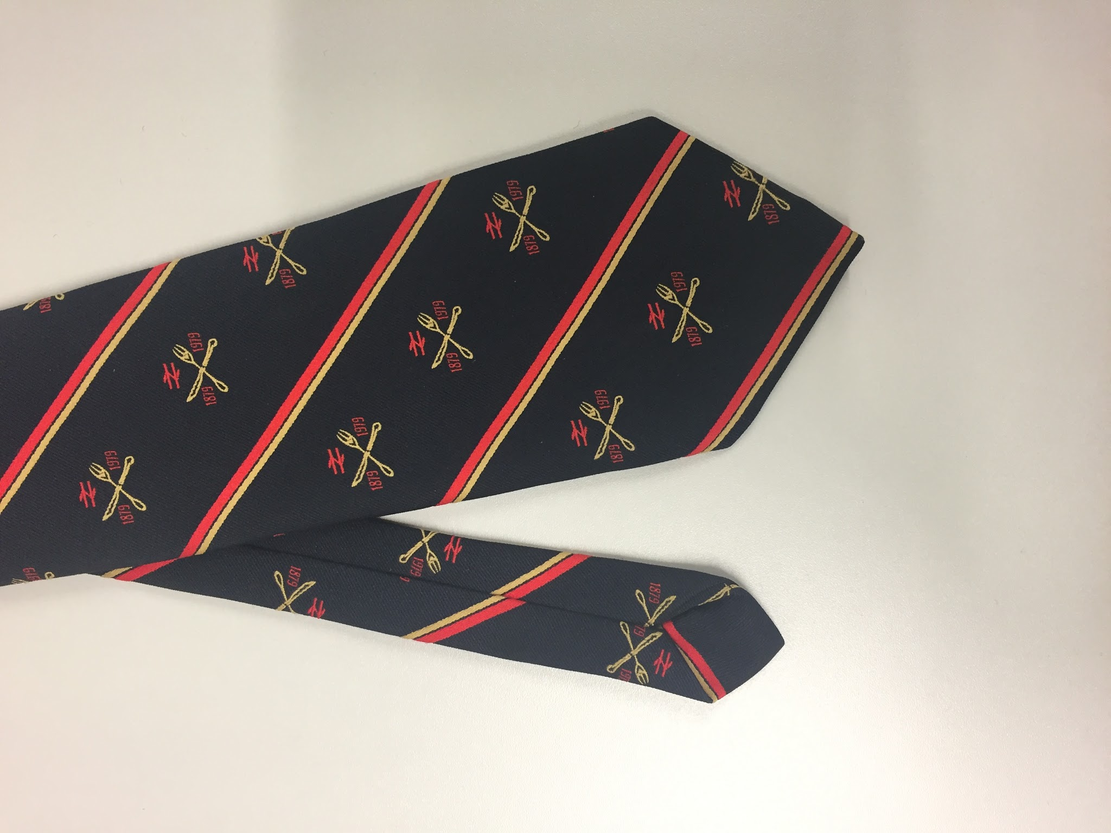 | Necktie, black with red and yellow stripes and rail motifs. | Ernex | Polyester
52 | 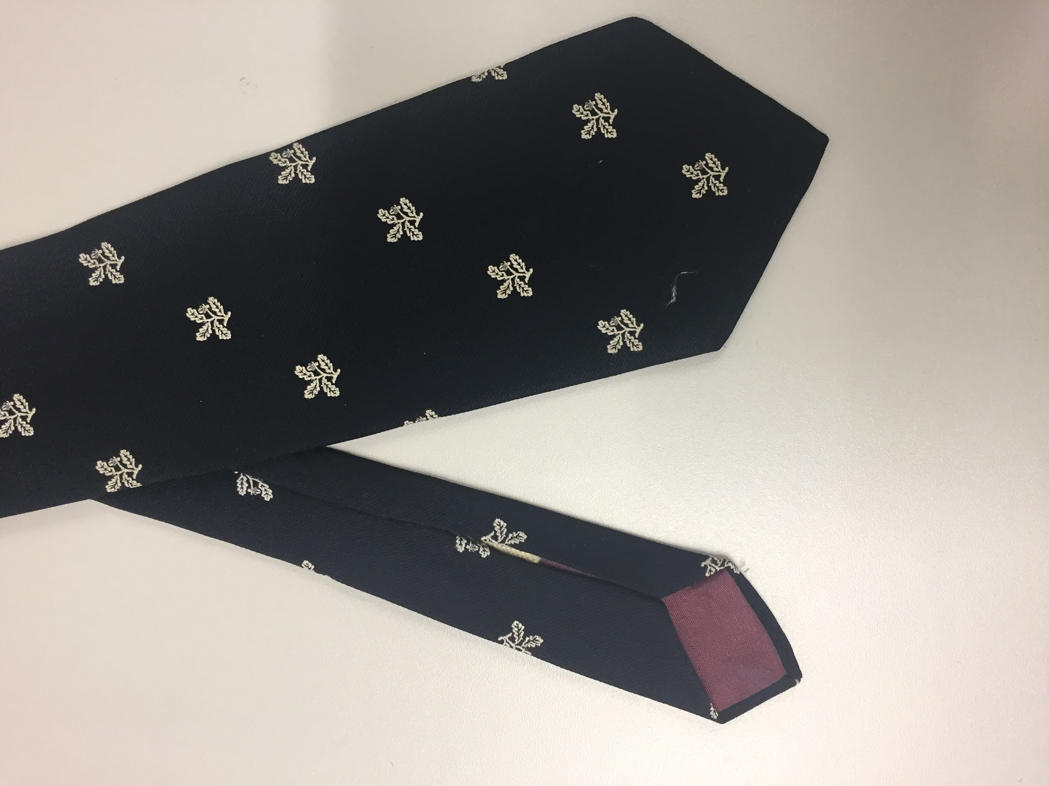 | Necktie, navy with National Trust motifs | No maker | Polyester
53 | 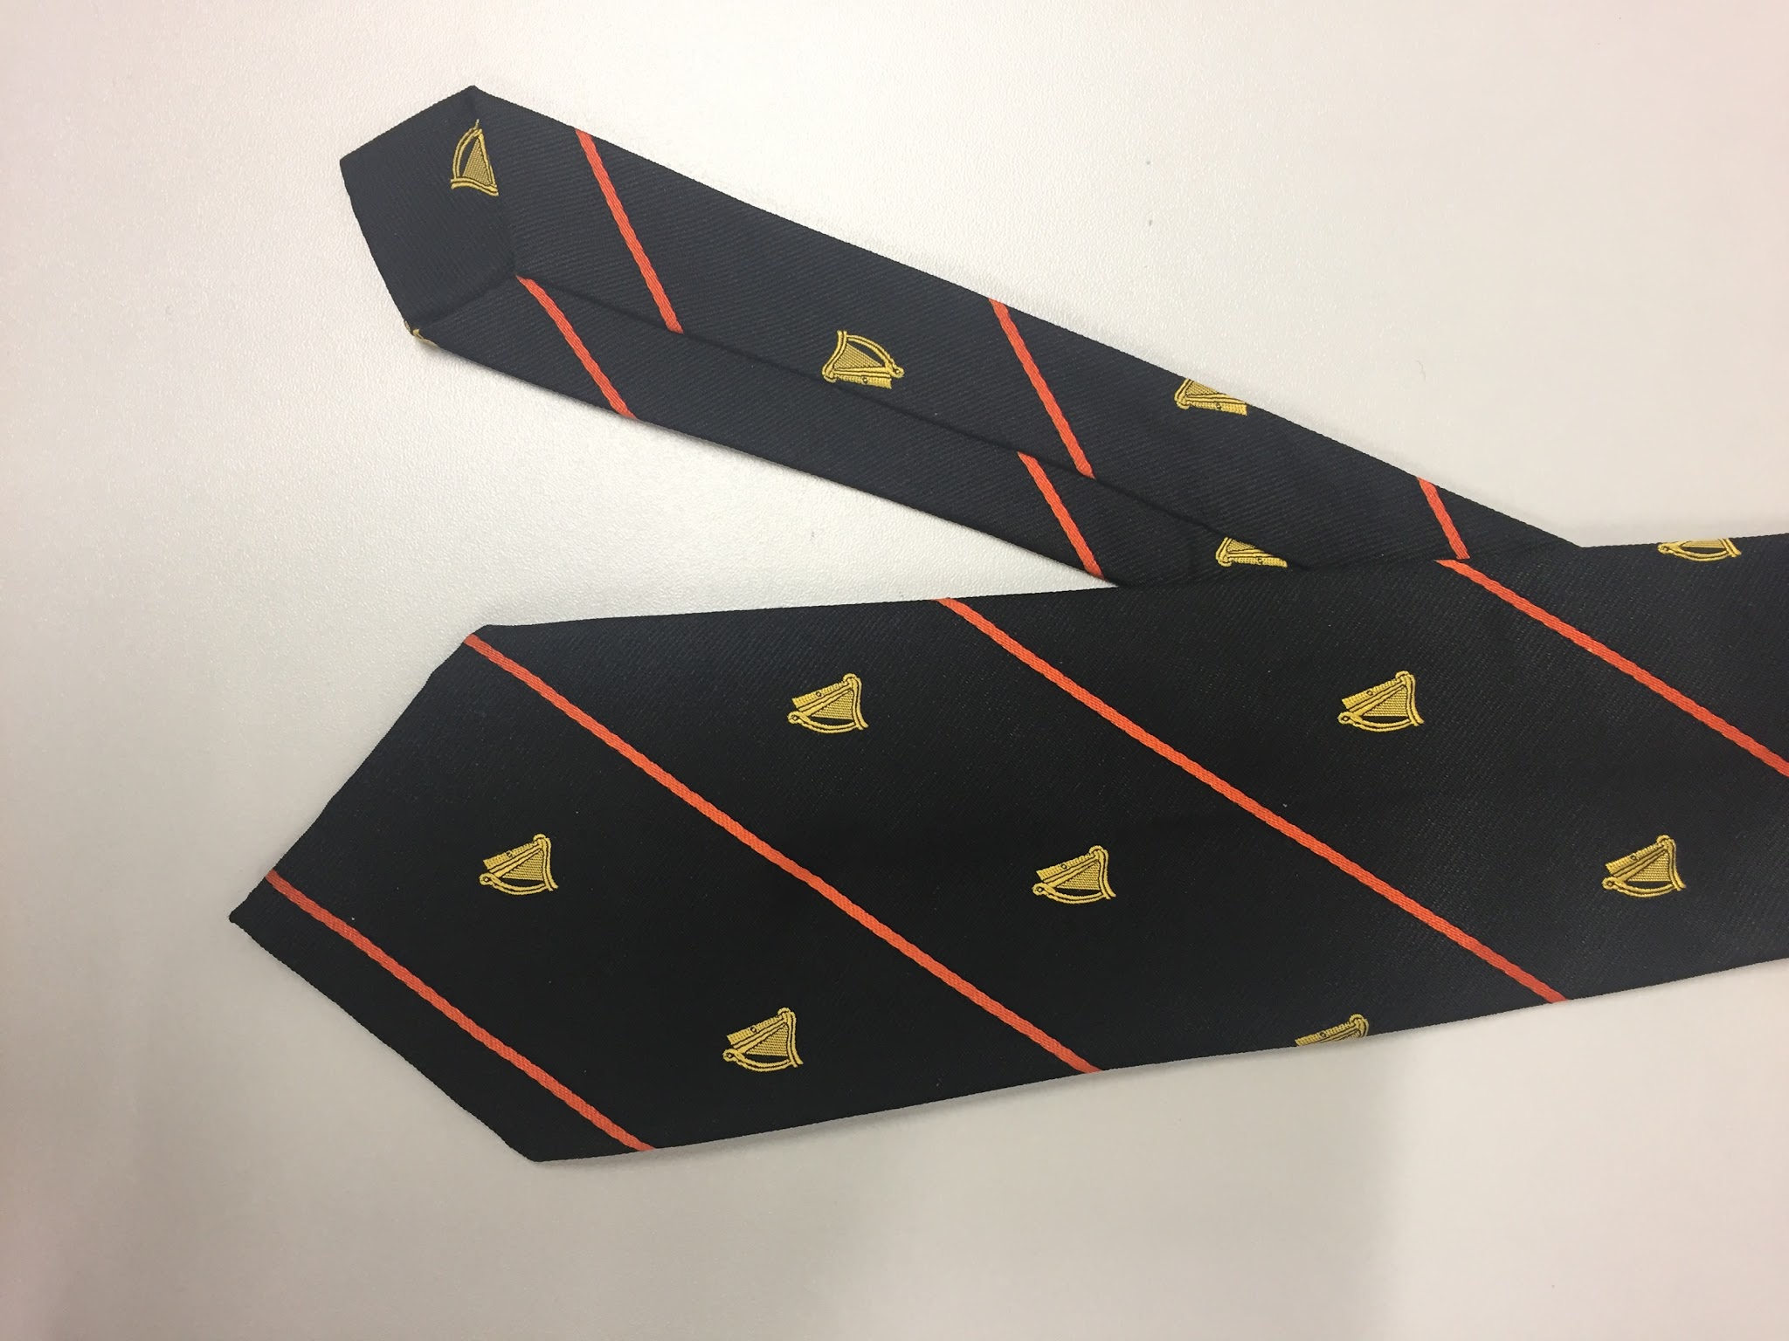 | Necktie, black with orange stripes and harp motifs | James Blackmore ltd. | Silk
54 | 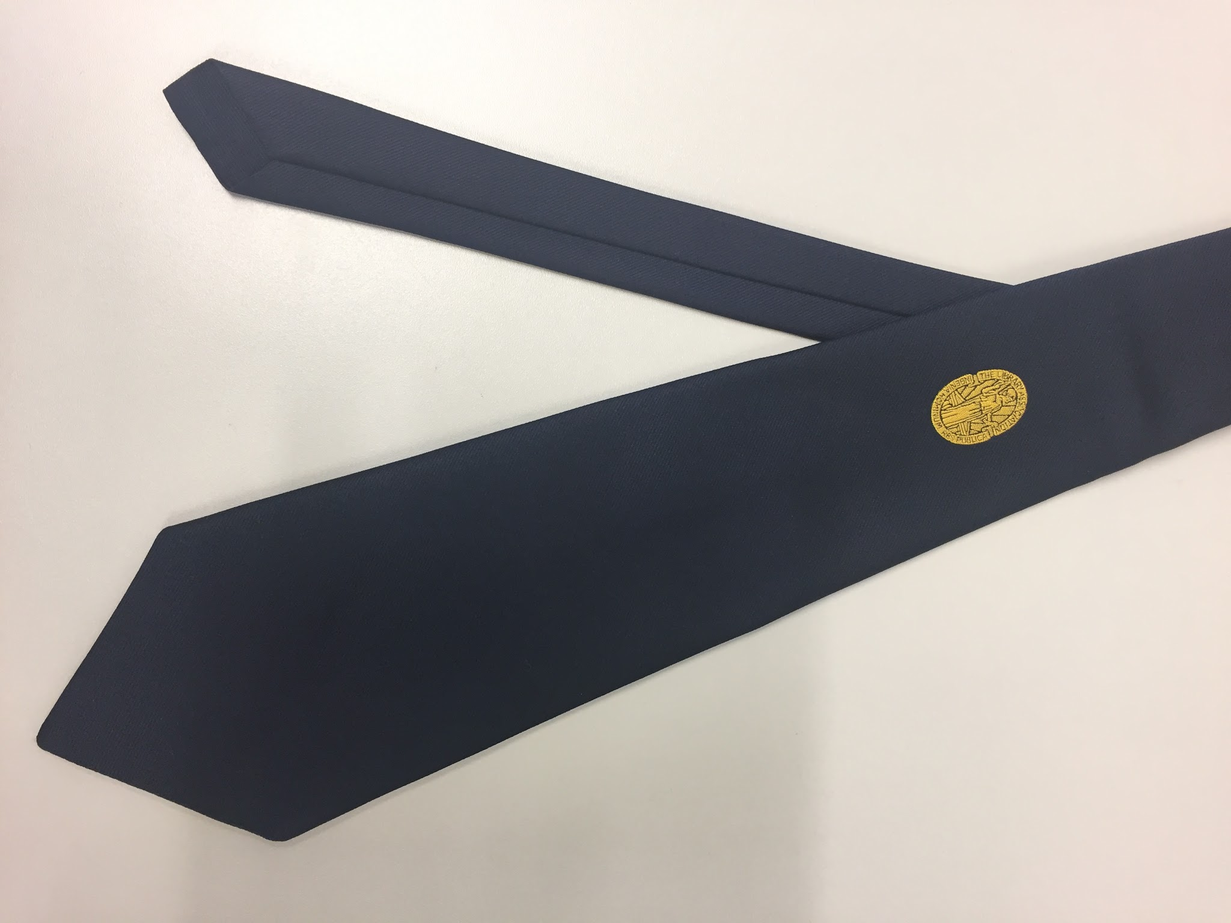 | Necktie, navy with library association motif | Glenfield | Polyester
55 | 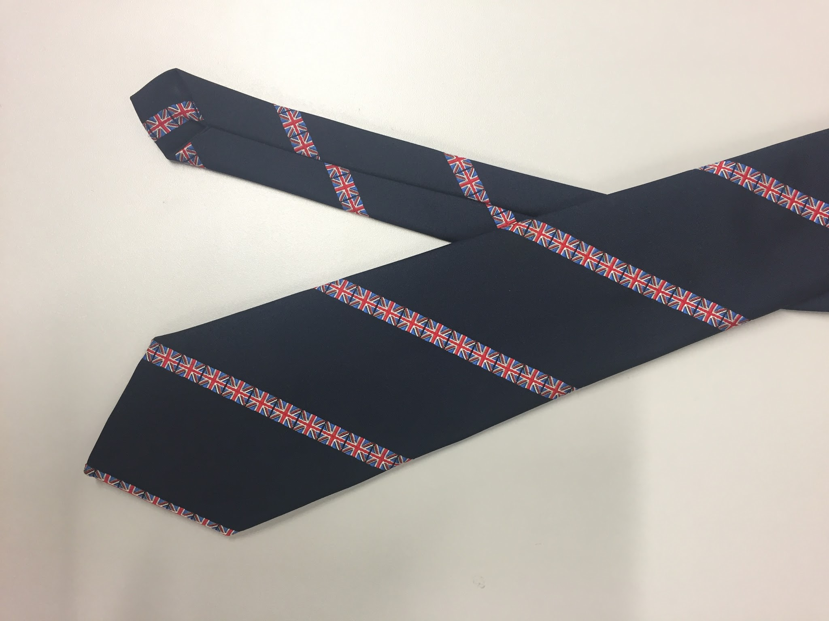 | Necktie, Navy with union flag stripes | Folkspeare | Polyester
56 | 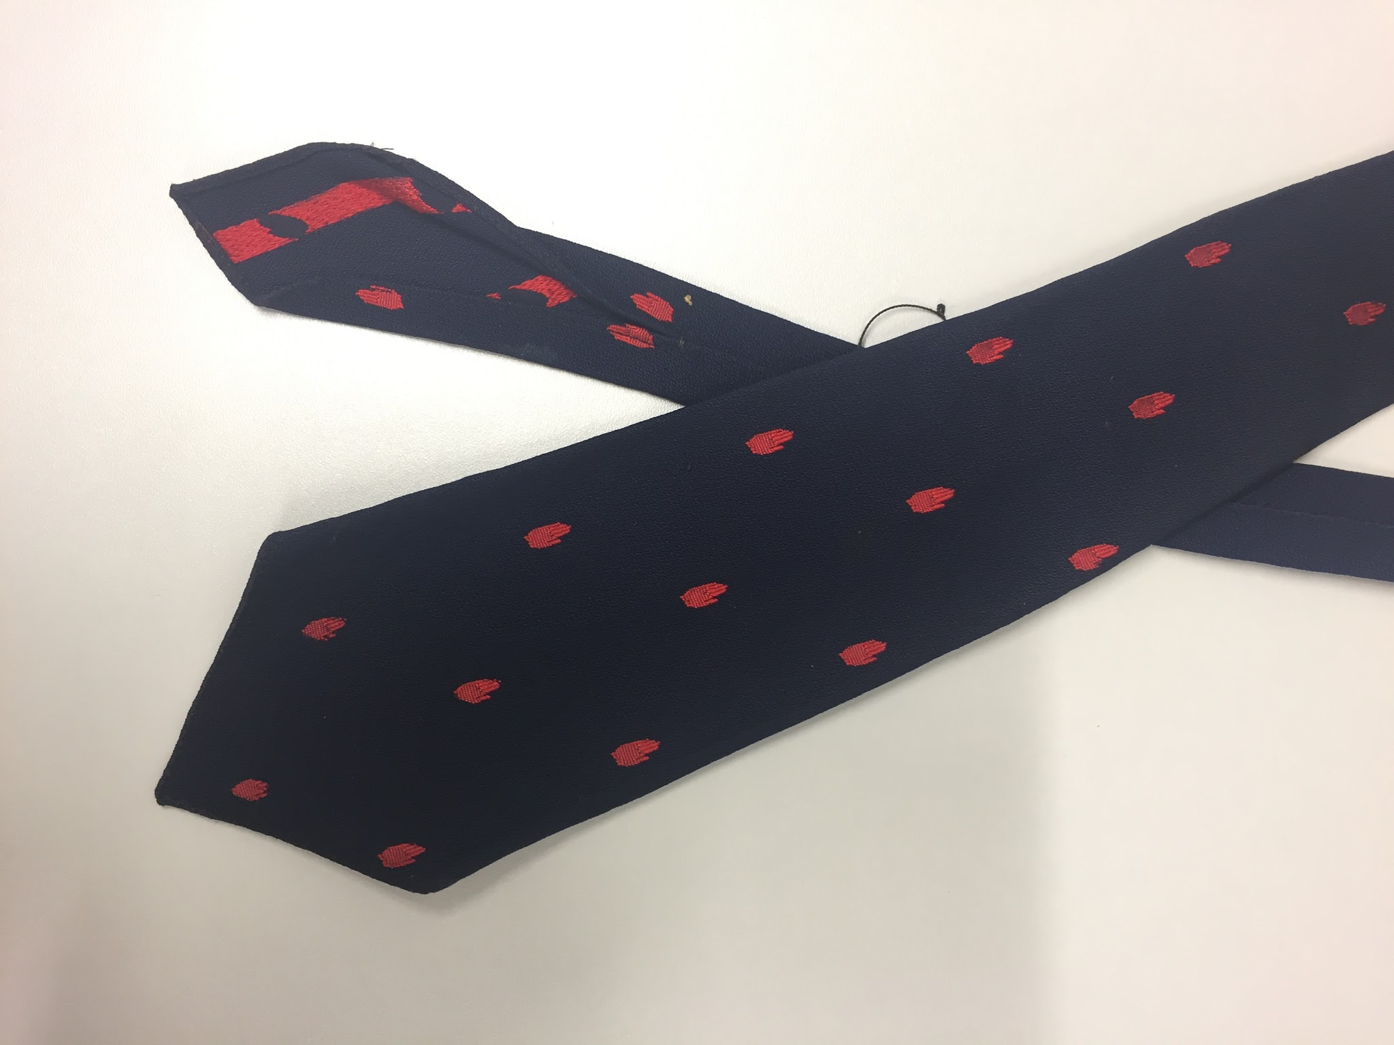 | Necktie, navy with red hand motif | Atkinsons (Ireland) | Silk
57 | 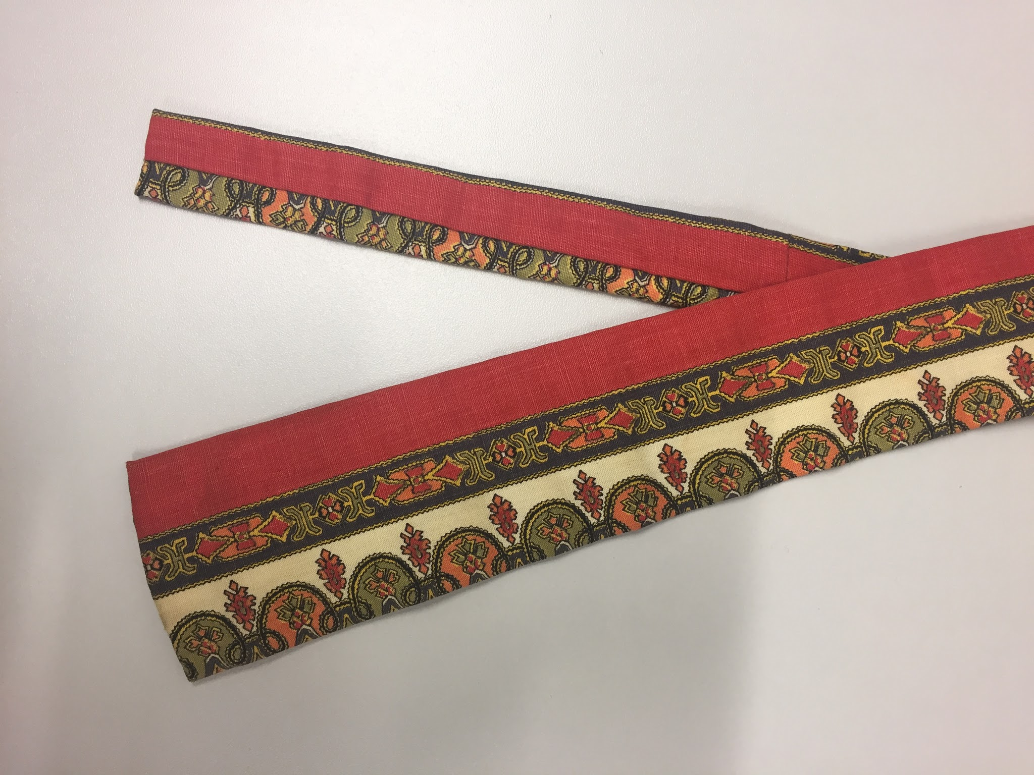 | Necktie, cream, orange and grey pattern | No maker | Cotton
58  59  60 | 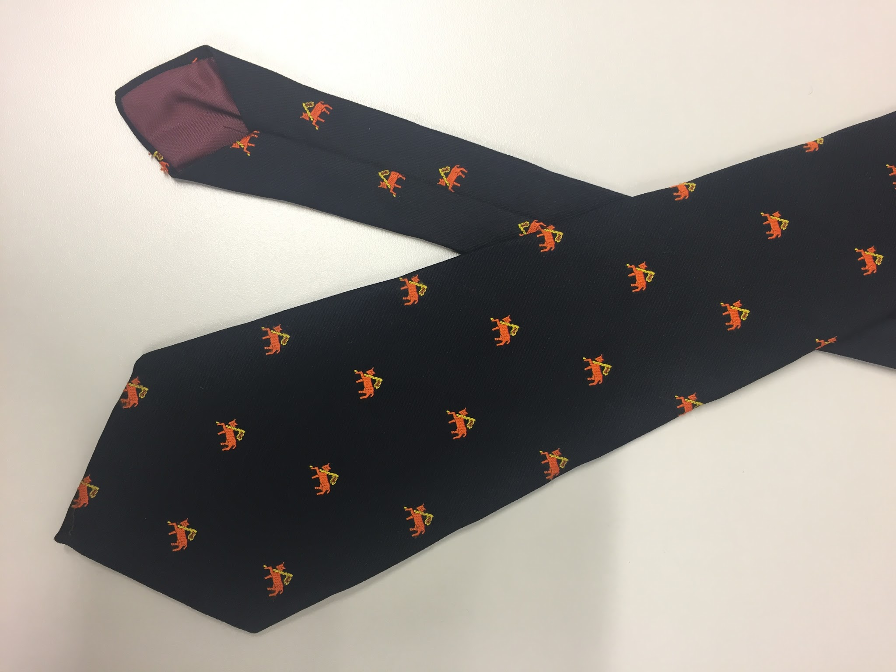 | Necktie, navy with orange cow and flag motif  Three of this same tie | Kol | Polyester
61 | 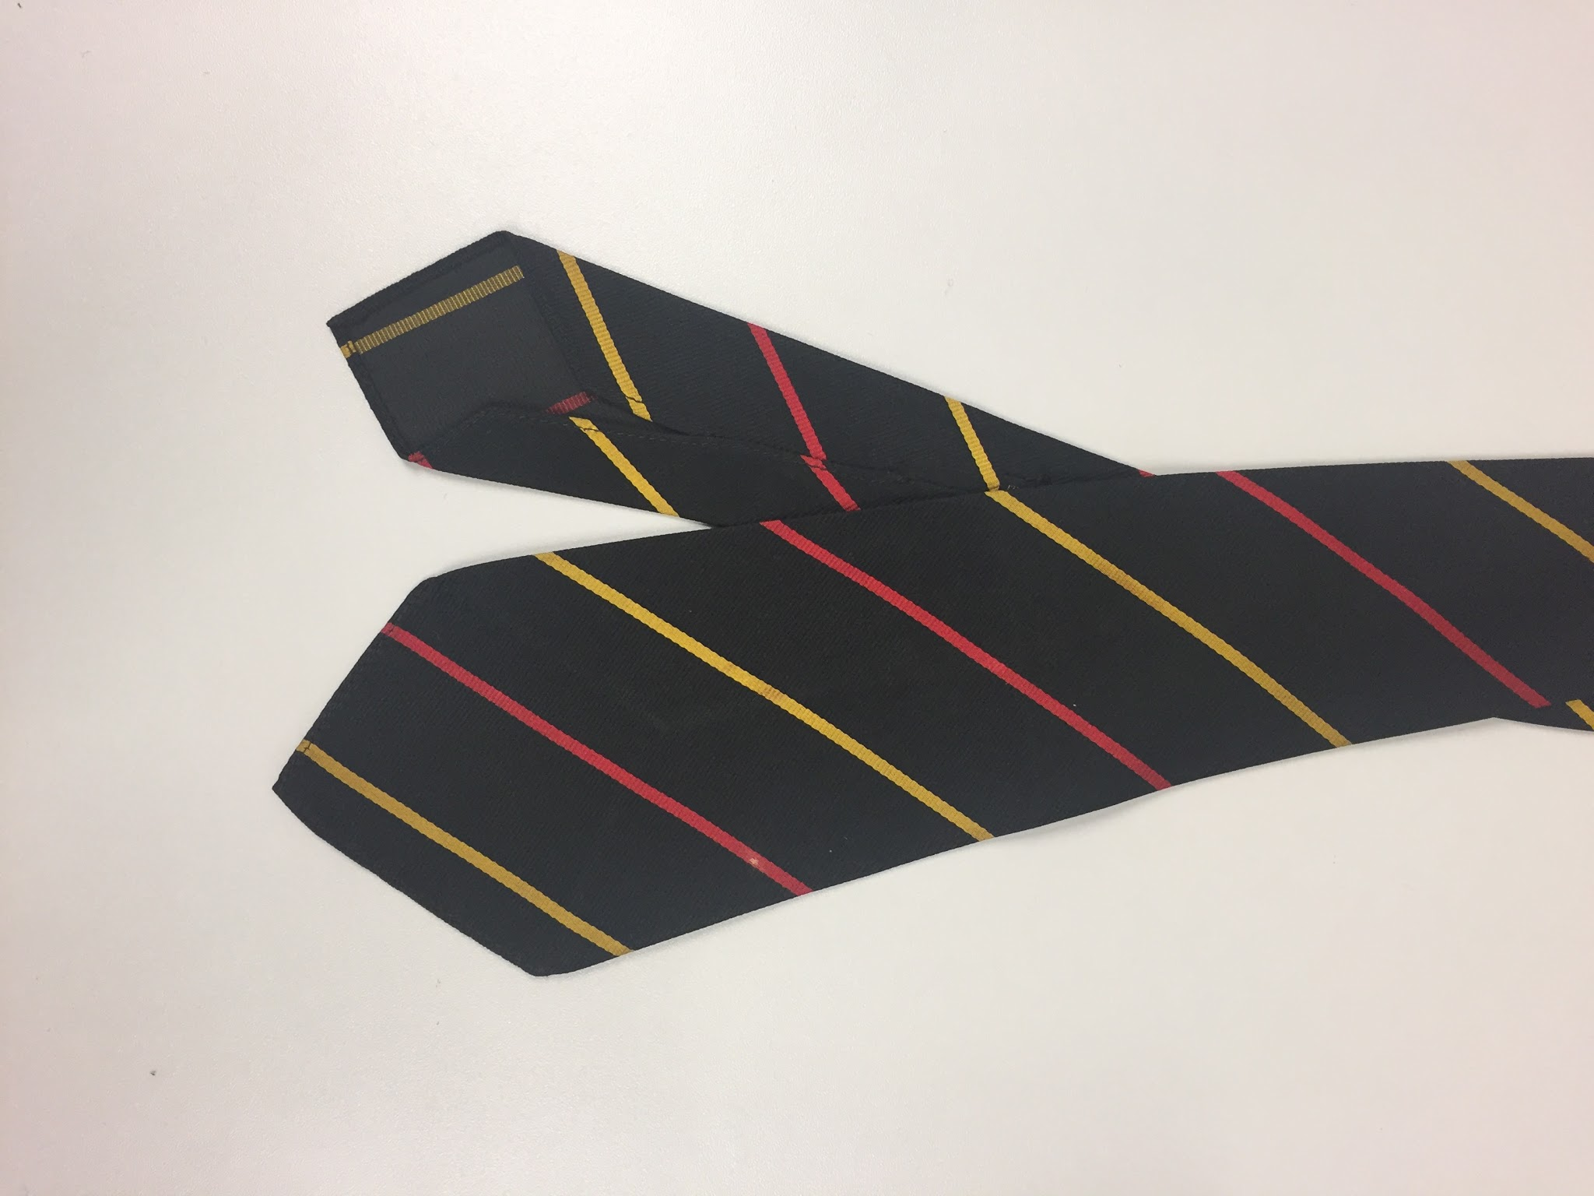 | Necktie, black with yellow and red stripe, St. John’s Oxford colours | Foster & Co. | Silk
62 | 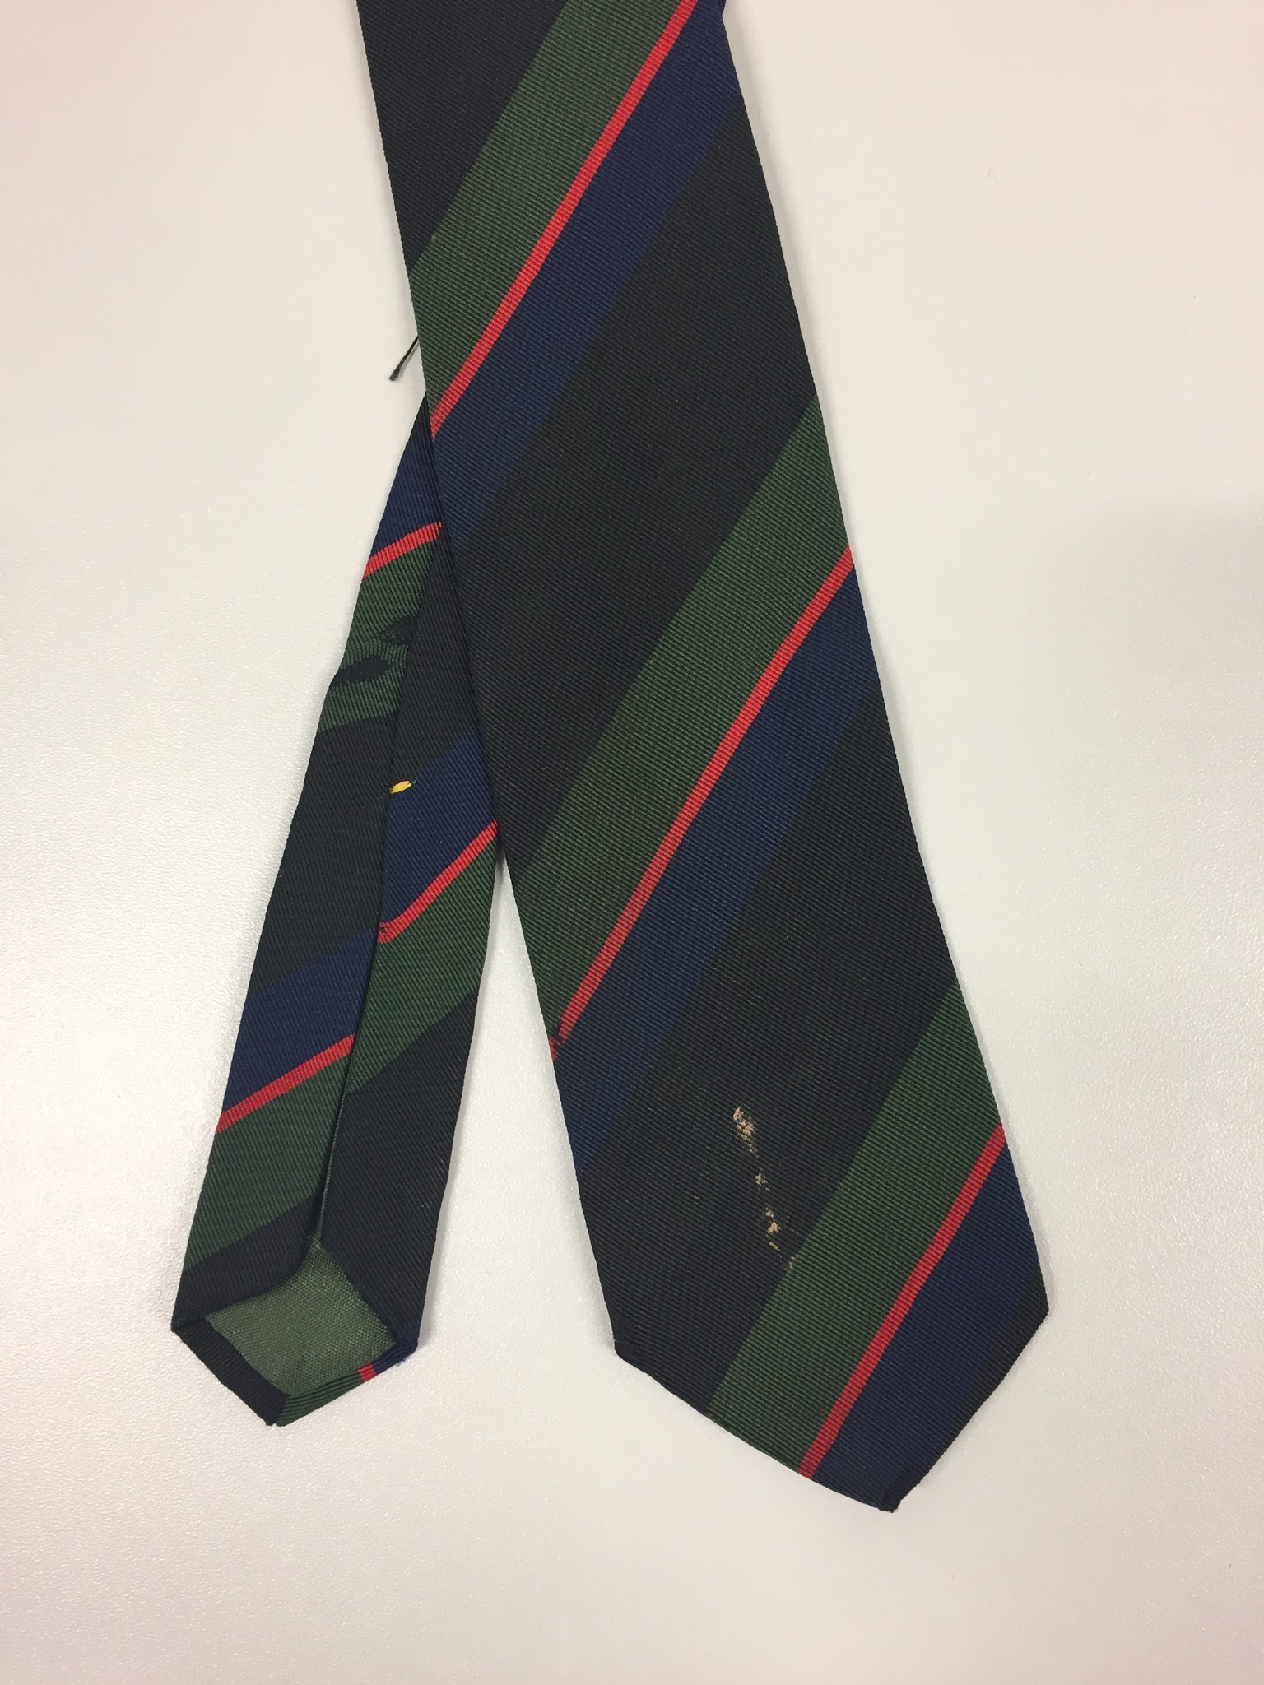 | Necktie, black with green/navy/red stripe | Atkinsons (Ireland) | Silk/wool blend
63 | 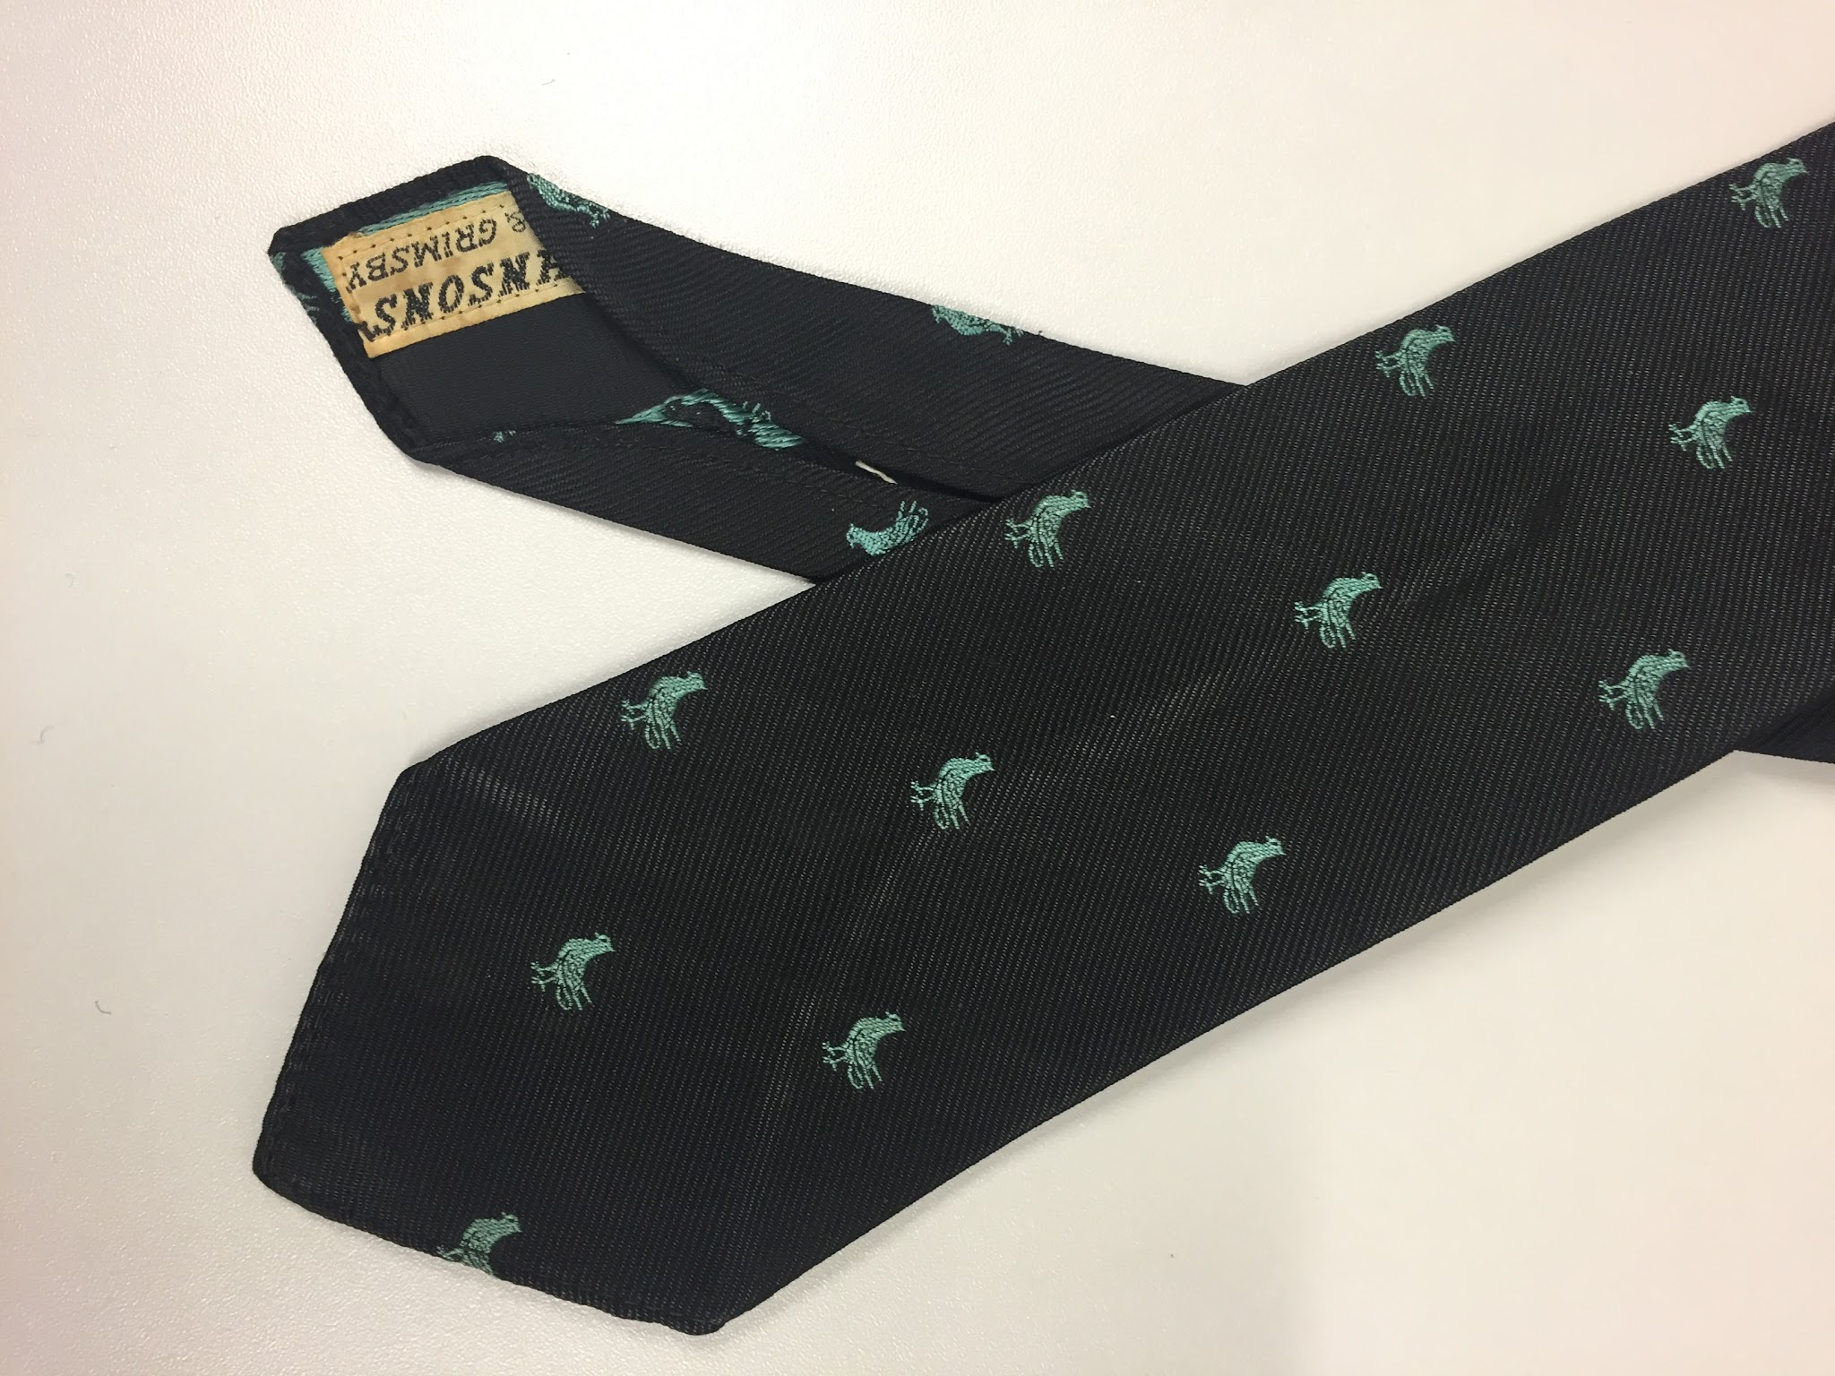 | Necktie, black with green bird motifs | Johnsons (Hull & Grimsby) | Terylene
64 | 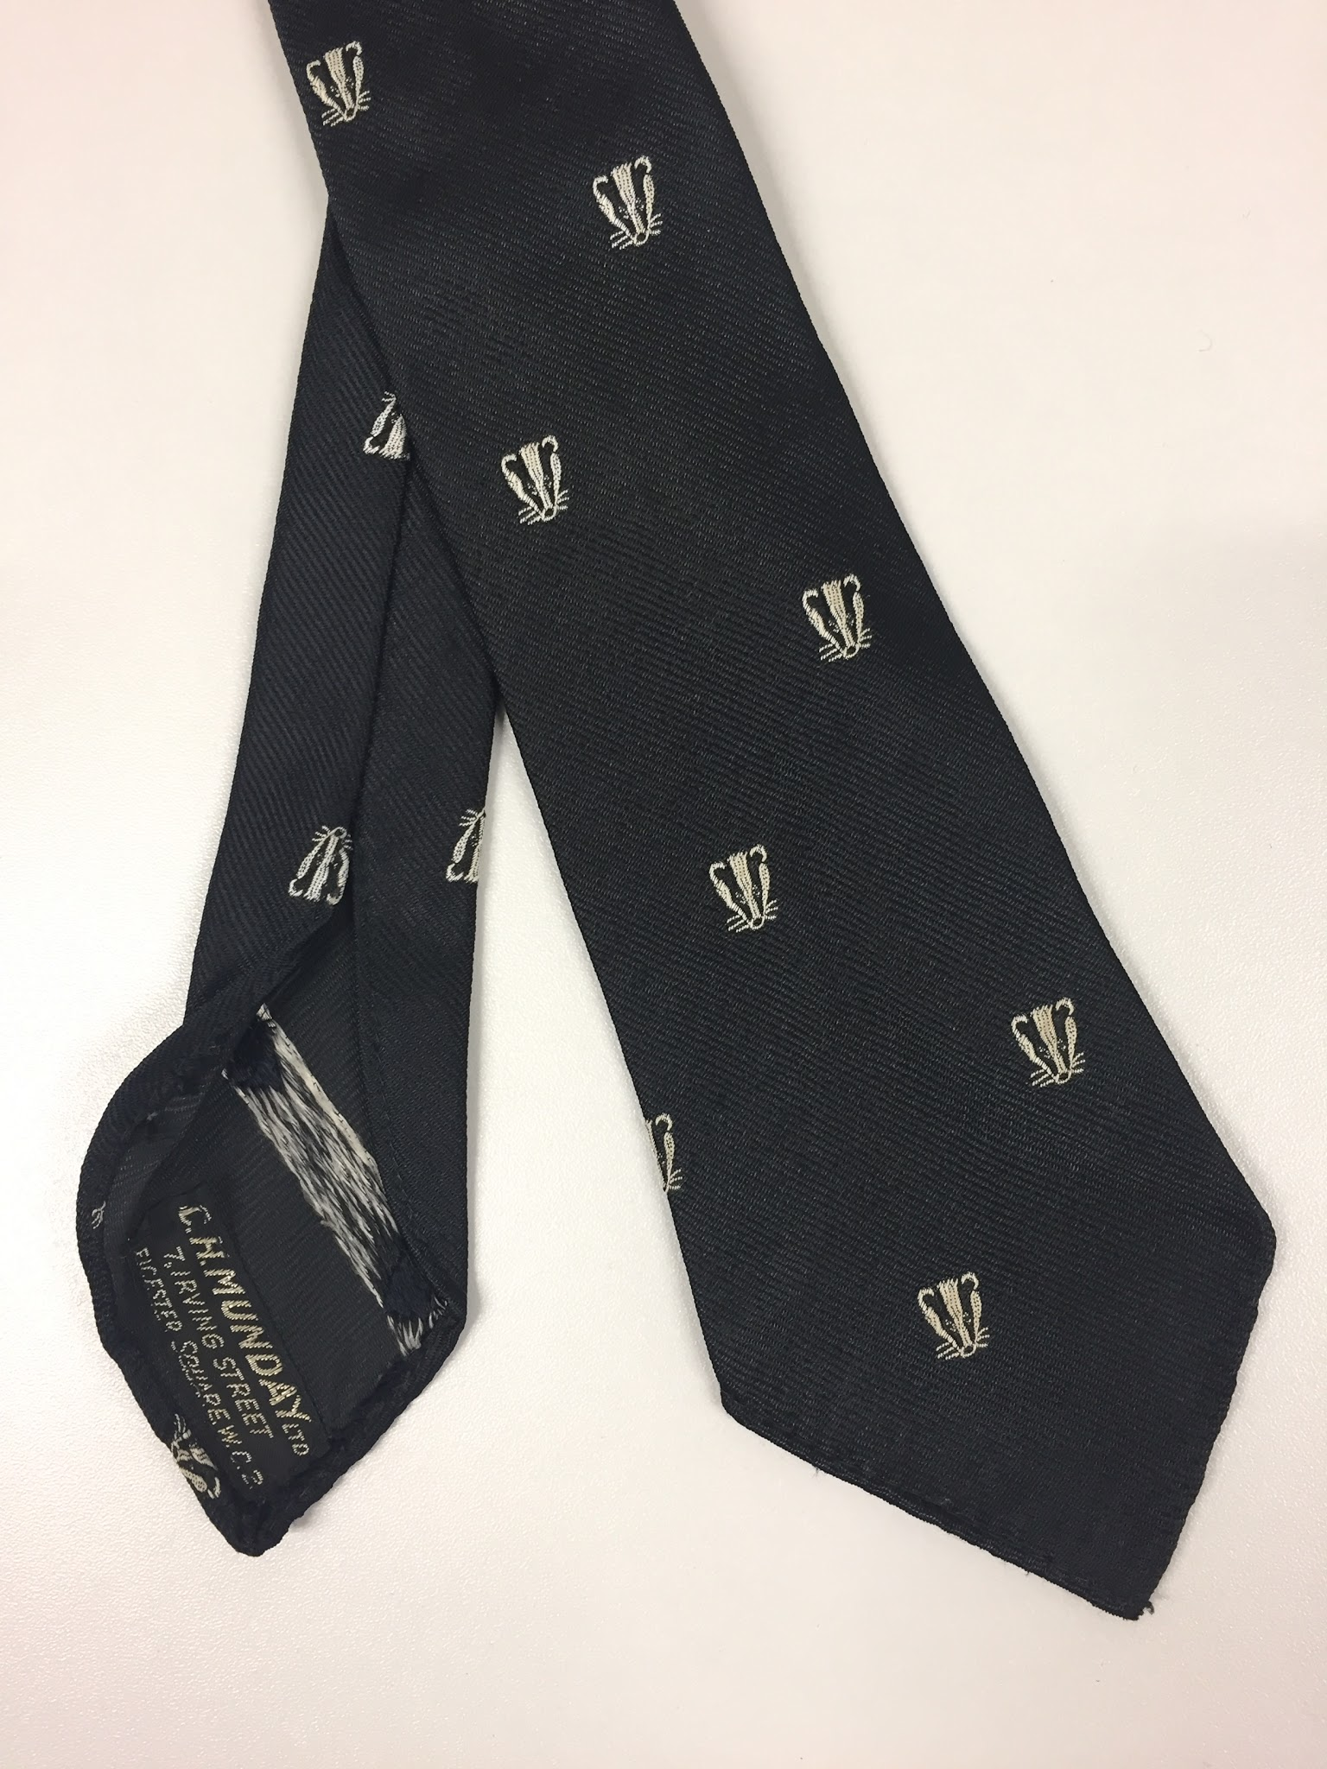 | Necktie, black with badger head motifs | C. H. Munday | Terylene
65 | 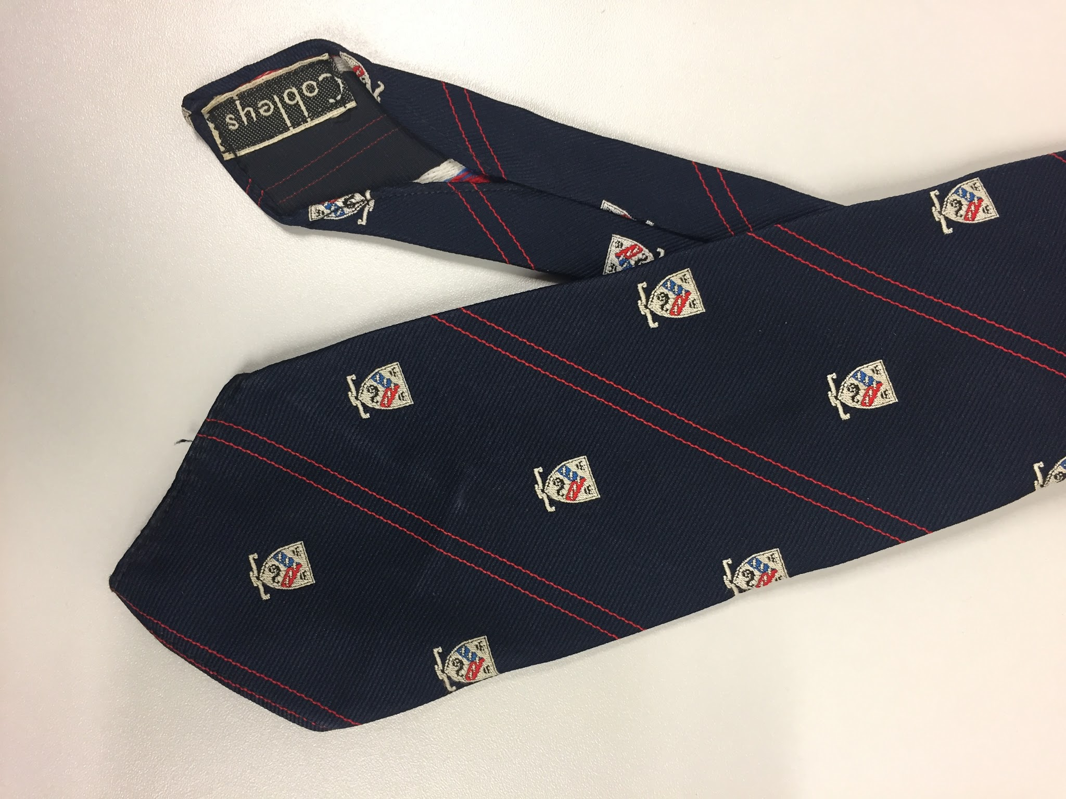 | Necktie, navy with double red stripe and unknown crest motif | Cobbleys | Terylene
66 | 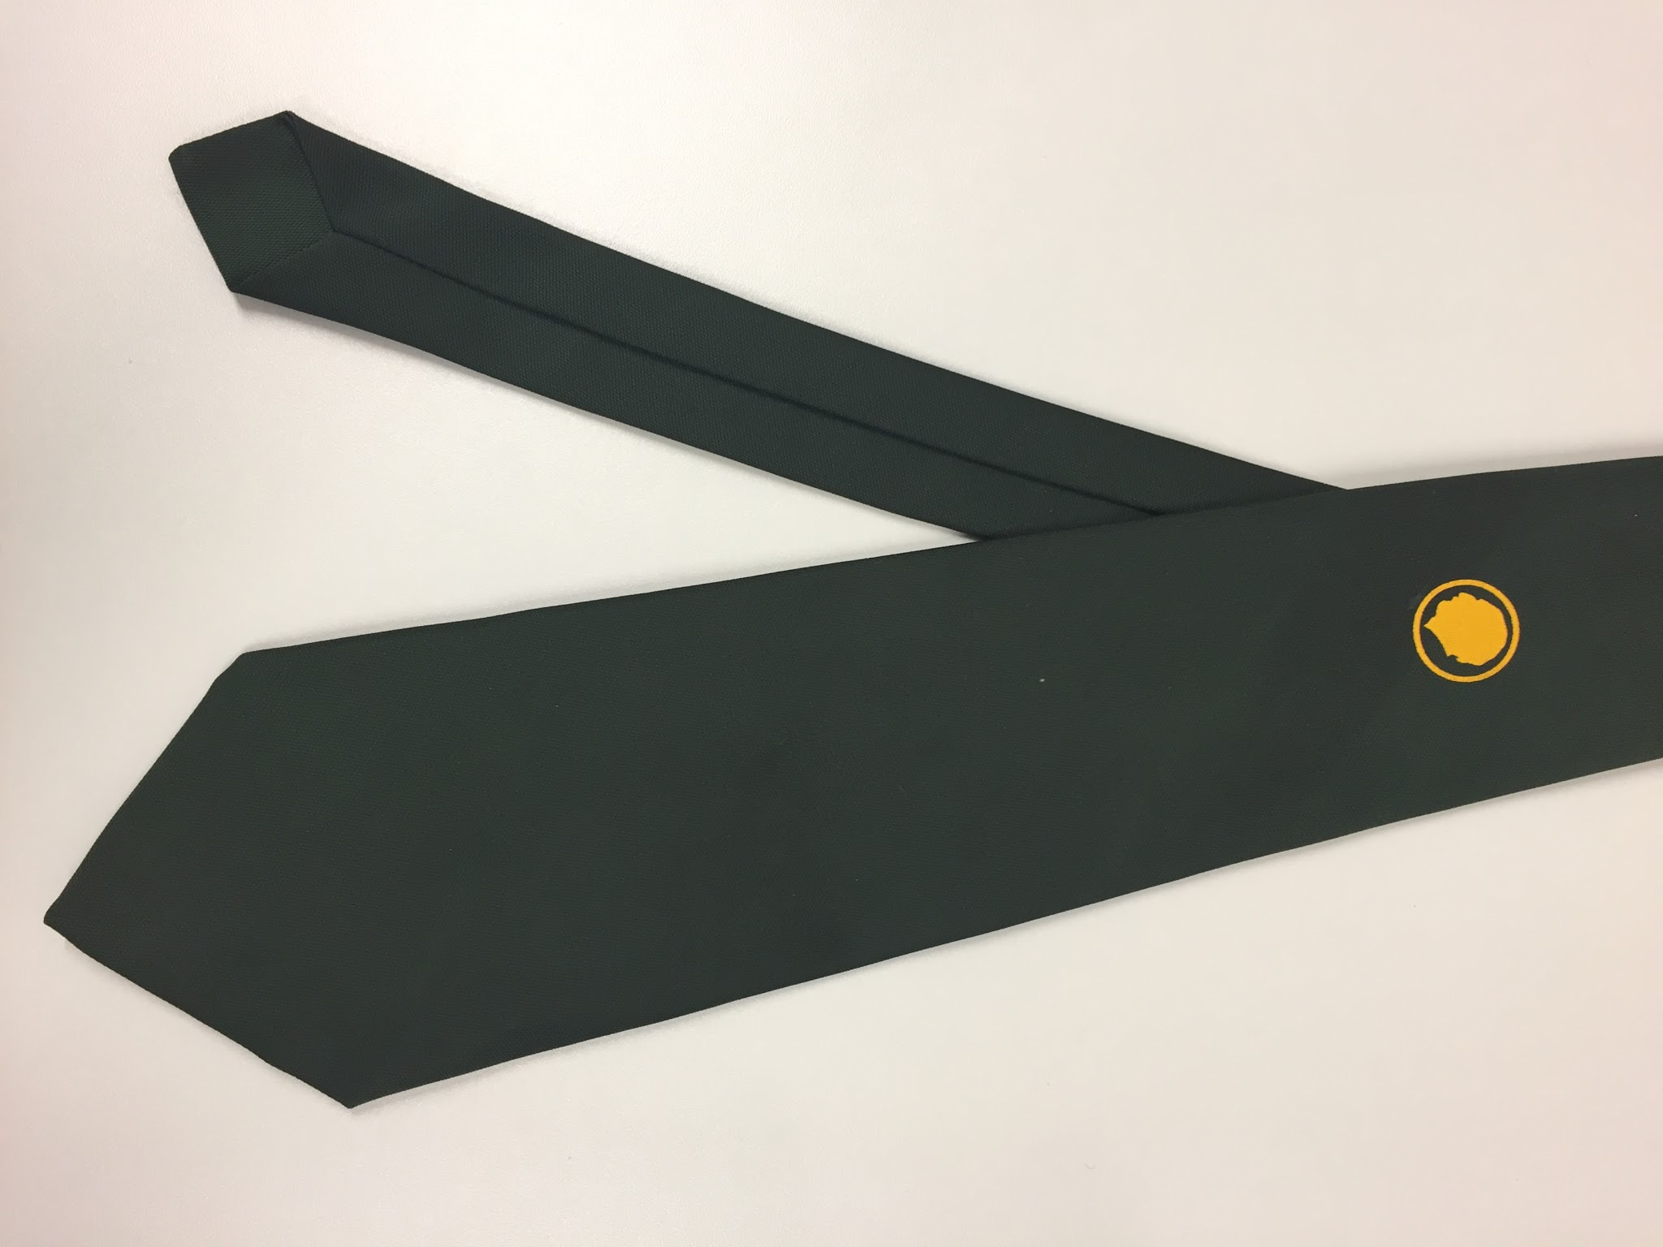 | Necktie, dark green with gold silhouette head motif | Ernex | Terylene
67 | 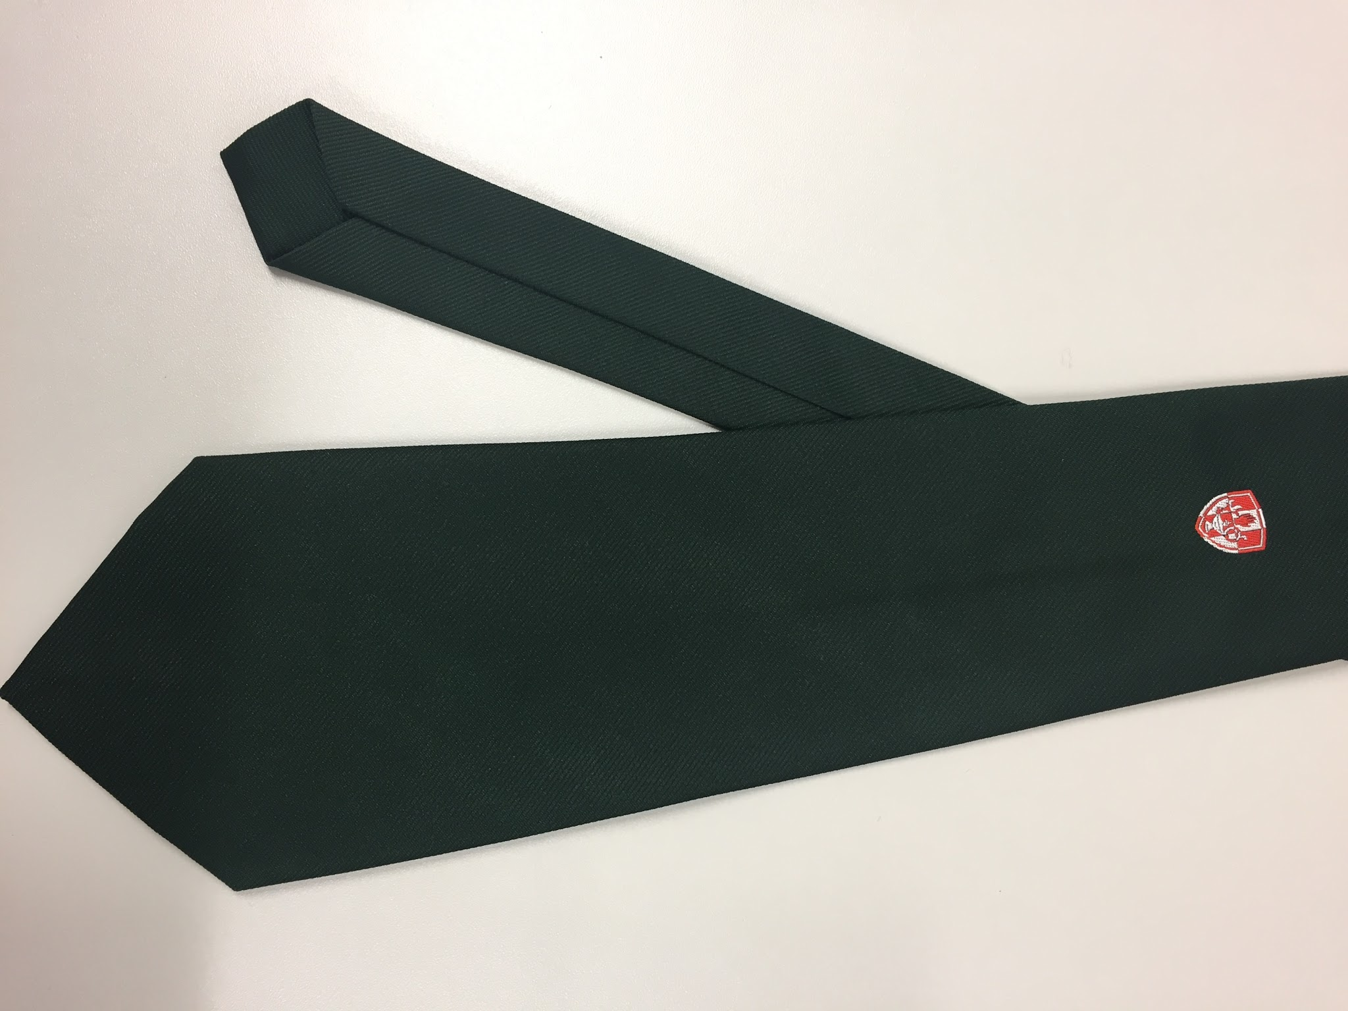 | Necktie, dark green with red hand and lamp crest | Colourtise | Terylene
68 | 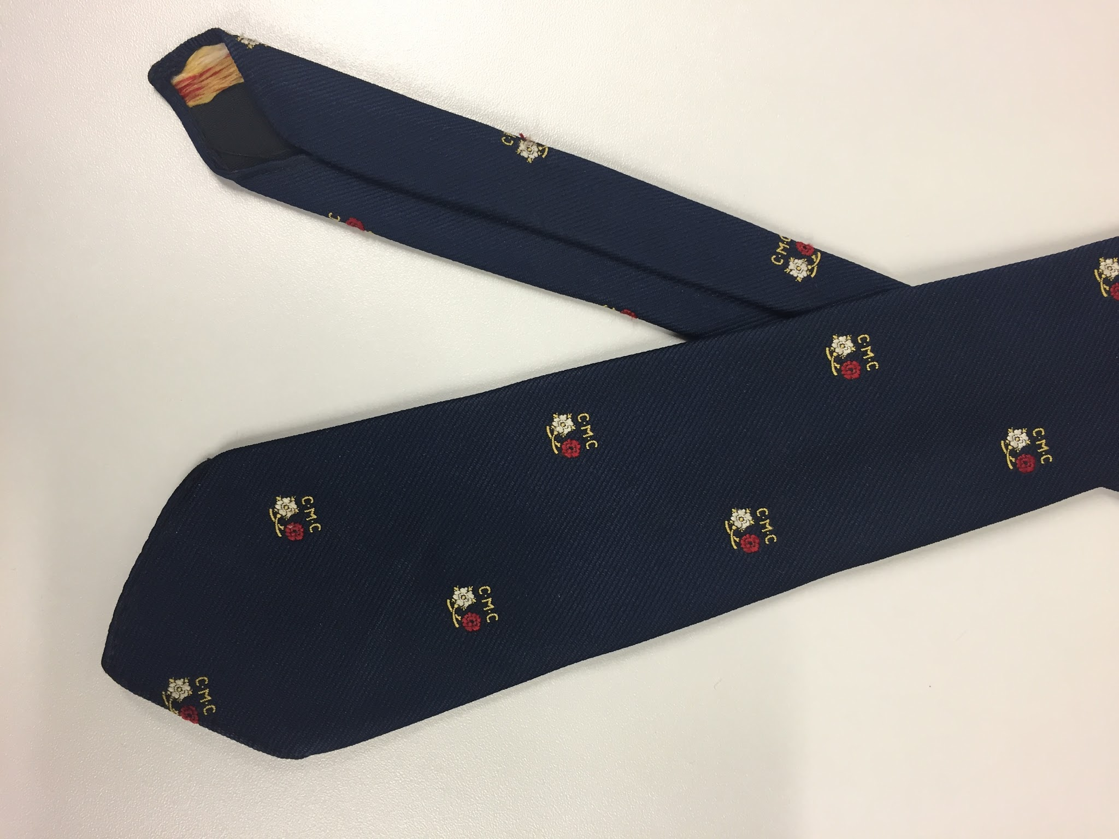 | Necktie, navy with red and white crossed roses and CMC motif | Ernex | Terylene
69 | 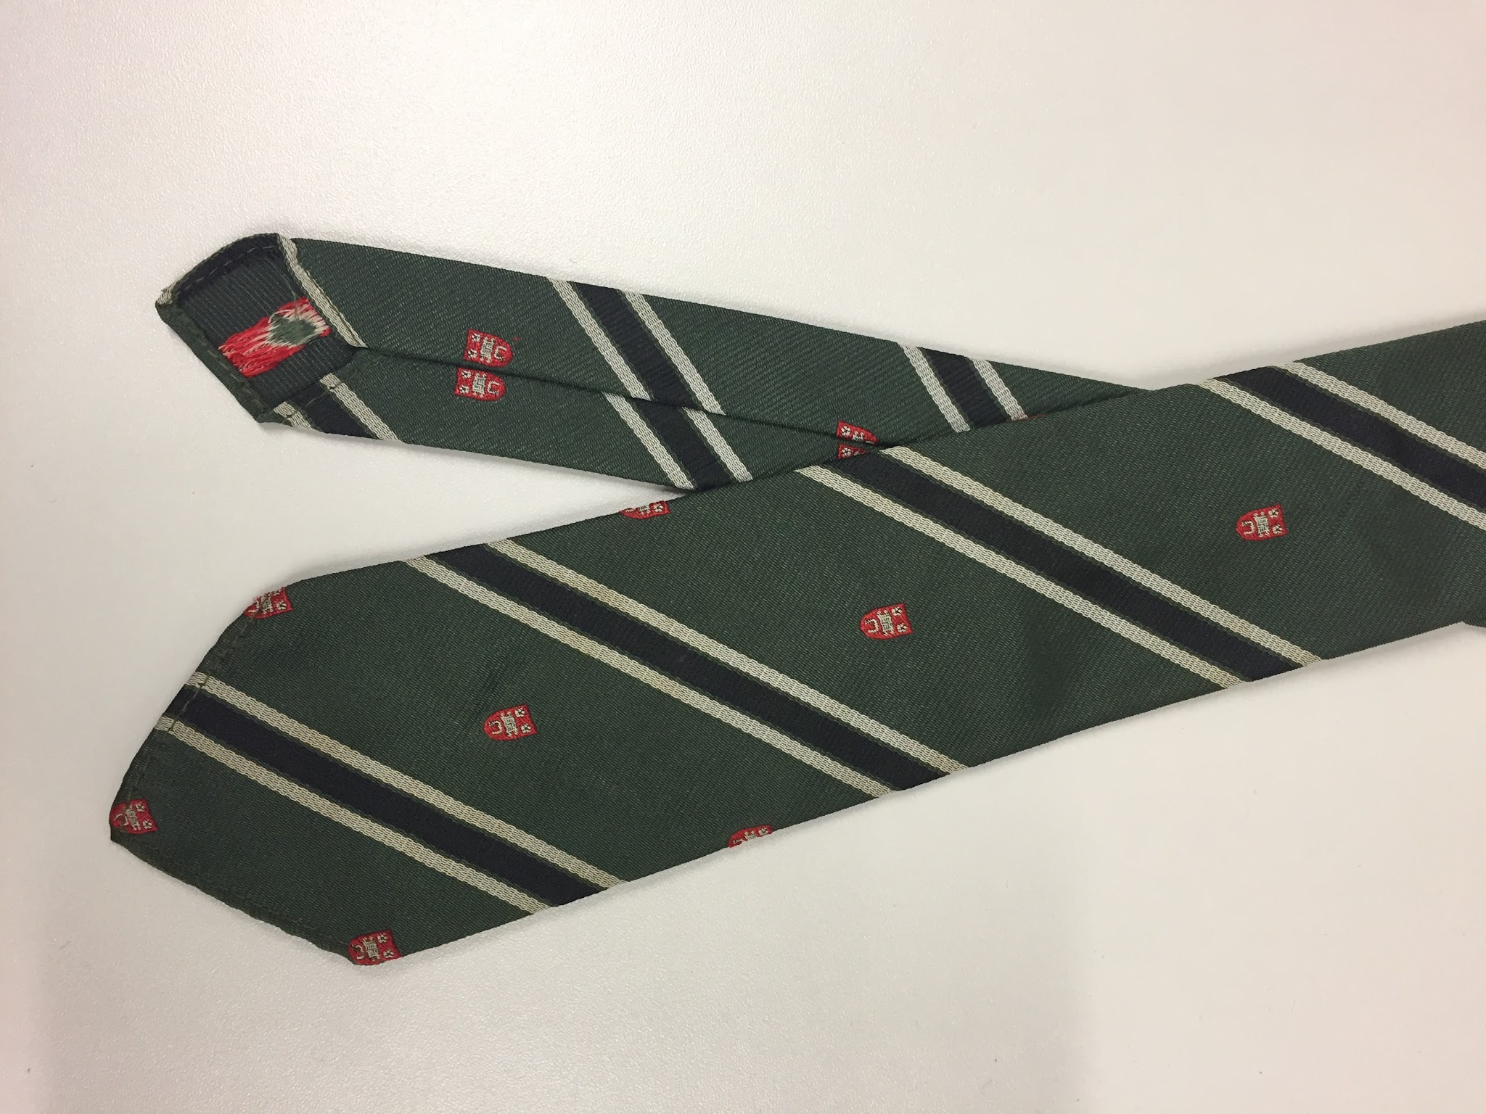 | Necktie, olive green with black and silver stripe and unknown red crest | Glenfield | Terylene
70 | 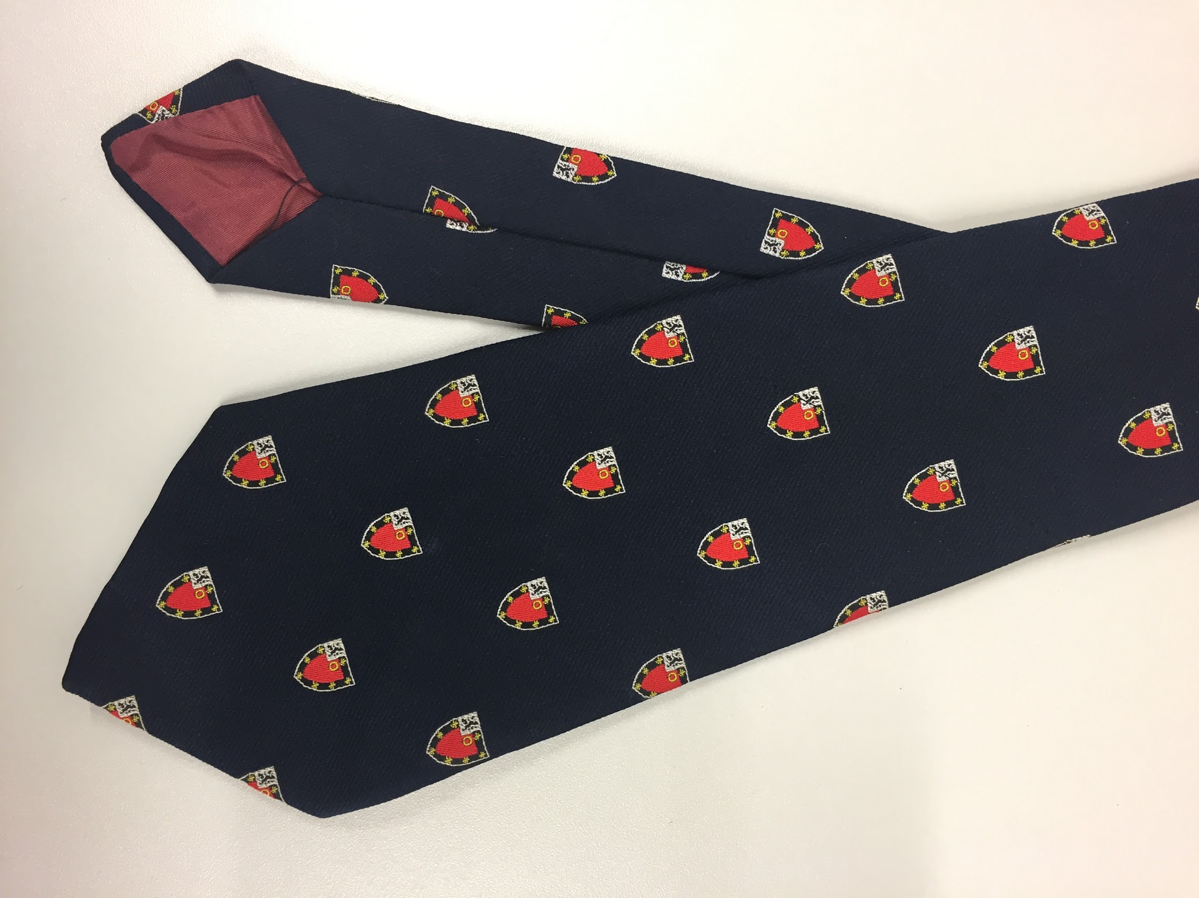 | Necktie, navy with St John’s Oxford crest motif | Castells of Oxford | Terylene
71 | 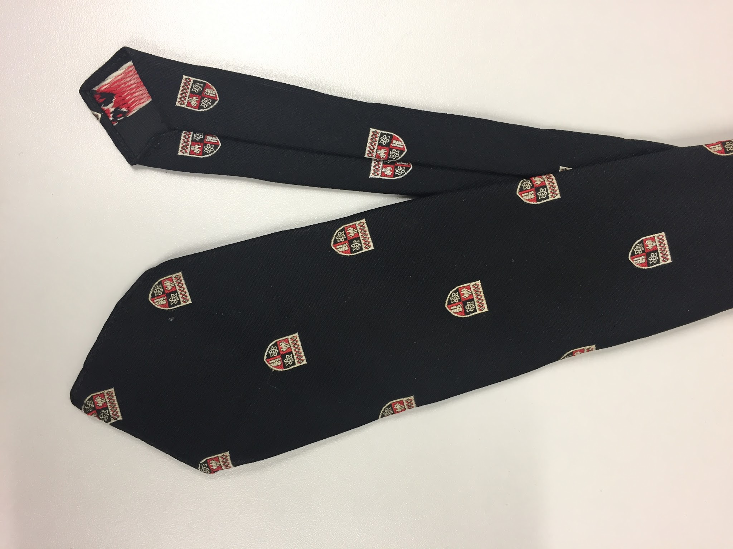 | Necktie, black with silver, red, black crest | Glenfield | Terylene
72 | 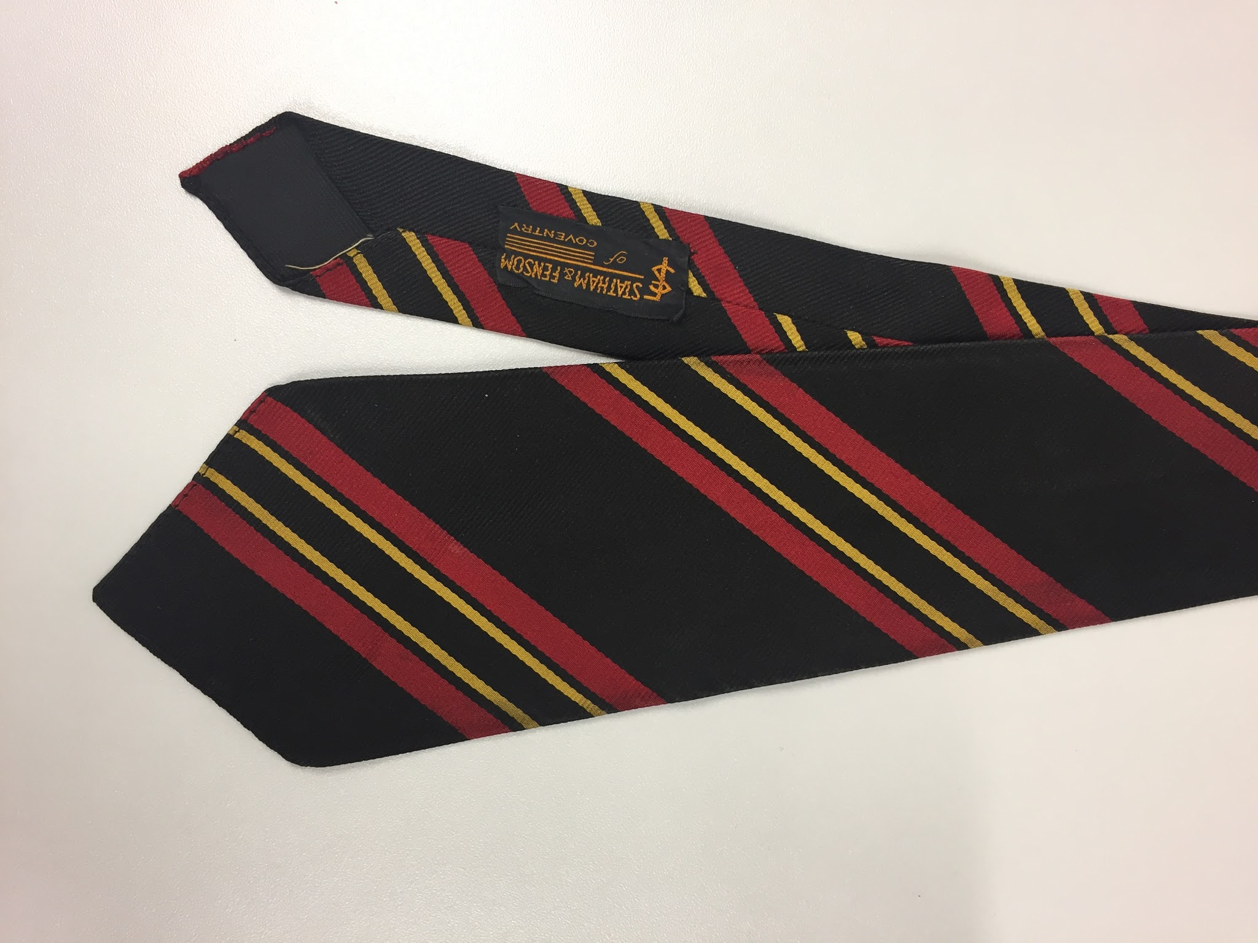 | Necktie, black with red and yellow stripes, smaller size, potentially a school tie | Stratham & Fensom (Coventry) | Silk
73 | 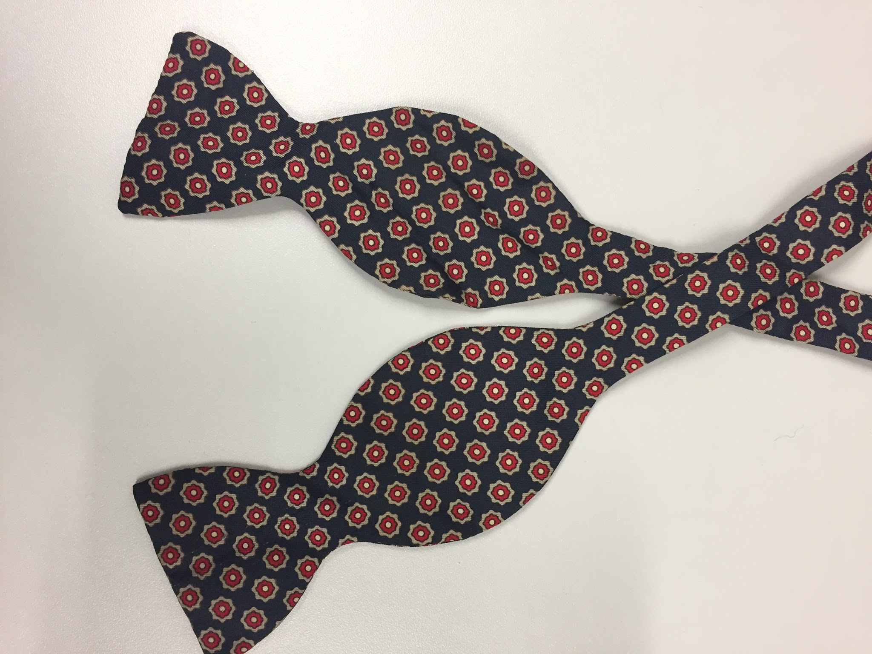 | Butterfly bow, navy with stone and red geometric print | No maker | Silk
74 | 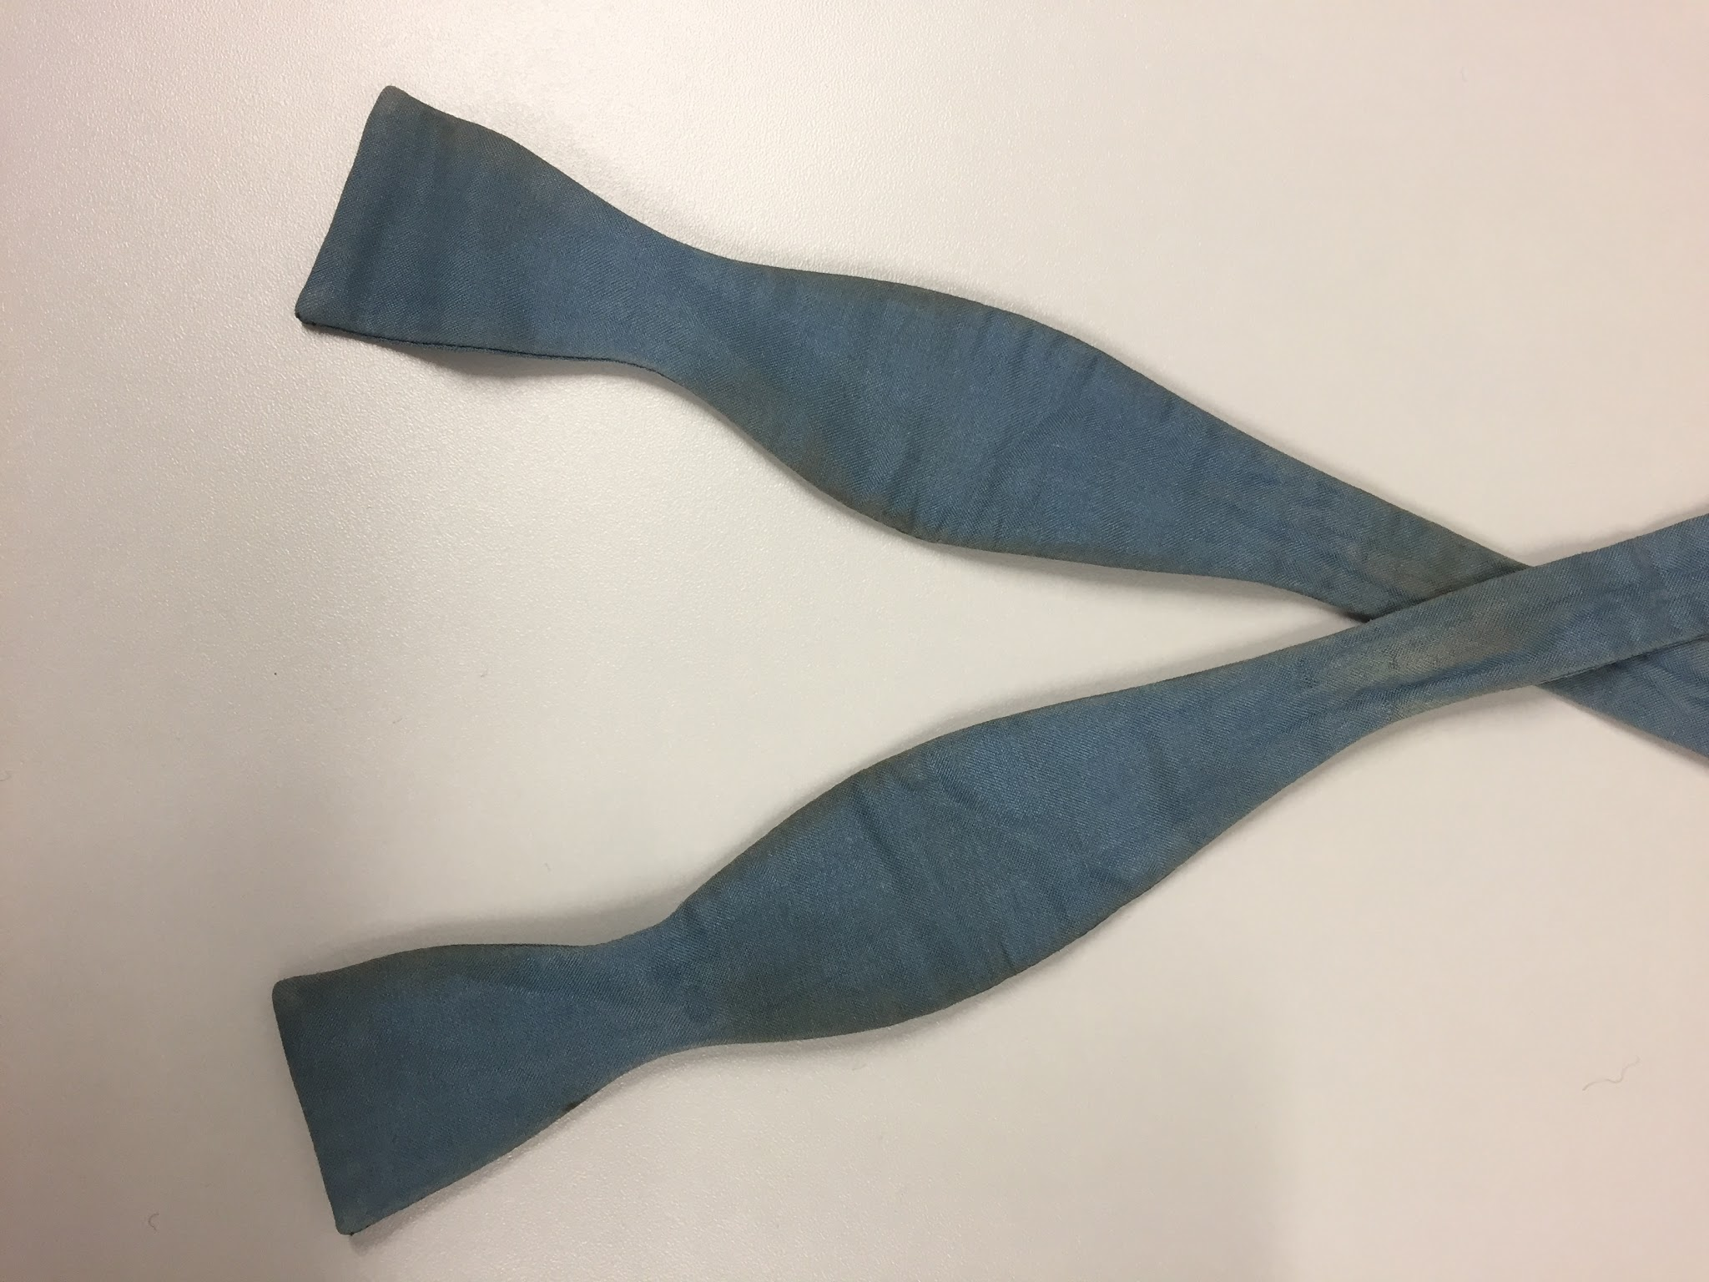 | Butterfly bow, teal | Austen Reed | Silk
75 | 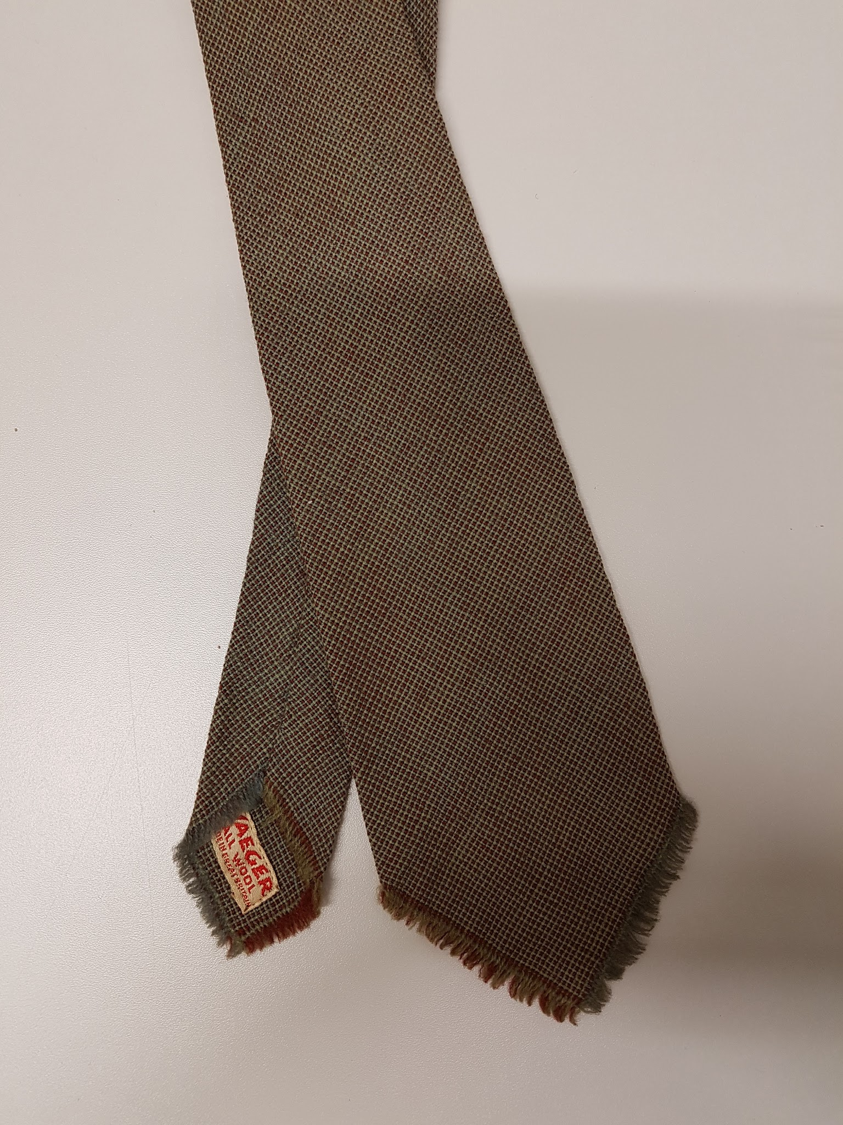 | Necktie, green and Burgundy woven tie | Jaeger | Wool
76 | 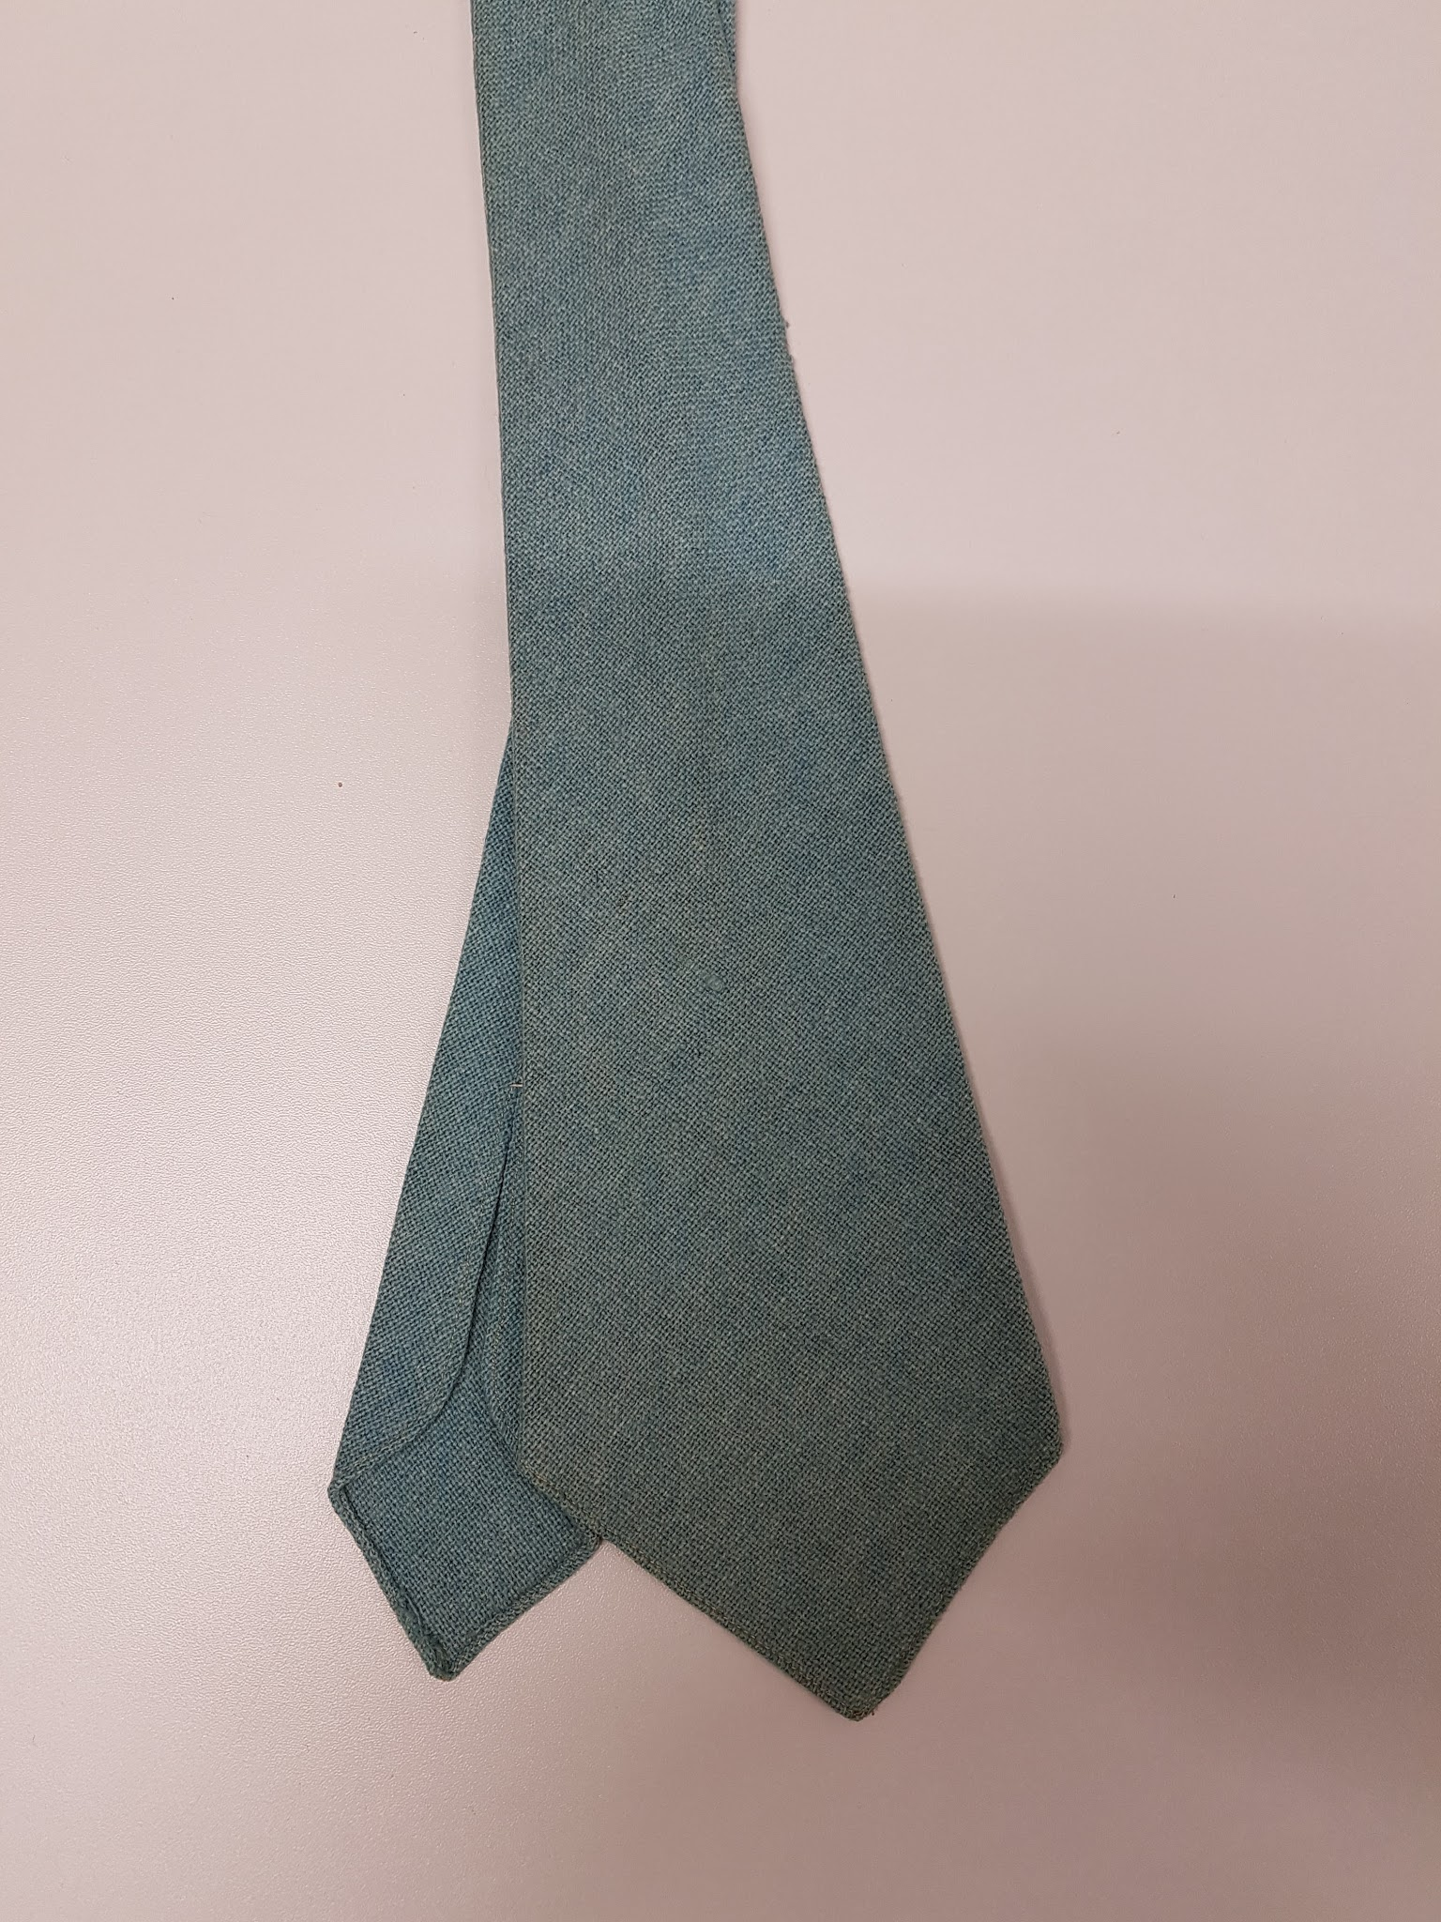 | Necktie, turquoise woven tie | No maker | Perhaps Wool
77 | 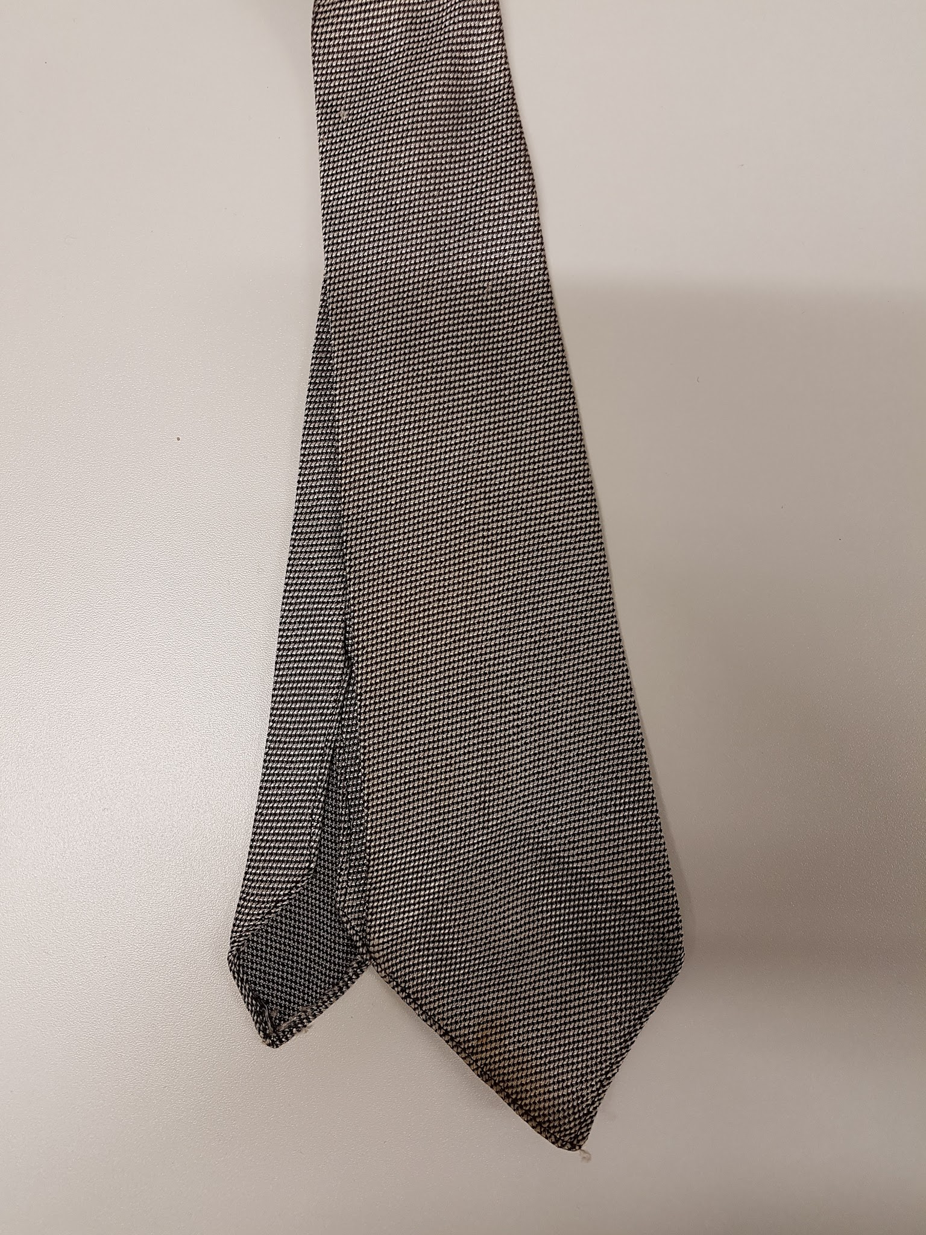 | Necktie, silver woven tie | No maker | Terylene
78 | 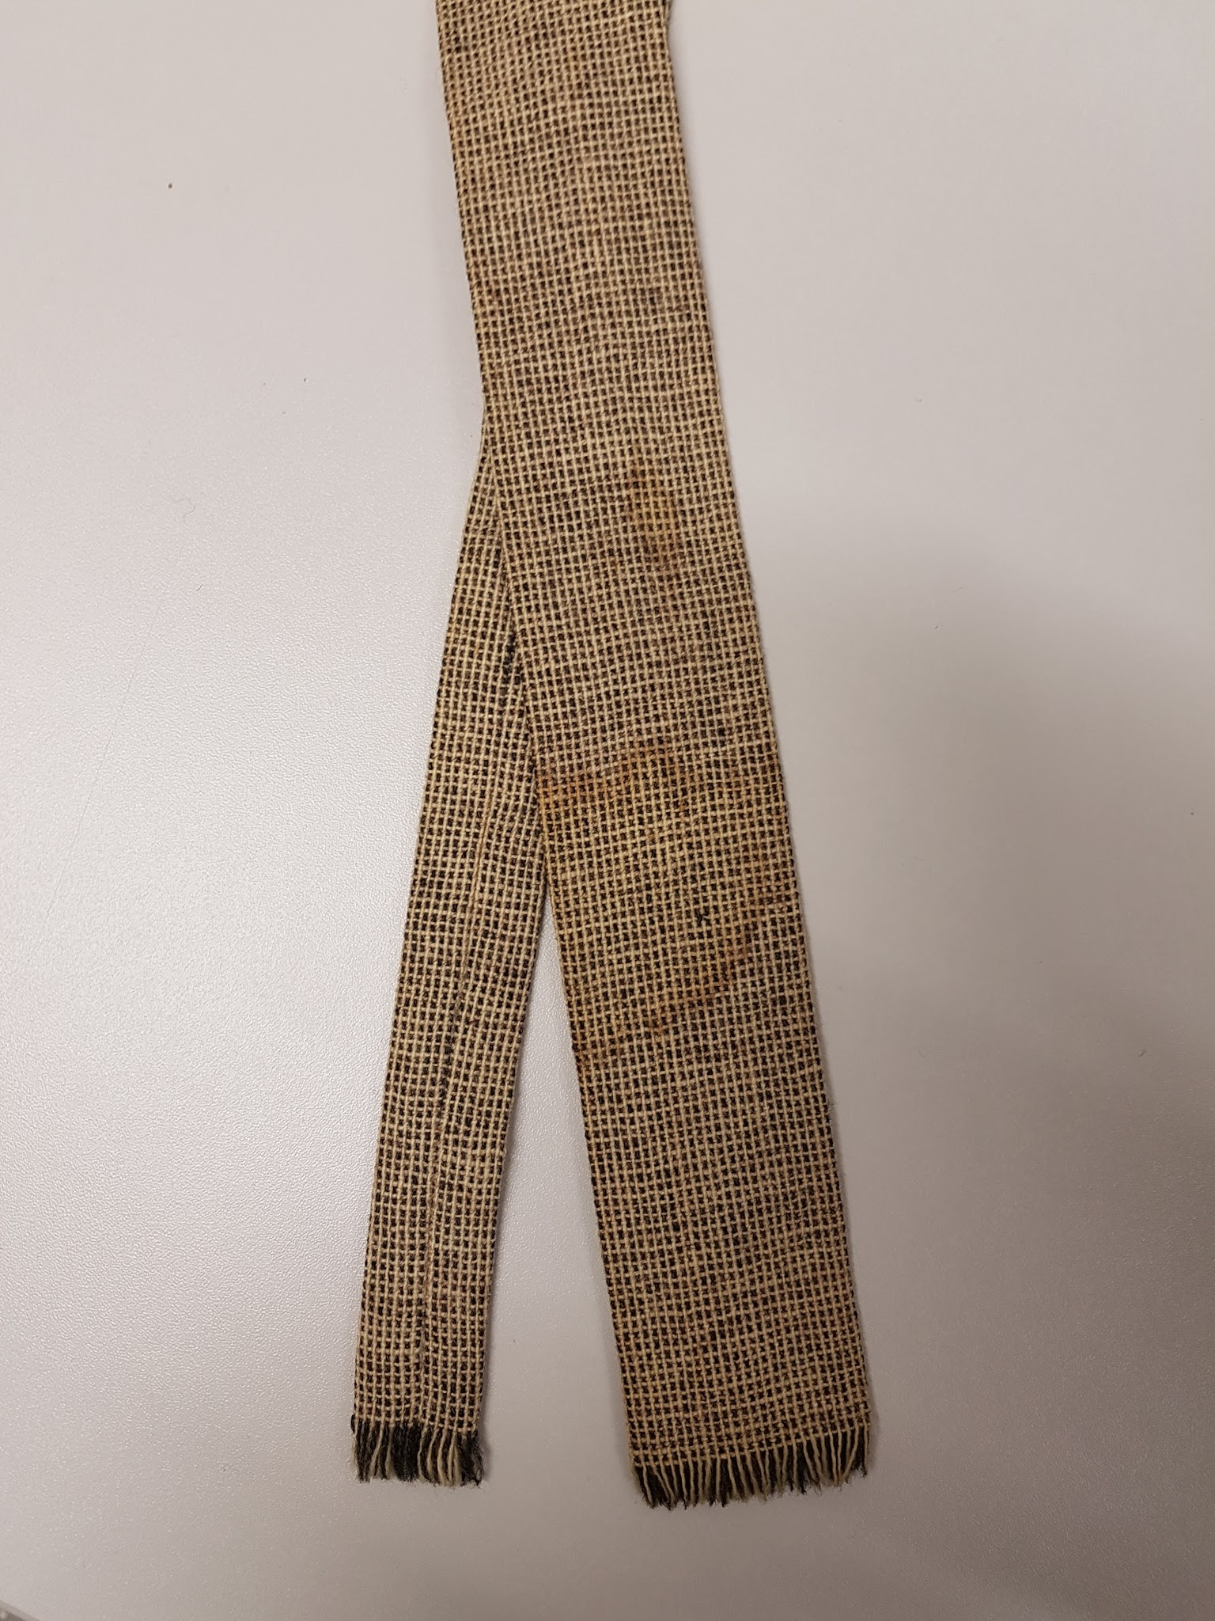 | Necktie, beige woven tie | Irish Cottage Industries | Wool
79 | 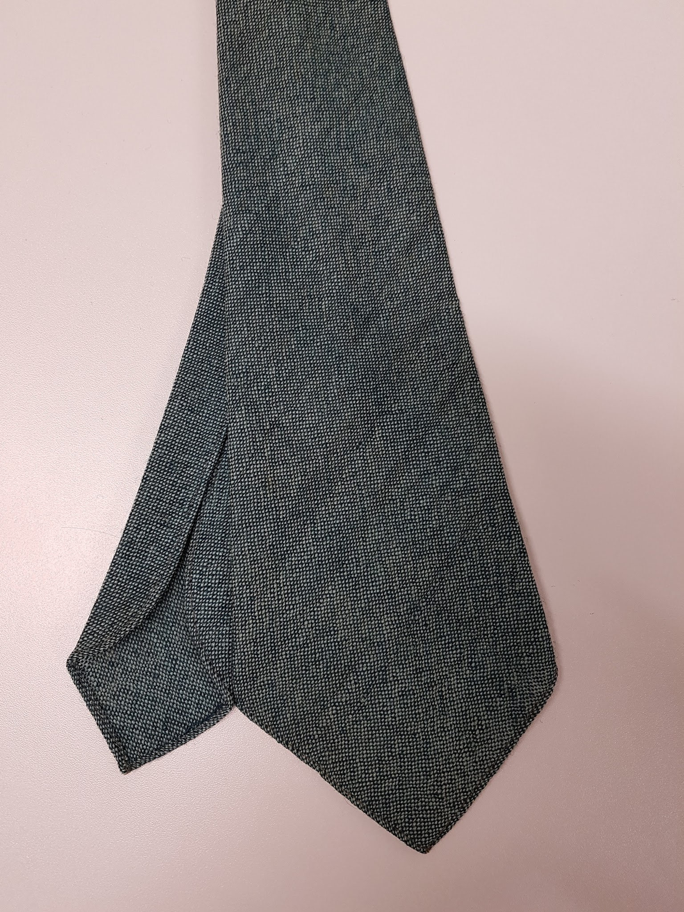 | Necktie, green, woven | No maker | Perhaps Wool
80 | 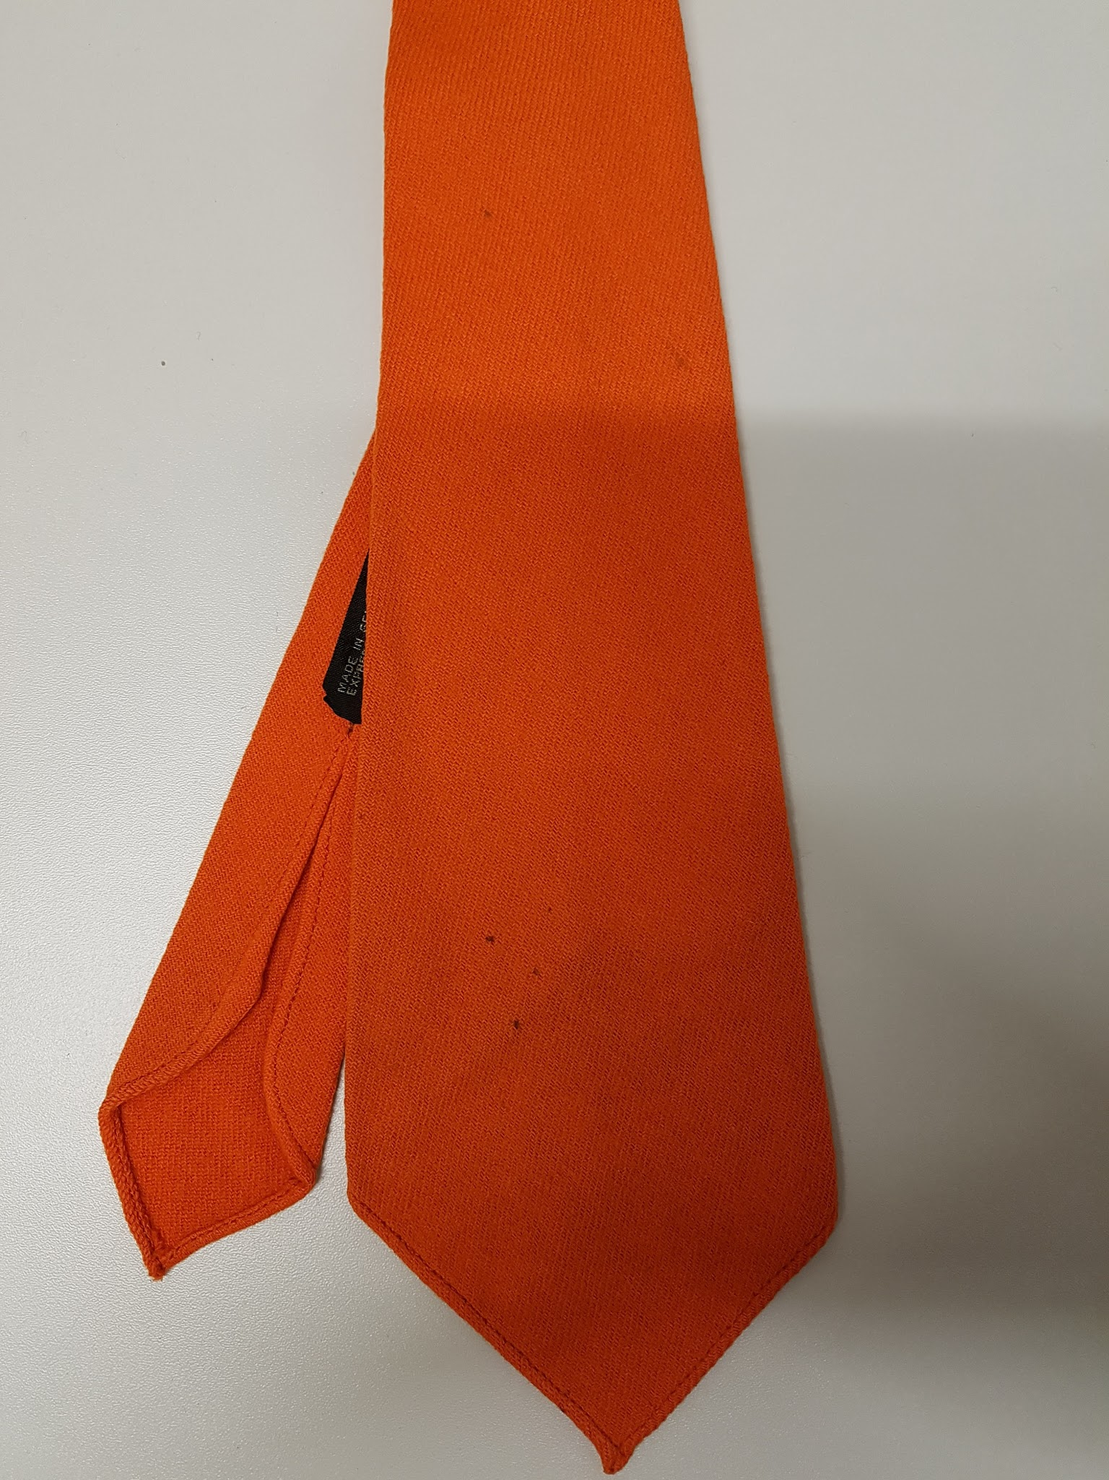 | Necktie, tangerine, woven | A.de Gruchy & Co. LTD | Perhaps Wool
81 | 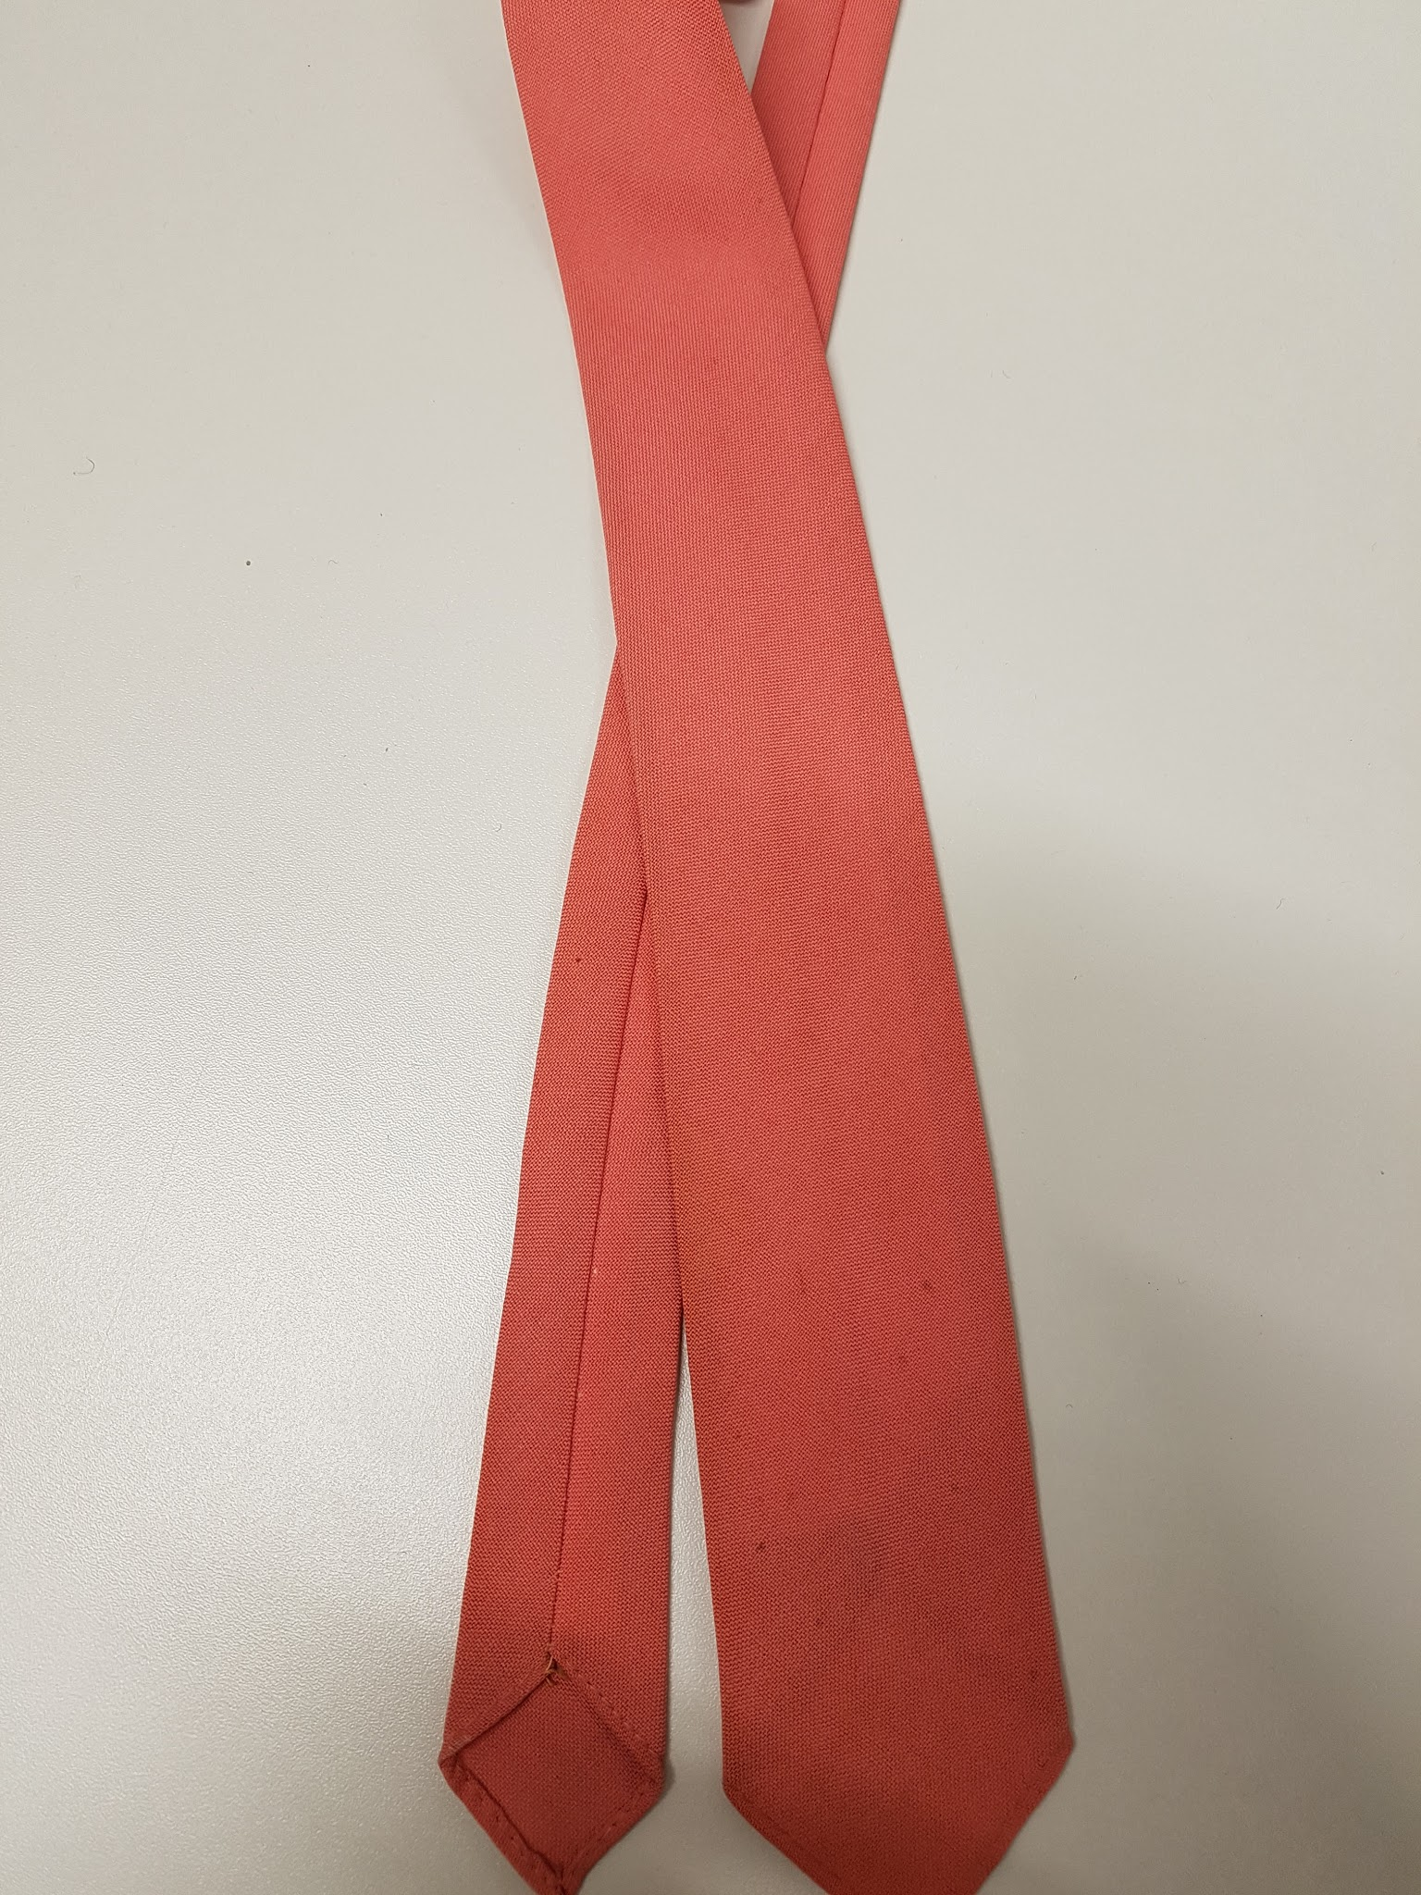 | Necktie, pink, woven | Giovanni | Wool
82 | 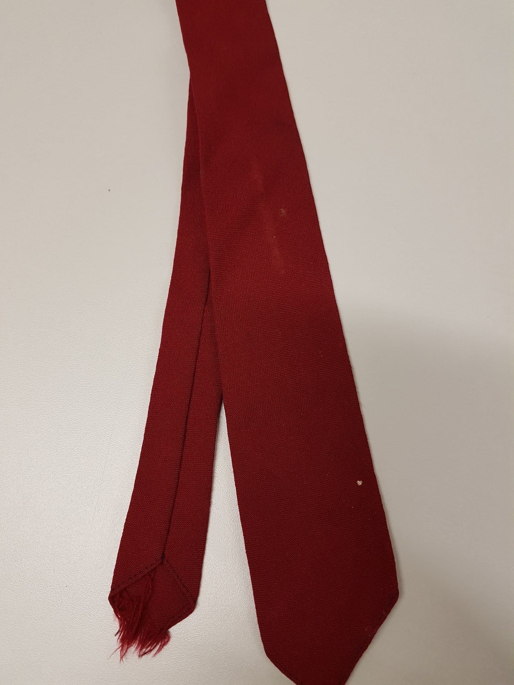 | Necktie, claret, woven | The New California | Wool
83 | 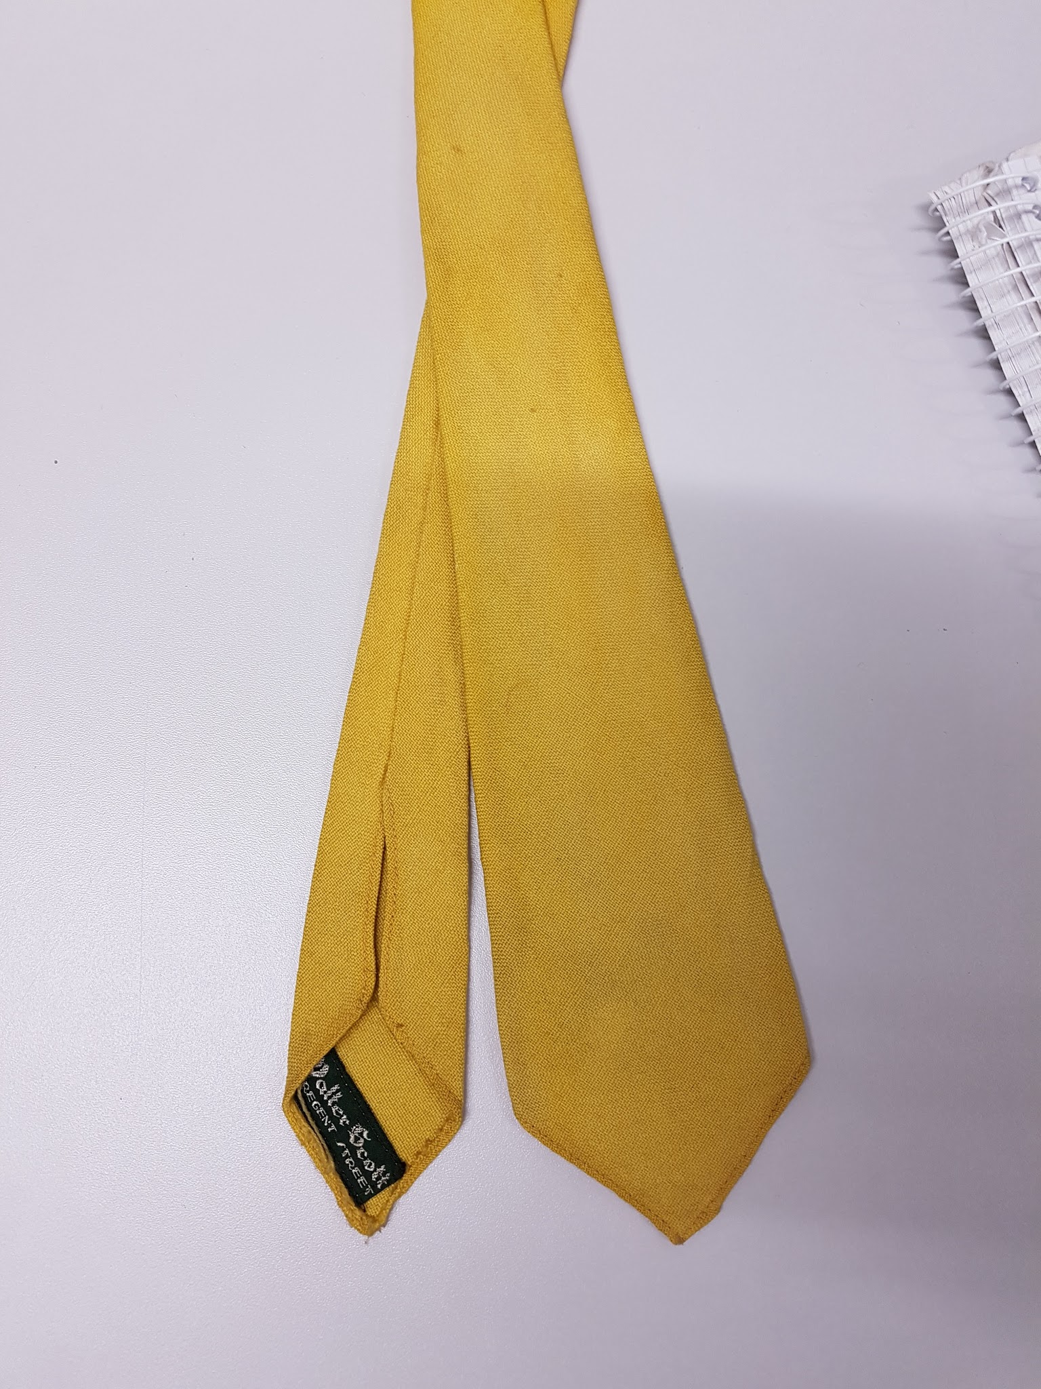 | Necktie, mustard, woven | Walter Scott of Regent Street | Perhaps Wool
84 | 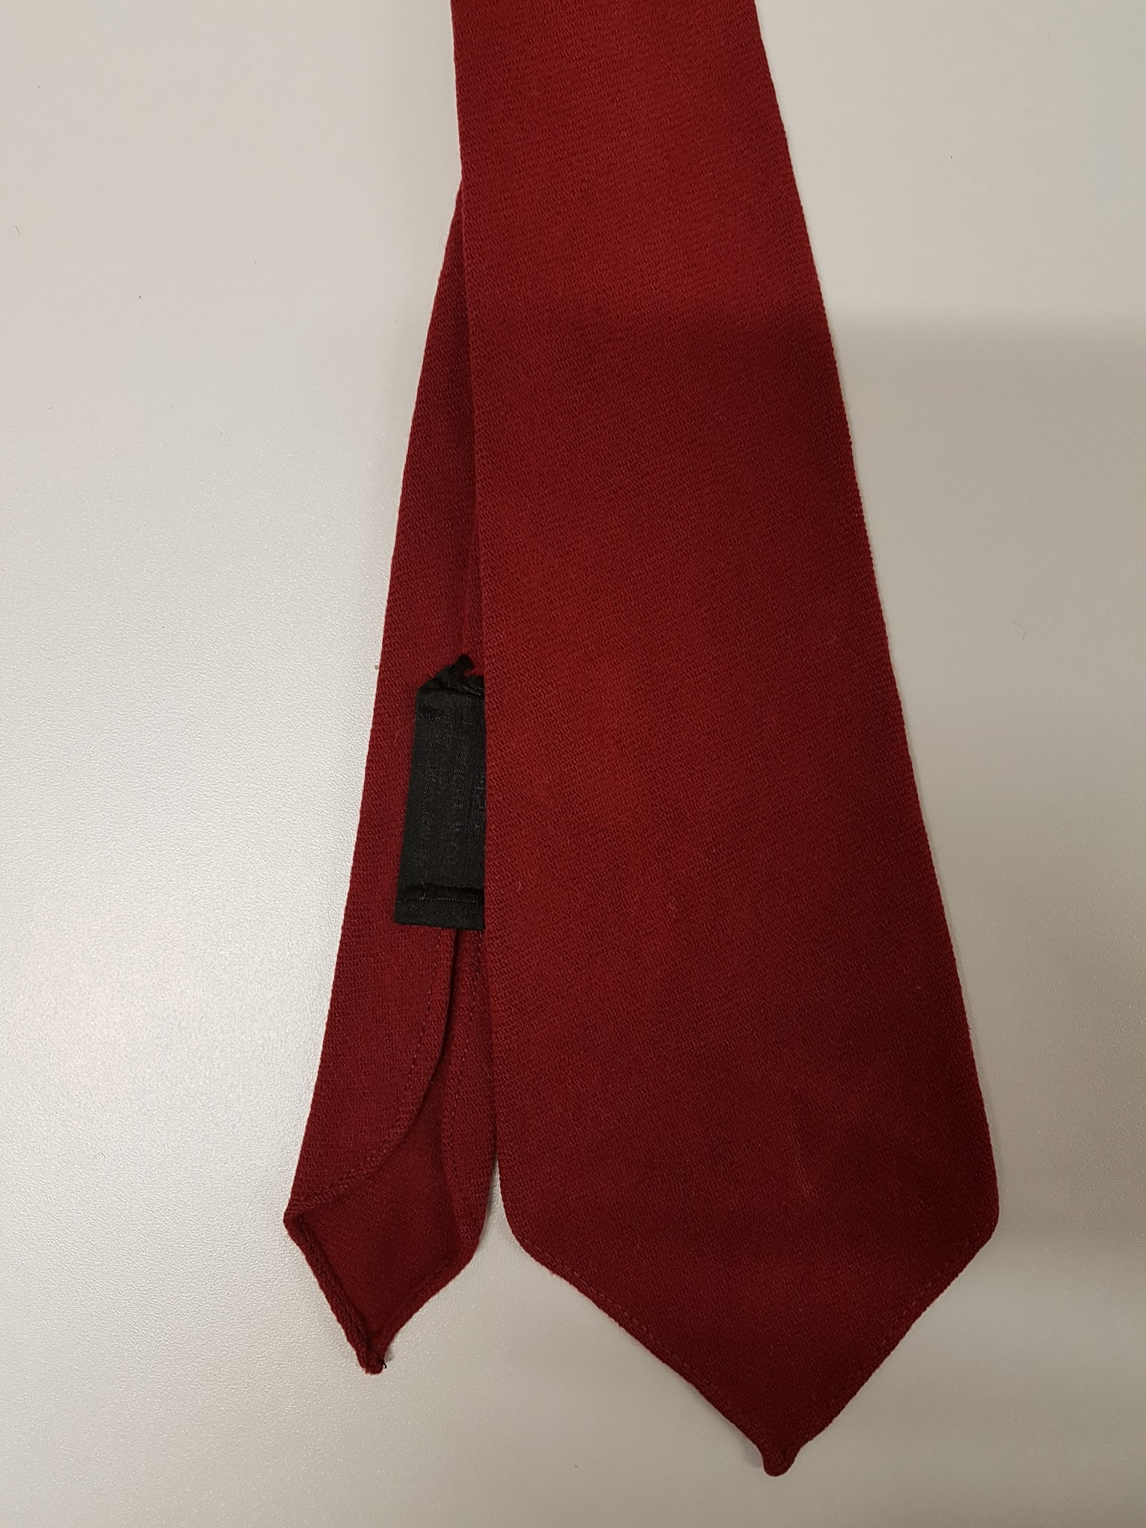 | Necktie, burgundy, woven | A.de Gruchy & Co. LTD | Perhaps Wool
85 | 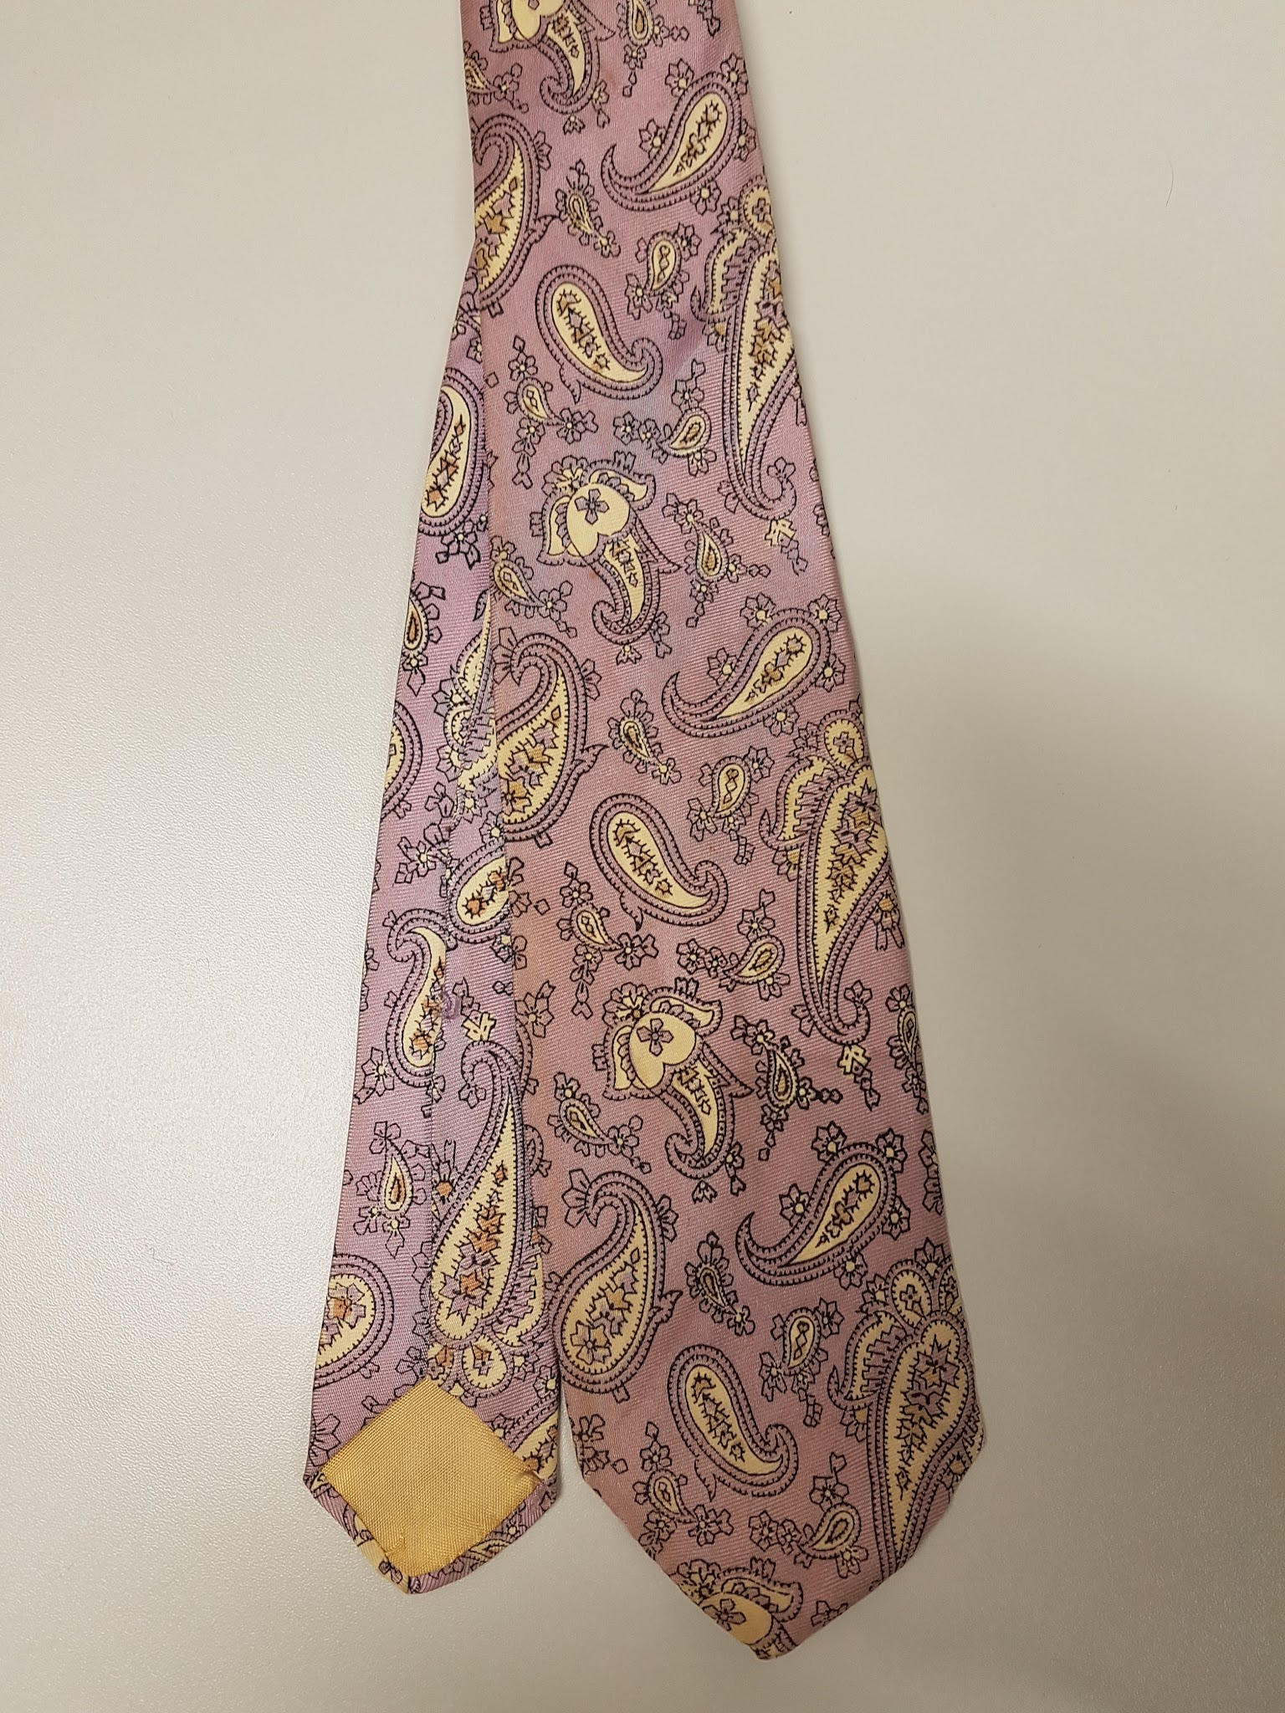 | Necktie, purple paisley patterned, | No maker | Silk
86 | 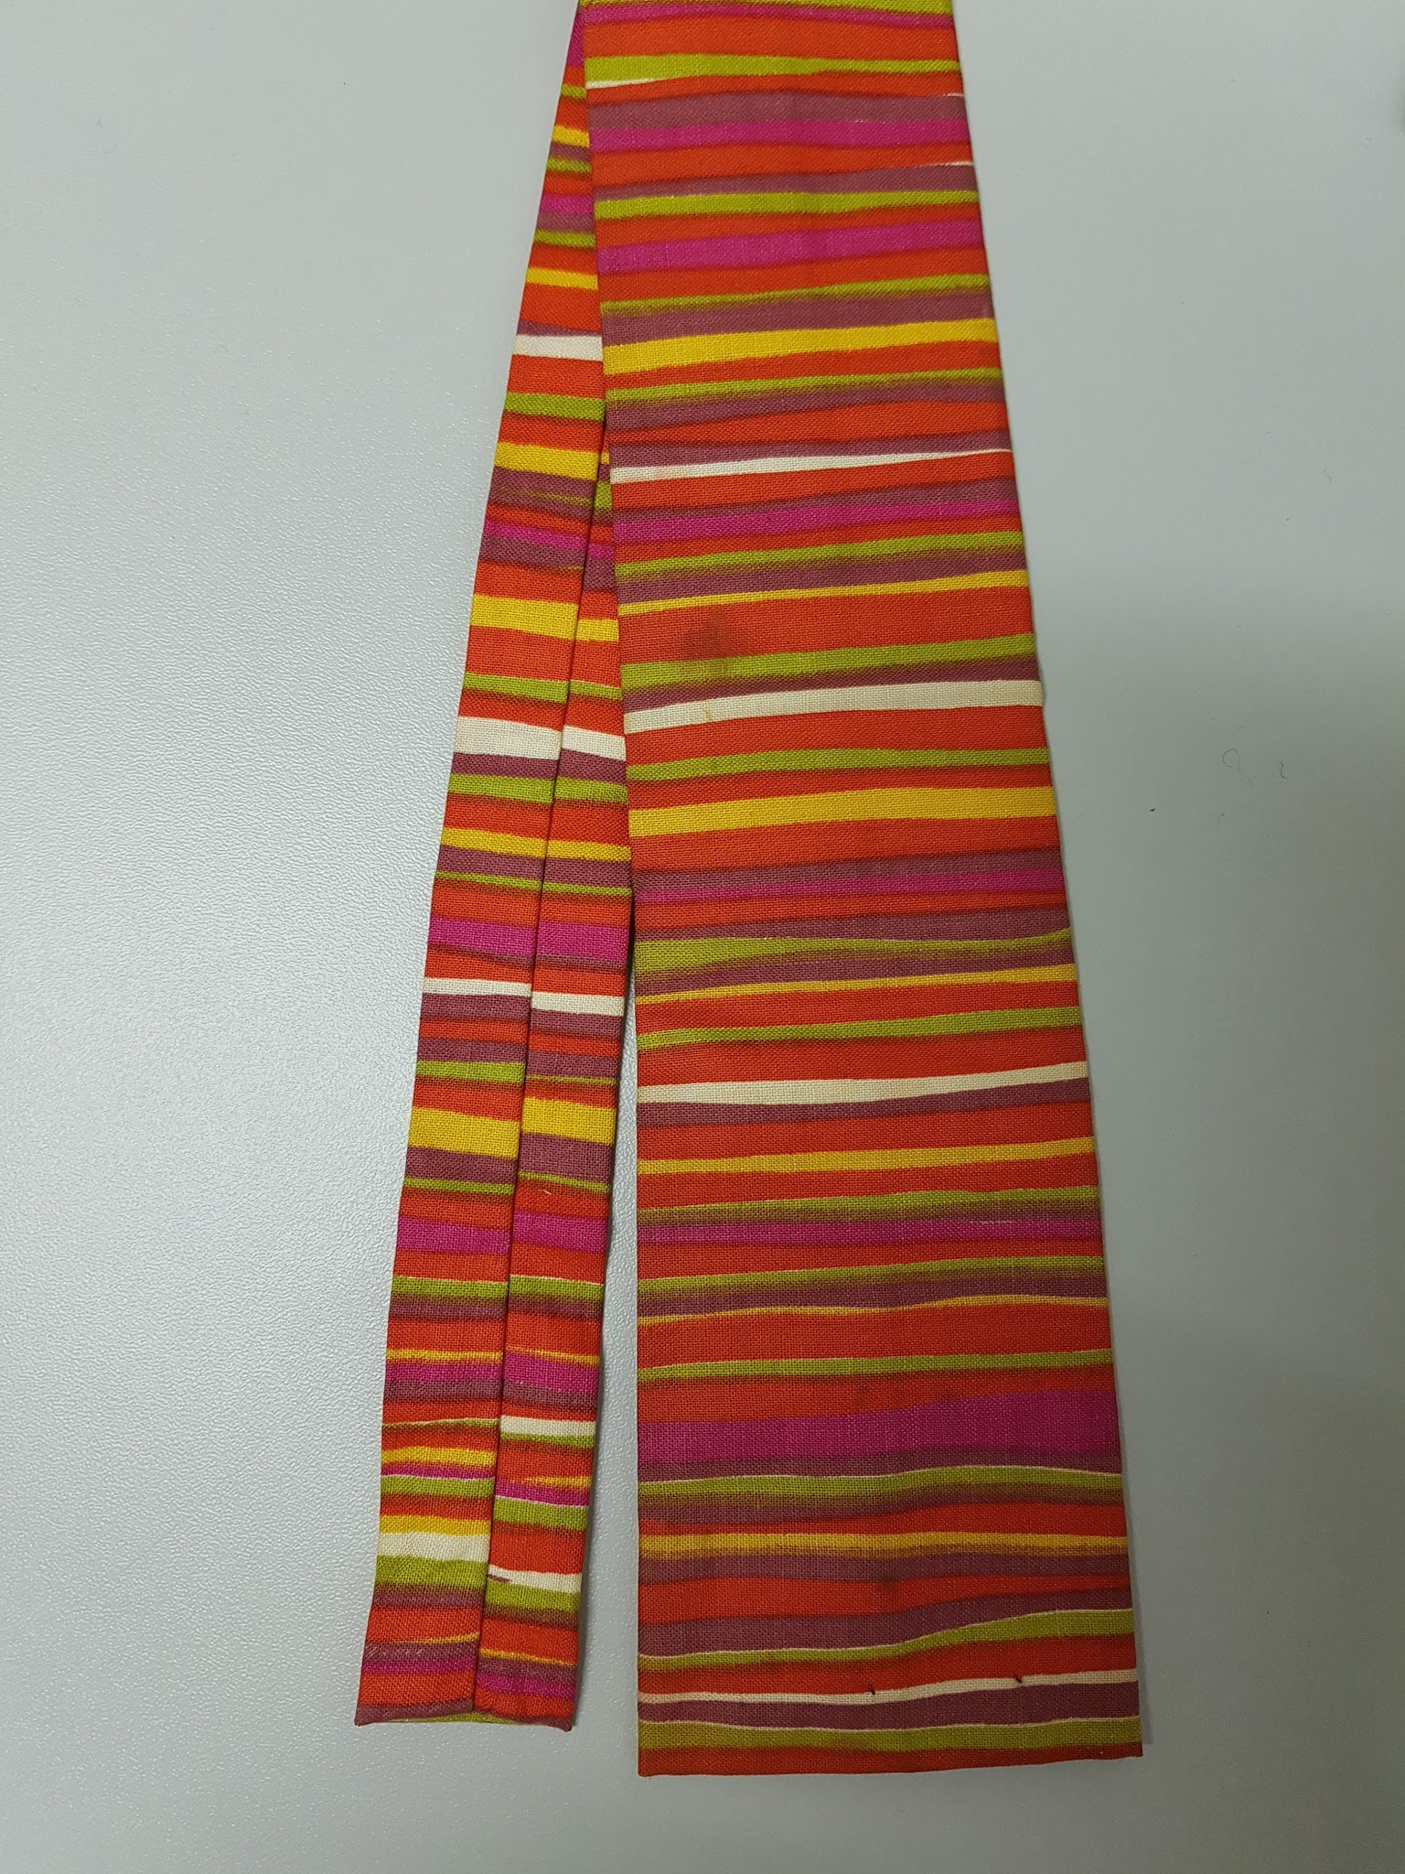 | Necktie, multicoloured striped pattern | No maker | Perhaps Cotton
87 | 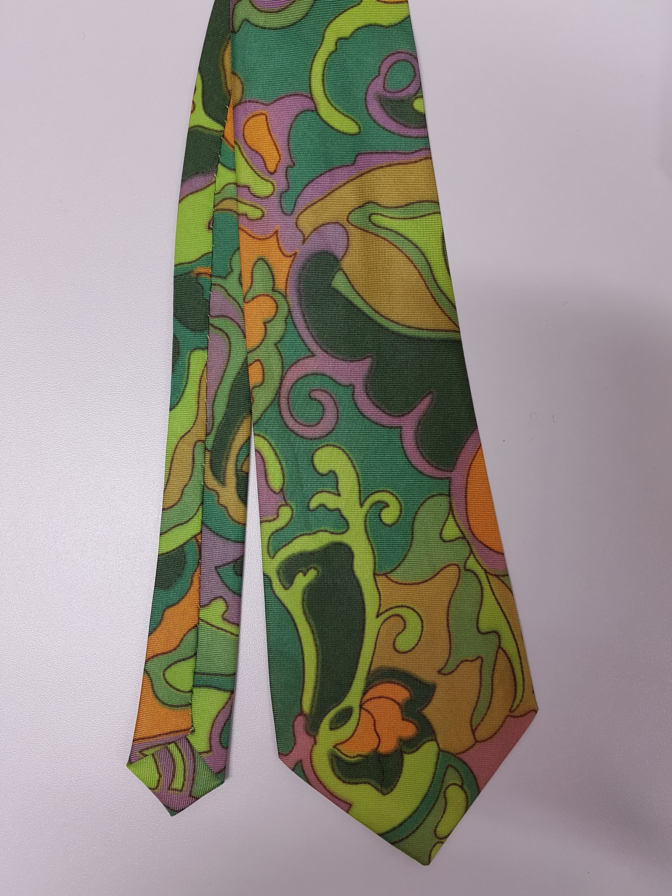 | Necktie, green and purple patterned | No maker | Polyester
88 | 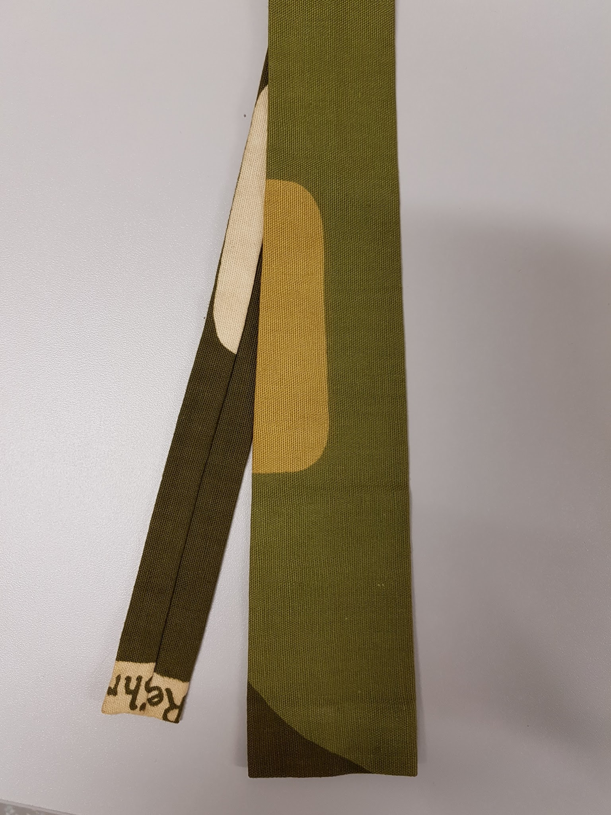 | Necktie, green and grey patterned | No maker | Perhaps Cotton
89 | 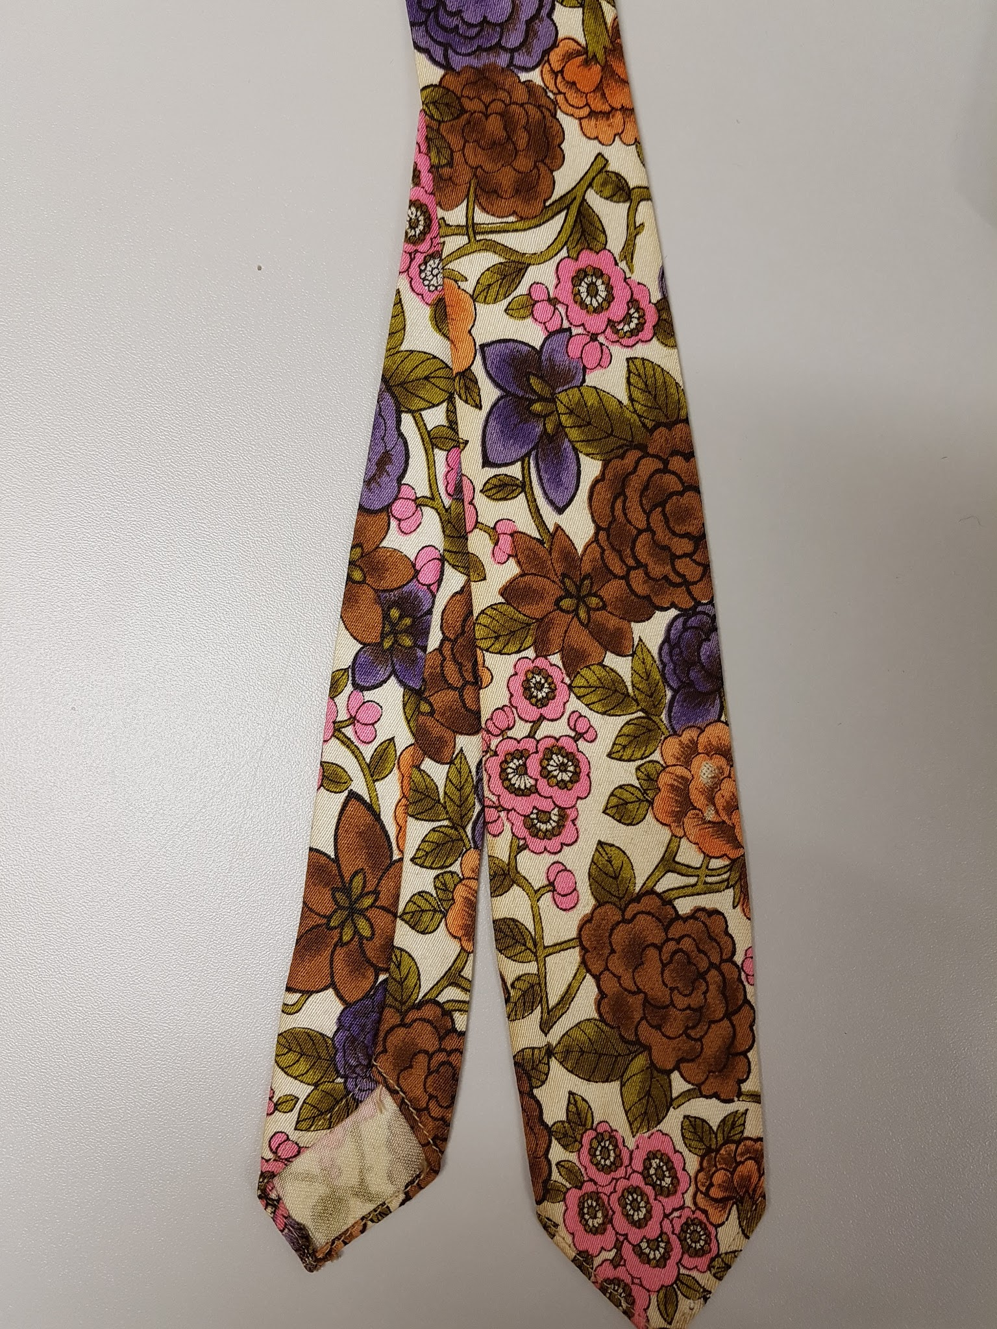 | Necktie, pink, purple, cream, brown and green floral patterned | Trend Tie | Silk
90 | 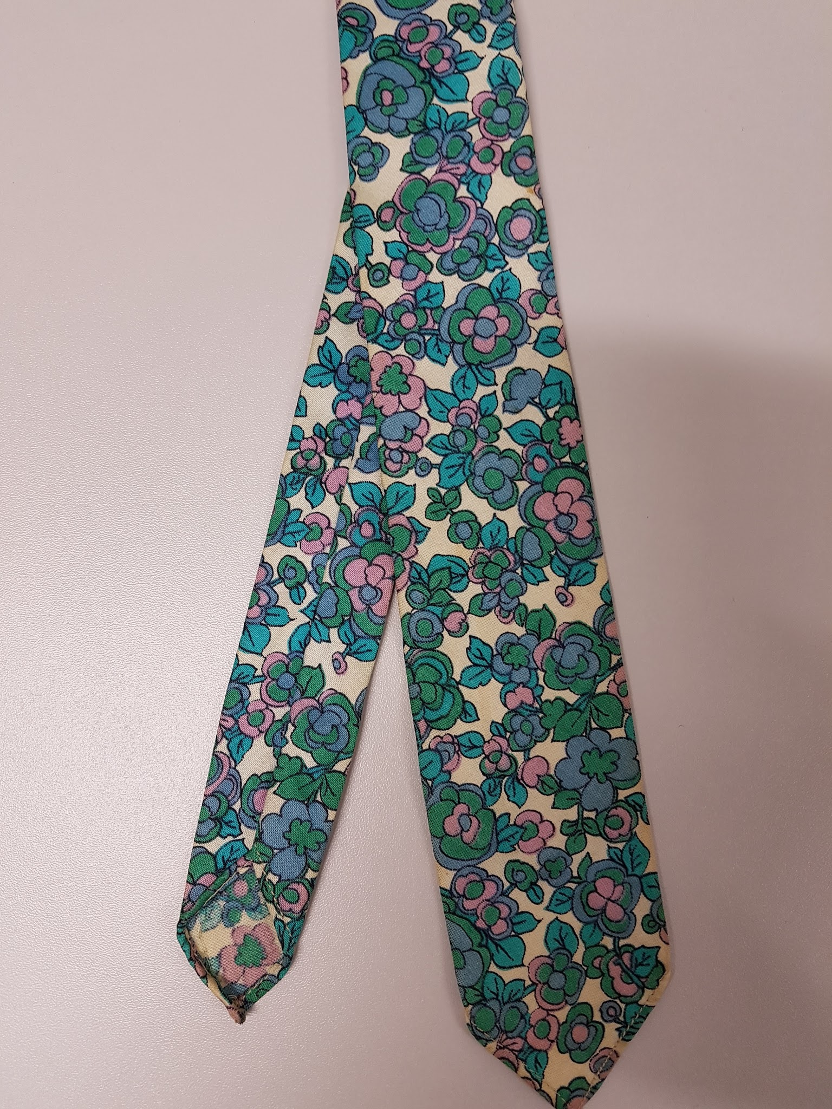 | Necktie, cream, blue, purple floral patterned | Trend Tie | Silk
91 | 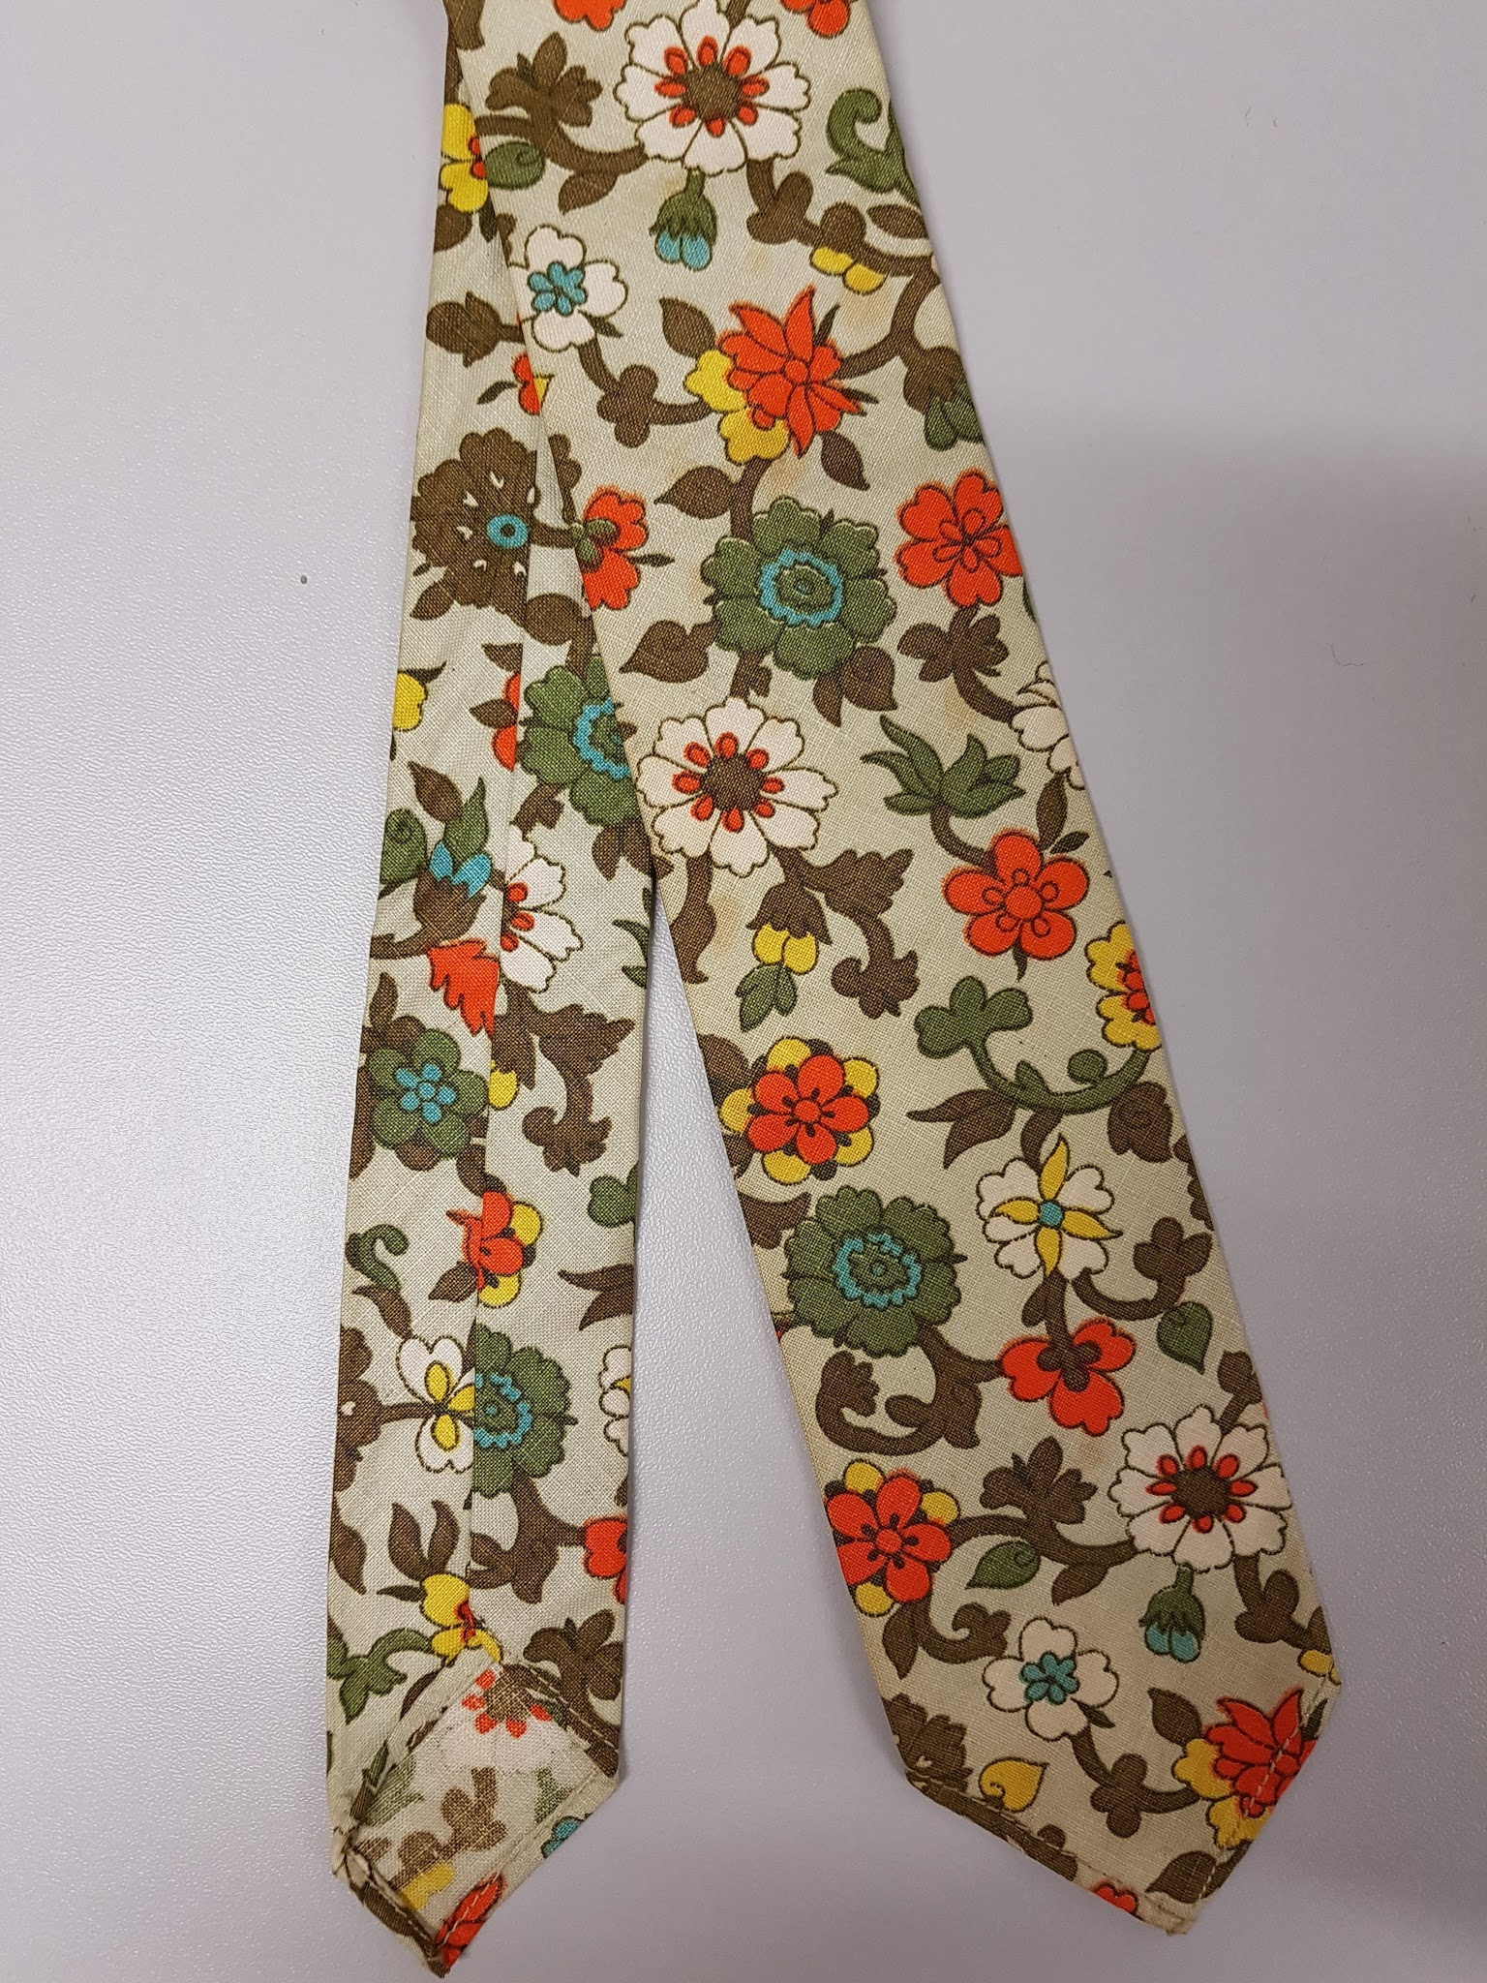 | Necktie, stone, brown, cream, orange and green patterned | Trend Tie | Perhaps Cotton
92 | 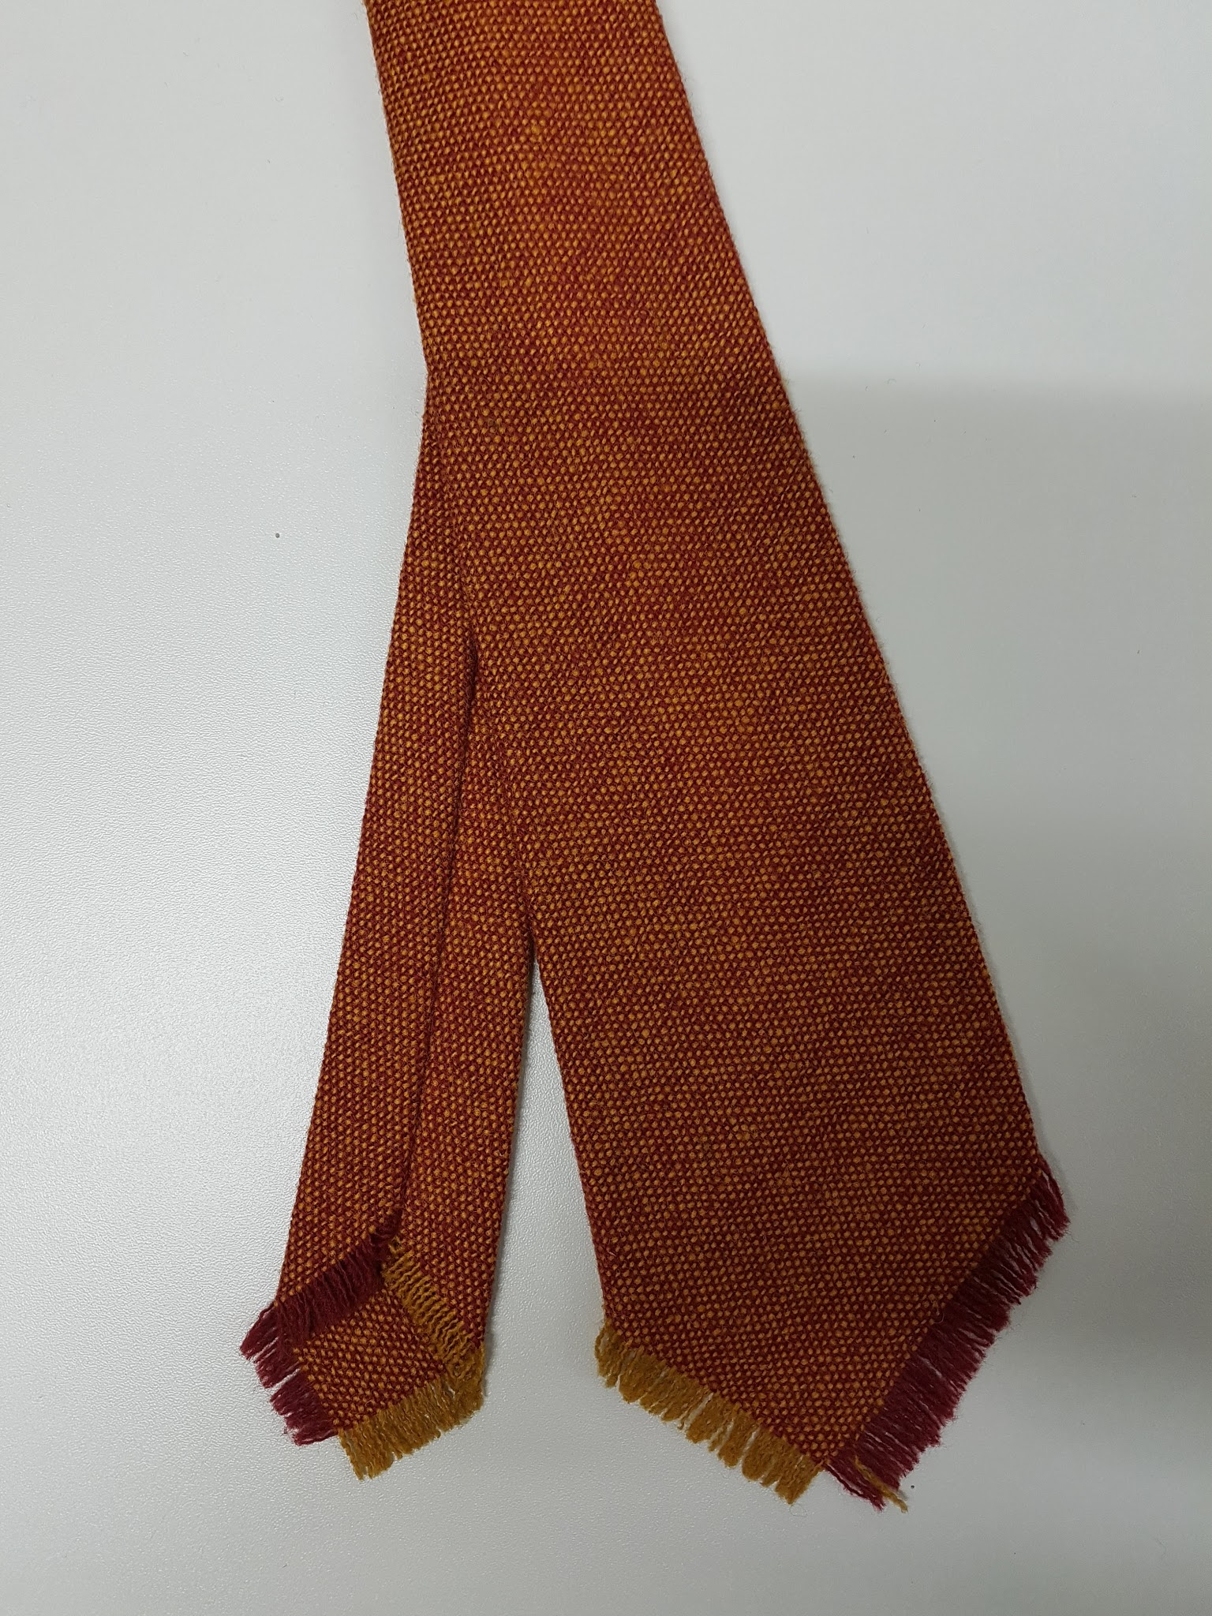 | Necktie, red and orange woven tie | No maker | Wool
93 | 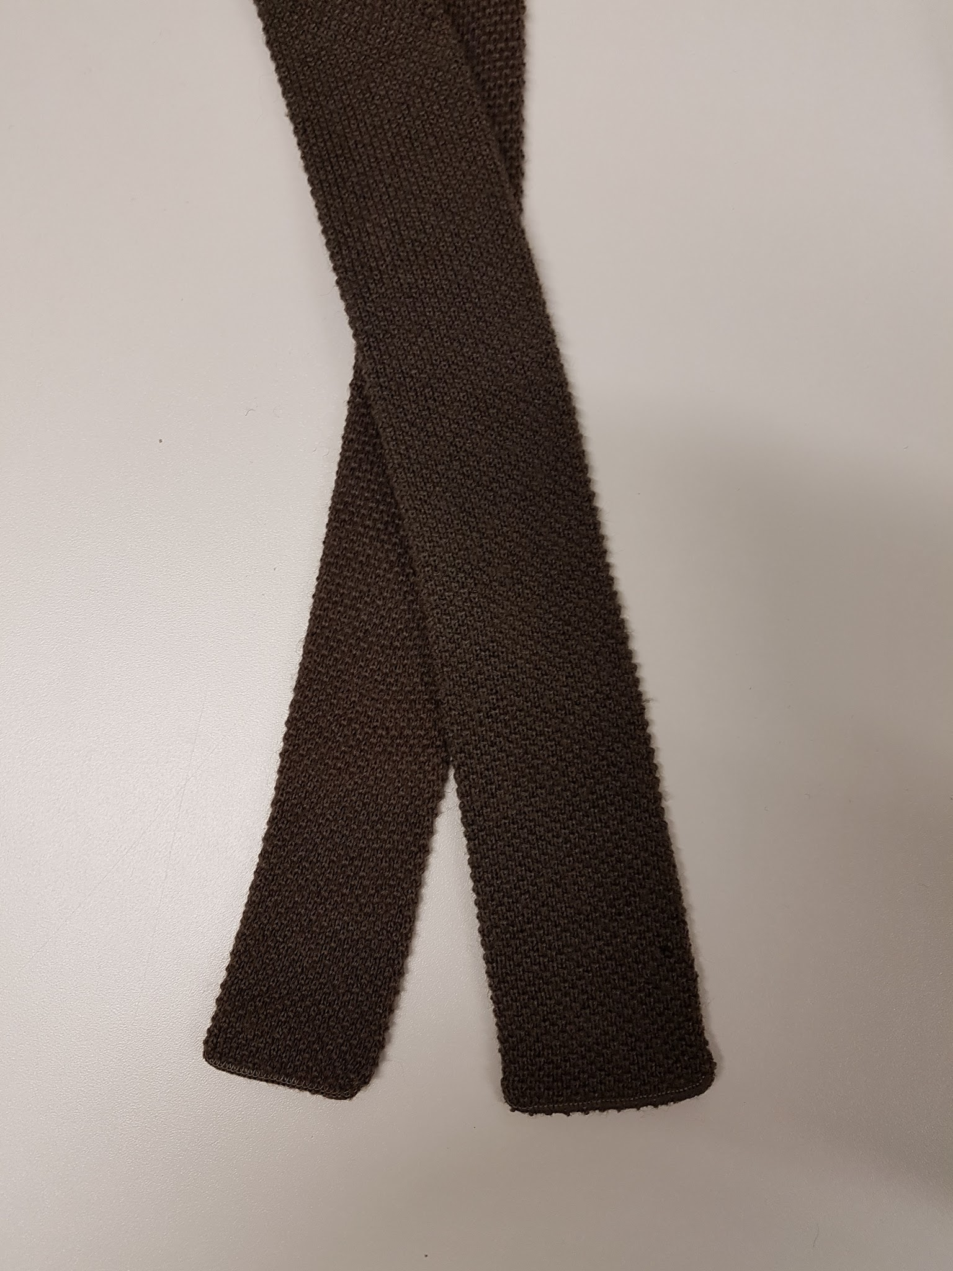 | Necktie, Dark Grey, knitted, | No maker | Wool
94 | 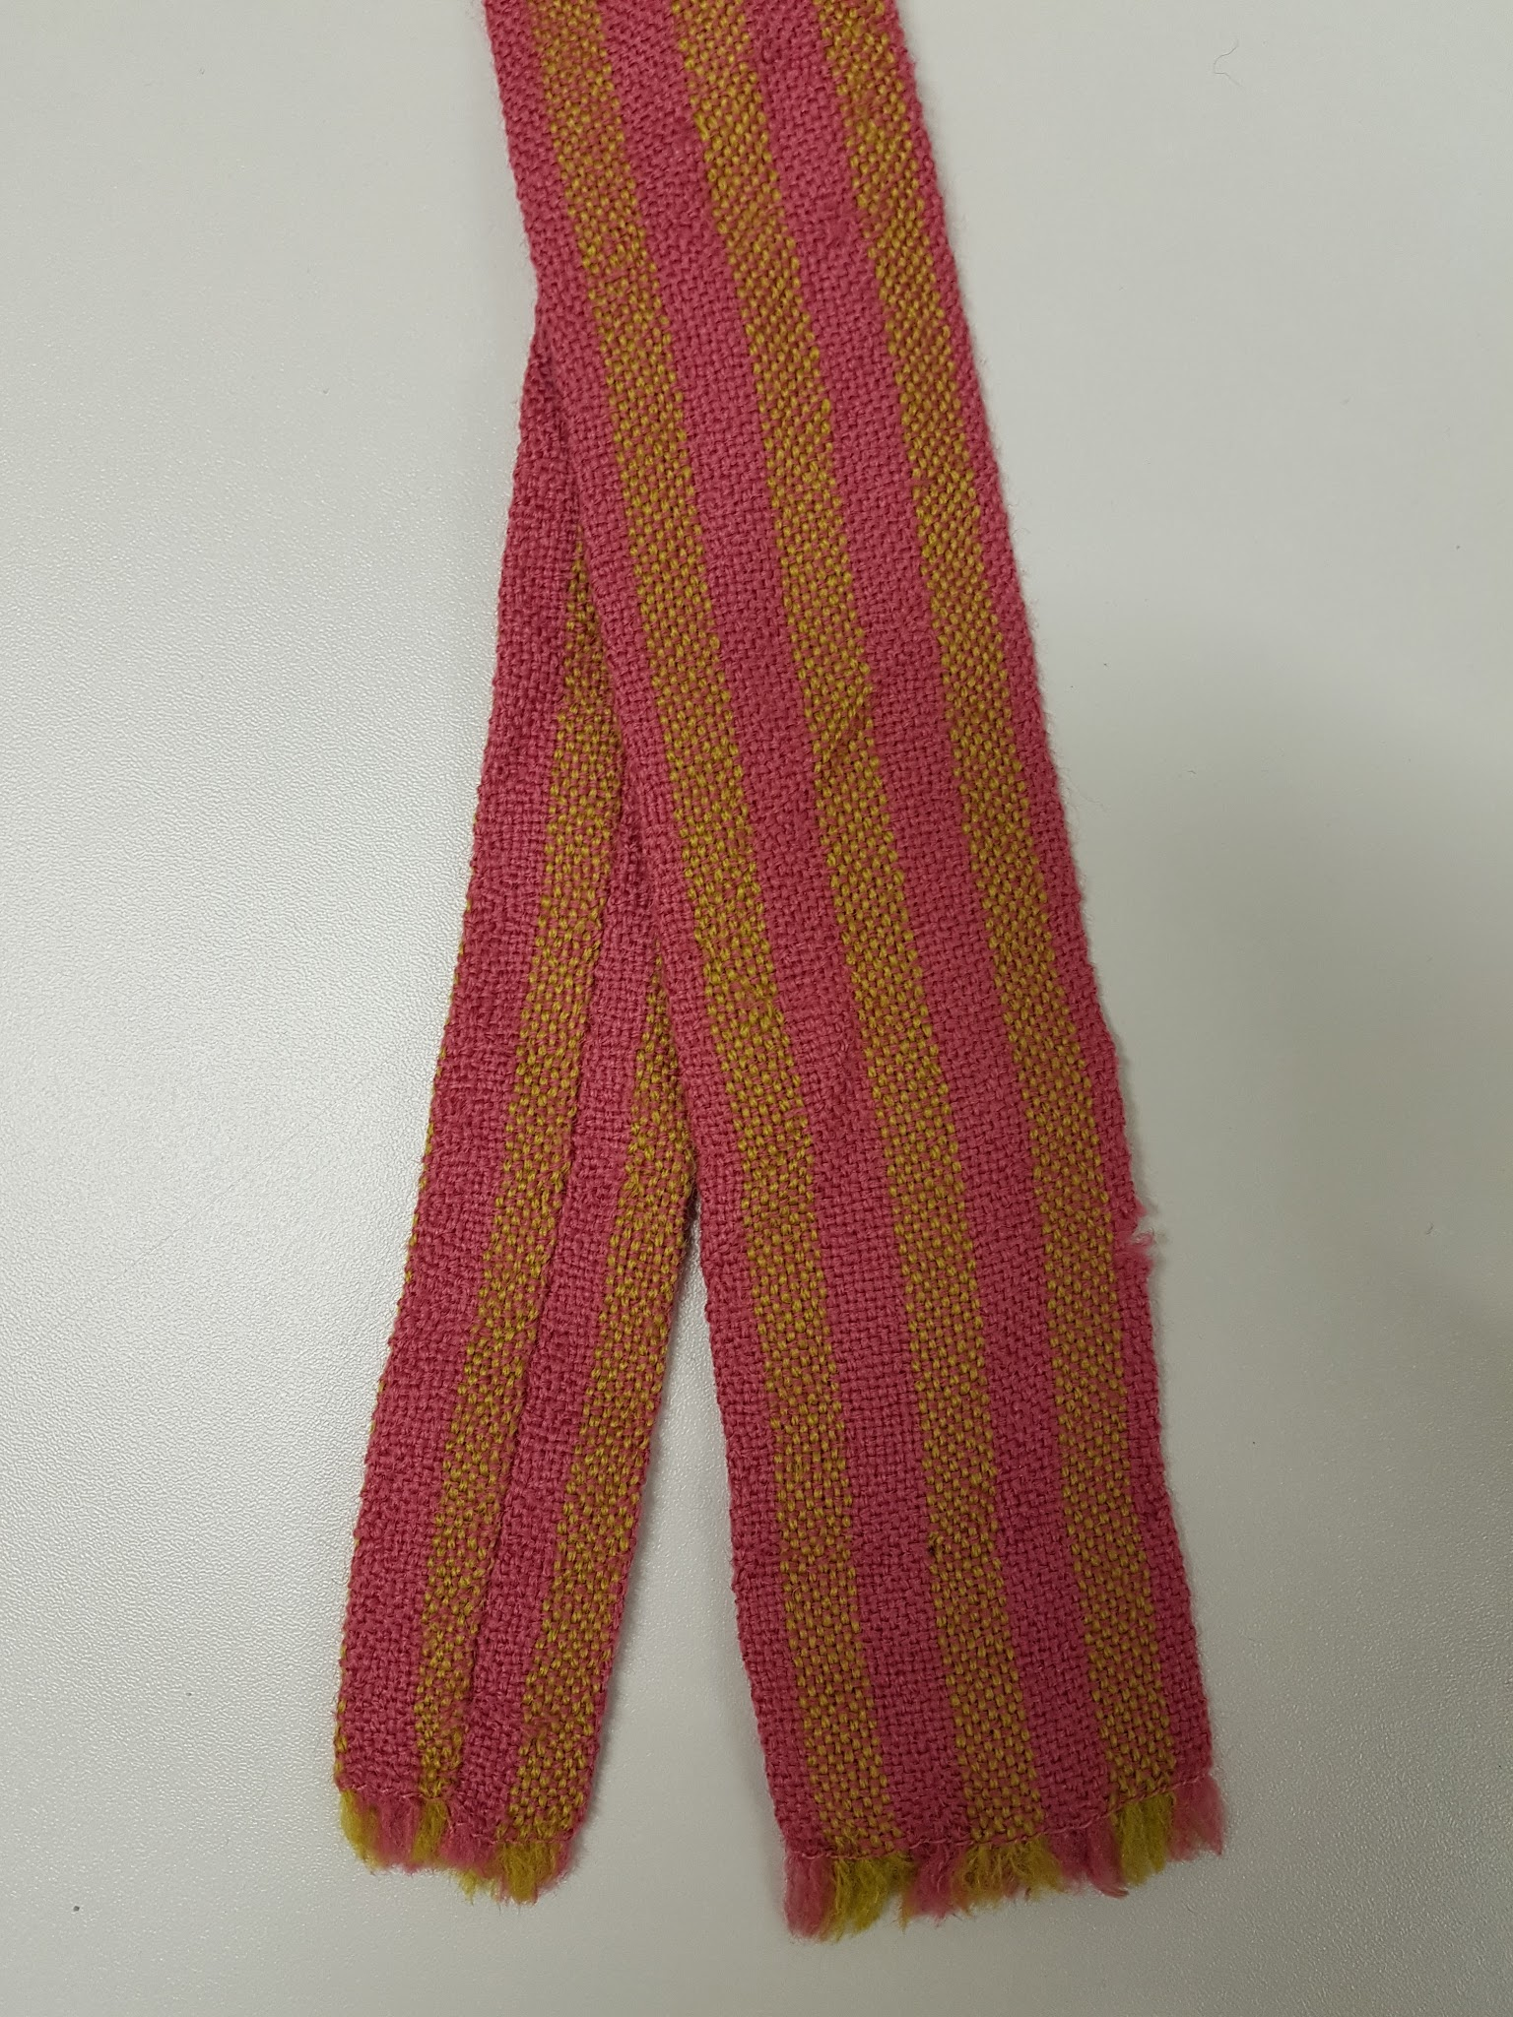 | Necktie, pink and green woven | Vardoc | Wool
95 | 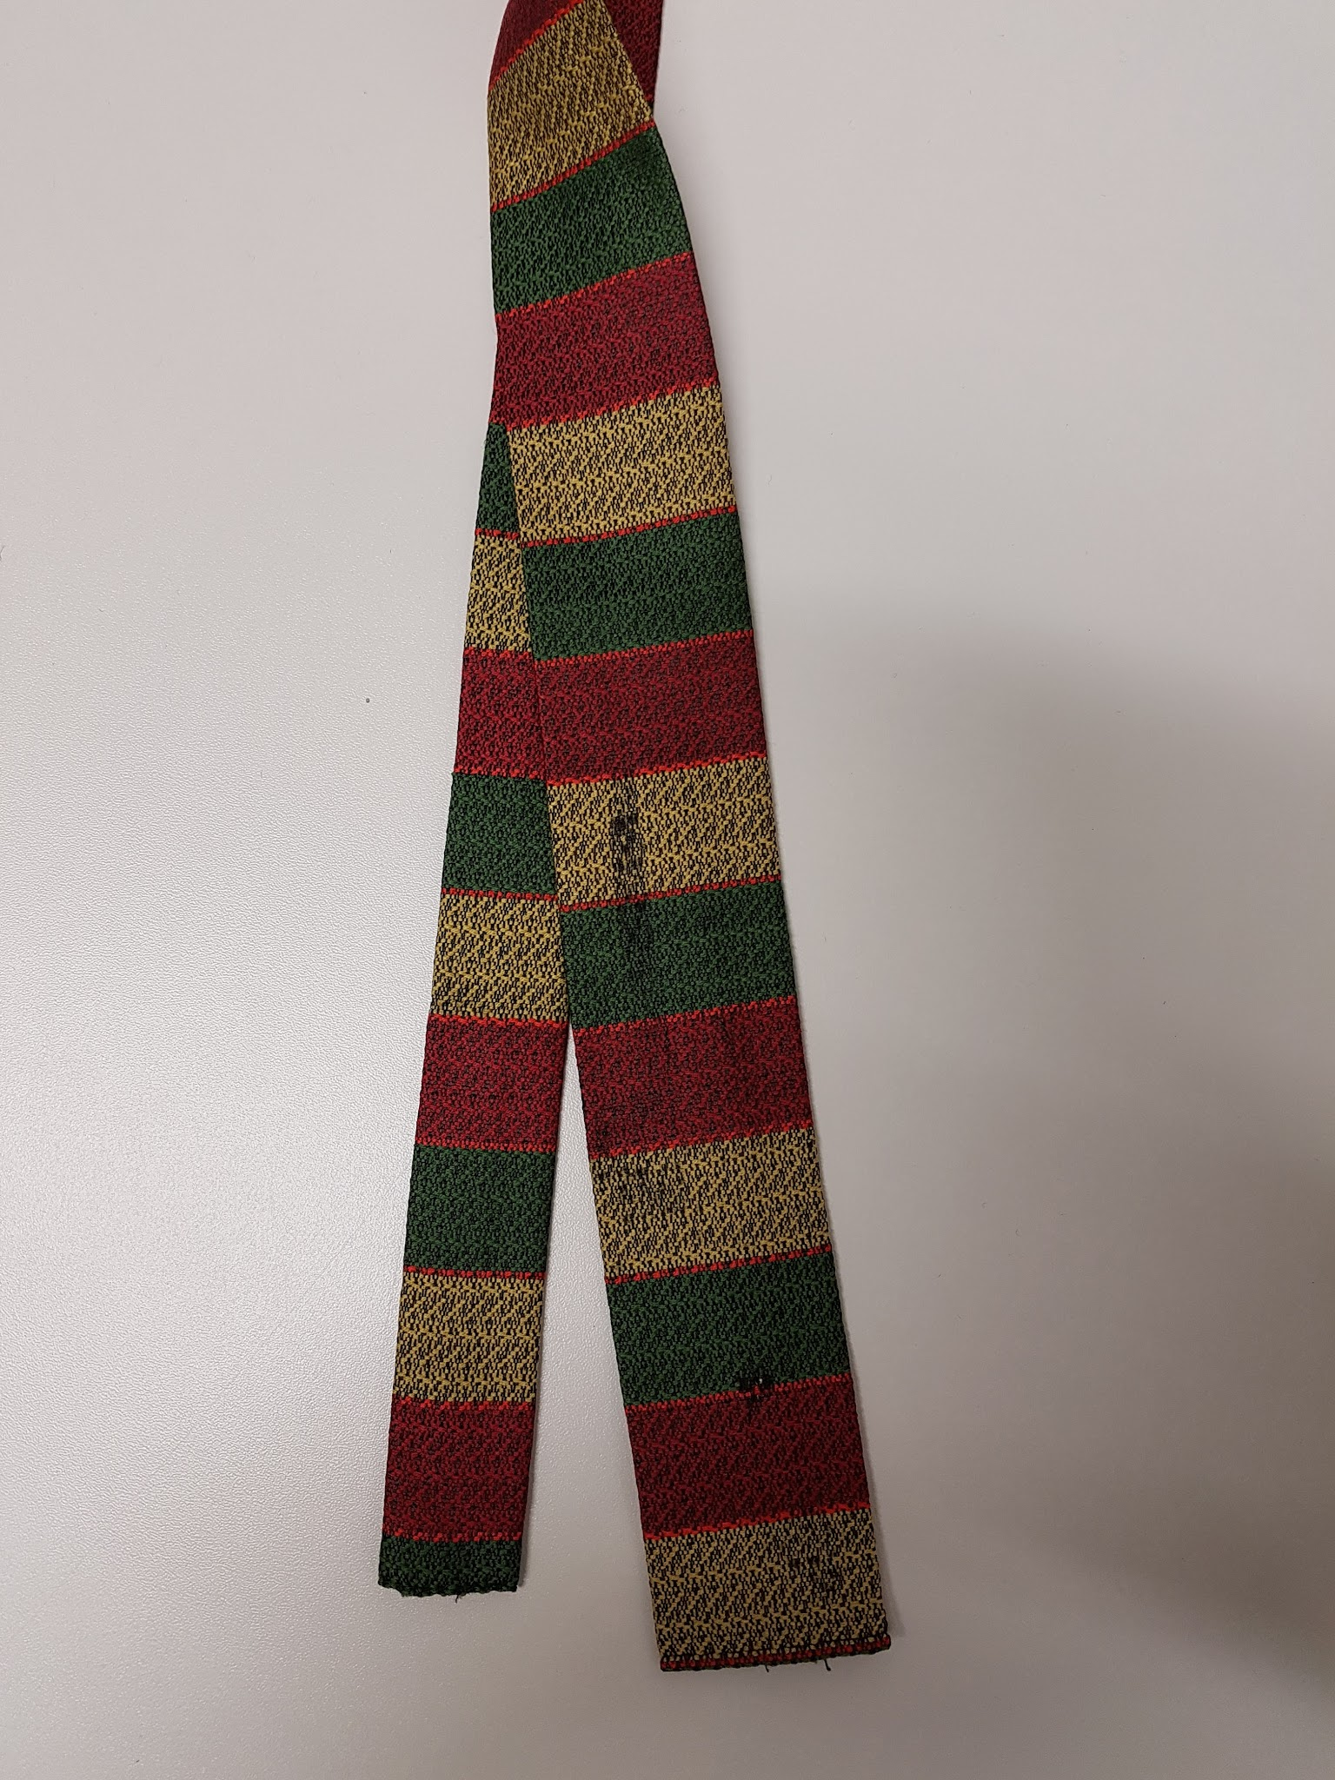 | Necktie, green, red, yellow striped pattern | No maker | Perhaps polyester
96 | 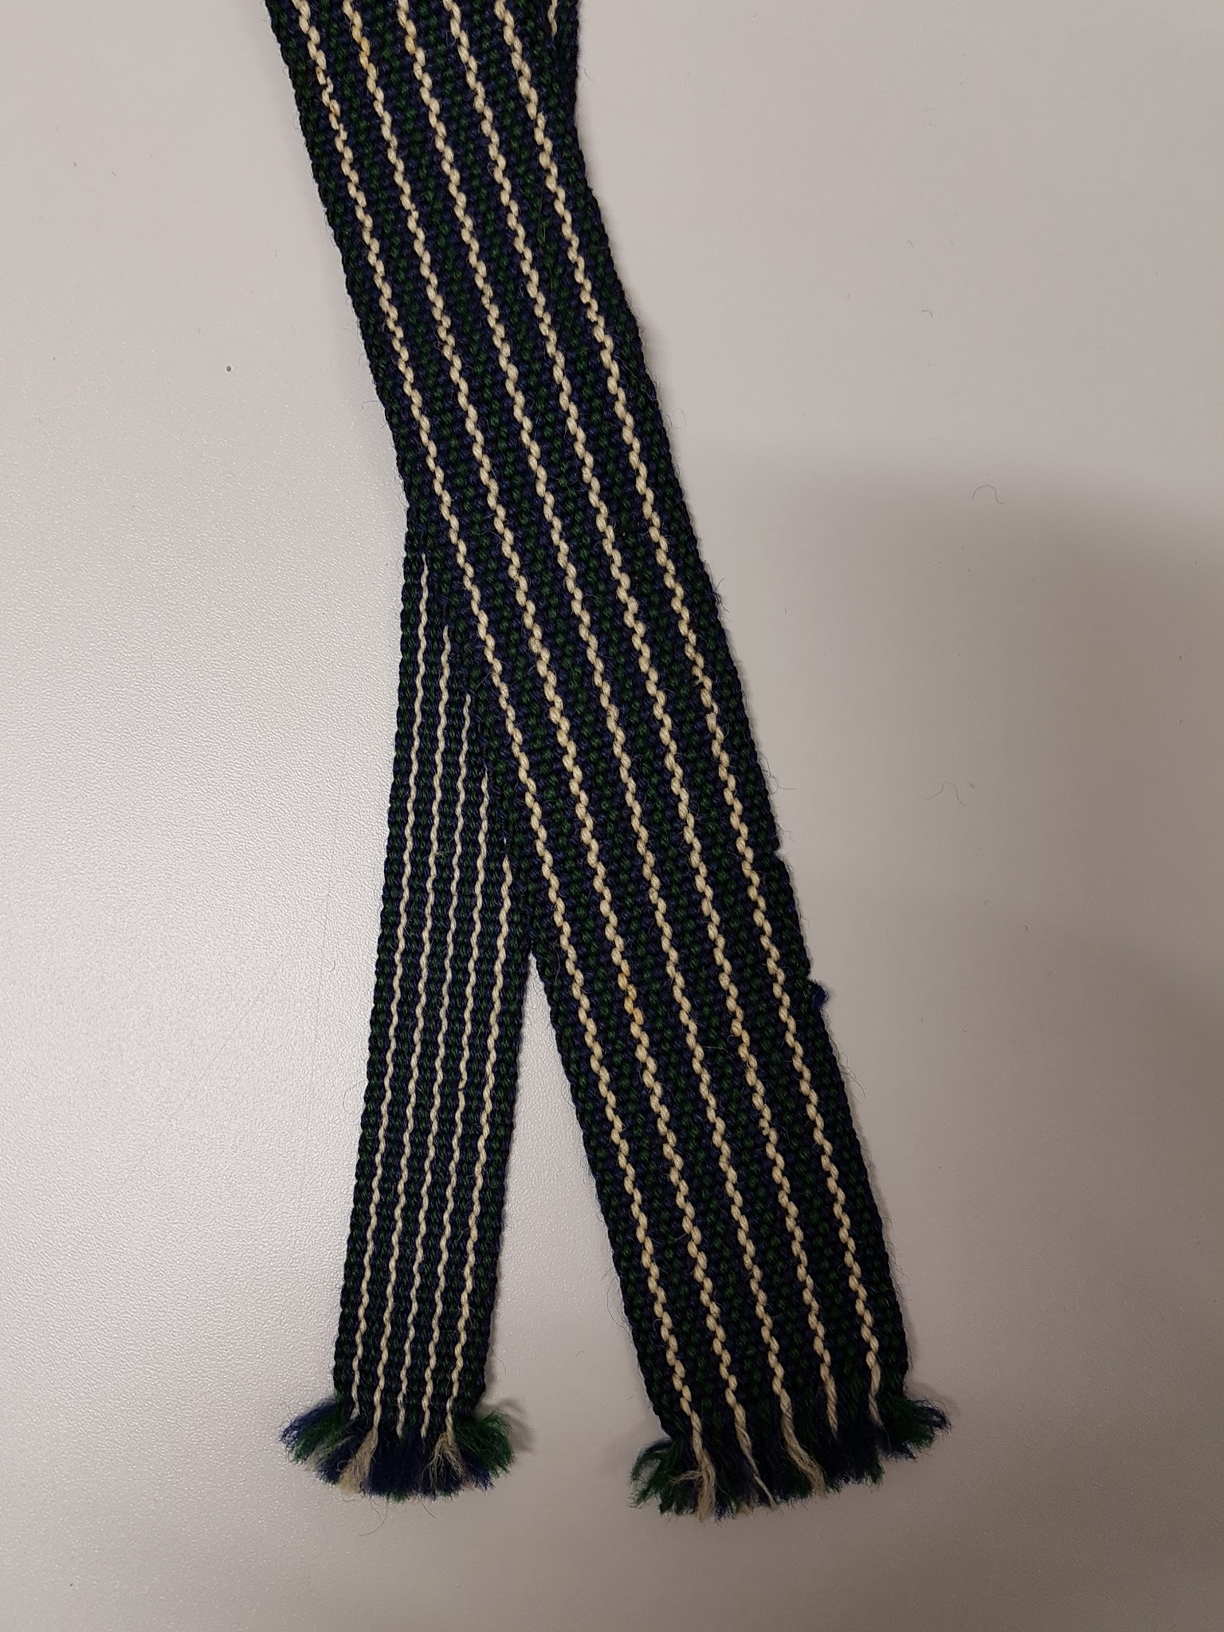 | Necktie, blue, green, white striped pattern, woven | No maker | Wool
97 | 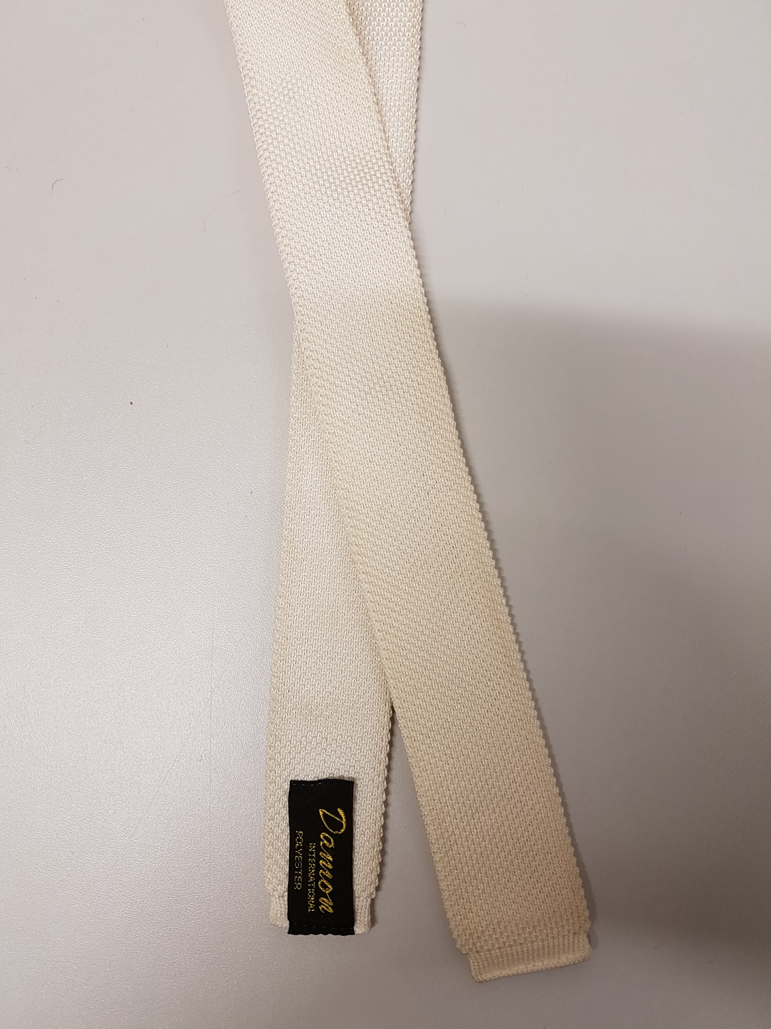 | Necktie, white, knitted | Damon International | Polyester
98 | 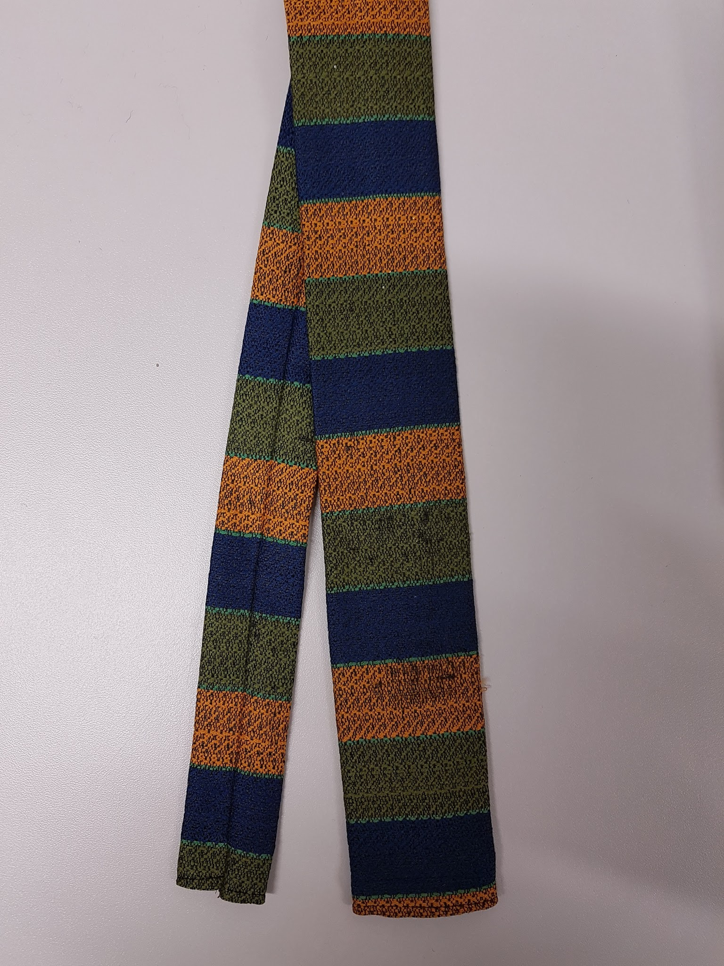 | Necktie, green, yellow, blue | No maker | Perhaps Polyester
99 | 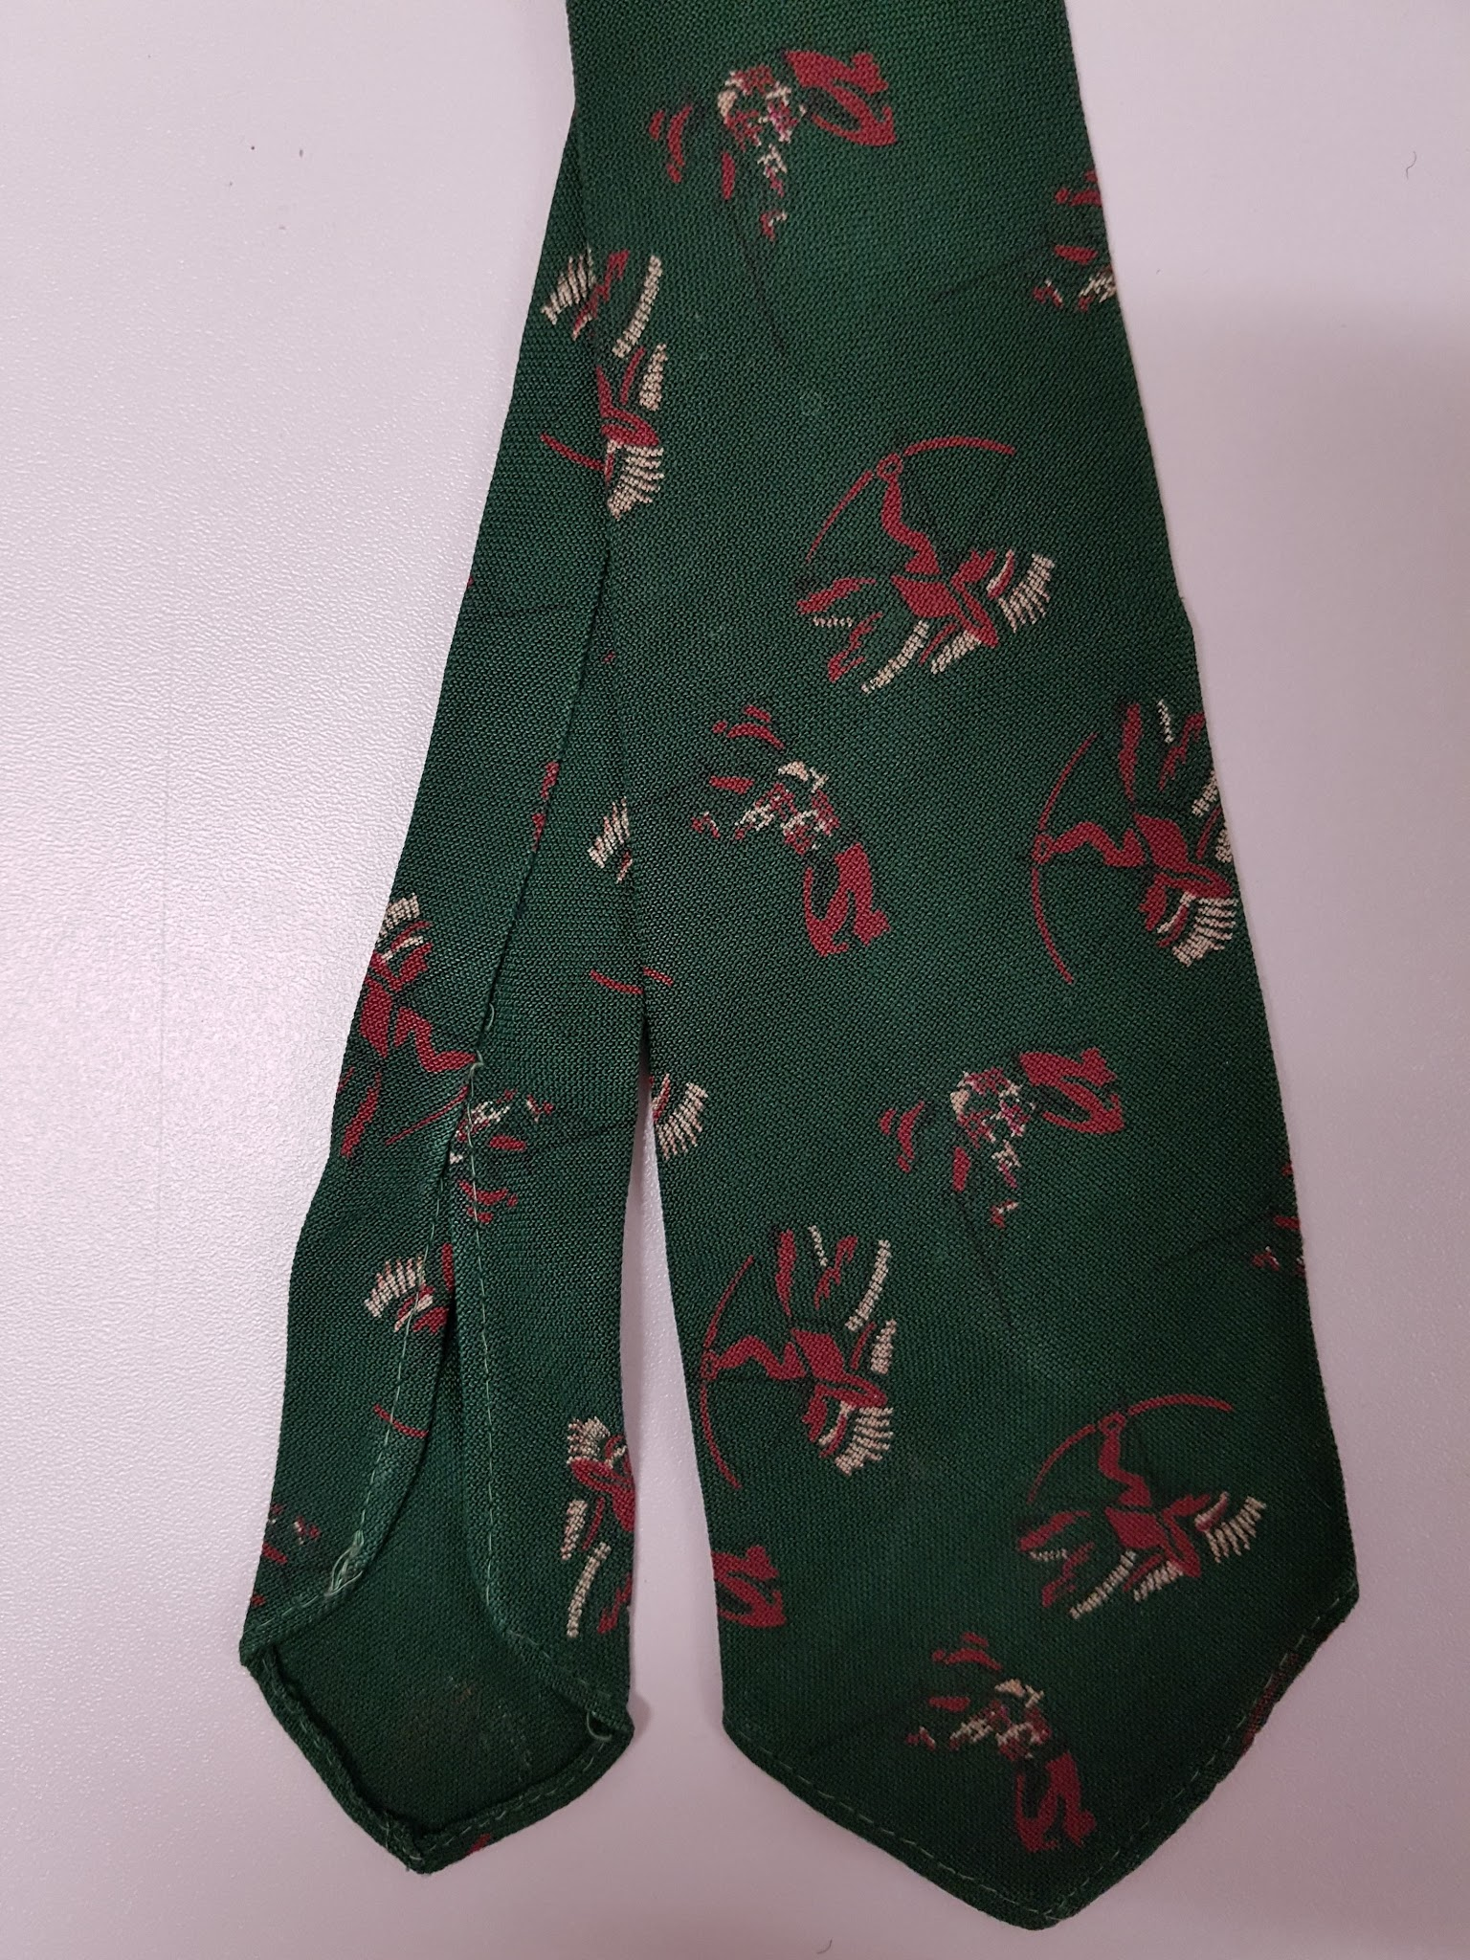 | Childs Necktie, dark green, Native American pattern | Tootal | Rayon
100 | 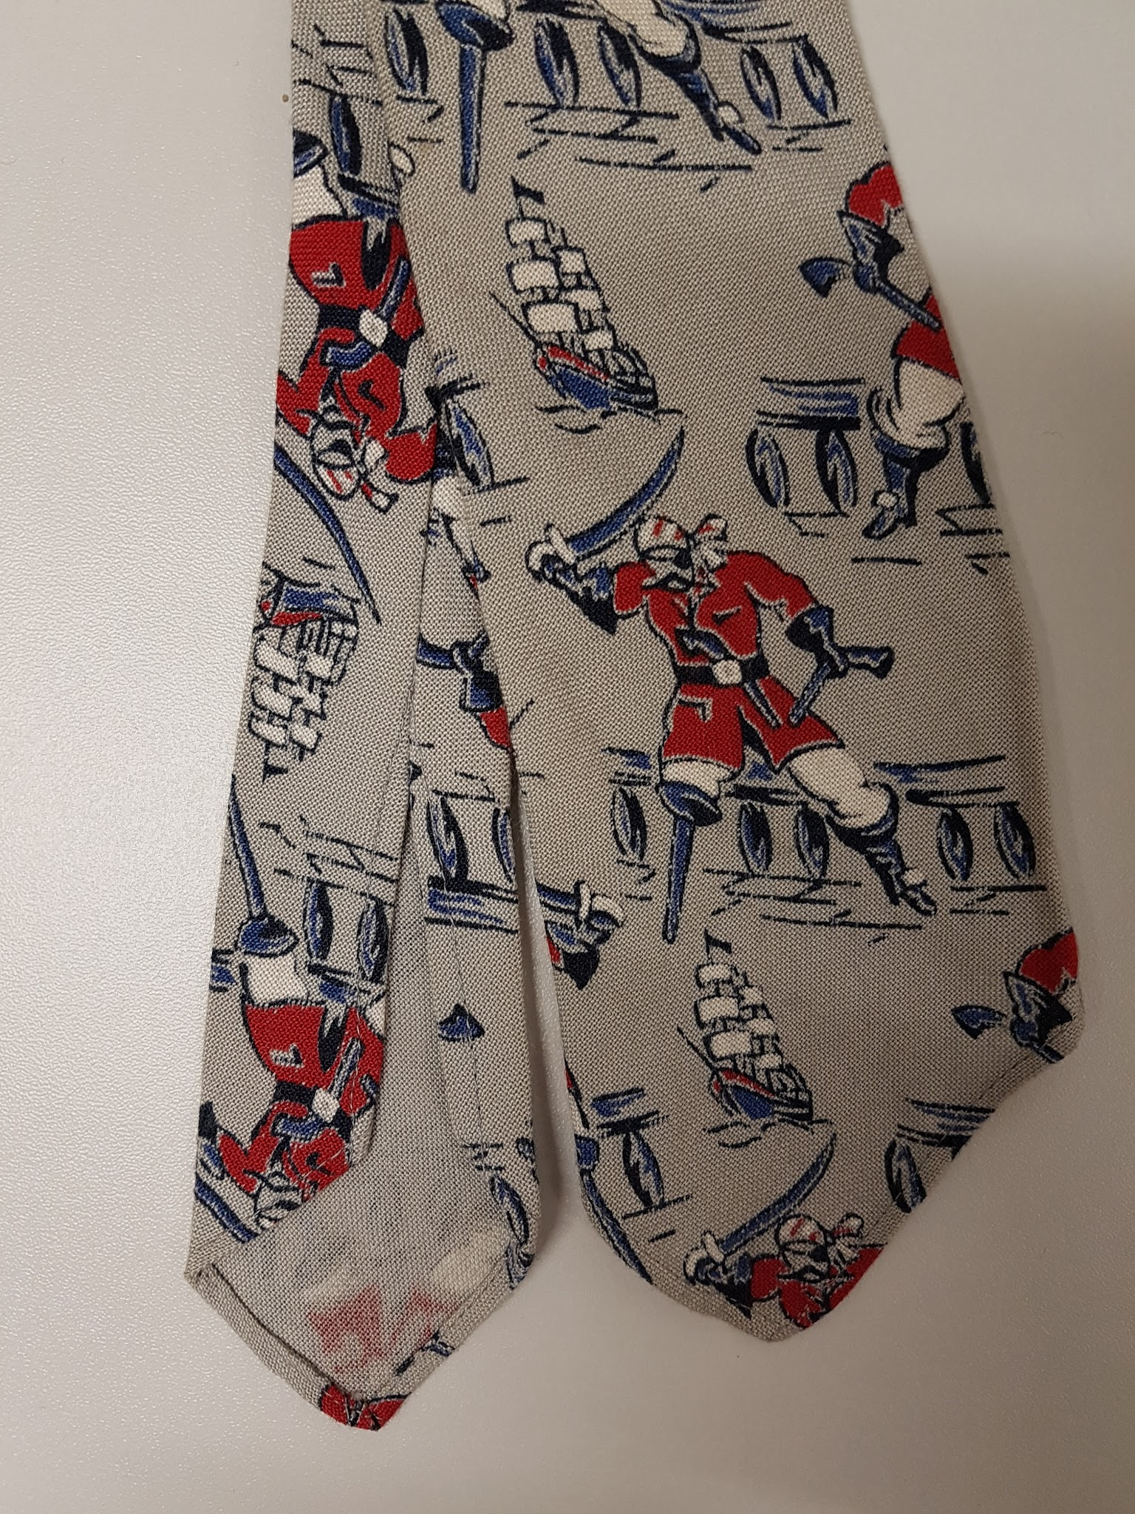 | Childs Necktie, grey, Pirate patterned | Tootal | Rayon
101 |  | Childs Necktie, red | No maker | Polyester
102 | 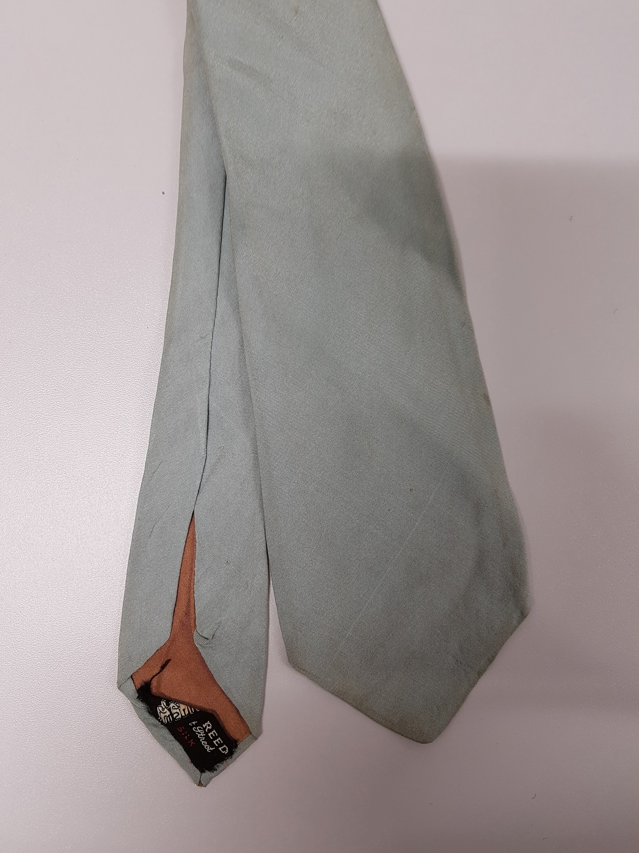 | Necktie, pale green | Austen Reed | Silk
103 | 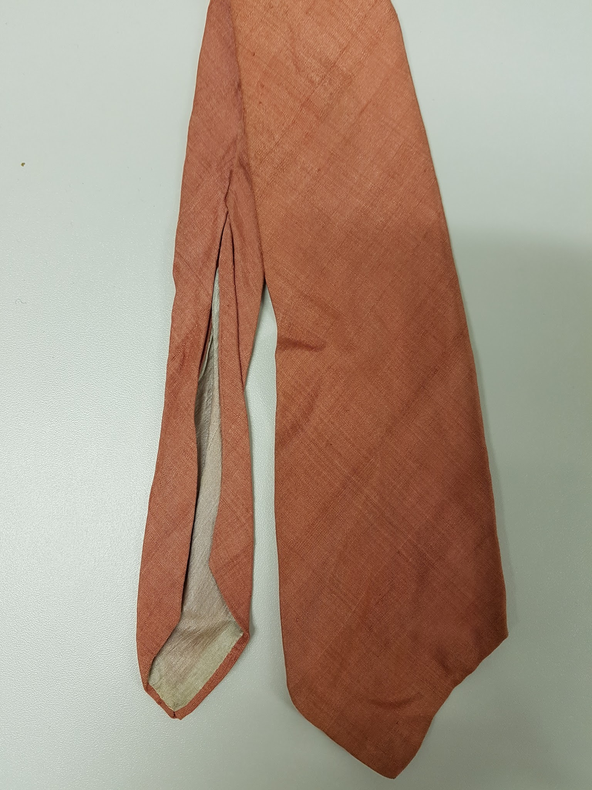 | Necktie, dark pink | Liberty of London | Silk
104 |  | Butterfly bow, charcoal | Austen Reed | Silk
105 | 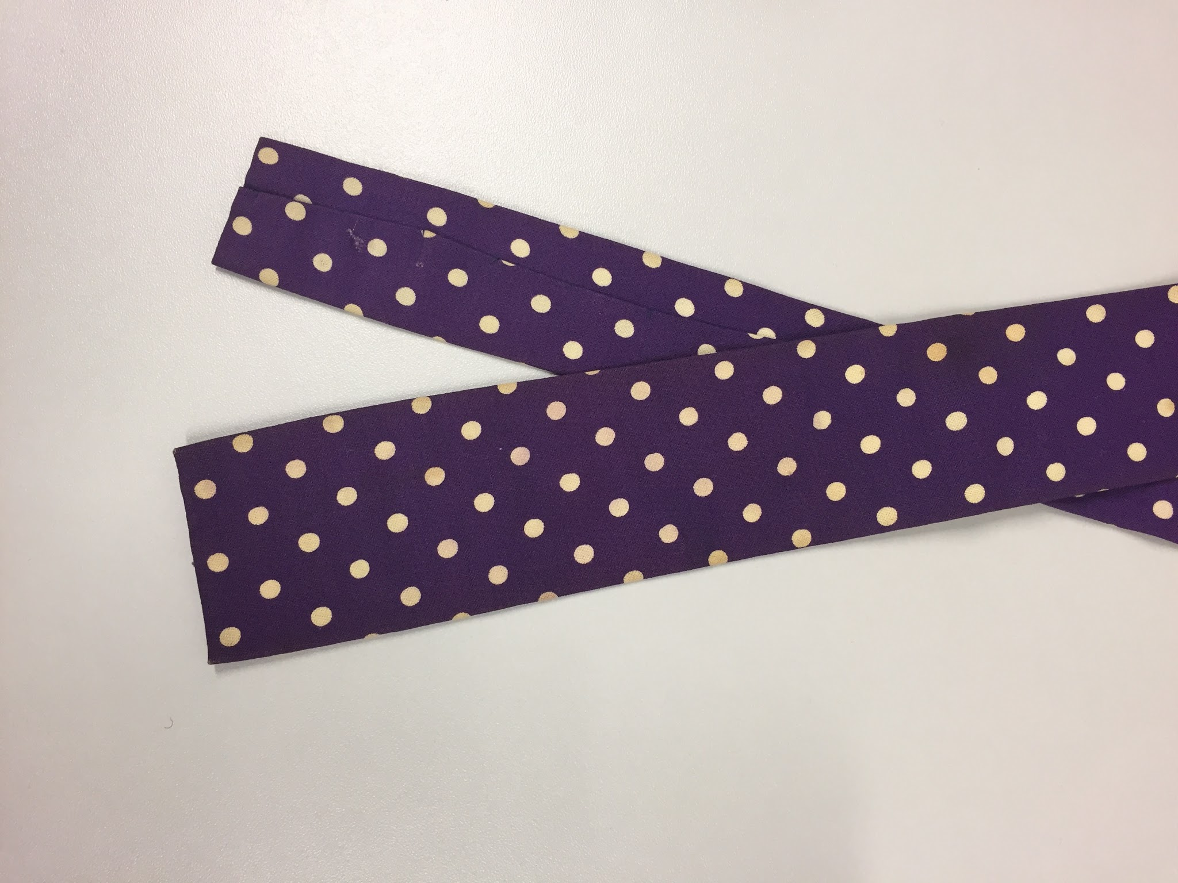 | Necktie, purple with white dots | No maker | Cotton
106 | 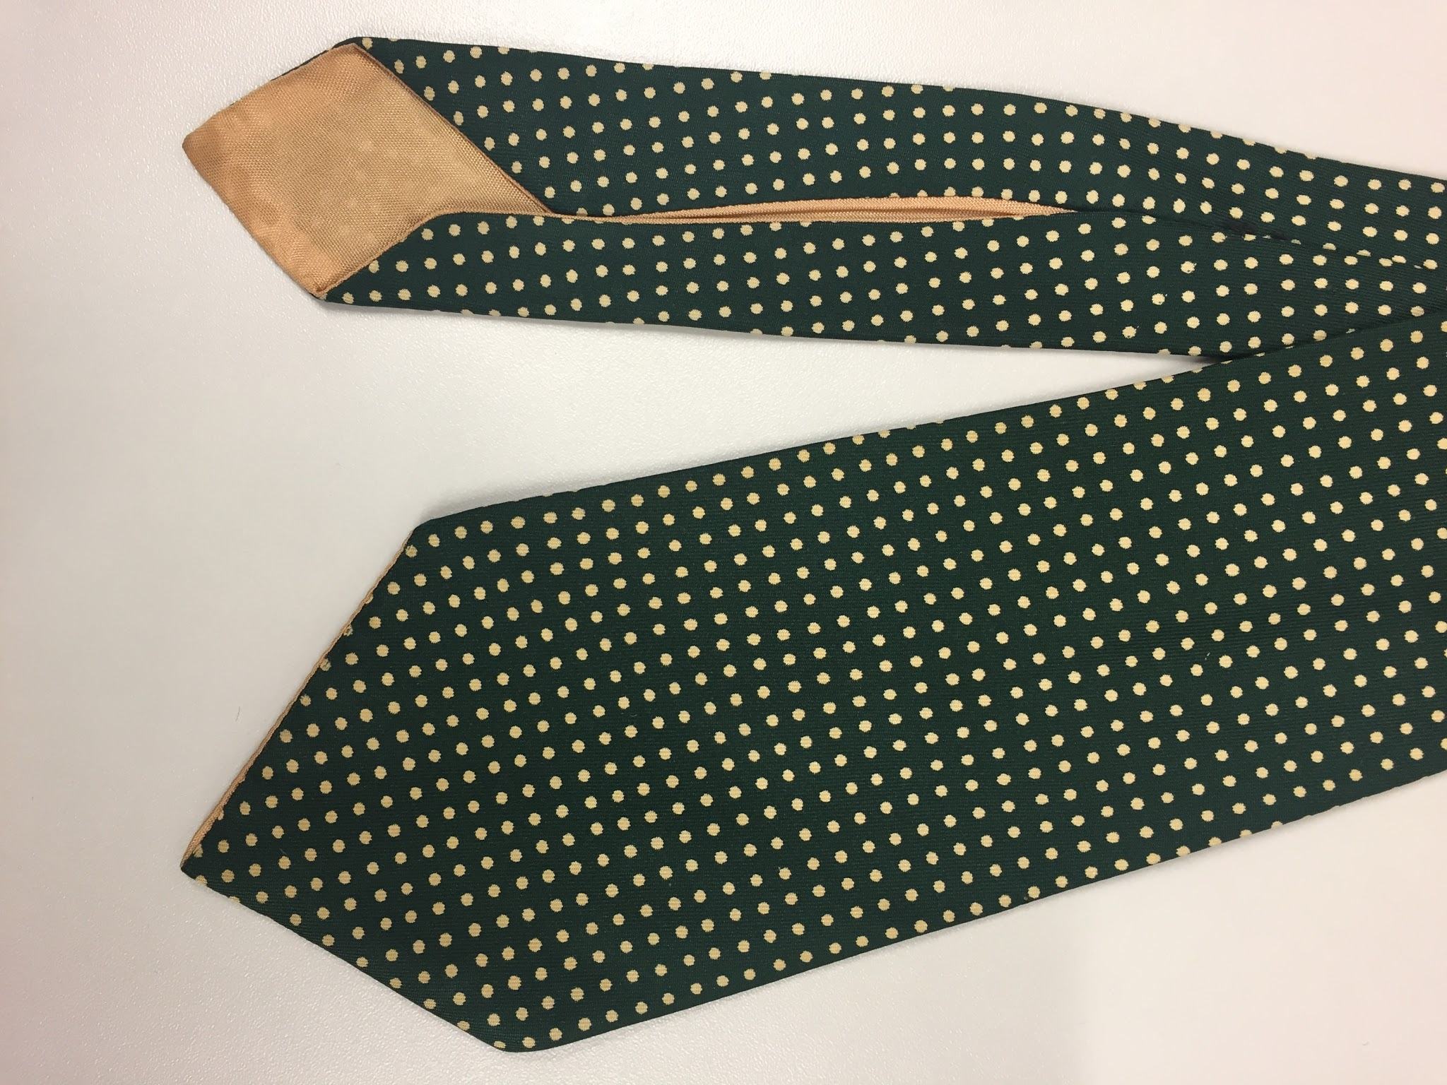 | Necktie, dark green with cream dots | JC | Silk
107 | 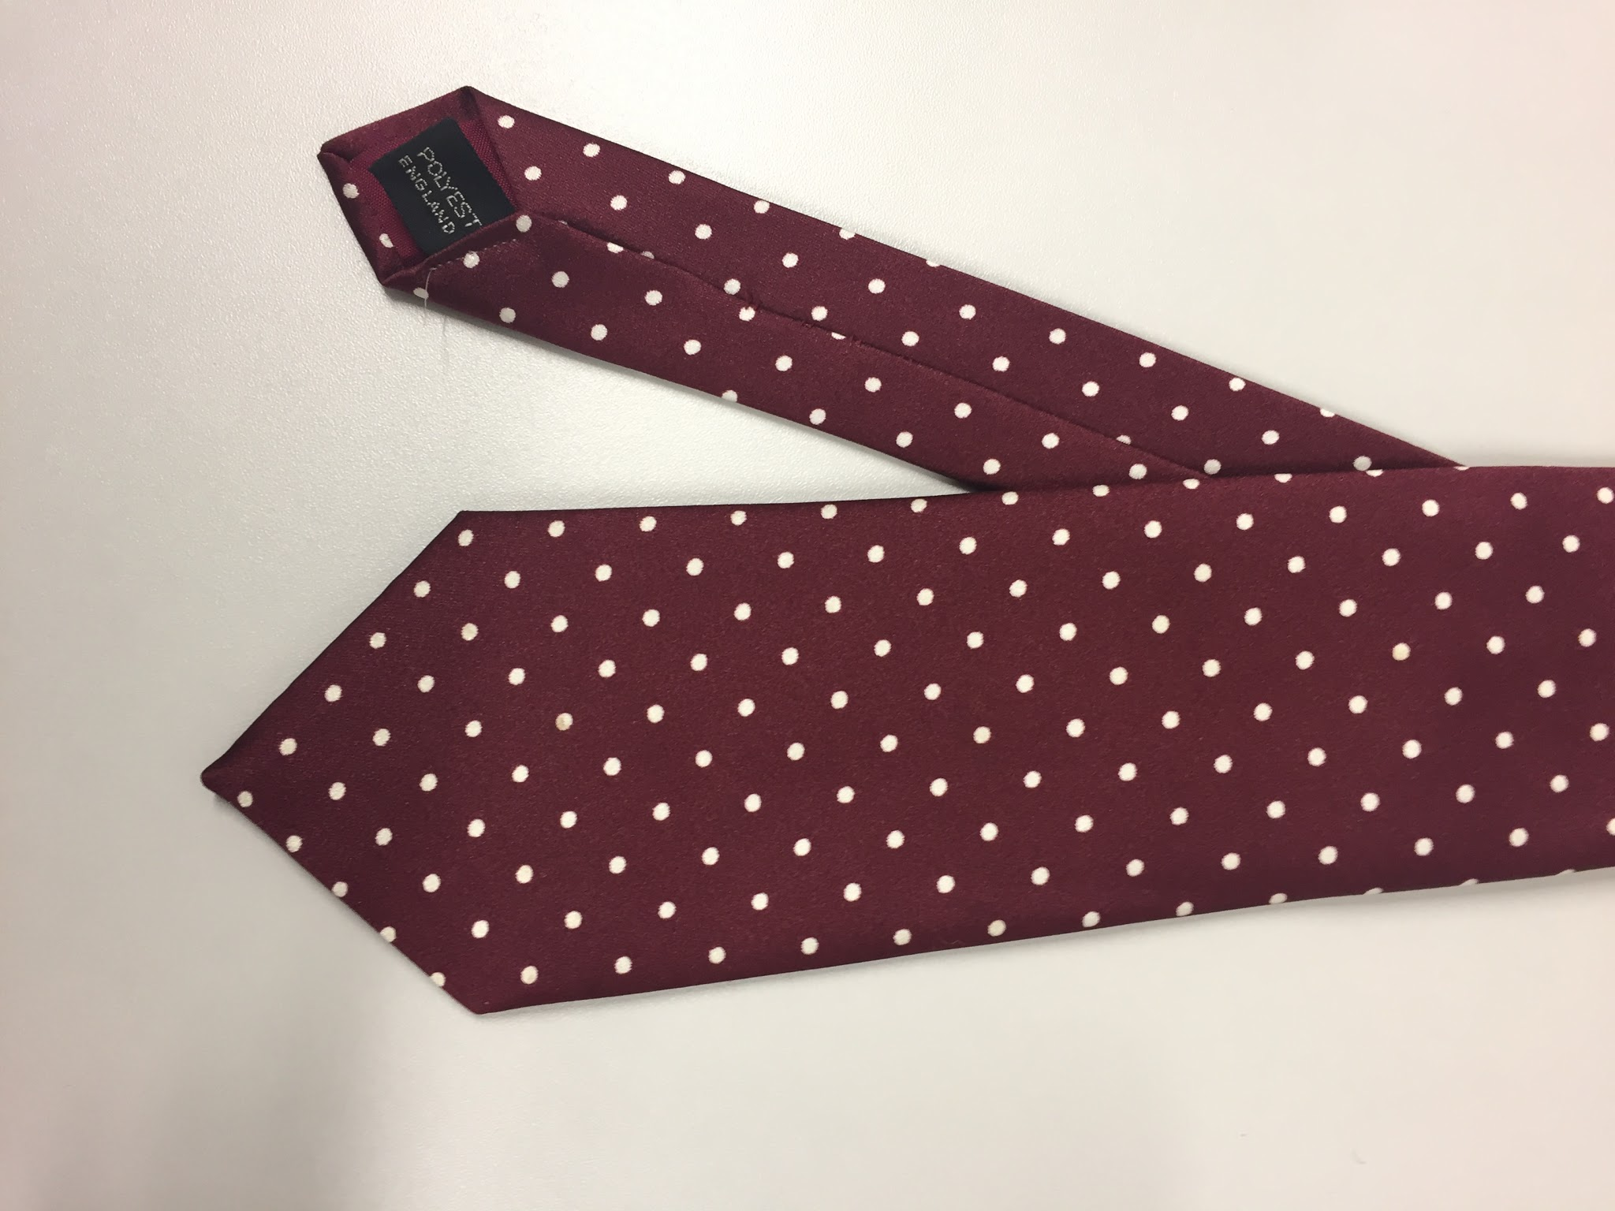 | Necktie, maroon with white dots | Michelsons | Polyester
108 | 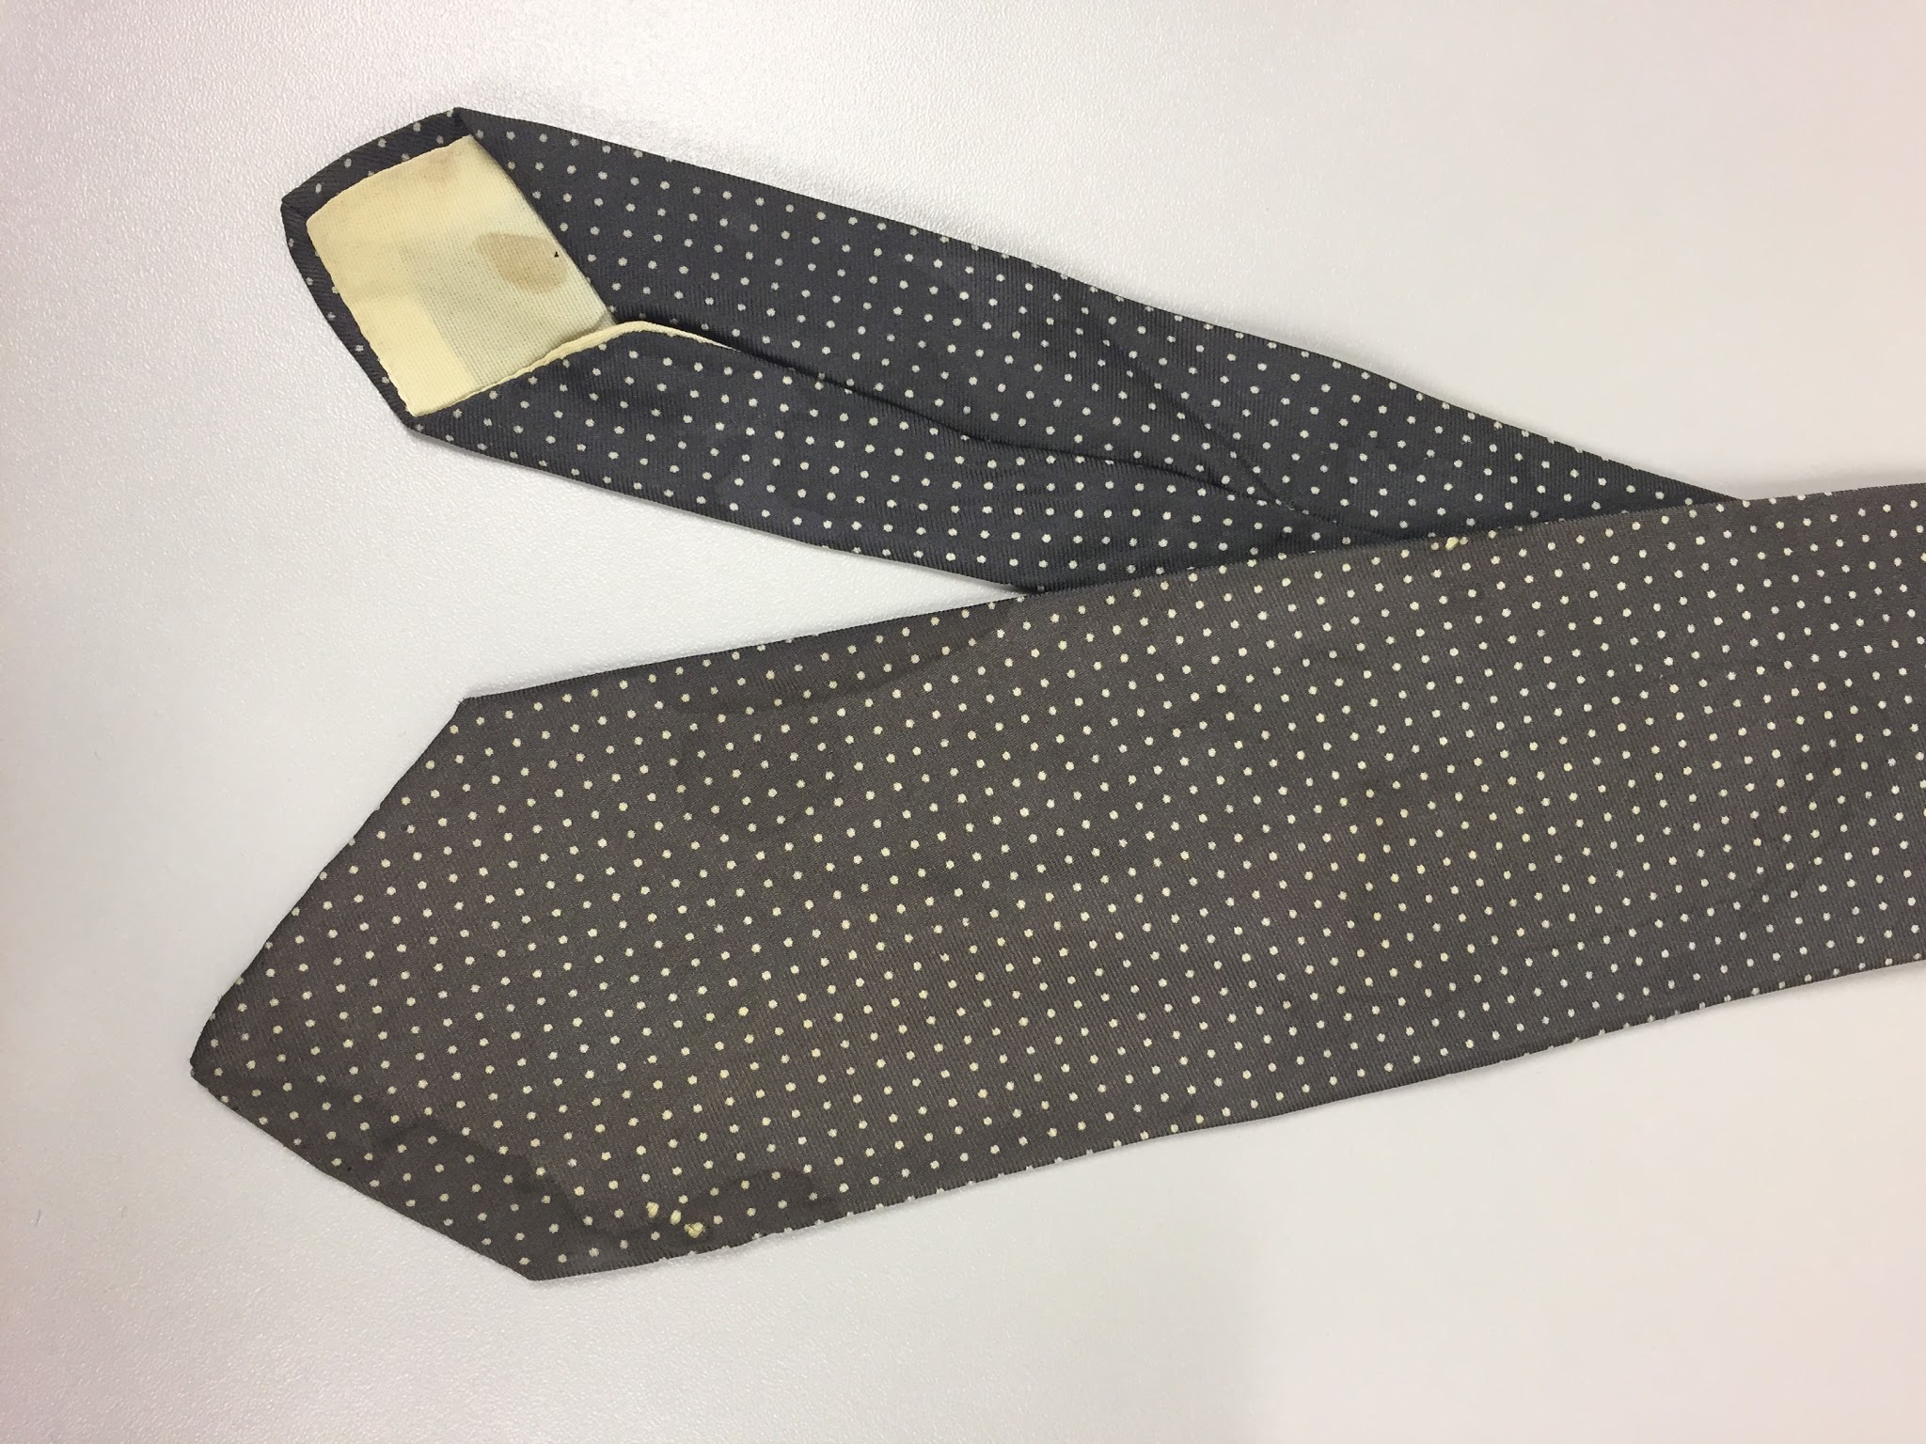 | Necktie, mid grey with small white dots | Tieswell | Silk
109 | 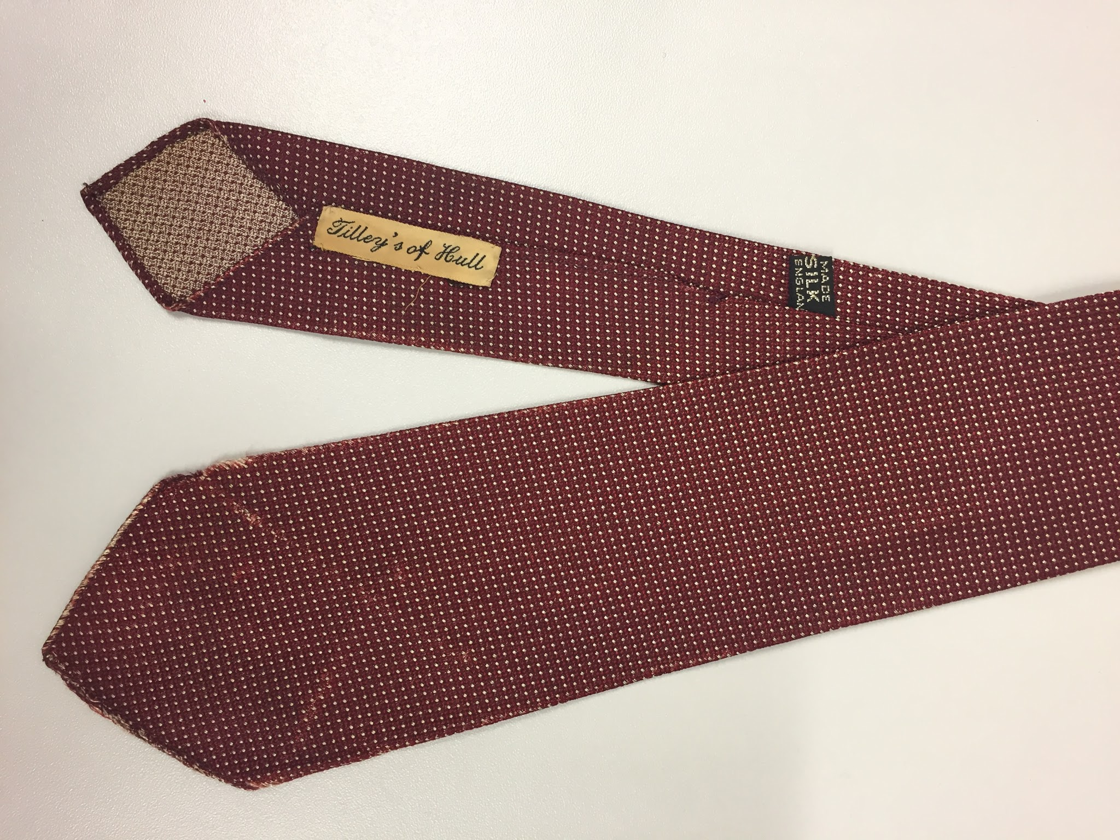 | Necktie, dark red with fine white dots | Tilley’s of Hull | Silk
110 | 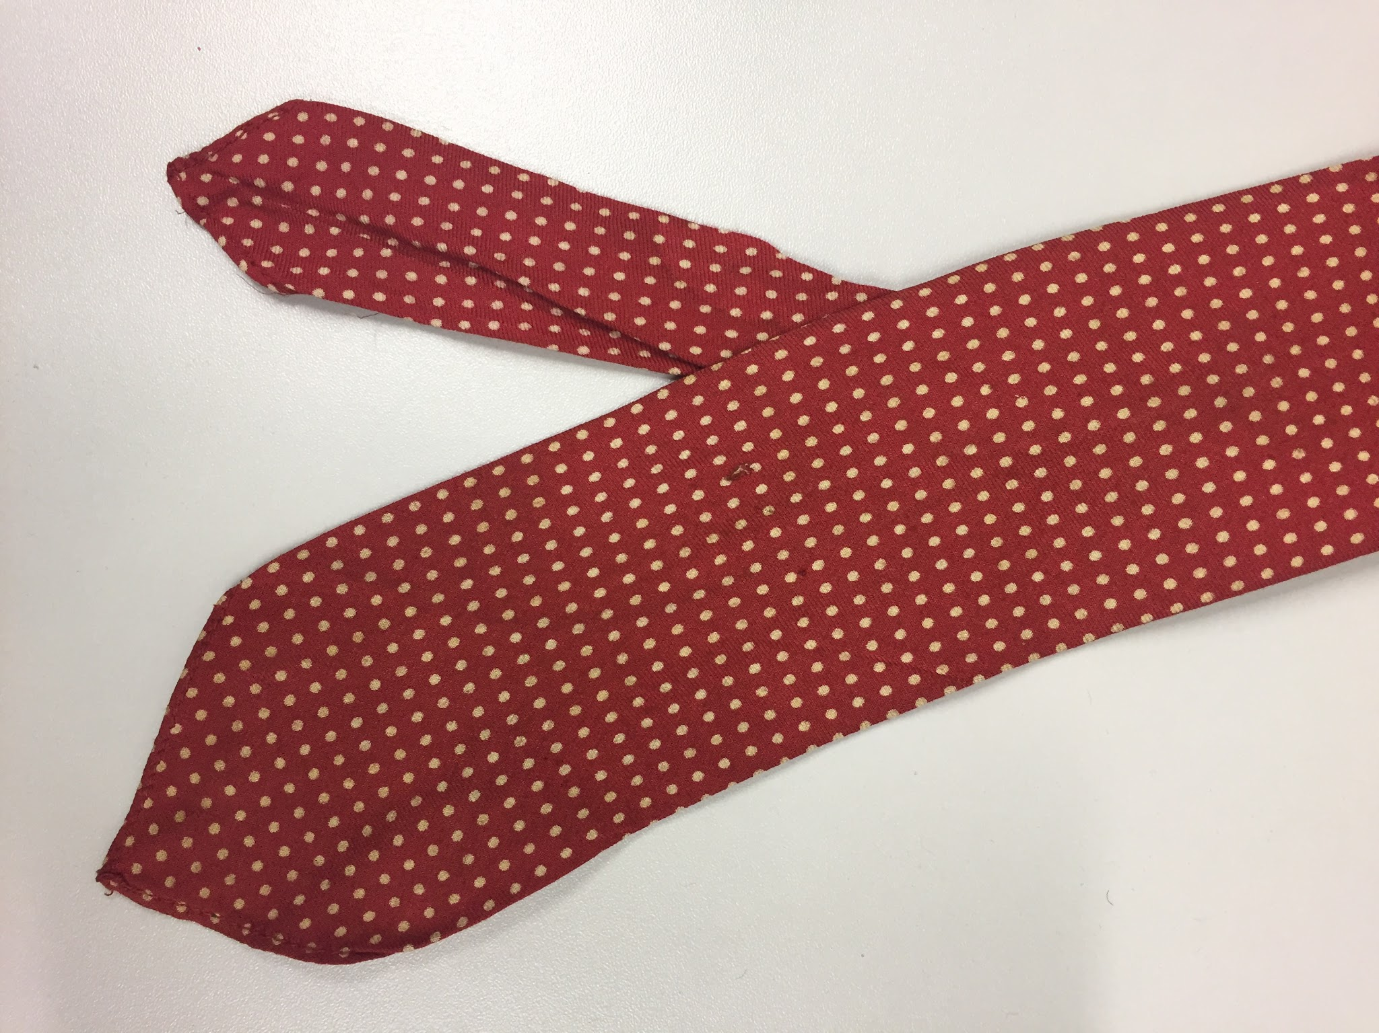 | Necktie, red with cream dots | Linosair | Silk
111 | 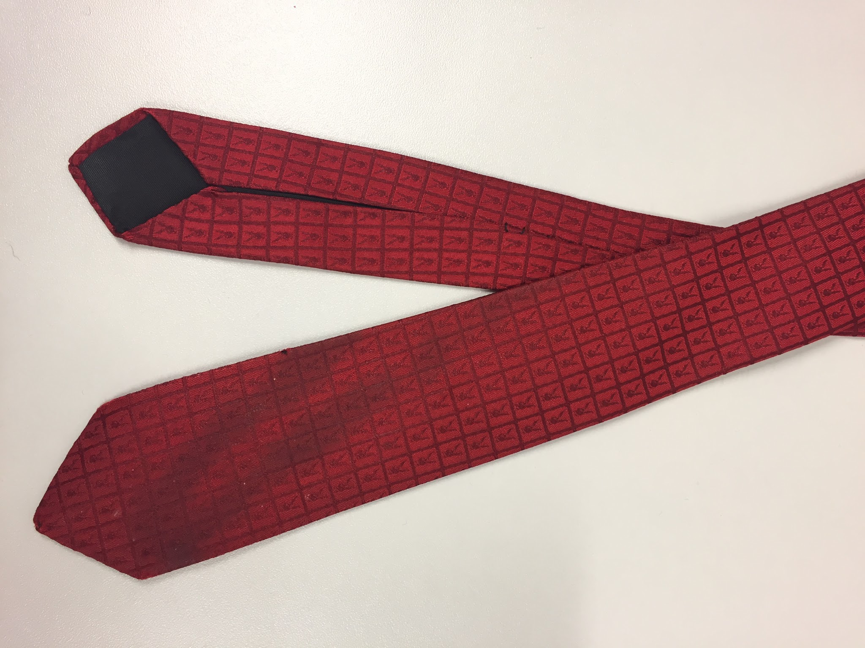 | Necktie, playboy check design | Playboy club tie, dated 1954 | Silk
112 | 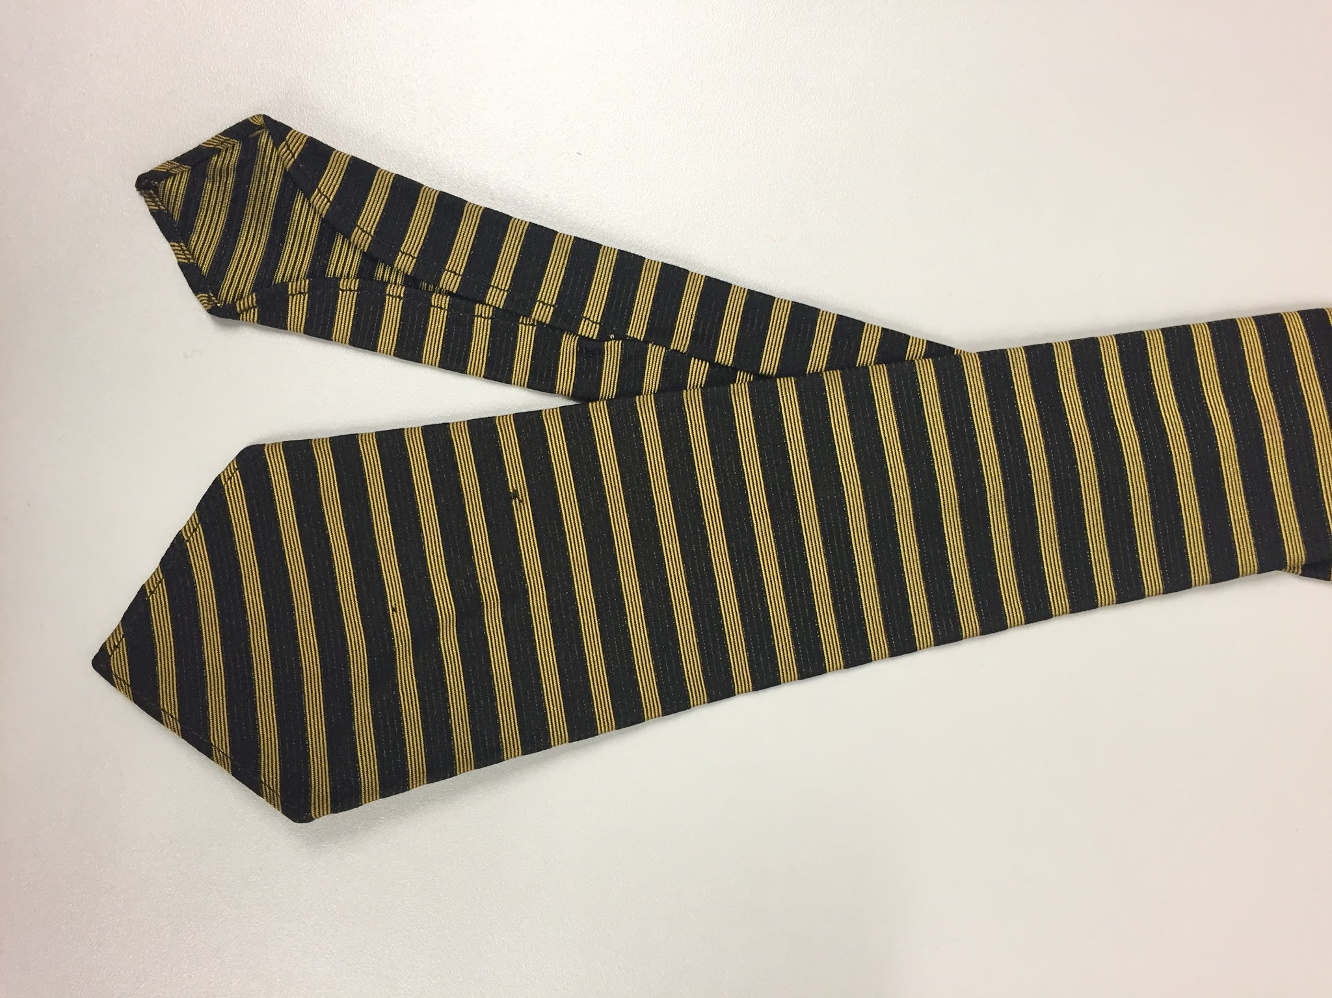 | Necktie, black and gold horizontal stripe | Sirodain | Silk
113 | 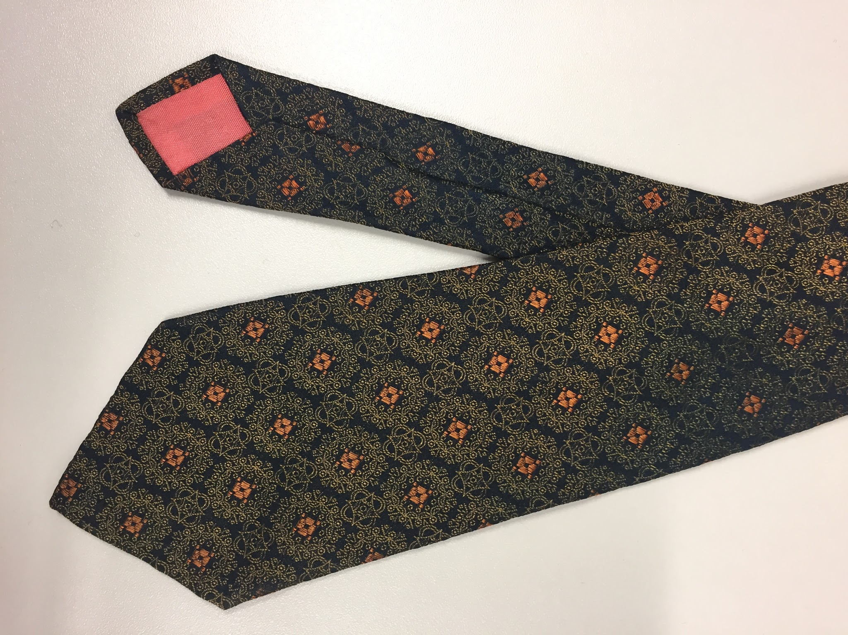 | Necktie, Navy with gold and orange pattern | Michelsons | Silk
114 | 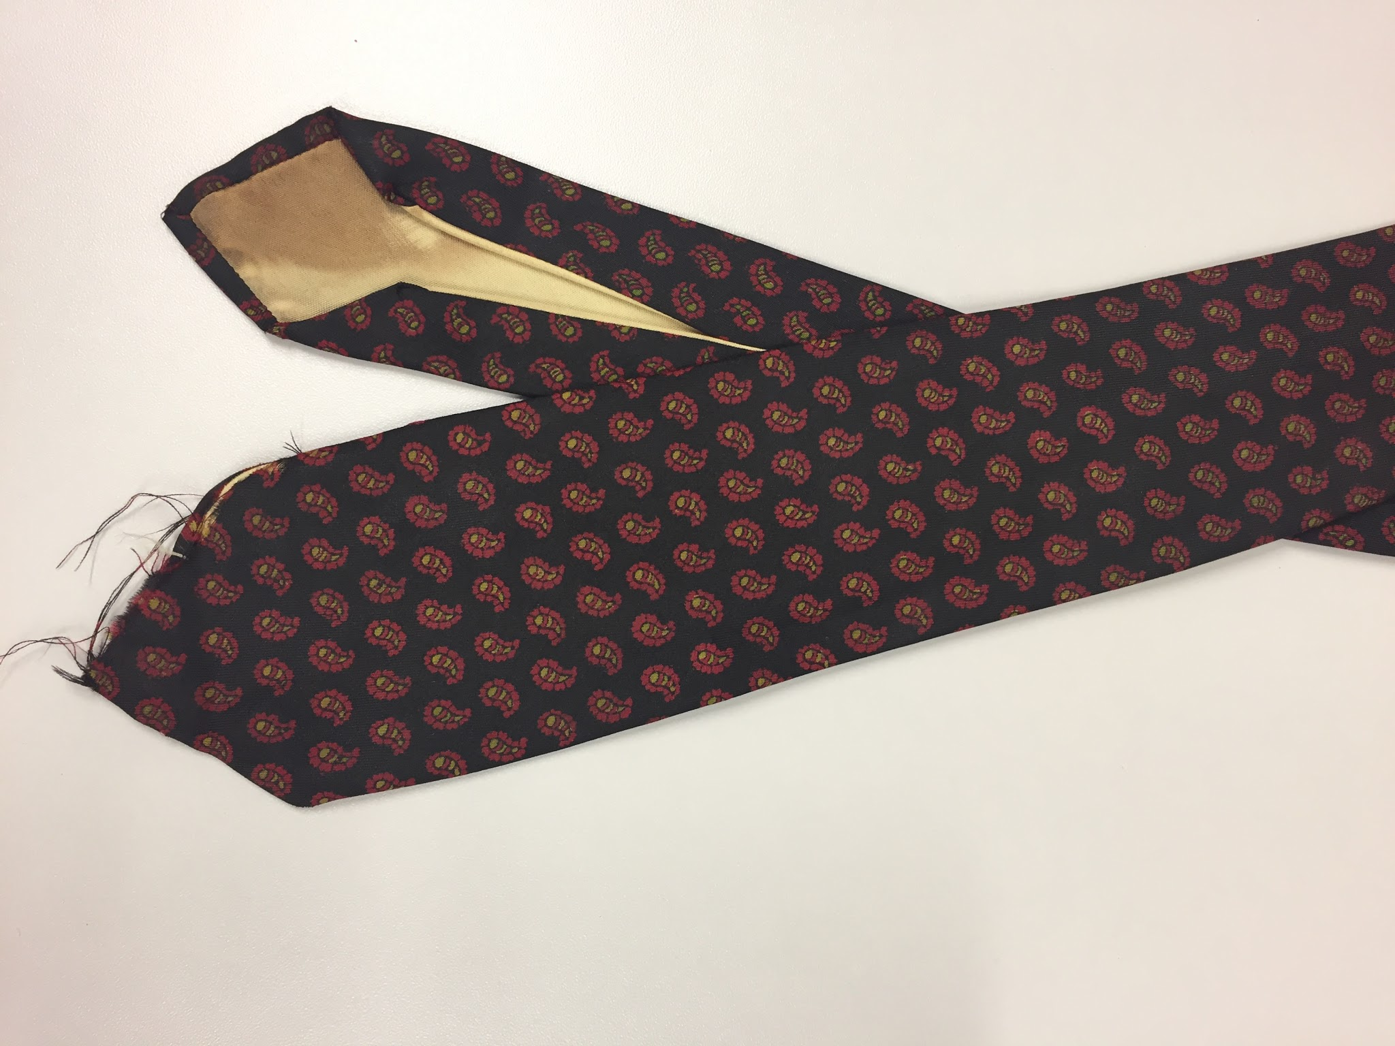 | Necktie, black with green and red paisley | Austen Reed | Gum twill
115 | 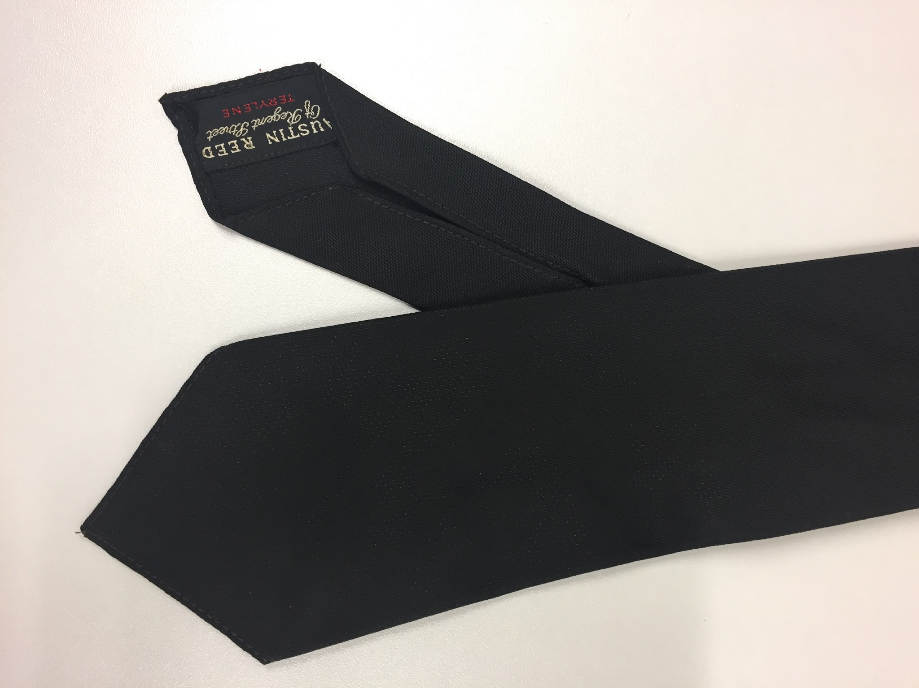 | Necktie, plain black | Austen Reed | Terylene
116 | 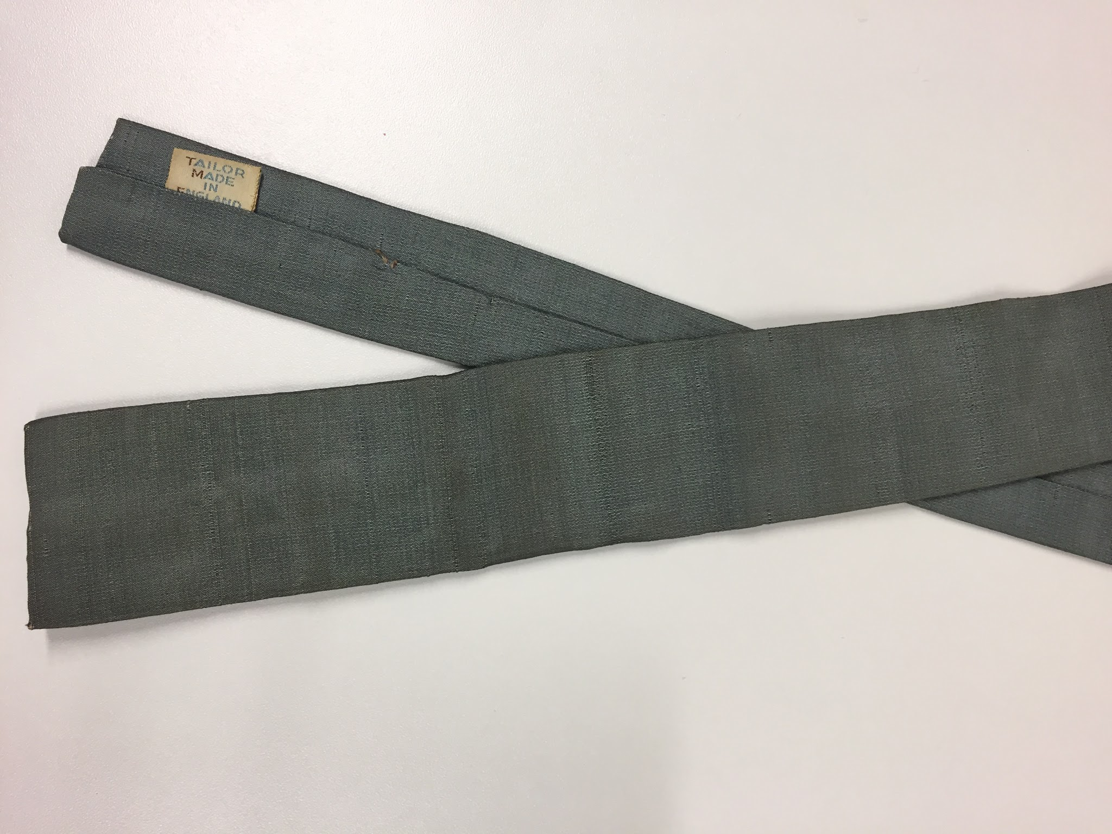 | Necktie, Silver, square | Harrods | Silk
117 | 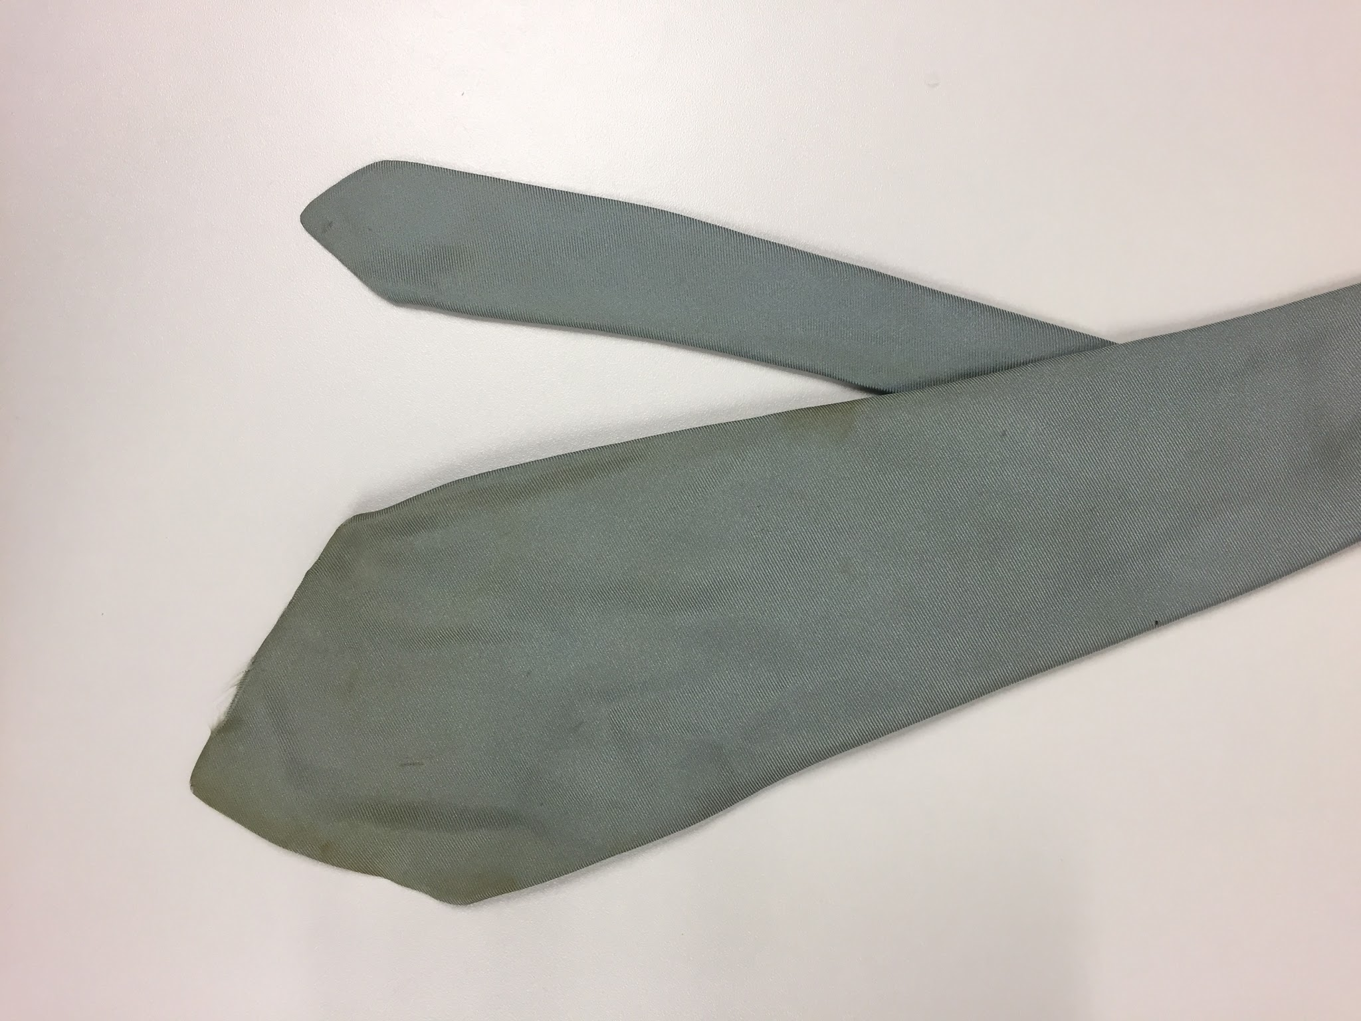 | Necktie, duck egg blue, wide | Austen Reed | Silk
118 | 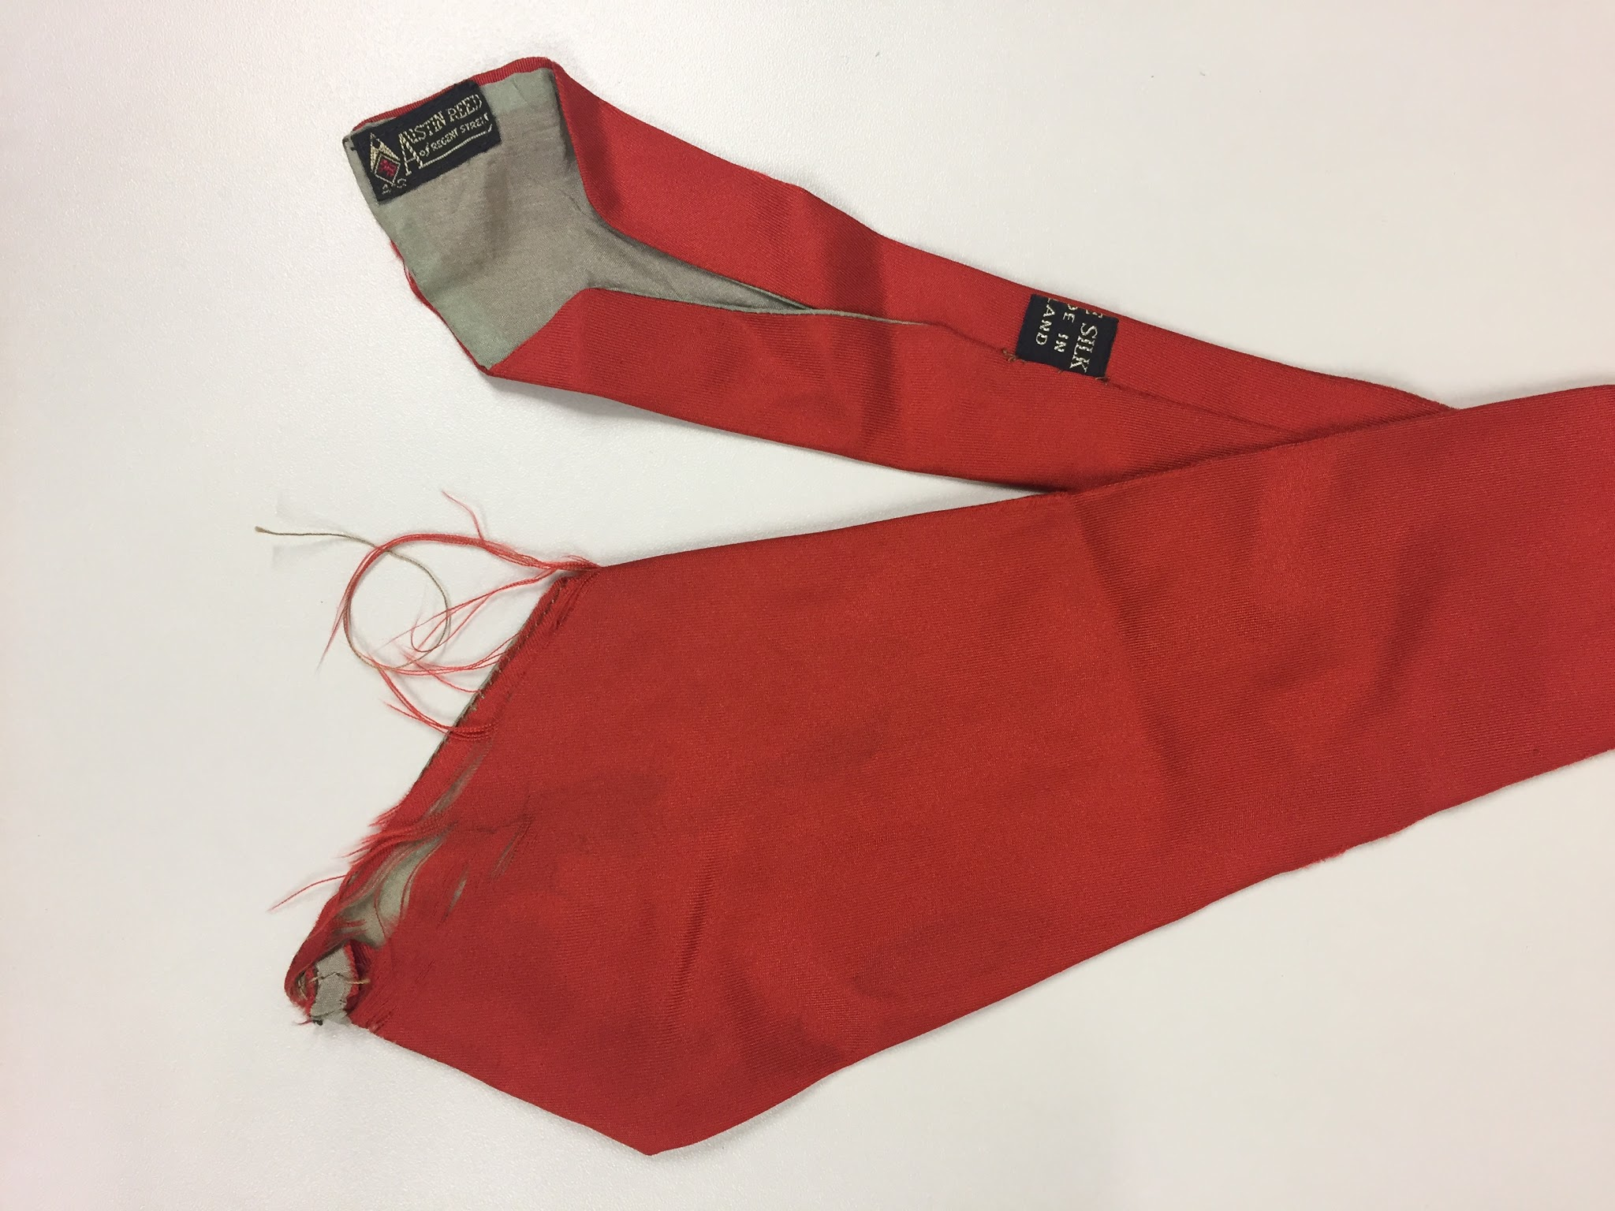 | Necktie, orange, wide | Austen Reed | Silk
119 | 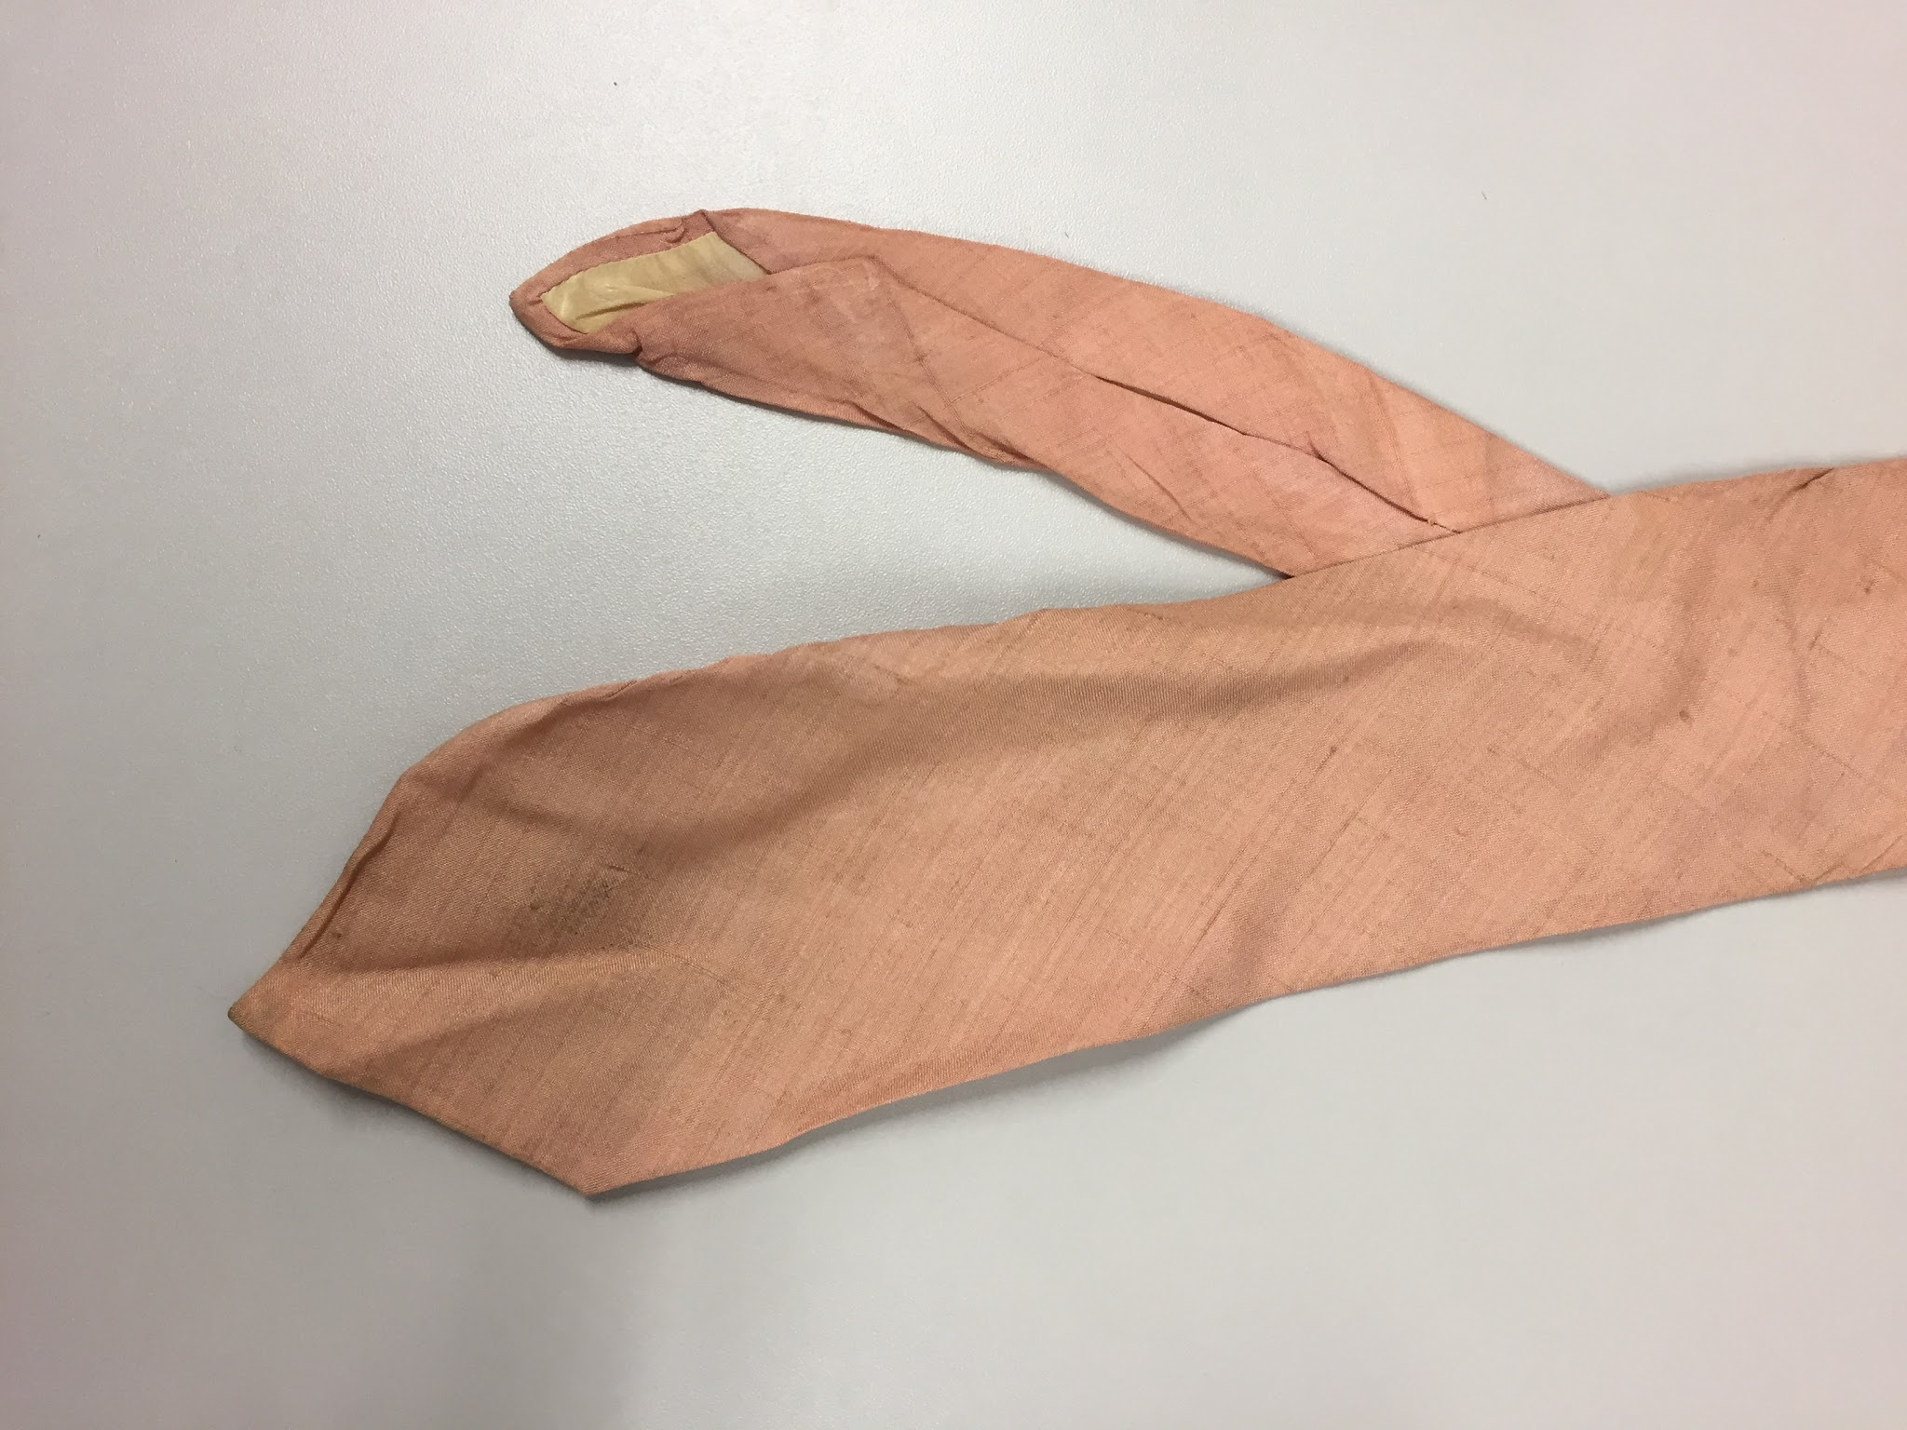 | Necktie, pale peach | Contie | silk

