**Tell the World**

How digital integration can build new and global audiences.

Dominic Gray (Opera North), Nina Rogers (Yorkshire Sculpture Park), Daniel Elms (New Sound Collective), Katherine Jewkes (MIF/Space) discuss how embracing digital technologies can bring new and global audiences to artists and work.

**Susannah Simons - Chair**

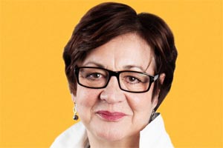

**Director for Arts and Outreach for CANVAS at Brave Bison**

Susannah Simons is Director Arts and Outreach for Canvas, the Arts Council England funded project designed to grow the audience for arts based online video particularly among the 18-30 year old demographic, whilst simultaneously developing the skills base of the sector with a mixture of online tutorials, workshops ,one-to-one surgeries and advice on digital strategy.

She was previously the Head of Policy and Outreach for BBC Radio and Music and was the Project Director of the BBC's engagement with the Cultural Olympiad between 2008 and 2013 , in which role she was also responsible the pilot phase of The Space.

She began her career as a broadcaster with BBC Radio 4 presenting the PM programme , World at One and Today before joining Channel 4 as presenter of Business Daily. She was one of the original presenters at Classic FM before swapping sides to become the Director of Communications of the GWR group and then returned to the BBC in a management role.

She is a Trustee of The Orchestra of the Age of Enlightenment , One Dance UK and the PRS Foundation for Music.

**Daniel Elms - Panellist**

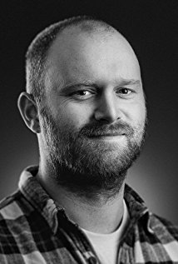

**New Sound Collective and Hull Born Artist**

Daniel Elms’ distinctive voice as a contemporary composer, humanist and prolific collaborator is captured in emotive soundscapes, which effortlessly fuse intricate orchestral textures with the electroacoustic instruments and urban sounds synonymous with his hometown of Hull in the North of England. Elms studied composition at the Royal College of Music under Joseph Horovitz and was mentored by Kenneth Hesketh, Peter Stark, and Carlos Bonell. Taking inspiration from progressive and humanist ideologies, his work addresses disparate social, economic, and political relationships between people and cities, and offers intimate commentaries on the human condition.

Elms’ music has been performed by members of the London Symphony Orchestra, Welsh National Opera, the Academy of St Martin in the Fields, the Aurora Orchestra, Britten Sinfonia, the Balanescu Quartet, the Jubilee String Quartet, and prominent soloists such as Richard Harwood, Thomas Gould, Peter Gregson, Joby Burgess and Giacomo Bigoni. Elms has also amassed a varied repertoire of collaborative works across feature film and theatre, including the BAFTA-nominated Ralph, the Academy-Award-nominated Library of Burned Books, Plaques and Tangles at Royal Court Theatre, and additional music for Taboo by Ridley Scott and Tom Hardy, for which he worked closely with fellow composer Max Richter.

**Nina Rogers - Panellist**



**Head of Marketing and PR Yorkshire Sculpture Park**

As Head of Marketing & PR at Yorkshire Sculpture Park, Nina Rogers has helped to take the UK’s leading sculpture park from hidden gem to CoolBrand and Art Fund Museum of the Year winner. Over the last 8 years she has transformed YSP’s digital presence, using audience insights to redesign the website, working with internationally renowned street artist KAWS to harness Instagram and using the latest technology to develop a new app with The Space. Nina held previous roles at Eureka! The National Children’s Museum and the V&A Museum of Childhood.

**Katherine Jewkes - Panellist**

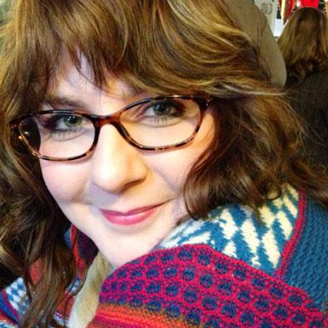

**Digital Producer at MIF & Associate at The Space**

Helping artists and organisations to playfully integrate technology into their work, supporting Policy makers and large organisations to nurture the sector as it develops talent in this area, and designing adventurous experiences that use technology at a range of scales from intimate one-on-one interactions to city-wide games and performances that surprise and delight audiences. Katherine loves transforming space with technology and installation design, and is at her best creatively when working in response to an interesting location.

Digital Producer #mif17 @MIFestival / Associate @thespacearts

**David Collins – Panellist**

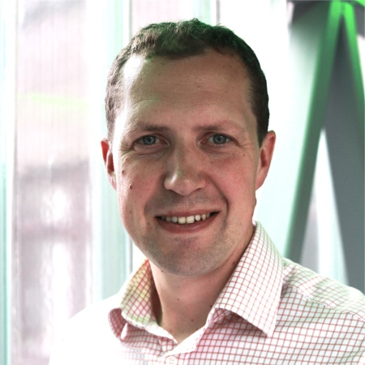

**Director of External Affairs at Opera North**

David Collins joined Opera North in 2016 as Director of External Affairs. His remit covers all marketing, communications and fundraising for the Company, a crucial part of which is the development of a digital strategy to take Opera North forward. In a crowded market place of live to cinema broadcast, the Company strives to find distinctive ways to create and distribute work digitally. Prior to joining Opera North David was Head of Marketing at the Royal Shakespeare Company where he helped launch their programme of cinema broadcasts, *Live from Stratford-upon-Avon,* and worked on digital projects that ranged from their recent collaboration on live motion capture with Intel, to a real time social media performance on Google plus in collaboration with Google Labs.