**How Can Arts Save the NHS?**

10:30 – 11:15 at 1@the Dock

**Nikki Bedi –** 07888723429

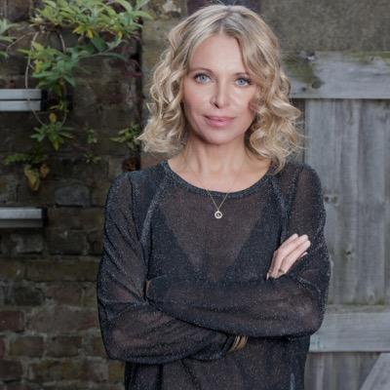 Televison and radio broadcaster with a passion for making arts and culture accessible.

**Nicky Taylor –** 07888723429

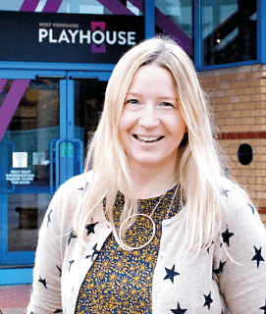Theatre & Dementia Research Associate

**Vicki Amedume -** 07939027444

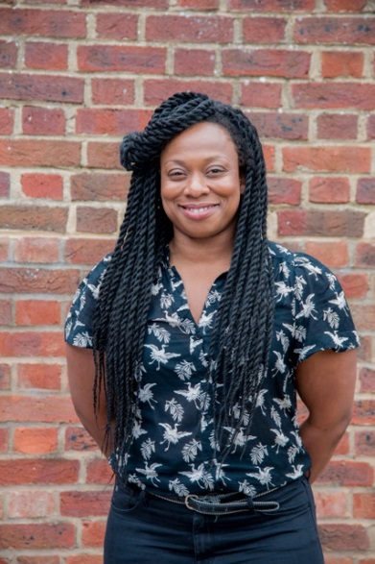 Artistic Director Upswing

**Dr Dan Roper -** 07760270467

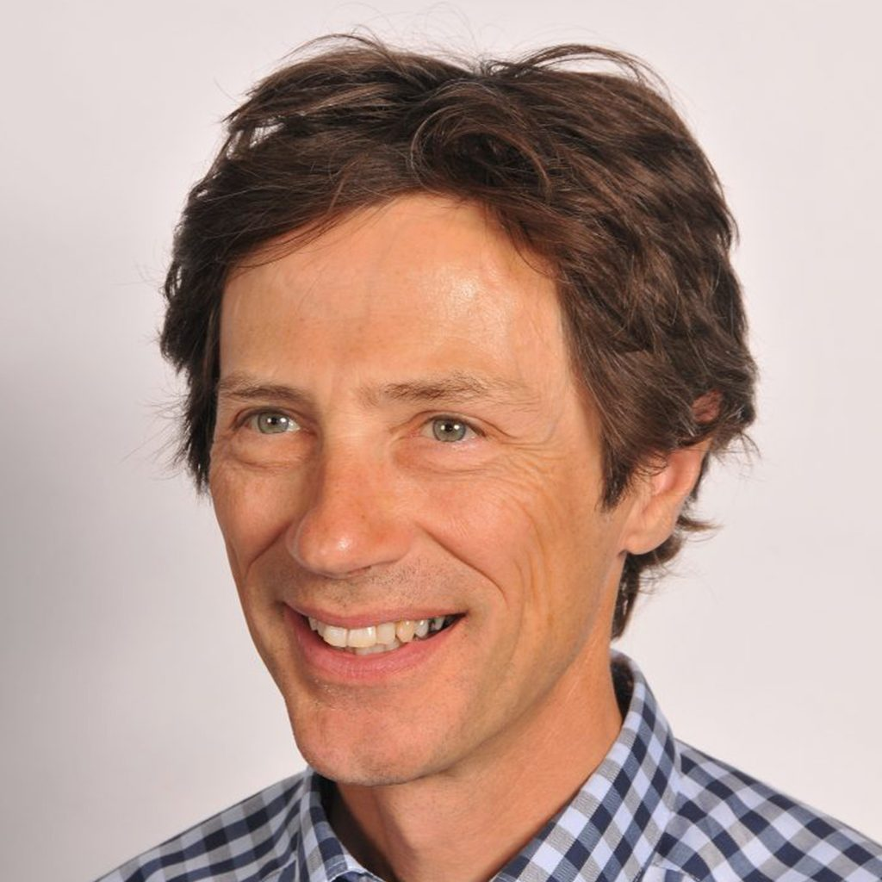Chair of Hull Clinical Commissioning Group

**Alex Mitchell -** 07855801234

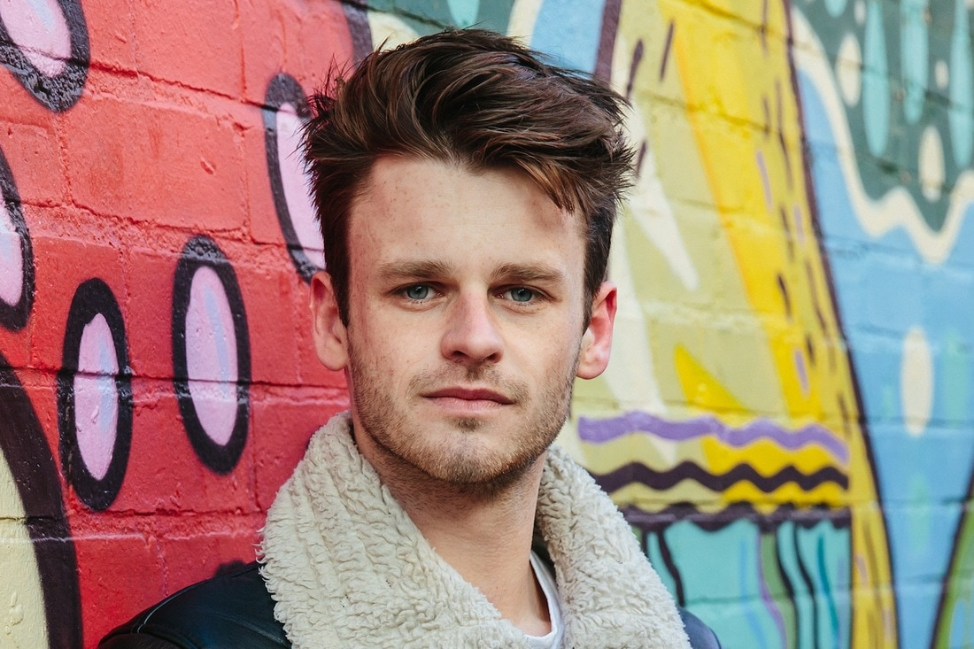 Artistic Director Silent Uproar

**Sarah Emmott -** 07763643281

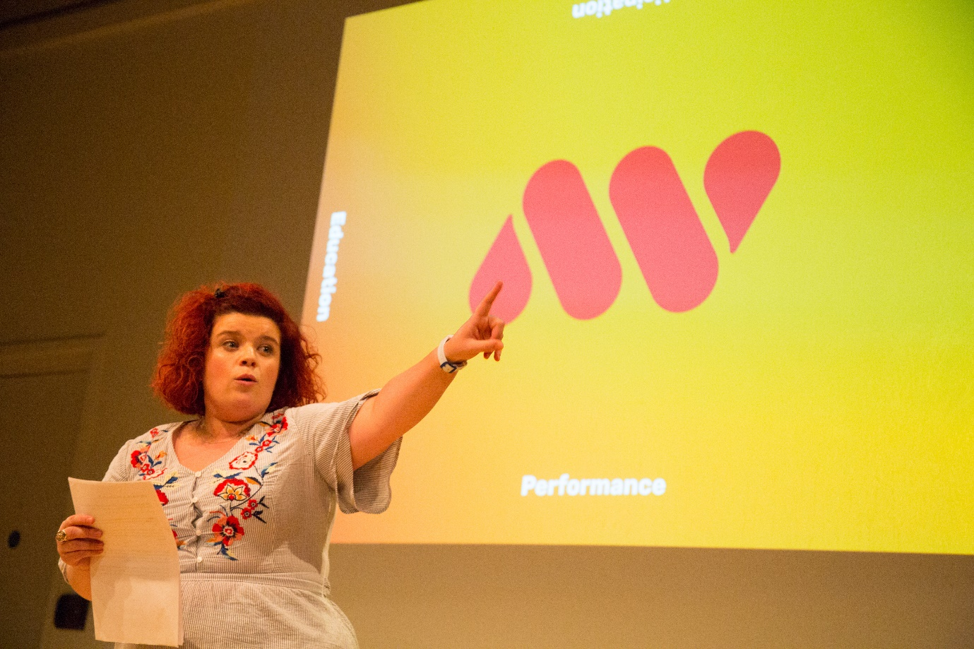 Creative Director: Art with Heart