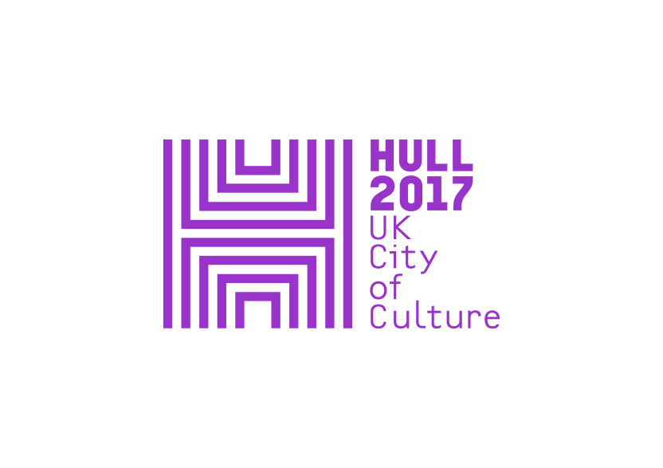

**PRESS RELEASE**

**Thursday 27 July 2017**

**ARTIST TO INSTALL LIFESIZE WHALE ARTWORK INTO**

**HULL DOCKSIDE SHOPPING CENTRE**

Consumerism and city's links with the sea explored

in latest Hull 2017 Look Up installation

**LOOK UP: ELEPHANT IN THE ROOM**

**BY CLAIRE MORGAN**

**7 August – 15 October 2017, Princes Quay Shopping Centre, Hull**

A striking, large-scale artwork modelled on the Greenland Right Whale, also known as the Bowhead Whale, is to be suspended in the central atrium of Hull's Princes Quay shopping centre, as part of the UK City of Culture 2017’s ***Look Up*** programme of public art.

Artist Claire Morgan is creating the major new artwork, called *Elephant in the Room*, which highlights Hull’s relationship with the sea and concerns about the environment and sustainability. Created over several days in full view of shoppers visiting Princes Quay, which sits on stilts above the original Princes Dock, dating from 1829, the completed artwork will be able to be seen from Monday 7 August.

From the beginning of its installation on 31 July people passing through the shopping centre will see over 12,000 fragments of paper and 4,270 individual threads come together to create the form of a life-size whale. When complete *Elephant in the Room* will measure 16.5m x 5m x 3m, drawing on its sense of place whilst massively altering the public space. The visible labour involved will directly touch on the notion of human ambition and endeavour.

Claire Morgan’s installations have been seen all over the world. From nature to industry to morality, she often draws together conflicting elements to explore how they interact.

She was fascinated by the significance of the whaling industry in Hull. The city was a major whaling port, with trade peaking around the 1820s, and accounting for around 40% of the British whaling industry at that time.

In 1869, the last remaining whaling vessel sailing from Hull was wrecked on its journey home, after which the industry moved to Scotland. In the 1970s public attitudes towards whales and whaling began to change, and cheaper alternatives were also being found for whale products. In 1982, commercial whaling was halted altogether.

But while most countries now no longer kill whales through hunting, in recent times many whales have washed up dead on beaches in UK and other European countries with stomachs full of plastic waste. Our throwaway consumer culture is having an incredible impact on the sea.

Claire Morgan said, *"With my installations, I hope to create things that provoke thought, wonder and something of the impossible**or**the unknown.*

*“I tend to draw a lot of different, often conflicting things together: nature and our difficult relationship with the rest of the living world, contemporary life, industry, popular culture, mortality, and how these things are intertwined.*

*“Elephant in the Room is a direct, specific response to its location: the function of the place and its physical position, located over the water. It’s also a response to Hull’s past, particularly its maritime history, and how that history might fit into our contemporary world."*

Claire’s other recent site specific work includes *Murmurations* at 111 Buckingham Palace Road; *Undercurrent* and *Coming Up For Air*, Oncologisch Centrum Spaarne Ziekenhuis NL; *Enchanted Parks*, Saltwell Park, Gateshead; *To Woo You*, Town Hall Hotel, London; and *Canopy* The Big Chill Festival 2009.

Sam Hunt, Executive Producer at Hull 2017, says: "Claire Morgan's artwork Elephant in the Room offers a commentary on Hull's maritime heritage and our consumerism. It will be fascinating to see how the public responds to it taking shape, as the artist completes the work, and the impact it has on what is a prominent landmark suspended over a historic site."

Sarah Smith, Marketing Manager at Princes Quay, says: “The City of Culture’s Look Up project has already had a huge impact on the city centre with thousands of additional visitors, so we hope that many more will come and visit the stunning installation within Princes Quay. Our unique central atrium will provide a striking space to suspend the 16 metre long sculpture which will hover above the heads of shoppers on the quayside level and there’ll be many more vantage points from around the centre. We’re thoroughly excited and privileged to be involved with the project and can’t wait to see it take shape.”

<http://www.claire-morgan.co.uk/home>

Princes Quay Shopping Centre - Free

For press information, please contact:

Susie Gray or Clair Chamberlain at The Corner Shop PR

[susie@thecornershoppr.com](mailto:susie@thecornershoppr.com) /07834 073 795

[clair@thecornershoppr.com](mailto:clair@thecornershoppr.com) / 020 7831 7657

For general information about Hull UK City of Culture 2017, please contact;

Ben McKnight – [ben.mcknight@hull2017.co.uk](mailto:ben.mcknight@hull2017.co.uk) / 07718 100 793.

Notes to editors

**Look Up** is a year-long programme of major public art commissioned by Hull UK City of Culture 2017 and made for the Hull’s public spaces and places, co-curated by Andrew Knight and Hazel Colquhoun.

Each installation will reflect Hull’s history, its present or future, each will catch passers-by by surprise interrupting the public realm with ideas that amuse, confront or challenge residents and visitors alike.

The first Look Up installation was Nayan Kulkarni’s ***Blade***, a 75 metre long Rotor blade that would normally be at the top of a wind turbine, which became an artwork and a spectacular interruption into the newly renovated public space in January this year. The second which runs till the end of the year is Michael Pinsky’s ***The City Speaks*** which functions as a 21st century Speakers’ Corner in which open-air public speaking takes on epic proportions as spoken words are translated to text and relayed on the west tower supporting Hull’s Tidal Surge Barrier.

During seasons two and three, *Look Up* sees commissioned works popping up in shopping centres, train stations, car parks, streets and public squares, by artists including Bob & Roberta Smith, Tania Kovats, Chris Dobrowolski and Claire Barber.

*Look Up* has been developed in partnership with a number of organisations and companies including The Deep, GF Smith, Hull School of Art & Design and Royal Institute of British Architects (RIBA).

**HULL UK CITY OF CULTURE 2017**

**Hull UK City of Culture 2017** is a 365 day programme of cultural events and creativity inspired by the city and told to the world. Hull secured the title of UK City of Culture 2017 in November 2013. It is only the second city to hold the title and the first in England.

**Divided into four seasons**, starting with **Made in Hull**, this nationally significant event draws on the distinctive spirit of the city and the artists, writers, directors, musicians, revolutionaries and thinkers that have made such a significant contribution to the development of art and ideas.

Hull 2017’s second season, **Roots and Routes**, runs from April to June and explore Hull’s unique place as a gateway to Europe and one of the world’s busiest ports. Its maritime history and global connections inspire the stories of the city; this season of work will also celebrate Hull’s international links, including Rotterdam, Reykjavik and Freetown.

**Freedom** runs from July to September. Building on the legacy of Hull-born anti-slavery campaigner William Wilberforce MP, *Freedom* will explore the concept of freedom in all its many forms. The final season, **Tell the World** will run from October to December.

The Culture Company was set up to deliver the Hull 2017 programme and is an independent organisation with charitable status. It has raised £32 million, with over 70 partners supporting the project, including public bodies, trusts and foundations and local and national businesses.

Key contributions are coming from: **Host City** – Hull City Council; **Principal Partners** - Arts Council England, BBC, Big Lottery Fund, East Riding of Yorkshire Council, Heritage Lottery Fund, KCOM, KWL, Spirit of 2012, Yorkshire Water and the University of Hull; **Major Partners** –Associated British Ports, Arco, BP, the British Council, British Film Institute, Green Port Hull, Hull Clinical Commissioning Group, MKM Building Supplies, P&O Ferries, Paul Hamlyn Foundation, Sewell Group, Siemens, Smith & Nephew and Wykeland Group. The National Lottery has contributed more than £10m of this funding, making it the largest single funding body for Hull 2017.

Hull 2017’s International Partners are: Aarhus, Denmark, which is European Capital of Culture 2017; Reykjavik, Iceland; Rotterdam, The Netherlands; and Freetown, Sierra Leone (twinned with Hull). These relationships are reflected in a number of events throughout the year.

For information go to [www.hull2017.co.uk](http://www.hull2017.co.uk) Follow us on Twitter @2017Hull Instagram @2017hull Facebook HullCityofCulture