**Saturday, 19 August 2017**

**The Gold Nose of Green Ginger**

Today we welcome a very special treasure, given to the city for safekeeping and on display in our atrium for the foreseeable future.

In 1967, foundations to lay the first houses on the Bransholme estate were being laid. During the excavations, workmen were puzzled when they came across a small casket buried deep within the crowd; pulling it out and brushing the dirt away, they opened it to reveal a strange gold object inside.

Described as ‘*looking like a ginger root…roughly in the shape of a warty nose’*, it had two nostrils and braided silk ties, indicating it was perhaps worn ceremonially at some point.

*The Gold Nose of Green Ginger*, as we now know it is called, has been mentioned throughout the annals of history, but has always been considered an urban myth. Shortly after its discovery on Bransholme, it swiftly disappeared again – no one knows quite why, but some reports claim that those who came into contact with it were blessed with unexplainable and plentiful good luck, so it was hidden from public interest until it could be fully understood. Others say it was stolen by someone who wanted to be exclusively imbued with fortune, while others believe it was quite simply lost



There is no evidence to suggest when and/or where The Gold Nose was first documented. Some theories suggest a boar, long considered a magical creature and deeply connected to the earth’s energies, had been foraging for food in the water meadow that became Bransholme and unearthed it (the name Bransholme coming from the old Scandinavian phrase meaning ‘*wild boar water meadow’*). Other variations on this story tell of the boar having special powers and turning the root gold itself.

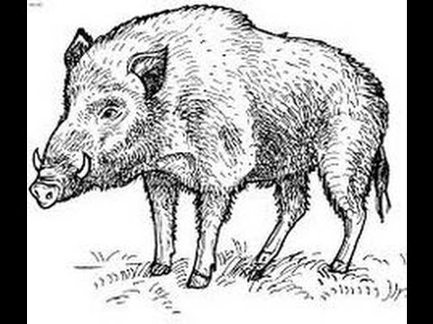

But what exactly is it? One popular theory relates to the discovery of excavations in the 1970’s in Wroxeter, Shropshire, where a set of Roman-period gold eyes - believed to bring healing to those suffering from ophthalmological conditions - were discovered. It is thought they were an offering to the gods; could The Gold Nose be something similar?  What we *do* know is Roman discoveries have been made across the region, including Roman coins found at Castle Hill and across Bransholme, so it’s possible.

We also know that an [amulet](https://en.wikipedia.org/wiki/Amulet) known as a ‘Bulla’ was given to male [children](https://en.wikipedia.org/wiki/Children_of_Ancient_Rome) in Ancient Rome nine days after birth. Meant to protect against evil spirits and forces, these would often be made of different materials depending on social status; usually lead or leather, but gold in wealthy families. There have been suggestions that The Gold Nose could be a variation on this, but this is so far unproven. Laboratory analysis does however confirm it is made of real gold.

But how did The Gold Nose come to Hull History Centre? Back in April, a local group of experts were called in to investigate the discovery of a large cache of crates found in a previously unknown vault beneath the city. During their extensive investigations, The Green Ginger Fellowship (link to greenginger.org) were drawn to a crate that smelled unmistakably of ginger; upon opening it, they discovered The Gold Nose lying within.

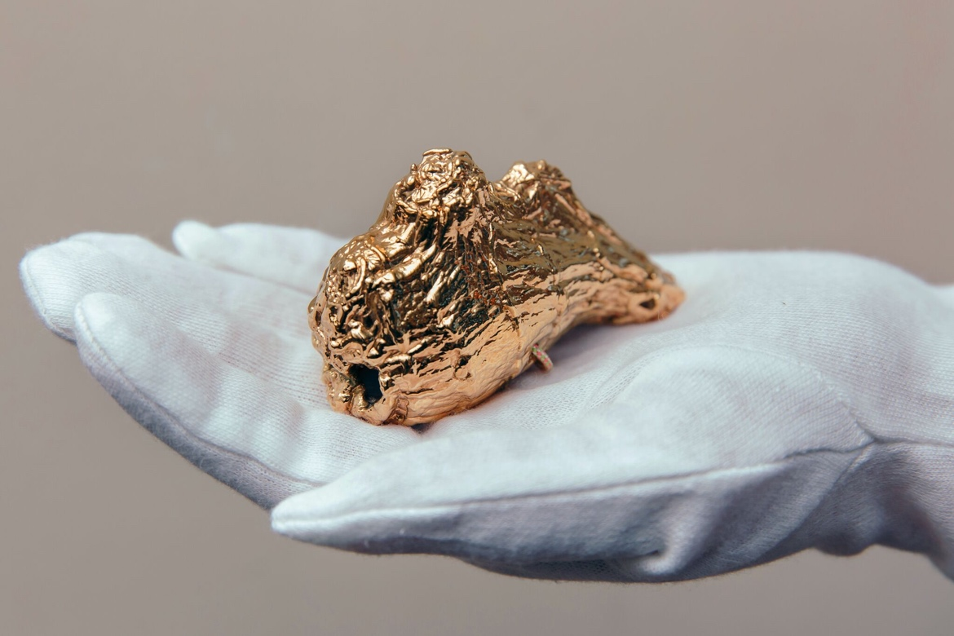

After much public interest in this unexpected rediscovery, The Gold Nose began a momentous two-month residency from Saturday 17 June 2017 at North Point Shopping Centre in Bransholme, Hull, displayed for the public to view at close quarters and make wishes on. It has now been handed back to the City of Hull for safekeeping, residing with us until it continues on its adventure.