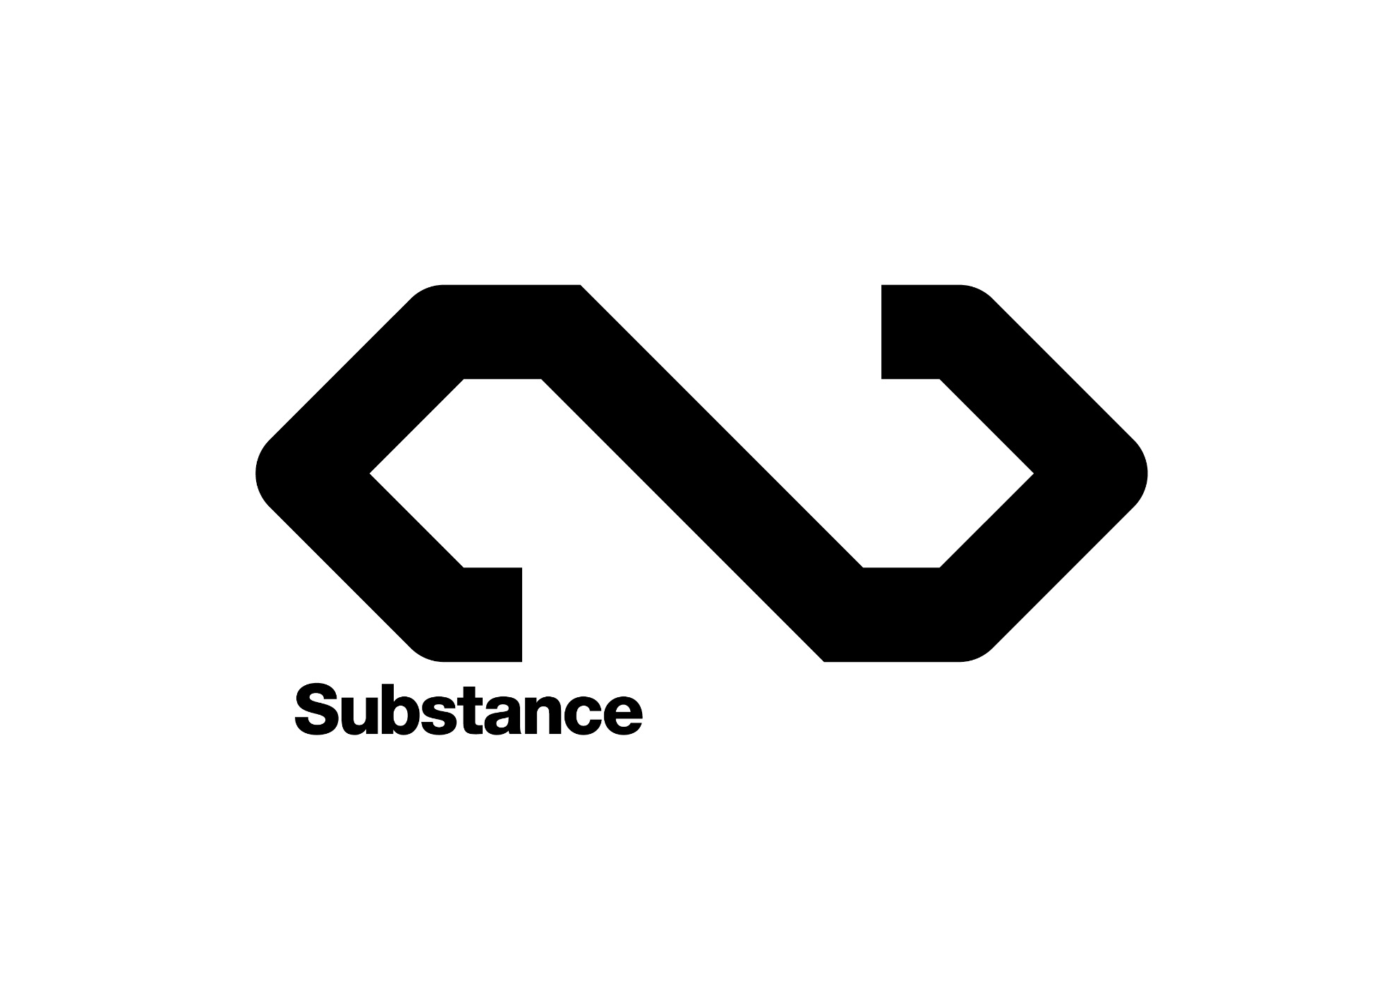

**Internal plan for 2017**



**Mission statement**

* Substance is a new celebration of the creativity, cultural diversity and future of the North.
* Performances, installations and events across the North, promoting ground-breaking, innovative and pioneering artists, and bringing them to a new audience.
* Taking those artists into the community, and to schools and colleges, to provide education and inspiration for the next generation of artists.
* Helping provide a cultural counterweight to a dominant South East, in order to help redress the geographical cultural inbalance.

**Update on partners and possible new partners**

**Hull 2017**

Luke Bainbridge regularly liaising with Martin Atkinson and Sam Hunt. Contract signed and counter signed in December 2017. Funding has been released for first two instalments of funding, as per contract. Funding should be released ASAP, which is quite key as Substance have been making payments upfront so far.

**The Quietus**

In December 2016 and January 2017, Luke Bainbridge agreed a deal with **The Quietus** to become a media partner of Substance. As part of the deal Substance will co-commission regular articles from new writers from across the North, writing on subjects relevant to Substance. The Quietus will also support/publicise Substance events throughout 2017.

**The Guardian**

Luke B in discussion with The Guardian about supporting Substance. First meeting went well, follow up meeting at the Guardian on Tuesday 17 January.

**Manchester International Festival**

David Norris met with MIF to discuss potential joint event in Manchester in summer 2017 to mark 10th anniversary since the passing of Tony Wilson. MIF are interested in theory. David, Luke and Jon Drape to meet with Christine Cort, MIF Director on 26 Jan to discuss further.

**BFI**

We have £19,000 additional funding from BFI, for 'building audiences for independent film'. Martin Atkinson met with Anna Plant to discuss on 11 January. Luke B and Martin A to look at best use of funding for Leeds event and possible Ken Loach event in Hull. Also look at working with Into Film and BFI Film Academy in schools in Hull. Luke B, Anna and Martin to lead.

**Liverpool 2018**

Robin Kemp.

St Lukes decision in the next month

**Sunderland 2021**

Luke Bainbridge in discussion with Rebecca Ball, head of Sunderland's bid for UK City of Culture 2021, to partner on an event in Sunderland.

**Northern Fiction Alliance**

Luke Bainbridge met with the Northern Fiction Alliance and Comma Press in December 2016, to discuss collaborating on an event, and a possible book of short stories from Hull, or new voices from the North. NFA and Comma very keen to collaborate on this. Luke B to lead on this, and look to confirm in the next few weeks.

Northern Fiction Alliance (NFA) is a cohort assembled to showcase the output of northern indie presses to the international market in an attempt to “level the playing field” and promote regional diversity in publishing. The core NFA cohort includes Peepal Tree Press (Leeds), And Other Stories (relocating to Sheffield from High Wycombe), Dead Ink Books (Liverpool) and Comma Press (Manchester). The cohort will showcase and sell the work of "exciting and diverse” authors to help build the cultural identity of independent British fiction as well as British publishing based in the North.

**RIBA**

Sam Hunt suggests partnering with RIBA on the event they want to do with Patrick Scumacher in Hull, debating social housing. Would come under Substance umbrella.

**Substance event plan for 2017**

Throughout 2017, Substance will celebrate the cultural diversity of the North by bringing groundbreaking artists to new audiences with a series of innovative and provocative events across the North.

Following on from the inaugural Substance event, that took place in Hull in November 2016, the initial Substance roadmap for 2017 is below...

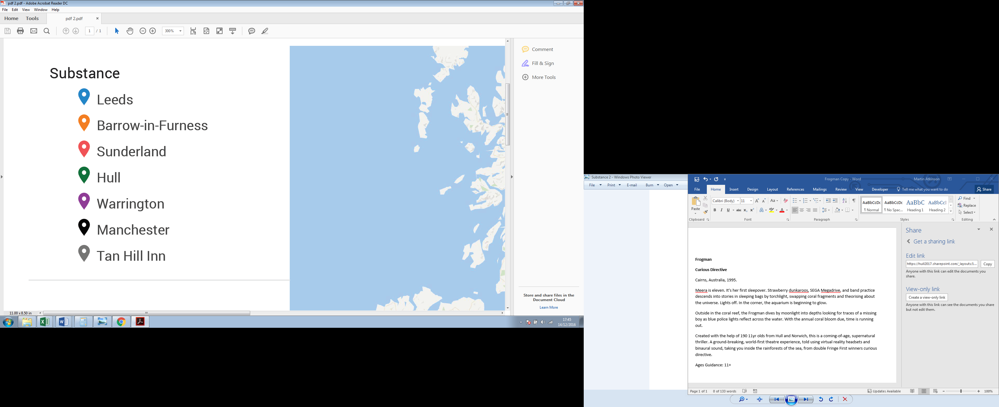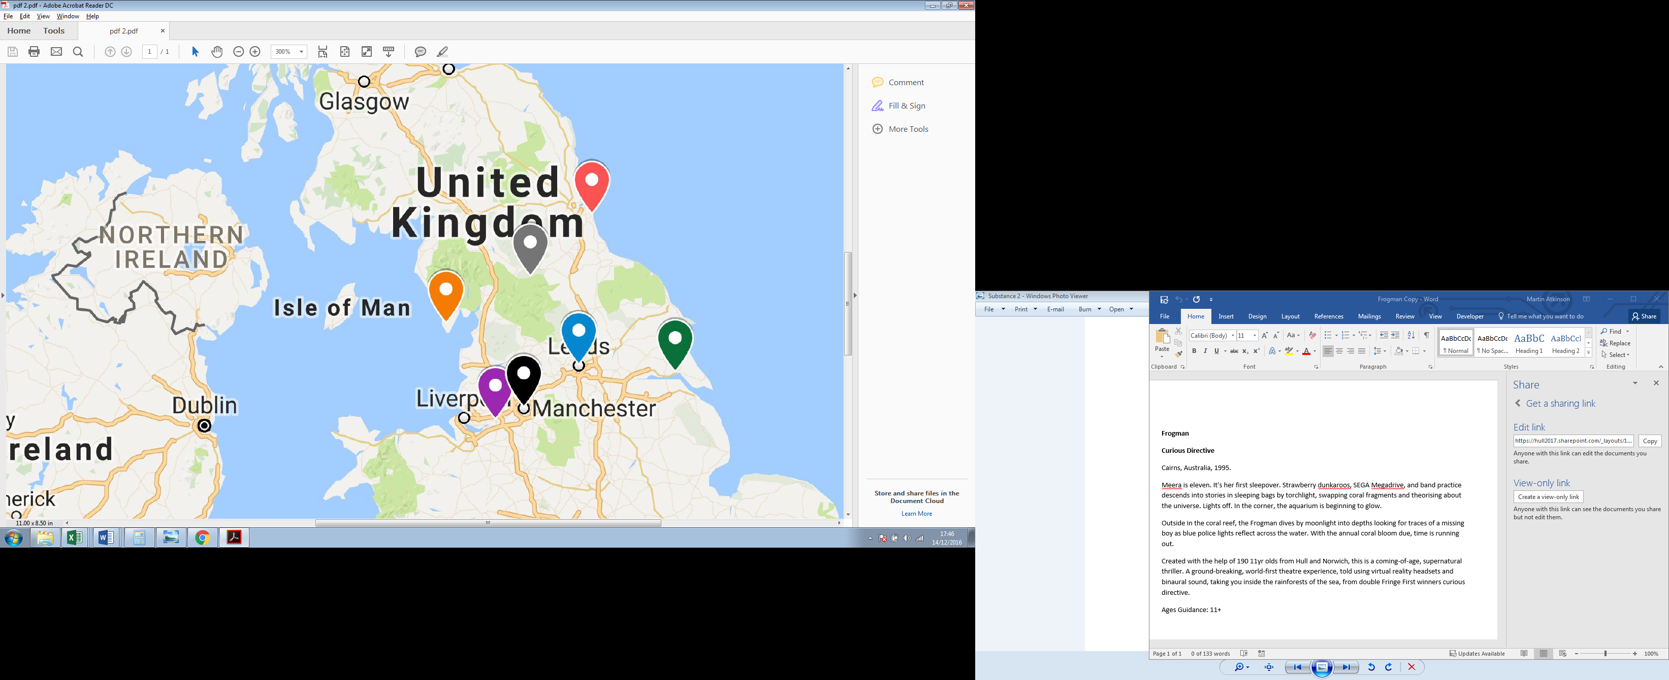

**Structure of each event:**

* The main event/performance will take place in the evening with engagement around this during the day.
* Before the evening event, the artist/s spend the day at a local college/organisation/club giving talks/passing on experience.
* Looking at the internationalism of the North and the history of arts and popular culture and the strong role second cities have played - i.e. it can be a more creative environment away from the capital.
* Spreading the message that you can have a career in the creative industries, with examples from artists of how they managed it.

**February 2017: SUBSTANCE in Sunderland**

**Programming Partners and Content:**

* Sunderland is bidding to be UK Capital of Culture in 2021. Luke Bainbridge is talking to **Rebecca Ball, Director of Sunderland 2021**, about collaborating on an event in late February 2017. More Information.
* Luke B to make site visit in mid-January.

Also talking to...

* **Customs House**. Great arts venue in South Tyneside www.customshouse.co.uk
* **The Word, the new National Centre for the Written Word** in South Shields. [More Information.](http://theworduk.org/about-the-word/)
* **Richard Millward** (Apples, Ten Storey Love Song) and Natalie Hardwick have just published this book about growing up in the North East, so could get them involved.

[*Stripped Tees is a double essay from two writers; novelist Richard Milward and BBC journalist Natalie Hardwick. Born and bred in Middlesborough and Stockton-on-Tees respectively, they explore the identity of the north east, in an affectionate, revelatory, sometimes angry but always erudite way.*](https://www.amazon.co.uk/Stripped-Tees-Endurance-Hope-North-ebook/dp/B01M025Q8S/ref=zg_bs_362577031_24)

**Social Change Partners Sunderland:**

* **Dave Stewart (Eurythmics)** is from Sunderland and has this project working in churches and is keen to work with Substance on an event. Luke B is in discussion with Jono Hart, who leads on the project for Dave Stewart Entertainment and is very keen on the idea.

<http://www.midaspr.co.uk/news-stories/rock-pop-come-church/>

<http://www.telegraph.co.uk/news/2016/06/25/englands-empty-churches-to-host-series-of-pop-and-rock-concerts/>

<http://www.chroniclelive.co.uk/whats-on/music-nightlife-news/dave-stewart-en-route-back-10121590>

**Timescale**

To have a date confirmed and announced by the end of January/beginning of February.

**April 2017: SUBSTANCE in Leeds**

**Programming Partners:**

* The third Substance event will take place in Leeds. This will be a film-led event, in Suggest making this a film even include Stuart Maconie & Adam Buxton: Northern Music Videos.
* Suggested venues - Hyde Park Picture House (classic old cinema) and Brudenell Social Club, 4 mins walk from each other.
* Possible Substance short film competition, in conjunction with Leeds Film Festival.

**Social Change Partners Leeds:**

* Link up with Khadijah Ibrahim: [Leeds Young Authors](https://www.youtube.com/watch?v=LUbiul6hduM)
* Leeds Carnival more in terms of audience.
* Peepal Tree Press
* Northern Fictional Alliance
* Lord Whitney

**Timescale**

To have a date pencilled by end of February. Confirmed and announced by the early March.

**June 2017: SUBSTANCE in Warrington.**

* Pete Waterman is from Warrington.

[“Do I want to live in Warrington or do I want to live in Santa Monica? I actually want to live in Warrington!”](https://www.youtube.com/watch?v=I31mT2L3Z9I)

* Simon Moran is from Warrington: SJM Concerts.

**Social Change Partners in Warrington:**

Need to find who would be suitable for Warrington.

**Aug/July 2017: SUBSTANCE / Tony Wilson tribute in Manchester**

* It's the 10th anniversary of Tony Wilson's death this summer.
* Luke B, David N and Jon Drape speaking to Manchester International Festival about a co-promoted MIF/Substance event to coincide with anniversary of Wilson's death.

**Timescale**

Luke B, David N and Jon Drape meeting with MIF in Manchester on 26 January.

**October 2017: SUBSTANCE in Barrow in Furness**

**Social Change Partner:**

* Signal Film and Media: <http://www.signalfilmandmedia.co.uk/> working with them to host and present. Possible short film contest.
* <http://www.grizedale.org/projects/the-honest-shop> Grizedale Arts

**Programming Partner:**

* Andy Turner/Aim. He’s never left Barrow and has managed to sell hundreds of thousands of records and run his own record label. He also somehow managed to persuade his lovely wife Niko to move from Brooklyn, NYC to a bungalow in Barrow-in-Furness, which is remarkable.
* **Eden Arts:** <http://www.edenarts.co.uk/about-us/> Maybe do something at Kendal Calling: 27-30 July.

**Hull December Weekend: 8-10 December 2017**

* Friday evening: big opening gig, pairing an iconic artist and a brilliant new artist. New Order if possible?
* Saturday: event of talks/debates/festival hub. University campus.
* [Future Everything:](http://futureeverything.org/) invite to present ideas and art that focus on the future.
* It should be a think tank – real talks, not back slapping. Avoid back slapping.
* Look at Green Port hull (Siemens, Dong). Engage Andy on this.
* Bring in global voices, link the issues around the world. Franco Bianchini: [Cities on the Edge.](http://www.johndavies.uk.com/cote.htm)
* Much younger name on Saturday night at the Asylum.
* Late night Saturday: possibly Warehouse project – something similar to end it all.
* Film running throughout at Middleton Hall.
* Humber Street on the Sunday.
* Ken Loach film festival on Sunday in cinemas.
* Blast Theory: talking about the future. An event will be part of Substance.
* Marshmallow Laser Fest will also feature as part of Substance.
* Invite Visr VR to show off their wares. Have a VR playground. See if they will do some cut outs for us.
* Martin Parr exhibition link up.
* Show the best short film entries from a launch of the competition in Sunderland, announce at every town and then event and bringing Leeds Film Festival and Signal Film and Media together during the Ken Loach film festival.

**Social Change Partners Hull:**

* Russ Litten
* The Warren: linking up with Daniel Elms and other musicians performing over the weekend.
* Daniel Elms: recording studios project

**Other Artists/speakers to approach**

* Maxine Peake
* Stuart Maconie
* Paul Morley: Author of The North, Late Review resident critic, and chief chronicler of Factory Records.
* Phil Redmond:Brilliant television producer and scriptwriter from Huyton, Lancashire. Creator of Grange Hill, Brookside.
* Ian Martin: Writer, The Thick of It, Veep. Columnist for 25 years in Architects’ Journal and now The Guardian. Long time resident of Lancaster.
* Guy Garvey: Lead singer of Elbow and 6Music presenter.
* Danny Boyle: "Manchester reinvented itself. It didn't wait for a leader to do that for it. In fact, it took the lack of interest that was clearly shown to it by Margaret Thatcher's premiership as the signal to do things for itself. There are some great northern cities that actually aren't beholden to anyone. And no matter how bad it gets, they will always regenerate themselves.”
* Elaine Constantine: Filmmaker and Photographer.
* Bernard Sumner: Joy Division/New Order
* MIF Director: John Mcgrath
* Paul Mason, economist
* West Yorkshire Playhouse – James Brining
* Joan Bakewell
* Richard Hawley
* Simon Armitage
* Dave Moutrey, Home
* Sarah Frankcom
* Namron: Co-founder of Northern School of Contemporary Dance, Leeds. 50 years old. First black dancer to be employed by British dance company.
* Jeanette Winterson – poet and author
* Sarah Lancashire
* Lee Brackstone - Faber & Faber
* Chloe Johnson-Hill – Penguin – can be a conduit for many northern authors.
* Diane Morgan / Philomena Cunk – comedian and actress
* Gary Neville
* Juan Mata
* Dean Wilson
* Chris Thorpe: strong northern performance making voice. Blackest Ever Black
* PlanningtoRock: <http://planningtorockofficial.com/>
* Simon Jenkins: Guardian journalist who has written several long reads in the Guardian on the Northern Powerhouse and elements of ‘devo Manc’. Also Chief of National Trust and previous Editor of The Times. Actually from Birmingham.