**Planning application ‘A Hall for Hull’  
Hull City of Culture 2017  
9 June 2017**

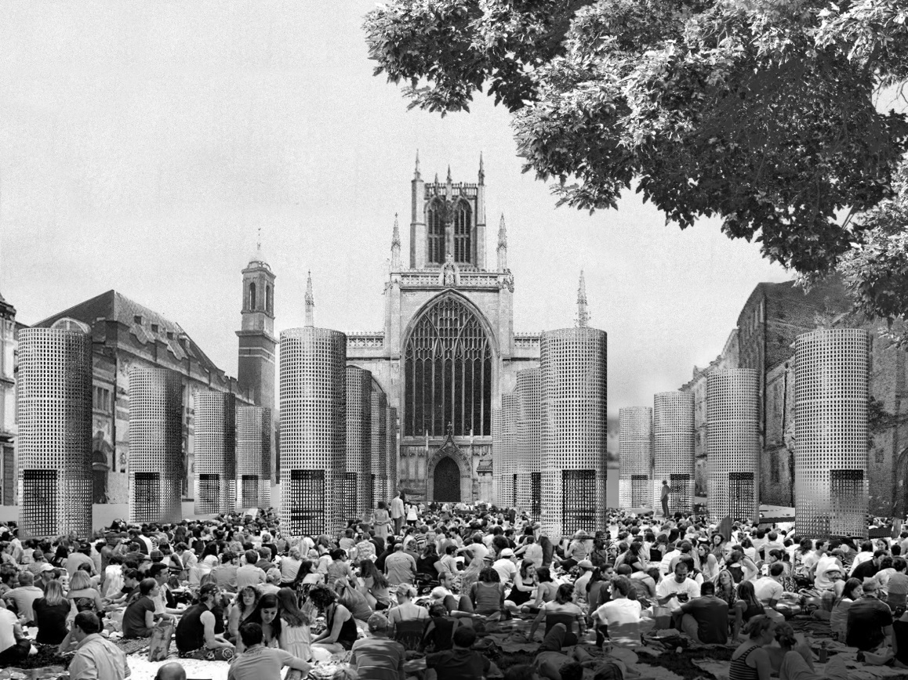

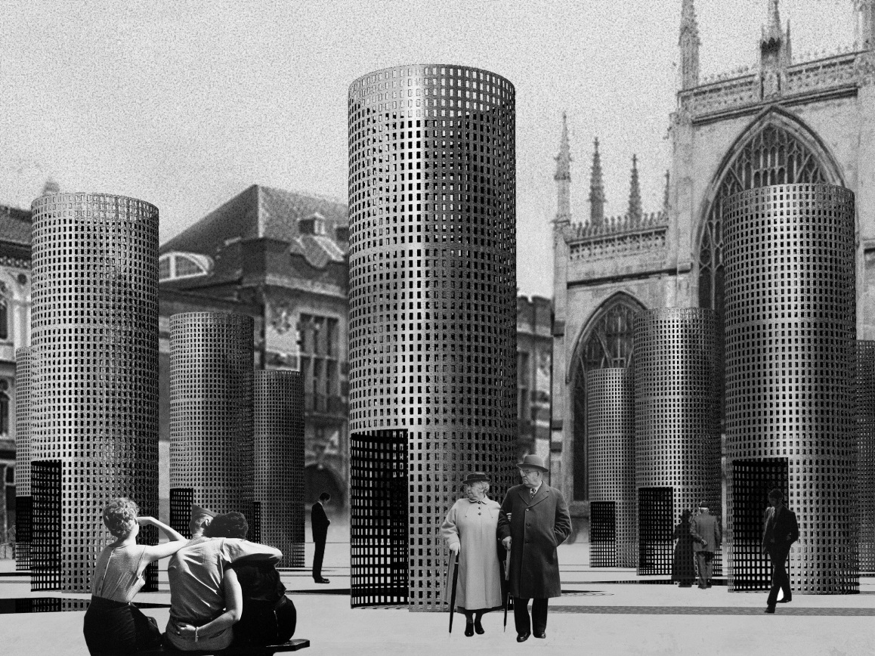

**Royal Institute of British Architects  
66 Portland Place  
London W1B 1AD**

**Contents**

**Introduction** 3

**1 Design and Access Statement “Hall for Hull”**

* 1. Proposed Development 3
  2. Compliance with Planning Policy 4
  3. Installation methodology 4
  4. Health and Safety 5

**2 Flood Risk Statement**

2.1 Flood Risk 5

1. **Heritage Statement**

3.1 Background to project 6

3.2 About the installation a “Hall for Hull” and the artists 7

3.3 Location and status of site 7

3.1 Historical and archaeological background 8

3.1.1 History and development of Hull 8

3.2 Discussion of the Cultural Heritage resource and potential impacts 8

3.2.1 Cultural heritage resource 9

3.2.2 Setting effects from the proposed development

**Introduction**

“A Hall for Hull” is a temporary installation for Trinity Square, Hull, created by architect/artist collaboration (architects Pezo von Ellrichshausen and artist Felice Varini). It is a joint commission by Hull 2017 UK City of Culture and RIBA (the Royal Institute of British Architects). A Hall for Hull is part of “Look Up”, a Hull 2017 programme of temporary installations in public places and spaces around the city, running throughout the year of City of Culture. The project was developed through an invited competition between architect/artist collaborations, with a brief to create a temporary intervention designed specifically for the square.

See image of proposed installation at accompanying drawings and artists bios **Appendix B: Installation Visuals and Artist Bio**

**1 Design and Access Statement “Hall for Hull”**

**1.1 Proposed Development**

* **Use** – The application is for the temporary use of land in Trinity Square for the display of a temporary installation, which comprises sixteen columns with applied artwork, presented in a grid formation. Trinity Square is a key open space within the city of approximately 2.5ha and situated in Hull’s ‘Old Town’. It is identified as a civic space[1], surrounded by multiple uses including visitor destinations, offices and restaurants, and dominated by Hull Minster. It is proposed to install ‘Hall for Hull’, beginning from 18 September with an official opening 1 October.
* **Scale and Materials** – ‘Hall for Hull’ consists of 16 columns set out in a regular grid across the square, 4 x 4. Each column is 2 metres in diameter and 6 metres high, weighing 4350kg, and to be constructed using a minimal galvanised steel structure (3mm mild steel), clad in a thin galvanised steel mesh. The grid of sixteen columns occupies 627m2, fronting Hull Minster symmetrically with a 5.68m space in-between each column, creating open access across the site and around each columns. All sixteen columns take up 50.24 m2 of the square’s paving. Please see **Appendix C: Structural Engineering Report**
* **Layout and Access** – The layout of the sixteen columns is a response to the square and its features and in particular to Hull Minster. The size of the columns, individually and as a group, is proportionate to the scale of Hull Minster. The location of the temporary columns preserves the visual and functional continuity of the square while highlighting the frontal symmetry to the historical church. With the simple grid of columns it will be possible to articulate a diverse range of accesses to this ‘temporal venue’, and with 2m in diameter and 6m in height, every column will be an inhabitable vertical shaft with one accessible opening. The mesh membrane ensures there are no solid barriers to obstruct views of the square and its surrounding buildings. Trinity Square has recently undergone a programme of works designed to de-clutter the space and open it up with improved access and legibility. Particular attention has been paid to accommodate the new permanent features within the grid layout and the columns are sensitively positioned to accommodate the new street furniture and ‘mirror pools’.

The proposed location and access to Hall for Hull is identified below and noted on accompanying drawings and plans **Appendix D: Layout and Elevations**:

* Access to the artwork via vehicle is by King Street, South Church Side (south of the church) and Posterngate, Trinity House Lane and North Church Side (north of the church).
* The location of the artwork is situated within the pedestrianised square, enclosed by South Church Side (S), a group of retail and office buildings (W), North Church Side (N) and Holy Hull Minster (E). It is accessible by walking, cycling, driving or train. The train station is a 10 minute walk to the west of the square
* The layout of the artwork allows for free movement of wheelchairs and prams/buggies between the columns.

**1.2 Compliance with Planning Policy**

**National Planning Policy Framework** – The application conforms to the policies within the NPPF, particularly policy 57 in achieving ‘high quality and inclusive design for all development including individual buildings, public and private spaces…’ The provision of this temporary artwork will create a strong sense of place during its temporary installation.

**Hull City Council Saved Local Plan (adopted 2000)** – The artwork conforms to the following policies:

Policy BE15 (Development providing public art in publicly visible locations) – The application is public art in a publicly visible place and will enhance the image of the City.

**Hull City Council Hull Local Plan (submitted for examination 16 December 2016)**

The artwork conforms to the following policies:

Policy 9 - The city centre accommodates a full range of main town centre uses and necessary infrastructure, to make Hull a world class visitor destination supporting the UK City of Culture 2017 aims.

Policy 14 – The artwork creates an inclusive public space that encourages community interactions through providing a high quality public realm.

* 1. **Installation methodology statement**

The installation time scale of four days necessitates erecting four columns per day, with two teams working concurrently. Each installation will reduce the working area available and protection will be applied where point loads are made. The mirror pools will be avoided and particular attention will be paid to safeguard the new landscaping.

Trees and crane boom radii will be assessed and Herras fencing placed around the square. For setting out purposes, it will be necessary to put down all the wooden bases and line them up prior to installation of the towers themselves. The plywood base (as reference on **Appendix C: Structural Engineering Report**) will safely protect the new paving from the galvanized steel columns, a material that doesn’t rust. The design of the bases means that there will be no staining or damage to the stones below.

Installation sequence (single tower):

CNC’d plywood packers to be positioned (all together to check positioning)  
Lift Steel base plates into position onto plywood packer  
Lift concrete base plate into position onto steel base plates and secure  
Place scaffold tower on the concrete base for internal access  
Lift single panel (1) into position with crane and bolt to base  
Support first panel with wooden braces from the exterior of the tower  
Bolt 2 panels together on the floor, along one spine  
Lift panels (2+3) with crane into position and bolt into the base  
Bolt panel 2 to panel 3 internally along spine  
Bolt 2 further panels together on the floor, along one spine  
Lift panels (4+5) with crane into position and bolt into the base  
Bolt panel 3 to panel 4 internally along spine  
Lift panel (6, doorway) into position  
Bolt panel 6 to panels 5 and 1 internally along spine  
Lift top supporting ring into position  
Bolt ring into place.

**Repeat 15 times**

Plant on site  
2 x mini cranes  
4 x small cherry pickers  
1 x fork lift  
2 x scaffold towers

* 1. **Health and Safety**

Climbing and other miss-use of the installation  
The columns have been designed to prevent climbing. The 3mm steel for the faces makes it very difficult to grip properly with 2/3 fingers to climb them and normal shoes will offer little grip.

Any attempt to climb the structures or other misuse is mitigated by invigilation. The square is public, and in daylight a public presence will deter misuse whilst security guards invigilate the structures at night.

Overturning  
Each column weights more than four ton, which would require at least 150 people to lift one column at a time. As mentioned above, security staff will mitigate any antisocial behaviour of the public square while the punched steel will allow wind through to prevent tipping. The structural engineering report provides detailed calculations to prevent any tipping/overturning.

Lighting  
Individual columns will cast shadows but the placement of each column, with a distance of nearly 5.7 meter between each, should not cause any sense of darkened enclosure for the square. It has been proposed to utilise the new artificial lighting on the structures at night.

Litter  
Litter is to pick from in and around the columns, they are accessible for street cleaning.

**2 Flood Risk Statement**

**2.1 Flood Risk**

The temporary artwork is situated within Flood Zone 3a as noted in Hull’s Strategic Flood Risk Assessment Flood Map. Temporary artworks are not specifically listed in any specific flood risk vulnerability classifications but this work is considered to fall within the “less vulnerable” classification by nature of its temporary display and its construction, and is therefore appropriate development within this flood zone.

The artwork will not increase the causes or impact of flooding given its construction from open mesh steel, which will allow flow of water through the structures. The securely weighted bases will not allow the works to be moved by flow of water. These design and construction features also mean that the artwork will not detract from managing flood risk through the City Centre.

**3 Heritage Statement**

**3.1 Background to project**

Royal Institute for British Architects (RIBA) are submitting this application for the temporary use of land for the display of a temporary public artwork at Trinity Square, Hull, forming part of a jointly commissioned project with Hull 2017. The artwork consists of sixteen columns (2 metres in diameter and 6 metres in height) placed in a grid formation. Temporary planning permission is sought for a period of two months. The artwork has been designed by Chilean architecture practice Pezo von Ellrichshausen in collaboration with Swiss artist Felice Varini, selected through an invited competition organised by the RIBA. The selection panel for the competition included representatives from Hull Minster, Hull City Council, Hull 2017, RIBA and a number of external advisors from the visual arts and architecture sectors.

The aim of the architect-artist collaboration as laid out in the competition brief was: *to commission a temporary public artwork intended to be exciting and though-provoking. It should encourage locals to see their city in a new way and cause national and international visitors to discover Hull for the first time. The artwork should take advantage of its city centre location, form a meaningful relationship with its surroundings and fulfil a purpose – it should be a structure with function, not a folly. The commission should offer new and memorable experiences that capture the excitement in Hull during 2017.*

This temporary public artwork forms part of Look Up, a programme of temporary artworks created for the city centre’s public spaces and places for Hull UK City of Culture 2017. This artwork, made of galvanised steel is locally made at Wedge’s galvanizing plant in Hull, and supported by Hull 2017, RIBA, British Council and Wedge.

This public artwork will become a flagship project for the final season “Tell the World” as part of Hull 2017.

**3.2 About the installation a “Hall for Hull” and the artists**

Developed in response to the architectural and historical significance of Hull Minster and the remodelling of Trinity Square, the selected proposal, entitled a “Hall for Hull” is a monumental hypostyle room, open to the sky and the immediate surroundings. It creates a new space evocative of both the origins of architecture and its close overlaps with land art and optical art, both expressions of the human efforts to find an appropriate balance with nature.

The sixteen accessible columns are intended to extend the range of potential activities and events which take place in the square: exhibitions could be displayed inside every column; they could function as kiosks for information, local crafts or flowers; talks could be presented in the central alley with a magnificent backdrop; performances, festivals or parties could happen in between the columns, meandering in countless directions, with different lighting qualities, furniture arrangements and sound configurations. The architects/artist are encouraging the city to use the installation actively for purposes defined by the citizens and organisations based in Hull.

The columns, constructed in galvanised steel, convey a sense of silent and graceful presence on the square that will be carefully distorted by Swiss artist Felice Varini. His work, ‘Three points of view’, will introduce a delicate colour figure that will redefine the geometry of the rigid grid system, challenging the perception of perspective, distance and the very scale of this particular civic setting.

Images of Felice Varini’s proposed artwork are illustrated on the wooden column models on **Appendix E: Artwork**

**3.3 Location and status of site**

The site for this commission is Trinity Square, situated in Hull’s ‘Old Town’. The square has recently undergone a programme of works designed to de-clutter the space and open it up with improved access and legibility.

The square, sometimes referred to as Market Place, is dominated by the grandeur of the west elevation of Hull Minster and the tower which rises behind it. Hull Minster is one of the greatest town churches of medieval England. Its status has recently been elevated to that of a Minster, in the year which will also mark the 500th anniversary of the reformation. An important feature of the improvements programme has been the removal of a Victorian church wall which effectively bisected the public space and separated the church from the square. The reunification and restoration of this public square opens a range of possibilities for future public use.

The square is surrounded by an interesting collection of buildings including the Old Grammar School (1583-5), Trinity House (1753-9) complex to the north, The Kingston pub on Trinity Lane Corner and the Edwardian Market Hall (1902-4) on North Church Side. The names of the streets and lanes which lead into the square reflect something of the city’s history and the square’s place in it – Fish Street, King Street, Posterngate and Market Place.  
  
  
**3.1 Historical and archaeological background**

**3.1.1 History and development of Hull**

Hull is located at a strategic transport nexus, where the rivers of Yorkshire and the East Midlands meet the North Sea. Hull became the major port through which wool from the surrounding areas was exported to Northern Europe. In turn raw materials, mostly timber from the Baltics, were imported into England. Larger vessels anchored in the estuary of the Hull to transfer cargo to and from smaller vessels which then transported goods up the navigable stretches of the various tributaries of the Hull to Beverley and Nottingham, Knottingley, Selby and York.

Hull was already in use as a port in 1293 during King Edward I’s military campaigns in Scotland. Kingston upon Hull was subsequently founded by the grant of a royal charter in 1299. The street layout of late medieval town and its associated defences can be traced through topographic and place name evidence. The town also had a medieval monastic grange and chapel.

The town has evidence of well-constructed Civil War defences, which were erected in the seventeenth century.

Hull underwent a period of rapid expansion in the late eighteenth and nineteenth centuries. Within the old town, which largely retained its medieval street plan, this involved the infilling of vacant plots, whilst more dramatic expansion occurred to the west of the historic core. This was partly spurred on by a scheme of dock building and land reclamation, and was also conditioned by the arrival of the railways in the early half of the nineteenth century.

In the twentieth century, much of the residential development west of the City, was then subject to slum clearance and demolition following destruction from bombing during World War II. Across this area, although the mid-nineteenth- century street pattern largely remained, the housing was replaced by industrial and commercial premises to the south of the present A63, and large residential estates to the north.

**3.2 Discussion of the Cultural Heritage resource and potential impacts**

**3.2.1 Cultural heritage resource**

The key designated heritage assets as identified from an initial scoping that lie within or adjacent to Trinity Square (see Figure 1) are discussed here briefly.

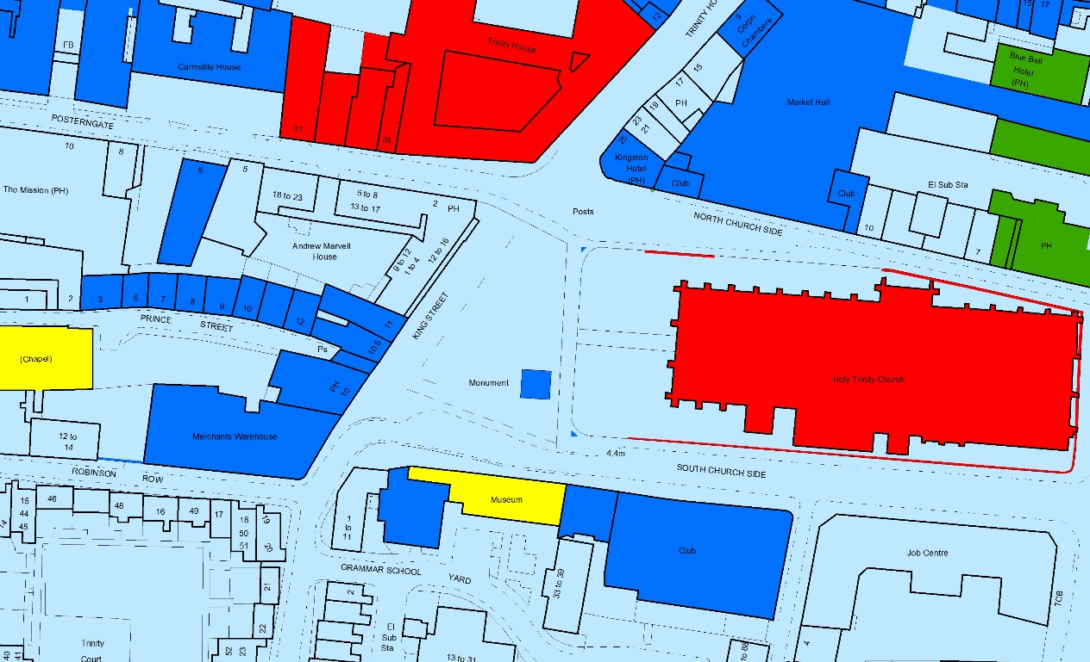

Fig 1 – Listed buildings are coloured red yellow or blue

Full detailed descriptions as taken from the National Heritage List England (NHLE) are provided in **Appendix A**. Analysis of the relative significance of the monuments assessed and the impact of the proposal on these are given in Tables 1-13 (see below).

The assets considered are those in the immediate vicinity of Trinity Square with a direct view of ‘Hall for Hull’. There are thirteen listed buildings, two are grade I, one is grade II* and ten are grade II.

**3.2.2 Setting effects from the proposed development**

The methodology adopted to assess the possible impact on setting is that outlined in the Historic England (HE) guidelines ‘The Setting of Heritage Assets Historic Environment Good Practice Advice in Planning: 3, March 2015’ and the guidance in the DMRB Vol. 11 for the assessment of impact on Cultural Heritage. The assets affected are all designated (either Scheduled Monuments or Listed Buildings) and of at least medium significance. They all have a direct view onto Trinity Square.

The degree to which the temporary installation of a work of public art will have an impact on the significance of the designated assets affected is assessed as being no more than slight. This is because, despite the work occupying a central position in Trinity Square, its undoubtedly high visual impact is largely negated because it is a temporary installation that will be removed after two months. There is therefore no permanent direct impact on the cultural heritage resource.

Table 1: Heritage impact assessment: Hull Trinity House, Trinity House Lane

|  |  |  |  |  |  |  |  |
| --- | --- | --- | --- | --- | --- | --- | --- |
| **NHLE No.** | **Name** | **Designation** | **Period** | **Summary Description** | **Significance of asset** | **Change to Setting** | **Effect on significance** |
| 1219563 | Hull Trinity House | Grade I | C18 | Trinity House, adjoining offices & houses | High | Minor  (Temporary) | Medium |

Table 2: Heritage impact assessment: Warehouse at corner of Robinson Row

|  |  |  |  |  |  |  |  |
| --- | --- | --- | --- | --- | --- | --- | --- |
| **NHLE No.** | **Name** | **Designation** | **Period** | **Summary Description** | **Significance of asset** | **Change to Setting** | **Effect on significance** |
| 1297008 | Warehouse at corner of Robinson Row | Grade II | C19 | Warehouse | Medium | Minor  (Temporary) | Medium |

Table 3: Heritage impact assessment: Former Fish Street Day Schools

|  |  |  |  |  |  |  |  |
| --- | --- | --- | --- | --- | --- | --- | --- |
| **NHLE No.** | **Name** | **Designation** | **Period** | **Summary Description** | **Significance of asset** | **Change to Setting** | **Effect on significance** |
| 1197658 | Former Fish St Day Schools | Grade II | C19 | Former school | Medium | Minor  (Temporary) | Medium |

Table 4: Heritage impact assessment: Old Grammar School Museum

|  |  |  |  |  |  |  |  |
| --- | --- | --- | --- | --- | --- | --- | --- |
| **NHLE No.** | **Name** | **Designation** | **Period** | **Summary Description** | **Significance of asset** | **Change to Setting** | **Effect on significance** |
| 1197660 | Old Grammar School Museum | Grade II* | C16 | Former grammar school | High | Minor  (Temporary) | Medium |

Table 5: Heritage impact assessment: Wool Exchange

|  |  |  |  |  |  |  |  |
| --- | --- | --- | --- | --- | --- | --- | --- |
| **NHLE No.** | **Name** | **Designation** | **Period** | **Summary Description** | **Significance of asset** | **Change to Setting** | **Effect on significance** |
| 1297106 | Wool Exchange | Grade II | C19 | Former warehouse | Medium | Minor  (Temporary) | Medium |

Table 6: Heritage impact assessment: Building between Kings Market & Wool Exchange

|  |  |  |  |  |  |  |  |
| --- | --- | --- | --- | --- | --- | --- | --- |
| **NHLE No.** | **Name** | **Designation** | **Period** | **Summary Description** | **Significance of asset** | **Change to Setting** | **Effect on significance** |
| 1297105 | Building between Kings Market & Wool Exchange | Grade II | C19 | Former warehouse | Medium | Minor  (Temporary) | Medium |

Table 7: Heritage impact assessment: Kings Market

|  |  |  |  |  |  |  |  |
| --- | --- | --- | --- | --- | --- | --- | --- |
| **NHLE No.** | **Name** | **Designation** | **Period** | **Summary Description** | **Significance of asset** | **Change to Setting** | **Effect on significance** |
| 1197659 | Building between Kings Market & Wool Exchange | Grade II | C19 | Former warehouse | Medium | Minor  (Temporary) | Medium |

1. As noted in the Hull Local Plan submission document.