**Art can change the world**

***How do artists talk about politics, place and gender?***

Artists often comment on the social and political landscapes but this becomes more apparent in times of austerity. Our political uncertainty in recent years has been spoken about a lot in the media - print and social, there has been reports issued and academic insight but what happens when artists use their skills to talk about it too. Can this have an effect? Can gender come into play within this conversation and will it change our sense of place?

**Nikki Bedi - Chair**

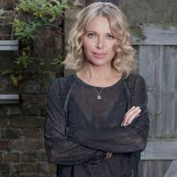

Nikki is a televison and radio broadcaster with a passion for making arts and culture accessible.  
  
She currently wakes up the capital presenting the **Early Breakfast Show** Monday to Friday on BBC Radio London. Nikki curates, writes and presents **The Arts Hour** on the BBC World Service, is a regular interviewer and presenter on BBC Radio 4’s **Loose Ends***,* can often be seen on BBC1's **Sunday Morning Live** interviewing famous names and celebrities about their faith and also on BBC1's current affairs show **Inside Out** reporting on everything from eye transplants to cinema restorations.  
Nikki also presents**The Heart Of***...* TV series on BBC World News, an arts and culture programme looking at fresh new talent from across the world's great cities and has presented BBC Radio 4's **Woman's Hour.**

**Kate West, Hack and Host – Session Lead**

Hack & Host is a collective of artists who have a mutual interest in raising the quality of contemporary art in Hull. Hack & Host will showcase contemporary art through interactive, participatory work, interventions, live art performances, and artist talks. We are a social space where conversation is generated around the theme of contemporary art from the viewpoints of the maker and the participant. We hope to challenge views and perceptions through progressive and experimental works.

**Gillian Nicol - Panellist**

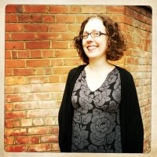

**Director of Digital and Online Content, a-n The Artists Information Company**  
Gillian has a key role in instigating and leading artistic and business developments at a-n. She is experienced in developing and delivering content via UK-wide networks of contributors across different publishing formats and social media. Her background in art practice and artist-led activity informs her commitment to ensuring artists’ voices are heard, rights are recognised and infrastructures to support developing practice are valued. She is based in Newcastle upon Tyne.

**Aisha Zia - Panellist**

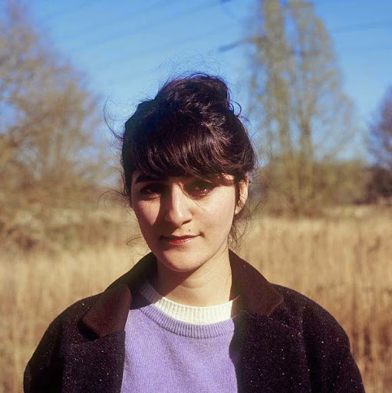

Aisha is a British writer for both theatre and film. She won Highly Commended from Amnesty International at the Edinburgh Fringe in 2013 for her play with Common Wealth Our Glass House, and The Scotsman Fringe First in 2014 for No Guts, No Heart, No Glory.

No Guts was selected for the Women of the World Festival a the Southbank Centre, and Live from TVC with the Battersea Arts Centre screened on BBC4 in 2015.

Aisha is currently resident playwright at Theatre 503, is under commission from Curve Theatre in Leicester and Contact Theatre in Manchester. She is former Resident Artist at Somerset House Studios in London and Foundation Jan Michalski in Switzerland where she began working on her new personal project, with a grant from Arts Council England.

**Léonie Higgins - Panellist**

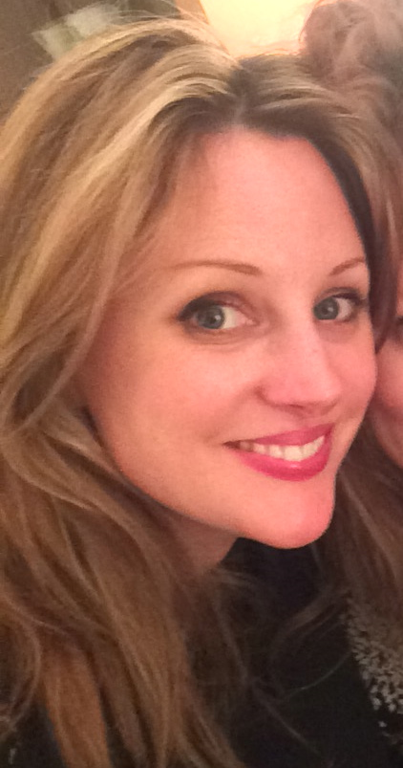

Léonie Higgins is one third of Eggs Collective - a Manchester-based performance company who write, produce and perform their work.

Eggs Collective are a trio making sharp, fun, culturally-observational performance that falls somewhere in the cracks between theatre and cabaret. They explore feminism and connection through the way they see the world and what they find funny. They have toured two full-length stage shows, and have performed in ballrooms, in cinemas, in toilet cubicles, on bars, on traffic islands and on stages for events and organisations including Contact, Duckie, The Royal Shakespeare Company, Southbank Centre, TED, Latitude Festival, HOME, Forest Fringe, Heart of Glass and Islington Mill.

This year they adapted their show Get A Round for BBC2's Performance Live series, supported by Battersea Arts Centre and Arts Council England. The show was broadcast on BBC2 in August 2017.

Léonie is also a writer, performer and musician. She has written and performed two solo theatre shows, and has performed her music at venues and festivals across the country.