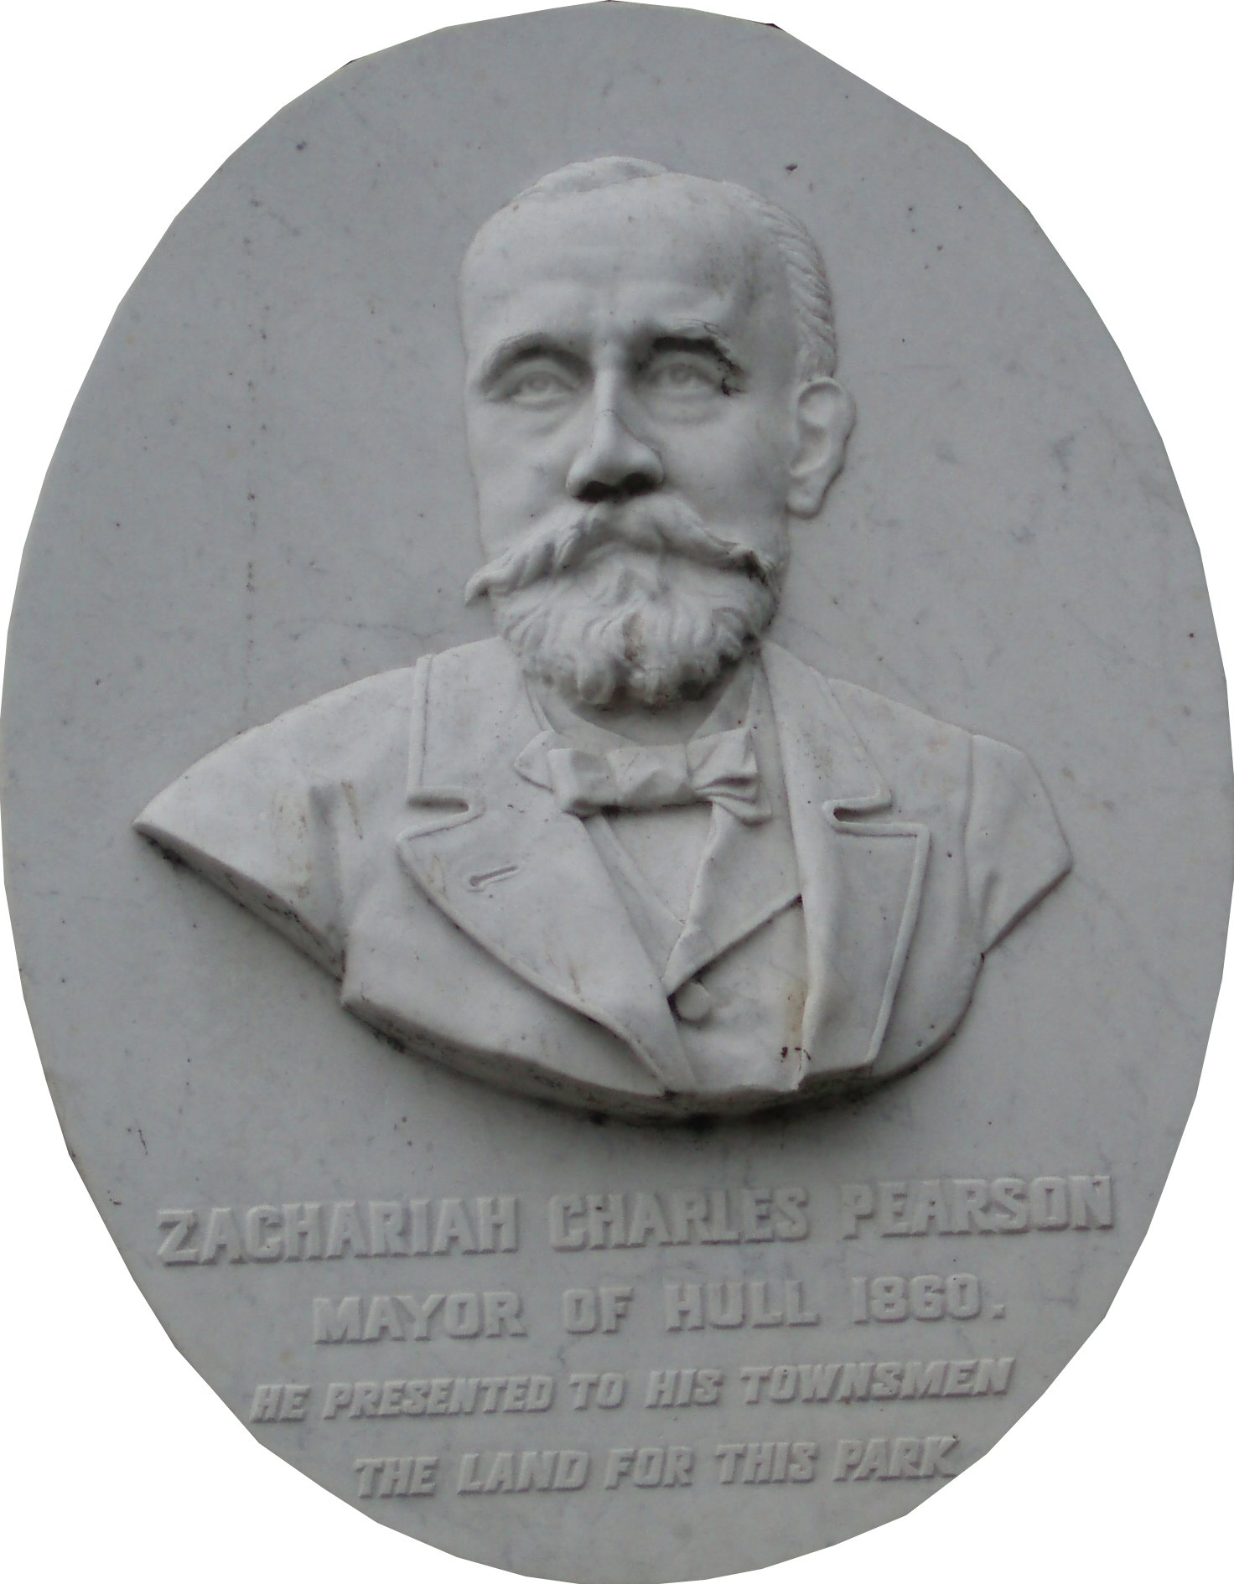
Pearson Park Trustees

Notification of proposed event / activity

Event Title/Name: | Epicycle by CirkVOST  Presented by Hull City of Culture 2017
Date of Event/Activity:  Start & Finish times:  Will the public be charged an entrance /activity fee? | The show dates are Saturday 12th and Sunday 13th August 2017. There is also a rehearsal on Friday 11th August.  We would also need access to the site from Monday 7th August – Tuesday 15th August 2017 for install and the de install and clearing of the site.  There would be one show per day on the show dates. As the show needs to take place at Dusk we are anticipating that the show would begin between 9pm-9:30pm. The show is an hour long in length.  Hull 2017 will submit an application for a temporary premise licence in order to allow the event to take place post 9pm. We would expect audience members to have left the event site by 10:30-11pm at the latest.  We are in discussions at the moment in regards to if the event will have a small fee or be free and will know this information shortly.
Location of Event/Activity:  (include map) | 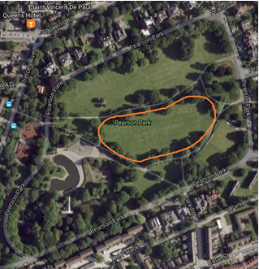  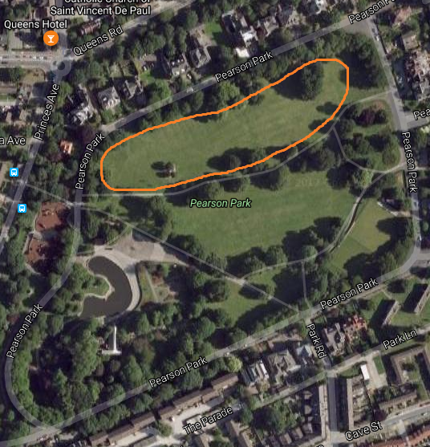There are two options for the event site. These are shown below. The preferred choice is option A but this is subject to site visit by the technical team from Epicycle.  Option A Option B
Details of Event/Activity: | Epicycle is a large scale touring outdoor circus show by CirkVOST. CirkVOST are based in Champclauson, France.  The show is inspired by comic books and performed on a bespoke circus rig - a 13.5 m double circle rising from the ground. Within this 'wheel' eight acrobats and a live musician perform.  The maximum capacity of the show is 4500 made up of 500 deckchairs provided by the company and 4000 standing. The total maximum capacity over the two nights is 9000. The event site would be manned by security, stewards and volunteers.  Epicycle has been performed over 200 times to 100,000 people, including as part of Piccadilly Circus Circus on 2 September 2012.  There will be a full event management plan produced for the event and this will be taken to ESAG, the event safety advisory group. Alongside this, there will be detailed method statements, risk assessments and health and safety information provided for the event.
Contact Name: | Katy Fuller, Executive Producer Hull 2017
Telephone No.: | 07771764656  01482 318 951
Evidence of Public Liability e.g. certificate, name of insurance co. | Please see attached the certificate.  Insurance company: Zurich Municipal  Policy no: XAO-122051-7383
Confirmation of CRB/DBS checks undertaken: | Please see attached the safeguarding policy. At the event there will also be dedicated staff for Lost Children.
Any further information: | Pearson Park is our preferred location for the event. We feel it would be the perfect place to hold this spectacular show. It would give the opportunity for people to experience Pearson Park in a new and exciting way, as well as bringing new visitors to the park and the local area.  We would expect local business to see an increase in custom over the event dates and would be happy to consult with them in advance of the event.  The restoration and protection of the park is of utmost importance and Hull 2017 have a reliable track record of using outdoor spaces around the city in a considerate and responsible manner. There will be a trackway placed down which will have a membrane under it to ensure that the land is protected from any damage. This will be used by all production vehicles on site.  The performance set, including the ‘13.5m circus rig’ as mentioned above, has been designed specifically to ensure it can be easily erected and de-installed as it is not a permanent structure.  Hull 2017 will take full responsibility for the cleaning of the park after use.  Hull 2017 will provide 24 hour security for the site from Monday 7th August until the de install and clearing of the site. The event site will be fenced off during install and de install to ensure maximum safety, security and to minimise disruption to the rest of the park.  Hull 2017 will take full responsibility for staffing the event with a full production team, security, stewards and volunteers. We will also provide the necessary facilities to ensure visitors have a safe and enjoyable experience.  Disruption to residents will be kept to a minimum. Information will be sent to all residents which will include contact details for the team with any enquiries as well as posters for the resident noticeboards. We would be happy to attend any resident meetings in advance to answer any questions and would love local residents to attend the event. There will also be a member of the production team present on site to help with any enquiries. Sound will be kept within notified times.
Please note the following:-
- There is a presumption that any event approved by the Trust should not start before 10.00am (set up no earlier than 8.00am) and will have concluded by 9pm ( including removal of all equipment) and that no extensions to these times will be permitted. Please also note that once approval for the event/activity has been given that no subsequent amendments to the proposed activity/event will be considered.

- Pearson Park lies within a residential area and the applicant must ensure that positive neighbourly relations are maintained and the applicant will provide proposals to ensure this. As a minimum the applicant is required to publicise events in the Park with leaflets delivered to all properties around the site and posters which the Area Team can display in its Noticeboards

- The applicant is responsible for the collection and disposal of any litter arising from the event. The park must be left in a clean condition.

- If additional public conveniences are to be made available for the event it is your responsibility to provide this and ensure they are maintained during the course of the event.

- The applicant is responsible for obtaining any necessary licenses and consents and for complying fully with all legal requirements when on site

- The serving of alcohol is not permitted in accordance with the Trust Deed.

- It is the responsibility of the event organiser to ensure any verge damage is reinstated. A representative of the Trust and event organiser will meet prior to approval to agree and note the condition of the ground/verge.

- Many events have the potential to generate noise nuisance within the park. In consultation with Environmental Health, the Trust will consider at the application stage whether it is necessary to control this by attaching conditions relating to limiting hours and/or sound levels.

- Where a charge for the event or activity is made, the Trust request that a small donation be made to the Trust which would be spent exclusively in Pearson Park

Please sign below to confirm your acceptance of these conditions
Signed : -
Date :-

