**Tell the World**

10:45 – 11:30 at C4DI Theatre

**Susannah Simons -** 0773 648 1163

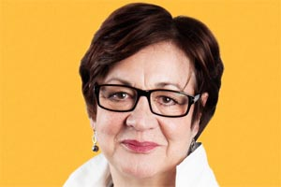 Director for Arts and Outreach for CANVAS at Brave Bison

**Daniel Elms -** 07731 587989

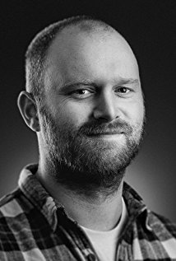 New Sound Collective and Hull Born Artist

**Nina Rogers -** 07973432489

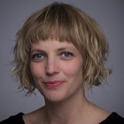 Head of Marketing and PR Yorkshire Sculpture Park

**Katherine Jewkes -** 07789510 528

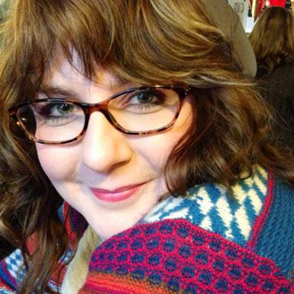 Digital Producer at MIF & Associate at The Space

**David Collins –** 07970 463173

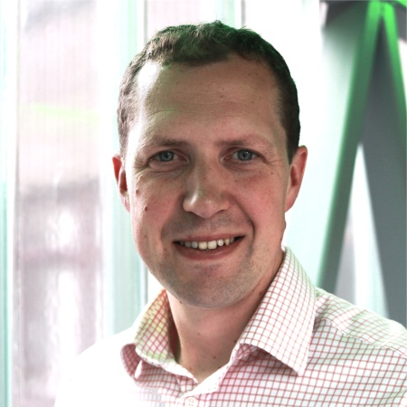 Director of External Affairs at Opera North