**Current Members**

**Name** - Antony O’Brien

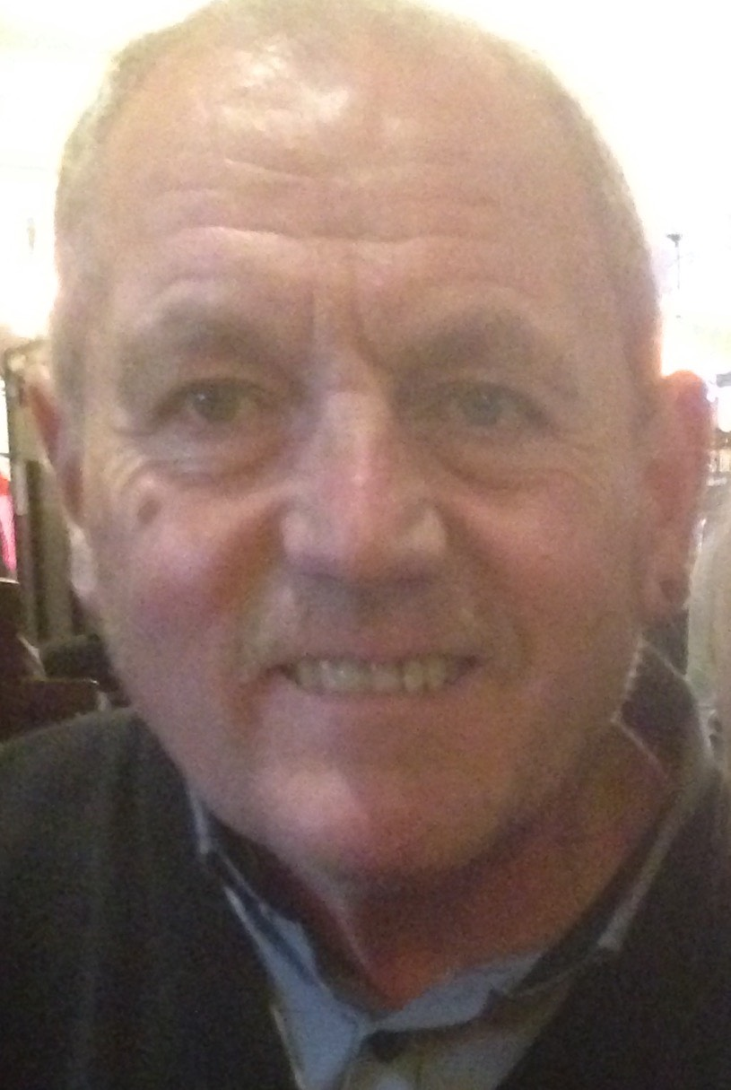

**Place of birth** - Kingston upon Hull

**Position** - Core team investigator

**Occupation** - I studied archaeology at the University of Hull, and gained my MA in Biological Anthropology at the University of Manchester, way back (or so it seems!) in 1976. I’ve always been fascinated by society and how we all move together, and, although my instinct is to discount anything without concrete proof, I’m always open to debate!

**Are you a believer, skeptic or open-minded?** - I try to remain open minded. As Hamlet says, *there is more to Heaven and Earth than is dreamt of in your philosophy’.* The combination of people, society and history is endlessly fascinating, especially so in a city like Hull. Where else could you speculate that a polar bear might be buried under High Street? Or that a statue leaves its plinth to go to the local pub? There’s so much more to be discovered.

**Your first experience?** – I don’t know if I’ve ever had a ‘proper’ experience, certainly nothing like Susan. But there have been moments where I’ve had the shiver or a sense that something isn’t quite as it usually is. Instinct is very important with these things, and if your gut tells you it isn’t as straightforward as it seems, you’re probably right.

**Date joined** - October 1970. I was one of the founding members of the GGF, and am proud to have been involved in nearly all of our investigations over the past 47 years.

**Hobbies** - Being with my family and grandchildren, having days out, the paranormal, music and football – I caught the bug when I studied in Manchester and yes, it’s City, not United.

**Other** – I’m currently taking piano lessons after twenty years of promising myself I would. The goal is to play a solo at my 65th birthday celebrations later this year. have a partner of 11 years

**Name** – Martin James Murphy

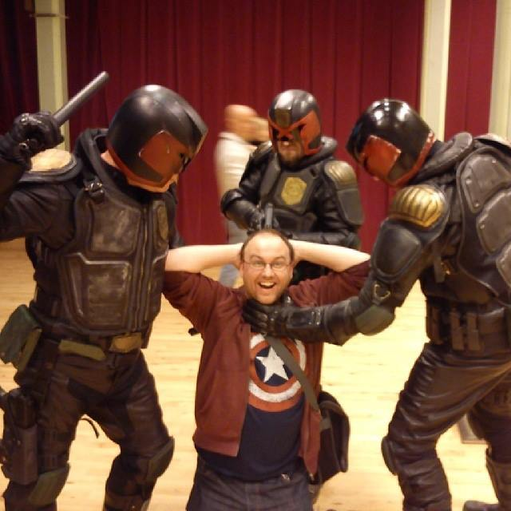

**Place of birth** - Scunthorpe

**Position -** Core team investigator

**Occupation** - Software developer / Conspiracy Theorist

**Are you a believer, skeptic or open-minded**? – I’m a complete believer – I’ve seen too much not to be.

**Your first experience?** – I dream about big events before they happen. The first one was when we had a car crash in our village. I was only little, maybe four or five, and I saw it happen in my dream the night before. I’ve had that all through my life.

**Date joined** - March 1992

**Hobbies –** For a software developer, I like to spend as much time away from the screen as possible when I have a day off! My perfect day would involve golf, sun, reading and a quiet pint in the county somewhere - I don’t get much chance to do any of that between the GGF and work.

**Other –** I took a creative writing degree at the University of Hull and graduated in 2009. You can keep up to date with my work at xxxx **(facebook link to naff-looking writer’s page).** I write mainly writer crime, suspense and horror.

**Name** – **Hana Gorzowski**

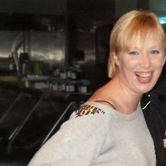

**Place of birth** – Lublin, Poland

**Position -** Core team investigator

**Occupation** - Archivist

**Are you a believer, skeptic or open-minded**? – I always believe until it is proved to be anything else.

**Your first experience?** – I have always felt my brother with us. We moved from Lublin after he died. I was ten years old, and the day after he died I saw him on the street outside our house, waving at me. He was smiling, like he always did.

I didn’t tell my mother because she would have been upset, but I saw him over and over again in different places. It was funny because he never got any older, but I did of course. I haven’t seen him for many years now, but I feel him in the house sometimes – less so since my mother passed, but still now and then.

**Date joined** – October 2009

**Hobbies –** I like to play piano and write poetry. Sometimes I turn them into songs. I also like photography, and am putting an exhibition together for later in the year. It is called ‘Lost Embraces’, about the cracks between the pavement, the things that you never know are missing, but are there.

**Other –** When I was small, my mother and grandmother would always tell us fairy tales and folk stories, very vivid. When we shut our eyes, it was like we could see the words in pictures. Most of the time we were scared half to death – The Black Volga haunted me for years - but we still always wanted to hear more.

When I moved from Poland to Hull with my mother and brother, I was told about The Fellowship from a girl we were then staying with. When I went, they made me feel like a friend straight away and they told me a lot about the stories of Hull. This city is very old with lots of history that people do not know yet.

**Name** – **Jeremy Johnson**

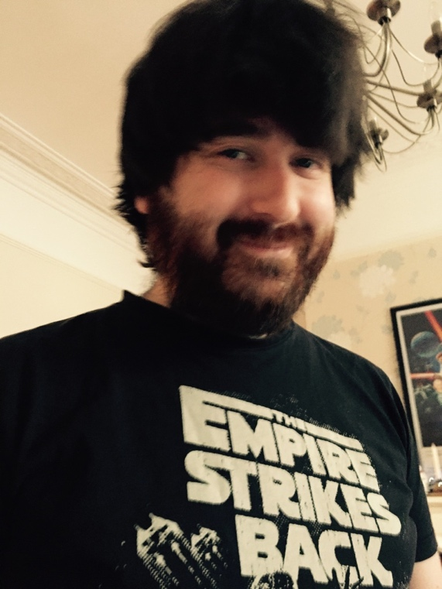

**Place of birth** – Kingston upon Hull

**Position -** Core team investigator

**Occupation** – Retail assistant

**Are you a believer, skeptic or open-minded**? – Believer. Pure and simple.

**Your first experience?** – I was lying on the bed in my gran’s house and an orb came through the wall, hovered by the CD rack and then went out the door. It was a big ball of light, about the size of a football. I wasn’t scared, I just felt very calm. I lay there, watching it move.

**Date joined** – April 1996

**Hobbies –** I like watching documentaries and drawing.I’m a big fan of comics and am working on my own graphic novel about a series of parallel universes that come together.

**Other –** I like the fact GGF is a small, friendly down-to earth-group which I think makes us unique and able to carry out investigations in smaller less accessible locations. We have members with wide experience and it’s a brilliant opportunity to be part of something diverse and interesting.

**Name** – **Pauline Squires**

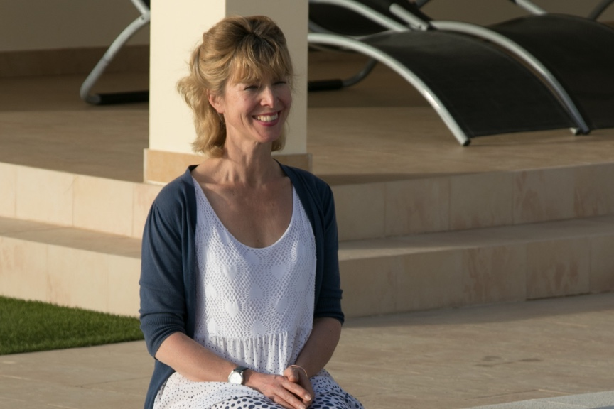

**Place of birth** - Newcastle

**Position -** Core team investigator

**Occupation** – Semi-retired / Counsellor

**Are you a believer, skeptic or open-minded**? – I’m absolutely open-minded – who are we to disprove anything?

**Your first experience?** – I once bought an old leather school satchel bag from a charity shop and it had my name in it - in my writing - but the address was somewhere in Hertfordshire, which I’ve never been to in my life. It was the oddest thing. Most people would put it down to sheer coincidence, but I don’t see how that could be possible.

**Date joined** – January 1970

**Hobbies –** I’m a keen dancer, and go to regular salsa classes. I also swim every day and enjoy spending time with my grandchildren, Harry (2) and Isabella (9).

**Other –** I’m a newly-qualified counsellor at the grand age of 57, and am currently studying aromatherapy.

**Name** – **Richard Mainprize**

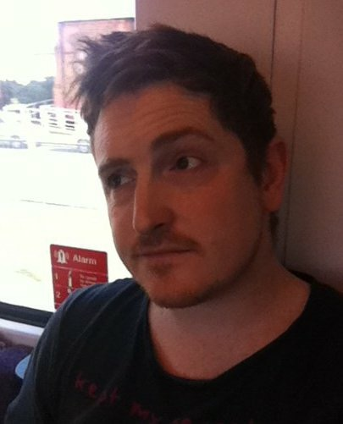

**Place of birth** – Kingston Upon Hull

**Position -** Core team investigator

**Occupation** – Stay-at-home dad

**Are you a believer, skeptic or open-minded**? – I don’t really know, I seem to change between all three. Today – probably a believer.

**Your first experience?** – I’ve always had an interest in the weird and wonderful from the days of Ghostbusters and Poltergeist, but it didn’t really grab me until my late teens. I haven’t really had any experiences myself at all – or if I have, I haven’t realised – but I’ve spoken to lots of people who have and they really do believe.

**Date joined** – April 1996

**Hobbies –** I enjoy cooking, gaming and looking after my twin girls, Amy-Louise and Molly-Mae.

**Other –** I’ve been deaf since birth, and communicate through sign language.

**Name** – **Tally Fisher**

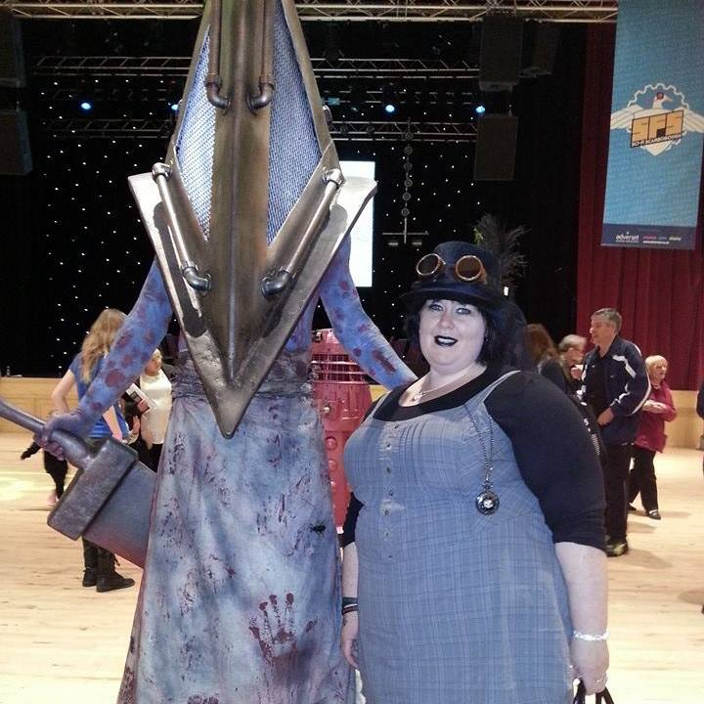

**Place of birth** - Coventry

**Position -** Core team investigator

**Occupation** – Mature Student

**Are you a believer, skeptic or open-minded**? – I’m open-minded

**Your first experience?** – I was born with my legs twisted and had lots of operations from being a baby. I lost my left leg due to complications in 2006, and I had an out-of-body experience on the operating table – I could literally see myself from the ceiling and was looking down on myself while they were taking my leg off. It was the most oddly calming experience of my life. When I told the surgeons they were listening to Bach during the operation, they went absolutely white. I think they thought they hadn’t given me enough anesthetic!

**Date joined** – September 2016

**Hobbies –** I love cosplaying and try to get to as many Sci Fi and Fantasy conventions as possible. I’m also a huge fan of manga art and have two mad cats, Wookie and Ewok.

**Other –** My main interests lie in out-of-body experiences and lucid dreaming, which I’ve never managed to master. It’s a good excuse to sleep though!

**Alumi**

**Allison Deaves**

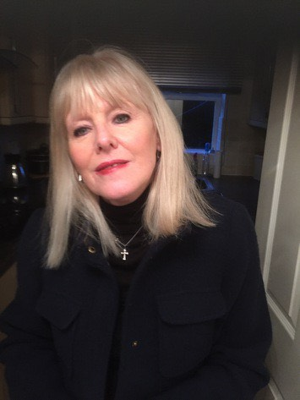

I’m a founding member of the GGF, along with Martin and Antony. Although I very much take a back seat these days, I still work closely with the team on a number of investigations, primarily in a research and advisory capacity.

**Susan Johns**

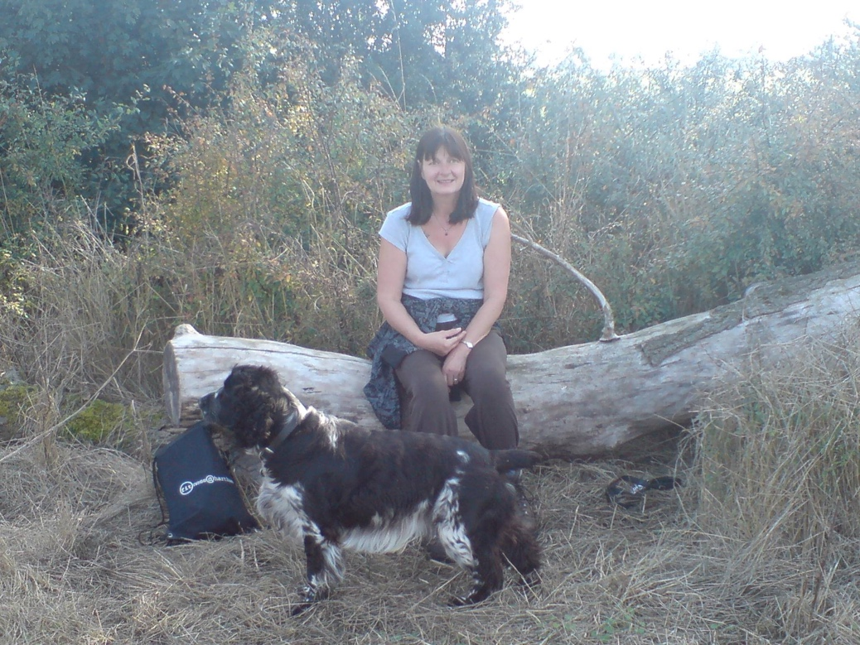

I joined the GGF after I was walking my dog down Barmstone Drain*. I’d just dropped my daughter at school and was coming back home and I saw a girl on the side of the grass. I didn’t think much about it, but the dog went a bit shy behind my legs and I couldn’t drag her. When I looked up, the girl was there, watching. I can’t explain it very well and it sounds crackers, but she just had massive black eyes, like holes in her head.

I knew I’d seen something that wasn’t of this earth. I wasn’t scared or anything, I just felt calm, like something had finally been proved. I found the GGF through the phone book and when I went to the first meeting, that was it. I just felt at home.

**\*Admin note** – We went to investigate the Drain in 1976 and then again last year. We’re currently typing up our old archives for the new website, so will share soon for those who are interested.

**Alan Storr**

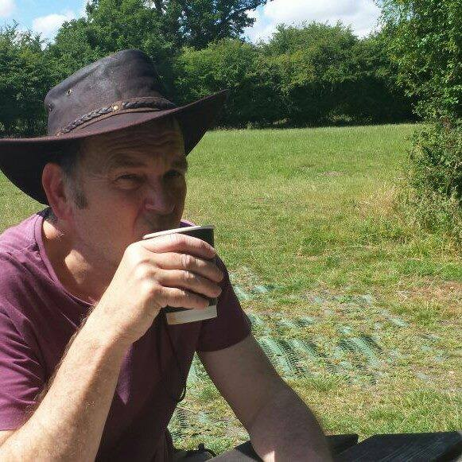

My dad said for years that he’d seen all sorts in Hull. He was a night security guard and he used to come home and tell us all sorts. He used to do a lot of work in buildings on Whitefriargate, and he was always complaining about noises and smells coming from underneath cellars – I don’t know if he was ever brave enough to investigate though!

I had to stop attending regular GGF meetings in 2007 to care for my wife, but I still take an active interest in the work of the Fellowship.

**\*Admin note** – We went to investigate the Drain in 1976 and then again last year. We’re currently typing up our old archives for the new website, so will share soon for those who are interested.