**PRSF NEW MUSIC BIENNIAL**

**HULL**

**29th JUNE to 2nd JULY 2017**

**ARTIST PACK**

**ARTIST**: Jason Singh and Anne Martin

**ARTIST CONTACT (Mobile number):** TBC – PROMOTER TO CONFIRM

**VENUE**: Mortimer Suite (Soft)

[Address](https://www.google.com/search?biw=2400&bih=1217&q=www+fruitspace+co+uk+address&stick=H4sIAAAAAAAAAOPgE-LWT9c3LDOyTMpKK9GSzU620s_JT04syczPgzOsElNSilKLiwFSWNTXLgAAAA&sa=X&ved=0ahUKEwiT5cTKt7jUAhUlKMAKHZ4BA-AQ6BMIowEwEA): Hull City Hall, Queen Victoria Square, Carr Lane, Hull, Hu1 3RQ

[Phone](https://www.google.com/search?biw=2400&bih=1217&q=www+fruitspace+co+uk+phone&sa=X&ved=0ahUKEwiT5cTKt7jUAhUlKMAKHZ4BA-AQ6BMIpgEwEQ): direct no??

**LOADING IN FROM:** Paragon Street (Pink Dot)

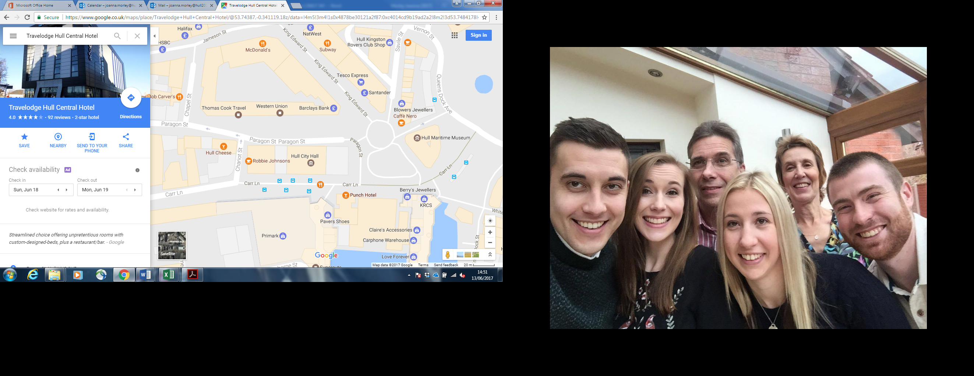

**PARKING REQUIREMENT and LOCATION:**

TBC – PROMOTER TO CONFIRM

**PERSONNEL**

**STAGE MANAGER (Primary contact show weekend only):** Danielle Harris - 07594 212377

**PRODUCTION MANAGER:** Gareth Hughes – 07733112272

**PRODUCTION ASSISTANT**: Joanna Morley – 07725 942808

**VENUE CONTACT**: Tony Evans (Technical)/Lorna (FOH)

**DATE AND TIME OF PERFORMANCE: Sunday 2nd July 12:15 (45mins)**

**PRODUCTION SCHEDULE:**

|  |  |  |
| --- | --- | --- |
| ***THURSDAY 29 JUNE*** |  |  |
| NO ACCESS TO MAIN HALL | AFTER PERFORMANCE 23:00 - 02:00 | Stage extension |
| STAGE EXT (23:00 - 02:00) | DAY | Set up dressing rooms |
|  | DAY | Dressing and branding |
|  | PM | OB truck into Paragon Street - |
|  | DAY | Volunteer briefing with Stage Manager |
|  |  |  |
| ***FRIDAY 30 JUNE*** |  |  |
| 06:00 - 00:00 (ACCESS) | 06:00 - 11:00 | Tech in - ALL |
|  | 09:00 | Piano delivery - Mortimer Suite - Sharpe |
|  | 10:00 | Piano tuning - Mortimer |
|  |  | BOTH SUITES TO BE USED AS DRESSING ROOMS FOR BBC PHIL |
|  | AM | Materials from storage to Mortimer Suite |
|  |  |  |
| ***SATURDAY 1 JULY*** |  |  |
| 08:00 - 00:00 (ACCESS) | 09:00 | Piano tuning - Mortimer and Main Hall |
|  | 16:00 - 19:00 | Tech set - Jason Singh |
|  | 19:00 - 21:00 | Jason Singh rehearsal - Mortimer Suite (soft) |
|  | 21:00 - 23:00 | Branding and dressing - Mortimer (soft) |
|  |  |  |
| ***SUNDAY 2 JULY*** |  |  |
| 08:00 - 20:00 (ACCESS) |  |  |
|  | 12:00 | DOORS - Mortimer Suite (soft) - Jason Singh |
|  | 12:15 | Jason Singh - PERFORMANCE |
|  | 13:00 | FINISH |
|  | 14:00 - 20:00 | Derig and clear |
|  |  |  |
| ***MONDAY 3 JULY*** |  |  |
|  | AM | Materials back to storage |
|  | AM | Piano off site |

**TECHNICAL**

**Sound**

**FOH Control**

1 Yamaha LS9-32

**Speaker System**

4 d&b C4-SUB Loudspeaker

2 d&b C4-TOP Loudspeaker

2 d&b P1200 Amplifier

1 EP5 Cabling

**Monitor System**

6 L Acoustic 108P

1 XLR & Powercon Package for 108P

**Microphones**

8 Behringer Ultra DI 100

1 AKG C451

4 Shure SM57

4 Shure SM58

1 Shure ULXP Beta58 Handheld Radio System - CH38

4 Microphone Stand - Short

4 Microphone Stand - Tall

**Misc**

1 Multicore System 3 - 24-way 75m

1 24-Way Veam Stagebox

1 16-Way Veam Returns Stagebox

**Staff**

1 Engineer - FOH

1 Local Crew

**Lighting**

**Material**

1 Avolites Titan One

1 Paradim Patch Rack Dimmer

6 Alu LED Par RGBW 18x 8W - 40deg

6 ETC Source Four Junior Zoom 25 - 50 Degree

4 Doughty Tank Trap

**Staff**

1 Engineer - FOH

**RIDER:**

TBC

**BACKLINE**:

**ACCREDITATION**

David & Alice Porter (Directors)

Steve & Sam Shaw (Directors)

Peter & Lorraine Boardman (Directors)

Wes Zepherin (Director)

Kirsty & Gary Halliday (Marketing)

Ben Pugh (Production)