And Now: Hull City of Culture:
Preliminary notes and proposal for LGG Macnas parade.

Makes.
And Now: Construct 3 crates, slightly Lighter weight more robust versions of the existing large crates. 2 of these crates fit to be lifted by crane. The crates would be constructed from ERW box-section steel and thin planking to look the same as the existing crates.

A larger LGG stencil would need to be made for branding. HCC to provide and spray the logo onto new crates when they arrive in Hull before being rigged on roof tops etc.

Positions of new Crates:
One would be positioned on the CO-OP roof, One outside the courts and one for the roof of the solicitors. The crates would be delivered on Friday the 3rd so that they can be rigged on Saturday the 4th by HCC.

CO-OP
One of the AndNow crates on the co-op roof, it is positioned on a raised deck, and strapped to it for stability. It is right up to and across the corner of the building at an angle.

HCC get crate in position and fix, and remove crate after Event.

HCC provide access to the roof for the And Now operator and HCC assistant. A safe working rail would be installed by HCC.
And Now will create a small, perfectly formed, magical miniature firework display that will come from the crate lasting a maximum of 60 seconds. It will consist of 2 metre cold gerbs, multiple firings of arena comets, mines and effects.
The material will be fired from within the crate on the roof top by an And Now Operator assisted by an HCC crew member located nearby on the roof ; the crew will additionally fire watch and monitor fallout..

The crate will weigh no more than 120 kg and the effects material and frames it is attached too, will weigh no more than 50 KG, There would also be a number of fire extinguishers and a firing system weighing no more than 50kg

Courts:
HCC provide 2 crates made good for stacking as per drawing, One crate on top of the other, the bottom crate ( crate 1 ) strong enough to take the weight of two operators who would be inside the second crate which is on top of crate one. The And Now crate ( crate 3 ) goes on top of the second crate at a very slight angle therefore being the third and top crate, this crate has no structural top on it ( it may have a theatrical light-weight lid for the show ).

The second crate that houses the operators has no top , but a structurally sound edge for crate 3 to sit on and a side opening hatch that makes it possible for the operators to get into position.

A small crate is used as a step up to the second crate. This is one And Now: operator and one HCC crew/assistant.

The operators fire confetti, smoke and small theatrical effects from the crate.

The crate is sort of rumbling and spewing small amounts of confetti and smoke, light dances in the smoke, there is something mysterious inside, then a performer runs from The Land of Green Ginger alley, climbs a ladder and shoots an effect at the crate, it ignites with light confetti and smoke, it shoots multiple very small comets and continues to do so as the procession cavorts by....

And Now provide the effects. And Now: will build crate 3 that will go on top of the other two, it will be lighter in weight, not more than 100kg- the stack of crate 2 and crate 3 will house the operators who will fire hand-held confetti, smoke additionally there will be rigged close proximity theatrical pyro units . And Now will provide battery powered lights and smoke machine/fogger for the crates.
There will be a ladder for the Macnas performer - she will not climb on the crates, And Now to bring the ladder - this has been confirmed with Macnas.
The top crate is open topped so as to let out confetti and small pyro effects., it may have a light weight lid that rumbles and then blows off, it remains attached by lines so that it does not blow away completely. This lid is lightweight and created from dressed Corex.

See sketch below.
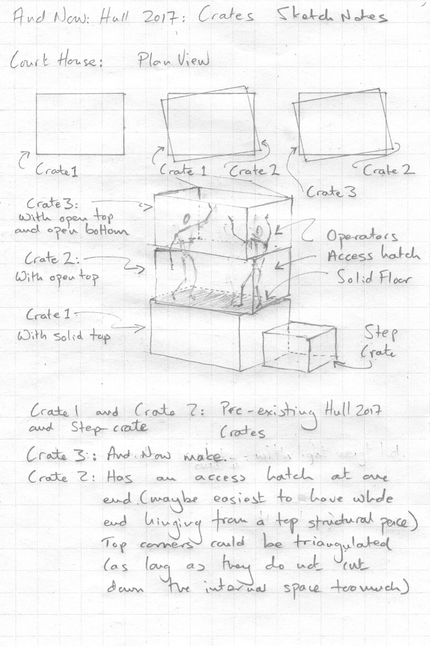

Solicitors crate set up:
And now make a crate for the solicitors roof, HCC rig it. Perhaps it has a light rigged in it HCC will provide light if it is to be used.
HCC rig and secure the crate on the roof and remove it after the event.
The crate is open topped and weighs no more than 120kg

Tele-handle crates
In the flower market car-parks we would position two tele-handlers, they would lift a crate each that will create a threshold gateway for the procession to go through. Each crate will have small scale effects fired from within and each crate would have an aluminium scaff pole that projects out and holds a waterfall over the road to create a final curtain for the procession to go through.

The crates would be raised up and moved over the road just before the procession arrives, the waterfall would be fired to herald the arrival, the procession would slow for one moment before processing through- The waterfall would last approximately 30 seconds and then the crates would move further up and back into the car-park and would continue to fire small fireworks and have a constellation of effects hanging below them, this may consist of fire drawings lines , ice fountains and more waterfall units (specifics TBC) the material would be close proximity and arena material.

HCC to provide the two crates for the telehandlers from existing crates, the crates need to be accessible from the side to rig the effects in and fit to be lifted by a telehandler, the tele-handle may need fork extensions.

HCC provide 2 x 17m tele-handlers and operators??

It would be great to have a further Fog machine and revolving lights/gobos. near where the procession disappear into the dockside street to create a final disappearing atmosphere(HCC provide these plus operators and generators, or(Lightning Rod...Bubble Vision could be a good option here, have worked with him before.
http://bubblevision.uk ) he was very cheap...

And Now would expect safe working space etc, security on the ground based work sites.

Extra help from HCC
We would need an extra hand on the co-op as firewatch and also for rig as no lone working.

We would need extra hand on the courts to operate Confetti etc, also help moving crates into position etc

We would need 2x telehandler drivers at the final/ 3rd set off crates..

And Now team:
8 people total (3 on parade and 5 on Crates plus Mandy as And Now: direction/production) 1 on co-op, 1 on court and 2 on 3rd crates and tele handlers.

Accommodation:
Thursday the 9th to Sunday the 12th for 8 x And Now: crew. Covered by Hull 2017 ?

Per diems - will hull 2017 cover these as we have not put them in to our budget so far ?

Schedule.

Friday the 3rd of November:
Crates arrive HCC rig in position over week end.

Thursday 9th:
And Now: arrive on Thursday the 8th in afternoon, Meet and production meeting?.....with Macnas and HCC

Friday: 10th
Prepare all material and equipment onto frames and ready for load in,
Rehearse, sort out all material and methods for parade. Test examples and rig flame projectors and any buttons and nail boards etc.

Saturday:11th
Rig all material into crates and onto parade images, train any vols or operators from Macnas.
Do show.
Derig

Sunday: 12th
Travel back and unpack and put away.

