**PRSF NEW MUSIC BIENNIAL**

**HULL**

**29th JUNE to 2nd JULY 2017**

**ARTIST PACK**

**ARTIST**: Ray Lee

**ARTIST CONTACT (Mobile number):** TBC – PROMOTER TO CONFIRM

James Ball - +44(0)7508 112 753

**VENUE**: Zebedee’s Yard

[Address](https://www.google.com/search?biw=2400&bih=1217&q=www+fruitspace+co+uk+address&stick=H4sIAAAAAAAAAOPgE-LWT9c3LDOyTMpKK9GSzU620s_JT04syczPgzOsElNSilKLiwFSWNTXLgAAAA&sa=X&ved=0ahUKEwiT5cTKt7jUAhUlKMAKHZ4BA-AQ6BMIowEwEA): Zebedee’s Yard, 23 Posterngate, Hull HU12JT

[Phone](https://www.google.com/search?biw=2400&bih=1217&q=www+fruitspace+co+uk+phone&sa=X&ved=0ahUKEwiT5cTKt7jUAhUlKMAKHZ4BA-AQ6BMIpgEwEQ):

**LOADING IN FROM: Posterngate (orange dot)**

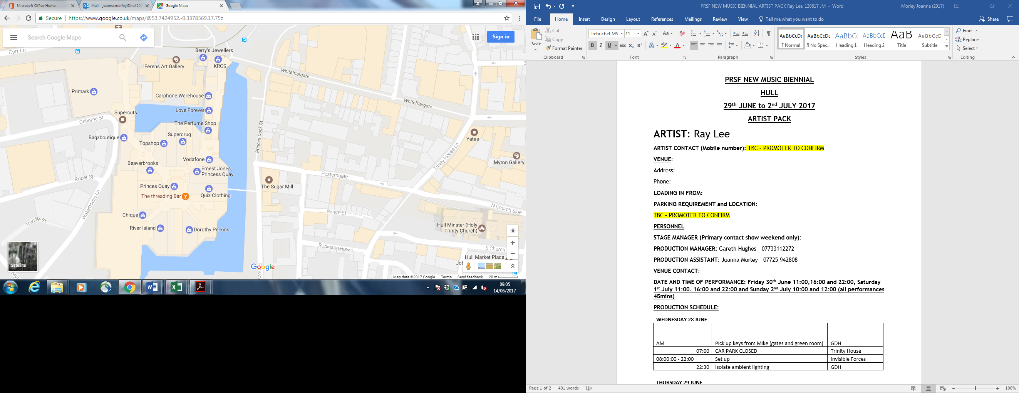

**PARKING REQUIREMENT and LOCATION:**

TBC – PROMOTER TO CONFIRM

**PERSONNEL**

**STAGE MANAGER (Primary contact show weekend only):**

**PRODUCTION MANAGER:** Gareth Hughes – 07733112272

**PRODUCTION ASSISTANT**: Joanna Morley – 07725 942808

**VENUE CONTACT**:

**DATE AND TIME OF PERFORMANCE: Friday 30th June 11:00,16:00 and 22:00, Saturday 1st July 11:00. 16:00 and 22:00 and Sunday 2nd July 10:00 and 12:00 (all performances 45mins)**

**PRODUCTION SCHEDULE:**

|  |  |  |
| --- | --- | --- |
| **WEDNESDAY 28 JUNE** |  |  |
|  |  |  |
| AM | Pick up keys from Mike (gates and green room) | GDH |
| 07:00 | CAR PARK CLOSED | Trinity House |
| 08:00:00 - 22:00 | Set up | Invisible Forces |
| 22:30 | Isolate ambient lighting | GDH |
|  |  |  |
| **THURSDAY 29 JUNE** |  |  |
| 12:00 | 12 rung Zarges dropped off | HPSS |
| DAY | 2x TV and media player set up - Greenroom | HPSS |
| 12:00 - 16:00 | Crew call x6 | Music Consortium |
| 16:00 - 20:00 | Crew call x2 | Music Consortium |
| 20:00 - 23:00 | Lighting and sound test | Invisible Forces |
| 23:00 - 00:00 | Lighting test only | Invisible Forces |
| 23:00 - 10:30 | 2x SIA - over night security | Prestige |
|  |  |  |
|  |  |  |
| **FRIDAY 30 JUNE** |  |  |
| 07:00 | CAR PARK CLOSED | Trinity House |
| 10:30:00 - 23:00 | 2x sia 2x stewards - event security | Prestige |
| 11:00 - 11:45 | PERFORMANCE - Ray Lee - Ring Out | Invisible Forces |
| 16:00 - 16:45 | PERFORMANCE - Ray Lee - Ring Out | Invisible Forces |
| 22:00 - 22:45 | PERFORMANCE - Ray Lee - Ring Out | Invisible Forces |
| 23:00 - 08:00 | 2x sia - over night security | Prestige |
|  |  |  |
| **SATURDAY 1 JULY** |  |  |
| 07:00 | CAR PARK CLOSED | Trinity House |
| 10:30:00 - 23:00 | 2x sia 2x stewards - event security | Prestige |
| 11:00 - 11:45 | PERFORMANCE - Ray Lee - Ring Out | Invisible Forces |
| 16:00 - 16:45 | PERFORMANCE - Ray Lee - Ring Out | Invisible Forces |
| 22:00 - 22:45 | PERFORMANCE - Ray Lee - Ring Out | Invisible Forces |
| 23:00 - 08:00 | 2x sia - over night security | Prestige |
|  |  |  |
| **SUNDAY 2 JULY** |  |  |
| 07:00 | CAR PARK CLOSED | Trinity House |
| 10:00 - 10:45 | PERFORMANCE - Ray Lee - Ring Out | Invisible Forces |
| 12:00 - 12:45 | PERFORMANCE - Ray Lee - Ring Out | Invisible Forces |
| 14:00 - 20:00 | OUT | Invisible Forces |
| 14:00 - 20:00 | Crew call x6 | Music Consortium |
| 20:00 | CAR PARK OPEN | Trinity House |

**TECHNICAL**

**Material**

1 Laptop

1 Samsung 55inch LCD Screen

1 Unicol K Stand Complete

**RIDER:**

TBC

**BACKLINE**:

N/A

**ACCREDITATION**

David & Alice Porter (Directors)

Steve & Sam Shaw (Directors)

Peter & Lorraine Boardman (Directors)

Wes Zepherin (Director)

Kirsty & Gary Halliday (Marketing)

Ben Pugh (Production)