*Inner Cover*

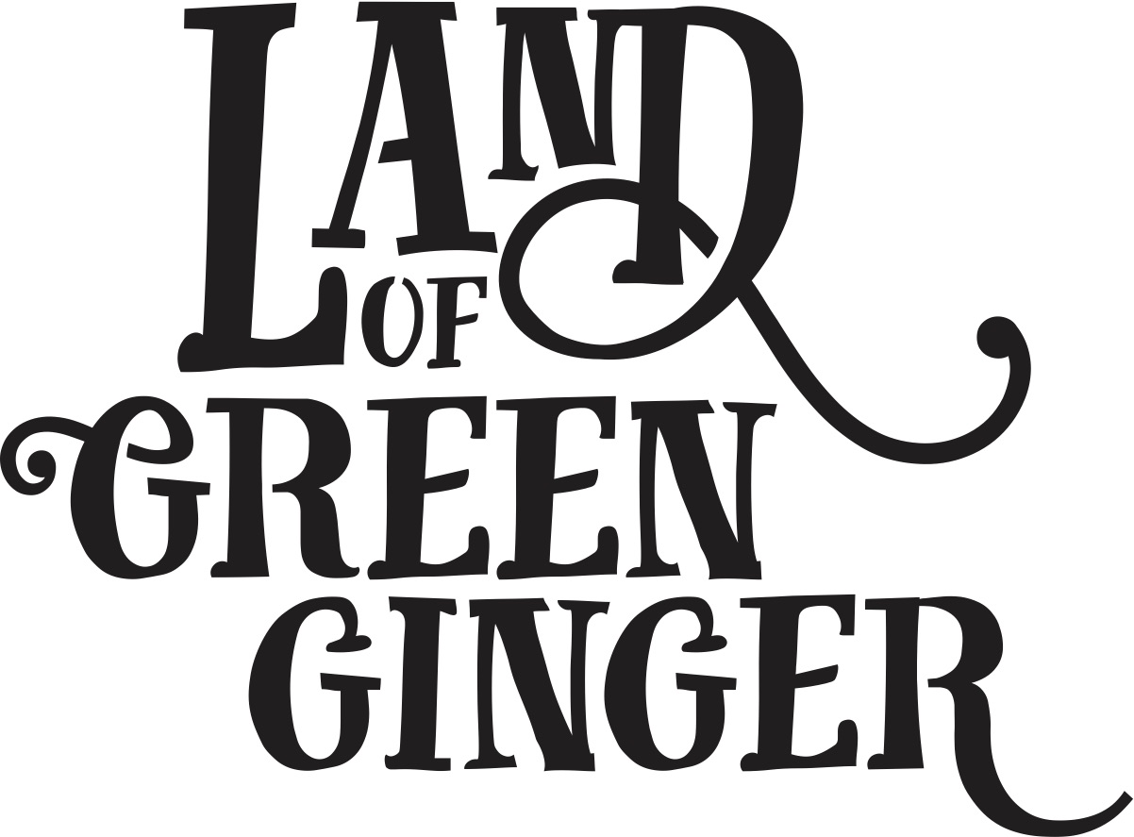

Written by

Illustrated by Katy Riddell

Info/ISBN

Rights/Copyright

Refer to this being Act VII

Some version of - *A culmination of a year of Acts of Wanton Wonder.*

Dedication?

**LoGG Story Pg**

*There once was a Land that nobody believed existed.  And every day people passed by it or around it or over it or through it, but never once saw it or felt it or heard it or knew any person or thing in it.*

[Illustration]

**LoGG story pg**

*Until one day the land revealed itself…*

[Illustration]

**Intro - NEW**

**PUNCTUATION 1**

[ILLUSTRATION]

**ACT I: 7 ALLEYS title page**

[ILLUSTRATION]

Story

*Text*

*Text*

*Text*

*Text*

*Text*

*Text*

*Text*

*Text*

[ILLUSTRATION]

Story

*Text*

*Text*

*Text*

*Text*

*Text*

*Text*

*Text*

*Text*

[ILLUSTRATION]

Story

*Text*

*Text*

*Text*

*Text*

*Text*

*Text*

*Text*

*Text*

[ILLUSTRATION]

Story

*Text*

*Text*

*Text*

*Text*

*Text*

*Text*

*Text*

*Text*

[ILLUSTRATION]

PUNCTUATION 2

[ILLUSTRATION]

Act II: Gold Nose of Green Ginger title page

[ILLUSTRATION]

Story

*Text*

*Text*

*Text*

*Text*

*Text*

*Text*

*Text*

*Text*

[ILLUSTRATION]

Story

*Text*

*Text*

*Text*

*Text*

*Text*

*Text*

*Text*

*Text*

[ILLUSTRATION]

Story

*Text*

*Text*

*Text*

*Text*

*Text*

*Text*

*Text*

*Text*

[ILLUSTRATION]

Story

*Text*

*Text*

*Text*

*Text*

*Text*

*Text*

*Text*

*Text*

[ILLUSTRATION]

PUNCTUATION 3

[ILLUSTRATION]

ACT III: THE LONGHILL BURN title page

[ILLUSTRATION]

Story

*Text*

*Text*

*Text*

*Text*

*Text*

*Text*

*Text*

*Text*

[ILLUSTRATION]

Story

*Text*

*Text*

*Text*

*Text*

*Text*

*Text*

*Text*

*Text*

[ILLUSTRATION]

Story

*Text*

*Text*

*Text*

*Text*

*Text*

*Text*

*Text*

*Text*

[ILLUSTRATION]

Story

*Text*

*Text*

*Text*

*Text*

*Text*

*Text*

*Text*

*Text*

[ILLUSTRATION]

PUNCTUATION 4

[ILLUSTRATION]

ACT IV: VOICE PARK

Title page

[ILLUSTRATION]

Story

*Text*

*Text*

*Text*

*Text*

*Text*

*Text*

*Text*

*Text*

[ILLUSTRATION]

Story

*Text*

*Text*

*Text*

*Text*

*Text*

*Text*

*Text*

*Text*

[ILLUSTRATION]

Story

*Text*

*Text*

*Text*

*Text*

*Text*

*Text*

*Text*

*Text*

[ILLUSTRATION]

Story

*Text*

*Text*

*Text*

*Text*

*Text*

*Text*

*Text*

*Text*

[ILLUSTRATION]

PUNCTUATION 5

[ILLUSTRATION]

ACT V: MICROPOLIS

Title page

[ILLUSTRATION]

Story

*Text*

*Text*

*Text*

*Text*

*Text*

*Text*

*Text*

*Text*

[ILLUSTRATION]

Story

*Text*

*Text*

*Text*

*Text*

*Text*

*Text*

*Text*

*Text*

[ILLUSTRATION]

Story

*Text*

*Text*

*Text*

*Text*

*Text*

*Text*

*Text*

*Text*

[ILLUSTRATION]

Story

*Text*

*Text*

*Text*

*Text*

*Text*

*Text*

*Text*

*Text*

[ILLUSTRATION]

PUNCTUATION 6

[ILLUSTRATION]

ACT VI: LOGG UNLEASHED

Title page

[ILLUSTRATION]

Story

*Text*

*Text*

*Text*

*Text*

*Text*

*Text*

*Text*

*Text*

[ILLUSTRATION]

Story

*Text*

*Text*

*Text*

*Text*

*Text*

*Text*

*Text*

*Text*

[ILLUSTRATION]

Story

*Text*

*Text*

*Text*

*Text*

*Text*

*Text*

*Text*

*Text*

[ILLUSTRATION]

Story

*Text*

*Text*

*Text*

*Text*

*Text*

*Text*

*Text*

*Text*

[ILLUSTRATION]

LoGG Story pg

**EPILOGUE**

*There once was a Land that nobody believed existed.  And every day people passed by it or around it or over it or through it, but never once saw it or felt it or heard it or knew any person or thing in it.*

*Until, one day, the Land revealed itself…*

*And because of that, people began to believe and behave in all sorts of strange and wonderful ways.  They wanted to leave work and play and wonder and be part of this amazing world.  They wanted to share it with friends and family and neighbours and visitors and strangers.*

*And because of that, this real world changed too.  The status quo was not so fixed and people questioned things they had always accepted.*

*And then, one day, the Land started to fade away and things began to return to something a little more akin to normal.  But traces and reminders and changes and memories remained.*

*Perhaps, one day, the Land of Green Ginger will return, but for now, our world is a little more like it.*

[ILLUSTRATION]

Contextualising of LoGG book in wider project.

Credits.

Inner cover