**PRSF NEW MUSIC BIENNIAL**

**HULL**

**29th JUNE to 2nd JULY 2017**

**ARTIST PACK**

**ARTIST**: Peter Edwards

**ARTIST CONTACT (Mobile number):** TBC – PROMOTER TO CONFIRM

Tour Manager – Dylan Bate - 07740844941

**VENUE**: Hull Minster

[**Address**](https://www.google.com/search?q=holy+trinity+church,+hull+address&stick=H4sIAAAAAAAAAOPgE-LSz9U3MCoqrMzO0ZLNTrbSz8lPTizJzM-DM6wSU1KKUouLAVGwcsEtAAAA&sa=X&ved=0ahUKEwjAypOSxrjUAhVnKcAKHfFbAysQ6BMIpAEwFQ)**:**Market Pl, Hull HU1 1RR, UK

[**Phone**](https://www.google.com/search?q=holy+trinity+church,+hull+phone&sa=X&ved=0ahUKEwjAypOSxrjUAhVnKcAKHfFbAysQ6BMIpwEwFg)**:**[+44 1482 224460](javascript:void(0))

**LOADING IN FROM:** North Church side, (Purple P)

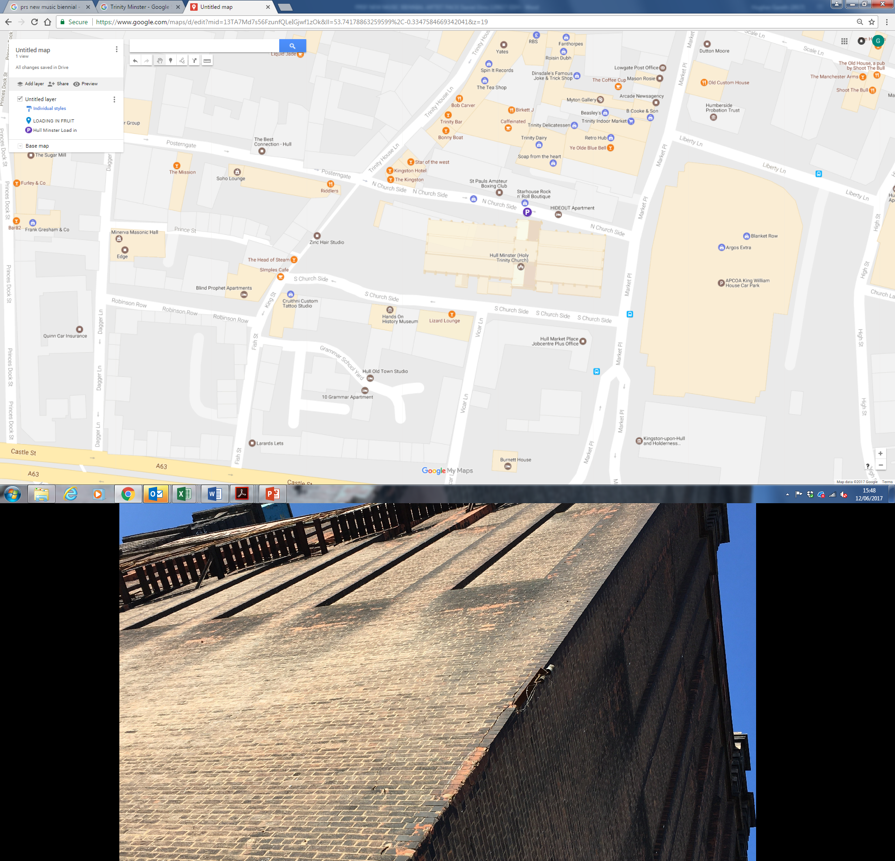

**PARKING REQUIREMENT and LOCATION:**

TBC – PROMOTER TO CONFIRM

**PERSONNEL**

**STAGE MANAGER (Primary contact show weekend only):** Ben Pugh - 07970 950552

**PRODUCTION MANAGER:** Gareth Hughes – 07733112272

**PRODUCTION ASSISTANT**: Joanna Morley – 07725 942808

**VENUE CONTACT**: Jane Owen

**DATE AND TIME OF PERFORMANCE: Sunday 2nd July 16:15 (45min)**

**PRODUCTION SCHEDULE:**

|  |  |  |  |
| --- | --- | --- | --- |
| **FRIDAY 30 JUNE** |  |  |  |
| 08:00 - 00:00 (ACCESS) | 09:00 - 16:00 | Sound in | HPSS |
|  | 13:00 - 20:00 | Daniel Elms - rehearsal | Dan Elms |
|  | 21:00 | Box office on site | David Watson |
|  | 21:45 | Doors | SM |
|  | 22:15 | Daniel Elms - PERFORMANCE | Dan Elms |
|  | 23:00 | Finish | SM |
|  | 00:00 | Cleared - SL/SR screens derigged | HPSS |
|  |  |  |  |
| **SATURDAY 1 JULY** |  |  |  |
| 20:30 | Piano delivered | From Fruit |  |
|  |  |  |  |
| **SUNDAY 2 JULY** |  |  |  |
| 08:00 - 00:00 (ACCESS) | 09:00 - 12:00 | Risers configured for Peter Edwards brass | HPSS |
|  | AM | Piano tuned | ??? |
|  | 12:15 - 13:00 | Artists arrive - Peter Edwards | Peter Edwards |
|  | 13:00 - 15:45 | Rehearsal - Peter Edwards | Peter Edwards |
|  | 15:45 | Doors | FOH |
|  | 16:15 | PERFORMANCE - Peter Edwards | Peter Edwards |
|  | ??? Sam Lee |  |  |
|  | ??? Sam Lee |  |  |
|  | 19:30 | Doors | FOH |
|  | 20:00 | PERFORMANCE - Sam Lee | Sam Lee |
|  | 21:30 | Cleared | FOH |
|  | 21:30 - 00:00 | LX and sound out | HPSS |
|  |  |  |  |
| **MONDAY 3 JULY** |  |  |  |
| 08:00 - 12:00 (ACCESS) | 08:00 - 12:00 | Staging out | HPSS |
|  | AM | Piano out | ??? |

**TECHNICAL**

**Sound**

**FOH Control**

1 Yamaha LS9-32

**Speaker System**

6 L Acoustics - KARA

4 L Acoustics - KARA-ANGARMEX

2 L Acoustics - KARA M-Bump

2 L Acoustics - SB18

2 L Acoustics LA8

**Monitor System**

2 L Acoustic 108P

2 Rane 4 Channel Headphone Amplifier

8 Sennheiser HD201 Headphones

10 6.35mm Headphone Extension Cable

**Microphones**

4 Shure SM58

4 Microphone Stand - Tall

3 d:vote DPA 4099

2 DPA Clip for Piano (PC4099)

1 DPA Clip for Sax and Trumpet (STC4099)

3 DPA DAD 6001 XLR 48 volt adapter

1 Sennheiser e906

1 Microphone Stand - Short

**Other Equipment**

1 63A 3-Phase Mains Distro #3

1 63A 1-Phase Cable 10m

**Staff**

1 Engineer - FOH

1 Local Crew

1 Local Crew

**AV**

**Projection**

1 Truss Hammer

1 Christie Lens ILS 0.73SX+/0.67HD

1 Christie Roadster HD20K- J Series Projector

1 8m x 4.5m Contrast Grey Projection Surface (Widescreen)

4 Litec QX30 - Corner Dado Section

2 Litec QX30S - 0.5m Truss Section

2 Litec QX30S - 1m Truss Section

4 Litec QX30S - 2m Truss Section

6 Litec QX30S - 3m Truss section

32 Litec QX30S - Spigot

128 Litec QX30S - Split Pin

128 Litec QX30S - Truss Pin

2 Geni Super Lift

1 Custom Screen Surround

**Sources**

1 Apple iMac 21.5"

**Processing**

1 Black Magic ATEM 1 M/E Production Studio 4K

2 Black Magic Mini Converter - HDMI to SDI 4k

2 Black Magic - Switching PSU for Mini Convertor

**Staff**

1 Engineer – AV

**Lighting**

**Control**

1 Avolites Tiger Touch Pro Console

1 Avolites PowerCube

1 100m Lighting Multicore

**Fixtures**

4 Alu LED Par RGBW 18x 8W - 40deg

6 Robe Pointe

6 Robe Robin 600 LED Wash

6 ETC Source Four Junior Zoom 25 - 50 Degree

12 Prolights SmartBat+

**Rigging**

2 Litec QX30S - 3m Truss section

**Misc**

1 63A 3-Phase Cable 23m

**Transportation**

1 7.5T Box Van

1 Engineer - Lighting

1 Lighting Tech

**RIDER:**

THE PROMOTER shall provide at no cost to Artist catering for up to TWENTY (20)

persons as follows:

A choice of vegetarian and non-vegetarian meals must be made available (fish is

acceptable for the vegetarians).

Pork is NOT acceptable for the Hot Meal for the non-vegetarians.

Please also ensure that a choice is available for any person with wheat, dairy or nut

allergies.

All Coffee should be Fair Trade Ground Coffee – not instant and DEFINITELY not

Nescafe. All other products (tea, fruit etc) should be Fair Trade where available. A

few extra pence here means a decent livelihood for producers across the world.

BEFORE ARRIVAL / SOUNDCHECK

Please provide the following rooms:

Peter Edwards (Principal/Conductor’s room/Star room)

Orchestra Gents

Orchestra Ladies

Production Office

Green Room

Room with practice piano (if available)

Please clearly sign all Dressing Rooms and ensure there is sufficient signage from

Dressing Rooms to Stage and Back.

IN GREEN ROOM

(Or distributed equally among Band Dressing Rooms if there is no Green Room):

Sandwiches, fruits, nuts, crisps, etc

(Sandwiches should be separate platters of vegetarian and non-vegetarian. Please

remember that Ham is Pork and Pork is not acceptable)

Fresh Coffee, Milk & Sugar

Tea (English and Herbal Selection)

1 Filter Coffee Machine

1 Kettle

10 ltrs fresh fruit juice - orange, apple, pineapple, etc

30 x 500ml bottles mineral water (still)

1 Ice bucket full of Ice

1 Iron & Ironing Board

1 Corkscrew & Bottle Opener

20 Mugs

20 Hi Ball Tumblers

Nu Civilisation Orchestra - The Jazz Ticket Page 3 of 10

TJT riders 2017-05-01.pages This version 1 May 2017

IN PRODUCTION OFFICE

Free use of:

1 Photocopier

Wifi Internet connection

13A Power sockets

Tea and Coffee, Milk, Sugar, Kettle & 5 Mugs

6 x 500ml bottles mineral water (Still)

MEALS:

At a time to be agreed with the Tour Manager, but generally after soundcheck.

Hot Meals for all members of the travelling party (or money to buy such meal at the

rate of GBP 15.00/person unless a greater amount is specified in the contract)

Meals should be at a nearby quality restaurant, or cooked on site by professional

music tour caterers. There should be Meat, Fish and Vegetarian options, and include

at least two courses. If the meal is in the venue, drinks from the dressing room rider

may be used. If the meal is not in the venue then drinks should also be included.

AFTER SOUNDCHECK:

I

N GREEN ROOM OR BAND DRESSING ROOMS:

10 ltrs fresh fruit juices - orange, apple, pineapple, etc

5 ltrs Coca Cola

20 x 500ml bottles mineral water (Still)

12 bottles good quality lager

2 bottles good quality red wine

2 bottles good quality dry white wine

Tea and Coffee replenished as required

All cold drinks to be iced

ON STAGE BEFORE HOUSE OPENS:

16 x 500ml bottles mineral water (Still)

16 Clean Hand towels

**BACKLINE**:

|  |  |  |
| --- | --- | --- |
| **BACKLINE** | Gretsch kit or similar: | ALBEMARLE KIT 3 |
|  | 18/10/12/14 | ALBEMARLE KIT 3 |
|  | 14x5.5 wooden snare | ALBEMARLE KIT 3 |
|  | Cymbal set | ALBEMARLE KIT 3 |
|  | All hardware | ALBEMARLE KIT 3 |
|  | 2m x 2m drum carpet | ALBEMARLE KIT 3 |
|  | Percussion 1 Set of Conga / Quinto / Tumba | STS |
|  | LP Galaxy Giovanni or similar quality | STS |

**ACCREDITATION**

David & Alice Porter (Directors)

Steve & Sam Shaw (Directors)

Peter & Lorraine Boardman (Directors)

Wes Zepherin (Director)

Kirsty & Gary Halliday (Marketing)

Ben Pugh (Production)