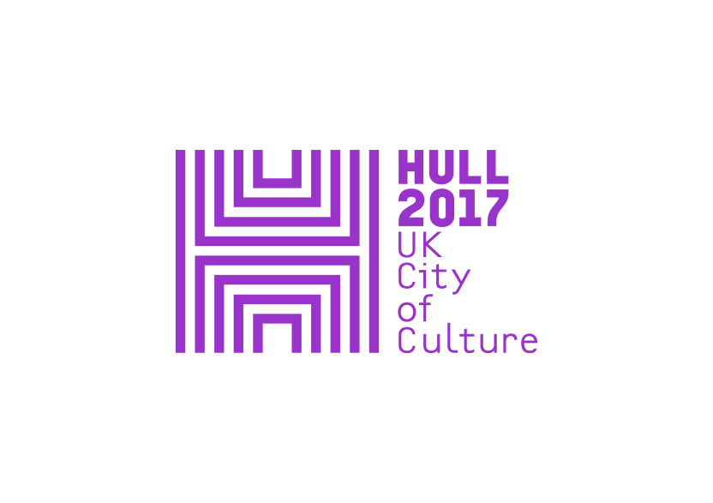

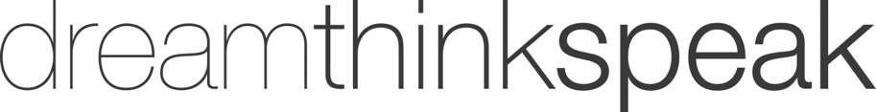

PRESS RELEASE

Thursday 25 May 2017

**ONE DAY, MAYBE**

Created by dreamthinkspeak

Commissioned by HULL UK CITY OF CULTURE 2017

**1 September –1 October 2017**

PRESS PERFORMANCES: Wednesday 6 & Thursday 7 September @6pm

KASANG Corporation, Hull City Centre

**ONE DAY, MAYBE** is the latest show from site responsive theatre company **dreamthinkspeak**, commissioned by Hull UK City of Culture 2017. ONE DAY, MAYBE invites audiences to enter a kaleidoscopic dreamworld where live performance, installation and new technology combine to create a vivid vision of a world spinning thrillingly out of control.

ONE DAY, MAYBE is inspired by the May 1980 Democratic Uprising in Gwangju, South Korea. Many demonstrators lost their lives during the military crackdown and the brutal interrogations that followed. Although little known in this country, the Uprising and the repressive aftermath were pivotal to paving the way for democratic rule and the birth of the Sixth Republic in 1987.

Whilst ONE DAY, MAYBE explores the bloody aftermath of the Gwangju Uprising, it is set in the present day and looks at the modern world we all inhabit from the perspective of May 1980, imagining those who died as spirits who return to witness the results of their sacrifices.

What if they could step into the shoes of the young people alive today and see the same world that we see? What would they make of the world we live in? Would they see an exciting world of global economic expansion, rapid technological development and freedom of expression?

For each performance, the company will throw open its doors to the general public. The audience is invited to access the public areas as well as the private offices and laboratories where they are allowed to test and participate in the technologies that are being developed.

As the audience is drawn deeper into this labyrinthine technological world, they find themselves slipping between past, present and future, tumbling back to the aftermath of May 1980 before stumbling forward towards a bright but uncertain future.

Artistic Director Tristan Sharps will lead a company of over 30 Korean performers and 50 collaborators to create a multi-layered series of audience journeys, mixing live performance with film and installation, ranging from pioneering technology to ancient ritual.

Martin Green, Director Hull 2017, said: "In a year that is intended to bring the unexpected, ONE DAY, MAYBE promises to be one of the most exceptional events of the year. dreamthinkspeak have a reputation for producing work that takes you on incredible journeys and I cannot wait to join this one in September."

**Tickets for ONE DAY, MAYBE are being sold in two batches: 7am, Wednesday 31 May 2017 and 7.30pm, Wednesday 28 June 2017. They will be available from** [**www.hull2017.co.uk/onedaymaybe**](http://www.hull2017.co.uk/onedaymaybe)**.**

For further information contact: Anna Arthur( anna@annaarthurpr.com) or Joanna Hawkins (Joanna@annaarthurpr.com).

**LISTINGS INFORMATION**

DATES: 1 September - 1 October 2017

TIMES: Tue – Sun: Various Time Slots

LOCATION: KASANG CORPORATION, Hull City Centre

PRICES:

BOOKING: [www.hull2017.co.uk/onedaymaybe](http://www.hull2017.co.uk/onedaymaybe) (From 7am, Wednesday 31 May 2017; and second release from 7.30pm on Wednesday 28 June 2017)

**NOTES TO EDITORS**

The Gwangju Uprising, also called May 18 Democratic Uprising by UNESCO, was the birth of the Gwangju Democratisation Movement. Gwangju citizens took up arms when local University students demonstrating against the Chun Doo-hwan government, were fired upon, killed, and beaten in an unprecedented attack by government troops. Estimates suggest up to 606 people may have died, though many more disappeared during the secret interrogations that followed. During Chun Doo-hwan’s presidency the authorities continued to define the incident as a rebellion instigated by Communist sympathizers and this day are those who question the legitimacy of the Uprising. By 1997, a national cemetery and day of commemoration (May 18) were established. In 2011, 1980 Archives for the May 18th Democratic Uprising against Military Regime were inscribed on the UNESCO Memory of the World Register.

**dreamthinkspeak**

Created in 1999 by artistic director Tristan Sharps, dreamthinkspeak is a key practitioner of site-responsive performance. The work interweaves live performance with film and installations to create extraordinary journeys that are technically ambitious, visually layered and popular with audiences wherever they are performed. Previous works have taken place in a variety of physical and architectural contexts from an underground abattoir in Clerkenwell, to a disused paper factory in Moscow to the formeTreasury in Perth to the vast Zuidas office complex in Amsterdam.

HULL UK CITY OF CULTURE 2017 and dreamthinkspeak

Present

ONE DAY, MAYBE

created by dreamthinkspeak

commissioned by HULL UK CITY OF CULTURE 2017

ONE DAY, MAYBE was originally commissioned by Asian Culture Complex, The Museum of Art, Kochi, 21st Century Museum of Art, Kanazawa, AsiaNow and dreamthinkspeak.

**Hull UK City of Culture 2017**

Hull UK City of Culture 2017 is a 365 day programme of cultural events and creativity inspired by the city and told to the world. Hull secured the title of UK City of Culture 2017 in November 2013. It is only the second city to hold the title and the first in England.

Divided into four seasons, this nationally significant event draws on the distinctive spirit of the city and the artists, writers, directors, musicians, revolutionaries and thinkers that have made such a significant contribution to the development of art and ideas.

Hull 2017’s second season, Roots and Routes, runs from April to June and explore Hull’s unique place as a gateway to Europe and one of the world’s busiest ports. Its maritime history and global connections inspire the stories of the city; this season of work will also celebrate Hull’s international links, including Rotterdam, Reykjavik and Freetown. Freedom runs from July to September. Building on the legacy of Hull-born anti-slavery campaigner William Wilberforce MP, *Freedom* will explore the concept of freedom in all its many forms. The final season, Tell the World will run from October to December.

The Culture Company was set up to deliver the Hull 2017 programme and is an independent organisation with charitable status. It has raised £32 million, with over 70 partners supporting the project, including public bodies, trusts and foundations and local and national businesses. The National Lottery has contributed more than £10m of this funding, making the National Lottery the largest single funding body of Hull 2017.

Key contributions are coming from: Host City – Hull City Council; Principal Partners - Arts Council England, BBC, Big Lottery Fund, East Riding of Yorkshire Council, Heritage Lottery Fund, KCOM, KWL, Spirit of 2012, Yorkshire Water and the University of Hull; Major Partners –Associated British Ports, Arco, BP, the British Council, British Film Institute, Green Port Hull, Hull Clinical Commissioning Group, MKM Building Supplies, P&O Ferries, Paul Hamlyn Foundation, Sewell Group, Siemens, Smith & Nephew and Wykeland Group.

Hull 2017’s International Partners are: Aarhus, Denmark, which is European Capital of Culture 2017; Reykjavik, Iceland; Rotterdam, The Netherlands; and Freetown, Sierra Leone (twinned with Hull). These relationships are reflected in a number of events throughout the year.

For information go to [www.hull2017.co.uk](http://www.hull2017.co.uk) Follow us on Twitter @2017Hull Instagram @2017hull Facebook HullCityofCulture Media can also contct Ben McKnight – [ben.mcknight@hull2017.co.uk](mailto:ben.mcknight@hull2017.co.uk) / 07718 100793