Hack II: Voices that take you places - Transforming the Bus Stop waiting experience.

We are looking for partners to help us transform the waiting experience at Bus stops around Hull via both the written and spoken word, by helping source words and voices of Hullians, both from archives and written specifically for this scenario, mixing both known and unknown ‘voices’.

Imagine a Bus Stop where a digital-text-display displays short story’s and poetry from local writers. - Both known and unknown, serious and comedic, local and from Hulls sister-city Freetown (Sierra Leone). - Where strange speaker contraptions hang suspended around the bus stop, like a ‘flock of speakers’, giving voice to these writers words. - Where you are served glasses of fresh mint tea, brewed in-situ on wood burners that puff green smoke and there is comfortable seating. ..Imagine ‘waiting’ here!

Two Questions & Challenges this project will take on:
- “What is the power of our voice capable of..?”
- “How can we subvert and hijack the bus stop waiting experience, transforming it so that people can both consider this question and also enable them to ‘travel whilst they wait’ ?”

The objective of this city hack is to demonstrate and explore the power of our ‘voices’ (both written & spoken) to make positive changes to our and other peoples public life and public space. I.e. The potential power of Hullian’s to use their words & ‘voice’ to transform our city - starting initially with the challenge of temporarily transforming the time we spend waiting at bus stops..

- The idea is to use the ‘hacked’ bus stop to mix and share examples of known ‘voices’ of Hull who have made changes happen (in a broader and inspirational sense), with new voices who will literally change our perception and experience of ‘sitting waiting at this bus stop on Beverley Road in Hull’. i.e. Words that broaden our perceptions of the potential of our voices to have effect and make positive changes happen and words that literally change our immediate situation.
Liam Rich
Producer
Hull UK City of Culture 2017
E: Liam.Rich@hull2017.co.uk
Mobile: +44 (0)7590 600 626 / +44 (0)7957 193 195

CONTACT:
Thor McIntyre-Burnie
Lead Artist and Director of Aswarm
Mob: 07830 126 329
E: thor@aswarm.com
W: www.aswarm.com
- The aim of the new material we write & gather is to gently subvert and play with the day-dreaming mind-state of those ‘waiting..’ - perhaps, like Gill Adams writing the play ‘Fish ‘n Leather’, they’re inspired by observing 2 ladies stood at a bus stop or perhaps they take us away to other places..

We’re are looking for Partners who can join us and participate in 3 possible ways:
- Write new material specifically for this scenario and theme. -These can be existing writer’s, play wrights, poets and wordsmiths or simply interested individuals or school/college students or even new migrant/refugee arrivals to Hull studying english language.
- Help source existing text from both archives and from current writers, poets and wordsmiths.
- Give voice to some of these texts, by reading and recording pieces at one of our sessions.

Specifically we would like to work with:
- Hull school that has an existing sister school relationship with a school in Sierra Leon*
- School in Sierra Leon* (partnered with Hull school)
- Local group or org that gathers poets, writers in Hull.
- Local comedians, poets, spoken word and play rights (Lucy Beaumont is helping us here too).
- WISE and other archives of historic voices (from Wilberforce, to movers.)
*(via: Deb Tague, HT Sutton Park Primary School & City of Culture & Global Schools Hull Collaborative Academy Trust?)

A Rough Sketch* of Transforming a Bus Stop in Hull
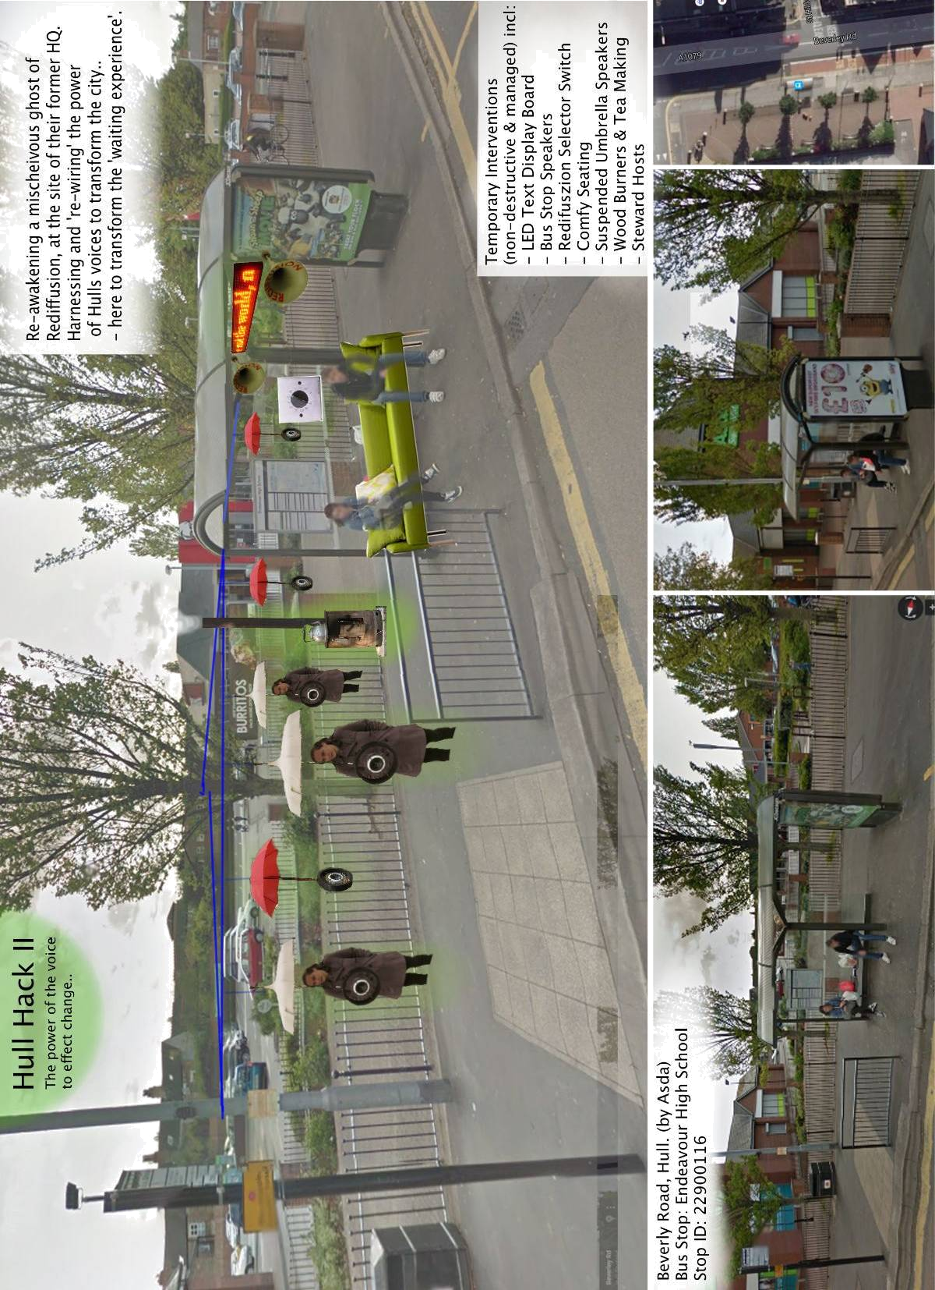
(* -This is just an early example illustration. Not for publication or redistribution)

