LGBT50 Evaluation Report

# EXECUTIVE SUMMARY

LGBT50 was a festival of events celebrating the 50th anniversary of the partial decriminalisation of homosexuality in the UK. It took place throughout the summer months of 2017, with a concentration of activity in the last week of July. Events and activities included:

* Pride in Hull’s presentation of the 1st UK Pride parade
* 50 Queers for 50 Years: Duckie’s 50 handmade and oversized LGBT icons
* A Pride concert in Queen’s Gardens with a headline performance by Marc Almond.
* A Moment in Time: a photography exhibition using publicly-submitted photographs
* Lads’n’Lasses: a new piece of theatre written and performed by local young people’s theatre group Aposarts, around the topic of homophobia in school
* A film festival
* A comedy night
* Polari literary salon
* An LGBT+ Entrepreneurs event
* 'The House of Kings and Queens': a specially commissioned exhibition of photography by Lee Price.
* A Duckie Summer Tea Party featuring a 50-performer dance show by Gary Clarke and Yorkshire Dance celebrating 50 years of queer culture
* BBC Radio 2 presented 'I Feel Love', a live concert from Hull City Hall broadcast on Radio 2 and Red Button, part of the BBC’s Gay Britannia season
* Fuel Nightclub hosted the Official LGBT50 Afterparty curated by Duckie
* Lost Property: a learning and participation project leading to the creation of a zine

The LGBT50 project set out to achieve two aims and four objectives:

* Within a festival of events celebrating LGBT culture, enable participants to explore LGBT themes and interact with people they wouldn’t normally have interacted with
  + Create opportunities for intergenerational interactions exploring LGBT themes
  + Engage participants in a new dance work to encourage a mass dance moment
* Enable creative community engagement in LGBT heritage
  + Increase awareness of the 50th anniversary of the partial decriminalisation of homosexuality in England and Wales
  + Explore LGBT heritage from 1967-2017 through creative events and activities

In addition to these project specific objectives, LGBT50 also contributed towards the aims and objectives listed within the Hull 2017 monitoring and evaluation framework across all five areas: Arts & Culture, Place making, Economy, Society & Wellbeing, and Partnerships, Development and Legacy.

SUMMARY OF KEY FINDINGS

SUMMARY OF KEY LEARNINGS

# BACKGROUND

The LGBT50 project included several strands, each working with different partners and venues, though with cross-fertilisation of ideas and process amongst many. These strands can be identified as follows:

**Duckie**

Artists from the Duckie collective took over an empty shop unit on Jameson Street in Hull city centre from the first week of June 2017 as a base and workshop space for the development of their commissions where members of the public and Hull 2017 volunteers could engage with and contribute to the making process. The space was open to the public and pre-booked volunteers from 4pm – 7pm on Thursdays and Fridays and 2pm – 5pm on Saturdays and Sundays from the 8 June – 21 July 2017. During this time participants contributed to the construction of 50 handmade and oversized LGBT icons drawn from 50 years of local, national and international queer history. The selection of the local icons was informed by research undertaken by one of the Duckie artists with the Hull LGBT+ community earlier in the year. Those who had participated in the making process and others who had followed through social media then volunteered to carry each of the icons (entitled ‘50 Queers for 50 Years’) in Pride in Hull’s presentation of the 1st UK Pride parade on Saturday 22 July. A selection of these icons were subsequently displayed alongside Duckie’s second commission on Saturday 29 July in Queen Victoria Square.

Within the LGBT50 programme, Duckie were also commissioned to produce two events on Saturday 29 July: ‘A Duckie Summer Tea Party’ from 1pm-6pm in Queen Victoria Square, and the ‘Official LGBT50 After Party’ from 10pm-2am at Fuel nightclub. ‘A Duckie Summer Tea Party’ saw the redecoration of the public space of Queen Victoria Square for the occasion and a programme of free performances utilising four specially installed podiums, the balcony of Hull City Hall and the raised platform around the statue of Queen Victoria as stages. A 50-performer dance show commissioned from Gary Clarke and Yorkshire Dance featured twice within the programme, alongside other performances from Duckie artists, compering from Miss Amy Lamé and music from the London Gay Big Band. Hull 2017 volunteers were recruited to become waiters for the afternoon and served free tea and cakes to one hundred attendees each hour selected from the crowd. The event concluded with a released of 20kg of confetti from a canon on the Hull City Hall balcony.

The main week of LGBT50 activity concluded with an ‘Official LGBT50 After Party’ at Fuel nightclub presented by Duckie and hostessed by Miss Amy Lamé. The evening’s programme included performances from the Readers Wifes, The LipSinkers and Victoria Sin as well as DJs. Tickets were £5 and sold on the door.

**Pride in Hull**

Pride in Hull were supported by the Hull 2017 team to increase the scale and ambition of their Pride offer, including a series of events from Saturday 22 to Friday 28 July. The week opened with the presentation of the 1st UK Pride parade commencing at 12 noon from Hull College, processing across the city centre to Paragon Square where a wreath was laid to remember LGBT people who had served in the armed forces, and returning to end at Queens Gardens. The parade was interspersed with Duckie’s ‘50 Queers for 50 Years’ icons and made up of walking groups from a range of community organisations, companies and public services. The parade ended with a Pride concert which commenced at 2pm in Queen’s Gardens and was headlined by Marc Almond and B*Witched. The parade was unticketed to watch, though walking groups needed to register in advance, and free to all. A donation was requested for access to the concert site with a suggested amount of £5. Alongside the concert, there were food and drink concessions, a marketplace of stalls, other entertainments, wrapped vehicles from Hull emergency services and the first display of the ‘A Moment in Time’ exhibition. This photography exhibition used publicly-submitted photographs to tell the LGBT+ story before the decriminalisation of homosexuality in 1967 and in the 50 years since and toured to other Pride in Hull events during the week.

Pride in Hull’s other events included:

* 24 July ‘Lads ‘n’ Lasses’ at Fruit: A new piece of theatre written and performed by local young people’s theatre group Aposarts, around the topic of homophobia in school. This was a free event.
* 25 July ‘Pride in Hull Film Festival’ at Kardomah 94, Vue Cinema Hull and Hull Truck Theatre: In partnership with Hull Independent Cinema, screenings of LGBT films with stories from every section of the LGBT community. These were ticketed screenings.
* 26 July ‘LGBT+ Entrepreneur Day’ at Kardomah 94: Workshops and business forum for members of the LGBT community thinking about setting up in business or developing existing businesses. This was a free event.
* 26 July ‘Out For A Laugh Comedy Night’ at Kardomah 94: A showcase event for workshop attendees along with local and national LGBT comedians. This was a ticketed event.
* 27 July ‘Polari Literary Salon’ at Kardomah 94: Paul Burston’s famous literary salon celebrating LGBT writers and literature in a fun, friendly and supportive environment. This was a ticketed event.
* 28 July ‘Red Ribbon Soiree’ at the Mercure Hull Royal Hotel: A fun-packed fundraiser for Hull’s only HIV hardship fund (Hardy Fund), saucy, adult entertainment, exotic buffet and dancing. This was a ticketed event.

**Humber Street Gallery**

On the 27 July, Humber Street Gallery (a venue run by Hull 2017) opened ‘The House of Kings and Queens’ exhibition. This was a specially commissioned exhibition of photography by Lee Price. Captured in Sierra Leone, where homosexuality remains illegal, Price’s images depict ‘The House’ where inhabitants can live without oppression, exposing what it means to be gay in Hull’s sister city Freetown. The exhibition ran until the 24 September.

Alongside this exhibition, on the 17 August, Humber Street Gallery also hosted the ‘Moved by Art LGBT50’. Moved by Art is a multidisciplinary arts project engaging local artists and young people aged 16-24. In this session artist James Nash explored ‘The House of Kings and Queens’ and gave participants the opportunity to engage with the exhibition and create inspired poetry and an LGBT graphic.

**Into the Light - Yorkshire Dance**

On the 29 July, ‘A Duckie Summer Tea Party’ included two performances of ‘Into the Light’, a dance project choreographed by Gary Clarke and presented by Yorkshire Dance in Queen Victoria Square. This new work celebrated 50 years of queer culture and involved participants recruited from Hull LGBT community and friends. Participants took part in a series of rehearsals in the month prior to the event.

**I Feel Love - BBC**

Following on from the tea party on the 29 July, BBC Radio 2 presented I Feel Love, a live concert from Hull City Hall broadcast on Radio 2 and Red Button which was part of the BBC’s Gay Britannia season. It was presented by BBC Radio 1’s Scott Mills and Scissor Sisters’ front woman and Radio 2 presenter Ana Matronic, and featured a line-up of artists including Bright Light Bright Light, Will Young, Tom Robinson and performers from the West End stage. This was a ticketed event with proceeds going to LGBT+ legacy event post 2017.

**Lost Property**

Alongside these events, a learning and participation project engaged local LGBT+ people in writing workshops leading to the production of a zine. Three weekly workshops took place on the 15, 22 and 29 June and the zine was launched at an event at Thieving Harry’s on 27 July. Ten writers were involved and they hadn’t needed to have written anything before. The aim of the project was to tell a series of stories connected in some way to the LGBT experience. Copies of the zine were distributed at other LGBT50 events.

**Other Events**

Two exhibitions at Artlink Community Arts Centre and a series of talks at the University of Hull were also promoted within the LGBT50 marketing materials. However, these activities are not evaluated within this report.

# ARTS & CULTURE

The LGBT50 programme included 9 new commissions and a total of 27 activities. Of these 14 were free and unticketed and 13 were ticketed with an entry charge.

Over 90,000 audience attendances were recorded across events within the LGBT50 programme including:

* 43,000 footfall and 9000 attendees at any one time at Hull Pride in Queens Gardens on the 22nd July
* 43,133 footfall through Queen Victoria Square at Duckie’s Summer Tea Party on the 29th July
* 1,200 at I Feel Love concert on the 29th July
* 4,954 (11th Aug) at The House of Kings and Queens Exhibition from the 27th July – 24 September

Of those attending during the week of 22-29 July 62% are estimated to have been from Hull, 21% were day visitors and 11% were overnight visitors to the city. Of those who are from Hull, 32.7% are estimated to have come from areas of the city within the most deprived decile in the country. This compares to 32.1% amongst Blade audiences, 23.6% at Place Des Anges and 26.6% at Made in Hull, which all took place in the city centre, 32.5% at 7 Alleys, which took place in East Park, and 32.8% at Epicycle, which took place in West Park. Overall, 45.1% of Hull’s population reside within these areas. There is also a trend in these figures of increased engagement from this segment of Hull’s population as the year progresses.

Of those attending during the week of 22-29 July, 37% identified as a member of the LGBT+ community some or all of the time and 63% did not identify as a member of this community. [Need to total up gender responses from postcards] Of a sample of 230 who responded to a telephone and online survey about their experiences at LGBT50 events, 61% identified as female, 30% identified as male, 1% identified as transgender and 8% have a gender identity not covered by the options provided.

Further to these attendances, there were opportunities for participation in the LGBT50 programme including:

* 2,500 participating in the Pride parade on the 22nd July
* Around 300 participating in making at Duckie’s workshops
* 42 community dancers in ‘Into the Light’
* 10 participants in the Lost Property project
* 50 participated as waiters at the tea party

At the 16August 2017 (268 responses), 70% of participants were from Hull and 30% were visitors to the city. However, the majority of the visitors to the city were residents of East Riding. Regarding their employment status: 52% were employed, 35% were retired, 5% were self employed, 3% were looking after family / home, and between 1% and 2% were each of unemployed, unable to work or students. Of all participants, 84% identify as female, 15% as male, 0.5% at transgender, 0.5% as gender non-conforming and 0.5% as other. Overall, 96% of participants were White British, 1% preferred not to say, and 3% were BAME. At the 2011 census, 89.7% of residents described themselves as White British. A total of 14.5% of participants reported having a disability which limited their day to day activities a little or a lot. Participants represented a spread of ages, though with a greater representation of 50-69 year olds (67% were in this age range).

Add diversity of participants broken down by events e.g. dancers vs parade walkers.

Hull 2017 and Hull City Council Events Team staff reported positive comments they had received from audience members at A Duckie Summer Tea Party, in particular those who identify as transgender or gender non-conforming, regarding how welcoming and inclusive the event and staff had been and appreciation that an event of this type was put on in such a visible location.

A total of 7 of the commissions were inspired by history or heritage and a total of 15 of the activities: 4 productions, 3 exhibitions, 4 films, and 4 other shows. TO ADD: ARTIST EXPLANATION OF HOW THEY EXPLORED HERITAGE THEMES (INC LGBT heritage from 1967-2017).

* 82% of audience members (note smaller/different sample frame on this Q?) reported being aware that 2017 was the 50th anniversary of the partial decriminalisation of homosexuality in England and Wales.
* 56% of audience members reported a high level of increase (7-10/10) in their understanding and appreciation of Hull and the UK’s LGBT+ heritage.

When asked if their thoughts and feelings about their life/future had changed positively as a result of being involved in LGBT50, participants’ statements included reports of how they had developed their understanding and appreciation of LGBT+ heritage:

* “Has given me more understanding of what my 76 year old cousin has had to experience over the years.” - Participant, Female, 60-64 years
* “A little more understanding of the struggles of previous generations.” – Participant, Female, 55-59 years
* “It made me reflect on my youth, I was 14 when the act was repealed. and I think of friends who are LGBT and that they would have been criminalised.” – Participant, Female, 60-64 years

# PLACEMAKING

LGBT50 events achieved X number of media articles of which X% were deemed to be positive from sentiment analysis.

It is anticipated that the LGBT50 programme of events will have contributed to the % of Hull residents who are proud to live in Hull and who would speak positively about the city to others. However, these figures will be collected through the Hull citywide residents survey in December 2017 and as such can’t be reported at this time.

From audience and participant surveys, a number of findings can be reported:

* 94% of audiences and 96% of participants agreed or strongly agreed that the LGBT50 events they attended offered a significant moment of civic pride for the LGBT community of the city
* 84% of audiences and 87% of participants agreed or strongly agreed that the LGBT50 events they attended provided them with a different experience of the city.

Audiences and participants also reported several ways that LGBT50 events had changed their views of the city:

* “I was very encouraged by the great attitude I felt from the local community. Was worried there'd be negativity.” Participant, female, 55-59 years
* “It made me appreciate that Hull is a far more accepting city than i thought and it makes me happier to be living here.” Participant, male, 30-34 years
* “I was amazed to see the community spirit and friendliness of people in hull, something that was really highlighted by this event.” Participant, female, 25-29 years
* “Feel more proud of the city and I feel I know more about LGBT as a whole.” Participant, female, 25-29 years
* “I was surprised to see how many people lined the streets when the parade was on. Most of which looked like they were enjoying the experience. Growing up in Hull this would not have been the case.” Participant, male, 50-54 years
* “Working as a volunteer in the Duckie shop…was the best volunteering experience I have had...Hull has a history of being rigid and narrow minded, and hopefully with the help of the above, this may be slowly changing.” Participant, female, 65-69 years
* “I feel more proud living somewhere that accepts these types of events and way of life. It has made me happier about living here.” Audience member, female, 30-34 years

# ECONOMY

From over 90,000 total audiences attending during the week of 22-29 July, 62% are estimated to have been from Hull, 21% were day visitors and 11% were overnight visitors to the city.

Economic impact measures?

# SOCIETY & WELLBEING

LGBT50 sought to contribute to wider Hull 2017 objectives to improve wellbeing through engagement and participation and to increase aspirations, abilities and knowledge of residents.

* In total, nearly 3000 people participated in an element of the LGBT50 programme
* 85% of participants reported feeling happier after participating in LGBT50
* 97% of audiences and 98% of participants agreed or strongly agreed with the statement that ‘Participating in LGBT50 was an enjoyable experience’
* 42% of participants and 78% of audiences reported that their thoughts and feelings about their life/future changed positively as a result of being involved in LGBT50.

Within the objectives for the project, the producing team wanted to focus on creating opportunities for the LGBT+ community to be visible in public spaces and to feel safe being so. Evidence of the achievement of this objective is evident in comments from audience members and participants.

* “I just feel that little bit prouder of being part of the LGBTQ+ community.” Audience member, male, 45-49 years
* “I can be myself more then ever before” Audience member, male, 30-34 years
* “It's nice to see all the support that everyone has for the LGBT community, and make me feel a lot more confident in the future for being accepted” Audience member, male, 18-19 years
* “Realising how big the LBGT community is.” Participant, preferred not to say.
* “As a straight person I understood a lot more about the problems and different attitudes the LGBTQ community have to face on a daily basis.” Participant, female, 60-64 years

One of the specific aims of the LGBT50 programme was to enable participants and audiences to interact with people they wouldn’t normally have interacted with, and in particular created opportunities for intergenerational interactions. ARTISTS/PARTNERS/PROJECT TEAM REPORTS ON CREATING OPPORTUNITIES FOR INTEGENERATIONAL INTERACTIONS.

* 76% of audiences and 81% of participants agreed or strongly agreed that LGBT50 events gave them the opportunity to interact with other people who they wouldn’t normally interact with
* 78% of audiences and 48% of participants agreed or strongly agreed that LGBT50 events made them think more positively about people from other generations
* 63% of audiences and 52% of participants agreed or strongly agreed that LGBT50 events inspired them to talk to people from other generations about the stories presented

A total of 42 participants from the LGBT community and its’ friends took part in rehearsals and two performances of ‘Into The Light’: a new dance work choreographed by Gary Clark which explored heritage themes including marking the 50th anniversary of the partial decriminalisation of homosexuality in England and Wales. For half of these respondents, participating in this project introduced them to mass dance for the first time.

# PARTNERSHIPS, DEVELOPMENT & LEGACY

The Sewell Group provided additional support to the LGBT50 programme of events and were credited as the presenting partner. They reported their motivation for this as being “To showcase that we're an equal opportunities employer and see diversity as an asset in business”.

In addition, a short survey was circulated to Hull 2017 partners to evaluate their involvement in promoting LGBT events and initiatives in 2017. This survey received 15 responses from 14 organisations. Of these responses, 47% felt that their company or organisations had promoted LGBT events and initiatives more in 2017 than in previous years. 60% of all respondents were significantly influenced (4 or 5 out of 5) by Hull’s UK City of Culture status in their promotion of LGBT events and initiatives this year. In comparison, only 20% were significantly influenced by it being the 50th anniversary of the partial decriminalisation of homosexuality in the UK.

# PROCESS EVALUATION

From team debrief

Artist Debrief info to be added in Sep.

# KEY LEARNINGS

# APPENDICES

Audience postcode mapping by LSOA:

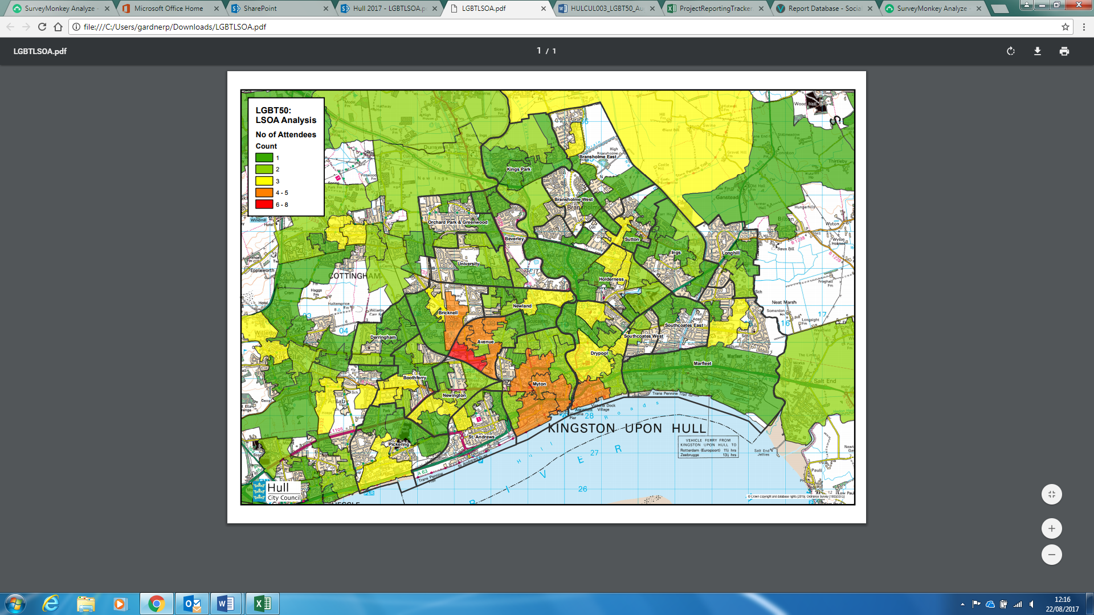

Audience postcode mapping by Ward:

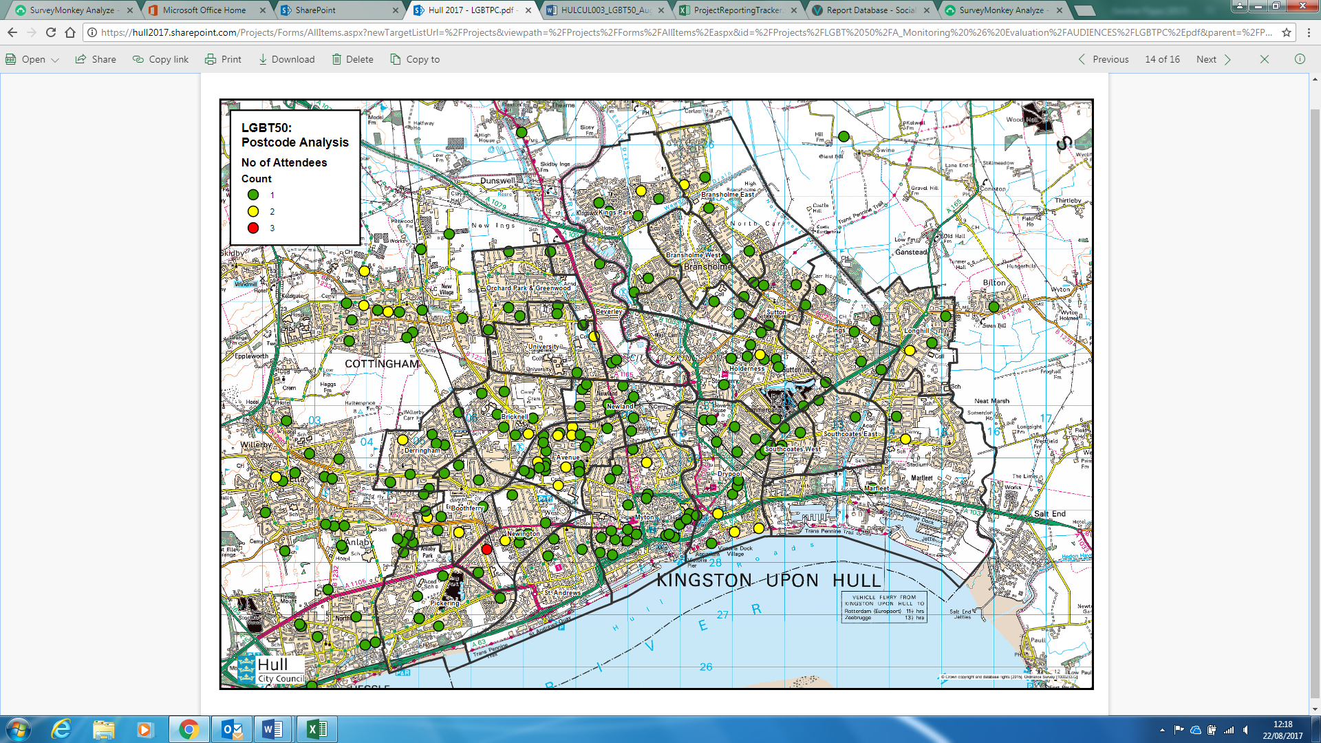

* Artwork from LGBT50 leaflet
* Links to FusionTable maps
  + LGBT50 Participants: <https://www.google.com/fusiontables/DataSource?docid=1lLRDNxn8Mnpbeel9YLIImHwLSQmI838ag9JcCIHp>
* Key graphs